Reggression Analysis:

The OLS Regression Results provide insights into the relationship between the COVID-19 Infection Rate and the socioeconomic factors

Coefficient for Median Household Income (Income): The coefficient of 0.0006 indicates that for each unit increase in median household income (measured in dollars), the infection rate increases by 0.0006 per 100,000 population. In this case, the coefficient is positive but statistically insignificant (p-value = 0.676), suggesting that there is no meaningful association between income and infection rates.

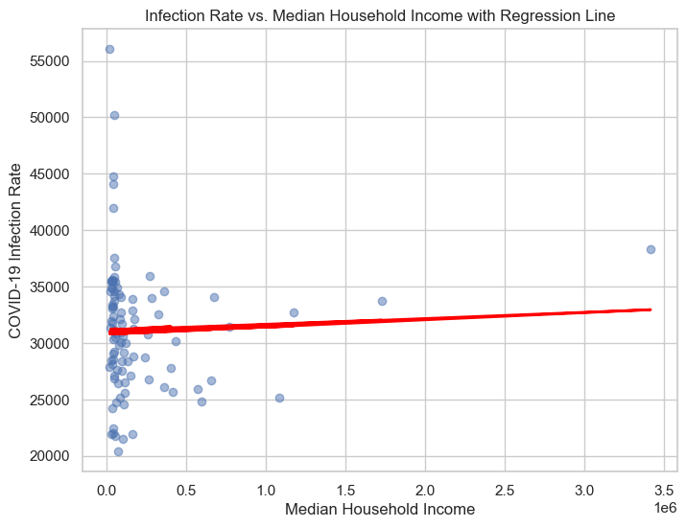
Coefficient for Percentage of Population Vaccinated (dose 1 %): The coefficient of -8.4235 suggests that for every additional percentage point of the population receiving the first dose of the COVID-19 vaccine, the infection rate decreases by 8.4235 per 100,000 population. However, this coefficient is also statistically insignificant (p-value = 0.835), indicating a weak association between vaccination rates and infection rates.
Intercept: The intercept of 31,585.91 represents the expected infection rate when both income and vaccination rates are zero. However, this value is of limited practical significance since it's highly unlikely for counties to have zero income or zero vaccination rates.

