**Results**

**Summary of Main Findings**

- I found a weak positive correlation (0.04) between Median Household Income and COVID-19 Infection Rate, but it was not statistically significant.

- There was a weak negative correlation (-0.01) between the Percentage of Population Vaccinated and Infection Rate, which was also not statistically significant.

**Graphical Representations**

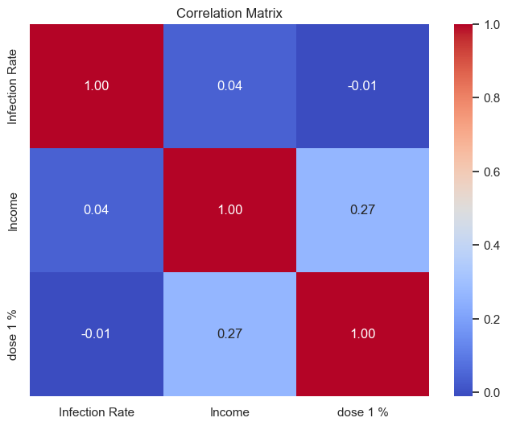

**Statistical Results**

- Coefficient for Median Household Income: 0.0061 (p-value: 0.676)

- Coefficient for Percentage of Population Vaccinated: -8.4253 (p-value: 0.835)

- Intercept: 31585.91