

Project title:

The most frequent food which is being eaten by the people during "COVID-19 pandemic".

Guided by: MR.BOSE **Academic: 2019-2020**

Student: Venkatesh d s

**Table of Contents:**

|  |  |  |
| --- | --- | --- |
| **1** | **Introduction** | **page -3** |
| **2** | **Questions asked in the survey** | **page4-5** |
| **3** | **Main food products concentrated in the survey form** | **page6** |
| **4** | **Milk** | **page6-8** |
| **5** | **Coffee and Tea** | **page 8-9** |
| **6** | **Oats and Kellogg’s corn flakes** | **page9-11** |
| **7** | **Rice** | **page11-13** |
| **8** | **Wheat Flour** | **page13-15** |
| **9** | **Oil** | **page15-17** |
| **10** | **Fruits and Soft drinks** | **page17-20** |
| **11** | **Conclusion** | **page20-21** |

***Introduction:***

This Project is based on the most frequent food which is been eaten by people during this COVID-19 panademic.The global recession, caused by lockdowns and other restrictions on business activity to control COVID-19, will lead to reductions in food consumption and in nutrition status especially among the poor .Wheather through rising food prices, falling incomes, or both,people will have less real income to pay for their food and will adjust accordingly.

To identify the impact of COVID-19 on food crises and business activities. I conducted a survey form, by analyzing the feedback gave by the people so we can conclude that how much is the impact of COVID-19 on this two criteria?...

***Questions asked in the Survey….***

* **Do you purchase milk everyday?**
* **If yes? comment the brand of milk purchased?**
* **Quantity of milk purchased in litres?**
* **Do you prefer coffee r tea?**
* **Name the Coffee or Tea powder purchased with quantity in Kg's??**
* **You include Oats or Kellogg's Corn Flakes in your breakfast??**
* **If yes? Name the brand of Oats or Kellogg's Corn Flakes purchased?**
* **Quantity of Oats or Kellogg's Corn Flakes purchased in Kg's?**
* **Do you add rice in your meal??**
* **If yes?? Name the brand of rice you purchase often?**
* **Quantity of rice purchased in Kg's?**
* **Do you include Chapati in your dinner?**
* **If yes? Name the brand of Wheat flour purchased?**
* **Quantity of Wheat flour purchased in Kg's?**
* **Do you purchase oil for cooking purpose?**
* **If yes? Name the brand of oil you purchase often?**
* **Quantity of oil purchased in Litres?**
* **What kind of fruits you like?**
* **Quantity of fruits purchsed in Kg's?**
* **Did you purchase any Soft drinks?**
* **If yes? Name the brand of Soft drink purchased?**
* **Quantity of Soft drink purchased in litres?**

***Main Food Products concentrated in the Survey form…..***

* **Milk**
* **Coffee and Tea powder**
* **Oats and Kellogg's Corn Flakes**
* **Rice**
* **Wheat flour**
* **Oil**
* **Fruits**
* **Soft drinks**

***Milk:***

* **From the survey report I observed that 85.7% people consume milk everyday.**
* **14.3% people are not consuming milk.**
* **35.7% people buy Nandhini brand.**
* **14.3% people buy Good life brand**
* **92.1% people buy 1 litre of milk**
* **7.1% people buy more then 2 litre of milk**

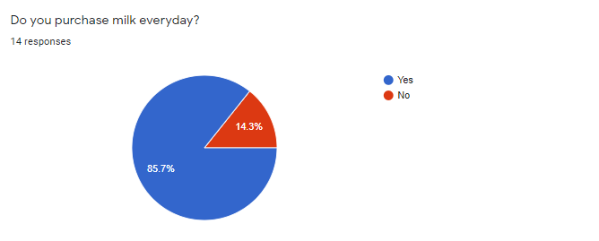

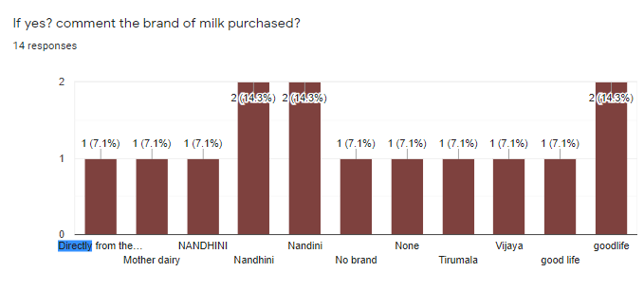

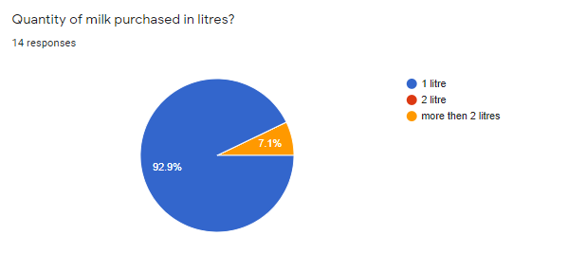

***Coffee and Tea powder:***

* **From the report..35.7% Prefer drinking Tea.**
* **21.4% Prefer coffee**
* **14.2% Prefer both Coffee and Tea**
* **21.4% Does not prefer neither of both so we can conclude that they prefer some other milk products like(ex: Boost, Horlicks etc)**
* **42.6% people buy Red Label Tea powder**
* **21.3% people buy Nescafe coffee powder**

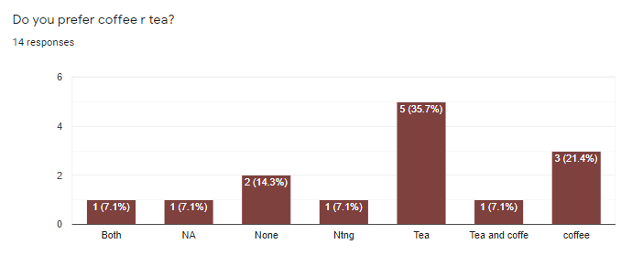

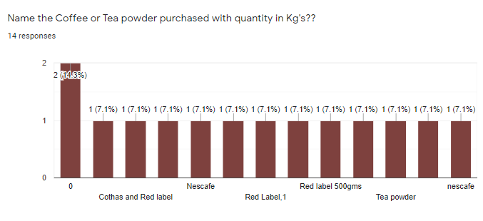

***Oats and Kellogg's Corn Flakes:***

* **71.4% people include Oats and Kellogg’s in their breakfast**
* **28.6% people prefer other kind of breakfast.**
* **14.1% people buy Saffola Oats**
* **7.1% people buy quicker Oats.**
* **35.7% people buy 1 kg of Oats**
* **7.1% people buy more then 1kg of Oats**

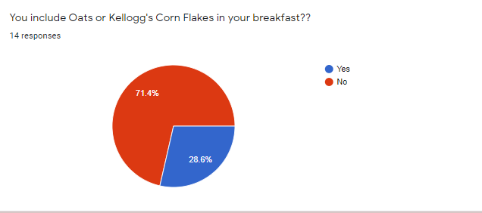

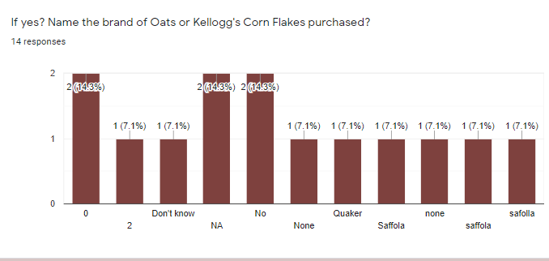

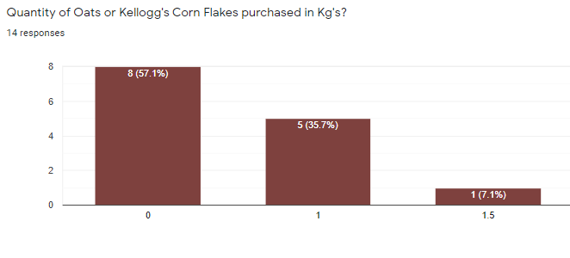

***Rice :***

* **92.9% people consume rice everyday**
* **7.1% people don’t consume rice.**
* **14.3% people purchase Bullet rice brand**
* **7.1% Dawat, 7.1% Tajmahal rice brand**
* **57.1% people purchase 25 kg of rice.**

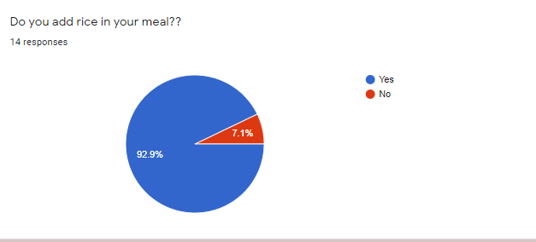

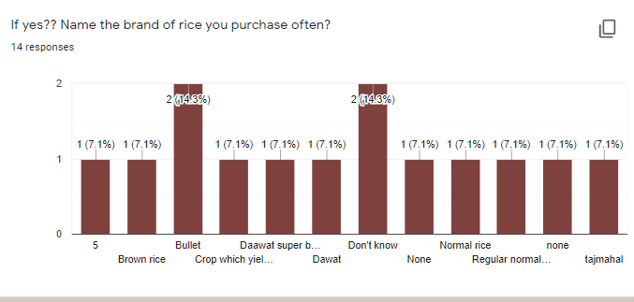

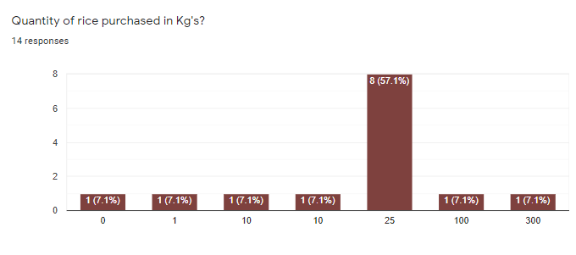

***Wheat Flour:***

* **85.7% people include chapathi in their dinner.**
* **14.3% doesn’t include.**
* **71.3% people using Ashirwad atta.**
* **50% people buy 10kg of wheat flour.**
* **21.4% people buy 5kg of wheat flour.**

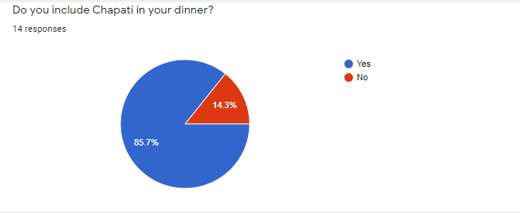

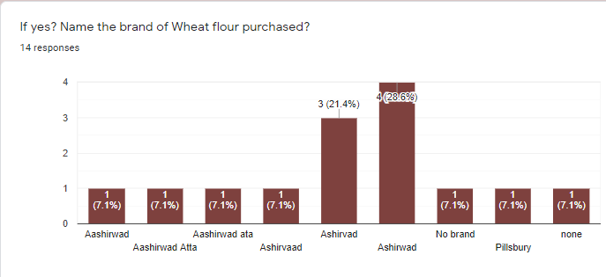

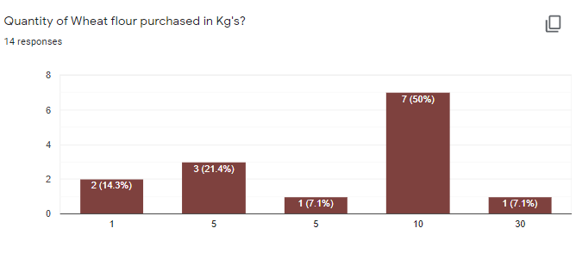

***Oil :***

* **92.9% people use oil for cooking purpose.**
* **21.3% uses Sun flower oil**
* **21.4% uses Sun pure oil.**
* **7.1% uses Furtune oil**
* **7.1% uses Gold Winner oil.**
* **71.4% people buy 5 to 10 litres of oil.**
* **28.6% people buy 1 litre of oil.**

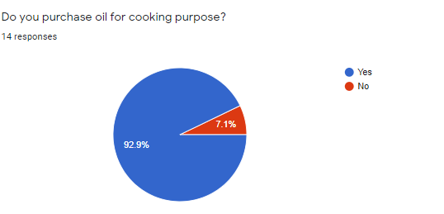

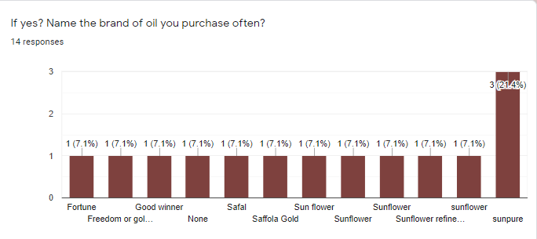

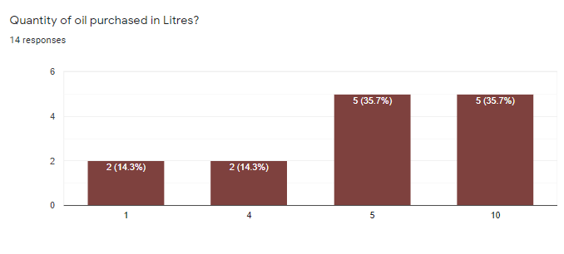

***Fruits and Soft Drinks:***

* **42.9% people eat’s Bannana.**
* **21.4% people eat’s Orange.**
* **14.3% people eat’s all kind of fruits.**
* **57.1% people buy 2kgof fruits**
* **28.6% people buy 1kg of fruits.**
* **14.2% people buy more then 3 kg of fruits.**
* **50% people buy Soft Drinks.**
* **42.9% people doesn’t buy Soft Drinks.**
* **14.3% people buy Pulpy orange.**
* **14.2% people buy mazza.**
* **50% people buy 1 litre of Soft drinks.**
* **7.1% people buy more then 2 litre of soft drinks.**

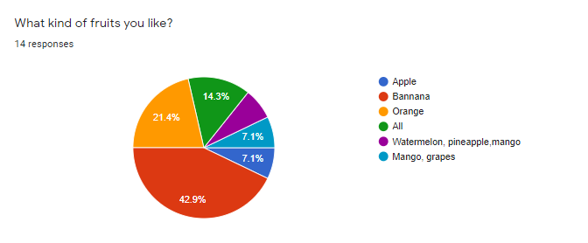

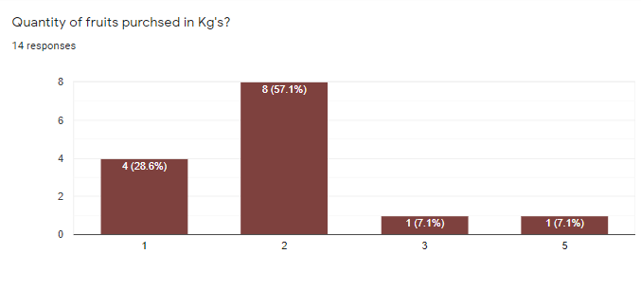

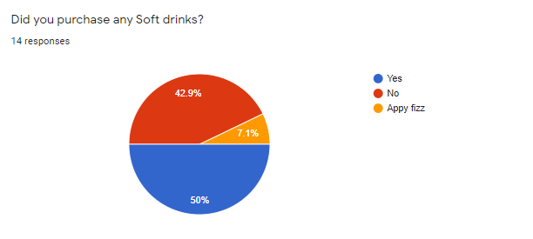

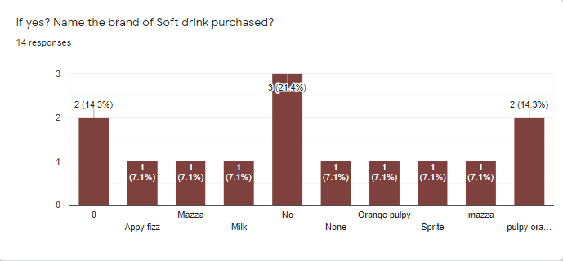

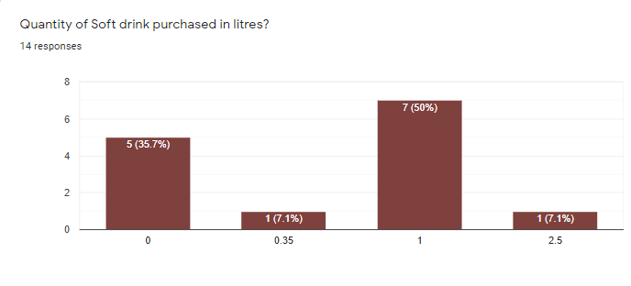

***Conclusion:***

**From the survey report we can conclude that..**

* **Large amount of people are consuming milk every day. Compare to the other milk selling brands Nandhini and Goodlife milk is mostly selling in the market.**
* **Most of the people prefer Coffee and Tea every day and Nescafe ,Red label is the brand frequently purchased by the people.**
* **Some people include Oats and Kellogg Corn flakes in their breakfast .Saffola and Quicker Oats is most selling brand.**
* **Large percentage of people include Rice and Chapathi in their diet .There are variety of rice brands as per my report Bullet , Dawat and Ashirwad atta is most selling in the market**
* **Oil is essential for cooking purpose.As per my survey people buy Sunpure ,Sunflower, fortune and Gold winner oil brands and they are most selling in the market**
* **Most frequent fruits eaten by people are Apple, Bannana, Orange .**
* **Many people Consume Soft drinks. As per my report Pulpy orange, mazza ,sprite is most selling.**