**ASSIGNMENT -2**

**BASIC STATISTICS -2**

**Task -1 :**

**Build 99% Confidence Interval Using Sample Standard Deviation**

**Objective:** Construct a 99% confidence interval for the mean number of characters printed before the print-head fails, using the sample standard deviation.

**Solution:**

Since the population standard deviation is not known and the sample size is relatively small (n=15), we will use the t-distribution to construct the confidence interval.

**Given dataset:**

**Data = [**1.13, 1.55, 1.43, 0.92, 1.25, 1.36, 1.32, 0.85, 1.07, 1.48, 1.20, 1.33, 1.18, 1.22, 1.29]

**n** = 15

**Confidence Interval** = SampleMean ± margin of error

**Margin of error** = T99%,n-1 standard deviation of sample/sqrt(n)

**Note: all the calculations are done with python.**

It’s a two tailed test so consider the t value for 99.5 %

**T99.5%**= 2.977

**Standard deviation of sample** = 0.193

**Sqrt of n** = 3.873

**Margin of error** = 0.148

**Sample Mean** = 1.239

**Confidence Interval** = [ (1.239 - 0.148 ) , 1.239 + 0.148) ]

= [ 1.09 , 1.387 ]

Hence, By using the above Confidence Interval values , 99% of the print-heads able to print **1.09 to 1.387** Million of characters until they failure.

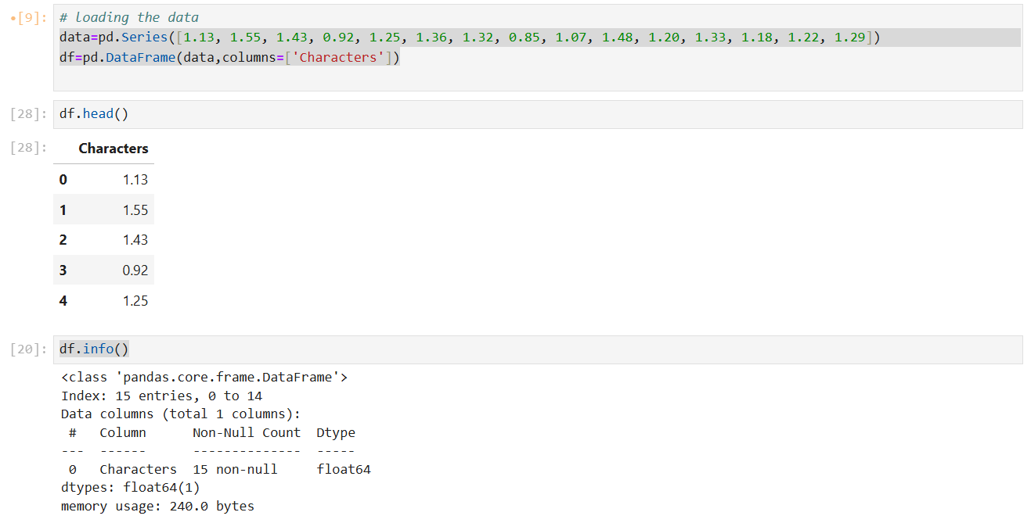

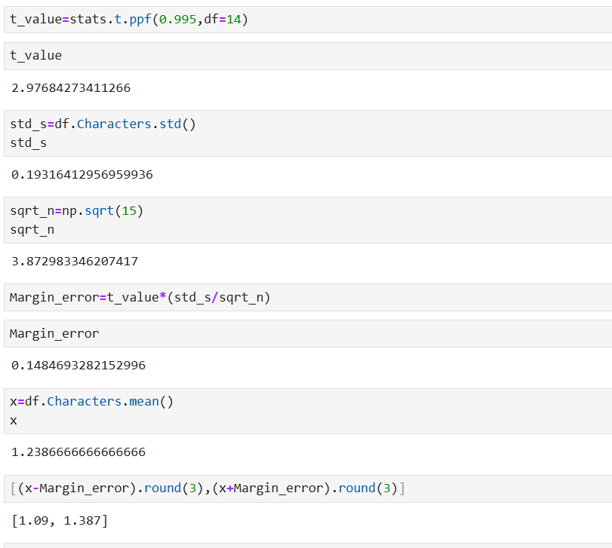

**Fig-1 : Imprting required libraries and loading the data**

**Fig-2 : Calculating the necessary parameters to find CI**

**Task -2**

**Build 99% Confidence Interval Using Known Population Standard Deviation**

**Objective:** Construct a 99% confidence interval for the mean number of characters printed before the print-head fails, using the population standard deviation.

**Solution:**

Since the population standard deviation is known and the sample size is relatively small (n=15), we will use the Z-distribution to construct the confidence interval.

**Given dataset:**

**Data** = [1.13, 1.55, 1.43, 0.92, 1.25, 1.36, 1.32, 0.85, 1.07, 1.48, 1.20, 1.33, 1.18, 1.22, 1.29]

**n** = 15

**Confidence Interval** = SampleMean ± margin of error

**Margin of error** = Z99%, standard deviation of population/sqrt(n)

It’s a two tailed test so consider the Z value for 99.5 %

**Z99.5%**= 2.579

**Standard deviation of population** = 0.2 ( given)

**Sqrt of n** = 3.873

**Margin of error** = 0.133

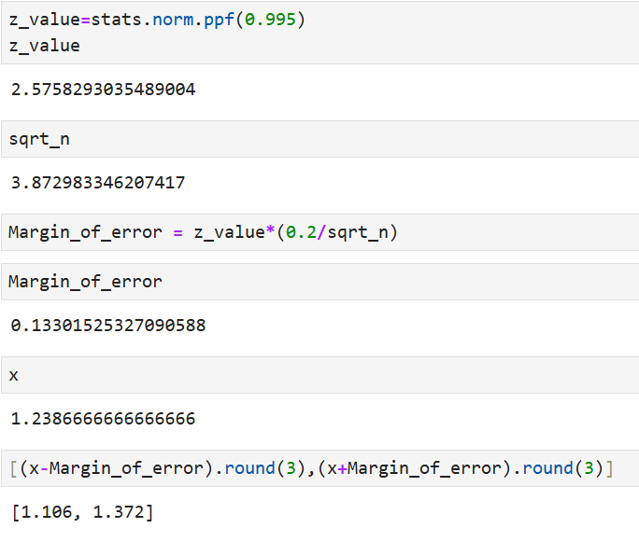**Sample mean** = 1.239

**Fig-2 : Calculating the necessary parameters to find CI**

**Confidence Interval** = [ (1.239 - 0.133) , 1.239 + 0.133) ]

= [ 1.106 , 1.372 ]

Hence, By using the above Confidence Interval values , 99% of the print-heads able to print **1.106 to 1.372** Million of characters until they failure.

**Conclusion:**

CI with Z – score method : [ 1.106 , 1.372 ]

CI with T- Distribution method : [ 1.09 , 1.387 ]

The Range is little more with the T- distribution when compared with the Z- score method, due to using the sample mean in T-distribution and Population mean in Z- score method, even though the intervals are almost equal.

So the print -heads able to print almost 1.1 to 1.3 million of characters until they failure.