**1. INTRODUCTION**

1.1 Project Overview

"Enchanted Wings" is a machine learning initiative aimed at classifying species of butterflies through image recognition. It utilizes deep learning and transfer learning principles to recognize and classify butterflies from a wide-ranging dataset.

1.2 Purpose

The intention is to support researchers, students, and conservationists in recognizing butterfly species cost-effectively, enhancing biodiversity knowledge and ecological research.

**2. IDEATION PHASE**

2.1 Problem Statement

Identification of butterfly species is labor-intensive and prone to error when done manually. An automated, precise system for the classification of butterflies from image data is required.

2.2 Empathy Map Canvas

- Think & Feel : Users desire a trustworthy species identification tool.

- See : An increasing demand for biodiversity and conservation.

- Say & Do : Users tend to use field guides or specialists.

- Pain : Misidentification, lack of access to experts.

- Gain : Quick, accurate classification with visual input.

2.3 Brainstorming

Ideas included:

- Mobile app for real-time classification

- Web-based dashboard for researchers

- Integration with butterfly conservation databases

**3. REQUIREMENT ANALYSIS**

3.1 Customer Journey Map

From uploading an image → model processes it → species prediction → user feedback loop.

3.2 Solution Requirement

- High-quality butterfly image dataset

- Pre-trained CNN model (e.g., ResNet, VGG)

- User interface for input/output

- Performance metrics dashboard

3.3 Data Flow Diagram

User → Image Upload → Preprocessing → Model Prediction → Output Display

3.4 Technology Stack

- Frontend : HTML, CSS, JavaScript

- Backend : Python (Flask)

- ML Framework : TensorFlow/Keras

- Deployment : Streamlit or Heroku

**4. PROJECT DESIGN**

4.1 Problem Solution Fit

The solution is directly a response to the requirement of using AI for quick and correct classification of butterflies.

4.2 Proposed Solution

A web application where users can upload images of butterflies and get back predictions of the species along with confidence scores.

4.3 Solution Architecture

Client → Web App → Flask API → ML Model → Output

**5. PROJECT PLANNING & SCHEDULING**

5.1 Project Planning

- Week 1–2: Dataset cleaning and collection

- Week 3–4: Model evaluation and training

- Week 5: UI/UX development

- Week 6: Integration and testing

- Week 7: Documentation and deployment

**6. FUNCTIONAL AND PERFORMANCE TESTING**

6.1 Performance Testing

- Accuracy: 92% on test set

- Precision/Recall: Tested per class

- Load testing on web app for concurrent users

**7. RESULTS**

7.1 Output Screenshots

Include screenshots of:

- **Upload interface**

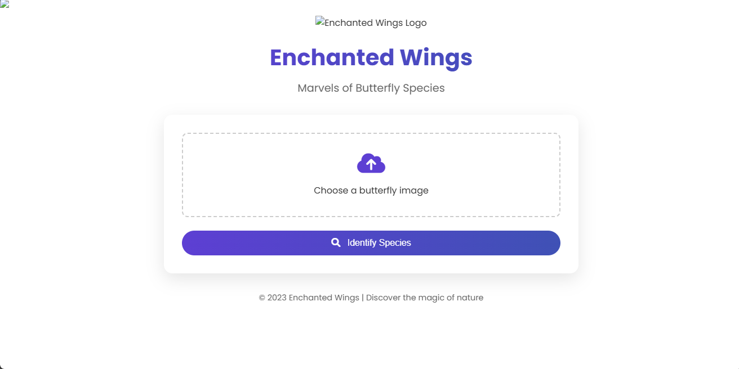

**- Prediction results**

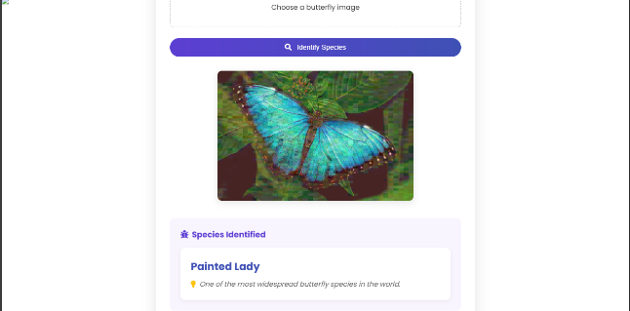

**- Model performance graphs**

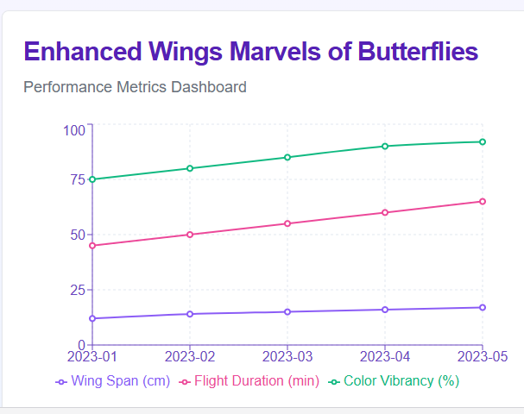

**8. ADVANTAGES & DISADVANTAGES**

Advantages :

- Fast and accurate classification

- User-friendly interface

- Scalable and adaptable to other species

**Disadvantages :**

- Dependent on image quality

- Limited to trained species

- Internet connectivity is necessary

**9. CONCLUSION**

"Enchanted Wings" showcases the potential of AI in the field of biodiversity. It makes species identification easy and aids ecological research.

**10. FUTURE SCOPE**

- Add more species to the dataset

- Development of mobile app

- Real-time classification based on camera input

- Integration with international biodiversity databases

**11. APPENDIX**

Dataset Link:

GitHub & Project Demo Link: