TABLE OF CONTENTS

1. INTRODUCTION
2. Administrator Module
2.1 Home
2.2 Masters
2.2.1 Mail Masters
2.2.2 Vendor Master
2.2.3 Trainer Master
2.2.4 Course Master
2.3 Session
2.3.1 Create New Session
2.3.2 Prepare Nomination List
2.4 Reports
2.4.1 View Comments
2.4.2 Feedback Defaulters
2.4.3 Overall Reports
2.4.4 Individual Reports
2.5 Feedback
2.5.1 Record My Feedback
3. User Module
3.1 Home
3.2 Feedback
3.2.1 Record My Feedback
4. Database Design
4.1 Admin
4.2 C_Session
4.3 course
4.4 CourseTypeMaster
4.5 EmpMailstatus
4.6 Feedback
4.7 Feedback_Comments
4.8 L1_QUESTIONS
4.9 Nomination_List
4.10 SectionType
4.11 Session_Trainer
4.12 TblMasterMail
4.13 TrainerDet
4.14 VendorDet

1. INTRODUCTION
The Feedback tool main purpose is user can easily enter them feedback through this tool. User and administrator can use the single time user name and password. Once user is successfully logged in they can able to see the list of pending feedback and total feedback details and then click on to the “Record My Feedback” link, redirect to Feedback form. Here user can enter feedback for more than one trainer.

Administrator can have rights to add new mail master, trainer, course, vendor and create new session details. Once all the session related information are added then Administrator need to prepare nomination list and send mail to nominated peoples for a particular session.

Administrator can have rights to view types of reports
1. View user comments and validate comments,
2. View feedback defaulters,
3. View individual report and overall report and
4. View Individual Analysis Report.
Administrator also enter them own feedback through “Record My Feedback” link.

2. Administrator Module
2.1 Home
In home admin can get few ideas about this tool. How to add course, Trainer, session, vendor and prepare nomination list.
2.2 Masters
2.2.1 Mail Masters
In mail master administrator no need to enter the From mail ID and URL. Admin Need to enter the CC, BCC mail id and subject. By default body of the mail is disabled if admin wants to edit the body of the message admin need to click on to “Edit” button to edit the body of the message. Once admin click on to the “Update” button updated mail body will be saved into database and successfully saved message will be displayed. Finally need to click on to the “Submit” button to save the all details to database and successfully saved message will be displayed. (Ref Figure 2.2.1 Views and Update Mail Master)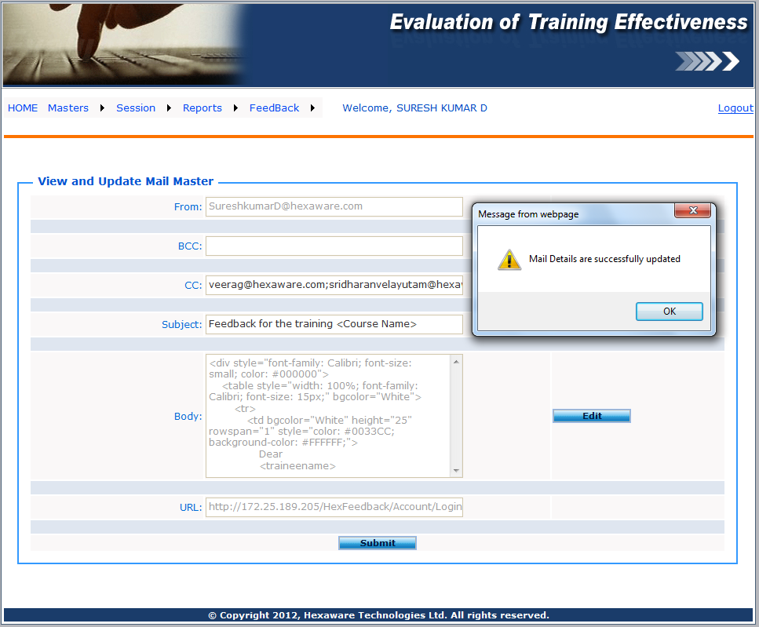
Figure 2.2.1 View and Update Mail Master
2.2.2 Vendor Master
Administrator Need to add Vendor ID and Vendor Name. Click on “Submit” button record will save successfully and message will be display. (Refer Figure 2.2.1 Add New Vendor)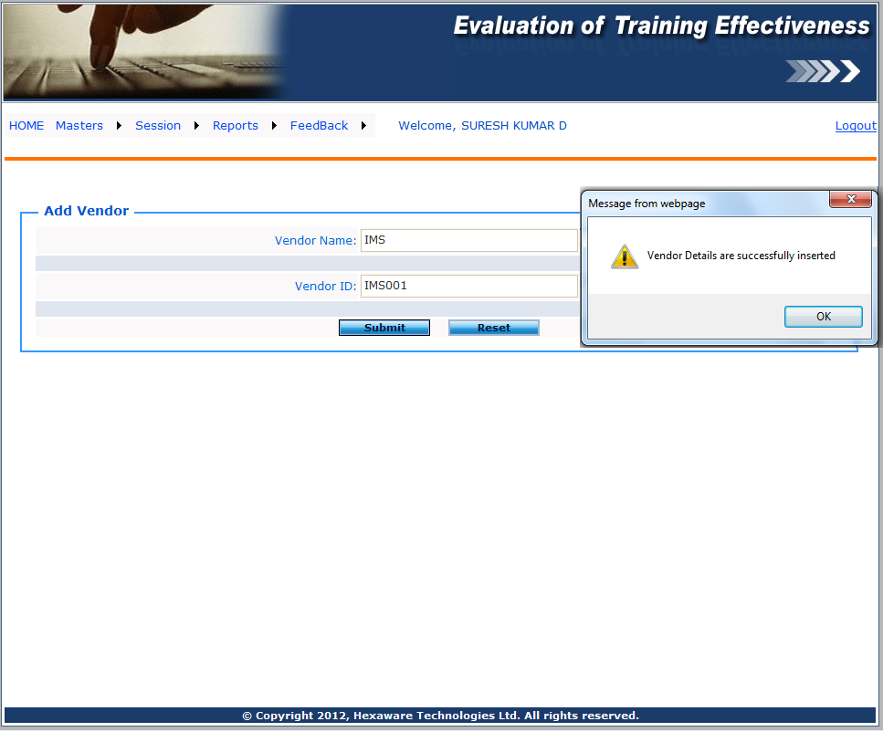
Figure 2.2.1 Add New Vendor

2.2.3 Trainer Master
First Admin wants to select the course and then need to select trainer type. If suppose trainer type is external admin wants to select a particular vendor and then trainer ID should be auto generated then enter only trainer name otherwise enter only trainer ID trainer name will be filled automatically. Click on to the “Submit” button trainer will be save successfully. (Figure 2.2.1 Add New Internal Trainer and 2.2.2 Add New External Trainer)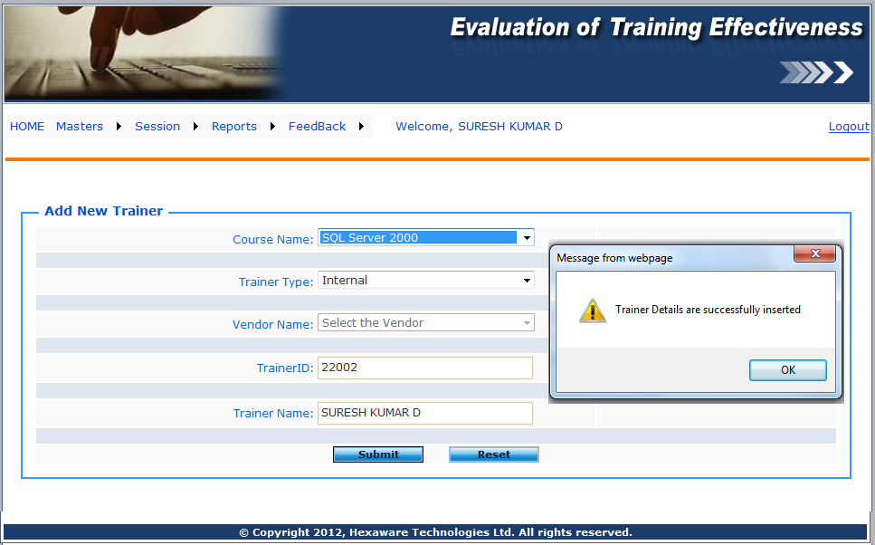
Figure 2.2.1 Add New Internal Trainer

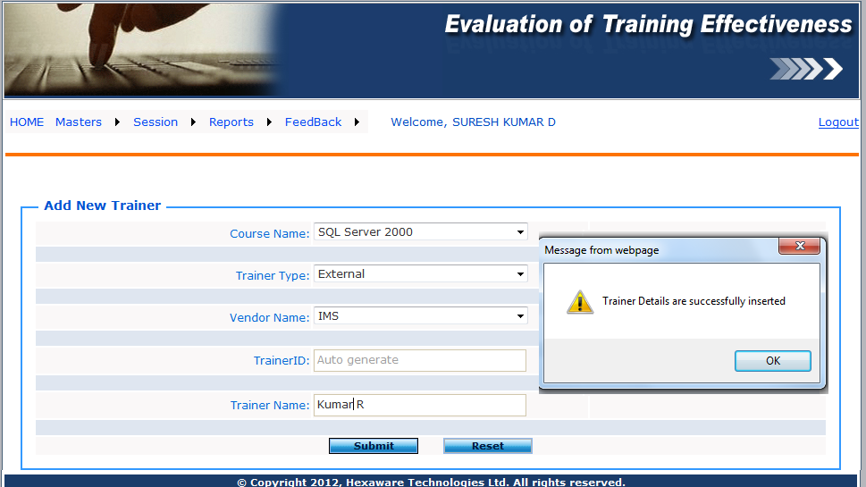
Figure 2.2.2 Add New External Trainer

2.2.4 Course Master
Enter Course ID, Name, Short Description, select internal or external and select type of course. Click on to “Submit” button, record will save successfully and redirect to create new session Screen. (2.2.1 Add New Course)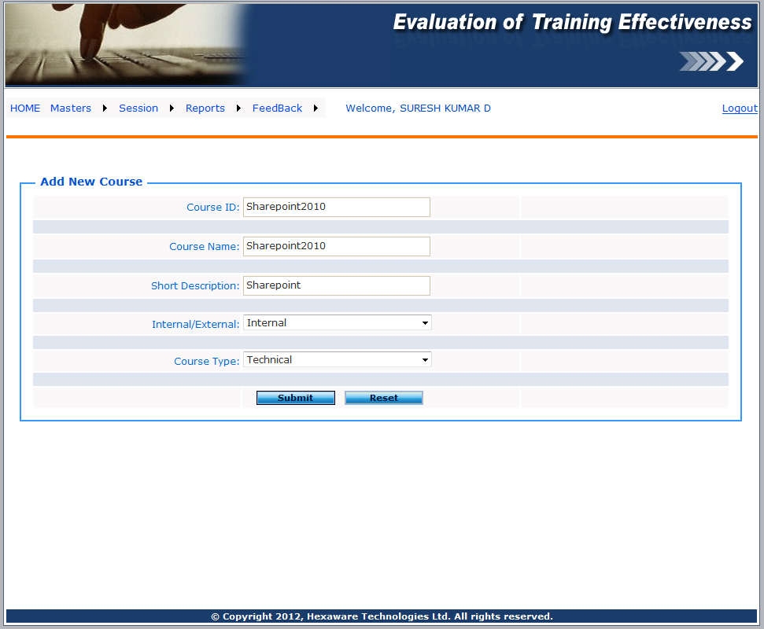
Figure 2.2.1 Add New Course

2.3 Session
2.3.1 Create New Session
In a particular session select course, session start date, end date, max number of participants, internal or external trainer. If suppose selected trainer is external than vendor name will be listed below based on the vendor name trainer name will be display. Based on the session details we can able to create the participants list. (Refer 2.3.1 Add New Session)
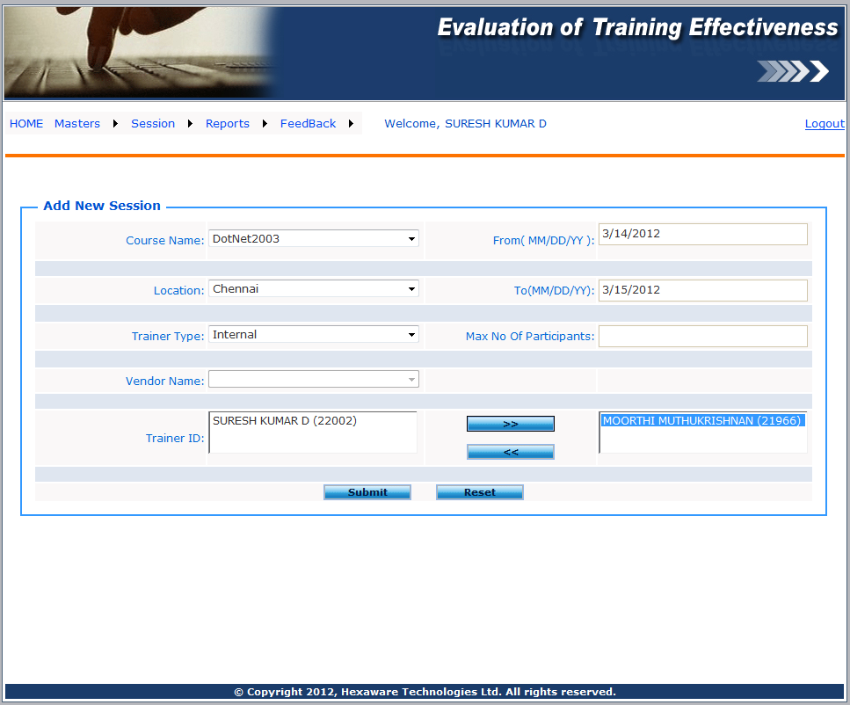
Figure 2.3.1 Add New Session

2.3.2 Prepare Nomination List
Select course, nomination list, browse and upload the nomination list from excel sheet. Click on the “Import” button to Import the excel sheet (Refer 2.3.1 Import participants List). Once participants list is imported successfully admin need to click on the “Send Mail” button to send a mail to imported participants. Admin can able to see the status of the mail (Refer 2.3.2 Send Mail to Participants)

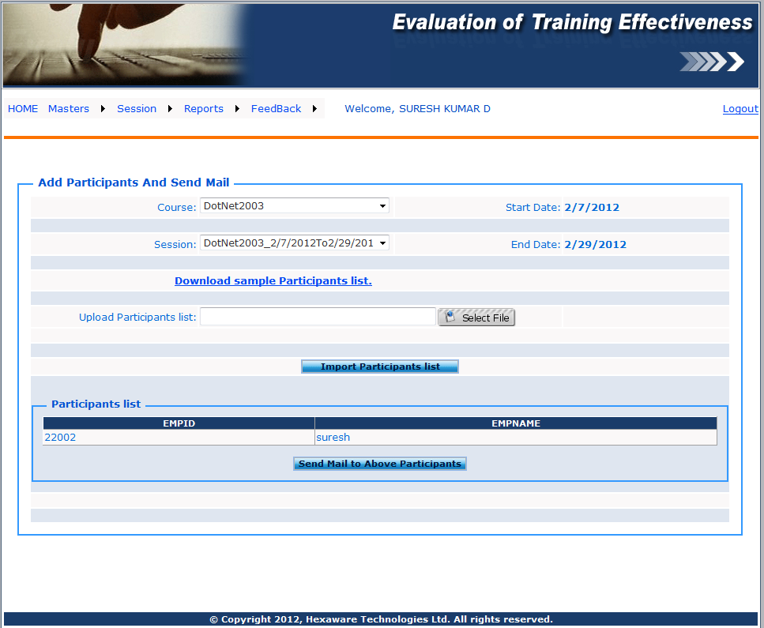
Figure 2.3.1 Import participants List
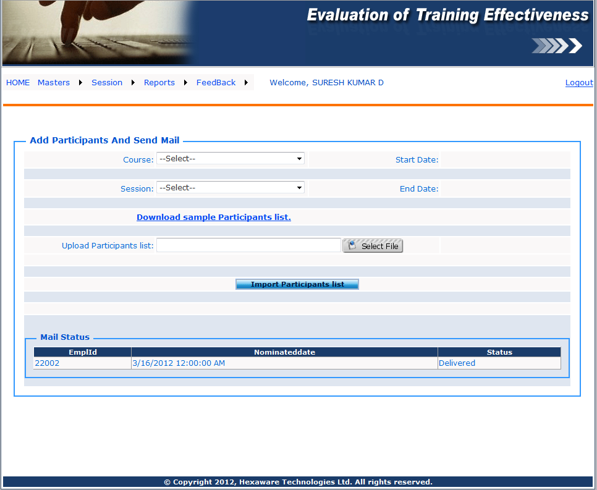
Figure 2.3.2 Send Mail to Participants

2.4 Reports
2.4.1 View Comments
Selects course and session based on the selection completed and pending feedback details are retrieved (Refer 1.9 View Commends). Click on the “View Commends” link to view and approve the valid commands (Refer 1.10 Approve Commends).

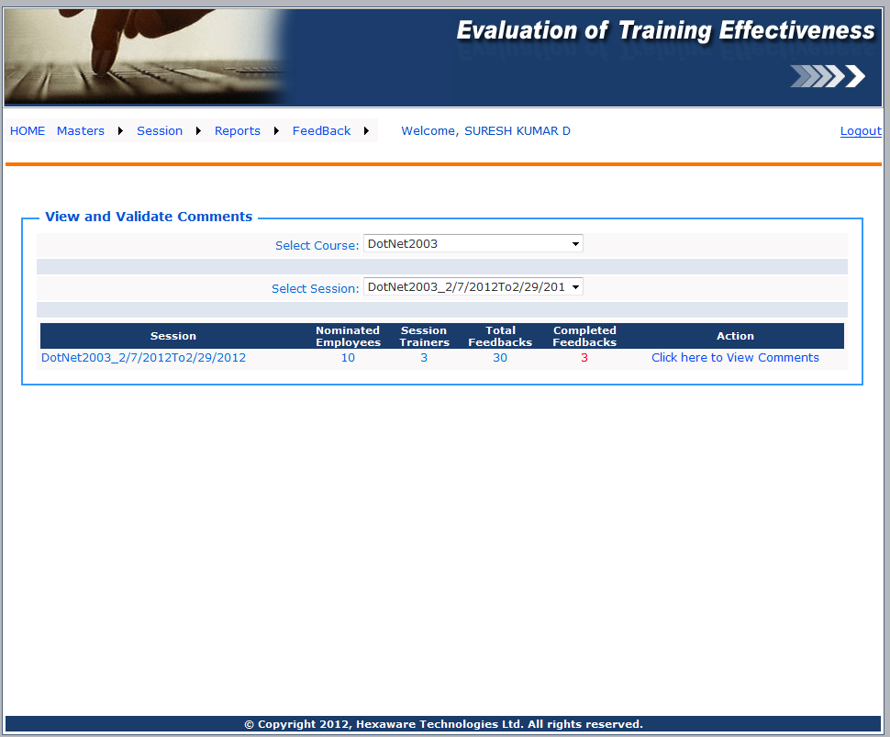
Figure 2.4.1 View Commends

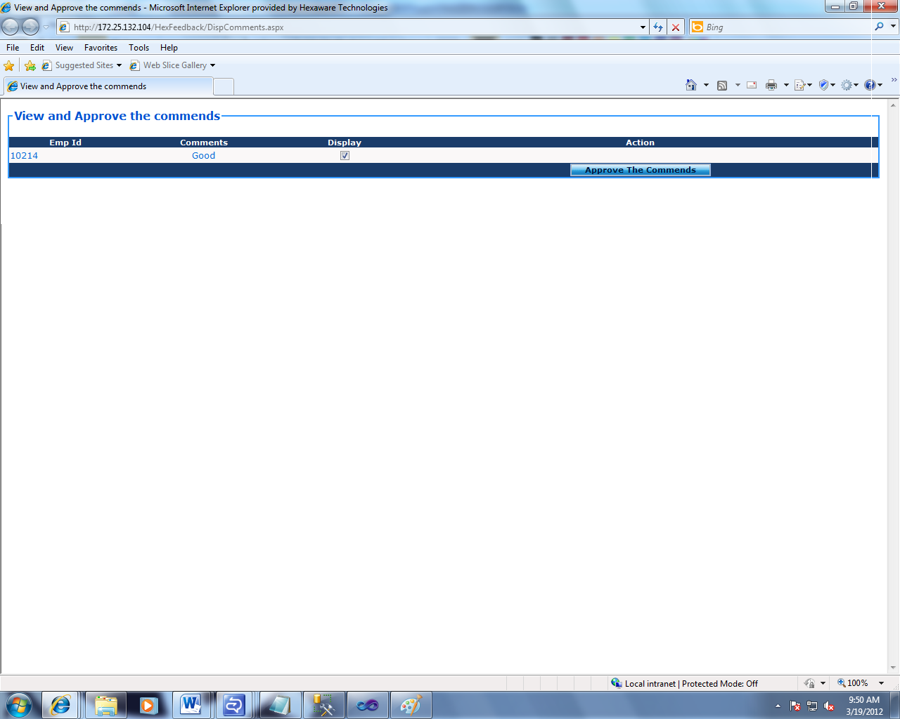
Figure 2.4.2 Approve Commends

2.4.2 Feedback Defaulters
Select course and session based on the selection employee details are retrieved as well as we can able to see the total and pending feedback of the particular employee (Refer 2.4.1 Feedback Defaulters).

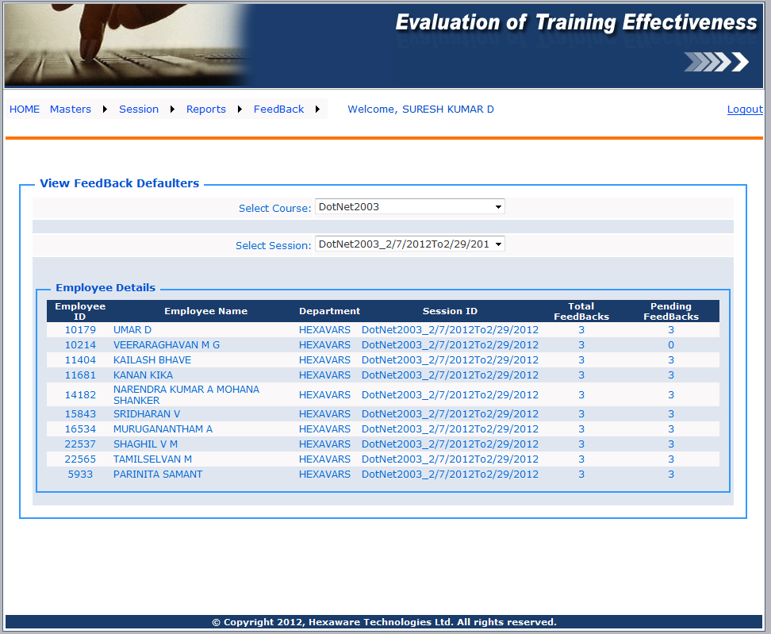
Figure 2.4.1 Feedback Defaulters

2.4.3 Overall Reports
Select course, session and trainers. Admin selects “Overall “report get rating only (Refer 2.4.1 Over All Report) else selects particular trainer get the rating table as well as pattern also displayed (Refer 2.4.2 Individual report).If admin needs PDF format of report they wants to click on the “Click here to export PDF document”.(Refer 2.4.3 View Report in PDF)
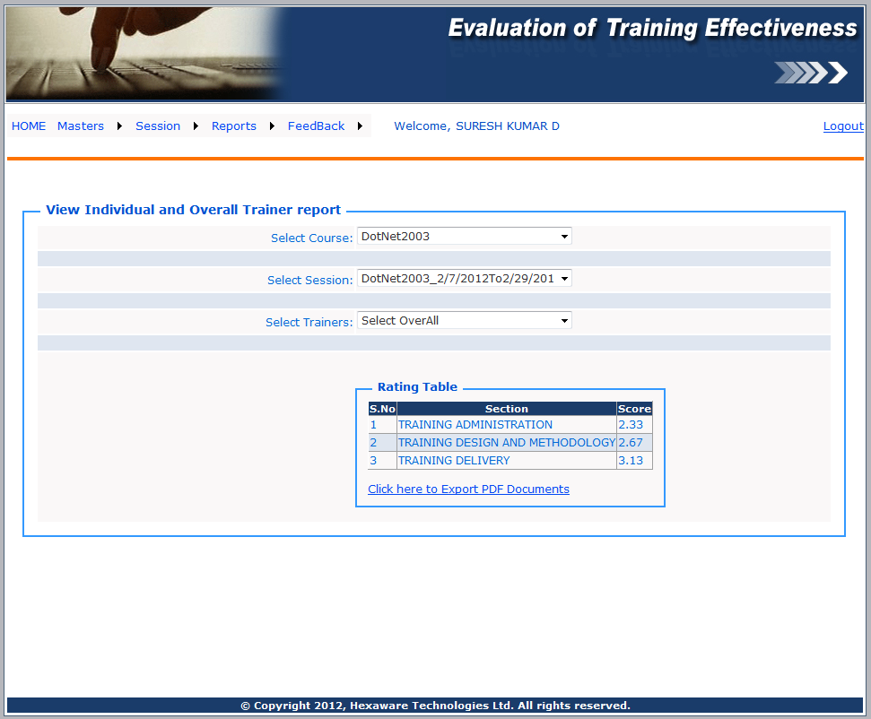
Figure 2.4.1 over All Report
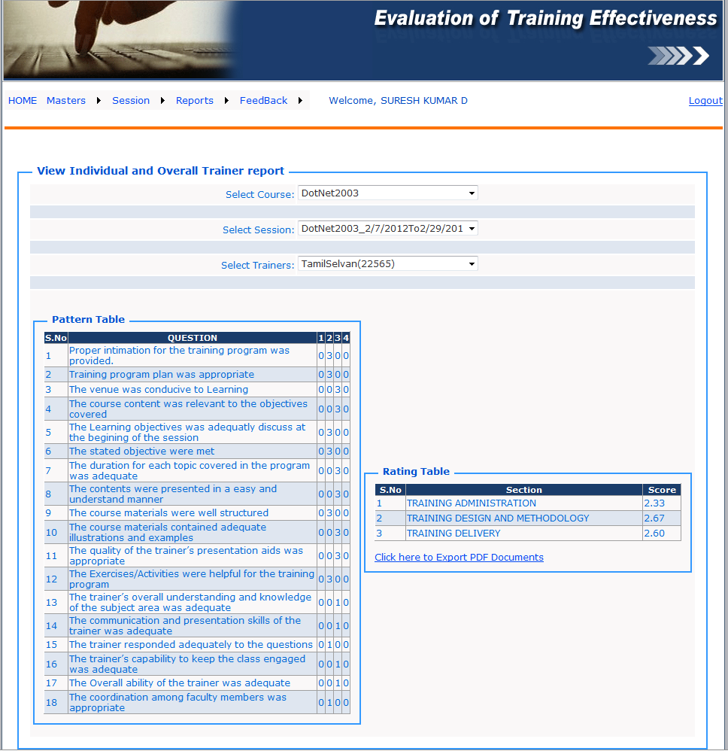

Figure 2.4.2 Individual report


2.4.3 View Report in PDF

2.4.4 Individual Reports
Select course, session, employee ID and trainer to retrieve particular employee response. If employee completed the feedback admin can see the response from the individual employee (Refer 2.4.1 Individual Analysis report) else “Selected employee Not provides feedbacks for these trainers” message will be displayed.
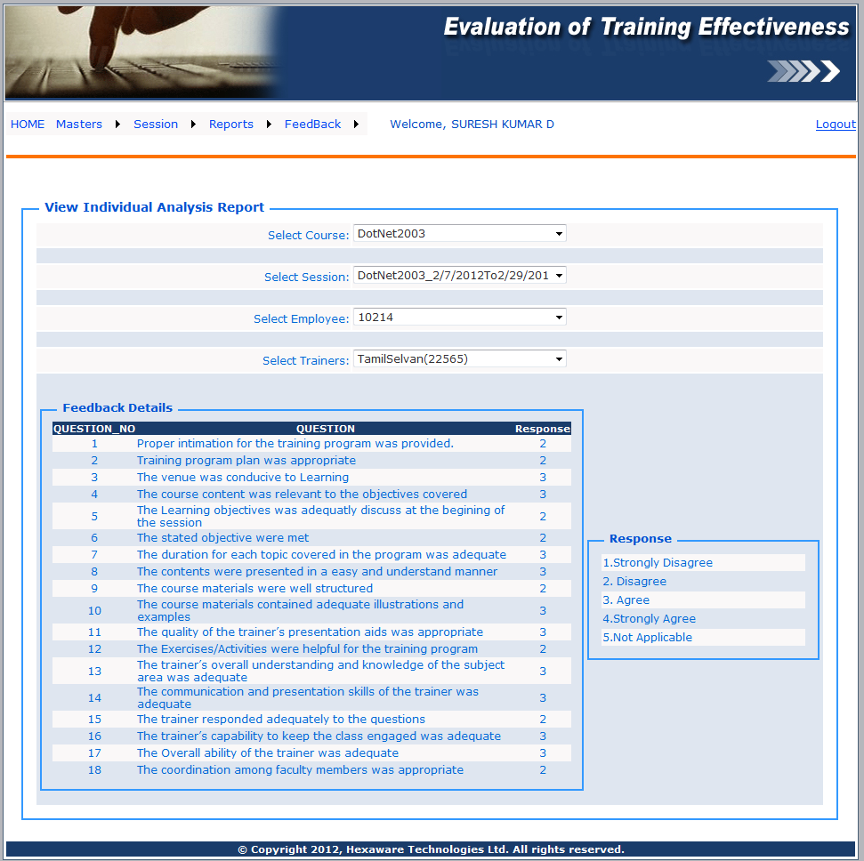
Figure 2.4.1 Individual Analysis report

2.5 Feedback
2.5.1 Record My Feedback
Selects “Record My feedback” menu admin can get pending feedback details if suppose any pending details are exist otherwise admin will not get any record (Refer 2.5.1 Record My Feedback).If record exist need to click on “Record My feedback” button to view the Feedback Form. In this form admin can get the own details like Employee Name, ID etc. If suppose more than one trainer is available in a particular session admin need to enter the feedback one by one else need to select a single trainer and admin can fill the feedback form than submit the details (Refer 2.5.2 Feedback Form).
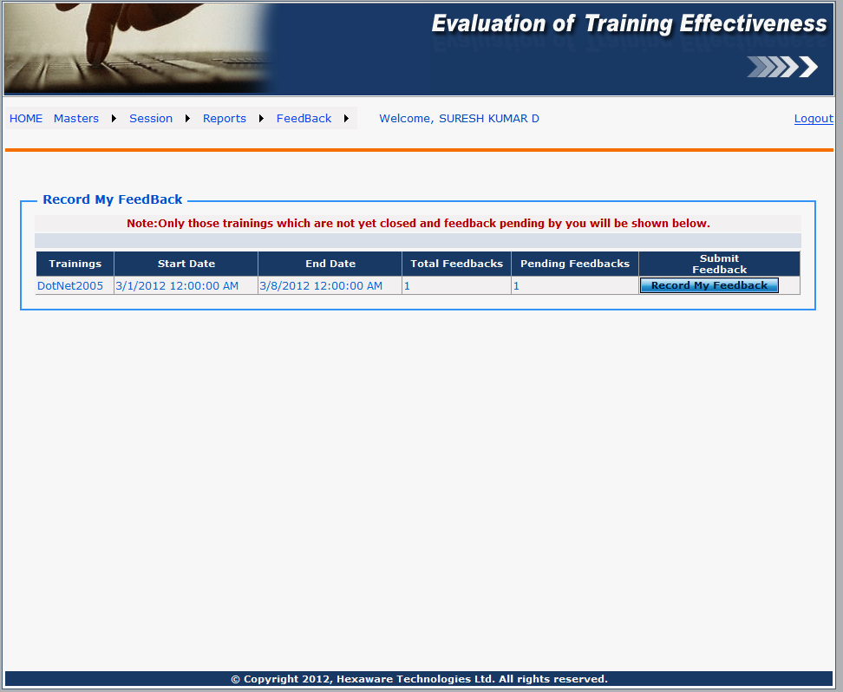
Figure 2.5.1 Record My Feedback
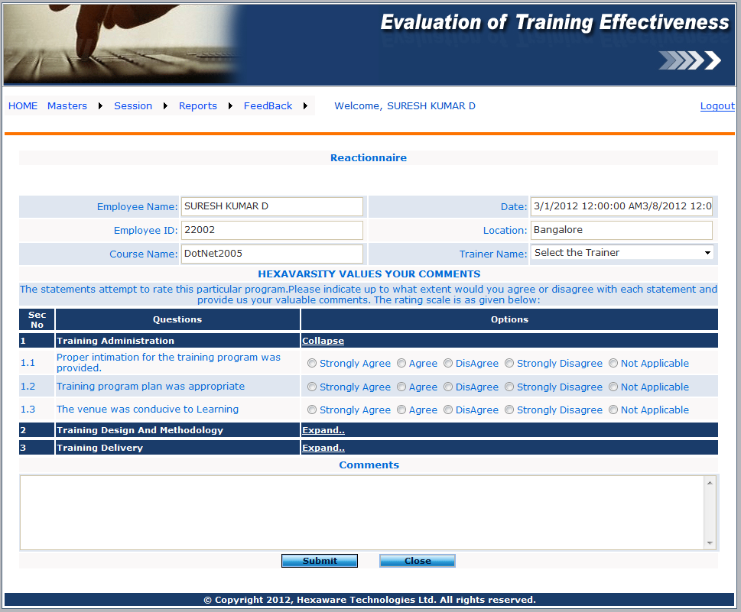
Figure 2.5.2 Feedback Form

3. User Module
3.1 Home
In home menu User can get few ideas about this tool and how to fill the feedback form.
3.2 Feedback
3.2.1 Record My Feedback
Selects “Record My feedback” menu user can get pending feedback details if suppose any pending details are exist otherwise user will not get any record (Refer 3.2.1 Record My Feedback).If record exist need to click on “Record My feedback” button to view the Feedback Form. In this form user can get the own details like Employee Name, ID etc. If suppose more than one trainer is available in a particular session user needs to enter the feedback one by one else need to select a single trainer and user can fill the feedback form than submit the details (Refer 3.2.2 Feedback Form).
Figure 3.2.1 Record My Feedback
Figure 3.2.2 Feedback Form

4. Database Design

4.1 Admin

Column Name | Data Type | Size | Null/Not Null | Primary Key | Foreign Key
EMP_ID | varchar | 7 | Not null | Yes | No
ISSuperAdmin | Smallint | 2 bytes | Not Null | No | No

4.2 C_Session

Column Name | Data Type | Size | Null/Not Null | Primary Key | Foreign Key
Courseid | varchar | 50 | Not Null | Yes | No
sessionid | Varchar | 50 | Not Null | Yes | No
startdate | date |  | Null | -Nil- | -Nil-
enddate | date |  | Null | -Nil- | -Nil-
max_participants | int |  | Not Null | -Nil- | -Nil-
TrainerId | varchar | 200 | Not Null | PK | No
Location | varchar | 200 | Not Null | -Nil- | -Nil-
createdby | varchar | 7 | Not Null | -Nil- | -Nil-
createddate | datetime |  | null | -Nil- | -Nil-
Modified by | varchar | 7 | null | -Nil- | -Nil-
Modified date | datetime |  | null | -Nil- | -Nil-
IsDeleted | int |  | null | -Nil- | -Nil-
IsFeedbackclose | int |  | null | -Nil- | -Nil-

4.3 course

Column Name | Data Type | Size | Null/Not Null | Primary Key | Foreign Key
courseid | Varchar | 50 | Not null | PK | No
course | Varchar | 500 | Not Null | -Nil- | -Nil-
Description | Varchar | 100 | Null | -Nil- | -Nil-
InternalExternal | char | 1 | Null | -Nil- | -Nil-
course_type | nvarchar | 100 | Null | -Nil- | -Nil-
createdby | varchar | 7 | Not Null | -Nil- | -Nil-
createddate | datetime |  | null | -Nil- | -Nil-
Modified by | varchar | 7 | null | -Nil- | -Nil-
Modified date | datetime |  | null | -Nil- | -Nil-
IsDeleted | int |  | null | -Nil- | -Nil-

4.4 CourseTypeMaster

Column Name | Data Type | Size | Null/Not Null | Primary Key | Foreign Key
CourseTYpeID | int |  | Not Null | -Nil- | -Nil-
CourceTypeName | nvarchar | 100 | Not Null | -Nil- | -Nil-
createdby | varchar | 7 | Not Null | -Nil- | -Nil-
createddate | datetime |  | null | -Nil- | -Nil-
Modified by | varchar | 7 | null | -Nil- | -Nil-
Modified date | datetime |  | null | -Nil- | -Nil-

4.5 EmpMailstatus

Column Name | Data Type | Size | Null/Not Null | Primary Key | Foreign Key
Courseid | varchar | 50 | Not Null | -Nil- | -Nil-
sessionid | varchar | 50 | Not Null | -Nil- | -Nil-
EmplId | varchar | 50 | Not Null | -Nil- | -Nil-
Nominateddate | date |  | Null | -Nil- | -Nil-
Status | varchar | 50 | Not Null | -Nil- | -Nil-
FeedbackSendDate | varchar | 50 | Null | -Nil- | -Nil-
FromMail | nvarchar | 50 | Null | -Nil- | -Nil-
ToMail | nvarchar | 50 | Null | -Nil- | -Nil-
BccMail | nvarchar | 1000 | Null | -Nil- | -Nil-
CcMail | nvarchar | 1000 | Null | -Nil- | -Nil-
Subject | nvarchar | 300 | Null | -Nil- | -Nil-
Body | nvarchar | Max | Null | -Nil- | -Nil-
URL | nvarchar | 100 | Null | -Nil- | -Nil-
MailSendFlag | int |  | Null | -Nil- | -Nil-

4.6 Feedback

Column Name | Data Type | Size | Null/Not Null | Primary Key | Foreign Key
Course_id | varchar | 50 | Not Null | No | Yes
session_id | varchar | 50 | Not Null | No | Yes
Employee_id | varchar | 7 | Null | -Nil- | -Nil-
Question_no | int |  | Not Null | No | Yes
Response | int |  | Not Null | -Nil- | -Nil-
TrainerId | varchar | 200 | Not Null | -Nil- | -Nil-
R1 | int |  | Null | -Nil- | -Nil-
R2 | int |  | Null | -Nil- | -Nil-
R3 | int |  | Null | -Nil- | -Nil-
R4 | int |  | Null | -Nil- | -Nil-
FeedbackGivenDate | varchar | 50 | Null | -Nil- | -Nil-
CommonFlag | int |  | Null | -Nil- | -Nil-

4.7 Feedback_Comments

Column Name | Data Type | Size | Null/Not Null | Primary Key | Foreign Key
sessionid | varchar | 50 | Not Null | -Nil- | -Nil-
TrainerId | varchar | 200 | Not Null | -Nil- | -Nil-
Employee_id | varchar | 7 | Not Null | -Nil- | -Nil-
Comments | varchar | max | Not Null | -Nil- | -Nil-
CommentsValid | varchar | 1 | Null | -Nil- | -Nil-
FeedbackGivenDate | datetime |  | Null | -Nil- | -Nil-
CommonFlag | int |  | Null | -Nil- | -Nil-

4.8 L1_QUESTIONS

Column Name | Data Type | Size | Null/Not Null | Primary Key | Foreign Key
QUESTION | varchar | 500 | Not Null | -Nil- | -Nil-
QUESTION_NO | int |  | Not Null | Yes | No
SECTION | int |  | Not Null | -Nil- | -Nil-

4.11 Nomination_List

Column Name | Data Type | Size | Null/Not Null | Primary Key | Foreign Key
course_id | varchar | 50 | Not Null | No | Yes
Session_id | varchar | 50 | Not Null | No | Yes
Employee_id | varchar | 7 | Null | -Nil- | -Nil-
createdby | varchar | 7 | Not Null | -Nil- | -Nil-
createddate | datetime |  | null | -Nil- | -Nil-
Modified by | varchar | 7 | null | -Nil- | -Nil-
Modified date | datetime |  | null | -Nil- | -Nil-
IsDeleted | int |  | null | -Nil- | -Nil-
IsExistsAlready | int |  | null | -Nil- | -Nil-

4.11 SectionType

Column Name | Data Type | Size | Null/Not Null | Primary Key | Foreign Key
Section | int |  | Not Null | -Nil- | -Nil-
Type | nvarchar | Max | Not Null | -Nil- | -Nil-
TotMarks | float |  | Null | -Nil- | -Nil-

4.12 Session_Trainer

Column Name | Data Type | Size | Null/Not Null | Primary Key | Foreign Key
SessionID | varchar | 50 | Not Null | -Nil- | -Nil-
TrainerID | varchar | 200 | Not Null | -Nil- | -Nil-

4.13 TblMasterMail

Column Name | Data Type | Size | Null/Not Null | Primary Key | Foreign Key
FrmMail | nvarchar | 1000 | Null | -Nil- | -Nil-
BccMail | nvarchar | 1000 | Null | -Nil- | -Nil-
CccMail | nvarchar | 1000 | Null | -Nil- | -Nil-
Subject | nvarchar | 300 | Null | -Nil- | -Nil-
Body | nvarchar | Max | Null | -Nil- | -Nil-
URL | nvarchar | Max | Null | -Nil- | -Nil-

4.14 TrainerDet

Column Name | Data Type | Size | Null/Not Null | Primary Key | Foreign Key
TrainerType | varchar | 1 | NotNull | -Nil- | -Nil-
TrainerId | varchar | 200 | NotNull | Yes | No
TrainerName | varchar | 50 | NotNull | Yes | No
VendorName | varchar | 200 | NotNull | -Nil- | -Nil-
courseid | varchar | 50 | NotNull | Yes | No

4.15 VendorDet

Column Name | Data Type | Size | Null/Not Null | Primary Key | Foreign Key
VendorName | nvarchar | max | NotNull | -Nil- | -Nil-
PrefixID | varchar | 50 | NotNull | Yes | No

