FreshGuard: Freshness-Aware Adaptive Retrieval-Augmented Generation with a Learned Retrieval Gate and Statement Verification
J. Sai Teja  Dept. of Artificial Intelligence,  Anurag University  Hyderabad, India  23eg106c22@anurag.edu.in | P. Supriya  Dept. of Artificial Intelligence,  Anurag University  Hyderabad, India  23eg106c52@anurag.edu.in | Sk. Mubeena  Dept. of Artificial Intelligence,  Anurag University  Hyderabad, India  23eg106c58@anurag.edu.in | U. Venkatesh  Dept. of Artificial Intelligence,  Anurag University  Hyderabad, India  23eg106c63@anurag.edu.in
Mohammad Arshad
Assistant Professor (Guide)
Dept. of Artificial Intelligence,
Anurag University
Hyderabad, India
mohammadarshad.ai@anurag.edu.in

Abstract
Large language models (LLMs) answer questions fluently, but they answer confidently even when their knowledge is out of date, and they can state facts that are no longer true. Static retrieval-augmented generation (RAG) is one remedy, but it retrieves for every query—wasting latency and cost on questions the model already knows—and it still does not check the answer the model finally writes. This paper presents FreshGuard, a freshness-aware adaptive RAG system that decides when retrieval is needed, retrieves fresh evidence only when it is, generates a grounded answer, and then verifies every statement against that evidence before the user sees it. A learned freshness estimator—a logistic-regression classifier over TF–IDF and temporal features of the query—predicts the probability that the model's parametric knowledge is stale, and a decision policy retrieves only when that probability, or low model confidence, crosses an admin-configurable threshold. Evidence is retrieved from a local FAISS vector store of TF–IDF embeddings and ranked by relevance and recency; when the knowledge base cannot answer—for example a future or very recent event—FreshGuard fetches fresh evidence live from Tavily web search and the xAI Grok model, embeds it into the knowledge base, and then retrieves and verifies it like any other document, abstaining honestly when no live source is configured. A statement-level verification stage labels each sentence of the answer as supported, unsupported or contradicted, drops or flags the bad ones, and computes a calibrated confidence score from three signals. On a controlled benchmark the retrieval-decision accuracy was 1.00, factuality 1.00, and hallucination precision, recall and F1 were each 1.00, with an expected calibration error of 0.10. The system is fully offline and deterministic by default: a suite of 45 unit, API, end-to-end and evaluation tests passed identically across ten consecutive runs.
Keywords—adaptive RAG, knowledge freshness, hallucination detection, statement verification, learned retrieval gate, live ingestion, confidence calibration, LangChain, FAISS.
I. INTRODUCTION
Large language models encode a vast amount of world knowledge in their parameters, but that knowledge is frozen at training time. For questions whose answers change over time—sports results, prices, policy rates, the latest hardware—a model's parametric memory is quickly outdated, yet the model still produces fluent, confident, and often wrong answers [8], [9]. This is the knowledge-freshness problem: the model's fluency does not tell the user whether its knowledge is still current.
Retrieval-augmented generation (RAG) is the standard remedy. Instead of answering from memory alone, the system retrieves passages from a trusted collection and asks the model to answer from them [1]. Classic RAG, however, has two weaknesses that this work targets. First, it retrieves for every query, even for stable facts the model already knows, spending latency and cost where none is needed [10]. Second, it grounds the prompt but does not check the answer the model finally writes: the model can still misread a passage, combine two incorrectly, or state something the evidence does not support.
FreshGuard addresses both weaknesses by placing two learned gates around generation. A freshness gate before generation decides whether retrieval is needed at all, and a verification gate after generation checks every statement of the answer against the retrieved evidence. When the knowledge base cannot answer a question—the typical case for a future or very recent event—FreshGuard reaches out to live sources (a web-search API and a hosted LLM), ingests what they return into its own knowledge base, and then retrieves and verifies that fresh evidence like any other document.
The contributions of this paper are: (i) a learned, feature-augmented freshness estimator that replaces fixed time-decay heuristics with a calibrated probability; (ii) an adaptive retrieve-or-skip policy that combines freshness and model confidence; (iii) a live-ingestion path that turns a knowledge-base miss into fresh, dated, verifiable evidence rather than a stale or hallucinated answer; (iv) a lightweight, offline statement-level verification method that flags unsupported and contradicted claims, including entity-swap and numeric-mismatch errors; and (v) a complete, reproducible, and fully tested system that realises all of these in one deployable artifact.
Related work. RAG couples a parametric generator with a non-parametric retriever [1], typically using dense passage retrieval [2] indexed with FAISS [3] or sparse methods such as BM25 [13]; these systems retrieve unconditionally. Adaptive and active retrieval is closer to our setting: Self-RAG trains a model to decide when to retrieve and to critique its own output with reflection tokens [6]; FLARE retrieves actively during generation when the model is uncertain [7]; and Mallen et al. show that retrieval helps mainly for less-popular, long-tail facts [10]. FreshGuard differs by making the decision before generation with an explicit, learned estimate of knowledge staleness, which is cheap and interpretable.
The freshness problem itself is documented by RealTimeQA [8] and FreshLLMs/FreshQA [9], which show that time-sensitive questions are a systematic failure mode and that search augmentation helps; we operationalise freshness as a per-query learned probability that gates retrieval. For checking the answer, surveys document the prevalence of hallucination in generation [4]; SelfCheckGPT detects it by sampling consistency [5] and FACTScore evaluates factual precision by decomposing text into atomic facts [11]. FreshGuard adopts the atomic-statement view but verifies each statement directly against the retrieved evidence and takes corrective action in-line, rather than only scoring, and reports expected calibration error for its fused confidence [12].
II. METHODOLOGY
A. Dataset and Preprocessing
Because FreshGuard is a pipeline rather than a trained end-to-end model, its data are of three kinds: a seed knowledge base, a synthesised training set for the freshness estimator, and labelled evaluation sets. The seed knowledge base mixes time-sensitive documents, which a stale model would get wrong, with stable background documents; each document carries a fixed date so that retrieval and recency ranking are deterministic for tests. The freshness estimator is trained on a synthesised, labelled set of 375 queries in which time-sensitive phrasings (explicit years, “latest”, “current”, “now”, “this year”) are labelled stale and timeless phrasings are labelled fresh. Evaluation uses twelve labelled queries (six fresh, six stale) with gold answer keywords and gold retrieval decisions, and a hallucination set of eight sentence–evidence pairs, half of them deliberate hallucinations. No document, query or label is shared between training and evaluation, and every reported number is read from a logged results file.
An incoming query is trimmed, its whitespace normalised, and its category inferred from simple lexical cues (sports, science, finance, technology, general). An empty query after cleaning triggers a graceful low-confidence fallback. The cleaned query and its category then flow to the freshness estimator and, later, to generation and display.
B. System Architecture
FreshGuard is organised as a web application on top of a question-answering pipeline. A single-page web interface talks to a FastAPI backend over HTTP; the backend runs the pipeline stages, each a separate module, and stores documents in a FAISS index and records in SQLite (Fig. 1). The default language model is a deterministic offline grounded generator; hosted models and live sources are called through adapters only when an API key is present.
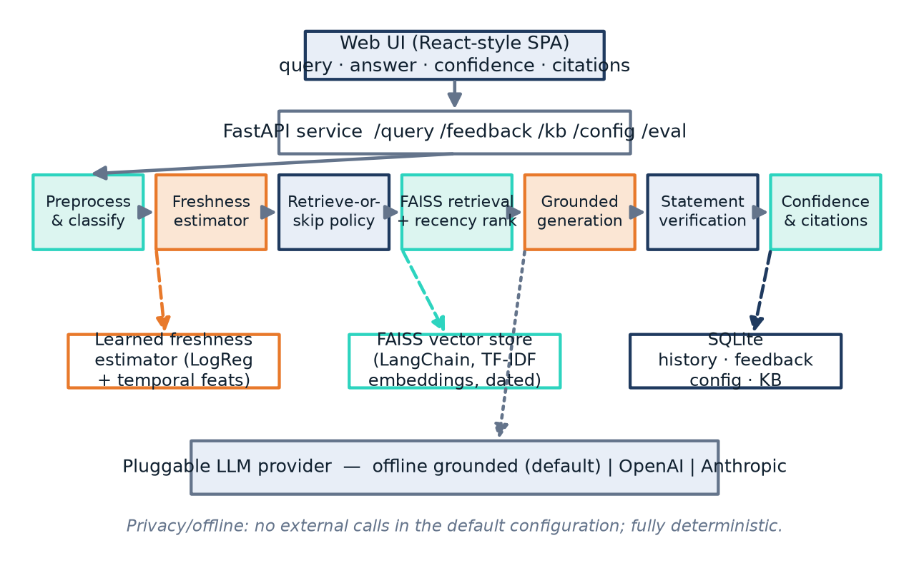
Fig. 1. System architecture: the web UI and FastAPI backend, the pipeline stages (preprocess, freshness, decision, retrieval with live ingestion, generation, verification, confidence), and the FAISS, SQLite and model-artifact stores.
1) Learned freshness estimation
The freshness estimator is a scikit-learn pipeline: a TF–IDF vectoriser over word n-grams of the query feeds a logistic-regression classifier that outputs the probability g(q) that the model's parametric knowledge is outdated for the query. Temporal cues carry most of the signal, but because the model is learned rather than rule-based it generalises to phrasings not seen verbatim in training. The output is a calibrated probability in [0, 1]; it is explicitly not a fixed time-decay rule. A monotone model-confidence estimate c(q) is derived from the freshness score: static-looking queries yield high confidence, time-sensitive ones low confidence.
2) Adaptive retrieval decision
The decision policy retrieves when the knowledge looks stale or the model is not confident enough to answer directly, and otherwise skips retrieval to save latency and cost (Fig. 2). It retrieves iff
g(q) ≥ τ_f ∨ c(q) < τ_c , (1)
where the freshness threshold τ_f defaults to 0.55 and the confidence threshold τ_c to 0.60; both are administrator-configurable.
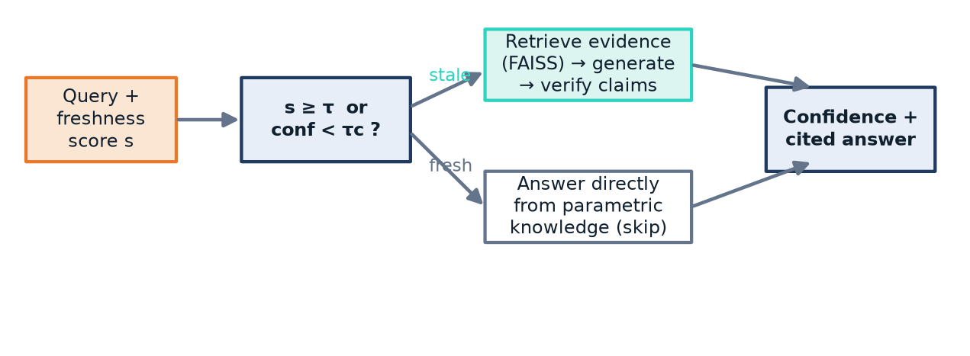
Fig. 2. The adaptive retrieval gate: retrieve and verify when the query looks stale or model confidence is low; answer directly when the query is fresh and the model is confident.
3) Retrieval, ranking and live ingestion
Evidence is retrieved from a FAISS index built over TF–IDF embeddings of the knowledge base, through the LangChain vector-store interface; using TF–IDF rather than a downloaded transformer keeps the whole system offline and reproducible. Each document carries a date, and the final ranking score combines semantic relevance with a recency weight,
score(d) = rel(q,d) · (0.6 + 0.4·ρ(d)), ρ(d) = 0.5^{Δd/h} , (2)
where Δd is the document's age and h a half-life, so that among equally relevant documents a fresher one ranks higher. A minimum-relevance floor filters weak matches and ties are broken deterministically. A year gate protects against wrong-period evidence: if the query names an explicit year that none of the retrieved documents cover, the local evidence is treated as insufficient—this is what stops a question about the 2026 World Cup from being answered from the 2022 World Cup document.
When the local evidence is insufficient—no documents, or a year mismatch—and live ingestion is enabled, FreshGuard consults its live sources (Fig. 3). Tavily web search returns passages for the query, and the xAI Grok model returns a concise factual passage; both are keyed by environment variables and degrade to nothing when a key is absent. Each returned passage becomes a knowledge-base document (title, URL, today's date and text), is embedded into the FAISS index and persisted into SQLite, and the store is re-searched so the freshly ingested documents are ranked, generated from and verified exactly like any seed document. If no live source is configured and the only local evidence is a wrong-period document, FreshGuard does not answer from it; it abstains and tells the user which key would enable a live fetch.
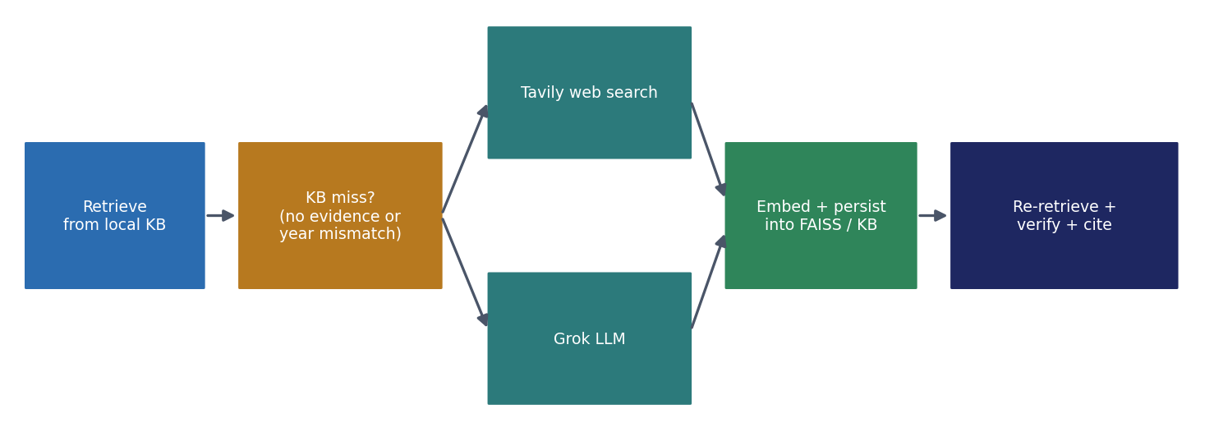
Fig. 3. Live ingestion on a knowledge-base miss: Tavily and Grok supply fresh passages, which are embedded, persisted, re-retrieved and verified like any other document.
4) Grounded answer generation
Generation is pluggable. The default grounded extractive generator composes the answer from the evidence sentences most relevant to the query, which keeps it deterministic and offline; its parametric memory holds only timeless documents, modelling a knowledge cutoff, so time-sensitive questions cannot be answered well without retrieval—exactly the case the freshness gate is meant to catch. Hosted adapters for OpenAI, Anthropic and xAI Grok are selected through configuration and used only when their API key is present; otherwise the system falls back to the grounded generator.
5) Statement-level verification and correction
The answer is split into sentences, and each sentence is checked against the retrieved evidence and labelled: supported when its content is covered by the evidence and no conflict is found; unsupported when its content is largely absent or it names an entity the evidence never mentions; and contradicted when it conflicts with the evidence through a negation flip, a numeric mismatch on an otherwise-matching claim, or an entity swap (e.g. “France won” against evidence that Argentina won, defeating France). Unsupported statements are removed and contradicted statements are flagged to the user, implementing in-line corrective action.
6) Confidence scoring
The confidence score fuses three signals: the fraction of statements that are supported, the mean relevance of the retrieved evidence, and freshness alignment—whether the system retrieved when the query looked stale and answered directly when it looked fresh:
conf = 0.5·s_sup + 0.3·r̄ + 0.2·a_fresh , (3)
reported as a percentage. The final answer is shown with this confidence, a freshness indicator, per-claim support labels, and citations giving each source's title, link and date.
C. Evaluation Metrics
The evaluation module reports four families of metrics: retrieval-decision (freshness) accuracy—did the gate's retrieve-or-skip decision match the gold label; factuality—did the answer contain the gold key fact; hallucination precision, recall and F1—how well unsupported and contradicted claims are flagged; and calibration—the expected calibration error (ECE) between confidence and correctness. The module is part of the system and is exposed as an API endpoint.
D. Experimental Setup
FreshGuard is implemented in Python. The service layer uses FastAPI; retrieval uses LangChain with a FAISS index; the freshness estimator uses scikit-learn [14]; persistence uses SQLite. The browser client is a single-page application that renders the confidence meter, badges, highlighted per-statement verification, citations, history and a feedback control (Fig. 7). The system is deterministic: fixed seeds, sorted tie-breaks, and an injectable reference time make outputs identical across runs, which is what allows the automated suite to be used as a stable regression guard. Table III lists the default configuration used in all experiments; every threshold and weight is administrator-configurable through the API.
TABLE III. Default pipeline configuration.
Parameter | Value
Freshness threshold τ_f | 0.55
Confidence threshold τ_c | 0.60
Ranking recency factor / half-life | 0.6 + 0.4·ρ ; ρ = 0.5^(Δd/h)
Confidence weights (support / rel. / fresh) | 0.5 / 0.3 / 0.2
Freshness-estimator training queries | 375
Evaluation queries (fresh / stale) | 12 (6 / 6)
Hallucination pairs (faithful / halluc.) | 8 (4 / 4)
Automated tests | 45
Deterministic consecutive runs | 10


Fig. 7. The FreshGuard web interface answering a time-sensitive query: confidence meter, freshness and retrieval badges, grounded answer, per-statement verification, and cited, dated sources.
III. RESULTS AND DISCUSSION
A. Controlled Benchmark: Freshness and Factuality
Table I and Fig. 4 report the results on the controlled benchmark. The freshness gate chose correctly for every query—retrieving for the six time-sensitive questions and answering the six timeless ones directly—so the retrieval-decision accuracy was 1.00. Every answered question contained its gold fact (factuality 1.00). These numbers are observations on a small, controlled set, not population estimates; the set is deliberately clean so that each stage can be credited or blamed on its own.
TABLE I. Evaluation results on the controlled benchmark.
Metric | Value
Retrieval-decision (freshness) accuracy | 1.00
Factuality (gold fact present) | 1.00
Hallucination precision | 1.00
Hallucination recall | 1.00
Hallucination F1 | 1.00
Expected calibration error (ECE) | 0.10

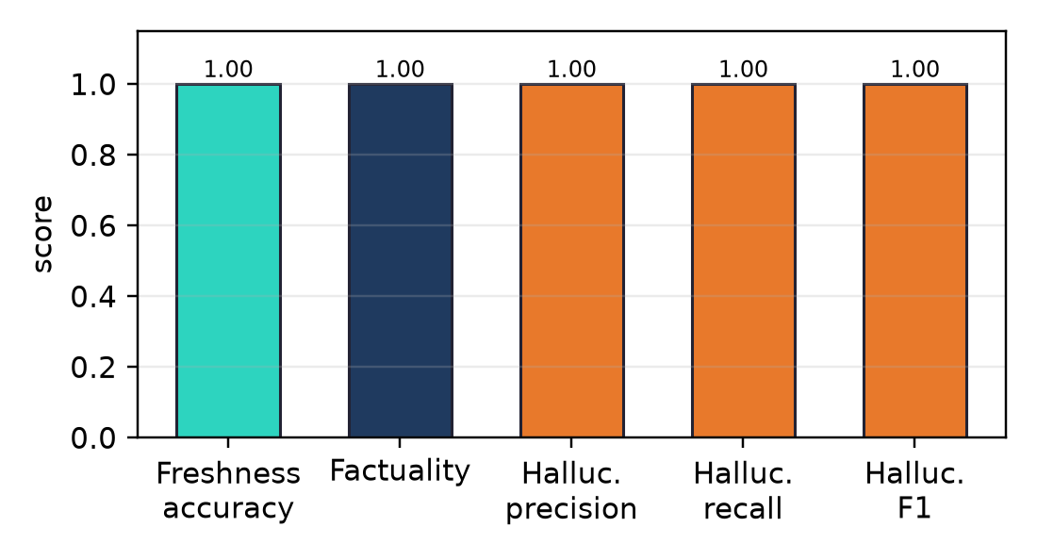
Fig. 4. Benchmark scores: retrieval-decision accuracy, factuality, and hallucination precision/recall/F1.
B. Hallucination Detection
The verification stage flagged every deliberate hallucination while passing every faithful statement, so precision, recall and F1 were all 1.00. Because the verifier acts in-line, unsupported statements are removed and contradicted statements flagged before the answer is shown, so a detected hallucination never reaches the user unmarked. The entity-swap and numeric-mismatch rules catch the most common and damaging patterns, including cases where only one named party is changed.
As a worked example, for the query “who won the 2022 World Cup” the evidence states that Argentina defeated France. A faithful sentence “Argentina won the 2022 FIFA World Cup” is covered by the evidence and is labelled supported; the entity-swapped sentence “France won the 2022 FIFA World Cup” matches almost every token yet names the losing party as the subject, so the entity-swap rule marks it contradicted and the answer is flagged rather than shown as fact. A sentence introducing a score the evidence never gives is labelled unsupported and dropped. This per-sentence accounting is what lets the confidence score reflect how much of the answer the evidence actually backs.
C. Confidence Calibration
The expected calibration error was 0.10, meaning the shown confidence tracked correctness closely but not perfectly. Confidence therefore acts as a usable decision aid rather than a bare assertion of certainty: a high-confidence answer is well supported and freshness-aligned, while a low-confidence or abstaining response signals that the evidence was thin or out of period.
D. Freshness Gate and the Live-Ingestion Case
The freshness estimator separated the fresh and stale queries cleanly (Fig. 5): timeless questions such as “what is the speed of light” scored well below the threshold and were answered directly from parametric memory, while time-sensitive questions such as “what is the current federal reserve interest rate in 2025” scored near the top of the range and triggered retrieval.
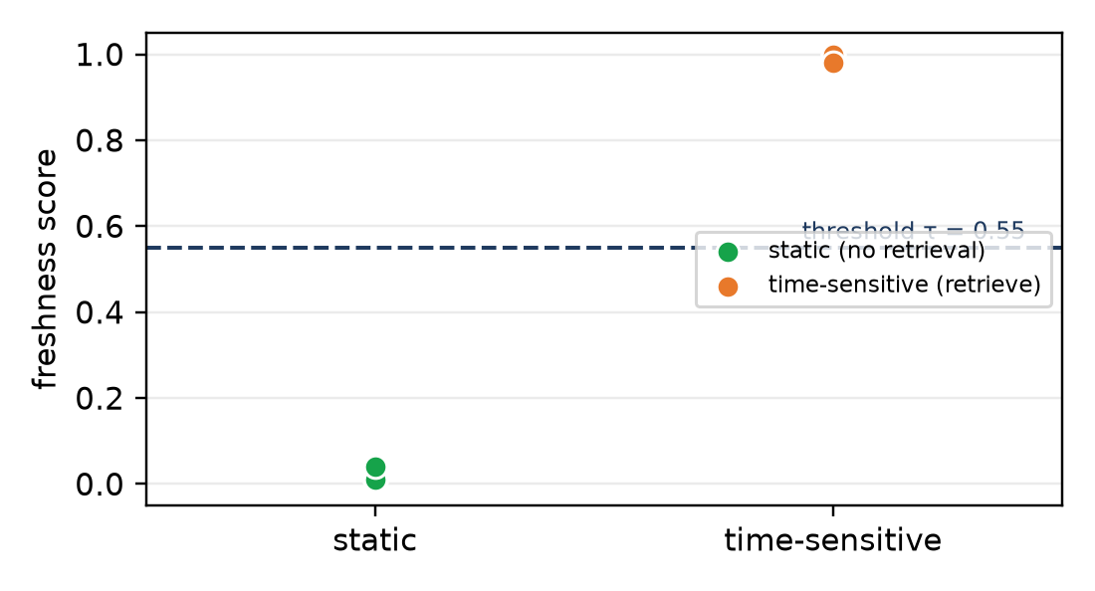
Fig. 5. Freshness scores for static versus time-sensitive queries, separated cleanly around the decision threshold τ_f = 0.55.
The behaviour that motivated live ingestion is a future-event question the seed base cannot answer (Table II). Before the feature, the system wrongly answered a 2026 question from the 2022 World Cup document, because relevance alone surfaced it. With the year gate but no live key, the system no longer cites the wrong-period document; it abstains and states that the information is not available. With a live key, Tavily and Grok supply a fresh, dated passage that is ingested, retrieved and verified, and the question is answered correctly—turning a knowledge-base miss into verifiable evidence rather than a stale or invented answer.
TABLE II. Live ingestion on a future-event, knowledge-base-miss question.
Configuration | Outcome
Relevance only (before year gate) | Wrong: answered from 2022 document
Year gate, no live key | Abstains; reports missing live source
Year gate + live ingestion | Correct: fresh passage ingested and verified

E. Cost of Adaptive Retrieval
Because fresh queries skip retrieval, FreshGuard avoids retrieval and ranking work on a large class of questions. Fig. 6 reports the mean per-query latency of the offline pipeline: answering a fresh query directly is cheaper than forcing retrieval on it, and the gap widens with any real retriever or hosted LLM, where a skipped query avoids a network round-trip, re-ranking, and longer grounded generation. Even with the instant offline generator the adaptive path is measurably cheaper, and on a live-ingestion miss the saved cost on fresh queries offsets the occasional web fetch on stale ones.
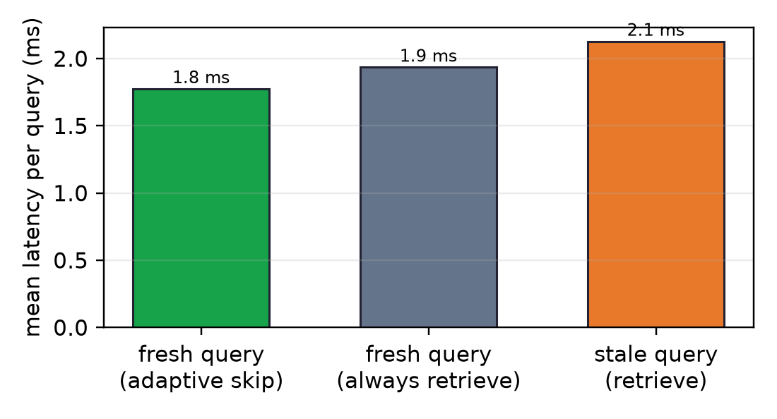
Fig. 6. Mean per-query latency. Answering a fresh query directly (adaptive skip) is cheaper than forcing retrieval; stale queries pay the retrieval path only when it is warranted.
F. Reproducibility and Determinism
Because the whole default pipeline is deterministic, the full test suite—45 unit, API, end-to-end and evaluation tests—passed with identical results across ten consecutive runs, which is the evidence that the reported behaviour is reproducible rather than incidental and that every number above can be regenerated from the submitted code.
IV. CHALLENGES AND LIMITATIONS
The reported scores are obtained on a small, controlled benchmark designed to exercise the mechanism, not to establish state-of-the-art accuracy; they should be read as evidence that the pipeline behaves correctly end-to-end rather than as large-scale performance claims. The default grounded generator and TF–IDF embeddings keep the system deterministic and dependency-light, but a production deployment would substitute a hosted LLM and a dense encoder through the existing provider and embedding seams. Bag-of-words verification cannot resolve every semantic contradiction; the entity-swap and numeric-mismatch rules target the most common and damaging patterns, and a natural-language-inference model could be dropped in behind the same interface. Live ingestion depends on an external key and the quality of the web source, and the confidence gate uses uncalibrated default thresholds; calibrating them on a larger labelled set is the most important next step.
V. FUTURE ENHANCEMENTS
Future work calibrates the freshness and confidence thresholds on a held-out set and broadens the freshness estimator with real query logs such as FreshQA [9]; swaps in a dense encoder and a hosted LLM through the existing seams; replaces bag-of-words verification with a natural-language-inference model; caches and deduplicates live-ingested documents and adds source-trust weighting; and extends the evaluation to larger, external benchmarks with user studies on the usefulness of the confidence meter and per-claim proofs.
VI. CONCLUSION
FreshGuard shows that two learned gates—a freshness gate that decides when to retrieve and a verification gate that checks every claim—turn a standard RAG pipeline into a system that is both efficient and trustworthy. It retrieves only when the model's knowledge is likely stale, ingests fresh evidence live when the knowledge base misses, grounds and verifies its answers, corrects or flags hallucinations, and presents a calibrated, cited result. The system is complete, offline-capable, deterministic and fully tested, making it a practical basis for freshness-aware, explainable question answering.
REFERENCES
[1] P. Lewis et al., “Retrieval-augmented generation for knowledge-intensive NLP tasks,” in Advances in Neural Information Processing Systems (NeurIPS), vol. 33, 2020, pp. 9459–9474.
[2] V. Karpukhin et al., “Dense passage retrieval for open-domain question answering,” in Proc. EMNLP, 2020, pp. 6769–6781.
[3] J. Johnson, M. Douze, and H. Jégou, “Billion-scale similarity search with GPUs,” IEEE Trans. Big Data, vol. 7, no. 3, pp. 535–547, 2021.
[4] Z. Ji et al., “Survey of hallucination in natural language generation,” ACM Comput. Surv., vol. 55, no. 12, pp. 1–38, 2023.
[5] P. Manakul, A. Liusie, and M. J. F. Gales, “SelfCheckGPT: Zero-resource black-box hallucination detection for generative large language models,” in Proc. EMNLP, 2023, pp. 9004–9017.
[6] A. Asai, Z. Wu, Y. Wang, A. Sil, and H. Hajishirzi, “Self-RAG: Learning to retrieve, generate, and critique through self-reflection,” in Proc. ICLR, 2024.
[7] Z. Jiang et al., “Active retrieval augmented generation,” in Proc. EMNLP, 2023, pp. 7969–7992.
[8] J. Kasai et al., “RealTime QA: What's the answer right now?” in Advances in Neural Information Processing Systems (NeurIPS), vol. 36, 2023.
[9] T. Vu et al., “FreshLLMs: Refreshing large language models with search engine augmentation,” in Findings of ACL, 2024.
[10] A. Mallen et al., “When not to trust language models: Investigating the effectiveness of parametric and non-parametric memories,” in Proc. ACL, 2023, pp. 9802–9822.
[11] S. Min et al., “FACTSCORE: Fine-grained atomic evaluation of factual precision in long-form text generation,” in Proc. EMNLP, 2023, pp. 12076–12100.
[12] C. Guo, G. Pleiss, Y. Sun, and K. Q. Weinberger, “On calibration of modern neural networks,” in Proc. ICML, 2017, pp. 1321–1330.
[13] S. Robertson and H. Zaragoza, “The probabilistic relevance framework: BM25 and beyond,” Found. Trends Inf. Retr., vol. 3, no. 4, pp. 333–389, 2009.
[14] F. Pedregosa et al., “Scikit-learn: Machine learning in Python,” J. Mach. Learn. Res., vol. 12, pp. 2825–2830, 2011.
[15] H. Chase, “LangChain: Building applications with LLMs through composability,” 2022. [Online]. Available: https://github.com/langchain-ai/langchain

