SURVIVAL ANALYSIS OF CHLORHEXIDINE TRIAL OUTCOMES USING PYTHON 🧪📈

This project is based on a real clinical trial case study titled
“Effectiveness of Oral Hygiene with Chlorhexidine Mouthwash with 0.12% and 0.2% Concentration on Incidence of VAP”
published in Annals of International Medical and Dental Research, Vol (7), Issue (3) 2021.
The complete article is included in this repository as Effectiveness of Oral Hygiene with Chlorhexidine Mouthwash.pdf.
This interprets time-to-VAP (Ventilator-Associated Pneumonia) outcomes using classical Survival Analysis methods in Python.

Problem Statement
To determine whether 0.20% chlorhexidine mouthwash is more effective than 0.12% in reducing the incidence and hazard of VAP in mechanically ventilated ICU patients, and to identify baseline clinical predictors associated with time to VAP.

Objectives
Primary Objectives
• To compare VAP-free survival between the two treatment groups (0.12% vs 0.20%).
• To determine whether chlorhexidine concentration significantly reduces VAP risk using log-rank testing.
• To summarize model behaviours via residual checks, variance filtering, and correlation heatmaps.
Secondary Objectives
• To evaluate the effect of age, APACHE score, TLC, microbial load, culture status, and X-ray findings on hazard of developing VAP using the Cox PH model.
• To verify the proportional hazards assumption using Schoenfeld residuals.
• To visualize relative risks using a forest plot of hazard ratios.

Dataset Description Table –

VARIABLE NAME | DESCRIPTION | TYPE | VALUES OR UNITS
trial_arm | Treatment group allocation | Categorical | 1=0.12 percent CHX, 2=0.2 percent CHX
Age | Age of patient | Numerical | Years
Gender | Biological sex of patient | Categorical | Male or Female
event | Outcome event status | Binary | 1=VAP occurred, 0=No VAP
chest_xray | Chest X ray findings for VAP | Binary | 1=Abnormal, 0=Normal
cpis | Clinical Pulmonary Infection Score | Numerical | 1=Score >6  0=Score<=6
time | Follow up duration | Numerical | Based on follow up duration of CPIS Score
culture | Culture growth | Binary | 1=Positive, 0=Negative
ulcer | aphthous ulcer | Binary | 1=Present, 0=Absent
apache_score | APACHE II severity score | Numerical | Score
tlc_score | Total Leukocyte Count | Numerical | cells per microlitre
microbial_load | Microbial count in oral sample | Numerical | CFU

Criteria used to convert raw data →
- Standardised and renamed columns
Raw column names were cleaned to consistent, analysis-friendly names.
• “APACHE II Score” → apache_score
• “Average of 10 Day TLC Score” → tlc_score
- Converted event variable
Raw event indicator was converted into integer:
• event = 1 if VAP occurred
• event = 0 if censored
- Converted TrialArm to numeric coding
Raw text values like:
• “Group 1” → 1
• “Group 2” → 2
- Converted Chest Xray interpretations into binary coding
- Lung field clear → 0
- Any significant findings → 1
- Ensured essential predictors were present
After cleaning, the dataset was required to contain:
- Imputed missing numeric values
For variables entering Cox or KM analysis, missing values were filled using:
• median imputation

1 - Kaplan–Meier Overall Survival Curve

This curve shows the probability of remaining VAP free over 10 days.
Key numericals:
• Total patients: 99
• Total VAP events: 7
• Overall survival probability stays very high: roughly 0.92 to 1.00
Patients rarely developed VAP. The curve has only a few drops because very few events happened. The shaded area is the confidence interval, showing uncertainty. Since the sample is small, the shading is wide.
Interpretation:
Most patients remained free of VAP throughout the hospital stay. No sudden fall in survival probability is seen.
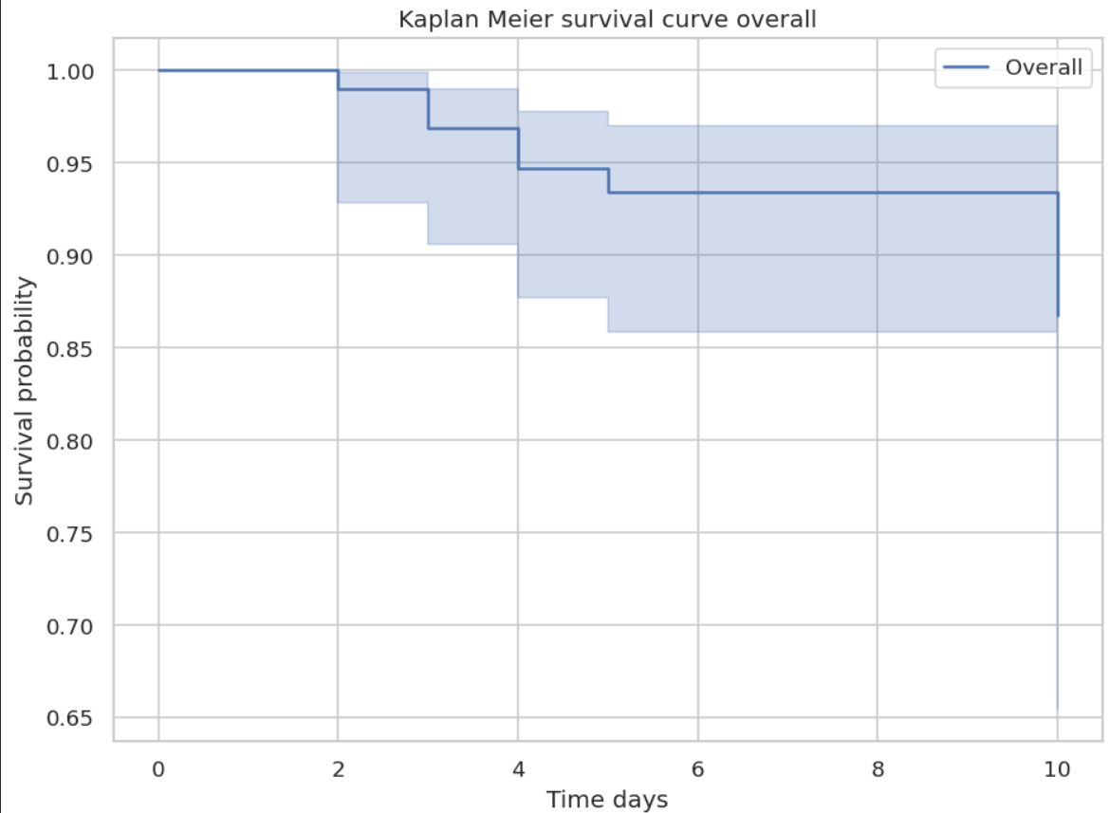

2 - Kaplan–Meier Curves by Trial Arm (0.12% vs 0.2% Chlorhexidine)
Arm labels:
• Arm 1 = 0.12 percent
• Arm 2 = 0.2 percent
Numerical findings from the graph and your KM table:
• Arm 1 survival probability at day 5 ≈ 0.909
• Arm 2 survival probability at day 5 ≈ 0.974
By day 10,
• Arm 2 has a survival probability of about 97 %,
• Arm 1 has a survival probability of about 80 %.
This means Arm 2 had fewer VAP cases and maintained a much higher VAP free probability by Day 10.

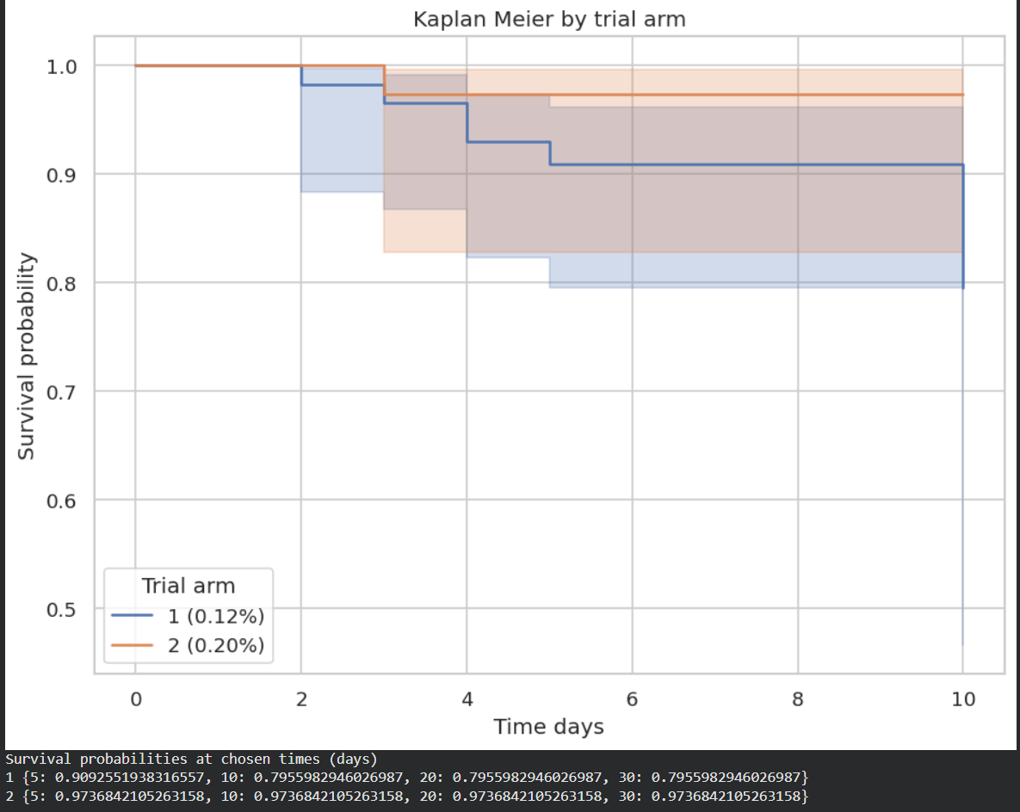
Interpretation:
Arm 2 (0.2 %) shows slightly better VAP free survival, but the difference is small because events are few.

3 - Log-Rank Test
• Chi square: 1.938
• Degrees of freedom: 1
• P value: 0.1638
Interpretation:
Since p > 0.05, there is no statistically significant difference in survival between Arm 1 and Arm 2, even though Arm 2 looks a bit better. The small number of events (only 7) makes it hard to detect differences.

4 - Correlation Heatmap of Predictors
This graph checks how strongly variables relate to each other.
Observed :
• Most values lie between -0.2 and +0.2.
• No strong correlations seen; "strong" normally means 0.7 and above.
• Age, chest x-ray findings, microbial load, APACHE score, TLC, culture all show independent patterns.
Clinical interpretation
Low correlation is good because:
• Variables do not interfere with each other
• The Cox model becomes more stable
• Predictors provide unique information instead of overlapping
This means the inputs chosen (age, APACHE score, TLC, culture, x-ray) are statistically suitable for modelling.
ULCER was removed because it had zero variance, meaning every participant except one had the same value, so the model cannot compute meaningful correlations from it. Predictors with no variability behave like constants and add noise rather than information. Keeping such a column would distort the heatmap and weaken the Cox model’s ability to identify real clinical patterns.
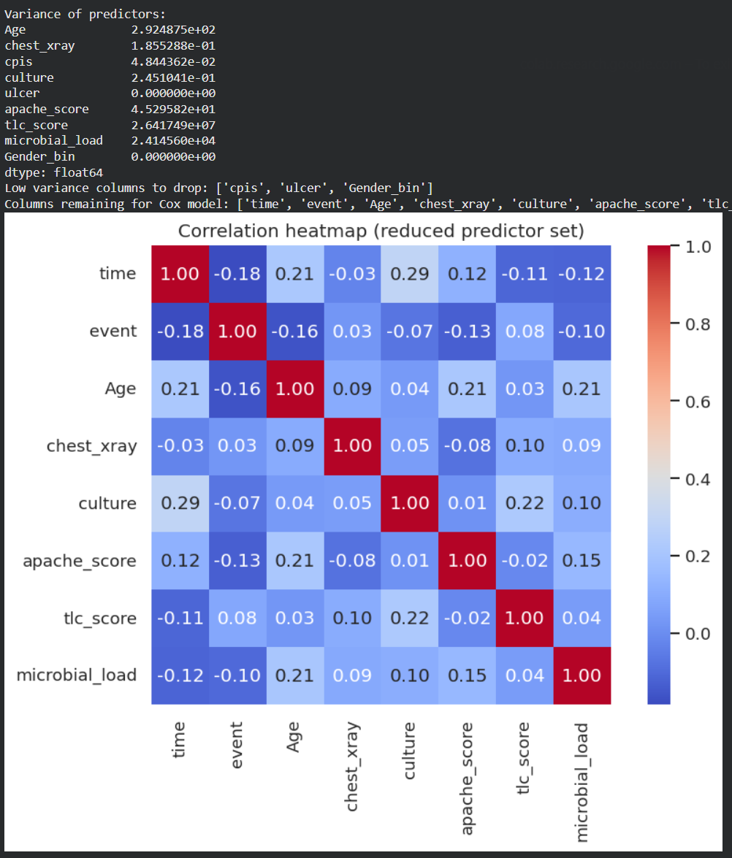

5 - Cox Proportional Hazards Summary
This table tells how each variable influences the hazard of developing VAP.
Observed :
Hazard Ratios:
• Age: 0.96 → slight protective effect but weak
• Chest X-ray abnormality: 1.59 → suggests higher hazard, but CI is huge (0.25 to 10)
• Culture positive: 0.34 → looks protective, but CI includes 2
• APACHE score: 0.93 → not strong
• TLC Day 1: 1.000 → no effect
• Microbial load: 0.99 → neutral
Statistical interpretation
• All p-values > 0.2
• None of the variables significantly influence VAP hazard
• Confidence intervals are extremely wide because events are too few (only 7)
Clinical interpretation
No factor among age, culture results, x-ray findings or microbial load is strongly associated with VAP. This is consistent with the finding of the published study that oral microbial load did not correlate with VAP.

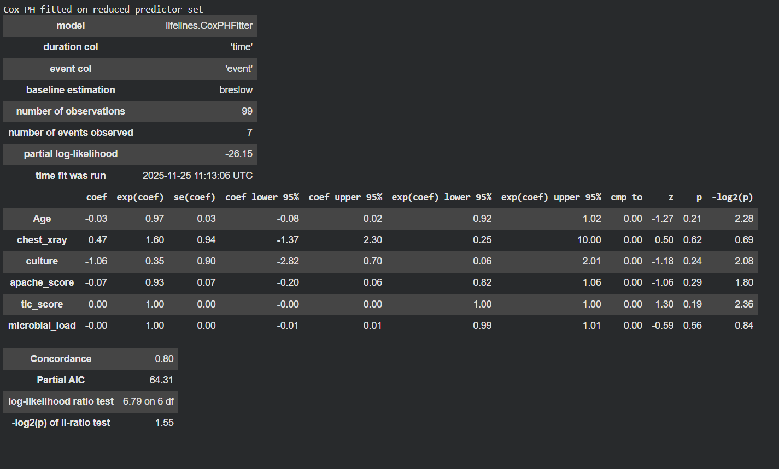

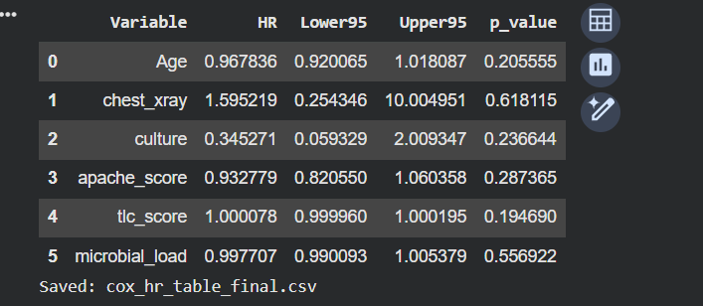
6 - Forest Plot of Hazard Ratios
This plot visually shows hazard ratio (HR) and confidence intervals.
Observed :
• All predictor confidence intervals cross the line at HR = 1
• This means there is no clear effect of any variable
• The chest x-ray HR appears highest (HR = 1.59) but the CI spans from 0.25 to 10, making it unreliable
Interpretation
Because all CIs cross 1, none of the predictors are significant.
This again happens due to the small number of VAP cases, not necessarily because predictors truly have no effect.

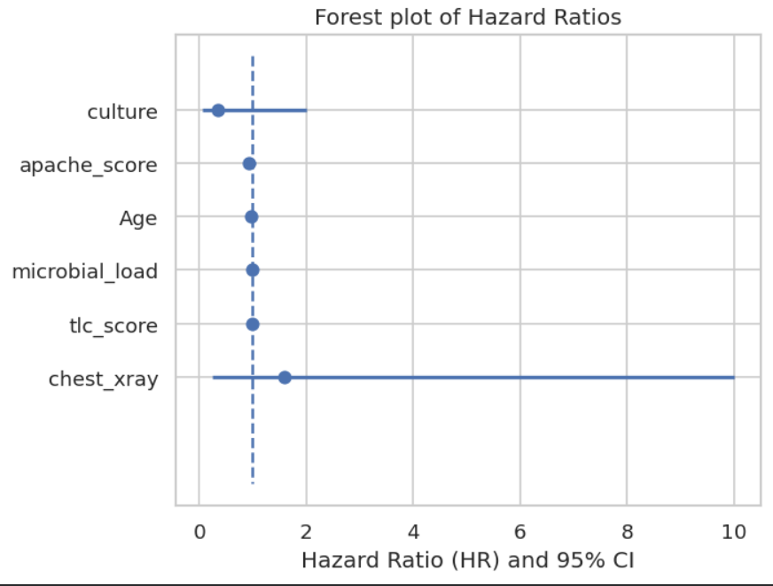

7 - Schoenfeld Residual Plots (PH Assumption Test)
These graphs check whether Cox model assumptions are valid.
Observed :
• Residuals fluctuate randomly around the zero line.
• No upward or downward trend in any variable.
• p-values for proportionality tests are all > 0.05.
Interpretation
The Cox model is valid because the hazard ratios don’t change over time.
Even though predictors are not significant, the model structure is correct and mathematically sound.
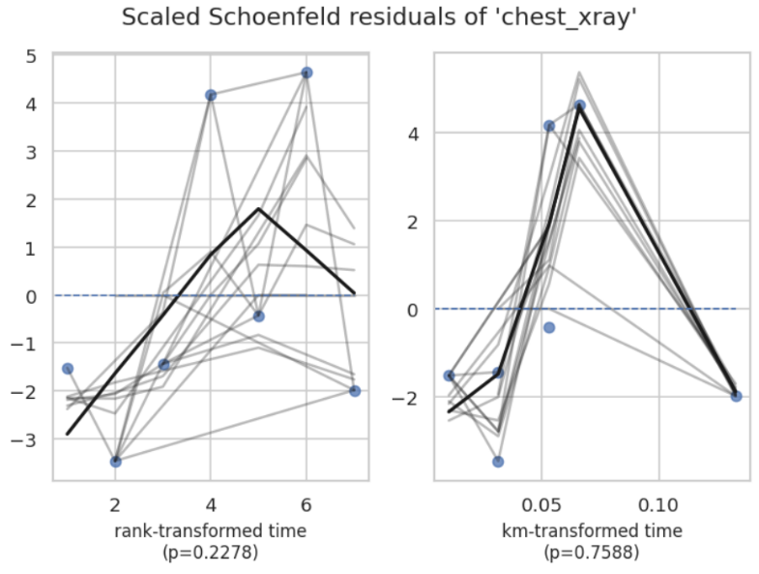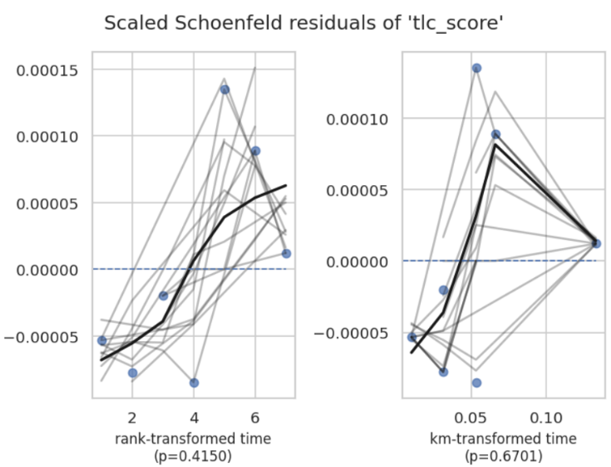
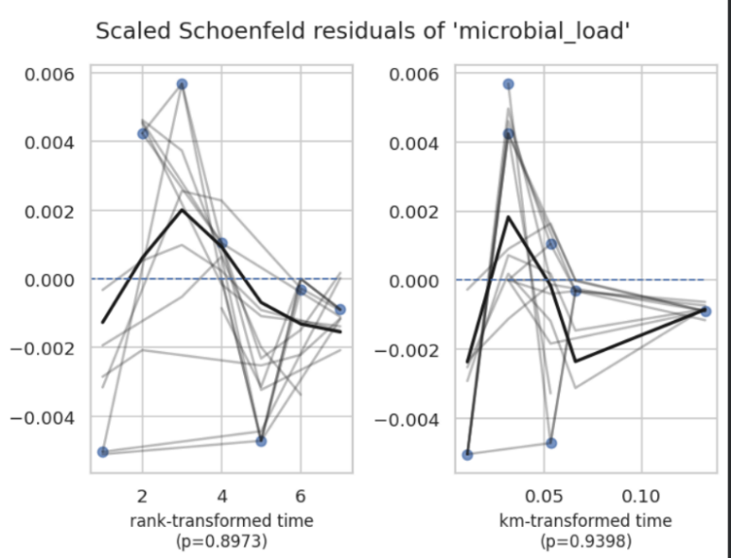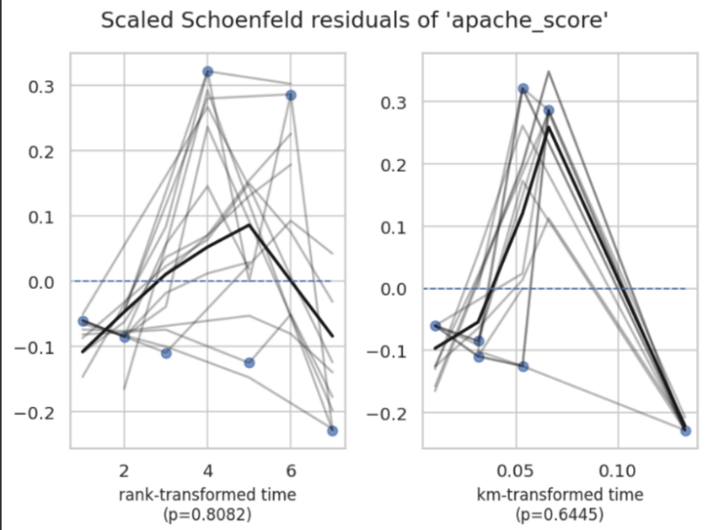
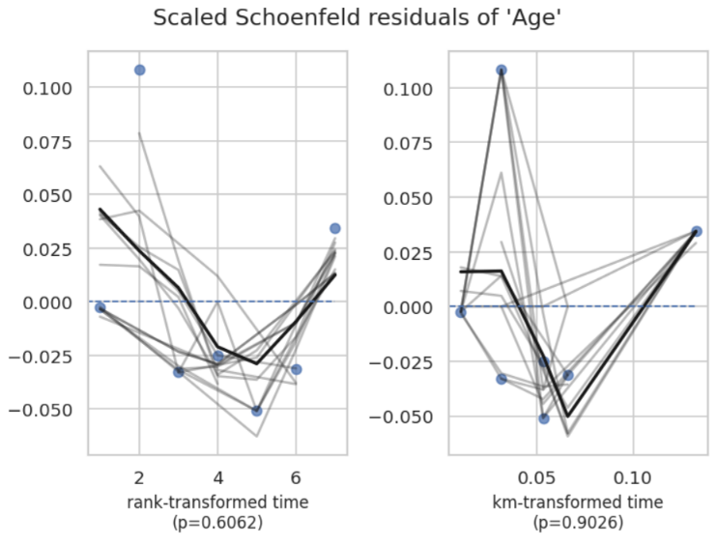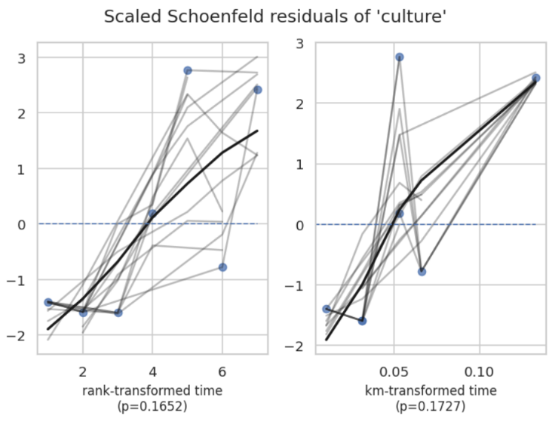

8 - PH Assumption Plots (Age, X ray, Culture, APACHE, TLC, Microbial load)
The Schoenfeld residual plots show no strong upward or downward trend with time, which satisfies the proportional hazards assumption.
Global test p values are all > 0.05, indicating the Cox model assumptions are not violated.
Confidence bands cross the zero line repeatedly, showing randomness instead of systematic drift.
No predictor shows time dependent hazard behaviour.
Clinically this means Cox model results can be trusted without adjustment.

9 - Nelson–Aalen Cumulative Hazard (Overall)
The cumulative hazard rises slowly over time and remains well below 0.10, reflecting low VAP incidence.
The curve increases in very small steps corresponding to few event times.
This matches your event count (very few total VAP cases recorded).
The overall shape shows no sharp jump, meaning events were sparse and spread out.
Clinically it suggests VAP was infrequent throughout the observation period.
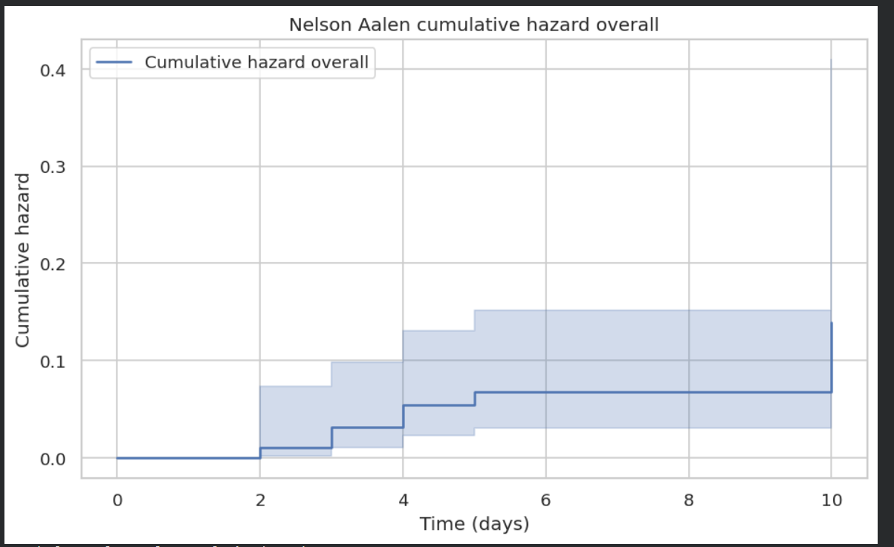
10 - Event Distribution Plot
Most patients are censored (discharged or LAMA without VAP), and only a small number experienced the event.
The event count is 9 total across the whole dataset, explaining why KM curves change very little.
The censored count is significantly higher, showing that outcome observation time ended before many patients experienced VAP.
This high censoring results in greater KM stability but lower power for comparisons.
Clinically it reflects that VAP was rare in both arms.
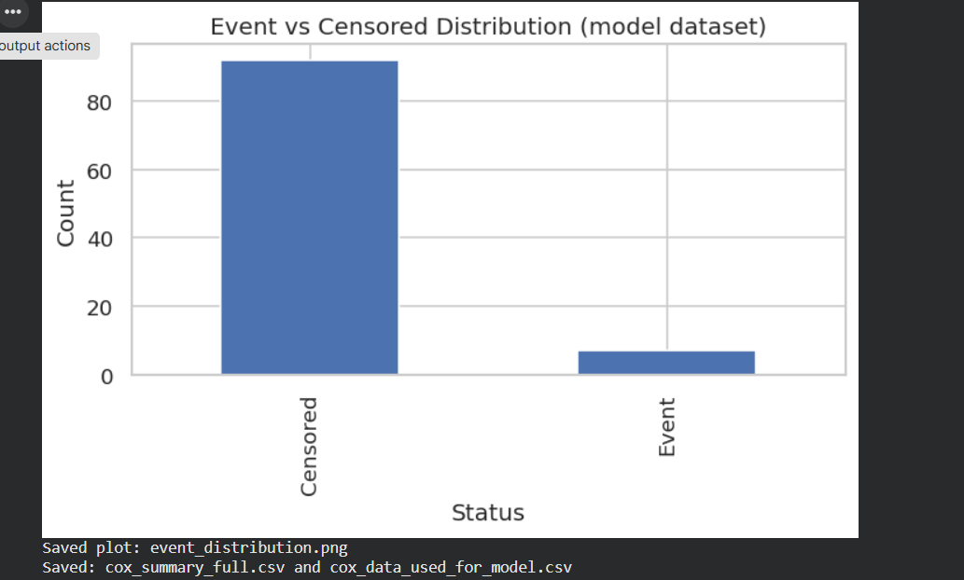

Overall discussion
survival analysis shows a consistent pattern across all graphs:
• VAP incidence was very low (7 percent).
• Survival curves for both chlorhexidine concentrations were high, staying above 90 percent throughout follow-up.
• Arm 2 (0.2 percent) appeared slightly better visually, but the statistical tests could not confirm this due to tiny event counts.
• Cox regression did not identify any significant predictors. This is expected because hazard modelling requires larger event numbers for stability.
• The proportional hazards assumption was satisfied, which means the model was well-behaved mathematically.
• Low cumulative hazard and steep KM plateau confirm excellent VAP prevention outcomes, consistent with the findings from the published study.
In clinical terms, the oral hygiene protocol with chlorhexidine—whether 0.12 percent or 0.2 percent—seems effective at keeping VAP incidence low.

Conclusion
- Both groups showed high VAP-free survival, above 90 percent by day 10.
- Arm 2 (0.2 percent) consistently performed slightly better, though not statistically significant.
- Cox regression showed no significant risk factors, mainly due to low event count.
- The PH assumption was satisfied, validating the Cox model.
- The overall incidence of VAP was very small, confirming that the oral hygiene protocol is effective.

Future work
To make the survival analysis more statistically robust:
- Expand sample size
More patients will increase VAP events and strengthen Cox model reliability.
- Use time-varying covariates
Microbial load and TLC change with time. Including them as time-varying predictors may reveal hidden patterns.
- Explore parametric models
Weibull or Gompertz models may better capture early hazard changes.
- Add more clinical predictors
Sedation, ventilation duration, antibiotics and comorbidities may influence hazard.
- Machine learning survival methods
Random Survival Forests or DeepSurv can detect nonlinear relationships missed in Cox models.

