TITLE- EDGE-AI SIGN LANGUAGE TRANSLATION KIOSK WITH WIRELESS SENSOR GLOVE
TOTAL PAGES: 7
PAGE NO: 1 of 7
APPLICANT – KAYALVIZHI, VENMUGIL RAJAN S, BUVANESH C, HARISH P
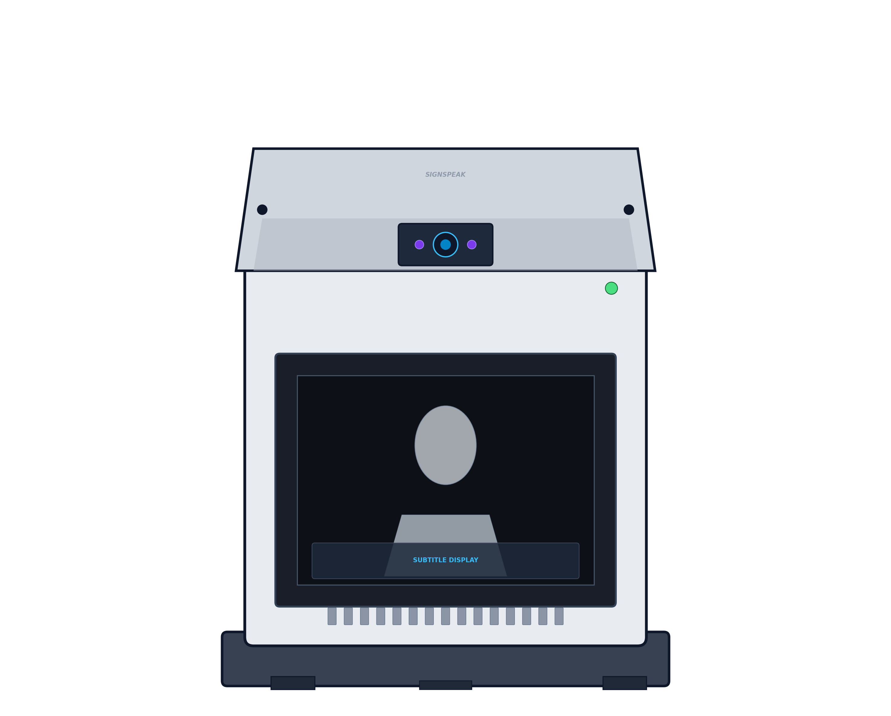

FRONT VIEW
The novelty resides in the shape and configuration of ‘EDGE-AI SIGN LANGUAGE TRANSLATION KIOSK WITH WIRELESS SENSOR GLOVE’ as illustrated.
No claim is made by virtue of this Registration, in respect of the use of the words, letter, number or trademarks, colour or colour combination appearing in the representation.
No claim is made by virtue of this Registration, in respect of any mechanical, principle action or operation of the article and of the base on which the article is placed.
Dated this 12th Day of March, 2026

TITLE- EDGE-AI SIGN LANGUAGE TRANSLATION KIOSK WITH WIRELESS SENSOR GLOVE
TOTAL PAGES: 7
PAGE NO: 2 of 7
APPLICANT – KAYALVIZHI, VENMUGIL RAJAN S, BUVANESH C, HARISH P



BACK VIEW
The novelty resides in the shape and configuration of ‘EDGE-AI SIGN LANGUAGE TRANSLATION KIOSK WITH WIRELESS SENSOR GLOVE’ as illustrated.
No claim is made by virtue of this Registration, in respect of the use of the words, letter, number or trademarks, colour or colour combination appearing in the representation.
No claim is made by virtue of this Registration, in respect of any mechanical, principle action or operation of the article and of the base on which the article is placed.
Dated this 12th Day of March, 2026

TITLE- EDGE-AI SIGN LANGUAGE TRANSLATION KIOSK WITH WIRELESS SENSOR GLOVE
TOTAL PAGES: 7
PAGE NO: 3 of 7
APPLICANT – KAYALVIZHI, VENMUGIL RAJAN S, BUVANESH C, HARISH P



LEFT VIEW
The novelty resides in the shape and configuration of ‘EDGE-AI SIGN LANGUAGE TRANSLATION KIOSK WITH WIRELESS SENSOR GLOVE’ as illustrated.
No claim is made by virtue of this Registration, in respect of the use of the words, letter, number or trademarks, colour or colour combination appearing in the representation.
No claim is made by virtue of this Registration, in respect of any mechanical, principle action or operation of the article and of the base on which the article is placed.
Dated this 12th Day of March, 2026

TITLE- EDGE-AI SIGN LANGUAGE TRANSLATION KIOSK WITH WIRELESS SENSOR GLOVE
TOTAL PAGES: 7
PAGE NO: 4 of 7
APPLICANT – KAYALVIZHI, VENMUGIL RAJAN S, BUVANESH C, HARISH P



RIGHT VIEW
The novelty resides in the shape and configuration of ‘EDGE-AI SIGN LANGUAGE TRANSLATION KIOSK WITH WIRELESS SENSOR GLOVE’ as illustrated.
No claim is made by virtue of this Registration, in respect of the use of the words, letter, number or trademarks, colour or colour combination appearing in the representation.
No claim is made by virtue of this Registration, in respect of any mechanical, principle action or operation of the article and of the base on which the article is placed.
Dated this 12th Day of March, 2026

TITLE- EDGE-AI SIGN LANGUAGE TRANSLATION KIOSK WITH WIRELESS SENSOR GLOVE
TOTAL PAGES: 7
PAGE NO: 5 of 7
APPLICANT – KAYALVIZHI, VENMUGIL RAJAN S, BUVANESH C, HARISH P

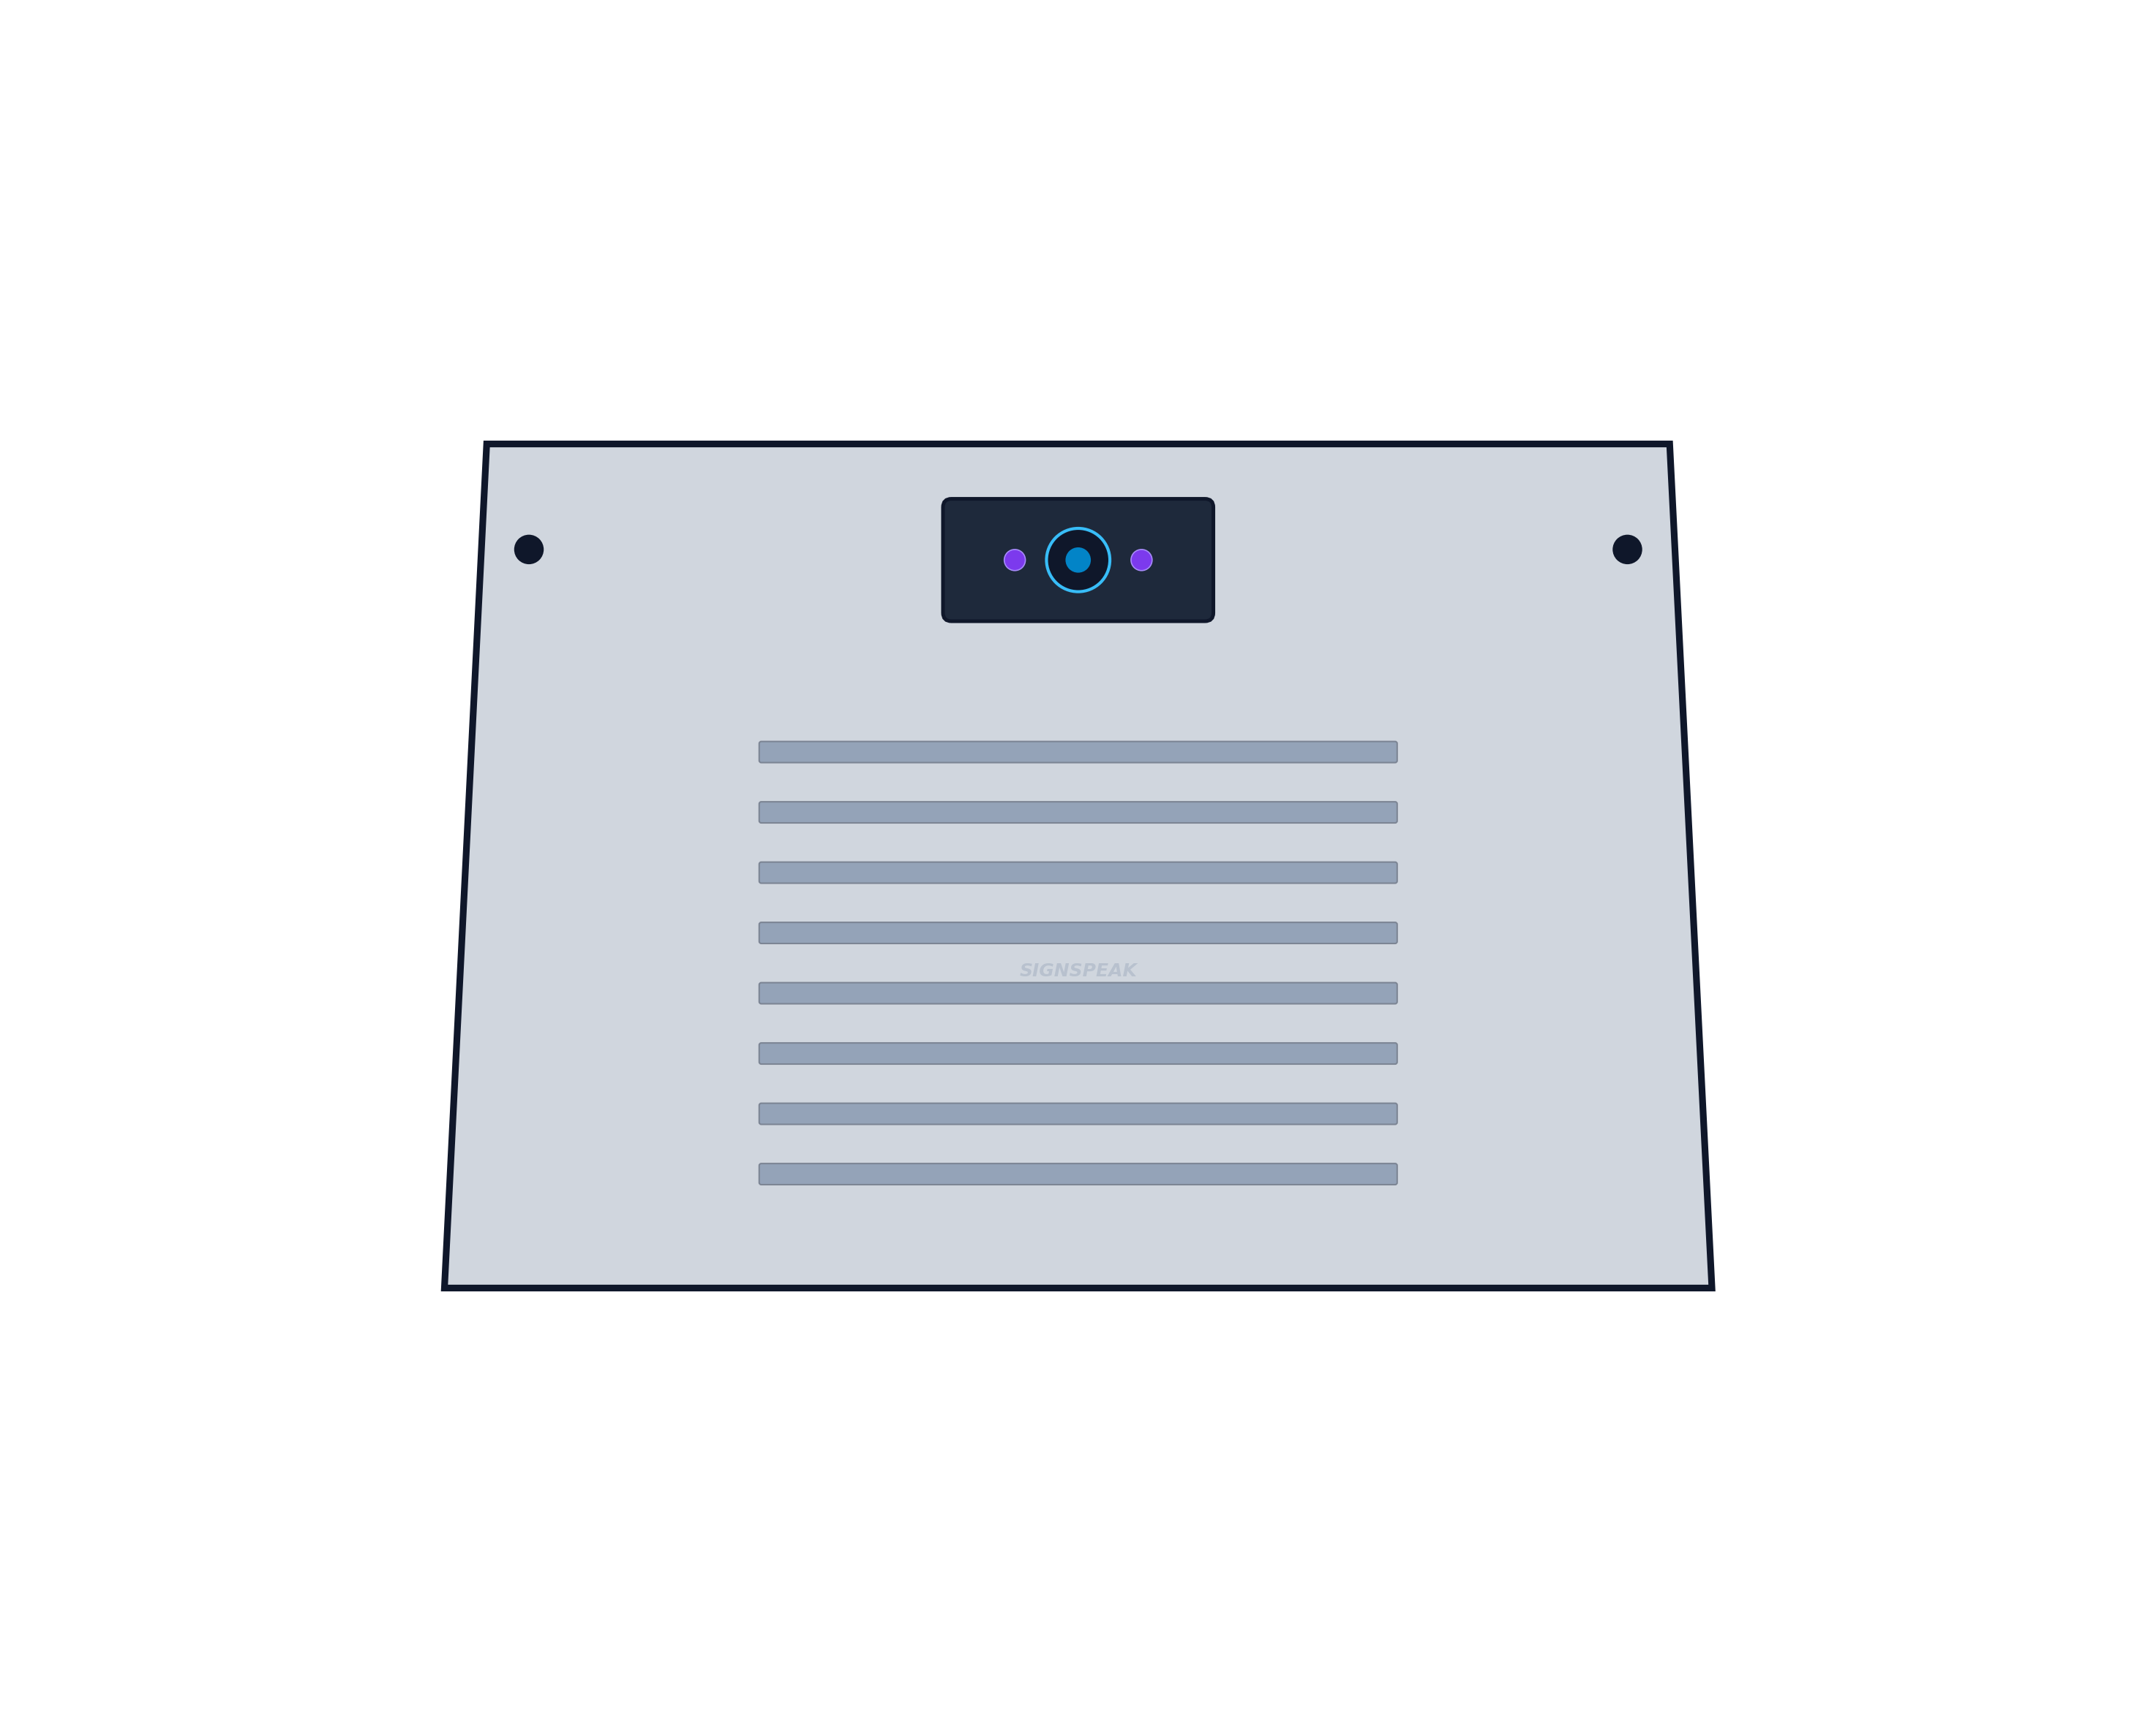

TOP VIEW
The novelty resides in the shape and configuration of ‘EDGE-AI SIGN LANGUAGE TRANSLATION KIOSK WITH WIRELESS SENSOR GLOVE’ as illustrated.
No claim is made by virtue of this Registration, in respect of the use of the words, letter, number or trademarks, colour or colour combination appearing in the representation.
No claim is made by virtue of this Registration, in respect of any mechanical, principle action or operation of the article and of the base on which the article is placed.
Dated this 12th Day of March, 2026

TITLE- EDGE-AI SIGN LANGUAGE TRANSLATION KIOSK WITH WIRELESS SENSOR GLOVE
TOTAL PAGES: 7
PAGE NO: 6 of 7
APPLICANT – KAYALVIZHI, VENMUGIL RAJAN S, BUVANESH C, HARISH P



BOTTOM VIEW
The novelty resides in the shape and configuration of ‘EDGE-AI SIGN LANGUAGE TRANSLATION KIOSK WITH WIRELESS SENSOR GLOVE’ as illustrated.
No claim is made by virtue of this Registration, in respect of the use of the words, letter, number or trademarks, colour or colour combination appearing in the representation.
No claim is made by virtue of this Registration, in respect of any mechanical, principle action or operation of the article and of the base on which the article is placed.
Dated this 12th Day of March, 2026

TITLE- EDGE-AI SIGN LANGUAGE TRANSLATION KIOSK WITH WIRELESS SENSOR GLOVE
TOTAL PAGES: 7
PAGE NO: 7 of 7
APPLICANT – KAYALVIZHI, VENMUGIL RAJAN S, BUVANESH C, HARISH P



PERSPECTIVE VIEW
The novelty resides in the shape and configuration of ‘EDGE-AI SIGN LANGUAGE TRANSLATION KIOSK WITH WIRELESS SENSOR GLOVE’ as illustrated.
No claim is made by virtue of this Registration, in respect of the use of the words, letter, number or trademarks, colour or colour combination appearing in the representation.
No claim is made by virtue of this Registration, in respect of any mechanical, principle action or operation of the article and of the base on which the article is placed.
Dated this 12th Day of March, 2026

