Applicants: Bannari Amman Institute of Technology, et al Total No. of sheets: 05
Sheet No.: 01 of 05
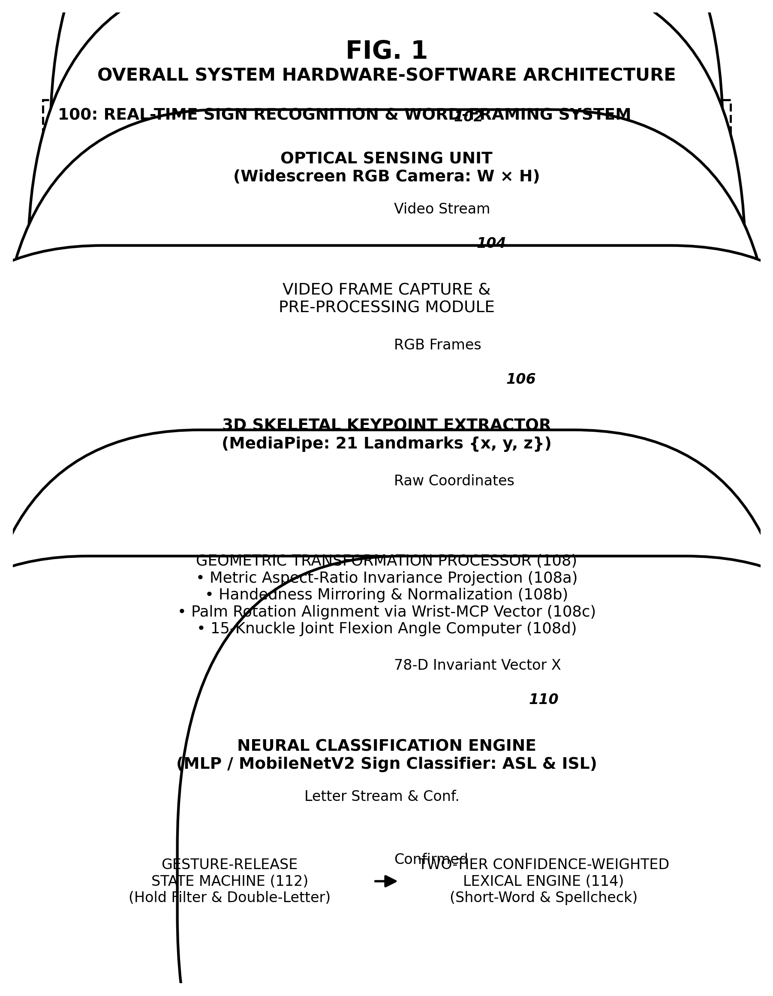
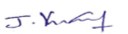
Vinoth Kumar
Patent Agent (IN/PA 6111)
Agent for the Applicant

Applicants: Bannari Amman Institute of Technology, et al Total No. of sheets: 05
Sheet No.: 02 of 05
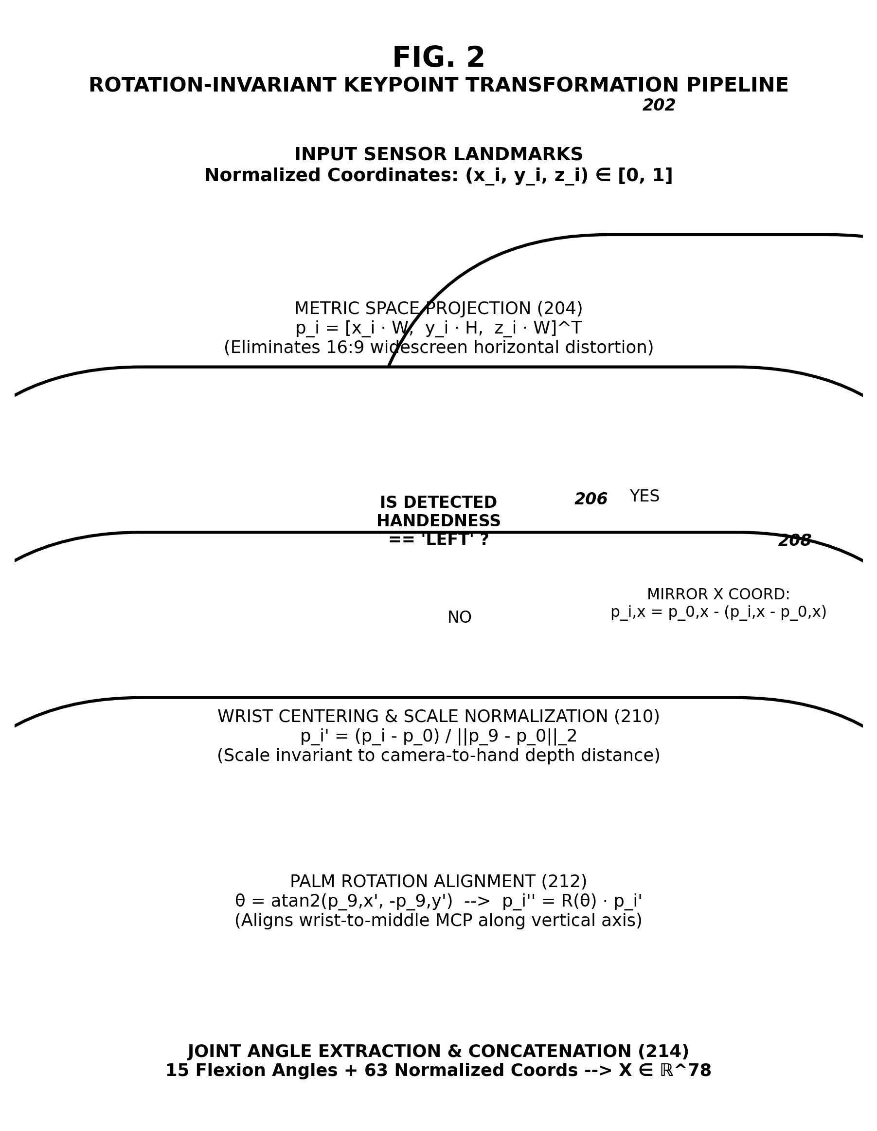
Vinoth Kumar
Patent Agent (IN/PA 6111)
Agent for the Applicant

Applicants: Bannari Amman Institute of Technology, et al Total No. of sheets: 05
Sheet No.: 03 of 05
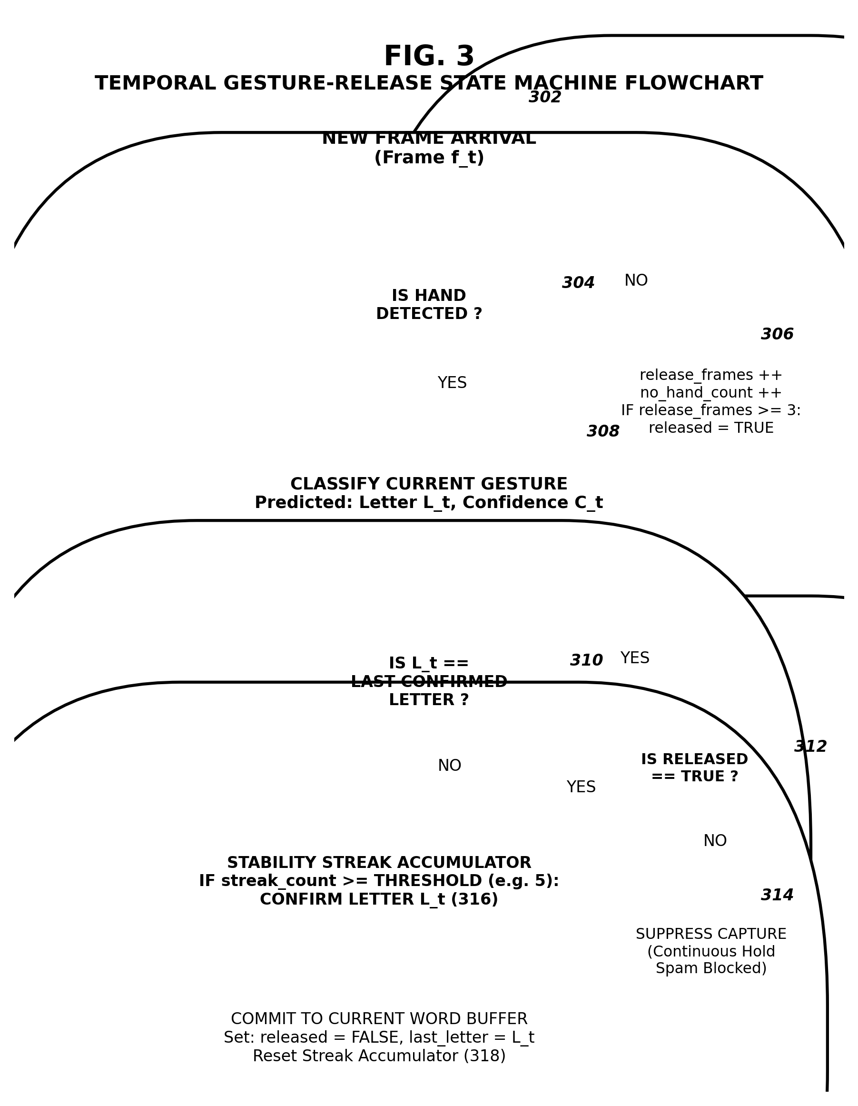
Vinoth Kumar
Patent Agent (IN/PA 6111)
Agent for the Applicant

Applicants: Bannari Amman Institute of Technology, et al Total No. of sheets: 05
Sheet No.: 04 of 05
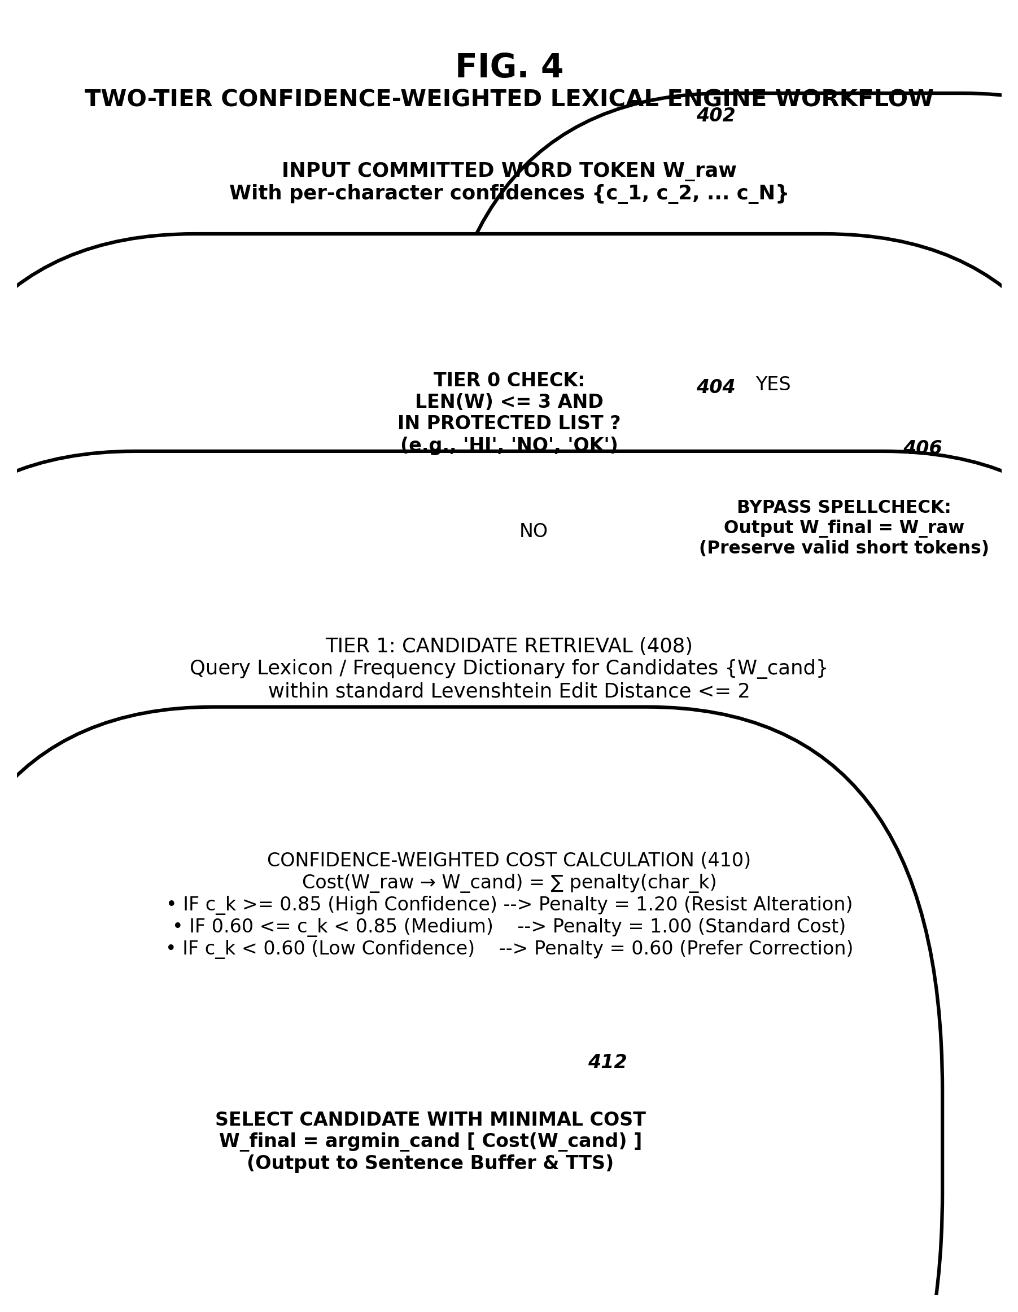
Vinoth Kumar
Patent Agent (IN/PA 6111)
Agent for the Applicant

Applicants: Bannari Amman Institute of Technology, et al Total No. of sheets: 05
Sheet No.: 05 of 05
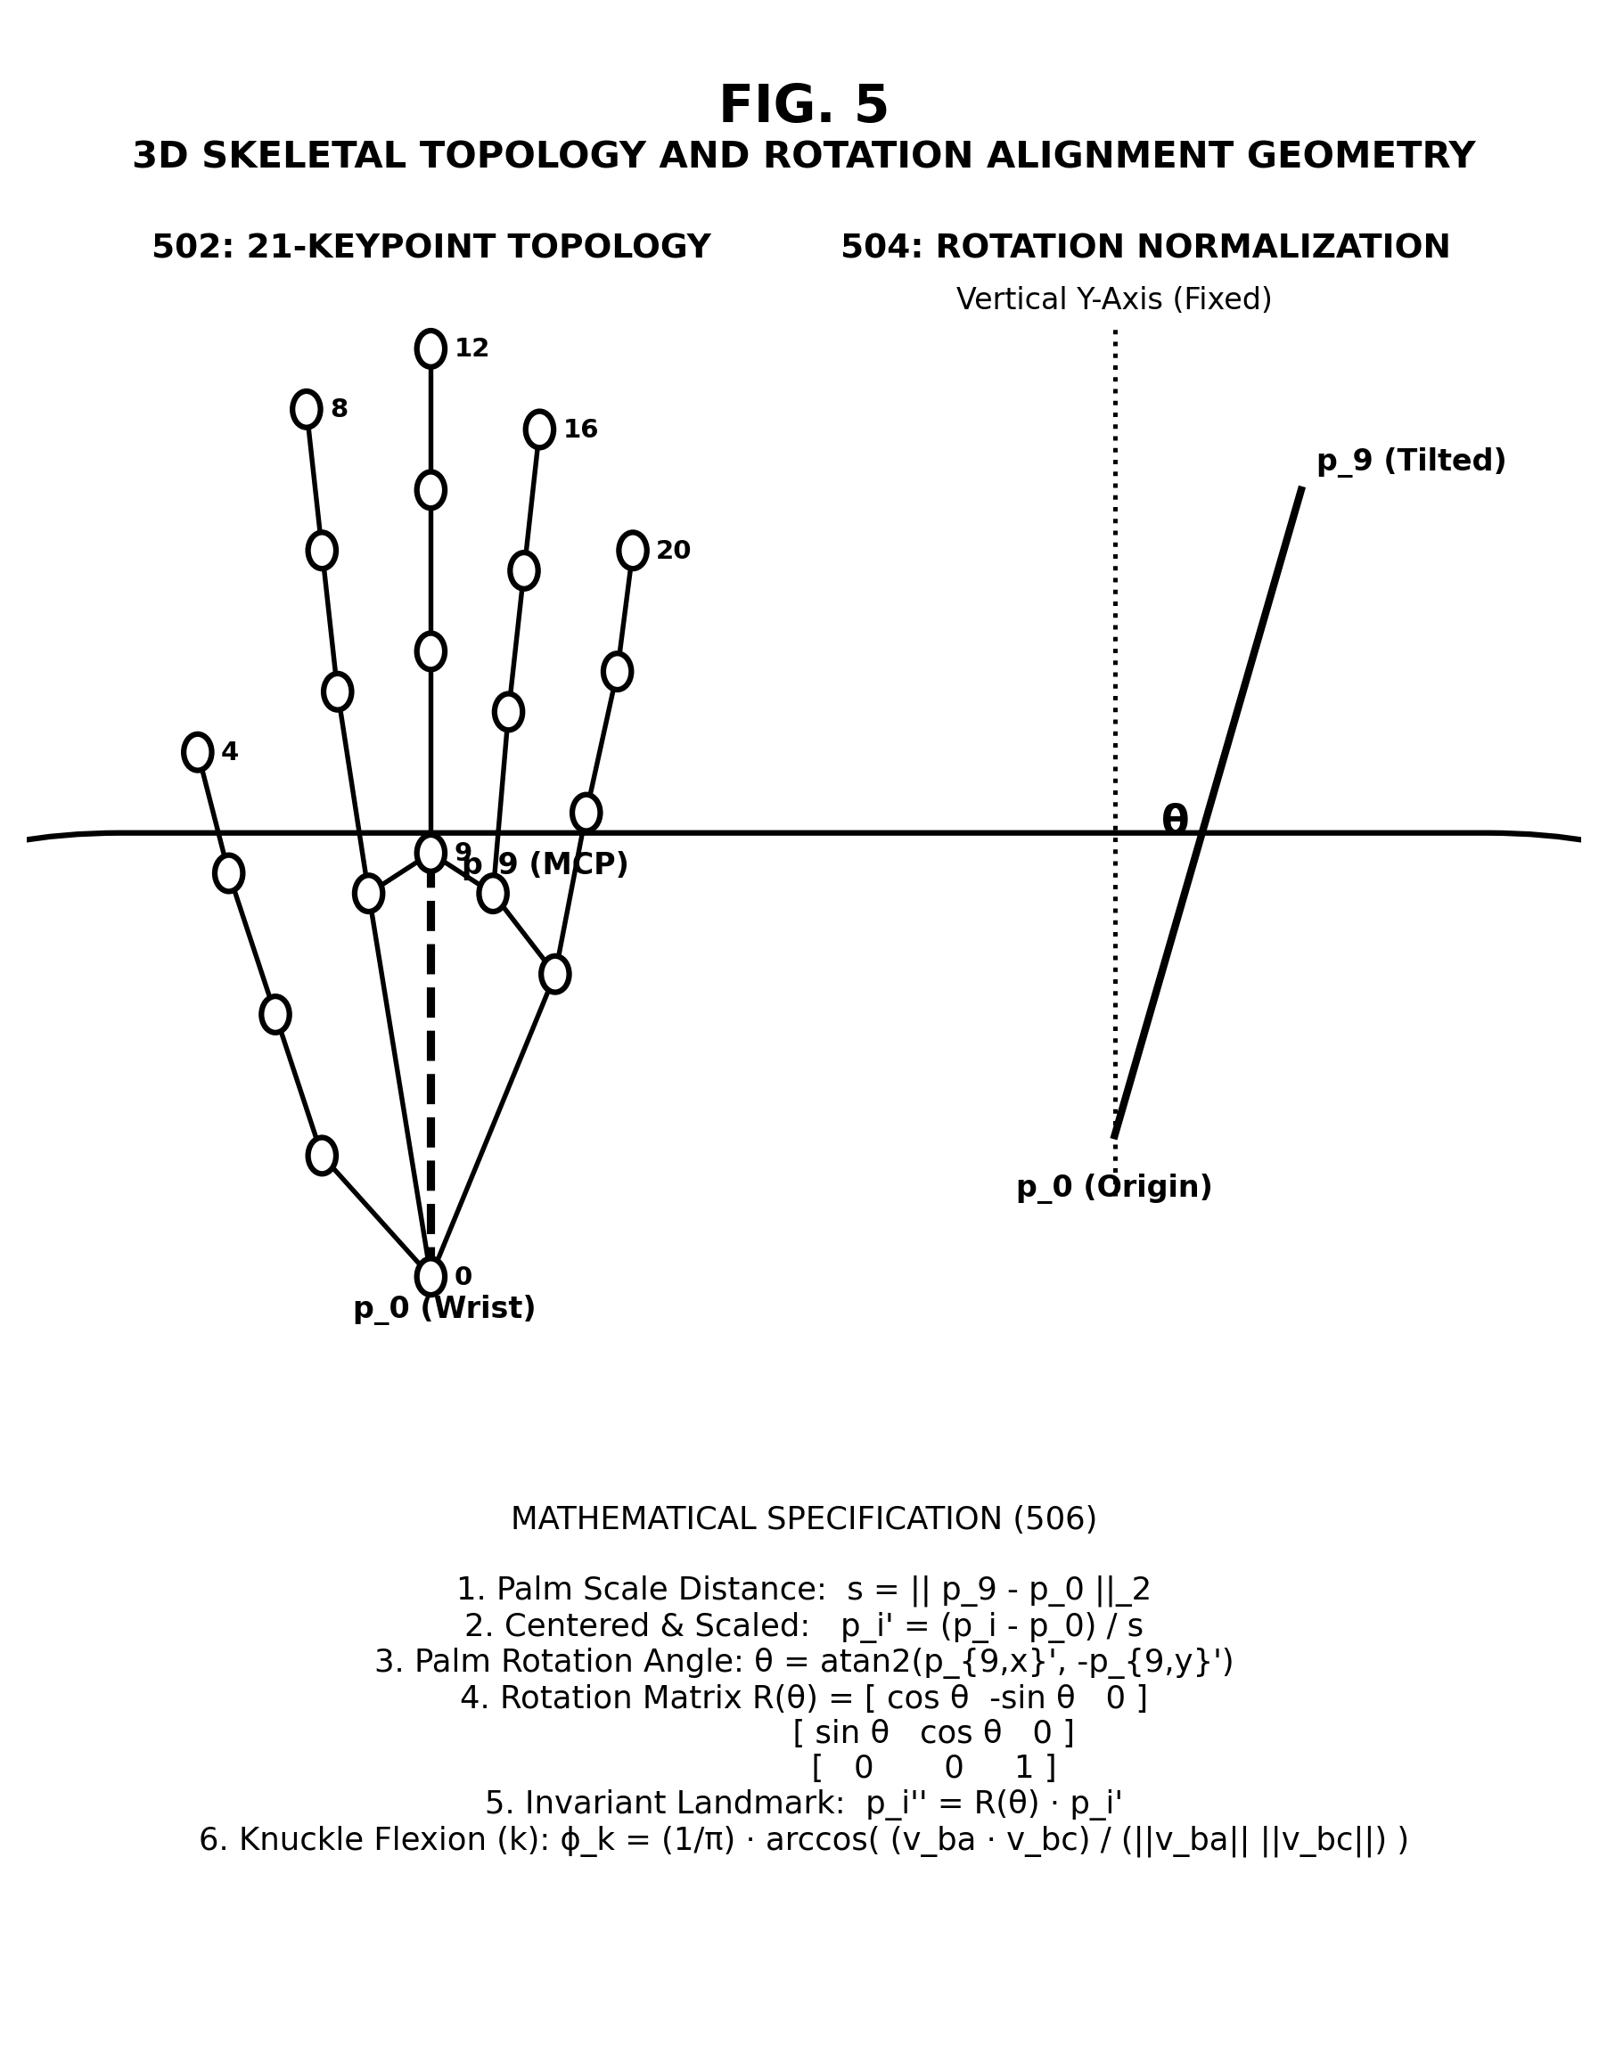
Vinoth Kumar
Patent Agent (IN/PA 6111)
Agent for the Applicant

