FORM 2
THE PATENTS ACT, 1970
(39 of 1970)
&
THE PATENTS RULES, 2003
PROVISIONAL SPECIFICATION
(See section 10 and rule 13)

1. TITLE OF THE INVENTION
“A SYSTEM AND METHOD FOR REAL-TIME DUAL-HANDED SIGN LANGUAGE RECOGNITION AND AUTOMATED WORD-FRAMING USING ROTATION-INVARIANT KEYPOINT TRANSFORMATION”
2. APPLICANT(S)
1. | Name: Buvanesh C  Nationality: Indian  Address: Department of Computer Science and Engineering, Bannari Amman Institute of Technology, Erode, Tamil Nadu, India  Email: buvaneshc.cs24@bitsathy.ac.in

2. | Name: Venmugilrajan R.  Nationality: Indian  Address: Department of Computer Science and Engineering, Bannari Amman Institute of Technology, Erode, Tamil Nadu, India  Email: venmugilrajanr.cs24@bitsathy.ac.in

3. | Name: Harish P  Nationality: Indian  Address: Department of Computer Science and Engineering, Bannari Amman Institute of Technology, Erode, Tamil Nadu, India  Email: harishp.cs24@bitsathy.ac.in

4. | Name: Kayalvizhi B (Project Guide)  Nationality: Indian  Address: Department of Computer Science and Engineering, Bannari Amman Institute of Technology, Erode, Tamil Nadu, India  Email: kayalvizhib@bitsathy.ac.in

3. PREAMBLE TO THE DESCRIPTION
The following specification describes the invention:
4. FIELD OF THE INVENTION
The present invention relates generally to human-computer interaction, computer vision, and assistive communication technologies. More particularly, the invention relates to an automated, edge-deployable system and method for real-time dual-handed sign language recognition, aspect-ratio-invariant geometric landmark normalization, temporal gesture-release state management, and confidence-weighted lexical word-framing.
5. BACKGROUND OF THE INVENTION AND PRIOR ART
Sign language is the primary communication medium for individuals who are deaf or hard-of-hearing. Vision-based sign language recognition (SLR) systems have evolved from compute-intensive RGB convolutional neural networks (CNNs) to lightweight 3D skeletal keypoint extractors such as MediaPipe.
However, existing landmark-based translation systems suffer from several critical technical limitations in real-world deployment:
1. Aspect-Ratio Coordinate Distortion: Standard webcam streams (e.g., 16:9, 1280×720) project normalized coordinate spaces ([0, 1]) with non-uniform horizontal scaling compared to square (1:1) training distributions.
2. Handedness Asymmetry: Prior systems train exclusively on right-hand datasets, leading to high error rates when users sign with their left hand due to opposing lateral knuckle geometries.
3. Double-Letter Truncation: Simple stability or hold filters treat repeated identical letters as duplicate noise, dropping the second letter in words such as “HELLO”, “PLEASE”, or “GOOD”.
4. Lexical Over-Correction: Generic dictionary algorithms corrupt valid short words (e.g., mutating “HI” into “NO”).
There exists an urgent need for an integrated system that achieves rotation and aspect-ratio invariance, dual-hand equivalence, and reliable letter-to-word auto-framing without cloud latency.
6. OBJECTS OF THE INVENTION
The principal object of the present invention is to provide an aspect-ratio-invariant and rotation-aligned 3D landmark processing pipeline for sign language translation.
Another object of the invention is to provide an automated handedness-detection and geometric inversion module that projects left-hand landmarks into the right-hand feature domain.
Yet another object of the invention is to provide a temporal gesture-release state machine that reliably captures consecutive duplicate letters without spamming.
A further object of the invention is to provide a two-tier, confidence-weighted lexical correction engine with short-word protection.
7. SUMMARY OF THE INVENTION
The present invention provides a novel system and method for real-time sign language recognition. The system comprises:
- An Optical Capture Module capturing live video streams.
- A Landmark Transformation Processor converting 21 3D hand keypoints into physical metric space, applying left-to-right geometric mirroring based on detected handedness, scaling by wrist-to-middle knuckle distance, aligning the vertical palm rotation axis, and generating a 78-dimensional invariant feature vector (including 15 knuckle joint flexion angles).
- A Neural Classification Engine mapping the feature vector to discrete alphanumeric sign classes.
- A Gesture-Release State Machine tracking release transition flags between successive confirmation cycles.
- A Two-Tier Lexical Engine filtering words via protected vocabulary lists and confidence-weighted Levenshtein distance penalties.
8. BRIEF DESCRIPTION OF THE DRAWINGS
- FIG. 1 illustrates the overall system block diagram and hardware-software architecture.
- FIG. 2 depicts the geometric transformation pipeline (metric conversion, handedness inversion, and rotation alignment).
- FIG. 3 shows the flowchart of the temporal gesture-release state machine.
- FIG. 4 shows the two-tier confidence-weighted lexical correction workflow.
9. DETAILED DESCRIPTION OF THE INVENTION
(A) Geometric Invariance and Handedness Normalization Pipeline
1. The video stream captures frames of resolution W × H. MediaPipe extracts 21 spatial landmarks (xi, yi, zi).
2. Physical metric projection:
pi = [xi·W, yi·H, zi·W]ᵀ
3. When the hand detector classifies handedness as “Left”, coordinate inversion is performed relative to the wrist p0:
pi,xᵇᵒʳᵐ = p0,x − (pi,x − p0,x)
4. Palm scale normalization: pi′ = (pi − p0) / ‖p9 − p0‖₂.
5. Vertical alignment rotation: Angle θ = atan2(p9,x′, −p9,y′) is calculated, rotating all points by matrix R(θ).
6. Flexion joint angles: 15 knuckle triad angles ϕ = (1/π)·arccos(…) are computed across all five digits.
7. Concatenation forms the 78-dimensional descriptor X ∈ ℝ⁷⁸.
(B) Gesture-Release State Machine Architecture
To distinguish deliberate repeated letters from prolonged static holds:
- Upon letter confirmation, released_since_last_confirm is set to False.
- The state machine requires the hand to transition to NO HAND or an alternate gesture for ≥ 2 consecutive frames before resetting released_since_last_confirm = True.
- A candidate letter matching last_confirmed_letter is only confirmed if released_since_last_confirm == True.
(C) Two-Tier Confidence-Weighted Spellchecker
- Tier 0: Words with length ≤ 3 matching protected vocabulary are passed as-is (0 edit distance).
- Tier 1: Lexical candidate searching applies confidence-weighted penalties: modifications on letters with prediction confidence ck > 0.85 are penalized heavily (1.2), whereas low confidence letters (ck < 0.60) are penalized lightly (0.6).
10. CLAIMS (Provisional Outline)
We claim:
1. A computer-implemented system for real-time sign language recognition comprising an image sensor, a landmark transformation processor, a neural classifier, and a temporal state machine.
2. The system of claim 1, wherein the landmark processor dynamically mirrors left-hand landmarks into right-hand geometric coordinates upon left-handedness classification.
3. The system of claim 1, wherein palm rotation alignment rotates the wrist-to-middle metacarpophalangeal vector along a fixed vertical axis.
4. The system of claim 1, wherein the temporal state machine utilizes a gesture-release flag to confirm consecutive identical letters while blocking continuous hold spam.
5. The system of claim 1, wherein the lexical engine applies neural prediction confidence weights to edit-distance penalties and protects short-word tokens from modification.

Dated this 29th day of August, 2026.
Signature of Applicants:
1. (Buvanesh C)
2. (Venmugilrajan R.)
3. (Harish P)
4. (Kayalvizhi B)

DRAWINGS
FIG. 1: Overall System Hardware-Software Architecture
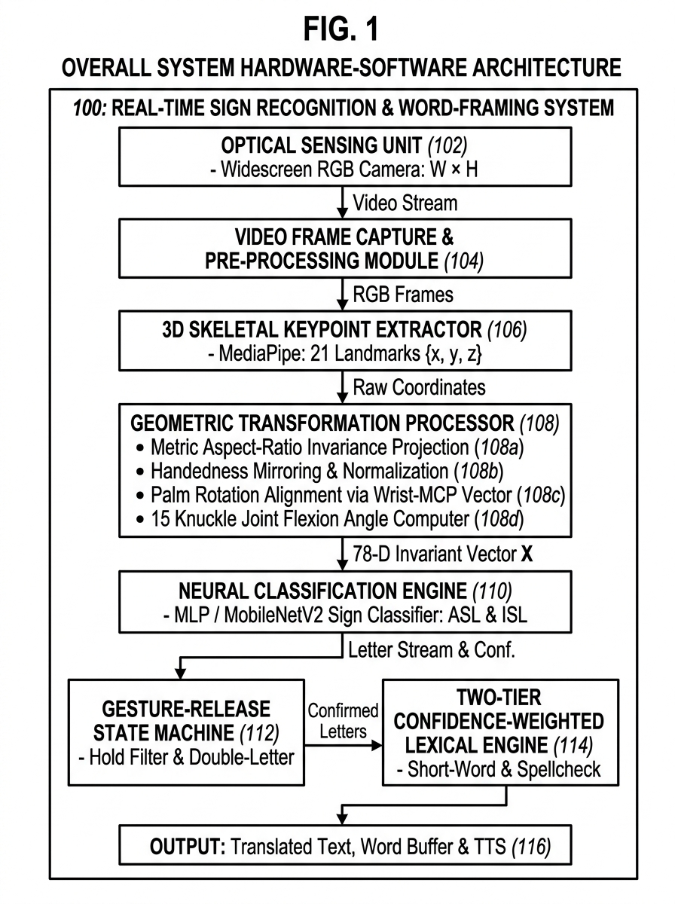

FIG. 2: Rotation-Invariant Keypoint Transformation Pipeline
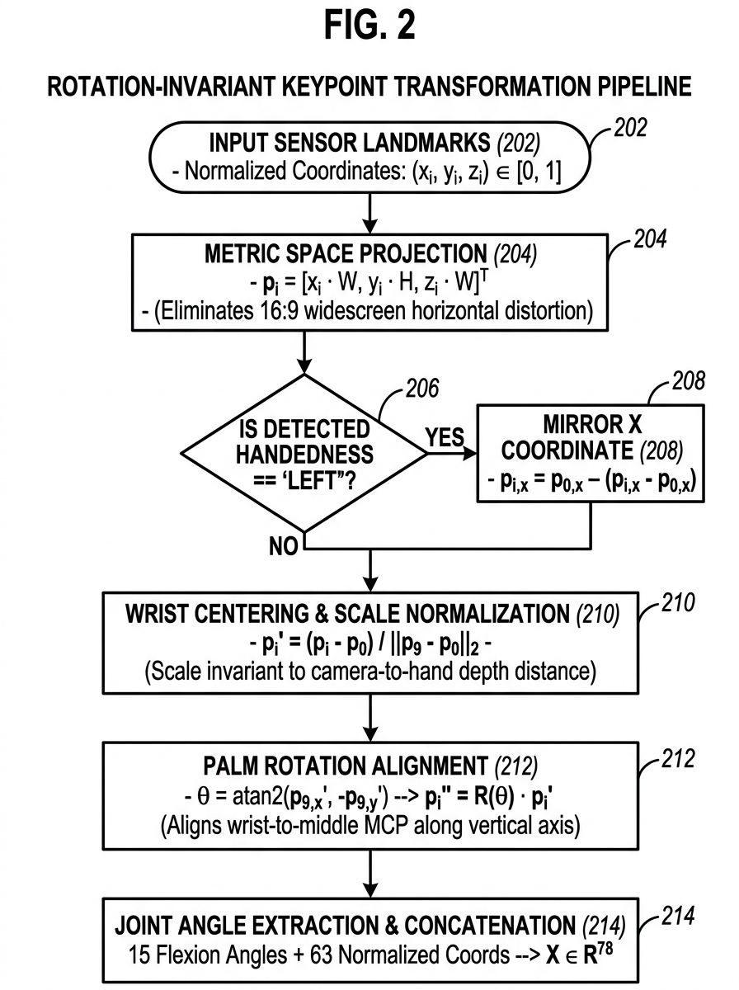

FIG. 3: Temporal Gesture-Release State Machine Flowchart
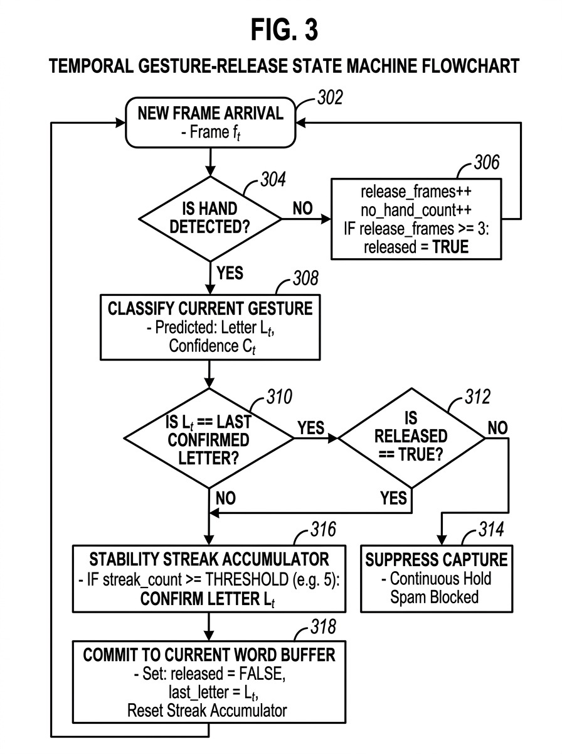

FIG. 4: Two-Tier Confidence-Weighted Lexical Engine Workflow
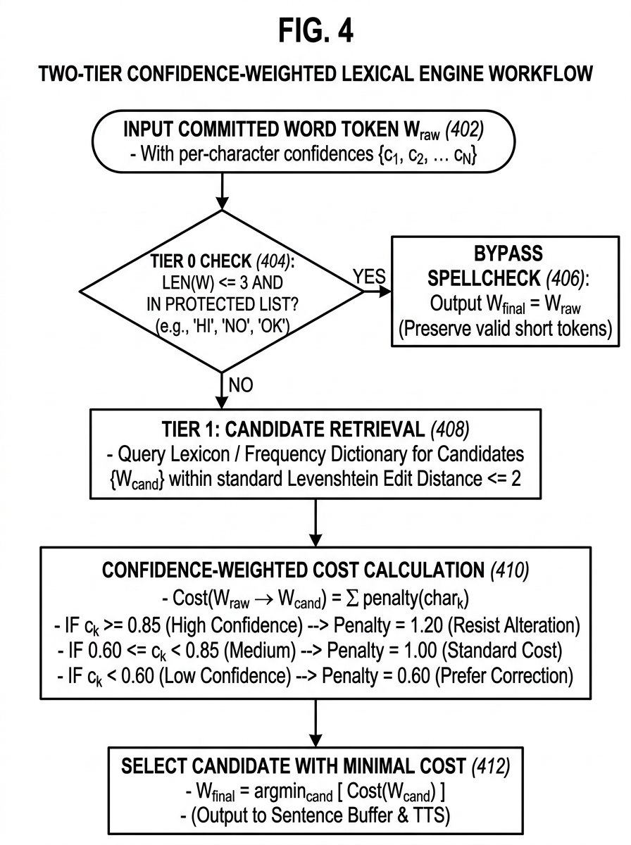

FIG. 5: 3D Skeletal Topology and Rotation Alignment Geometry
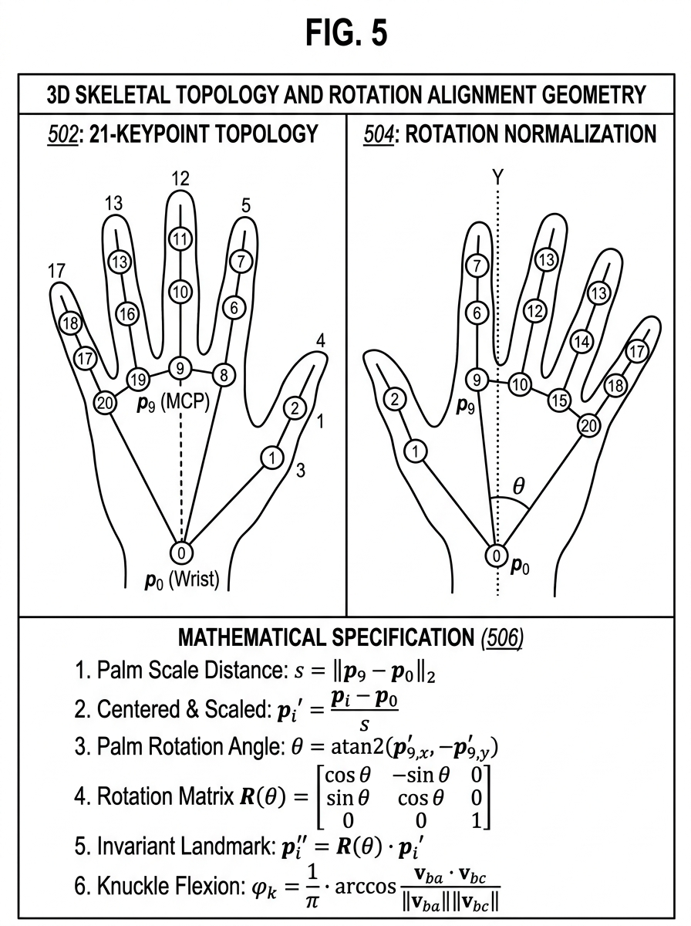

ABSTRACT
“A SYSTEM AND METHOD FOR REAL-TIME DUAL-HANDED SIGN LANGUAGE RECOGNITION AND AUTOMATED WORD-FRAMING USING ROTATION-INVARIANT KEYPOINT TRANSFORMATION”
The present invention discloses a real-time, edge-deployable system and method for translating dual-handed sign language gestures into natural-language text. The system captures live video streams via an optical sensing unit and extracts 21 three-dimensional hand skeletal landmarks using a MediaPipe-based 3D keypoint extractor. A novel geometric transformation processor converts raw normalized coordinates into physical metric space, applies automatic left-to-right handedness mirroring, performs wrist-centered scale normalization, and aligns palm rotation via a wrist-to-middle-MCP rotation matrix, producing a 78-dimensional rotation-invariant feature vector that includes 15 knuckle joint flexion angles. A neural classification engine (MLP or MobileNetV2) maps the invariant descriptor to discrete alphanumeric sign classes for both American Sign Language (ASL) and Indian Sign Language (ISL). A temporal gesture-release state machine distinguishes deliberate repeated letters from prolonged static holds by tracking release transition flags between successive confirmation cycles, enabling accurate capture of consecutive duplicate letters (e.g., “HELLO”, “GOOD”). A two-tier confidence-weighted lexical correction engine protects valid short words (e.g., “HI”, “NO”) from over-correction while applying neural prediction confidence weights to edit-distance penalties for longer words. The system achieves aspect-ratio invariance, handedness equivalence, and reliable letter-to-word auto-framing entirely on local hardware without cloud dependency.
[Reference Figure: FIG. 1]

11. INDUSTRIAL APPLICABILITY
The present invention has broad industrial applicability across multiple sectors where real-time sign language recognition and assistive communication are required. The following non-exhaustive list describes key application domains:
Education and E-Learning: The system can be deployed in educational institutions to enable deaf and hard-of-hearing students to communicate with teachers and peers in real-time. Smart classrooms, online learning platforms, and examination systems can integrate the invention to provide inclusive education without the need for human interpreters.
Healthcare and Medical Communication: Hospitals, clinics, and emergency rooms can deploy the system to facilitate communication between medical professionals and patients who use sign language. Real-time translation during triage, diagnosis, and treatment consultations can significantly improve patient outcomes and reduce miscommunication risks.
Public Services and Government: Government offices, courts, police stations, and public service counters can utilize the system to provide accessible services to sign language users. The edge-deployable nature of the system eliminates the need for internet connectivity, making it suitable for rural and underserved areas.
Telecommunications and Video Conferencing: The system can be integrated into video conferencing platforms (e.g., Google Meet, Zoom, Microsoft Teams) to provide real-time sign language-to-text captioning, enabling seamless participation of deaf individuals in remote meetings and teleconferences.
Banking and Financial Services: ATM kiosks, bank counters, and financial advisory services can integrate the system to serve sign language users independently, improving financial inclusion and accessibility compliance.
Transportation and Navigation: Railway stations, airports, bus terminals, and metro systems can deploy kiosk-based implementations of the system for ticket booking, information inquiry, and emergency communication, providing accessible transit services.
Consumer Electronics and IoT: The lightweight, edge-deployable architecture enables integration into smartphones, tablets, smart displays, and IoT devices, allowing sign language control of smart home systems and personal assistants.

12. ADVANTAGES OF THE INVENTION
1. Aspect-Ratio Invariance: Unlike prior art systems that assume square (1:1) input frames, the invention dynamically converts normalized coordinates to physical metric space using actual frame dimensions (W × H), eliminating horizontal distortion artifacts caused by widescreen (16:9) webcam streams.
2. Handedness Equivalence: The automatic left-to-right geometric mirroring module enables the system to achieve equivalent recognition accuracy for both left-handed and right-handed signers, a critical limitation of existing single-hand-trained systems.
3. Reliable Double-Letter Capture: The temporal gesture-release state machine solves the fundamental double-letter truncation problem by requiring an explicit hand release (or alternate gesture) between consecutive identical letters, enabling accurate spelling of words like “HELLO”, “PLEASE”, and “GOOD” without character duplication spam.
4. Short-Word Protection: The two-tier lexical correction engine protects valid short words (e.g., “HI”, “NO”, “OK”) from being mutated by generic spellcheck algorithms, a significant improvement over prior art that corrupts short tokens through over-correction.
5. Confidence-Weighted Spelling: By weighting edit-distance penalties with per-character neural prediction confidence scores, the system makes intelligent correction decisions—resisting changes to high-confidence letters while preferring corrections on uncertain characters.
6. Edge Deployment: The entire pipeline operates on local hardware (laptop, desktop, or embedded device) without requiring cloud connectivity, ensuring zero-latency translation, data privacy, and offline functionality.
7. Dual Language Support: The system supports both American Sign Language (ASL) and Indian Sign Language (ISL) through separate trained classifiers sharing the same geometric preprocessing pipeline, demonstrating extensibility to additional sign language vocabularies.
8. Rotation Invariance: Palm rotation alignment via the wrist-to-middle-MCP vector rotation matrix ensures consistent feature extraction regardless of the user’s hand orientation, improving robustness in unconstrained environments.

13. SCOPE OF THE INVENTION
While the present invention has been described with reference to specific embodiments, it is understood that the invention is not limited to the described implementations. The following variations and extensions fall within the scope of the present invention:
1. The optical sensing unit may comprise any image sensor including webcam, smartphone camera, depth camera (e.g., Intel RealSense, Azure Kinect), or stereo camera pair.
2. The 3D skeletal keypoint extractor is not limited to MediaPipe and may include any hand pose estimation framework that provides 21+ 3D landmarks, including but not limited to OpenPose, FrankMocap, or custom-trained hand pose networks.
3. The neural classification engine may utilize any supervised classifier architecture including but not limited to Multi-Layer Perceptrons (MLPs), Convolutional Neural Networks (CNNs), MobileNetV2, EfficientNet, Vision Transformers (ViT), or ensemble models.
4. The system may be extended to recognize dynamic gestures (signs involving motion trajectories) by incorporating temporal sequence models such as Long Short-Term Memory (LSTM) networks, Gated Recurrent Units (GRUs), or Transformer-based sequence encoders.
5. The lexical correction engine may be augmented with language model-based contextual correction (e.g., n-gram models, BERT-based masked language models) to improve sentence-level coherence.
6. The system may support additional sign languages beyond ASL and ISL, including but not limited to British Sign Language (BSL), Japanese Sign Language (JSL), Chinese Sign Language (CSL), and Arabic Sign Language (ArSL), by training additional classifier heads on the shared geometric preprocessing pipeline.
7. The output modality may include Text-to-Speech (TTS), visual display, Braille output, or integration with messaging and communication platforms.
8. The system may be deployed on various hardware platforms including desktop computers, laptops, smartphones, tablets, embedded systems (e.g., Raspberry Pi, NVIDIA Jetson), or cloud-edge hybrid architectures.
The foregoing description of specific embodiments reveals the general nature of the invention sufficiently that others can, by applying current knowledge, readily modify or adapt the invention for various applications without departing from the generic concept. Therefore, such adaptations and modifications are intended to be comprehended within the meaning and range of equivalents of the disclosed embodiments.
DECLARATION
We, the undersigned applicants, hereby declare that the invention described in this provisional specification is novel and has not been published or disclosed in any prior publication, to the best of our knowledge and belief. The invention was independently conceived and developed by the applicants listed herein.
We further declare that the drawings and figures included herein are accurate representations of the system components, processing pipelines, and algorithmic workflows described in this specification.
Dated this 29th day of August, 2026.
Signature of Applicants:
1. (Buvanesh C)
2. (Venmugil Rajan S)
3. (Harish P)
4. (Kayalvizhi B)

