Applicants: Bannari Amman Institute of Technology,
Total No. of sheets: 05
Sheet No.: 01 of 05
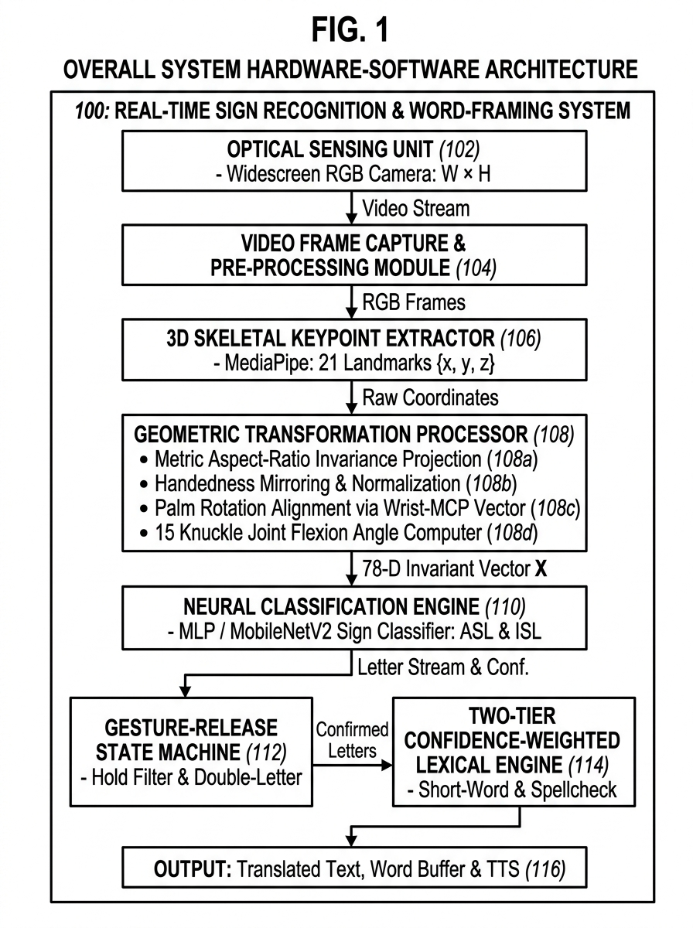

Applicants: Bannari Amman Institute of Technology,
Total No. of sheets: 05
Sheet No.: 02 of 05
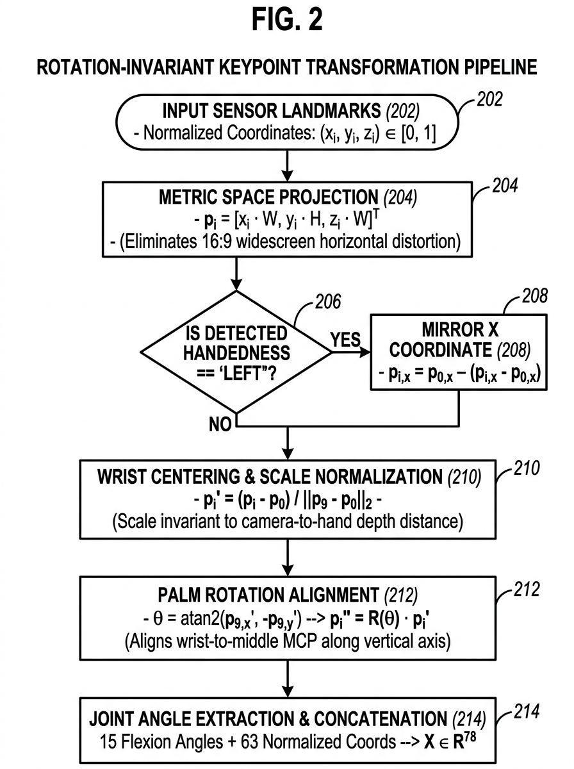

Applicants: Bannari Amman Institute of Technology,
Total No. of sheets: 05
Sheet No.: 03 of 05
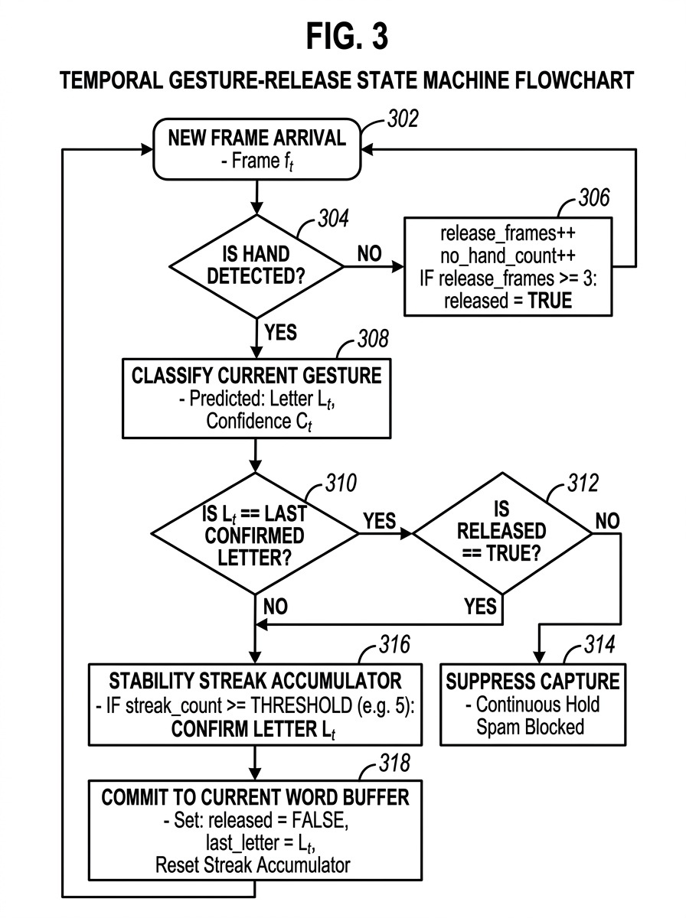

Applicants: Bannari Amman Institute of Technology,
Total No. of sheets: 05
Sheet No.: 04 of 05
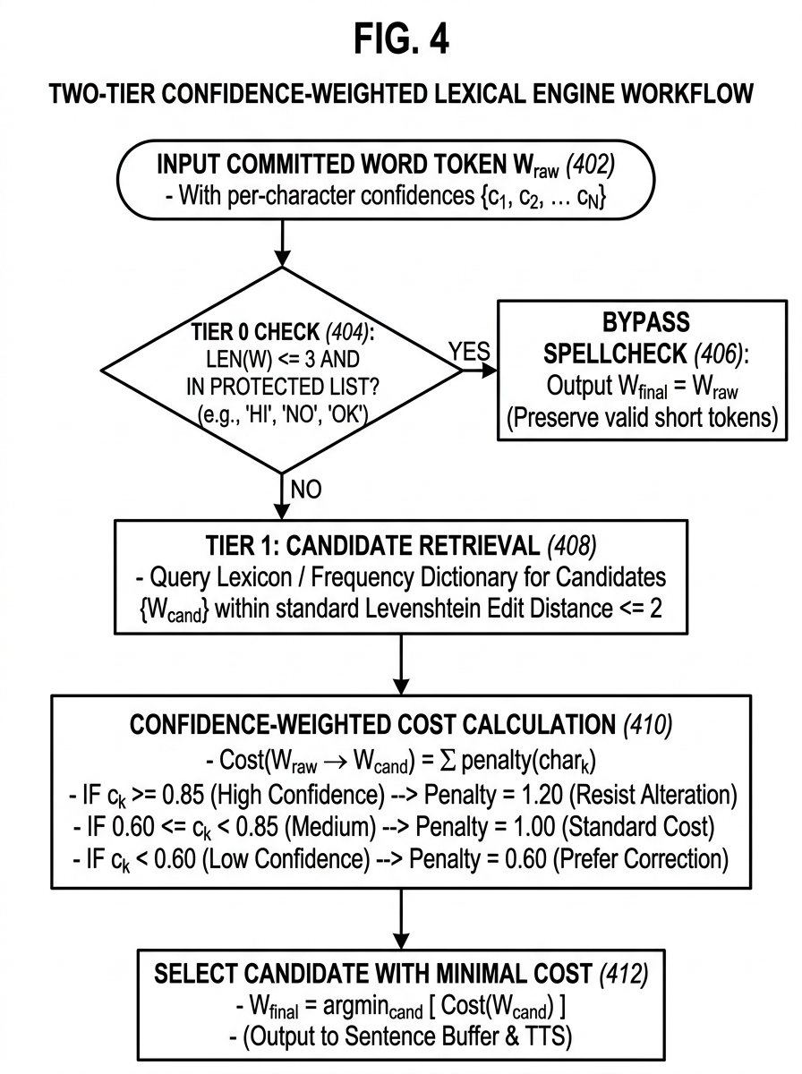

Applicants: Bannari Amman Institute of Technology,
Total No. of sheets: 05
Sheet No.: 05 of 05
