Garbage Collection in Java

Garbage collection in Java is the process by which Java programs perform automatic memory management. Java programs compile to bytecode that can be run on a Java Virtual Machine, or JVM for short. When Java programs run on the JVM, objects are created on the heap, which is a portion of memory dedicated to the program. Eventually, some objects will no longer be needed. The garbage collector finds these unused objects and deletes them to free up memory.

What is Garbage Collection?
In C/C++, a programmer is responsible for both the creation and destruction of objects. Usually, programmer neglects the destruction of useless objects. Due to this negligence, at a certain point, sufficient memory may not be available to create new objects, and the entire program will terminate abnormally, causing OutOfMemoryErrors.

But in Java, the programmer need not care for all those objects which are no longer in use. Garbage collector destroys these objects. The main objective of Garbage Collector is to free heap memory by destroying unreachable objects. The garbage collector is the best example of the Daemon thread as it is always running in the background.

How Does Garbage Collection in Java works?
Java garbage collection is an automatic process. Automatic garbage collection is the process of looking at heap memory, identifying which objects are in use and which are not, and deleting the unused objects. An in-use object, or a referenced object, means that some part of your program still maintains a pointer to that object. An unused or unreferenced object is no longer referenced by any part of your program. So the memory used by an unreferenced object can be reclaimed. The programmer does not need to mark objects to be deleted explicitly. The garbage collection implementation lives in the JVM.
Types of Activities in Java Garbage Collection
Two types of garbage collection activity usually happen in Java. These are:

Minor or incremental Garbage Collection: It is said to have occurred when unreachable objects in the young generation heap memory are removed.
Major or Full Garbage Collection: It is said to have occurred when the objects that survived the minor garbage collection are copied into the old generation or permanent generation heap memory are removed. When compared to the young generation, garbage collection happens less frequently in the old generation.
Important Concepts Related to Garbage Collection in Java
1. Unreachable objects: An object is said to be unreachable if it doesn’t contain any reference to it. Also, note that objects which are part of the island of isolation are also unreachable.

Integer i = new Integer(4);
// the new Integer object is reachable via the reference in 'i'
i = null;
// the Integer object is no longer reachable.
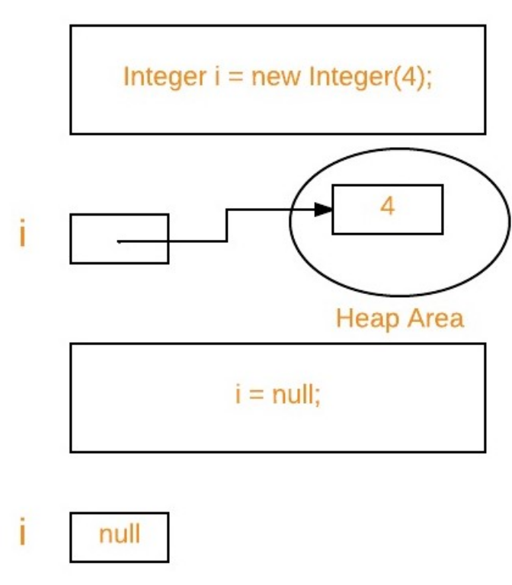
2. Eligibility for garbage collection: An object is said to be eligible for GC(garbage collection) if it is unreachable. After i = null, integer object 4 in the heap area is suitable for garbage collection in the above image.

Ways to make an object eligible for Garbage Collector
Even though the programmer is not responsible for destroying useless objects but it is highly recommended to make an object unreachable(thus eligible for GC) if it is no longer required.
There are generally four ways to make an object eligible for garbage collection.
Nullifying the reference variable
Re-assigning the reference variable
An object created inside the method
Island of Isolation
Ways for requesting JVM to run Garbage Collector
Once we make an object eligible for garbage collection, it may not destroy immediately by the garbage collector. Whenever JVM runs the Garbage Collector program, then only the object will be destroyed. But when JVM runs Garbage Collector, we can not expect.
We can also request JVM to run Garbage Collector. There are two ways to do it :
Using System.gc() method: System class contain static method gc() for requesting JVM to run Garbage Collector.
Using Runtime.getRuntime().gc() method: Runtime class allows the application to interface with the JVM in which the application is running. Hence by using its gc() method, we can request JVM to run Garbage Collector.
There is no guarantee that any of the above two methods will run Garbage Collector.
The call System.gc() is effectively equivalent to the call : Runtime.getRuntime().gc()
Finalization
Just before destroying an object, Garbage Collector calls finalize() method on the object to perform cleanup activities. Once finalize() method completes, Garbage Collector destroys that object.
finalize() method is present in Object class with the following prototype.
protected void finalize() throws Throwable
Based on our requirement, we can override finalize() method for performing our cleanup activities like closing connection from the database.

The finalize() method is called by Garbage Collector, not JVM. However, Garbage Collector is one of the modules of JVM.
Object class finalize() method has an empty implementation. Thus, it is recommended to override the finalize() method to dispose of system resources or perform other cleanups.
The finalize() method is never invoked more than once for any object.
If an uncaught exception is thrown by the finalize() method, the exception is ignored, and the finalization of that object terminates.
Advantages of Garbage Collection in Java
The advantages of Garbage Collection in Java are:

It makes java memory-efficient because the garbage collector removes the unreferenced objects from heap memory.
It is automatically done by the garbage collector(a part of JVM), so we don’t need extra effort.
Real-World Example
Let’s take a real-life example, where we use the concept of the garbage collector.

Question: Suppose you go for the internship at GeeksForGeeks, and you were told to write a program to count the number of employees working in the company(excluding interns). To make this program, you have to use the concept of a garbage collector.

This is the actual task you were given at the company:

Write a program to create a class called Employee having the following data members.

1. An ID for storing unique id allocated to every employee.
2. Name of employee.
3. age of an employee.

Also, provide the following methods:

A parameterized constructor to initialize name and age. The ID should be initialized in this constructor.
A method show() to display ID, name, and age.
A method showNextId() to display the ID of the next employee.

JVM (Java Virtual Machine) Architecture
JVM(Java Virtual Machine) acts as a run-time engine to run Java applications. JVM is the one that actually calls the main method present in a Java code. JVM is a part of JRE(Java Runtime Environment).

Java applications are called WORA (Write Once Run Anywhere). This means a programmer can develop Java code on one system and can expect it to run on any other Java-enabled system without any adjustment. This is all possible because of JVM.

When we compile a .java file, .class files(contains byte-code) with the same class names present in .java file are generated by the Java compiler. This .class file goes into various steps when we run it. These steps together describe the whole JVM.

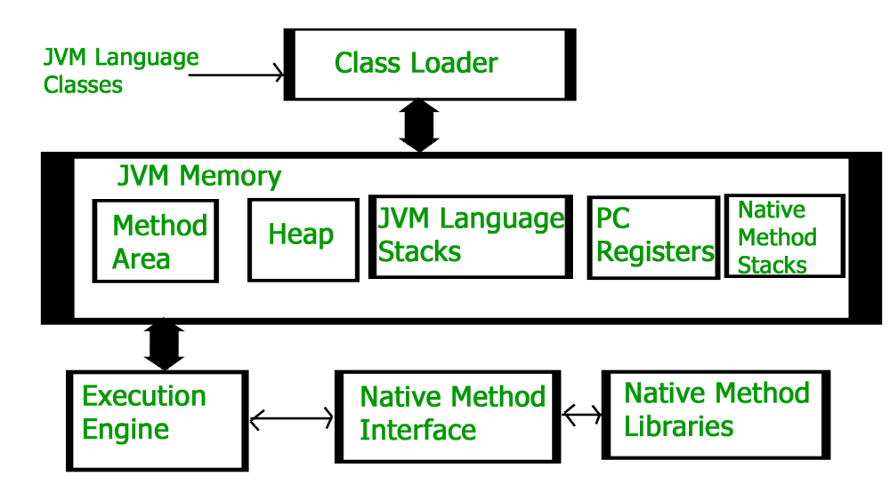
Class Loader Subsystem

It is mainly responsible for three activities.
Loading
Linking
Initialization
Loading: The Class loader reads the “.class” file, generate the corresponding binary data and save it in the method area. For each “.class” file, JVM stores the following information in the method area.

The fully qualified name of the loaded class and its immediate parent class.
Whether the “.class” file is related to Class or Interface or Enum.
Modifier, Variables and Method information etc.
After loading the “.class” file, JVM creates an object of type Class to represent this file in the heap memory. Please note that this object is of type Class predefined in java.lang package. These Class object can be used by the programmer for getting class level information like the name of the class, parent name, methods and variable information etc. To get this object reference we can use getClass() method of Object class.

Verification: It ensures the correctness of the .class file i.e. it checks whether this file is properly formatted and generated by a valid compiler or not. If verification fails, we get run-time exception java.lang.VerifyError. This activity is done by the component ByteCodeVerifier. Once this activity is completed then the class file is ready for compilation.
Preparation: JVM allocates memory for class static variables and initializing the memory to default values.
Resolution: It is the process of replacing symbolic references from the type with direct references. It is done by searching into the method area to locate the referenced entity.
Initialization: In this phase, all static variables are assigned with their values defined in the code and static block(if any). This is executed from top to bottom in a class and from parent to child in the class hierarchy.
In general, there are three class loaders :
Bootstrap class loader: Every JVM implementation must have a bootstrap class loader, capable of loading trusted classes. It loads core java API classes present in the “JAVA_HOME/jre/lib” directory. This path is popularly known as the bootstrap path. It is implemented in native languages like C, C++.
Extension class loader: It is a child of the bootstrap class loader. It loads the classes present in the extensions directories “JAVA_HOME/jre/lib/ext”(Extension path) or any other directory specified by the java.ext.dirs system property. It is implemented in java by the sun.misc.Launcher$ExtClassLoader class.
System/Application class loader: It is a child of the extension class loader. It is responsible to load classes from the application classpath. It internally uses Environment Variable which mapped to java.class.path. It is also implemented in Java by the sun.misc.Launcher$AppClassLoader class.

Note: JVM follows the Delegation-Hierarchy principle to load classes. System class loader delegate load request to extension class loader and extension class loader delegate request to the bootstrap class loader. If a class found in the boot-strap path, the class is loaded otherwise request again transfers to the extension class loader and then to the system class loader. At last, if the system class loader fails to load class, then we get run-time exception java.lang.ClassNotFoundException.
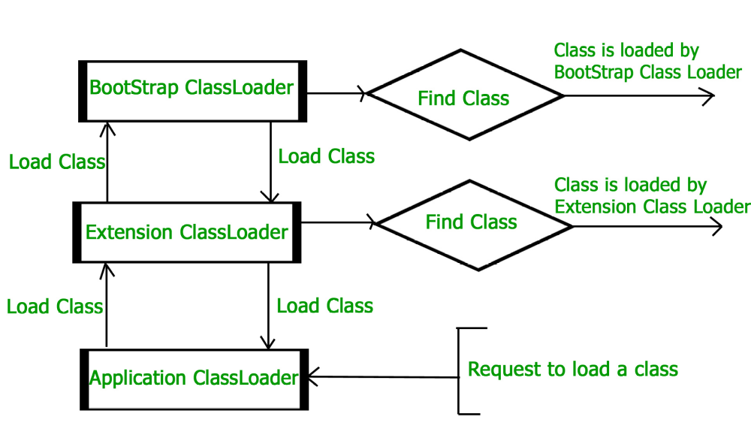
JVM Memory

Method area: In the method area, all class level information like class name, immediate parent class name, methods and variables information etc. are stored, including static variables. There is only one method area per JVM, and it is a shared resource.
Heap area: Information of all objects is stored in the heap area. There is also one Heap Area per JVM. It is also a shared resource.
Stack area: For every thread, JVM creates one run-time stack which is stored here. Every block of this stack is called activation record/stack frame which stores methods calls. All local variables of that method are stored in their corresponding frame. After a thread terminates, its run-time stack will be destroyed by JVM. It is not a shared resource.
PC Registers: Store address of current execution instruction of a thread. Obviously, each thread has separate PC Registers.
Native method stacks: For every thread, a separate native stack is created. It stores native method information.
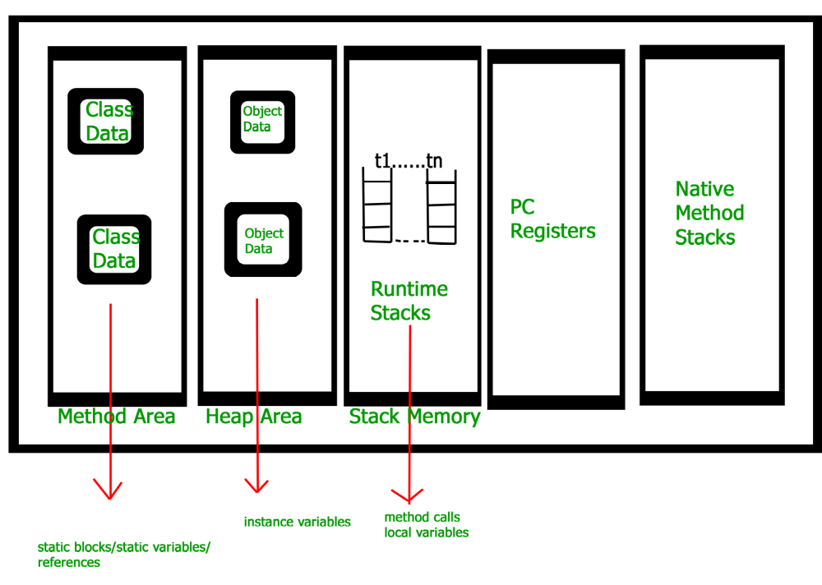
Execution Engine

Execution engine executes the “.class” (bytecode). It reads the byte-code line by line, uses data and information present in various memory area and executes instructions. It can be classified into three parts:

Interpreter: It interprets the bytecode line by line and then executes. The disadvantage here is that when one method is called multiple times, every time interpretation is required.
Just-In-Time Compiler(JIT) : It is used to increase the efficiency of an interpreter. It compiles the entire bytecode and changes it to native code so whenever the interpreter sees repeated method calls, JIT provides direct native code for that part so re-interpretation is not required, thus efficiency is improved.
Garbage Collector: It destroys un-referenced objects. For more on Garbage Collector, refer Garbage Collector.
Java Native Interface (JNI) :

It is an interface that interacts with the Native Method Libraries and provides the native libraries(C, C++) required for the execution. It enables JVM to call C/C++ libraries and to be called by C/C++ libraries which may be specific to hardware.

Native Method Libraries :

It is a collection of the Native Libraries(C, C++) which are required by the Execution Engine.

