AWS Cloud EC2
EC2 is a virtual server in the AWS Cloud.
AWS EC2 is short for AWS Elastic Cloud Compute.
It makes scaling of capacity up and down easy.

Why AWS EC2?
It makes the process of increasing and decreasing capacity easier.
As a result, you can access the resources at demand.
No upfront investment is needed.
You only pay for what you need.
EC2 is secure.

1. Launch
Start with selecting a template with basic configurations.
The config includes the operating system, application server, or applications.
Next, decide the instance type and hardware configuration of your instance.
Finally, specify the security settings to control the traffic in and out of your instance.

2. Connect
There are many ways to connect an instance.
Programs and applications have multiple connection methods to exchange data.
Users can connect and access the computer desktop by logging in.

3. Use
Once connected, you can use the instance.
Execute commands to install software, add storage, copy, and organize files, and much more.

AWS EC2 Instance Types
There are different instance types.
Which one to use depends on the needs.

More About EC2 Instance Types
The types are best used for different things.
Therefore, when selecting an instance type, consider the needs.
For example, needs can be a requirement for compute, memory, or storage.

General Purpose Instance
The General Purpose Instance balances computing, memory, and networking resources.
It fits many purposes. Such as:
- Application servers
- Gaming servers
- Backend servers for companies
- Small and medium databases
The General Purpose Instances are best when there is a balance between the resources.

Compute Optimized Instances
The Compute Optimized Instances are best there is a need for high compute.
This type is also good for application servers, gaming servers, and web applications.
The main difference is that this type is ideal for high-performance and compute-intensive needs.

Memory Optimized Instances
This type can deliver large dataset workloads fast.
Memory is a temporary storage area.
It loads from storage, holds the data, and processes it before the computer can run it.
The processing allows for a preloading process and gives the CPU direct access to the computer program.
The Memory Optimized Instances are best when huge amounts of data need to be preloaded before running the app.

Accelerated Computing Instances
This type use hardware accelerators.
The accelerators boost the data processing.
The Accelerated Computing Instances are best for graphics applications and streaming.

Storage Optimized Instances
This type is best when you have large datasets on local storage.
Some examples:
- Large file systems
- Data warehouses
- Online transaction systems
The Storage Optimized Instances are designed to deliver many inputs as fast as possible.

AWS EC2 Scaling
Scaling is about only using the resources that you need.
In addition, have the flexibility to grow freely.
Make sure to have an architecture that can handle changes in demand.
Designing a scalable architecture allow you to only pay for the resources that you need at any given time.

AWS EC2 Auto Scaling
Servers can get more requests than they can handle.
Too many requests can cause timeouts and outages.
AWS EC2 Auto Scaling allows you to add or remove EC2 instances automatically.
It automates the capacity to the demand.
There are two approaches:
- Dynamic scaling: responds to changing demand
- Predictive scaling: schedules the number of instances based on a predicted demand
- Dynamic and Predictive scaling can be combined to scale faster
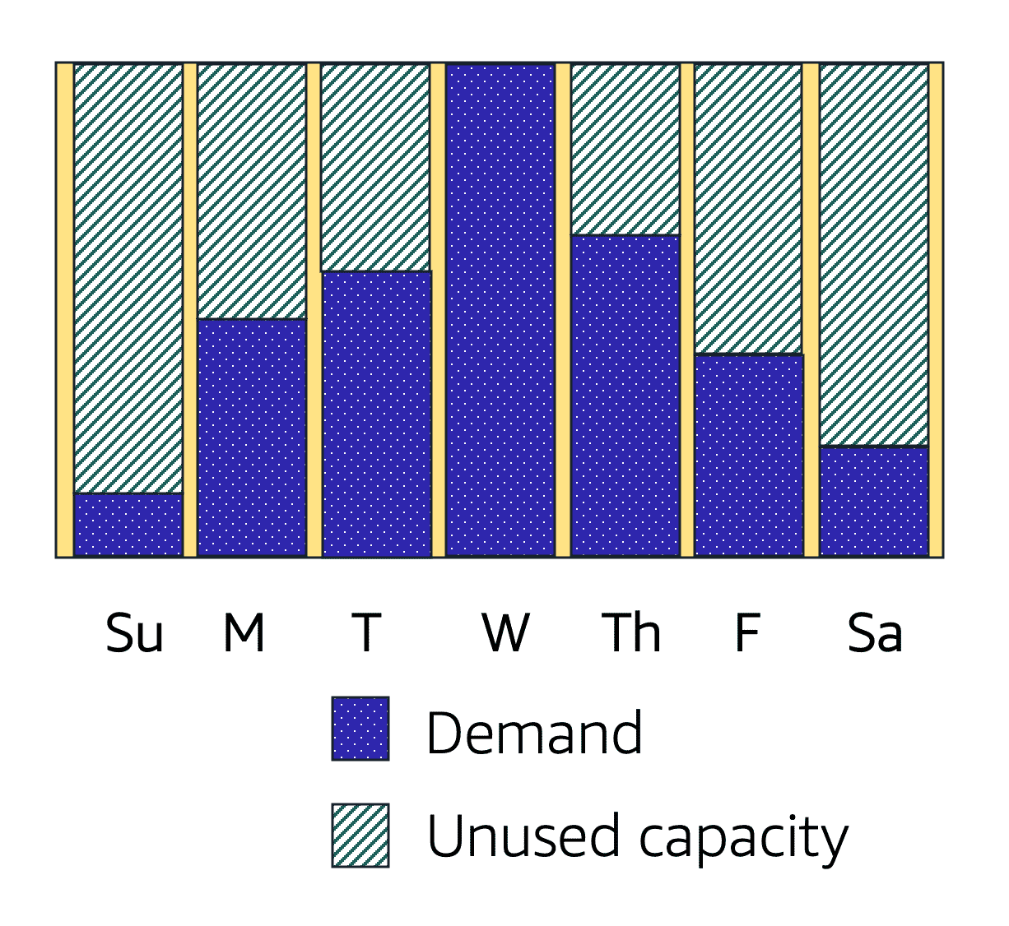

AWS EC2 Auto Scaling
EC2 Auto Scaling can be added as a buffer on top of your instances.
It can add new instances to the application when necessary and terminate them when no longer needed.
You can set up a group of instances.
Here you can set a minimum capacity of instances that will always be running. The rest will operate when necessary.
You can set the desired number of AWS EC2 instances in the scaling group.
However, the desired capacity defaults to your minimum capacity if not specified.
The last configuration is Maximum capacity.
Here you set the maximum capacity of instances to be used.
The Auto Scaling groups allow you to have a dynamic environment.
You set the minimum capacity, the desired number, and the maximum capacity.
The group will operate within the config and give you a predictable and cost-effective architecture.

Cloud Storage - AWS S3
AWS S3 is also called AWS Simple Storage Service.
S3 is a storage service.
It allows uploading any type of file.
In S3 you can set access permissions to a file.
It is object-level storage.
It offers unlimited space in the storage.
The maximum file size is 5 TB.

What is Object-Level Storage?
Object-level storage contains objects.
Each object is made of:
- Data - any type of file
- Metadata - information about what the data is
- Key - unique identifier

AWS S3 Storage Classes
There are many AWS S3 storage classes.
They differ in data availability.
How frequent data is retrieved and cost price.

S3 Standard
S3 Standard is ideal for data that is accessed often.
Provides high availability for stored objects.
It stores data in at least three Availability Zones.
It is the most expensive class.

S3 Standard-Infrequent Access
S3 Standard-Infrequent Access is also called S3 Standard-IA
S3 Standard-IA is ideal for data that is often accessed.
It has the same level of data availability as S3 Standard.
It stores data in at least three Availability Zones.
Lower storage price but higher data retrieval price.
It is higher priced than other classes.

S3 One Zone-IA (S3 One Zone-Infrequent Access)
It stores data in one Availability Zone.
It is cheaper than S3 Standard and S3 Standard-IA classes.

S3 Intelligent-Tiering
S3 Intelligent-Tiering requires automation and monitoring.
It is recommended for data with unknown or frequently changing access.
It moves the object to the S3 Standard-IA class if it is not accessed for 30 days.
It moves objects to S3 Standard if accessed in S3 Standard-IA or S3 One Zone-IA classes.

S3 Glacier
S3 Glacier is recommended for archiving data.
It can retrieve objects within a few minutes.
S3 Glacier is a cheaper and slower class.

S3 Glacier Deep Archive
S3 Glacier Deep Archive has the lowest cost.
Like S3 Glacier, it is best for archives.
Compared to S3 Glacier, S3 Glacier Deep Archive can retrieve objects within 12 hours.

AWS CloudWatch

Cloud Monitoring and Management Service - AWS CloudWatch
CloudWatch lets you monitor your resources.
It is a web-based service.
Configure the service to monitor and set alarms based on your metrics.

CloudWatch Alarms
CloudWatch lets you create automatic alarms.
Configure the alarms as you like.
Alarms are triggered at thresholds defined by you.
Alarms are used to control resources. For example, stop idle or near to inactive services.

CloudWatch Dashboard
Access CloudWatch from your browser.
It gives you an overview of your resources in one single view.
CloudWatch gives insights across AWS services.

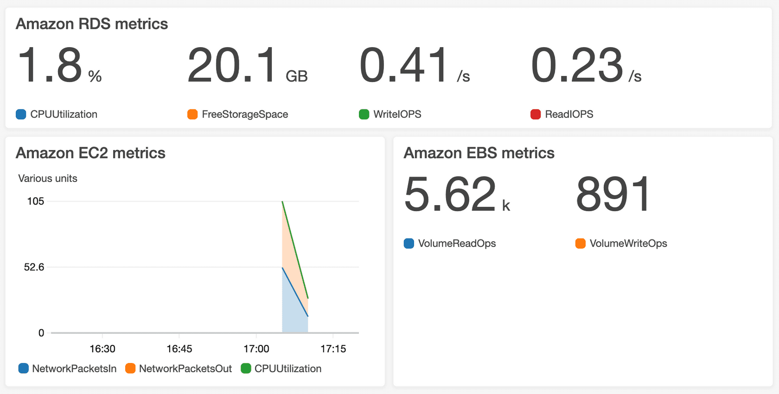
You can make many dashboards based on your needs.

- CloudWatch is a service used to monitor your AWS resources and applications that you run on AWS in real time. CloudWatch is used to collect and track metrics that measure your resources and applications.
- It displays the metrics automatically about every AWS service that you choose.
- You can create the dashboard to display the metrics about your custom application and also display the metrics of custom collections that you choose.
- You can also create an alarm to watch metrics. For example, you can monitor CPU usage, disk read and disk writes of Amazon EC2 instance to determine whether the additional EC2 instances are required to handle the load or not. It can also be used to stop the instance to save money.

Following are the terms associated with CloudWatch:
Dashboards: CloudWatch is used to create dashboards to show what is happening with your AWS environment.
Alarms: It allows you to set alarms to notify you whenever a particular threshold is hit.
Logs: CloudWatch logs help you to aggregate, monitor, and store logs.
Events: CloudWatch help you to respond to state changes to your AWS resources.

