Week 5
Task 1
Aim: To find the maximum possible sum of a subarray in a circular array, considering both normal and wrap-around subarrays.
Algorithm:
- Use Kadane’s algorithm to find the maximum subarray sum.
- Use Kadane’s algorithm to find the minimum subarray sum.
- Compute the total sum of the array.
- Calculate circular sum as totalSum − minSubarraySum.
- If all elements are negative, return the normal maximum subarray sum.
- Otherwise, return the maximum of normal sum and circular sum.
Program:
class Solution {
public int maxSubarraySumCircular(int[] nums) {
int total = 0;
int maxSum = nums[0];
int curMax = 0;
int minSum = nums[0];
int curMin = 0;
for (int n : nums) {
curMax = Math.max(curMax + n, n);
maxSum = Math.max(maxSum, curMax);
curMin = Math.min(curMin + n, n);
minSum = Math.min(minSum, curMin);

total += n;
}

if (maxSum < 0) return maxSum;

return Math.max(maxSum, total - minSum);
}
}

Output:

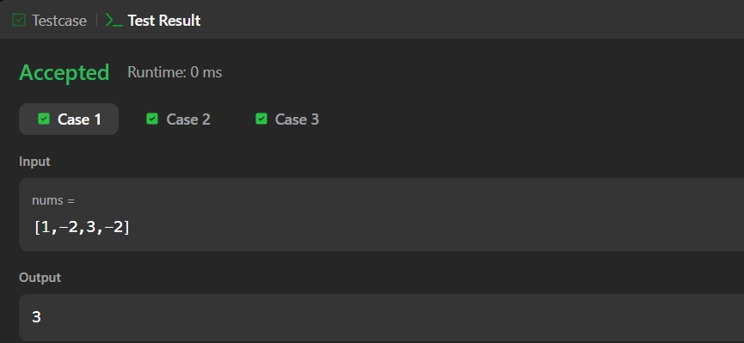

Result: To find the maximum possible sum of a subarray in a circular array, considering both normal and wrap-around subarrays has successfully verified.
Task 2
Aim: To find the number of contiguous segments of length m in the chocolate bar such that the sum of elements equals d.
Algorithm:
- Initialize count = 0 and sum = 0.
- Traverse the list from index 0 to n-1.
- Add the current element to sum.
- If window size exceeds m, subtract the element leaving the window (i - m).
- When window size becomes m, check:
  - If sum == d, increment count.
- After traversal, return count
Program:
class Result {
public static int birthday(List<Integer> s, int d, int m) {
int count = 0;
int sum = 0;
for (int i = 0; i < s.size(); i++) {
sum += s.get(i);
if (i >= m) {
sum -= s.get(i - m);
}
if (i >= m - 1 && sum == d) {
count++;
}
}
return count;

}}

Output:
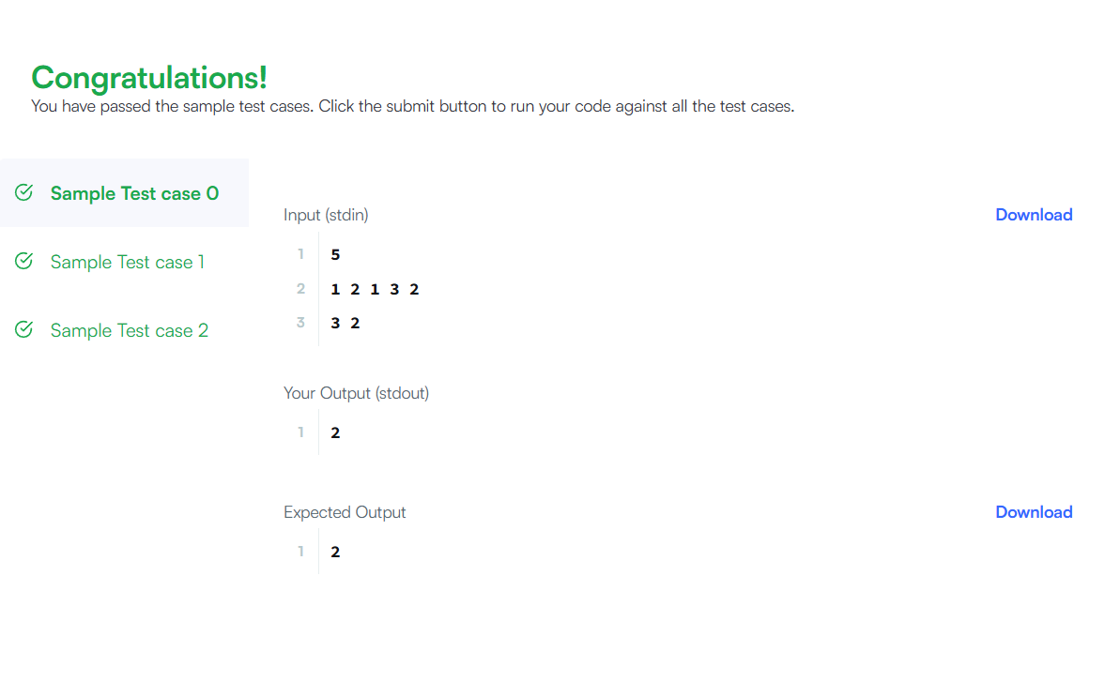

Result: To find the number of contiguous segments of length m in the chocolate bar such that the sum of elements equals d has successfully executed .
Task 3
Aim: To compute the maximum sum of a contiguous subarray and the maximum sum of a non-contiguous subsequence from a given integer array.
Algorithm:
- Initialize currentSum and maxSubarray with the first element.
- Traverse the array:
- Update currentSum = max(arr[i], currentSum + arr[i]).
- Update maxSubarray with the maximum value.
- For subsequence:
- Add all positive elements to maxSubsequence.
- Track the maximum element in the array.
- If no positive elements exist, set subsequence sum to the maximum element.
- Return both sums.
Program:
public static List<Integer> maxSubarray(List<Integer> arr) {
int maxSubarray = arr.get(0);
int currentSum = arr.get(0);
int maxSubsequence = 0;
int maxElement = arr.get(0);
for (int i = 0; i < arr.size(); i++) {
int val = arr.get(i);
if (i > 0) {
currentSum = Math.max(val, currentSum + val);
maxSubarray = Math.max(maxSubarray, currentSum);
}if (val > 0) {
maxSubsequence += val;
}

maxElement = Math.max(maxElement, val);
}

if (maxSubsequence == 0) {
maxSubsequence = maxElement;
} return Arrays.asList(maxSubarray, maxSubsequence);
}
Output:

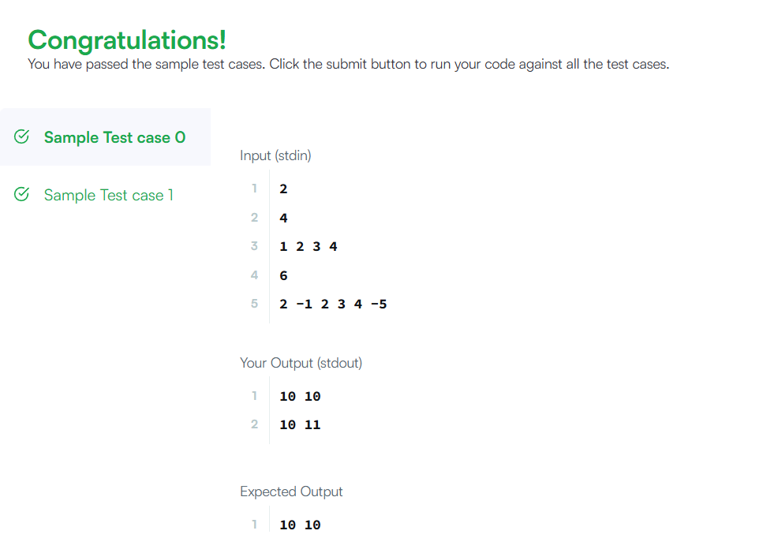

Result: To compute the maximum sum of a contiguous subarray and the maximum sum of a non-contiguous subsequence from a given integer array was successfully executed.
Task 4
Aim: To find the maximum sum of a contiguous subarray from the given integer array.
Algorithm:
- Initialize currentSum and maxSum with the first element.
- Traverse the array from the second element.
- For each element, update currentSum as the maximum of the current element or the sum of current element with previous sum.
- Update maxSum if currentSum is greater.
- Return maxSum.
Program:
class Solution {
public int maxSubArray(int[] nums) {
int currentSum = nums[0];
int maxSum = nums[0];
for (int i = 1; i < nums.length; i++) {
if (currentSum + nums[i] > nums[i]) {
currentSum = currentSum + nums[i];
} else {
currentSum = nums[i];
}
if (currentSum > maxSum) {
maxSum = currentSum;
}
}
return maxSum;
}
}

Output:

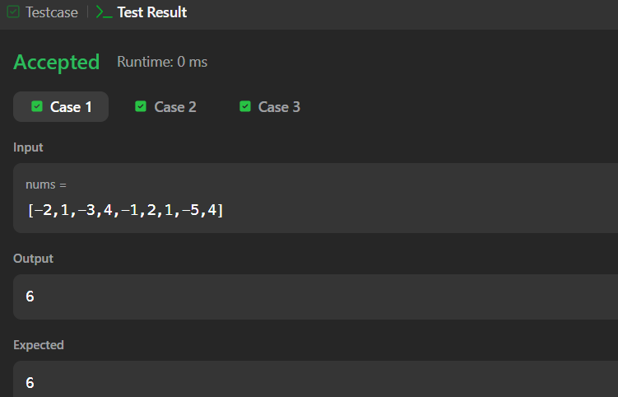

Result: To find the maximum sum of a contiguous subarray from the given integer array has successfully verified.
Task 5
Aim: Convert a given string into a 32-bit signed integer by handling spaces, sign, digits, and overflow.
Algorithm:
- Remove leading spaces using trim().
- If string is empty, return 0.
- Initialize variables
- sign = 1
- i = 0
- result = 0
- Check sign
- If '+' → positive
- If '-' → negative
- Move index forward.
- Traverse digits
- While character is digit, convert and build number
- result = result * 10 + digit
- Check overflow
- If result exceeds integer range, return Integer.MAX_VALUE or Integer.MIN_VALUE.
- Return final answer
- result * sign
Program:
class Solution {
public int myAtoi(String s) {
s = s.trim();
if (s.length() == 0) return 0;
int sign = 1;
int i = 0;
long result = 0;
if (s.charAt(i) == '-' || s.charAt(i) == '+') {
if (s.charAt(i) == '-') sign = -1;
i++;
}

while (i < s.length() && Character.isDigit(s.charAt(i))) {
result = result * 10 + (s.charAt(i) - '0');
if (sign * result > Integer.MAX_VALUE) return Integer.MAX_VALUE;
if (sign * result < Integer.MIN_VALUE) return Integer.MIN_VALUE;

i++;
}
return (int)(sign * result);
}
}
Output:
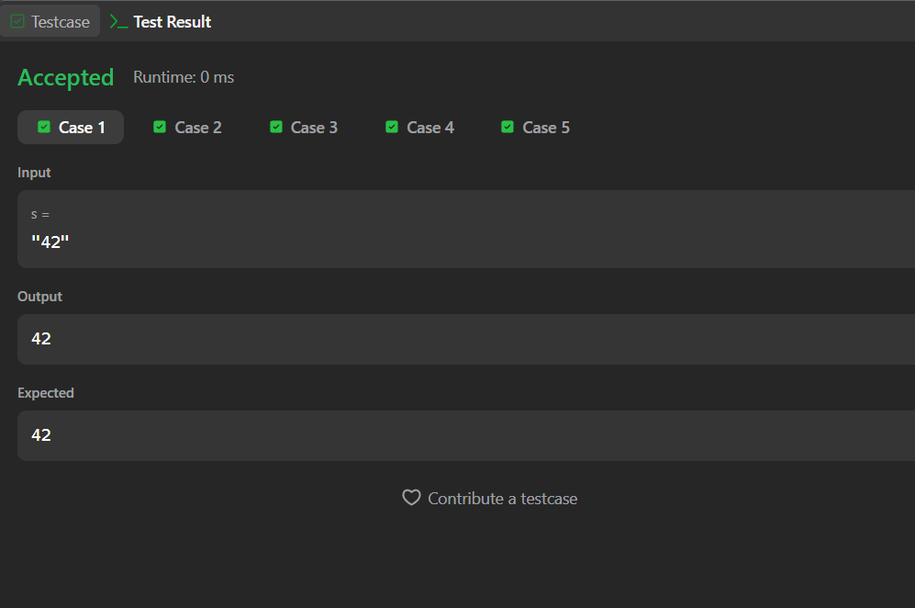

Result: Convert a given string into a 32-bit signed integer by handling spaces, sign, digits, and overflow has successfully executed.
Task 6
Aim: To find the minimum number of deletions required so that no two adjacent characters in the string are the same.
Algorithm:
- Initialize a variable count = 0.
- Traverse the string from index 1 to end.
- Compare current character with previous character.
- If both characters are the same, increment count (delete one character).
- After traversal, return count.
Program:
public static int alternatingCharacters(String s) {
int count = 0;
for (int i = 1; i < s.length(); i++) {
if (s.charAt(i) == s.charAt(i - 1)) {
count++;
}
}
return count;
}

Output:
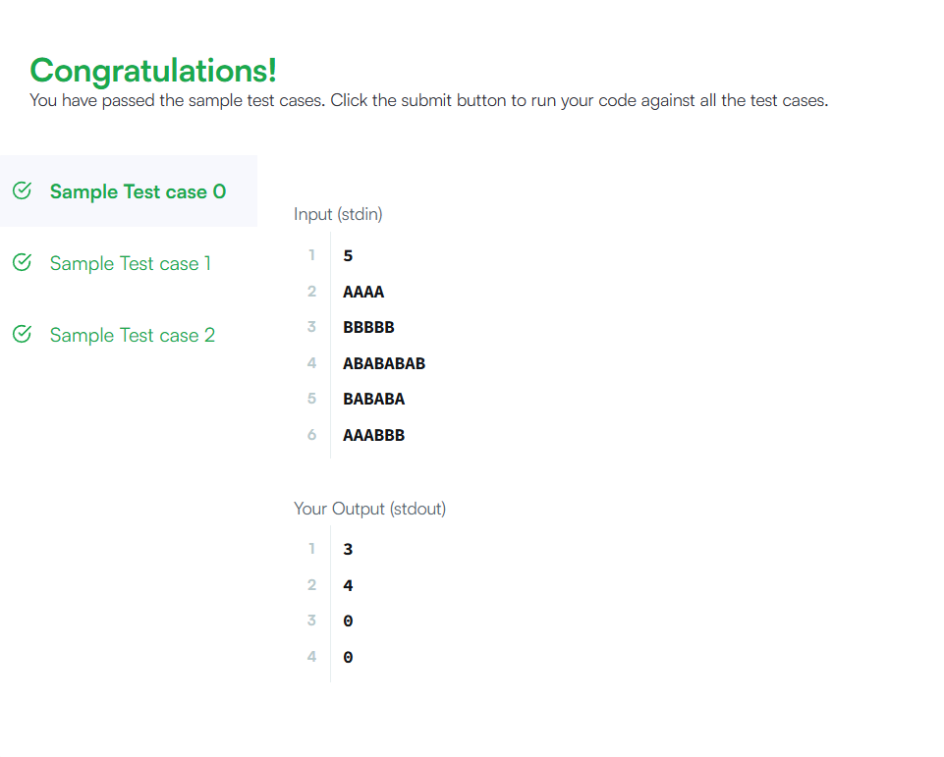

Result: To find the minimum number of deletions required so that no two adjacent characters in the string are the same has successfully executed.

Task 7
Aim: To find the length of the longest substring without repeating characters in a given string.
Algorithm:
- Use a sliding window with a HashSet to track characters without repetition while moving through the string.
- If a duplicate character appears, remove characters from the start until the substring becomes unique and update the maximum length.
Program:
import java.util.*;
class Solution {
public int lengthOfLongestSubstring(String s) {
Set<Character> set = new HashSet<>();
int left = 0, maxLength = 0;
for (int right = 0; right < s.length(); right++) {
while (set.contains(s.charAt(right))) {
set.remove(s.charAt(left));
left++;
}
set.add(s.charAt(right));
maxLength = Math.max(maxLength, right - left + 1);
}
return maxLength;
}
}

Output:
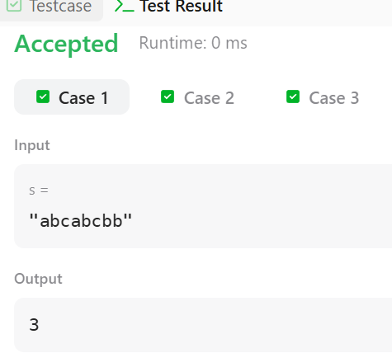

Result: The program successfully finds the maximum length of a substring without repeating characters.

Task 8
Aim: To identify all words in a given list that follow the same character pattern as the given pattern string.
Algorithm:
- Read the input array words and the string pattern.
- Create an empty list to store words that match the pattern.
- For each word in the array, check if its length matches the pattern length.
- Traverse characters of the word and pattern simultaneously and check if the mapping is consistent.
- If any character violates the mapping rule, discard the word and move to the next word.
- If all characters satisfy the bijection rule, add the word to the result list.
- Return the list containing all words that match the pattern.
Program :
import java.util.*;
class Solution {
public List<String> findAndReplacePattern(String[] words, String pattern) {
List<String> result = new ArrayList<>();
for (String word : words) {
if (isMatch(word, pattern)) {
result.add(word);
}
}
return result;
}
private boolean isMatch(String word, String pattern) {
int[] map1 = new int[26];
int[] map2 = new int[26];

Arrays.fill(map1, -1);
Arrays.fill(map2, -1);
for (int i = 0; i < word.length(); i++) {
int w = word.charAt(i) - 'a';
int p = pattern.charAt(i) - 'a';
if (map1[p] == -1 && map2[w] == -1) {
map1[p] = w;
map2[w] = p;
}
else if (map1[p] != w) {
return false;
}
}
return true;
}
}

Output:

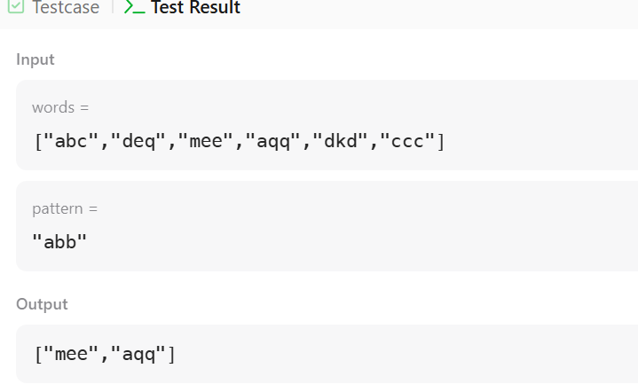

Result: The program successfully finds all words that follow the same pattern mapping as the given pattern.
Task 9
Aim: To find all strings in the array that appear as a substring of another string in the same array.
Algorithm:
- Read the input array words.
- Create an empty list result to store words that are substrings of another word.
- Use two loops to compare each word with every other word in the array.
- Skip comparison when both indices are the same (avoid comparing the word with itself).
- Check if words[i] is contained inside words[j] using the contains() method.
- If it is a substring, add words[i] to the result list and break the inner loop.
- After checking all words, return the result list.
Program :
import java.util.*;
class Solution {
public List<String> stringMatching(String[] words) {
List<String> result = new ArrayList<>();
for(int i = 0; i < words.length; i++) {
for(int j = 0; j < words.length; j++) {
if(i != j && words[j].contains(words[i])) {
result.add(words[i]);
break;
}
}
}
return result;
}
}

Output:

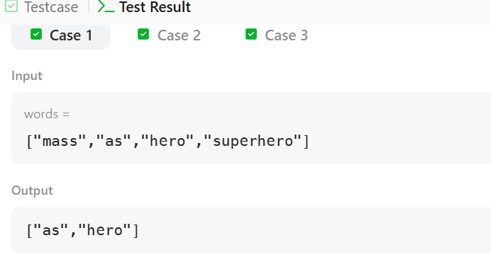

Result: The program successfully finds all words that are substrings of another word in the array.

Task 10
Aim: To check whether a pattern string exists inside a given text string using the Naive Pattern Searching method.
Algorithm:
- Read the input strings S (text) and P (pattern).
- Let N be the length of text and M be the length of the pattern.
- Slide the pattern over the text from index 0 to N − M.
- For each position i, compare characters of pattern P[j] with text S[i + j].
- If all M characters match, the pattern is found in the text.
- If any mismatch occurs, move the pattern one position to the right.
- Continue this process until all positions are checked and return true if pattern exists, otherwise false.
Program :
class Solution {
boolean search(String pat, String txt) {
int M = pat.length();
int N = txt.length();
for (int i = 0; i <= N - M; i++) {
int j;
for (j = 0; j < M; j++) {
if (txt.charAt(i + j) != pat.charAt(j)) {
break;
}
}
if (j == M) {
return true;
}
}
return false;
}
}
Output:
Input: txt = "geeksforgeeks", pat = "geeks"
Output: true

Result: The program successfully checks whether the pattern exists in the given string.

