TASK1
Aim : To determine whether the two halves of a given even-length string are alike by checking if both halves contain an equal number of vowels.
Algorithm:
- start
- Read the input string s.
- Find the midpoint of the string using mid = length / 2.
- Initialize two counters countA and countB to zero.
- Define a string containing all vowels (both uppercase and lowercase).
- Traverse from index 0 to mid - 1:
- If the character in the first half is a vowel, increment countA.
- If the corresponding character in the second half is a vowel, increment countB.
- Compare countA and countB.
- If both counts are equal, return true; otherwise, return false.
- stop
Program:
class Solution {
public boolean halvesAreAlike(String s) {
int mid = s.length() / 2;
int countA = 0, countB = 0;
String vowels = "aeiouAEIOU";
for (int i = 0; i < mid; i++) {
if (vowels.indexOf(s.charAt(i)) != -1) {
countA++;
}
if (vowels.indexOf(s.charAt(i + mid)) != -1) {
countB++;
}
}
return countA == countB;
}
}

Output:
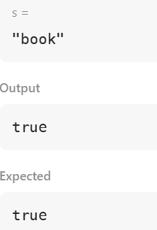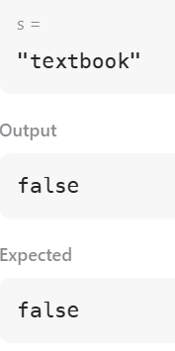

Task2

Aim: To check whether a given string is a lapindrome. A string is said to be a lapindrome if, after splitting it into two halves (ignoring the middle character if the length is odd), both halves contain the same characters with the same frequency.

Algorithm:
- Start.
- Read the number of test cases T.
- For each test case:
  - Read the string S.
  - Find the length n of the string.
  - Calculate the middle index mid = n / 2.
- Create two frequency arrays of size 26 (for lowercase English letters).
- Count the frequency of characters in the first half of the string.
- Count the frequency of characters in the second half of the string:
  - If the string length is odd, skip the middle character.
- Compare both frequency arrays:
  - If all frequencies match, the string is a lapindrome.
  - Otherwise, it is not a lapindrome.
- Print "YES" if the string is a lapindrome, else print "NO".
- Stop
Program :
import java.util.*;
import java.lang.*;
import java.io.*;
class Codechef {
public static void main (String[] args) throws java.lang.Exception {
Scanner sc = new Scanner(System.in);
int T = sc.nextInt();
while (T-- > 0) {
String s = sc.next();
int n = s.length();
int[] freq1 = new int[26];
int[] freq2 = new int[26];
int mid = n / 2;

for (int i = 0; i < mid; i++) {
freq1[s.charAt(i) - 'a']++;
}
for (int i = (n % 2 == 0 ? mid : mid + 1); i < n; i++) {
freq2[s.charAt(i) - 'a']++;
}
boolean isLapindrome = true;
for (int i = 0; i < 26; i++) {
if (freq1[i] != freq2[i]) {
isLapindrome = false;
break;
}
}
if (isLapindrome)
System.out.println("YES");
else
System.out.println("NO");
}
sc.close();
}
}

Output:

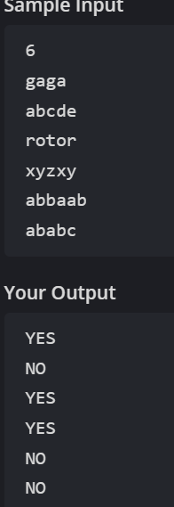

Result: The program successfully identifies whether each given string is a lapindrome or not by comparing the character frequencies of its two halves and displays “YES” for lapindrome strings and “NO” for non-lapindrome strings.

