US718691 Test Plan:-
Test Case | UserStory | Test Case Scenario | Expected Result | Comments
1 | US768800 | 1) Start a new 381 quote.  2) Proceed to "Dwelling" page.  3) Select the number of resident living on same premises >1.  4) Check for the personal liability(CPL) or Premises liability(PREM) or Premises liability including lead (PREML), if not add any one of the coverage.  5) Click on continue and save. | The UW Rule Number 9548A should be fired. | Pass
2 | US768800 | 1) Start a new 381 quote.  2) Proceed to "Dwelling" page.  3) Select the number of resident living on same premises <1.  4) Check for the personal liability(CPL) or Premises liability(PREM) or Premises liability including lead (PREML), if not add any one of the coverage.  5) Click on continue and save. | The UW Rule Number 9548A should not be fired. | Pass

Scenario/s: -
- 9548A Should be fired:

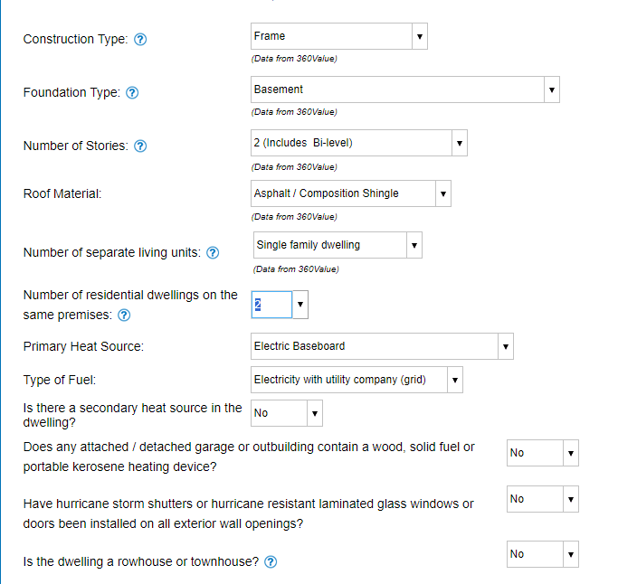

PREML:
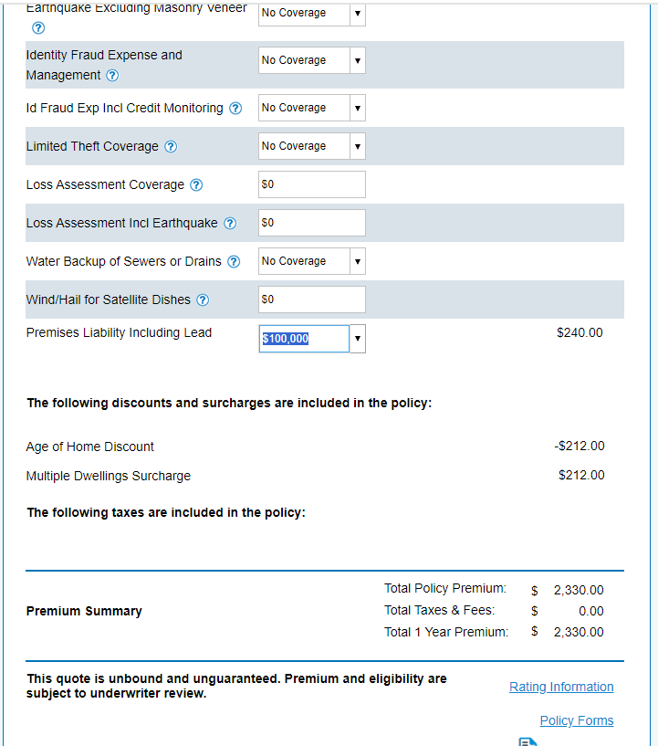
PREM:
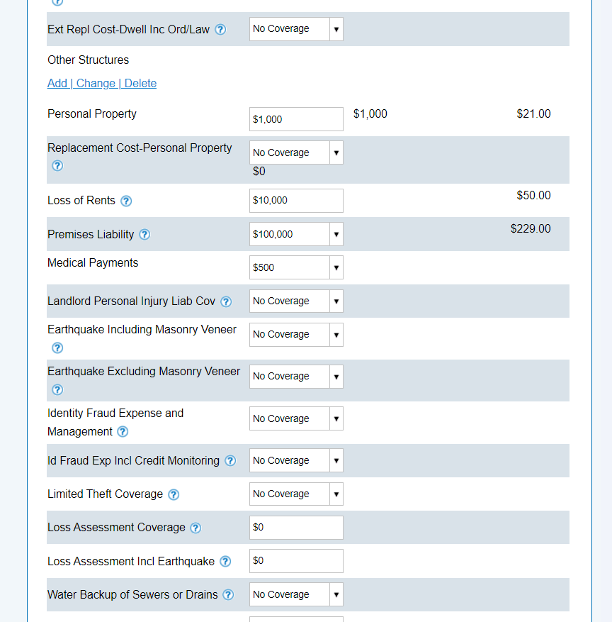
CPL:
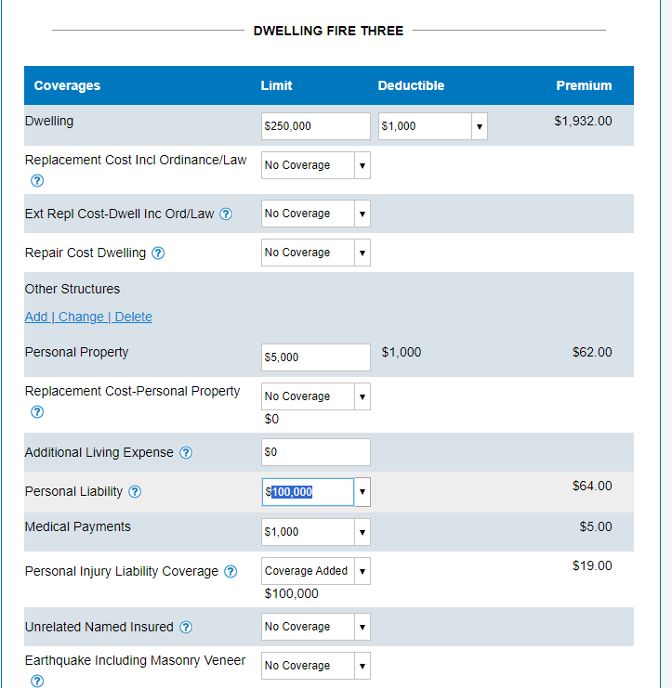
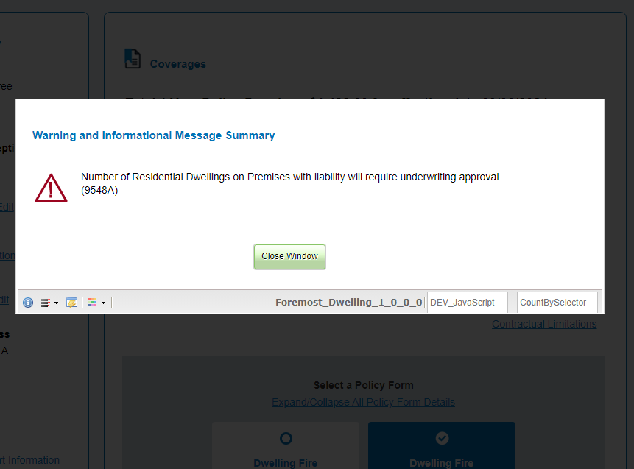
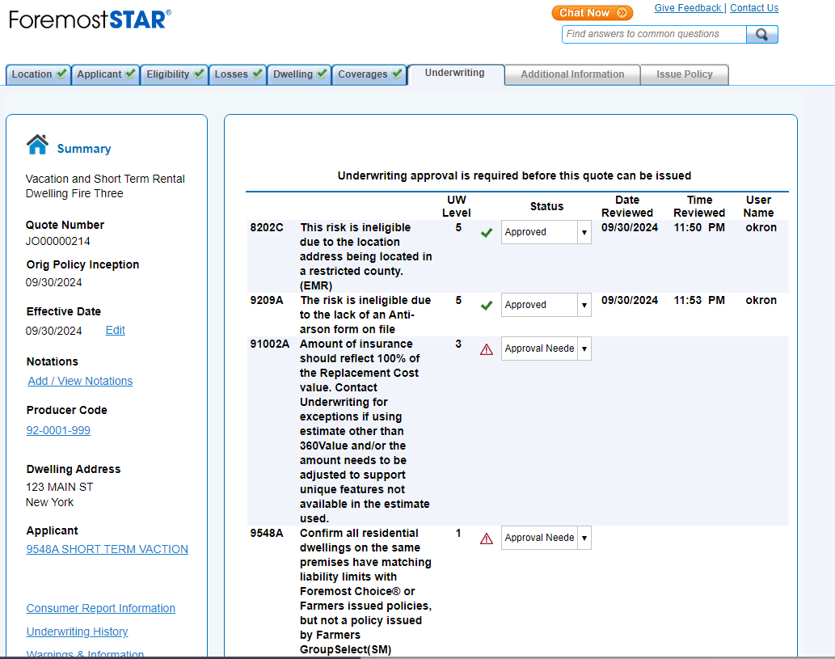

- 9548A shouldn’t be fired:
