**Business Problem:**

Given a user comment, we need to identify the classes of toxicity it will fall into. This is a Multi-label classification (toxic, severe_toxic, obscene, threat, insult, identity_hate)

**Exploratory Data Analysis:**

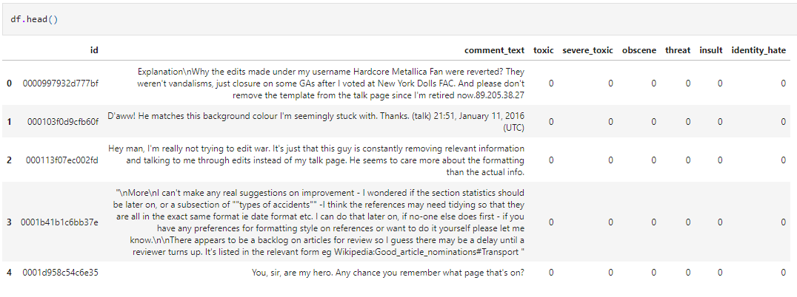

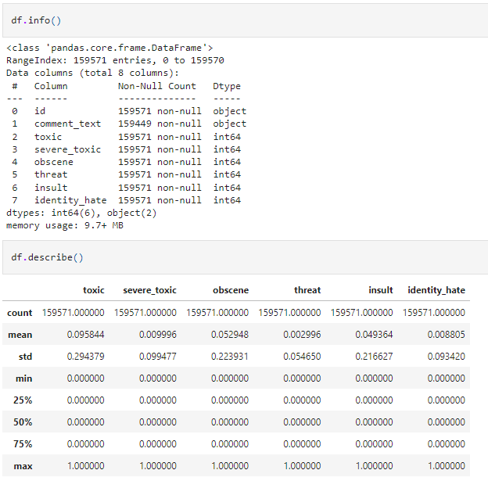

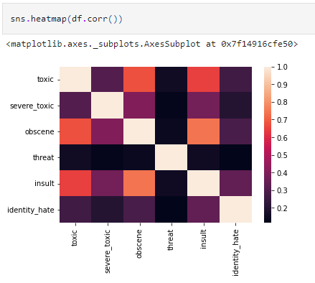

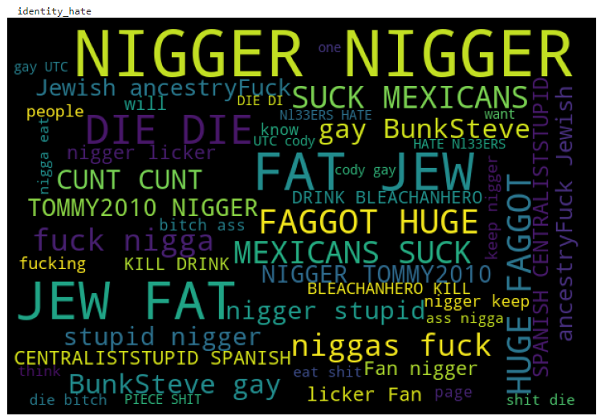

**Data preprocessing:**

* Removing special characters.
* Converting everything to lowercase
* Stop word removal
* Lemmatization
* Removing extra space characters
* Removing words with less than 2 characters
* Removing NULL values

**Vectorization:**

Tf-Idf weighted word2vector

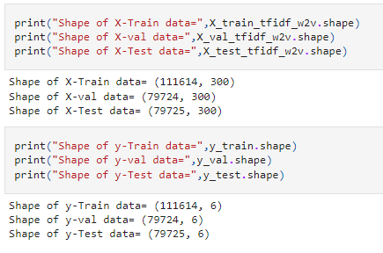

**Baseline Models:**

BinaryRelevance

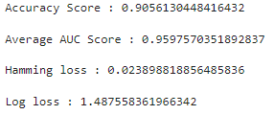

Label PowerSet

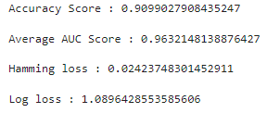

**Neural Networks:**

DNN:

accuracy: 0.9670

avg_AUC: 0.9728

Hamming_Loss: 0.0205

Log_Loss: 1.6014

Bi-directional LSTM:

accuracy: 0.9917

avg_AUC: 0.5366

Hamming_Loss: 0.0432

Log_Loss: 0.4641

**Confusion Matrix:**

DNN:

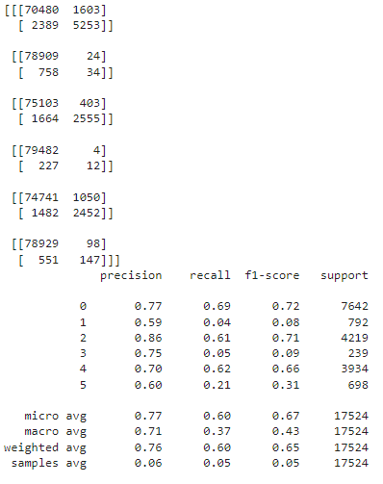

Bi-directional LSTM:

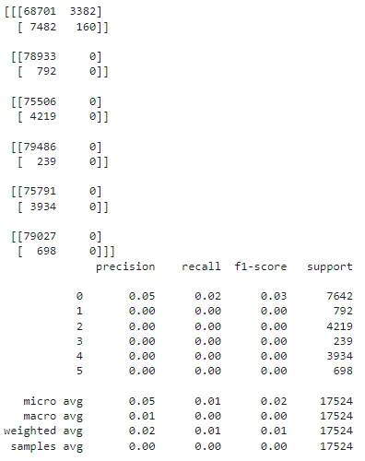

**Future work:**

* Splitting the train, test and validation datasets using stratification technique.
* Performing Hyper-parameter tuning for the Deep Learning models using Optuna library.
* Using Bert
* …