/**************************************************************************

TITLE: RPC - REMOTE PROCEDURE CALL

**************************************************************************/

//SERVER FILENAME: server.c

#include"rpc/rpc.h"

#include"square.h"

#include"stdio.h"

#include"stdlib.h"

#include"math.h"

square_out *squareproc_1_svc(square_in *inp,**struct** svc_req *rqstp)

{

**static** square_out out;

out.res1= inp->arg1 * inp->arg1;

**return**(&out);

}

// CLIENT FILENAME: client.c

#include"errno.h"

#include"rpc/rpc.h"

#include"square.h"

#include"stdio.h"

#include"stdlib.h"

#include"math.h"

**int** main(**int** argc,**char** **argv)

{

CLIENT *cl;

square_in in;

square_out *outp;

f(argc!=3)

{

printf("\n\n error:insufficient arguments!!!");

exit(-1);

}

cl=clnt_create(argv[1],SQUARE_PROG,SQUARE_VERS,"tcp");

in.arg1=atol(argv[2]);

**if**(cl==NULL)

{

printf("\nerror:%s",strerror(errno));

exit(-1);

}

**if**((outp=squareproc_1(&in,cl))==NULL)

{

printf("\nerror :%s",clnt_sperror(cl,argv[1]));

exit(-1);

}

printf("\n\n result is : %ld",outp->res1);

exit(0);

}

// .h FILENAME: square.h

**struct** square_in

{

/*input arg*/

**long** arg1;

};

**struct** square_out

{

/*op result*/

**long** res1;

};

program SQUARE_PROG

{

version SQUARE_VERS

{

square_out SQUAREPROC(square_in)=1; /*proc no=1*/

}=1; /*version no*/

}=0x31230000;/*prog no*/

[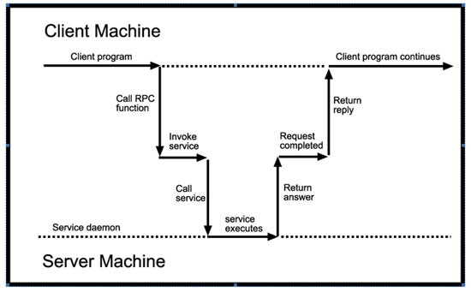](http://img.c4learn.com/2012/02/RPC-diagram.jpg)

**Output & Execution :**

[root@localhost~]#rpcgen -C square.x

[root@localhost~]#cc -c client.c -o client.o

[root@localhost~]#cc -c square_clnt.c -o square_clnt.o

[root@localhost~]#cc -c square_xdr.c -o square.xdr.o

[root@localhost~]#cc -o client client.o square_clnt.o square_xdr.o

[root@localhost~]#cc -c client.c server.c square_xdr.c

[root@localhost~]#cc -c server.c -o server.o

[root@localhost~]#cc -c square_svc.c -o square_svc.o

[root@localhost~]#cc -o server server.o square_svc.o square_xdr.o

[root@localhost~]#./server &

[1] 2264

[root@localhost~]#./client localhost 4

result is: 16