**DISTRIBUTED SYSTEMS PROJECT 1**

**MYWAYPOINTS**

Lakshmi Vennela Veerisetty

Person Number: 50286879

Email: [lveerise@buffalo.edu](mailto:lveerise@buffalo.edu)

1.**Scope**

To develop a web application to display the route and weather conditions along the requested path from source to destination by web API calls and log the requested data into the database.

2.**Introduction**

MYWAYPOINTS is a web based map application, which will provide the route and weather along the route from the source to destination by using the google maps API, weather API on the User Interface. The UI has the source and destination input fields, when inputted those fields, and clicking the submit button, a map with the waypoints in the route is obtained. When mouse is hovered on the waypoints, it contains the precipitation and weather details. From the APIs, we get the data in the JSON format, and in the frontend we send it in the xml format.

3.**Design and Modules**:

This application has three modules: User Interface, Server and Database

User Interface: In the user interface initially a form should be submitted with the source and destination text fields. On submitting this data, it is sent to the server.

Server: Server will handle web API calls to the google maps API and logging/fetching of data from the database. Server will log every new route data into the database.

Database: Here the data collected for each waypoints in the route are stored.

4.**Technology Stack Used**:

HTML, CSS, JS, PHP, MYSQL, Apache Tomcat Server.

5. **Functioning (phase 1)**: This is the landing page of the project

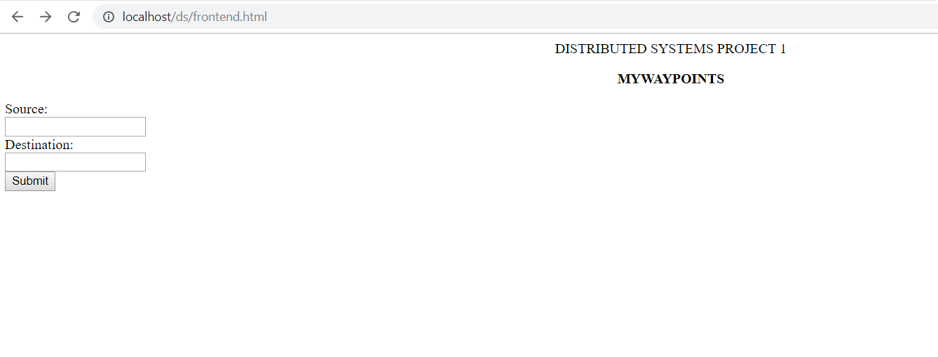

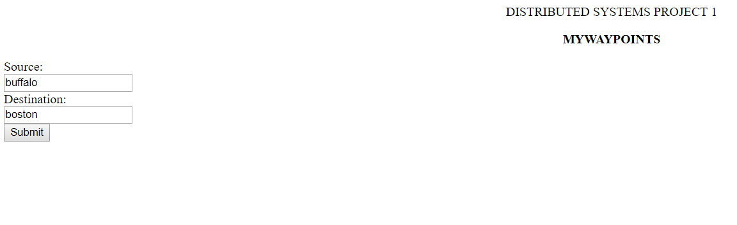

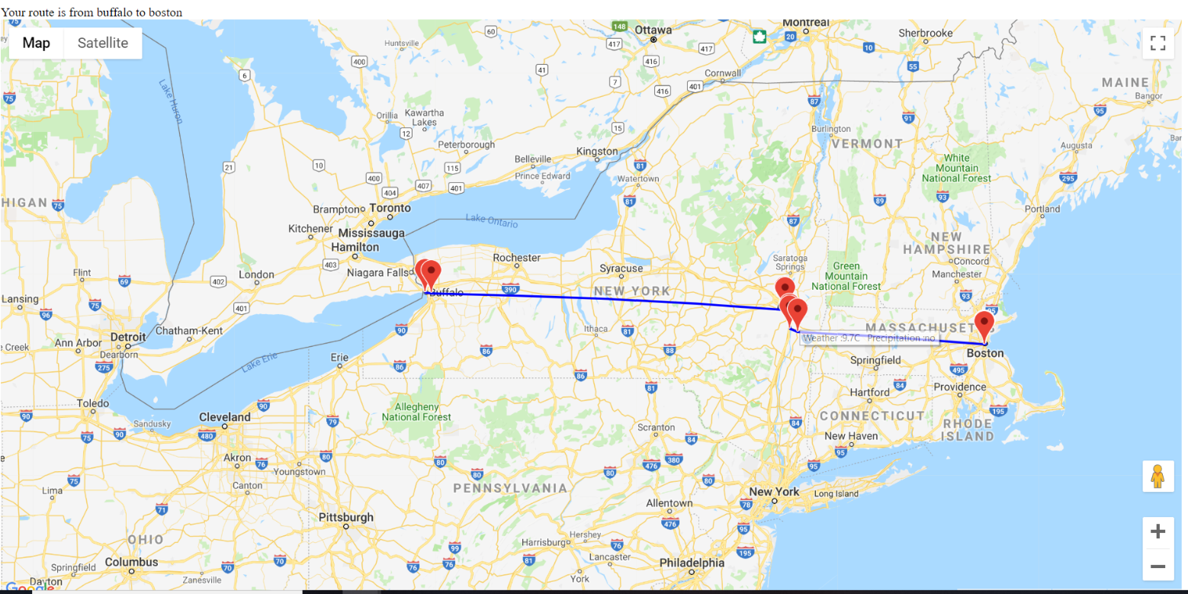

Finally, the waypoints are as shown and the weather and precipitation are also shown when the mouse is being hovered on the waypoints.

6.**Functioning (phase 2)**: For the phase 2, the waypoints weather and precipitation are cached in the database, so that when a different user wants to search the same route, the API hits are avoided so that the retrieving will be fast from the database rather than calling the API.



Here the API is not being called rather the waypoints information is retrieved from the database.

7**. References**:

1. <https://developers.google.com/maps/documentation/>

2. <https://cloud.google.com/maps-platform/>

3. <https://openweathermap.org/api>