1
Name :B.vennela
192412604

Simulation of LTE throughput performance under varying bandwidth, SNR,
modulation order, coding rate, and user load
Aim : To simulate a Frequency Division Multiple Access (FDMA) system using MATLAB
and analyze its communication performance in terms of channel bandwidth, data rate, and
signal-to-noise ratio (SNR).
Code: clc; clear; close all;
fs=1000; t=0:1/fs:1;
TBW=600; Users=3;

CBW=TBW/Users;
fc=[100 300 500];
m=sin(2*pi*10*t);
s1=m.*cos(2*pi*fc(1)*t);
s2=m.*cos(2*pi*fc(2)*t);
s3=m.*cos(2*pi*fc(3)*t);
subplot(2,1,1)
plot(t,s1,'r',t,s2,'g',t,s3,'b'),grid on
title('FDMA Channel Allocation'),xlabel('Time (s)'),ylabel('Amplitude')
subplot(2,1,2)
bar(1:Users,CBW*ones(1,Users)),grid on
xlabel('Users'),ylabel('Channel Bandwidth (kHz)'),title('Channel Bandwidth per User')
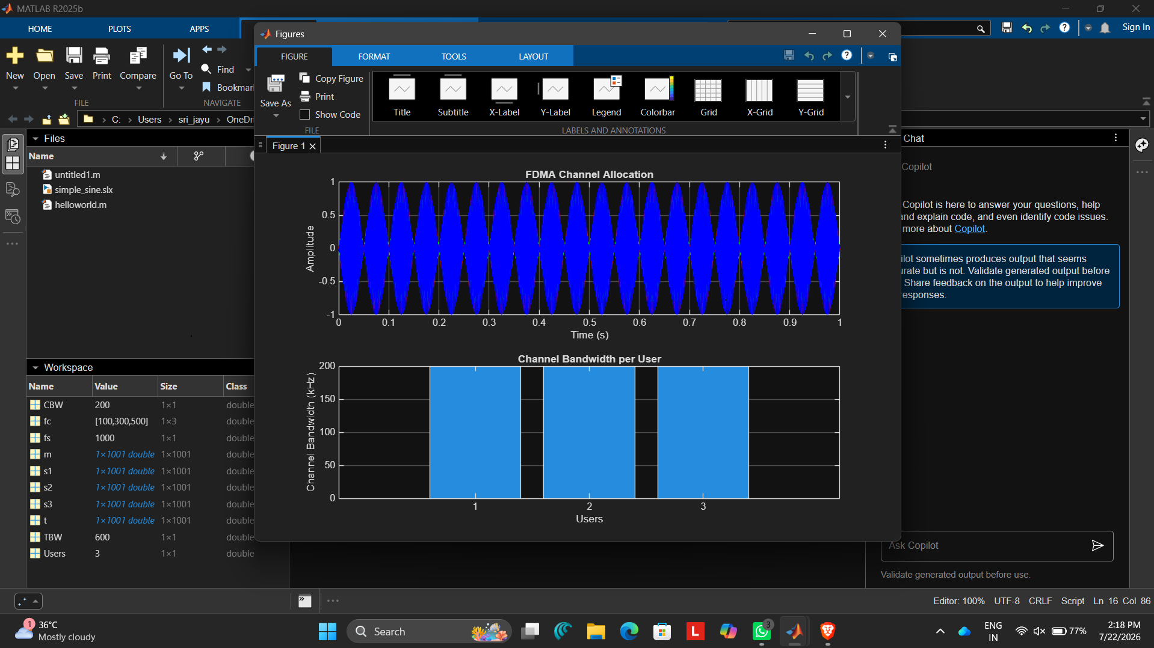

Result :The FDMA system was successfully simulated by allocating separate frequency channels
to three users, and the channel bandwidth assigned to each user was determined.

2 Simulation of LTE protocol stack delay analysis under uplink traffic, downlink traffic,
packet size, retransmission count, and channel quality (BL4)
code : clc;
clear;
close all;

%% LTE Protocol Stack Delay Analysis

% Packet Sizes (Bytes)
packetSize = [64 128 256 512 1024 1500];

% Retransmission Count
retransmission = [0 1 2 3];

% Channel Quality (CQI)
CQI = 1:15;

uplinkDelay = zeros(length(packetSize),length(CQI));
downlinkDelay = zeros(length(packetSize),length(CQI));

%% Delay Calculation

for i = 1:length(packetSize)

for j = 1:length(CQI)

baseDelay_UL = 5; % ms
baseDelay_DL = 3; % ms

packetDelay = packetSize(i)/250;

channelDelay = (16-CQI(j))*0.8;

retransDelay = retransmission(end)*2;

uplinkDelay(i,j)=baseDelay_UL+packetDelay+channelDelay+retransDelay;

downlinkDelay(i,j)=baseDelay_DL+packetDelay+(channelDelay*0.7)+(retransDelay*0.8);

end

end

%% Plot 1 - Uplink Delay

figure;

plot(CQI,uplinkDelay','LineWidth',2);

grid on;

xlabel('Channel Quality Index (CQI)');
ylabel('Delay (ms)');
title('LTE Uplink Protocol Stack Delay');

legend('64B','128B','256B','512B','1024B','1500B','Location','northeast');

%% Plot 2 - Downlink Delay

figure;

plot(CQI,downlinkDelay','LineWidth',2);

grid on;

xlabel('Channel Quality Index (CQI)');
ylabel('Delay (ms)');
title('LTE Downlink Protocol Stack Delay');

legend('64B','128B','256B','512B','1024B','1500B','Location','northeast');

%% Retransmission Analysis

avgUL = [];
avgDL = [];

for r = retransmission

avgUL = [avgUL mean(uplinkDelay(:))+r*2];

avgDL = [avgDL mean(downlinkDelay(:))+r*1.5];

end

figure;

plot(retransmission,avgUL,'-o','LineWidth',2);
hold on;

plot(retransmission,avgDL,'-s','LineWidth',2);

grid on;

xlabel('Retransmission Count');

ylabel('Average Delay (ms)');

title('Impact of Retransmissions');

legend('Uplink','Downlink');

%% Packet Size Analysis

avgPacketUL = mean(uplinkDelay,2);
avgPacketDL = mean(downlinkDelay,2);

figure;

plot(packetSize,avgPacketUL,'-o','LineWidth',2);
hold on;

plot(packetSize,avgPacketDL,'-s','LineWidth',2);

grid on;

xlabel('Packet Size (Bytes)');
ylabel('Average Delay (ms)');
title('Packet Size vs LTE Delay');
legend('Uplink','Downlink');

%% Display Results

disp('Average Uplink Delay (ms)');
disp(mean(uplinkDelay(:)));

disp('Average Downlink Delay (ms)');
disp(mean(downlinkDelay(:)));
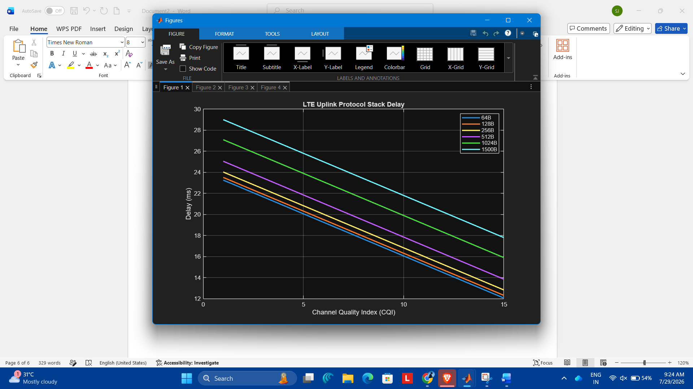

Exp : 3
. Simulation of carrier aggregation performance in LTE-Advanced under single carrier,
dual carrier, triple carrier, varying bandwidth, and SNR (BL4)
code: clc;
clear;
close all;

% Bandwidth (MHz)
bandwidth = [5 10 15 20];

% SNR (dB)
snr = 0:5:30;

% Throughput Calculation (Mbps)
single = bandwidth * 5;
dual = bandwidth * 10;
triple = bandwidth * 15;

% Graph 1: Throughput vs Bandwidth
figure;
plot(bandwidth, single,'-o','LineWidth',2);
hold on;
plot(bandwidth, dual,'-s','LineWidth',2);
plot(bandwidth, triple,'-^','LineWidth',2);

grid on;
xlabel('Bandwidth (MHz)');
ylabel('Throughput (Mbps)');
title('Carrier Aggregation vs Bandwidth');
legend('Single Carrier','Dual Carrier','Triple Carrier');

% Graph 2: Throughput vs SNR
single_snr = 20 + snr*2;
dual_snr = 40 + snr*2.5;
triple_snr = 60 + snr*3;

figure;
plot(snr, single_snr,'-o','LineWidth',2);
hold on;
plot(snr, dual_snr,'-s','LineWidth',2);
plot(snr, triple_snr,'-^','LineWidth',2);

grid on;
xlabel('SNR (dB)');
ylabel('Throughput (Mbps)');
title('Carrier Aggregation vs SNR');
legend('Single Carrier','Dual Carrier','Triple Carrier');
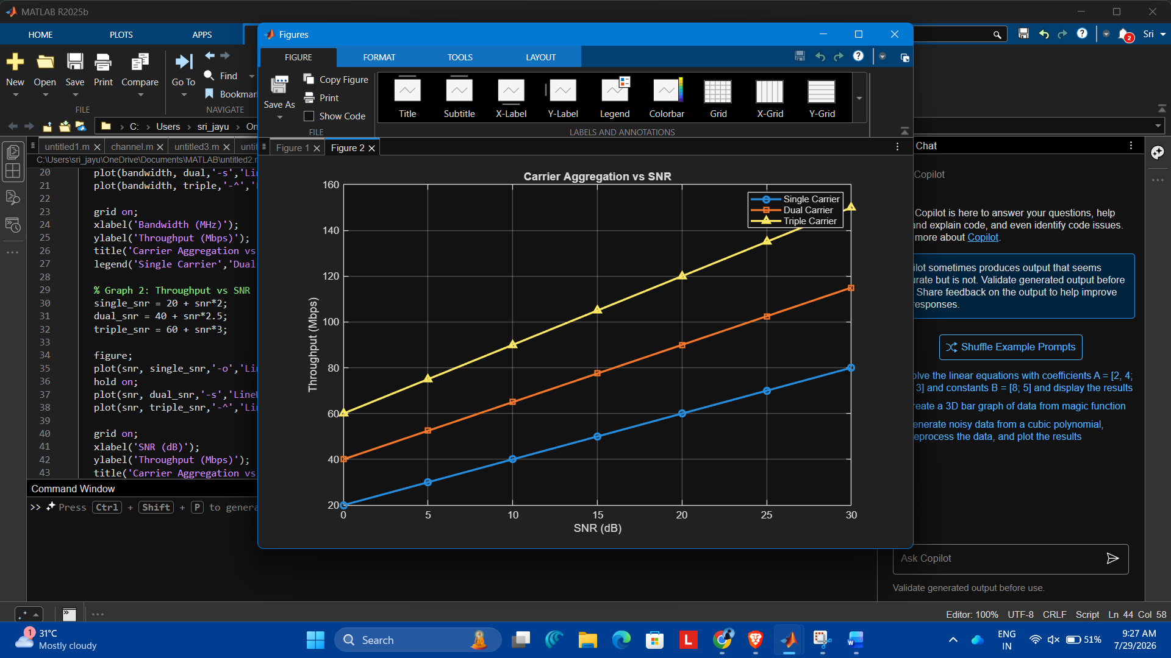
re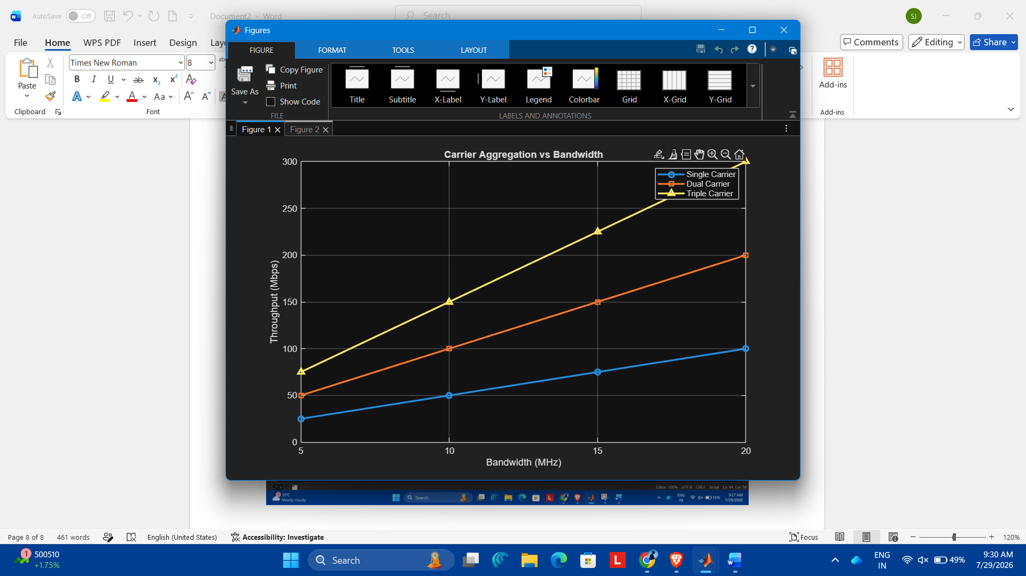
result: Throughput increases as bandwidth increases.
Gra: Throughput increases as SNR increases, with triple carrier giving the highest throughput, followed by dual carrier, then single carrier

Exp :4
Simulation of LTE resource block allocation under different user numbers, scheduling
methods, bandwidths, traffic load, and interference levels (BL4)
code : clc;
clear;
close all;

% Number of Users
users = [10 20 30 40 50];

% Bandwidth (MHz)
bandwidth = [5 10 15 20 25];

% Resource Blocks Allocated
RB = bandwidth * 5;

% Graph 1: Resource Blocks vs Number of Users
figure;
plot(users,RB,'-o','LineWidth',2);

grid on;
xlabel('Number of Users');
ylabel('Allocated Resource Blocks');
title('LTE Resource Block Allocation vs Users');

% Traffic Load (%)
traffic = [20 40 60 80 100];

% Interference Levels
low = [95 90 85 80 75];
medium = [90 82 74 66 58];
high = [80 68 56 44 32];

% Graph 2: Resource Allocation Efficiency
figure;
plot(traffic,low,'-o','LineWidth',2);
hold on;
plot(traffic,medium,'-s','LineWidth',2);
plot(traffic,high,'-^','LineWidth',2);

grid on;
xlabel('Traffic Load (%)');
ylabel('Allocation Efficiency (%)');
title('LTE Resource Allocation under Interference');
legend('Low Interference','Medium Interference','High Interference');
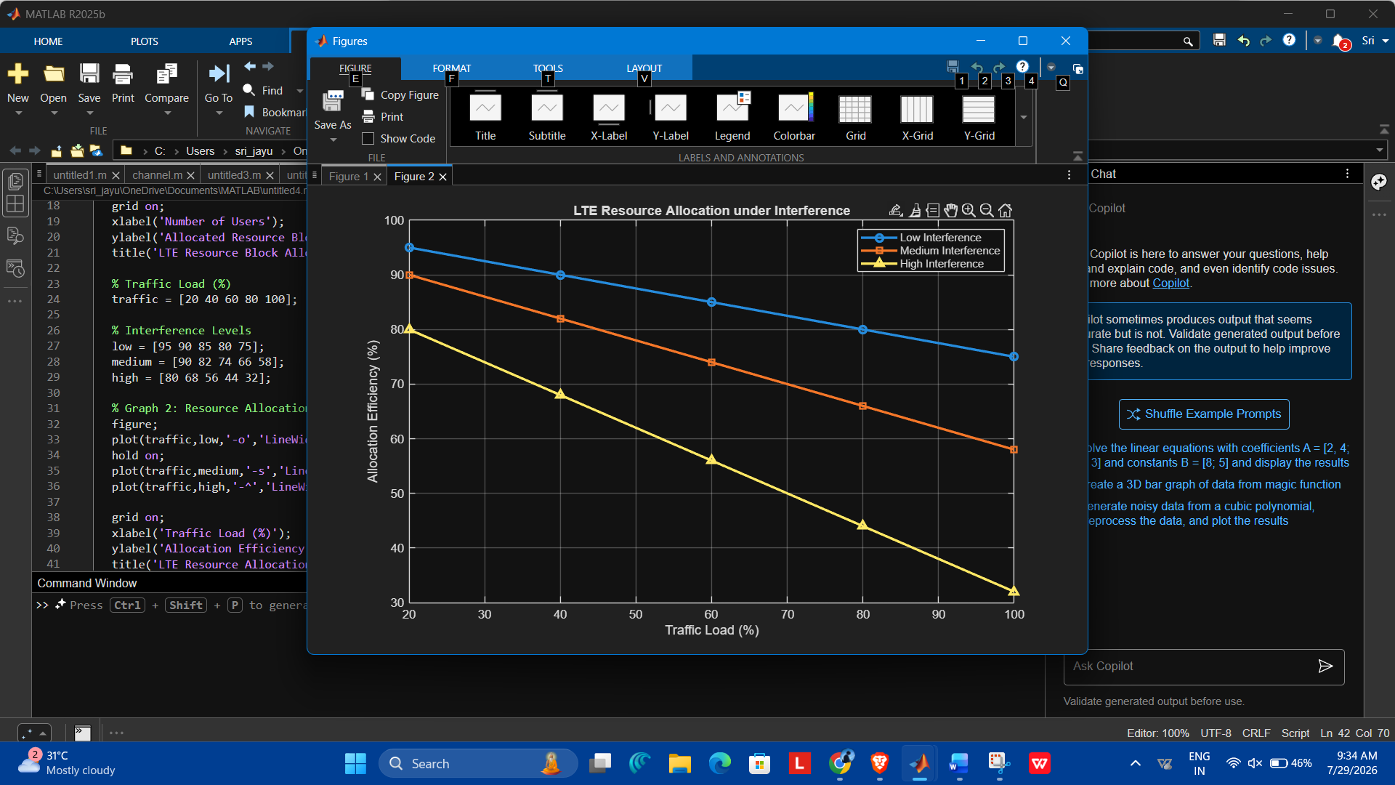
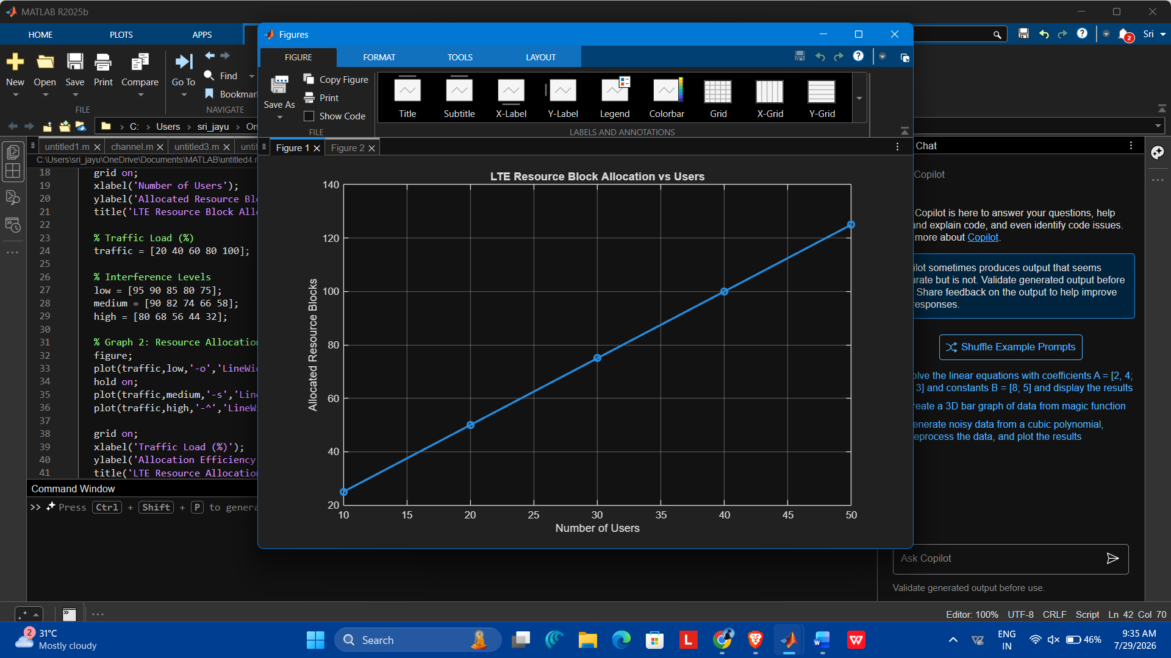

Exp: 5
Simulation of LTE scheduler performance using Round Robin, Proportional Fair,
C/I, delay variation, and throughput comparison (BL4)
Code : clc;
clear;
close all;

% Number of Users
users = [10 20 30 40 50];

% Average Throughput (Mbps)
RR = [20 35 48 58 65];
PF = [25 42 58 72 82];
MaxCI = [30 50 68 85 98];

% Graph 1: Throughput Comparison
figure;
plot(users,RR,'-o','LineWidth',2);
hold on;
plot(users,PF,'-s','LineWidth',2);
plot(users,MaxCI,'-^','LineWidth',2);

grid on;
xlabel('Number of Users');
ylabel('Throughput (Mbps)');
title('LTE Scheduler Throughput Comparison');
legend('Round Robin','Proportional Fair','Max C/I');

% Average Delay (ms)
delay_RR = [15 18 21 24 28];
delay_PF = [12 14 17 19 22];
delay_MaxCI = [10 11 13 15 18];

% Graph 2: Delay Comparison
figure;
plot(users,delay_RR,'-o','LineWidth',2);
hold on;
plot(users,delay_PF,'-s','LineWidth',2);
plot(users,delay_MaxCI,'-^','LineWidth',2);

grid on;
xlabel('Number of Users');
ylabel('Delay (ms)');
title('LTE Scheduler Delay Comparison');
legend('Round Robin','Proportional Fair','Max C/I');
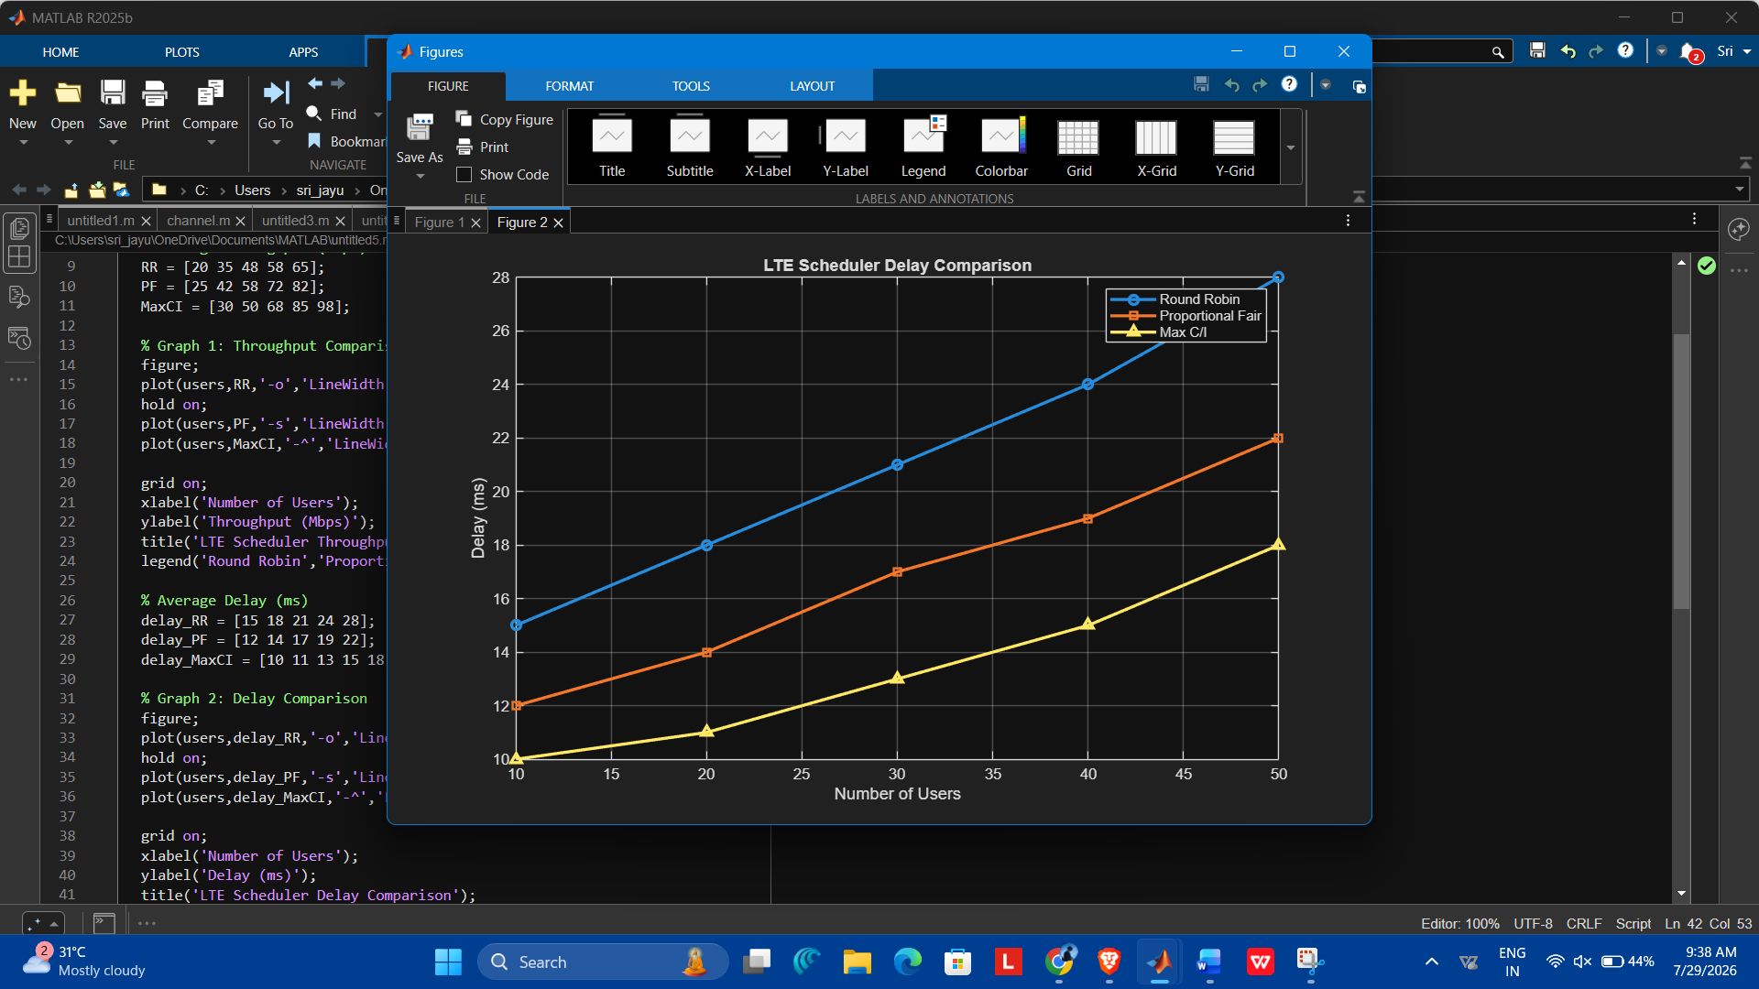
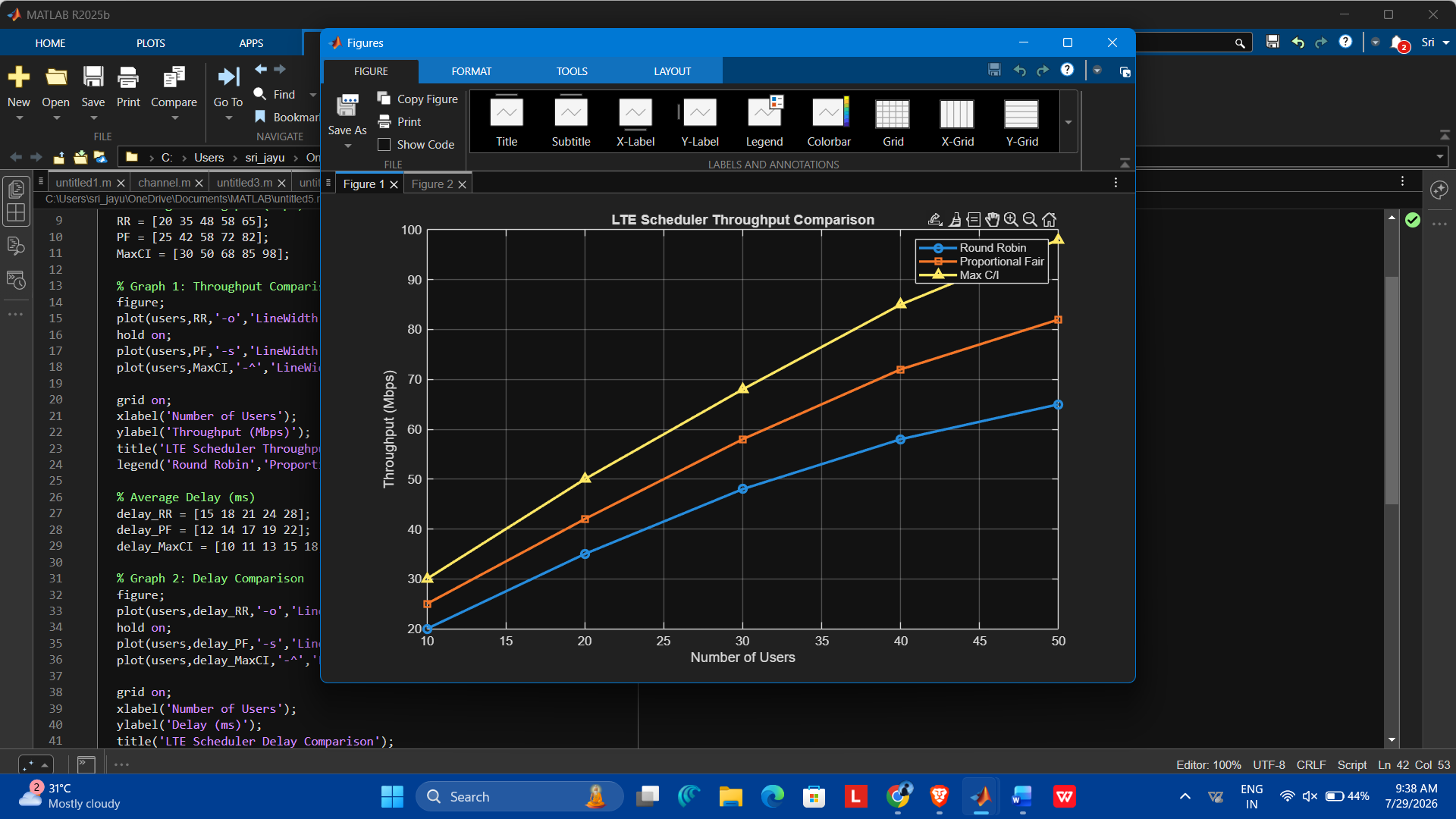
Result: • Graph 1: Max C/I achieves the highest throughput, followed by Proportional Fair, while Round Robin has the lowest throughput.
• Graph 2: Max C/I has the lowest delay, Proportional Fair provides a balance between delay and fairness, and Round Robin has the highest delay as the number of users increases.

