Q1
1. Design a system architecture for Multi-access Edge Computing to reduce latency in
smart traffic applications.

Aim
To design and simulate a Multi-access Edge Computing (MEC) based smart traffic system in MATLAB to process traffic data at the edge and reduce communication and processing
Algorithm
- Initialize the smart traffic system.
- Generate traffic sensor data such as vehicle count and vehicle speed.
- Send the sensor data to the nearby MEC server.
- Process the traffic information at the edge.
- Classify traffic as low, medium, or high.
- Generate an appropriate traffic-signal decision.
- Calculate the edge processing latency.
- Send traffic information to the cloud for long-term analysis.
- Repeat the process for multiple sensor readings.
- Display traffic conditions, decisions, and latency.
Code :
clc;
clear;
close all;

% Number of simulation samples
N = 10;

% Generate traffic data
vehicleCount = randi([10 100], 1, N);

% Simulated MEC latency (milliseconds)
mecLatency = 2 + 0.03 * vehicleCount + rand(1,N);

% Simulated Cloud latency (milliseconds)
cloudLatency = 30 + 0.15 * vehicleCount + rand(1,N);

% Plot latency comparison
figure;

plot(vehicleCount, mecLatency, '-o', 'LineWidth', 2);
hold on;
plot(vehicleCount, cloudLatency, '-s', 'LineWidth', 2);

xlabel('Number of Vehicles');
ylabel('Latency (ms)');
title('MEC vs Cloud Latency in Smart Traffic');
legend('MEC Edge', 'Cloud');
grid on
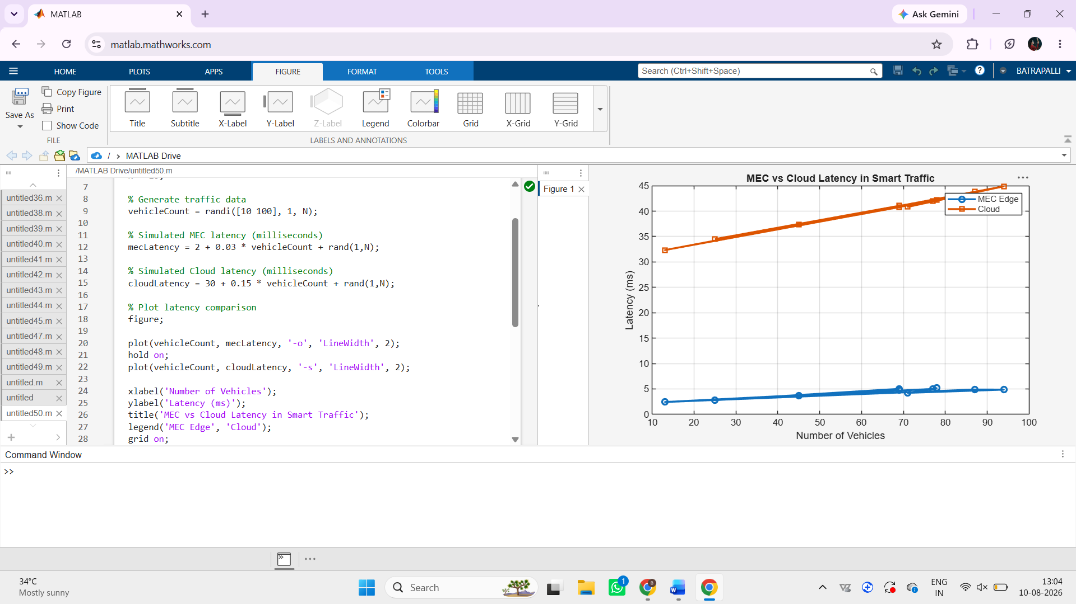

Result
The MEC-based smart traffic system successfully processes traffic information locally and generates traffic-control decisions with low processing latency. This demonstrates how edge computing can support low-latency smart traffic applications
Q2 Develop a cloud-edge communication model for wireless healthcare monitoring. (BL6)

Aim
To develop and simulate a cloud-edge communication model for wireless healthcare monitoring in MATLAB for real-time patient-condition detection and efficient transmission of healthcare data to the cloud.
Algorithm
- Initialize the wireless healthcare monitoring system.
- Generate patient sensor data such as heart rate, SpO2, and temperature.
- Transfer the sensor data to the edge gateway.
- Process the patient data at the edge.
- Check the sensor values against predefined thresholds.
- Detect abnormal patient conditions.
- Generate an immediate alert when an abnormal condition is detected.
- Calculate the edge processing latency.
- Send patient data to the cloud for storage and remote monitoring.
- Repeat the monitoring process for multiple readings.
Code :
clc;
clear;
close all;

% Simulation samples
samples = 1:10;

% Illustrative latency values
edgeLatency = [4 5 4 6 5 4 5 6 4 5];
cloudLatency = [35 38 40 37 42 39 41 43 38 40];

figure;

plot(samples, edgeLatency, '-o', 'LineWidth', 2);
hold on;
plot(samples, cloudLatency, '-s', 'LineWidth', 2);

xlabel('Simulation Sample');
ylabel('Latency (ms)');
title('Edge vs Cloud Latency for Healthcare Monitoring');

legend('Edge Processing', 'Cloud Processing');
grid on;

- 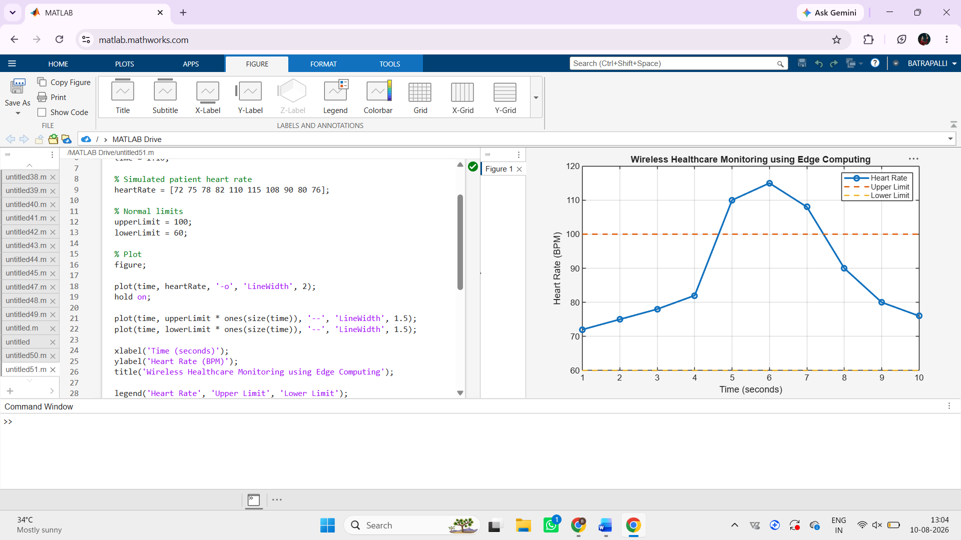

Result The cloud-edge healthcare monitoring system successfully collects patient data, detects abnormal conditions at the edge, generates alerts, and transfers patient information to the cloud. The simulation demonstrates the benefit of edge processing for fast healthcare monitoring.

