SSL(Secure Socket Layer)
- It is internet security protocol.
- Ensures privacy , encryption and authentication over internet communication.
- Provides security to data between web browser and web server
Why SSL is important?
- Generally the information which is on web is plaintext so anyone can intercept the message.
- For example When you shop online, you often provide sensitive information, such as your credit card details, home address, and phone number. SSL encrypts this data during transmission between your browser and the e-commerce site’s server, preventing hackers from intercepting and stealing your information.
Additionally, SSL helps prevent cyber attacks by:
- Authenticating Web Servers: Ensuring that users are connecting to the legitimate website, not a fake one set up by attackers.
- Preventing Data Tampering: Acting like a tamper-proof seal, SSL ensures that the data sent and received hasn’t been altered during transit.
SSL Protocol Stack
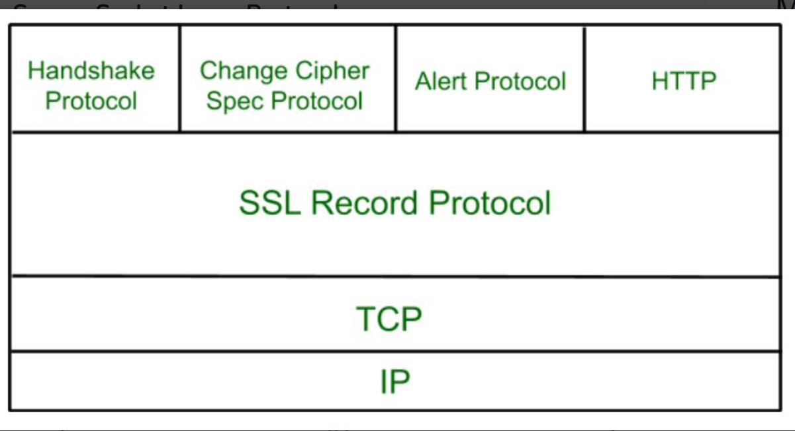

- SSL protocol stack includes :
- Handshake Protocol
- SSL Record Protocol
- Change-Cipher Spec Protocol
- Alert Protocol

Handshake Protocol

The handshake protocol is responsible for establishing the secure connection. It includes several steps to negotiate security parameters, authenticate the server (and optionally the client), and establish session keys for encryption.
Steps:
- Client Hello: The client sends a list of supported SSL/TLS versions and cipher suites to the server, along with a randomly generated number.
- Server Hello: The server responds with its chosen SSL/TLS version and cipher suite, and another random number.
- Server Certificate: The server sends its digital certificate to the client for authentication.
- Server Key Exchange (if necessary): Depending on the chosen cipher suite, the server may send additional key exchange information.
- Client Key Exchange: The client generates a pre-master secret, encrypts it with the server’s public key, and sends it to the server.
- Session Key Generation: Both the client and server use the pre-master secret and the random numbers to generate session keys.
- Finished Messages: Both the client and server send encrypted "Finished" messages to each other to confirm that the handshake was successful.

2. Record Protocol
The record protocol is responsible for the actual transmission of data. It ensures that data is securely transmitted between the client and server.
Functions:
- Fragmentation: Large messages are fragmented into smaller blocks for easier transmission.
- Compression (optional): Data can be compressed before encryption to save bandwidth.
- Encryption: Data is encrypted using the session keys established during the handshake.
- Message Authentication: A Message Authentication Code (MAC) is appended to the data to ensure its integrity and authenticity.

3. Change Cipher Spec Protocol
The change cipher spec protocol is a simple protocol used to signal transitions in the encryption and decryption processes.
Function:
- Change Cipher Spec Message: This message indicates that subsequent records will be protected under the newly negotiated cipher suite and keys. It is sent by both the client and the server after the session keys are established.

4. Alert Protocol
The alert protocol is used to convey SSL/TLS-related alerts to the peer.
Types of Alerts:
- Warning Alerts: Informational alerts that don’t terminate the connection (e.g., close notify to indicate that the connection is about to close).
- Fatal Alerts: Alerts that indicate a serious problem, causing the connection to terminate immediately (e.g., bad certificate, unsupported certificate, decrypt error).
Diagram for overall SSL handshake:

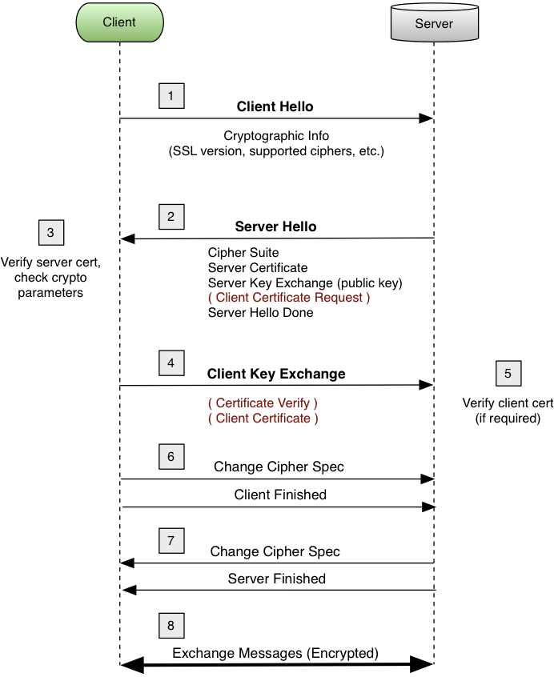

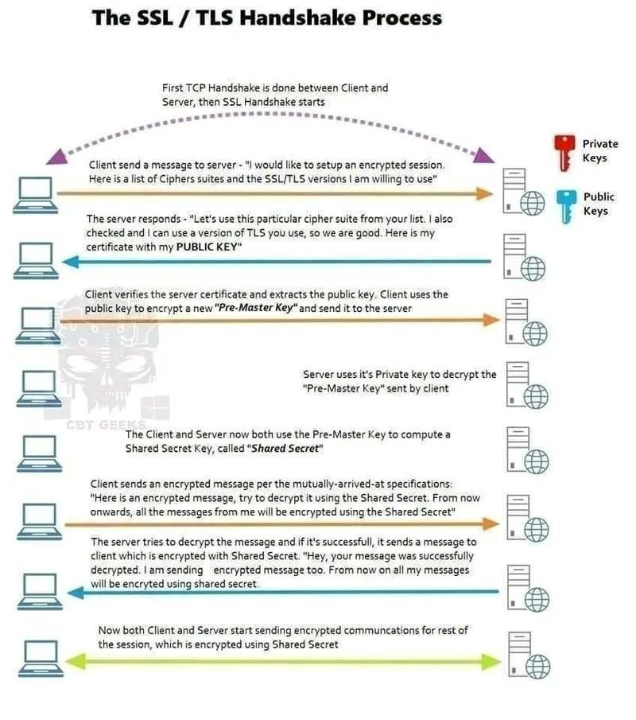

Wireshark TLS Filter:

