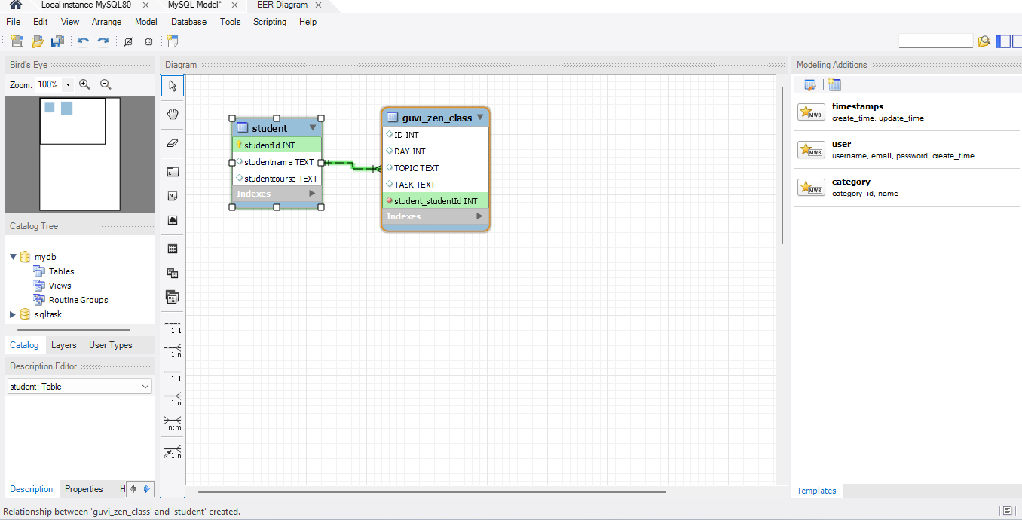

-- create database sqltask;

-- use sqltask;

-- create a table

CREATE TABLE Guvi_ZEN_Class

(

DAY INTEGER NOT NULL,

TOPIC TEXT,

TASK TEXT

);

-- Inserting Data

INSERT INTO Guvi_ZEN_Class

(DAY, TOPIC, TASK)

VALUES

(1, "Introduction to Browser & web", "Introduction to Browser & web"),

(2, "Request & Response cycle", "Request & Response cycle"),

(3, "JS array & objects", "Looping Of Arrays & Objects"),

(4, "What is XMLHTTP Request? & scope", "XMLHTTP Request"),

(5, "Functions", "IIFE & Annoymous Function"),

(6, "Functions recap", "Functions"),

(7, "ES5 vs ES6", "NIL"),

(8, "OOP", "OOP PROBLEMS"),

(9, "MRF Array Method", "MRF Method"),

(10, "Complete Recap", "NIL"),

(11, "HTML", "HTML & CSS Mini Task"),

(12, "HTML recap CSS", "NIL"),

(13, "CSS", "NIL"),

(14, "CSS", "NIL"),

(15, "Responsive web design", "NIL"),

(16, "Bootstrap design demo", "Responsive Design"),

(17, "DOM", "NIL"),

(18, "Document vs Window", "NIL"),

(19, "Recap of Topics", "CALCULATOR HTMLForms PAGINATION"),

(20, "Recap of Topics", "NIL"),

(21, "Callback", "Callback Hell"),

(22, "Promise", "NIL"),

(23, "Fetch Api", "NIL"),

(24, "Promise_fetch - request info & request init", "NIL"),

(25, "Recap of Topics", "3 API TASKS"),

(26, "REACT", "Pricing Table"),

(27, "React hooks & states", "Shop-Homepage"),

(28, "React components", "Dashboard"),

(29, "React router", "CRUD_Userlist"),

(30, "recap with previous day topics", "NIL"),

(31, "Context API", "API task completion using context"),

(32, "recap with previous day topics", "NIL"),

(33, "AXIOS", "CRUD using Axios"),

(34, "formik in react", "CRUD for product with validation"),

(35, "practice with formik & recap", "NIL"),

(36, "Database - MySQL", "MYSQL queries"),

(37, "Database - MySQL", "Design DB model for Guvi Zen class"),

(38, "Database - MongoDB", "MongoDB queries"),

(39, "MongoDB", "database-design-zen-class"),

(40, "Nodejs", "Nodejs file system"),

(41, "Nodejs & Expressjs", "Hall Booking Application"),

(42, "Node & mongo DB connectivity", "Mentor and Student Assigning with Database"),

(43, "Nodejs deployment", "Mentor and Student Assigning with Database"),

(44, "Authentication", "Password Reset Flow"),

(45, "JWT", "URL Shortener Application");

select * from Guvi_ZEN_Class;

-- drop table Guvi_ZEN_Class;

ALTER TABLE Guvi_ZEN_Class

ADD PRIMARY KEY (DAY);

create table student

(

studentId int not null unique,

studentname text,

studentcourse text

);

INSERT INTO student

(studentId, studentname, studentcourse)

VALUES

(1,"vennila","topic1"),

(2,"baskaran","topic2"),

(3,"mozhianbu","topic3");

select * from student;

ALTER TABLE student

ADD PRIMARY KEY (studentId);

SELECT Guvi_ZEN_Class.DAY, student.studentname, Guvi_ZEN_Class.TOPIC

FROM Guvi_ZEN_Class

INNER JOIN student ON Guvi_ZEN_Class.DAY=student.studentId;

