PYTHON ACTIVITY-BASED LEARNING

Selected from the supplied case-study list. Programs are kept simple and use basic Python concepts.

Selected Topics
1. Progressive Electricity Billing (Topic 2)
Calculate a household electricity bill using simple consumption slabs.
2. Employee Payroll and Deduction Analysis (Topic 4)
Calculate gross salary, deductions, and net salary.
3. Retail Billing with Multiple Discount Rules (Topic 7)
Calculate the total price of items and apply a simple discount.
4. Examination Result and Grace-Mark Validation (Topic 11)
Calculate total marks, average, and pass/fail result.
5. Attendance Recovery Computation (Topic 12)
Calculate attendance percentage and the number of classes needed to reach a target.
6. ATM Transaction Sequence Simulation (Topic 13)
Simulate deposits and withdrawals and show the final balance.
7. Fuel Consumption and Route Comparison (Topic 18)
Calculate fuel needed and journey cost.
8. Password Policy Validation Engine (Topic 29)
Check password length and whether it contains letters and digits.
9. Text Compression Using Character Runs (Topic 35)
Count consecutive repeated characters in a string.
10. Food Waste Monitoring System (Topic 53)
Calculate leftover meals and food-waste percentage.

Case Study 1: Progressive Electricity Billing

1. Problem Statement
Calculate an electricity bill based on units used. The first 100 units cost ₹2 per unit, and units above 100 cost ₹3 per unit. A fixed charge of ₹50 is added.

2. Objectives
- Calculate the bill using conditional statements.
- Display the total amount payable.

3. Assumptions
- Units used cannot be negative.
- The fixed charge is ₹50.

4. Algorithm
1. Read units.
2. If units are negative, display invalid input.
3. If units <= 100, energy charge = units * 2.
4. Otherwise, energy charge = 100 * 2 + (units - 100) * 3.
5. Add fixed charge and display bill.

5. Flowchart
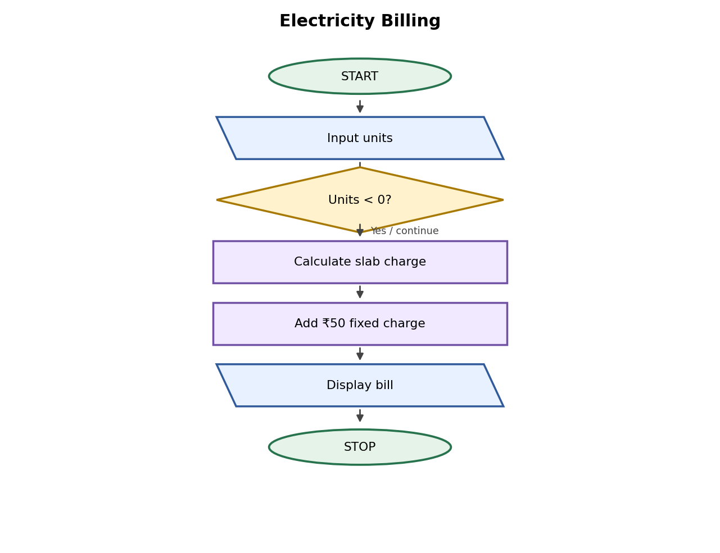

6. Pseudocode
READ units
IF units < 0: DISPLAY invalid
ELSE IF units <= 100: charge = units * 2
ELSE: charge = 200 + (units - 100) * 3
bill = charge + 50
DISPLAY bill

7. Python Source Code
units = int(input("Enter units used: "))
if units < 0:
print("Invalid units")
elif units <= 100:
bill = units * 2 + 50
print("Electricity bill: Rs.", bill)
else:
bill = 200 + (units - 100) * 3 + 50
print("Electricity bill: Rs.", bill)

8. Test Cases
Test 1: 50 units → ₹150. Test 2: 120 units → ₹410.

Sample Output
Input: 120 units
Output: Electricity bill: Rs. 410

9. Conclusion
The program calculates an electricity bill using simple if-else conditions.

Case Study 2: Employee Payroll

1. Problem Statement
Calculate an employee's gross salary, deduction, and net salary.

2. Objectives
- Add basic pay and allowance.
- Subtract the deduction from gross salary.

3. Assumptions
- Allowance and deduction are entered as amounts.
- All amounts should be non-negative.

4. Algorithm
1. Read basic pay, allowance, and deduction.
2. Calculate gross = basic + allowance.
3. Calculate net = gross - deduction.
4. Display gross and net salary.

5. Flowchart
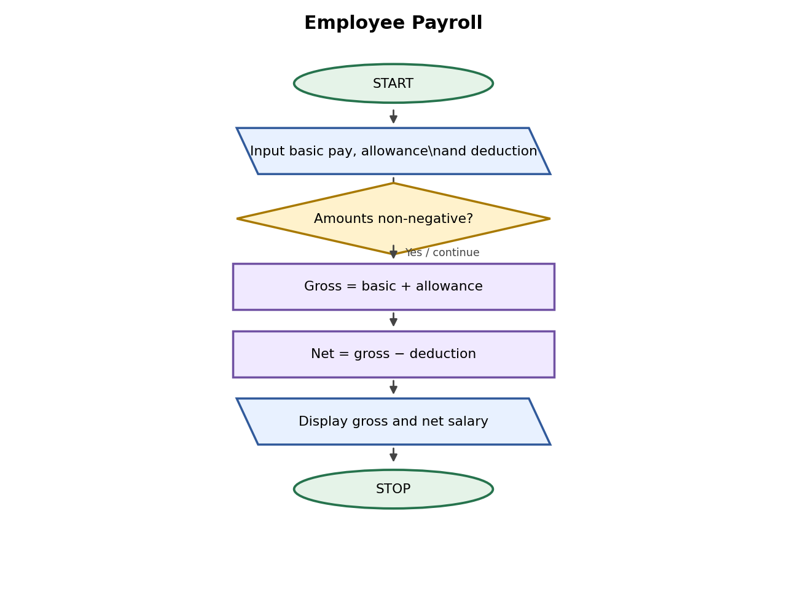

6. Pseudocode
READ basic, allowance, deduction
gross = basic + allowance
net = gross - deduction
DISPLAY gross, net

7. Python Source Code
basic = float(input("Enter basic salary: "))
allowance = float(input("Enter allowance: "))
deduction = float(input("Enter deduction: "))

gross = basic + allowance
net = gross - deduction

print("Gross salary:", gross)
print("Net salary:", net)

8. Test Cases
Test 1: 20000, 3000, 1000 → gross 23000, net 22000. Test 2: 15000, 1000, 500 → gross 16000, net 15500.

Sample Output
Input: Basic ₹20000, allowance ₹3000, deduction ₹1000
Output: Gross salary: 23000.0
Net salary: 22000.0

9. Conclusion
The program uses variables and arithmetic operators to prepare a simple salary statement.

Case Study 3: Retail Billing with Discount

1. Problem Statement
Calculate the total cost of a purchase and give a 10% discount when the total is ₹1000 or more.

2. Objectives
- Calculate total cost.
- Apply a discount if the condition is met.

3. Assumptions
- Quantity and price must be non-negative.
- Discount is 10% for totals of ₹1000 or more.

4. Algorithm
1. Read product price and quantity.
2. Calculate total = price * quantity.
3. If total >= 1000, calculate 10% discount.
4. Subtract discount and display final amount.

5. Flowchart
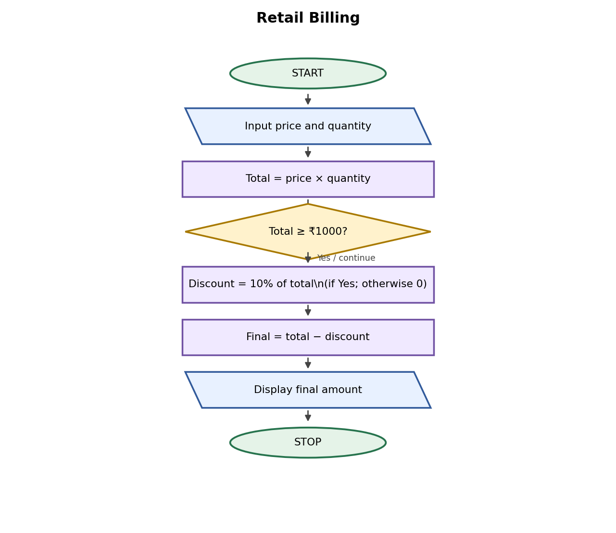

6. Pseudocode
READ price, quantity
total = price * quantity
IF total >= 1000: discount = total * 0.10
ELSE: discount = 0
final = total - discount
DISPLAY final

7. Python Source Code
price = float(input("Enter price per item: "))
quantity = int(input("Enter quantity: "))
total = price * quantity

if total >= 1000:
discount = total * 0.10
else:
discount = 0

final_amount = total - discount
print("Total:", total)
print("Discount:", discount)
print("Final amount:", final_amount)

8. Test Cases
Test 1: price 250, quantity 4 → final ₹900. Test 2: price 100, quantity 2 → final ₹200.

Sample Output
Input: price ₹250, quantity 4
Output: Total: 1000.0
Discount: 100.0
Final amount: 900.0

9. Conclusion
The program demonstrates multiplication and a simple discount condition.

Case Study 4: Examination Result

1. Problem Statement
Calculate a student's total marks, average, and result for three subjects.

2. Objectives
- Find total and average marks.
- Display pass or fail.

3. Assumptions
- Each subject is out of 100.
- A student passes if every subject mark is at least 35.

4. Algorithm
1. Read three subject marks.
2. Calculate total and average.
3. If every mark is at least 35, display Pass; otherwise, display Fail.
4. Display total and average.

5. Flowchart
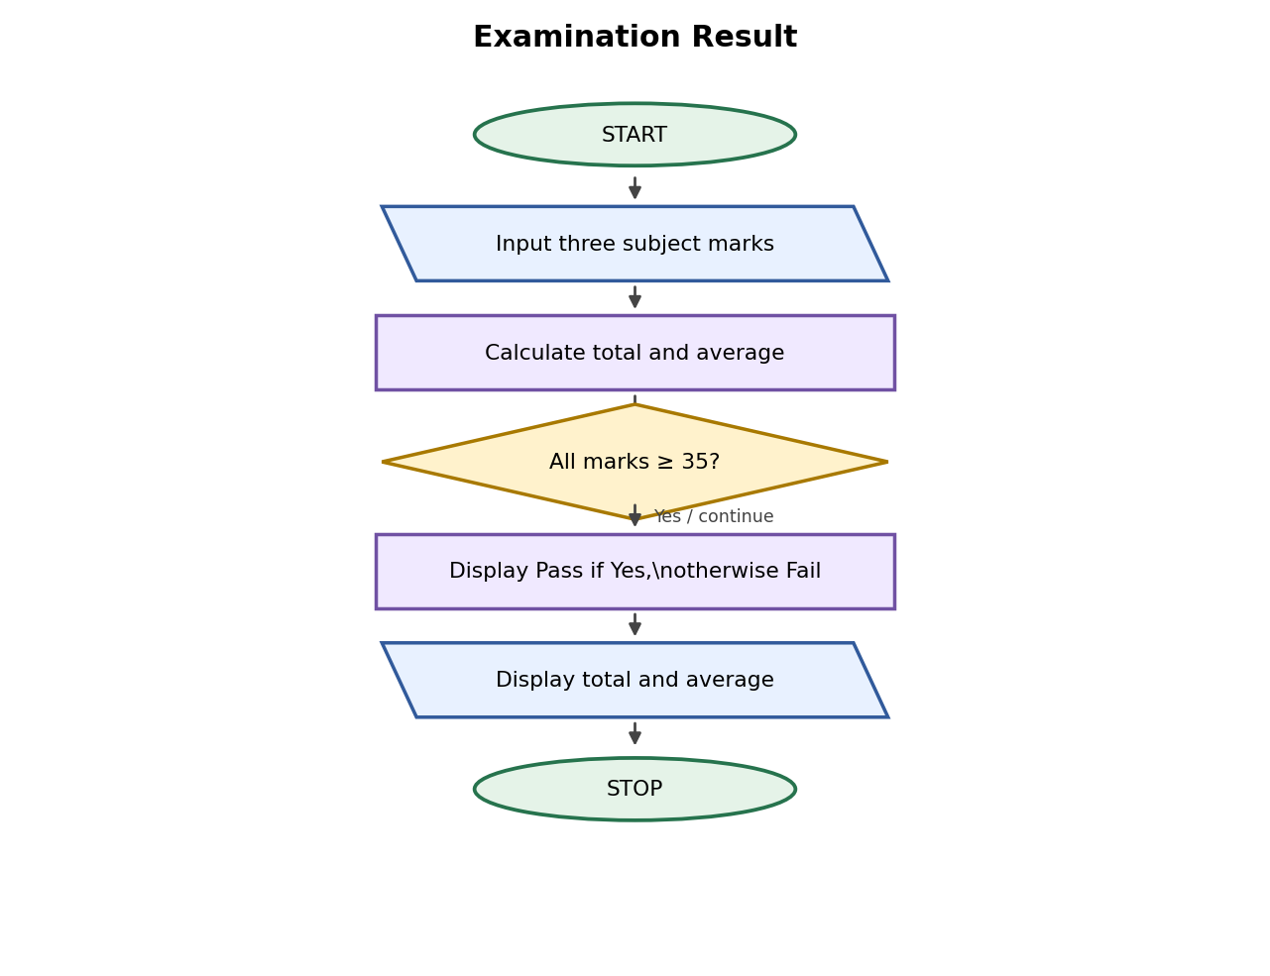

6. Pseudocode
READ m1, m2, m3
total = m1 + m2 + m3
average = total / 3
IF m1 >= 35 AND m2 >= 35 AND m3 >= 35: DISPLAY Pass
ELSE: DISPLAY Fail

7. Python Source Code
m1 = int(input("Enter subject 1 marks: "))
m2 = int(input("Enter subject 2 marks: "))
m3 = int(input("Enter subject 3 marks: "))

total = m1 + m2 + m3
average = total / 3
print("Total marks:", total)
print("Average:", round(average, 2))

if m1 >= 35 and m2 >= 35 and m3 >= 35:
print("Result: Pass")
else:
print("Result: Fail")

8. Test Cases
Test 1: 70, 60, 80 → Pass. Test 2: 70, 30, 80 → Fail.

Sample Output
Input: 70, 60, 80
Output: Total marks: 210
Average: 70.0
Result: Pass

9. Conclusion
The program calculates marks and uses a condition to determine the result.

Case Study 5: Attendance Recovery

1. Problem Statement
Calculate current attendance percentage and find how many consecutive classes a student must attend to reach a target percentage.

2. Objectives
- Calculate current attendance percentage.
- Find additional classes needed.

3. Assumptions
- Total classes must be greater than zero.
- The student attends all additional classes.

4. Algorithm
1. Read total classes, attended classes, and target percentage.
2. Calculate current percentage.
3. Use a while loop to count future classes until the target is reached.
4. Display results.

5. Flowchart
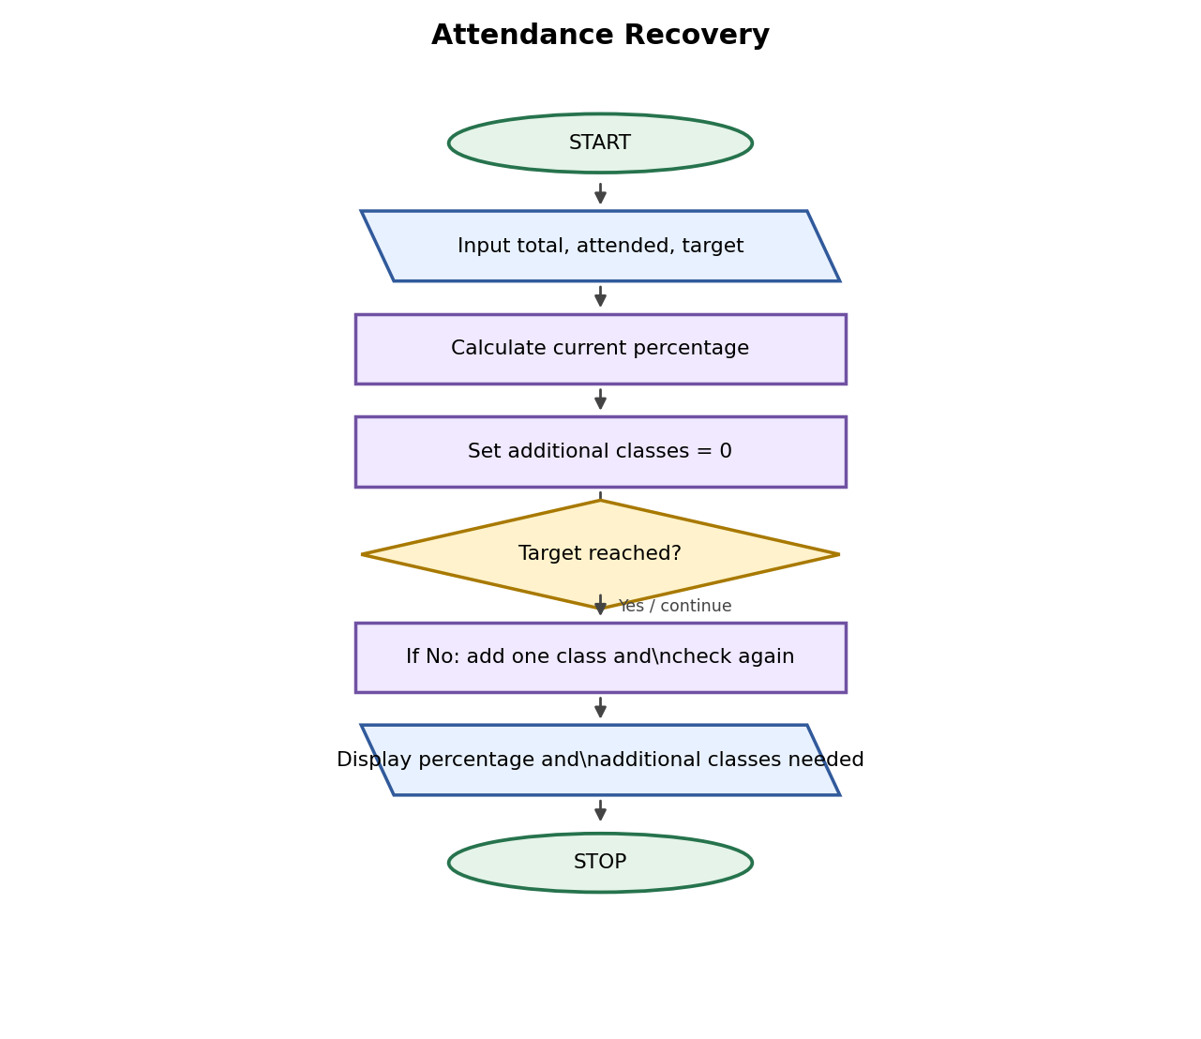

6. Pseudocode
READ total, attended, target
percentage = attended / total * 100
future = 0
WHILE (attended + future) / (total + future) * 100 < target: future = future + 1
DISPLAY percentage, future

7. Python Source Code
total = int(input("Total classes: "))
attended = int(input("Classes attended: "))
target = float(input("Target percentage: "))

if total <= 0 or attended < 0 or attended > total or target < 0 or target > 100:
print("Invalid input")
else:
print("Current attendance:", round(attended / total * 100, 2), "%")
future = 0
while (attended + future) / (total + future) * 100 < target:
future = future + 1
print("Additional classes needed:", future)

8. Test Cases
Test 1: 40 total, 30 attended, target 75 → 0 additional classes. Test 2: 40 total, 24 attended, target 75 → 24 classes.

Sample Output
Input: total 40, attended 24, target 75
Output: Current attendance: 60.0 %
Additional classes needed: 24

9. Conclusion
The program uses a while loop to find how many classes are needed to meet an attendance target.

Case Study 6: ATM Transaction Simulation

1. Problem Statement
Simulate a bank account with deposit and withdrawal transactions.

2. Objectives
- Add deposits to the balance.
- Allow withdrawals only when the balance is sufficient.

3. Assumptions
- The opening balance and transaction amounts are non-negative.
- D means deposit and W means withdrawal.

4. Algorithm
1. Read opening balance.
2. Read transaction type and amount.
3. Add a deposit or subtract a valid withdrawal.
4. Reject invalid transactions.
5. Display final balance.

5. Flowchart
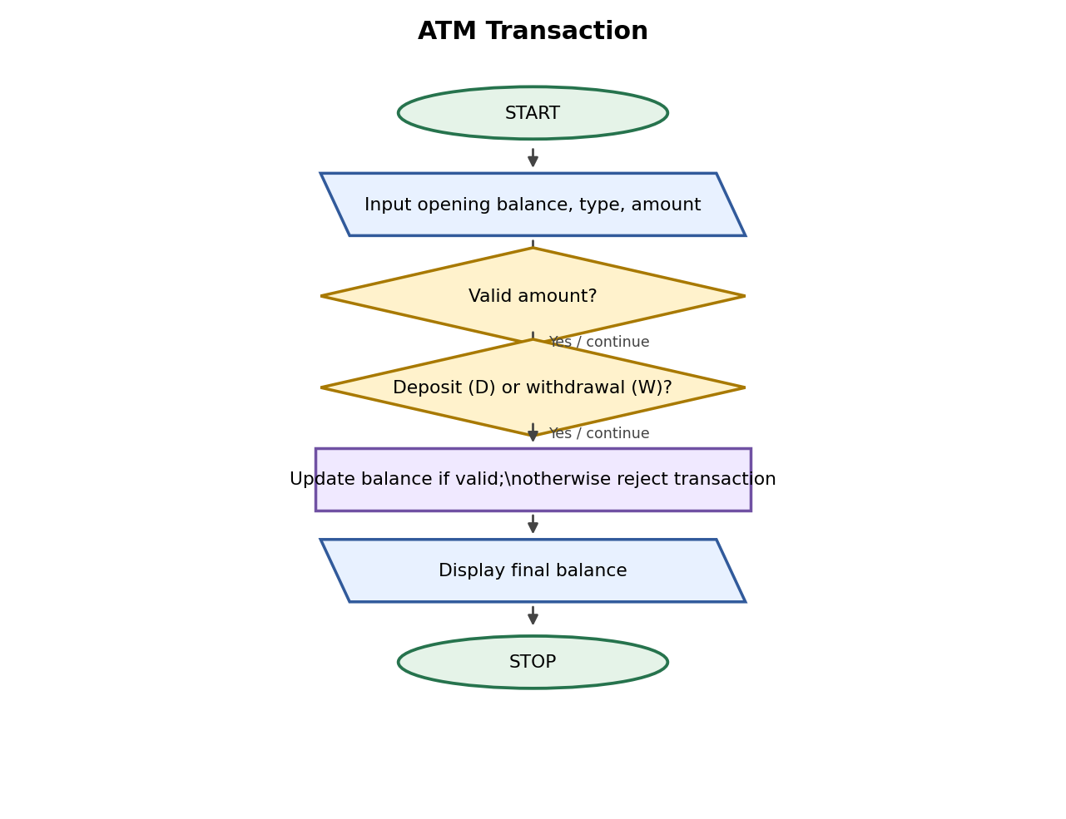

6. Pseudocode
READ balance, type, amount
IF amount <= 0: reject
ELSE IF type == D: balance = balance + amount
ELSE IF type == W AND amount <= balance: balance = balance - amount
ELSE: reject
DISPLAY balance

7. Python Source Code
balance = float(input("Opening balance: "))
kind = input("Enter D for deposit or W for withdrawal: ").upper()
amount = float(input("Enter amount: "))

if amount <= 0:
print("Invalid amount")
elif kind == "D":
balance = balance + amount
print("Deposit successful")
elif kind == "W":
if amount <= balance:
balance = balance - amount
print("Withdrawal successful")
else:
print("Insufficient balance")
else:
print("Invalid transaction type")

print("Final balance:", balance)

8. Test Cases
Test 1: balance 1000, deposit 500 → 1500. Test 2: balance 100, withdrawal 200 → insufficient balance and balance remains 100.

Sample Output
Input: opening balance ₹1000, type W, amount ₹200
Output: Withdrawal successful
Final balance: 800.0

9. Conclusion
The program demonstrates if-else conditions and updates a balance based on transactions.

Case Study 7: Fuel Consumption and Route Cost

1. Problem Statement
Calculate fuel required for a journey and its total fuel cost.

2. Objectives
- Calculate fuel needed from distance and mileage.
- Calculate the total cost.

3. Assumptions
- Distance and mileage must be positive.
- Fuel price is per litre.

4. Algorithm
1. Read distance, mileage, and fuel price.
2. Validate values.
3. Fuel needed = distance / mileage.
4. Cost = fuel needed * fuel price.
5. Display results.

5. Flowchart
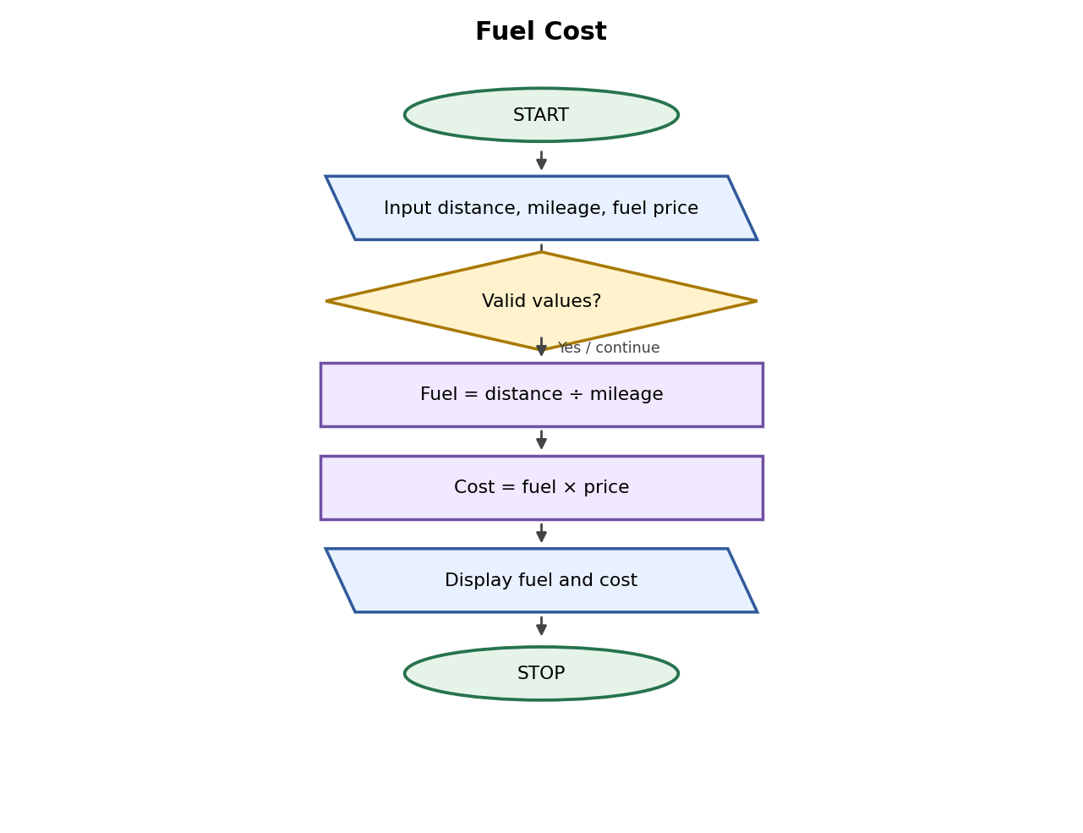

6. Pseudocode
READ distance, mileage, price
IF distance < 0 OR mileage <= 0 OR price < 0: DISPLAY invalid
ELSE fuel = distance / mileage
cost = fuel * price
DISPLAY fuel, cost

7. Python Source Code
distance = float(input("Journey distance in km: "))
mileage = float(input("Vehicle mileage in km per litre: "))
price = float(input("Fuel price per litre: "))

if distance < 0 or mileage <= 0 or price < 0:
print("Invalid input")
else:
fuel = distance / mileage
cost = fuel * price
print("Fuel required:", round(fuel, 2), "litres")
print("Fuel cost: Rs.", round(cost, 2))

8. Test Cases
Test 1: 150 km, 15 km/litre, ₹100/litre → 10 litres, ₹1000. Test 2: 100 km, 20 km/litre, ₹95/litre → 5 litres, ₹475.

Sample Output
Input: distance 150 km, mileage 15 km/litre, fuel price ₹100/litre
Output: Fuel required: 10.0 litres
Fuel cost: Rs. 1000.0

9. Conclusion
The program calculates fuel requirements and journey cost using arithmetic operators.

Case Study 8: Password Policy Validation

1. Problem Statement
Check whether a sample password has at least eight characters and contains both a letter and a digit.

2. Objectives
- Check password length.
- Check for letters and digits.

3. Assumptions
- This is a basic classroom exercise, not a complete security checker.
- The program does not save the password.

4. Algorithm
1. Read a sample password.
2. Check its length.
3. Loop through characters to find a letter and a digit.
4. Display whether it meets the sample rules.

5. Flowchart
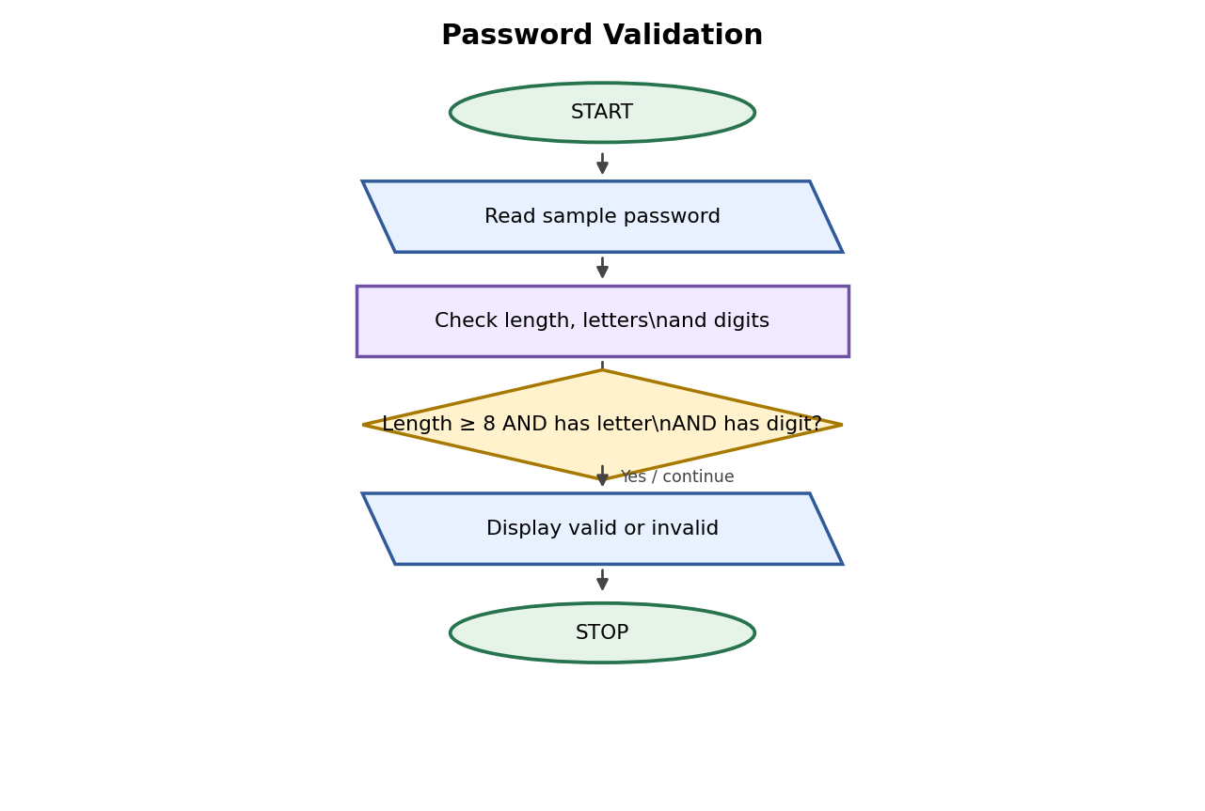

6. Pseudocode
READ password
SET letter = False, digit = False
FOR each character: check isalpha and isdigit
IF length >= 8 AND letter AND digit: DISPLAY valid
ELSE DISPLAY invalid

7. Python Source Code
password = input("Enter a sample password: ")
has_letter = False
has_digit = False

for ch in password:
if ch.isalpha():
has_letter = True
if ch.isdigit():
has_digit = True

if len(password) >= 8 and has_letter and has_digit:
print("Password meets the sample rules")
else:
print("Password does not meet the sample rules")

8. Test Cases
Test 1: student123 → meets rules. Test 2: abc12 → does not meet rules.

Sample Output
Input: student123
Output: Password meets the sample rules

9. Conclusion
The program practices strings, loops, and conditional statements.

Case Study 9: Text Compression

1. Problem Statement
Replace each group of consecutive repeated characters with the character and its count.

2. Objectives
- Find repeated consecutive characters.
- Display a simple compressed string.

3. Assumptions
- Input should not contain spaces for this beginner version.
- Every character is followed by its count.

4. Algorithm
1. Read text.
2. Count consecutive matching characters.
3. Append each character and count to the result.
4. Display compressed text.

5. Flowchart
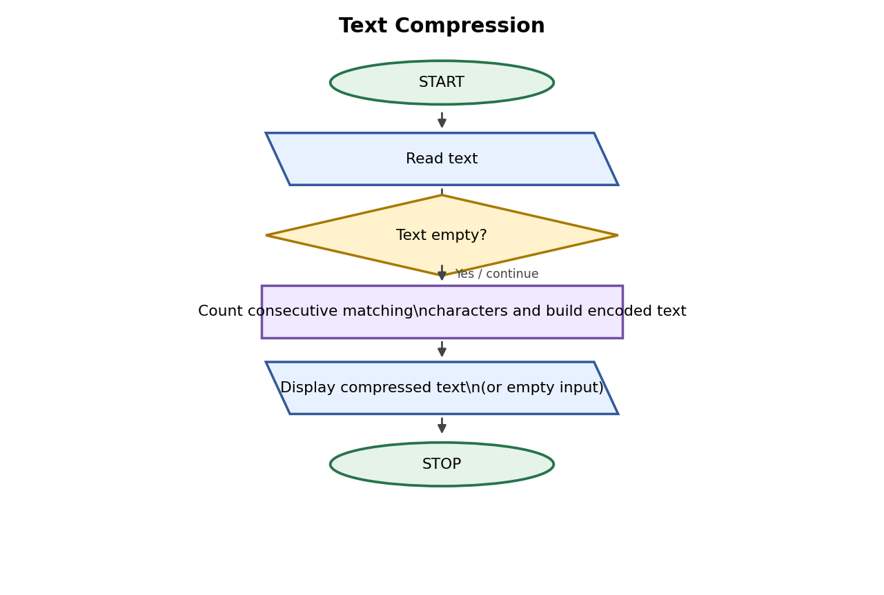

6. Pseudocode
READ text
IF text is empty: DISPLAY empty
ELSE SET encoded = empty, count = 1
SCAN each next character
IF same as previous: increase count; ELSE append previous and count
Append last character and count
DISPLAY encoded

7. Python Source Code
text = input("Enter text without spaces: ")

if text == "":
print("Empty input")
else:
encoded = ""
count = 1
for i in range(1, len(text)):
if text[i] == text[i - 1]:
count = count + 1
else:
encoded = encoded + text[i - 1] + str(count)
count = 1
encoded = encoded + text[-1] + str(count)
print("Compressed text:", encoded)

8. Test Cases
Test 1: aaabbc → a3b2c1. Test 2: aaaa → a4.

Sample Output
Input: aaabbc
Output: Compressed text: a3b2c1

9. Conclusion
The program introduces simple string processing and consecutive character counting.

Case Study 10: Food Waste Monitoring

1. Problem Statement
Calculate leftover meals and the percentage of food wasted in a canteen.

2. Objectives
- Calculate leftover meals.
- Calculate waste percentage.

3. Assumptions
- Meals prepared must be greater than zero for percentage calculation.
- Meals served cannot exceed meals prepared.

4. Algorithm
1. Read meals prepared and served.
2. Validate values.
3. Leftovers = prepared − served.
4. Calculate percentage wasted.
5. Display results.

5. Flowchart
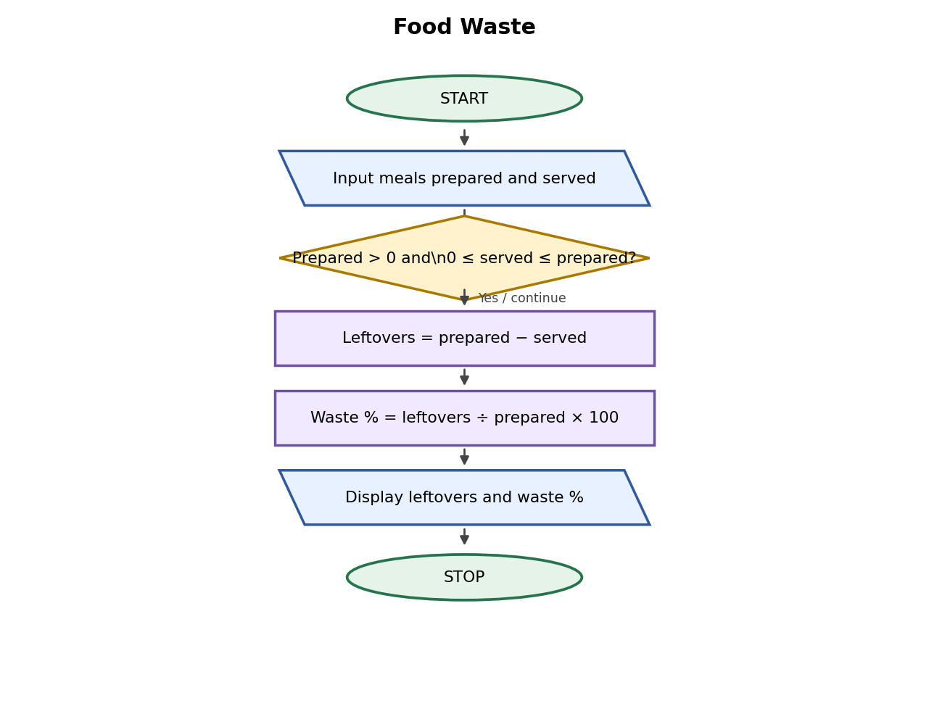

6. Pseudocode
READ prepared, served
IF prepared <= 0 OR served < 0 OR served > prepared: DISPLAY invalid
ELSE waste = prepared - served
percentage = waste / prepared * 100
DISPLAY waste, percentage

7. Python Source Code
prepared = int(input("Meals prepared: "))
served = int(input("Meals served: "))

if prepared <= 0 or served < 0 or served > prepared:
print("Invalid meal data")
else:
waste = prepared - served
percentage = waste / prepared * 100
print("Leftover meals:", waste)
print("Waste percentage:", round(percentage, 2), "%")

8. Test Cases
Test 1: 100 prepared, 85 served → 15 leftovers, 15%. Test 2: 80 prepared, 76 served → 4 leftovers, 5%.

Sample Output
Input: meals prepared 100, meals served 85
Output: Leftover meals: 15
Waste percentage: 15.0 %

9. Conclusion
The program helps monitor leftover food and calculate the percentage of waste.

