Insert by ID

First go to config module page.
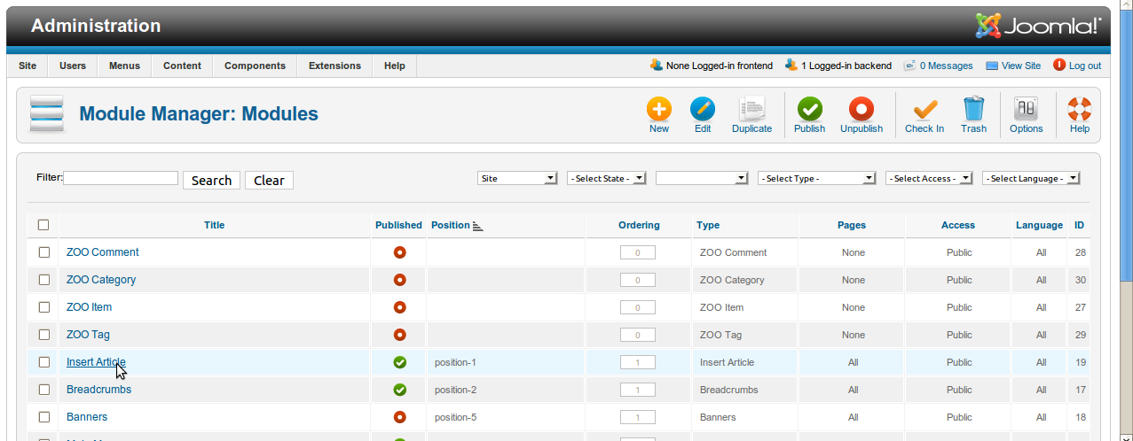
Edit the module, and SELECT AND ARTICLE, in the old version was the id acticle, but now is with a selectable frame with the title arcticle. More easy.

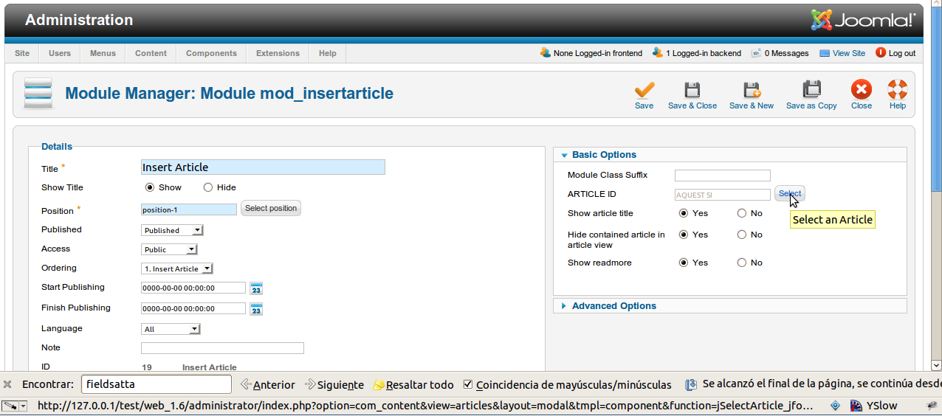
Article selectable page

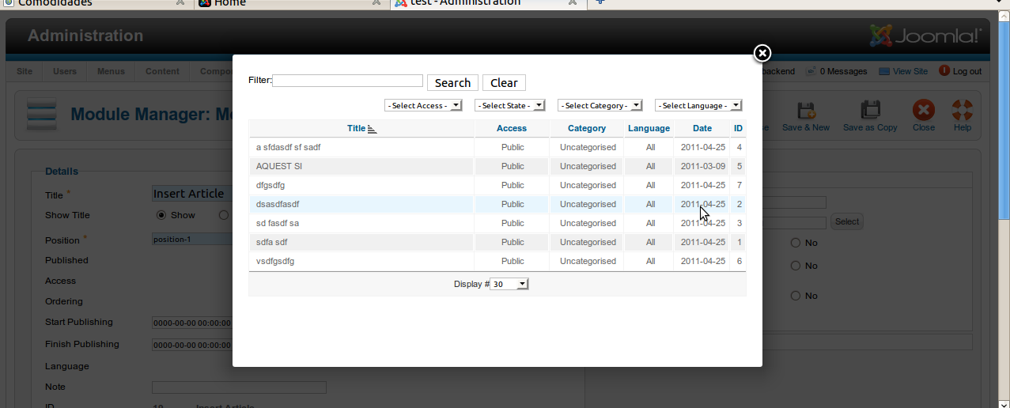

Selecta a artícle and a position template and save. Make sure that, the module are published.

