This project you will need to use Python’s **dash** and **plotly** modules.

Device a Python app that will read the following dataset (securities_prices_volumes.csv)

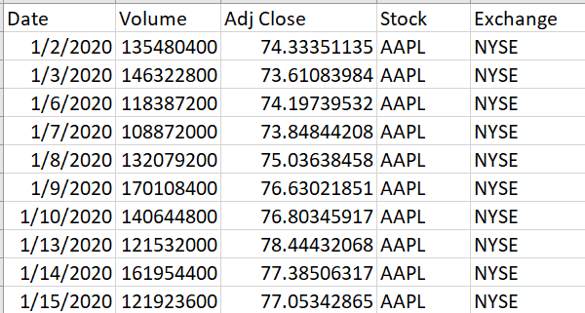

The app will have the following functionality, components:

**Upload** the csv, after browsing into your machine, into the app.

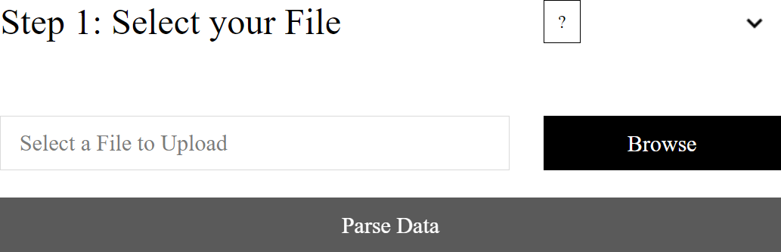

After clicking on **parsing** data, select the appropriate **data type** for each of the columns. Do provide the

option to ‘**ignore**’ any column:

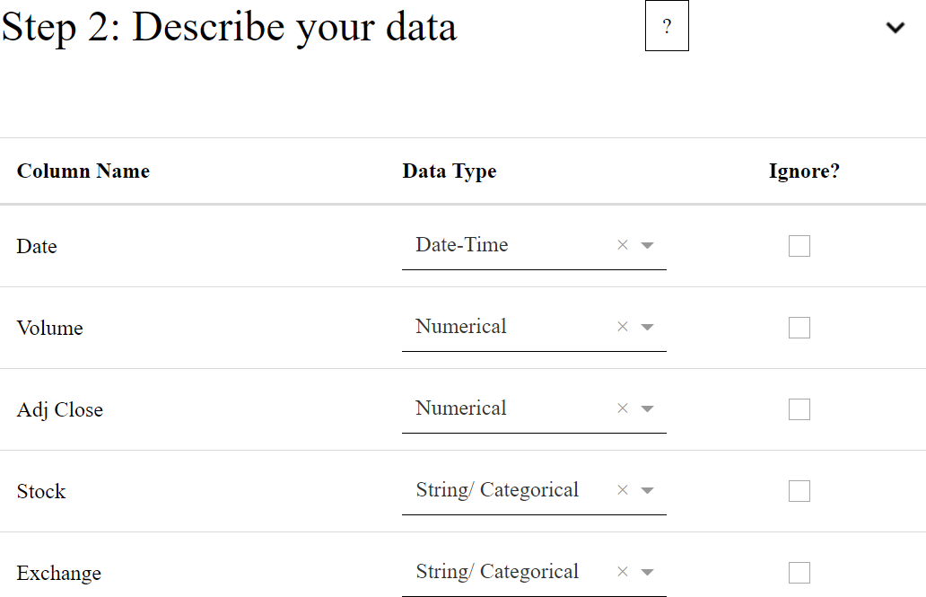

Then preview the data, along with a corresponding line graph (you can use your own names/labels for each column):

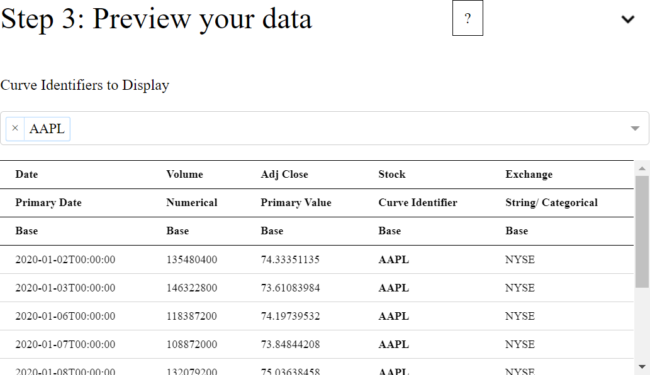

Should you choose more than one security from the 2nd drop-down list, the line graph should look like:

(You could easily plot ‘Volume’ instead of ‘Adj Close’ price from the 1st drop-down list)

