**Enterprise Rent-A-Car Database**

Database Fundamentals

IT 214 -BO3

Professor: Pavlenko

O’Ryan Lattin

Enterprise Database ERD

Enterprise Database

# Table: VEHICLE_TYPE

a.

b.

c.

d.

# Table: VEHICLE

a.

b.

c.

d.

# Table: INSURANCE_PLAN

a.

b.

c.

d.

# Table: CUSTOMER

a.

b.

c.

d.

# Table: RENTAL

a.

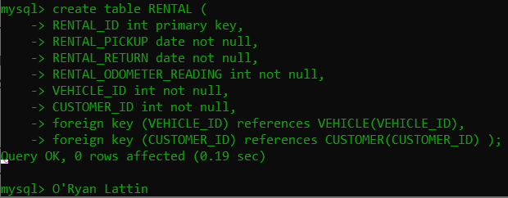

b.

c.

d.

Enterprise DB Example Queries

a)

b)

c)

d)

e)

