test-word.docx — Word test document
Each test below has an ID (for the checklist), what is tested, and the expected result. Compare what you see with "Expected". Open the same file in Microsoft Word to compare if unsure.

1. Fonts and text
DOCX-01 · Font families Expected: Each line is shown in the font it names (Calibri, Cambria, Arial, Times New Roman, Courier New, Georgia, Verdana)
This line is Calibri. The quick brown fox jumps over the lazy dog 0123456789
This line is Cambria. The quick brown fox jumps over the lazy dog 0123456789
This line is Arial. The quick brown fox jumps over the lazy dog 0123456789
This line is Times New Roman. The quick brown fox jumps over the lazy dog 0123456789
This line is Courier New. The quick brown fox jumps over the lazy dog 0123456789
This line is Georgia. The quick brown fox jumps over the lazy dog 0123456789
This line is Verdana. The quick brown fox jumps over the lazy dog 0123456789
DOCX-02 · Font sizes Expected: Five lines growing from 8 pt to 28 pt
This text is 8 pt
This text is 11 pt
This text is 14 pt
This text is 20 pt
This text is 28 pt
DOCX-03 · Text styles Expected: Each word looks like its name: bold, italic, underline, double underline, strikethrough, x² superscript, H₂O subscript, SMALL CAPS, ALL CAPS
Bold Italic Underline Double underline Strikethrough Small caps all caps x² superscript H₂O subscript
DOCX-04 · Text colors and highlight Expected: Red, blue, green and orange text; yellow and bright green highlight; a paragraph with light blue background
Red text Blue text Green text Orange text Yellow highlight Green highlight
This whole paragraph has a light blue background (paragraph shading).
DOCX-05 · Alignment Expected: Lines aligned left, centered, right; the long paragraph is justified (straight right edge)
Left aligned
Centered
Right aligned
Justified: This paragraph is justified so both the left and the right edges are straight lines. This paragraph is justified so both the left and the right edges are straight lines. This paragraph is justified so both the left and the right edges are straight lines.
DOCX-06 · Indents and line spacing Expected: Indented paragraph (1 inch), first-line indent, hanging indent; then 1.0, 1.5 and 2.0 line spacing
Indented 1 inch from the left. Indented 1 inch from the left. Indented 1 inch from the left.
First line indented half an inch. First line indented half an inch. First line indented half an inch.
Hanging indent: the first line starts left, the next lines are indented. Hanging indent: the first line starts left, the next lines are indented.
Line spacing 1.0. Line spacing 1.0. Line spacing 1.0. Line spacing 1.0. Line spacing 1.0. Line spacing 1.0. Line spacing 1.0. Line spacing 1.0.
Line spacing 1.5. Line spacing 1.5. Line spacing 1.5. Line spacing 1.5. Line spacing 1.5. Line spacing 1.5. Line spacing 1.5. Line spacing 1.5.
Line spacing 2.0. Line spacing 2.0. Line spacing 2.0. Line spacing 2.0. Line spacing 2.0. Line spacing 2.0. Line spacing 2.0. Line spacing 2.0.
DOCX-07 · Headings and styles Expected: Title style, then Heading 1, 2, 3 in decreasing size and in the theme color

Title style

Heading 1

Heading 2

Heading 3

2. Bullets and numbering
DOCX-08 · Round bullets (Symbol font) Expected: Round • bullets
- Round bullets item 1
- Round bullets item 2
- Round bullets item 3
DOCX-09 · Square bullets (Wingdings §) Expected: Small square ▪ bullets — NOT the § sign and NOT empty boxes
- Square bullets item 1
- Square bullets item 2
- Square bullets item 3
DOCX-10 · Arrow bullets (Wingdings Ø) Expected: Arrow-head ➢ bullets — NOT Ø
- Arrow bullets item 1
- Arrow bullets item 2
- Arrow bullets item 3
DOCX-11 · Check-mark bullets (Wingdings ü) Expected: Check ✓ bullets — NOT ü
- Check-mark bullets item 1
- Check-mark bullets item 2
- Check-mark bullets item 3
DOCX-12 · Hollow circle bullets (Courier New o) Expected: Hollow o bullets
- Hollow circle bullets item 1
- Hollow circle bullets item 2
- Hollow circle bullets item 3
DOCX-13 · Dash bullets Expected: Dash – bullets
- Dash bullets item 1
- Dash bullets item 2
- Dash bullets item 3
DOCX-14 · Numbered list Expected: Numbered 1. 2. 3.
- Numbered item 1
- Numbered item 2
- Numbered item 3
DOCX-15 · Multi-level list (1 / a / i / bullet) Expected: Level 1 numbered 1., level 2 a), level 3 i., level 4 ▪ bullet; each level indented more
- First level
  - Second level
    - Third level
      - Fourth level (square bullet)
  - Second level again
- First level again

3. Tables
DOCX-16 · Table borders, header shading, column widths Expected: Dark blue header row with white bold text; all cells have borders; numbers right-aligned
Region | Q1 | Q2 | Total
West | 1,200 | 1,350 | 2,550
East | 1,300 | 1,400 | 2,700
North | 1,400 | 1,450 | 2,850
DOCX-17 · Merged cells and cell colors Expected: Top row is one merged cell; "Merged down" spans two rows; green, yellow and red cell backgrounds
Merged across three columns
Merged down | Green | Yellow
Merged down | Red | Plain

4. Pictures, shapes and arrows
DOCX-18 · Inline picture Expected: The "Embedded picture" test chart is shown at about 4 inches wide
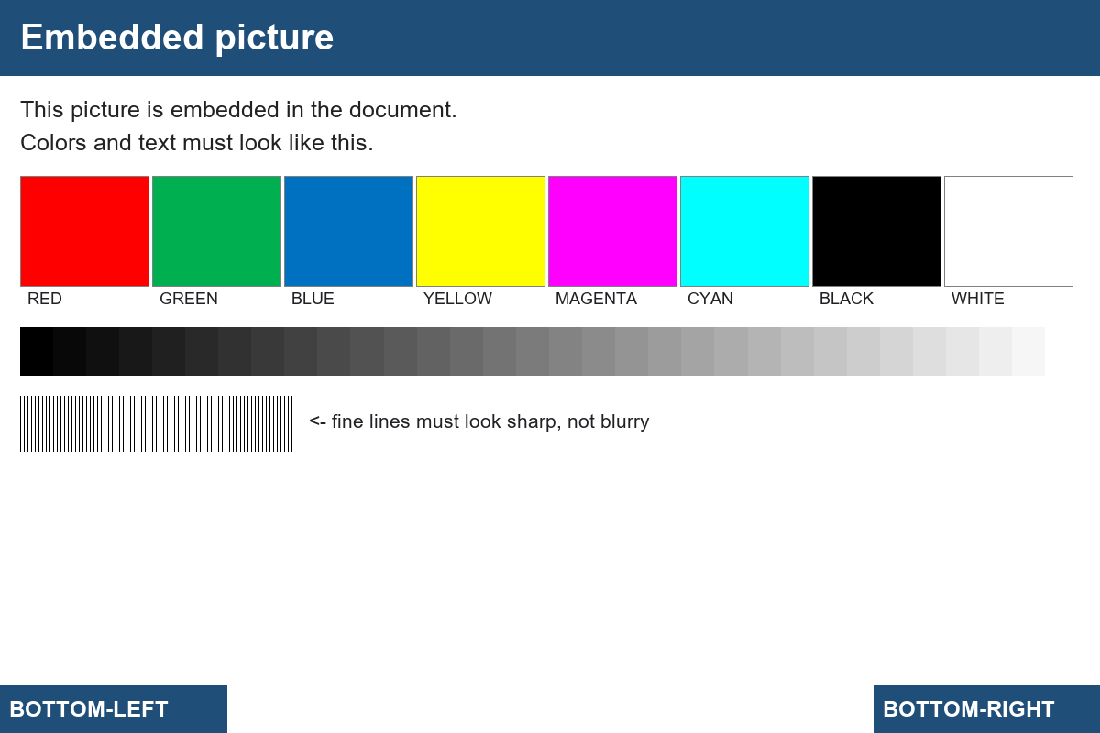
DOCX-19 · Shapes and arrows over a picture Expected: Over the picture below: a red right-arrow at the left pointing at the gray ramp, a yellow rounded box "Look here" at the top right, a green circle outline at the right end of the gray ramp, and a blue line with an arrow head below the fine lines
Look here
DOCX-20 · Text box Expected: A light gray box with a dark border containing two lines of text, to the right of this paragraph
This paragraph has a text box placed next to it. This paragraph has a text box placed next to it. This paragraph has a text box placed next to it.
Text box title
Second line inside the box
DOCX-21 · Floating picture with text wrap Expected: The small purple "Picture 2" sits on the right; this text wraps around its left side
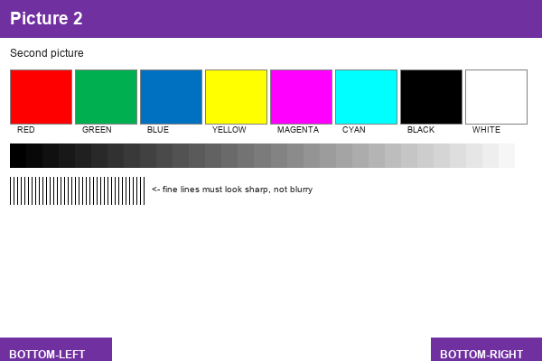
Text wraps around the floating picture. Text wraps around the floating picture. Text wraps around the floating picture. Text wraps around the floating picture. Text wraps around the floating picture. Text wraps around the floating picture. Text wraps around the floating picture. Text wraps around the floating picture. Text wraps around the floating picture. Text wraps around the floating picture. Text wraps around the floating picture. Text wraps around the floating picture.

5. Links and equation
DOCX-22 · Hyperlink Expected: Blue underlined link "Open example.com"; clicking it opens https://example.com in a new tab
Open example.com
DOCX-23 · Equation (math) Expected: The formula E = mc² and a fraction a over b, shown as math (not plain text)
$E=mc^{2}, \frac{a}{b}$
DOCX-24 · Page break Expected: This test is at the top of page 5 (pages 1-4 end with page breaks)
DOCX-25 · Header and footer Expected: Header "Docs Viewer test pack" at the top of every page; footer "Page N" with the right number

6. Two columns
DOCX-26 · Two-column layout Expected: Text flows in two columns side by side (like a newsletter)
Column text paragraph 1. Text continues in two columns. Text continues in two columns. Text continues in two columns. Text continues in two columns. Text continues in two columns. Text continues in two columns.
Column text paragraph 2. Text continues in two columns. Text continues in two columns. Text continues in two columns. Text continues in two columns. Text continues in two columns. Text continues in two columns.
Column text paragraph 3. Text continues in two columns. Text continues in two columns. Text continues in two columns. Text continues in two columns. Text continues in two columns. Text continues in two columns.
Column text paragraph 4. Text continues in two columns. Text continues in two columns. Text continues in two columns. Text continues in two columns. Text continues in two columns. Text continues in two columns.
Column text paragraph 5. Text continues in two columns. Text continues in two columns. Text continues in two columns. Text continues in two columns. Text continues in two columns. Text continues in two columns.
Column text paragraph 6. Text continues in two columns. Text continues in two columns. Text continues in two columns. Text continues in two columns. Text continues in two columns. Text continues in two columns.

7. Landscape page
DOCX-27 · Landscape page in a portrait document Expected: This page is wider than it is tall (landscape); the pages before it are portrait
Landscape page content. Landscape page content. Landscape page content. Landscape page content. Landscape page content. Landscape page content. Landscape page content. Landscape page content. Landscape page content. Landscape page content. Landscape page content. Landscape page content. Landscape page content. Landscape page content. Landscape page content. Landscape page content. Landscape page content. Landscape page content. Landscape page content. Landscape page content.

