1. **Identify Relationships in the following diagrams**

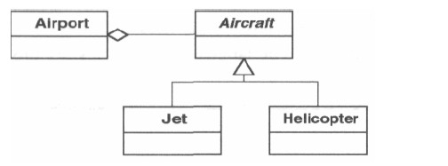

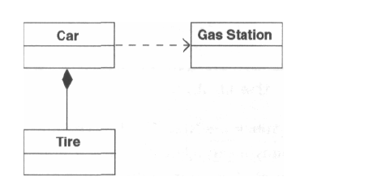

1. **Identify the Pattern**

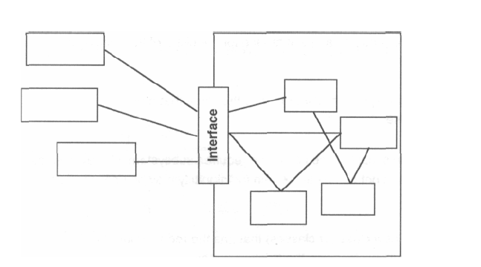

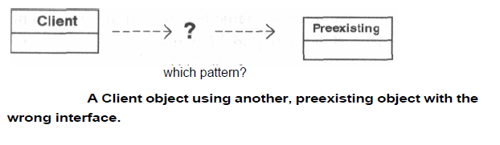

1. **Refactor the Design and Name the pattern**

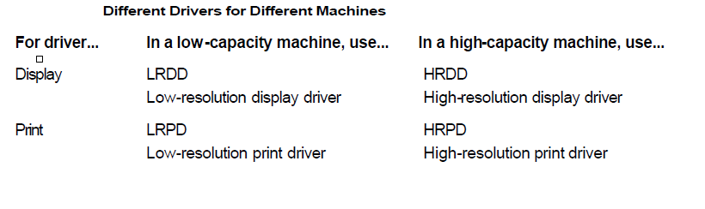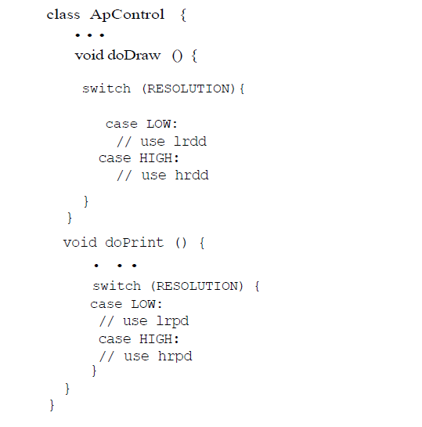

1. **Identify the patterns in the following design:**

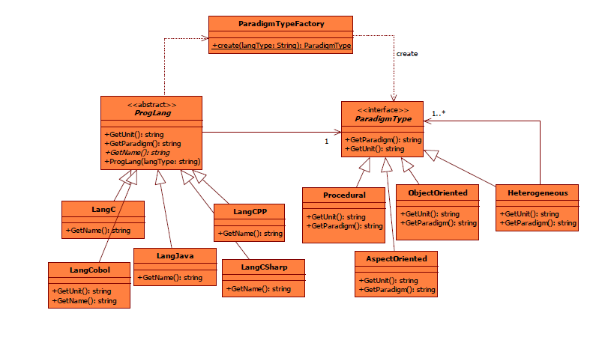

1. **Which of the SOLID principle violated in the following code and Refactor the Design**

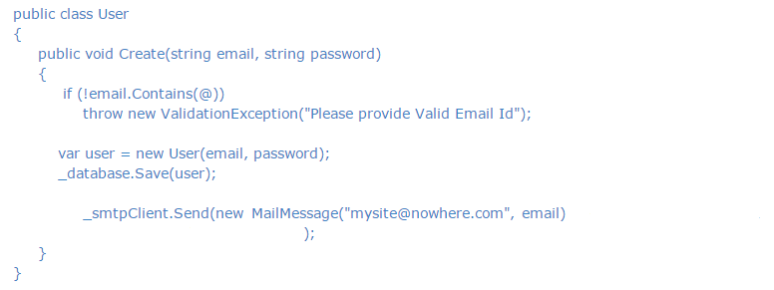

1. **Which best defines the use of the Composite Design Pattern?**
   1. The Composite design pattern allows the clients to build a complex object of smaller different ones
   2. The Composite design pattern allows adding and removing functionality dynamically
   3. the Composite design pattern allows the clients to treat individual objects and compositions uniformly
2. **___________The relationship used to represent a class invoking static methods of another class is**
   1. association
   2. contains
   3. comoposition
   4. inheritance
3. **Which of the following pattern works as a bridge between two incompatible interfaces?**
   1. Builder Pattern
   2. Adapter Pattern
   3. Prototype Pattern
   4. Bridge Pattern
4. **Which of the following pattern is primarily used to reduce the number of objects created and to decrease memory footprint and increase performance?**
   1. Composite Pattern
   2. Facade Pattern
   3. Flyweight Pattern
   4. Decorator Pattern
5. **It is also known as Wrapper, it is used when sub classing is not possible or practical to add functionality and it is used to add functionality at runtime. This pattern is :**
   1. Composite
   2. Adapter
   3. Decorator
   4. Proxy
6. A typical product database consists of two types of product components — product categories and product items. A product category is generally composite in nature. It can contain product items and also other product categories as its subcategories. Example Product Categories: a. Computers b. Desktops c. Laptops d. Peripherals e. Printers f. Cables the Computers product category contains both the Desktops and the Laptops product categories as its subcategories. The Desktop category can contain a product item such as Compaq Presario 5050. Product items are usually individual, in the sense that they do not contain any product component within. Design and implement an application to list the dollar value of a product component. Use the appropriate pattern to allow the client application to refer to both the product categories and the product items in a uniform manner
7. Suggest the Correct Pattern

Let us build a sales reporting application for the management of a store with multiple departments. The features of the application include:

* 1. Users should be able to select a specific department they are interested in.
  2. Upon selecting a department, two types of reports are to be displayed:
     1. Monthly report — A list of all transactions for the current month for the selected department.
     2. YTD sales chart — A chart showing the year-to-date sales for the selected department by month.

Whenever a different department is selected, both of the reports should be refreshed with the data for the currently selected department.

1. Refactor the Design using Appropriate Pattern

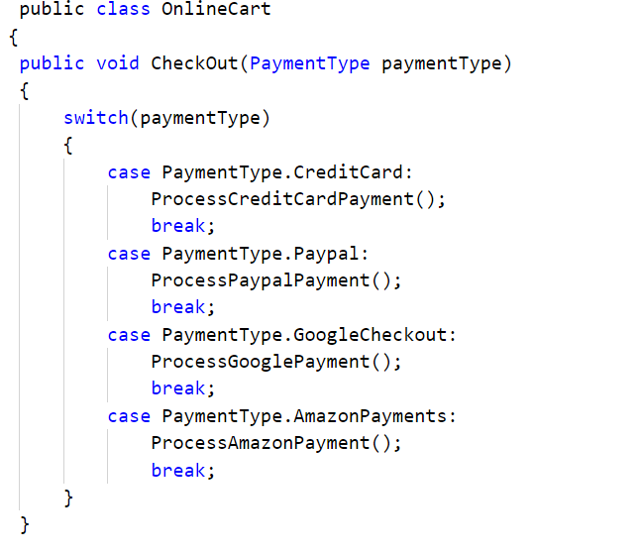

1. Refactor using appropriate Pattern

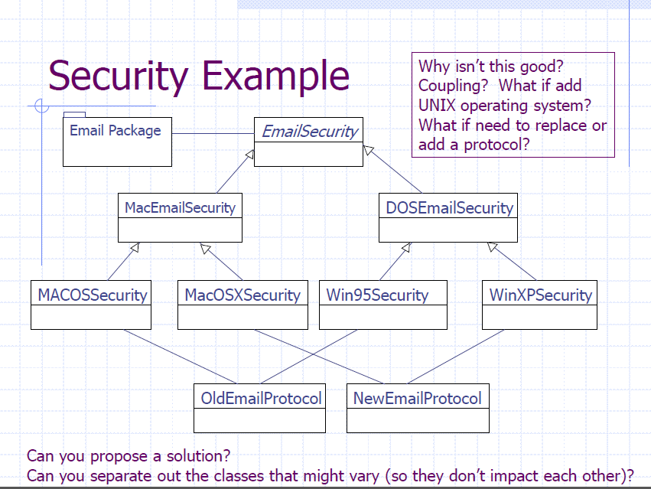

1. A computer user in a typical organization is associated with a user account. A user account can be part of one or more groups. Permissions on different resources (such as servers, printers, etc.) are defined at the group level. Users get all the permissions defined for all groups that their accounts are part of. Let us consider an organization with three different user groups — Administrators, FieldOfficers and SalesResps. Further assume that the organization is in the process of migrating user accounts from one server to a different server environment. As part of this process, all user accounts are first exported to an XML file as follows

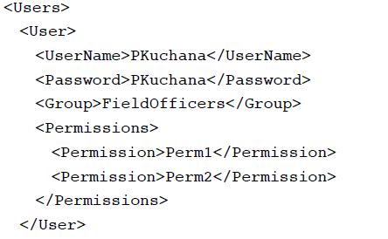

It is to be noted that permissions for all accounts in a given group are the same. This can be considered as the intrinsic data. The user name and the password details vary from user to user and should be treated as extrinsic data. User accounts in the new server environment are created using the

Exported XML file. Make any necessary assumptions and design an application using the appropriate pattern to parse the XML file to create different user account objects.