Visitor Management System

Table of contents

Executive summary 2

Project Scope (our understanding) 2

Feature of the tool 2

Front end 2

Backend 2

Solution 3

Workflow 3

Technology Stack 5

Time line 5

Cost 5

Assumptions 5

# Executive summary

Blocmatrix, would like to help in design & development of the solution and ensure a successful implementation of the Visitor management software.

Modelcraft group is looking for a visitor management tool to accommodate event at Riyadh

# Project Scope (our understanding)

The Requirements of the project mentioned by the group are as follows

* Visitor will do the registration online through a web Interface or on-site with volunteers
* The web interface would have set limit for the number of registrations
* Hosts would be notified about the total number of registrations
* On registration, an unique QR code would be generated for the user and the same can be used as a badge
* Volunteers would be provided with an mobile app that is used to scan the badge and notify system/hosts about the user attendance (entry/exit and gift distribution)
* Gift shall be distributed to the first time visitors (individual/family/group) and are duly verified at the backend.

# Feature of the tool

# Front end

* Pre-Registrations

Provide check-in details via email even before the visitor arrives.

* Visitor Badges

Provide badges to visitors for easy identifications and check-out.

* Dashboard/Registration Management

Use the dashboard to manage visitors, invites, and  profile settings

* Host Notifications

Automatically notify Backend on visitor arrival

**\*\*** During the Registration process, visitor is asked to print a copy of the registration confirmation which would have the barcode/QR code for quick access**\*\***

Equipment Need

Badge printer (To be procured by the client )

# Backend

Permission to add / modify / delete user details

Show notification for new request of Registration as well as show all kind of requests

Show reports in graph as well as in tabular format

Option to download reports in excel sheet /Desired format

Permission to add / modify / delete any tool user/Employee

# Solution

# Workflow

**Off-Site Registration (Web)**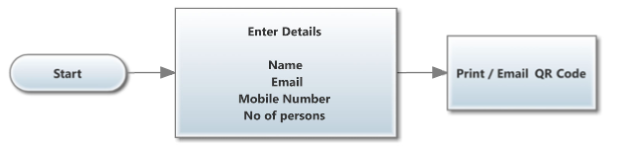

**On-Site Registration**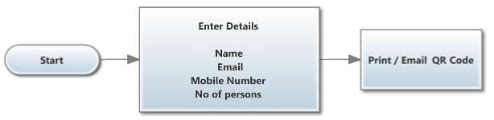

**Entry Gate**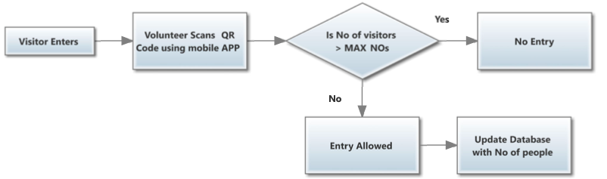

**Exit Area**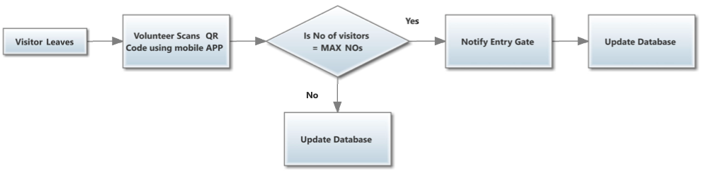

**Gift Area**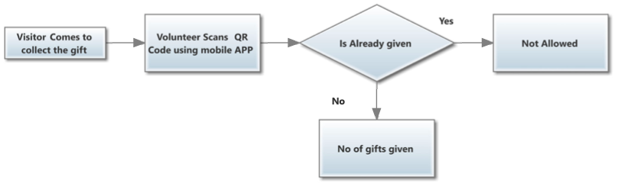

# Technology Stack

We propose that the solution will be built on Open Source technologies and would ensure seamless implementation

Architecture – SOA

Frontend – Angular 5+, TypeScript, BootStrap, HTML5, CSS3

App – Android

Backend – NodeJs, Express Framework, MySQL, MongoDB

Server – Cloud (AWS) & Web Server (Ngnix)

# Time line

We should be able to complete project in **15 working days** with complete development and UAT.

Phases will be decided on basis of priority and mentioned on the project plan above

Adequate training would also given if needed

# Cost

Rs 2,50,000 INR + Taxes

# Assumptions

Barcode scanning should be performed through Mobile Devices (Android only).

Any Enhancements requested would not be part of this development and scope is strictly restricted to the above mentioned deliverables

Badge printer should be procured by the client