<https://hub.docker.com/_/nginx>

nano Dockerfile *

FROM ubuntu:18.04

RUN apt update -y

RUN apt install nginx -y

RUN apt install jq -y

FROM VS RUN

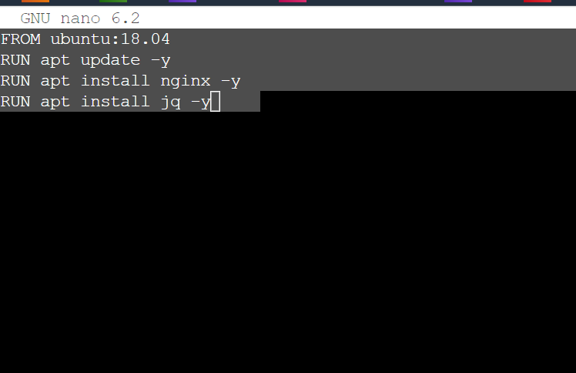

Run the container

root@ip-10-1-1-124:~# docker build -t sreeharshav/rollingupdate:v2 .

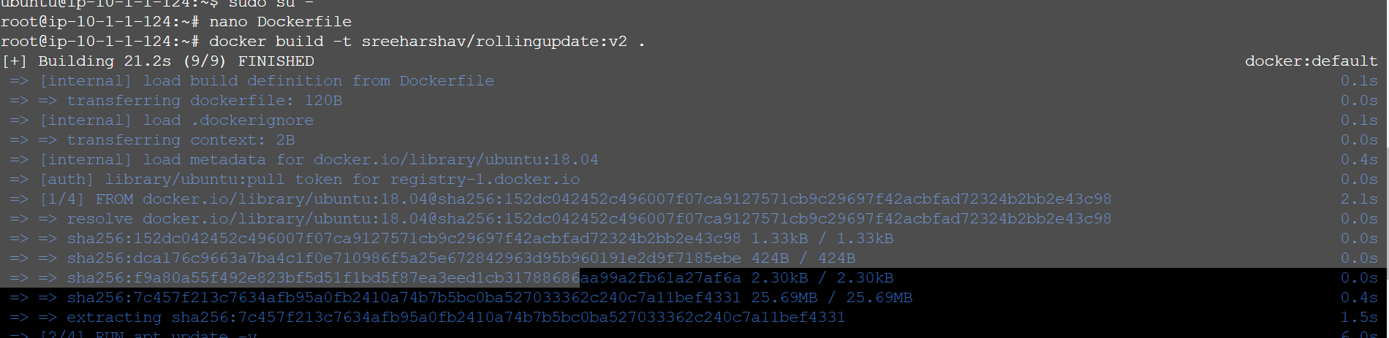

Running successfully



COPY VS ADD

Create function;

Nano Venu.sh

#!/bin/bash

for I in {1..20}

do

echo $I

sleep 1

done

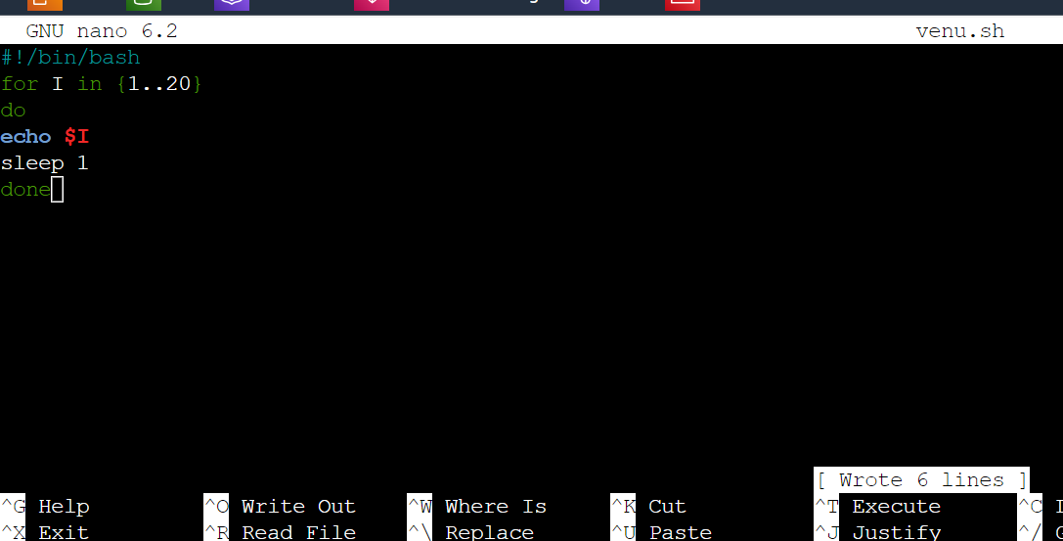

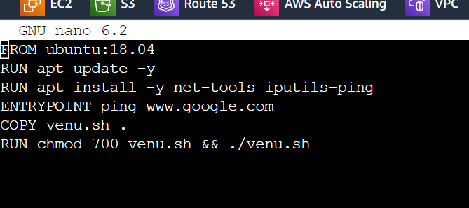

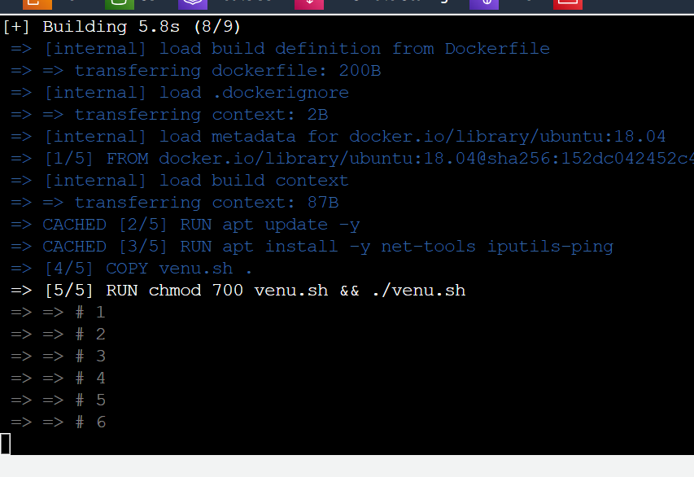

Copy vs add using same link

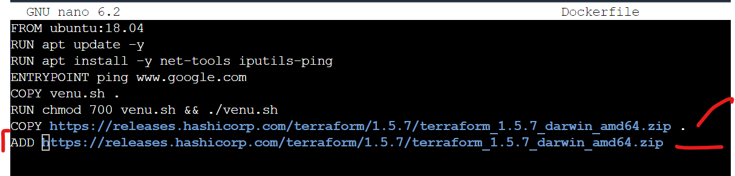

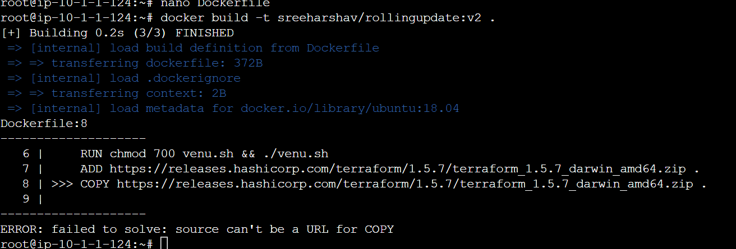

CMD vs ENTRYPOINT

Cmd command

FROM ubuntu:18.04

RUN apt update -y

RUN apt install -y net-tools iputils-ping

CMD ping [www.google.com](http://www.google.com)

Edit in dockerfile

2. step Docker build -t sreeharshav/rollingupdate:v2 .

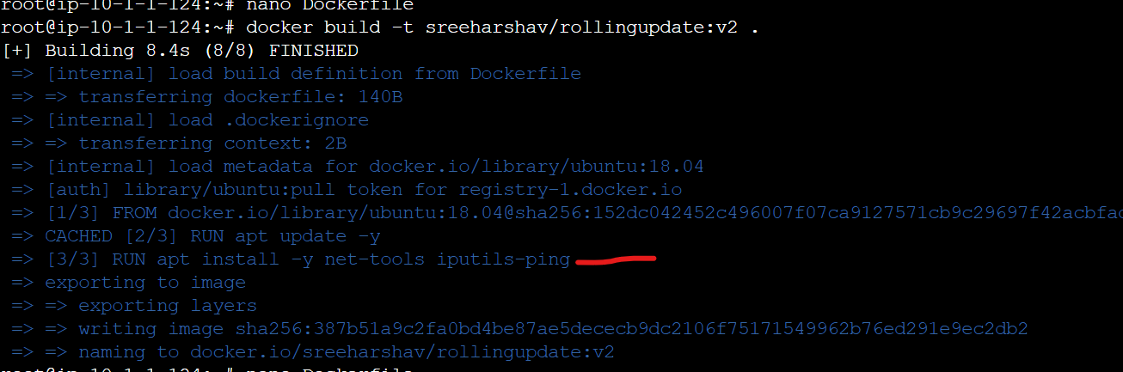

Pinging

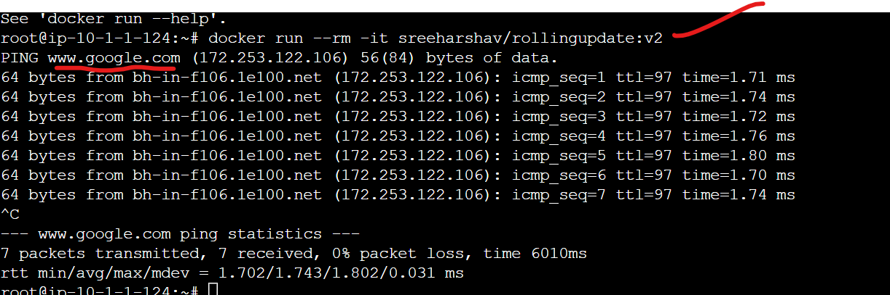

Step3. docker run –rm -it sreeharshav/rollingupdate:v2

Step4. docker run –rm -it sreeharshav/rollingupdate:v2 ping [www.facebook.com](http://www.facebook.com)

We can overwrite while execution execution of container by using cmd

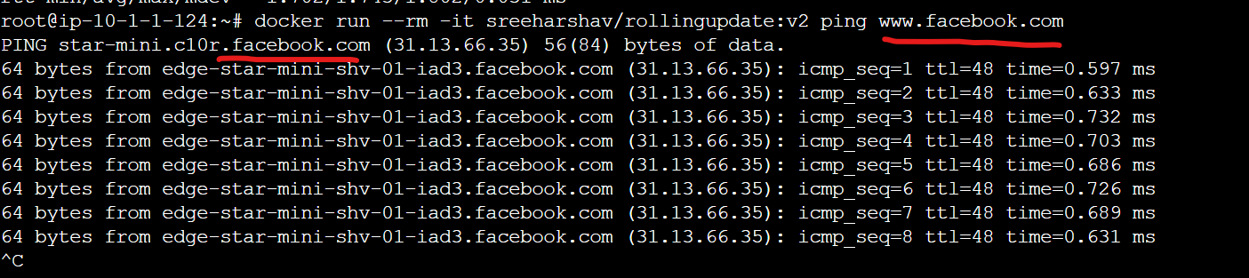

ENTRYPOINT:

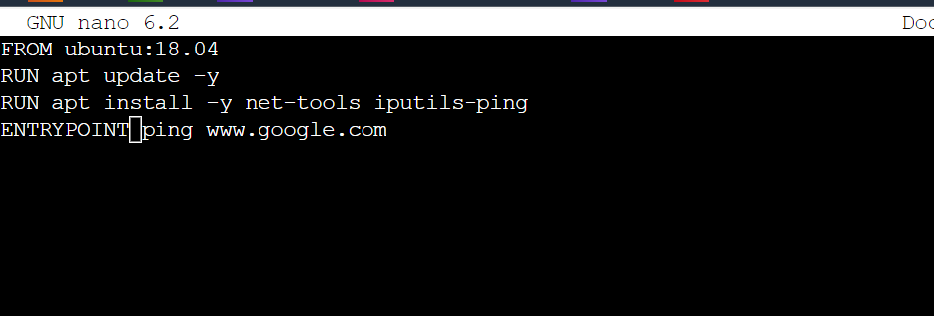

FROM ubuntu:18.04

RUN apt update -y

RUN apt install -y net-tools iputils-ping

ENTRYPOINT ping [www.google.com](http://www.google.com)

2.docker bu

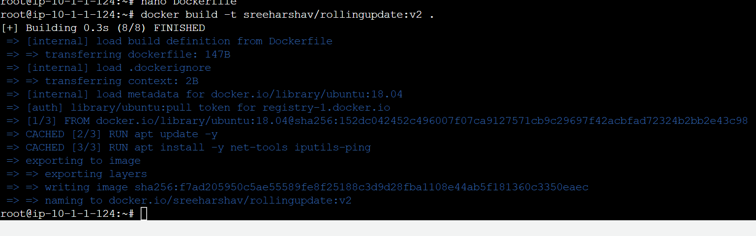

=> => naming to docker.io/sreeharshav/rollingupdate:v2 0.0s

Step 2root@ip-10-1-1-124:~# docker build -t sreeharshav/rollingupdate:v2 .

we cant overwrite command while execution container by sing entrypoint check below screenshot

step3. Docker run –rm -it sreeharshav/rollingupdate:v2 ping www.facebook.com

