How to Consume SOAP service with multi-part(message contains multiple parts) WSDL using Mule ESB.

Componants used:

1.CXF as JAX-WS client

2.SOAP Router

3.XML to JAXBObject transformer

4.WSDL2Java tool by CXF can be found at below link. <http://cxf.apache.org/download.html>

when using a document style SOAP binding for an operation with messages (input, output, or fault) that are defined with multiple parts, all parts other than the one selected to be bound to the SOAP body must be bound as attachments or headers.

Read more about multipart wsdl in below link.

<https://www.ibm.com/support/knowledgecenter/SSTLXK_7.5.1/com.ibm.wbpm.main.doc/topics/cadm_wsdlstyle.html>

Whenever you try consuming servi ces with multi-part messages , webservice consumer shows warning as “Warning: Operation Messages With More Than 1 Part Are Not Supported.”

When you drag and drop DW componant it senses either SOAP Body or Other parts, which makes it difficult for developers to perform transformations.

**Step 1:** Generate JaxB Objects corrosponds to given service WSDL.

Before generating JAXB objects we need to make below change to WSDL.

Find the PortType for your interface and place below binding statement in your wsdl.

<jaxws:bindings xmlns:jaxws="http://java.sun.com/xml/ns/jaxws"> <jaxws:enableWrapperStyle>false</jaxws:enableWrapperStyle>

</jaxws:bindings>

a.Drag and Drop CXF componant ,Select Operation as Jax-WS Client as shown in below Screenshot.

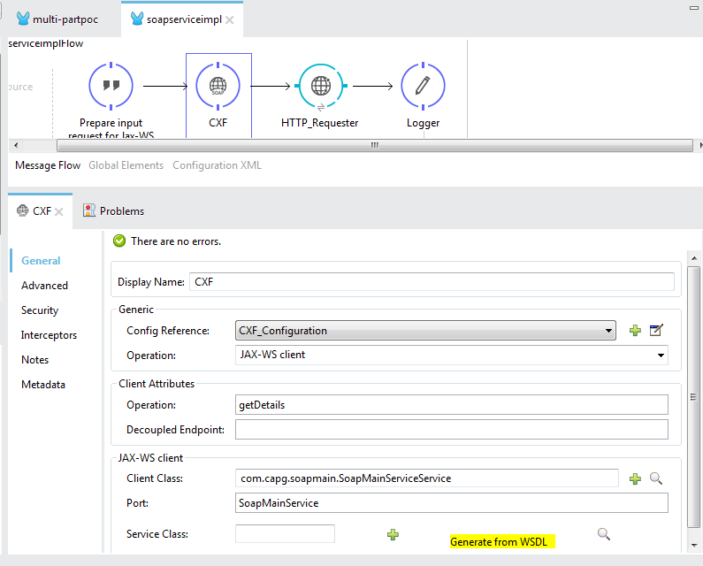

b. To genegate JAXB objects click on Generate from WSDL as highlighted in above screenshot. Enter WSDL location and java package Name in Generate from from WSDL pop-up.

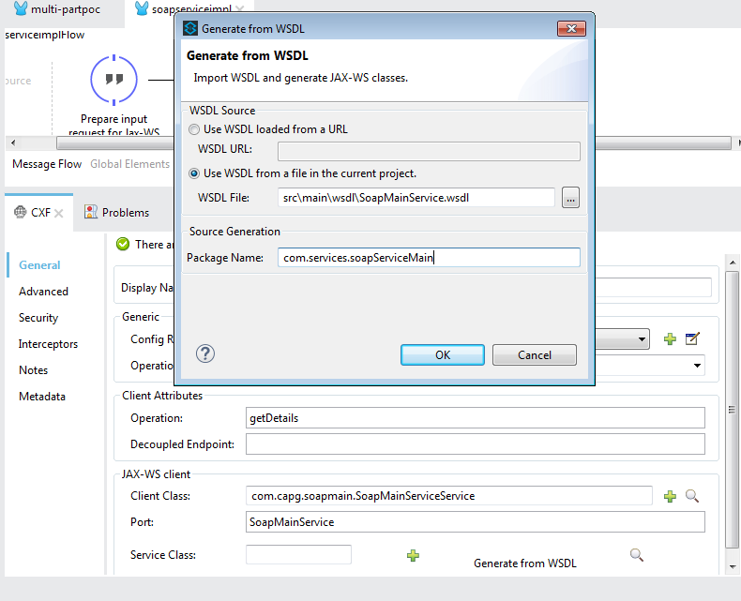

**Step 2:** Identify below classes from generated java files:

1.Interface represents Webservice(tip: search with “@WebService”).

2.Request Header and Body Java Objects(tip:Identify from Interface class Operation).

3.Webservice Client class(tip:search with “@WebServiceClient”).

**Step 3:**Prepare Request for Jax-WS client.

1.As our message payload contains data formats such as XML , we need to convert XML to equivalent JaxB object using XML to JaxB Object Transformer.

Header JaxB object creation:  
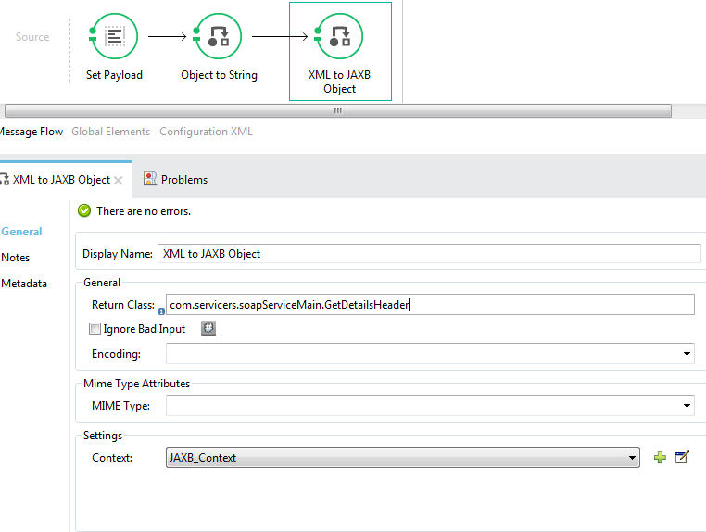

Body JaxB Object creation:

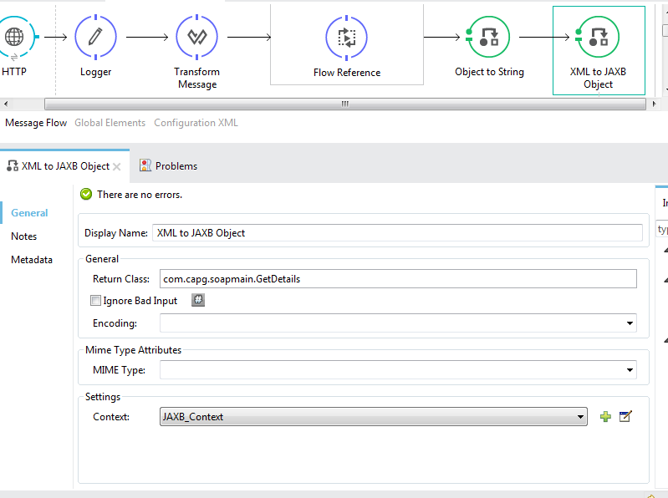

**Step 4:**

Consume Webservice :

Assign Payload with required variables for the given Operation.As **getDetails** operation as two parameters out payload will be array of two jaxBobjects.

@WebMethod

@WebResult(name = "getDetailsResponse", targetNamespace = "http://soapMain.capg.com", partName = "parameters")

**public** GetDetailsResponse getDetails(

@WebParam(partName = "getDetails", name = "getDetails", targetNamespace = "http://soapMain.capg.com")

GetDetails getDetails,

@WebParam(partName = "InputHeader", name = "getDetailsHeader", targetNamespace = "http://soapMain.capg.com", header = **true**)

GetDetailsHeader inputHeader

);

Request Payload:

**requestPayload = new object[2]();**

**requestPayload[0] = payload;**

**requestPayload[1] = flowVars.flwJaxBHeader;**

**payload = requestPayload;**

Add combination of CXF as Jax-WS client and HTTP requester for consuming Webservice.

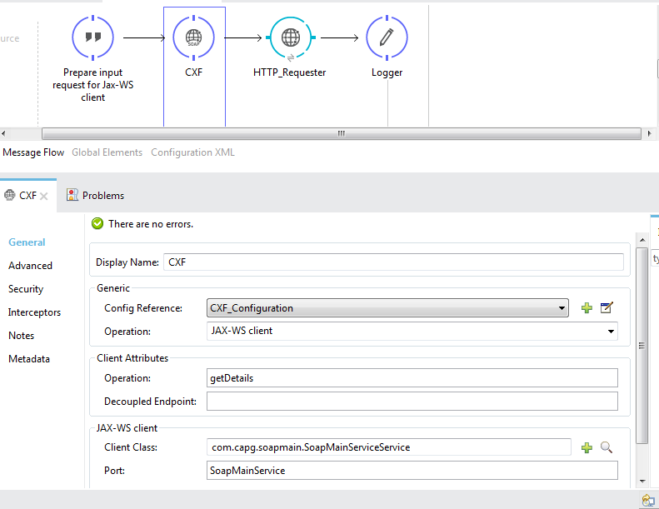

Tada – we are ready.