1. **Decompile the APK file**

**Command :** java -jar apktool_2.12.1.jar d base.apk

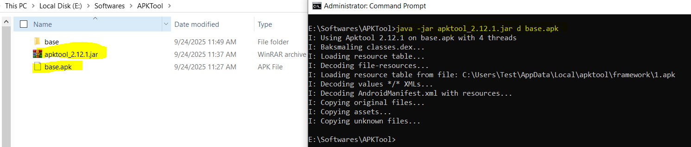

1. **Find the DB in the app extracted files**

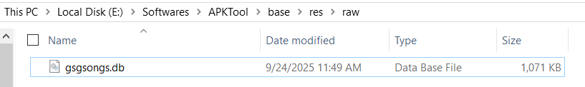

**Didn’t work with apksigner**

apksigner.bat sign --ks "C:\Program Files\Java\jdk-18.0.2\bin\release.keystore" --ks-key-alias worshipsongs --out "E:\Softwares\APKTool\base\dist\Newbasev1.apk"

1. **Modify the DB Tables**

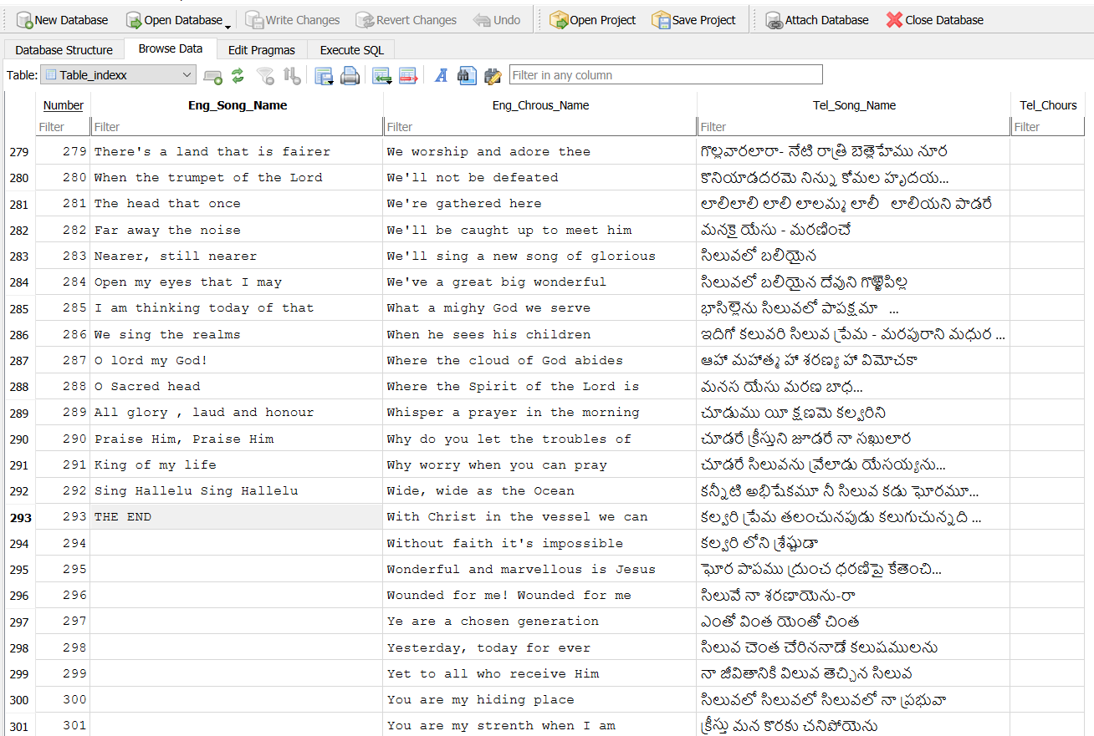

1. **Create a KeyStore for signing the modified apk**

**Command:**

C:\Program Files\Java\jdk-18.0.2\bin\keytool.exe -genkey -v -keystore release.keystore -alias <alias_name> -keyalg RSA -keysize 2048 -validity 10000

1. **App Sign using jarsigner(Java)**

**Command:**

jarsigner -verbose -sigalg SHA1withRSA -digestalg SHA1 -keystore "C:\Program Files\Java\jdk-18.0.2\bin\release.keystore" "E:\Softwares\APKTool\base\dist\base.apk" worshipsongs

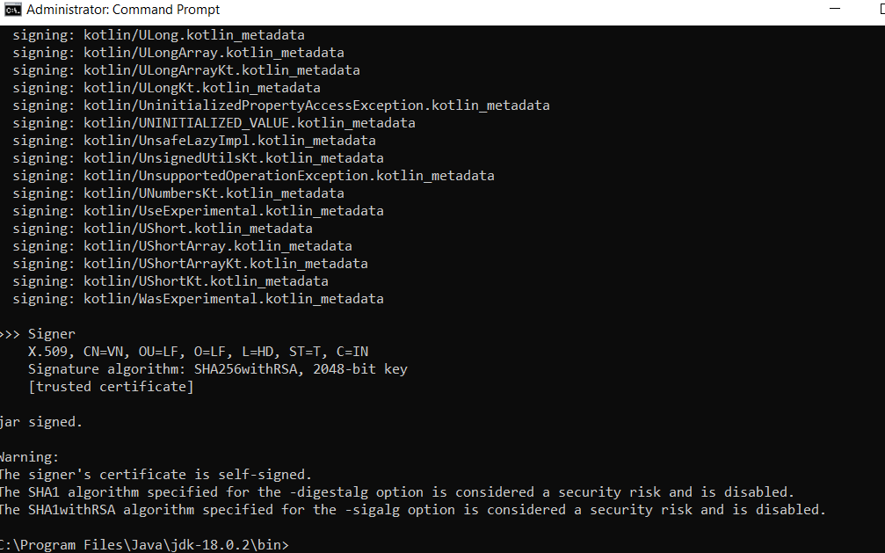

1. **Align the modified apk with the sign using zipalign**

**Command:**

E:\Softwares\Android SDK\android-9>zipalign -v 4 "E:\Softwares\APKTool\base\dist\base.apk" "E:\Softwares\APKTool\base\dist\NewbaseV3.apk"

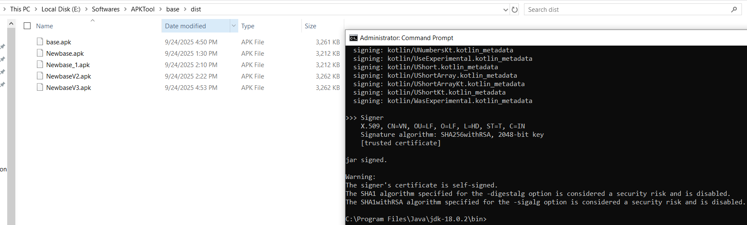

1. Copy the generated apk(aligned) to the mobile device
2. Uninstall the existing app and install using modified apk

**Troubleshooting:**

1. **Using ADB utility from Android SDK platform tools, connect to the mobile device through USB and enable developer options in the mobile to allow adb commands from system**

E:\Softwares\Android SDK\**platform**-tools>adb devices

* daemon not running; starting now at tcp:5037

* daemon started successfully

List of devices attached

ZA222JF8GS device

1. **Pull the Internal DB of the app to gsg_pulled.db (gsg.dani.songs is the internal DB folder identified from the smali scripts)**

E:\Softwares\Android SDK\platform-tools>adb exec-out run-as gsg.dani.songs cat databases/gsgsongs.db > gsg_pulled.db

