Install command:

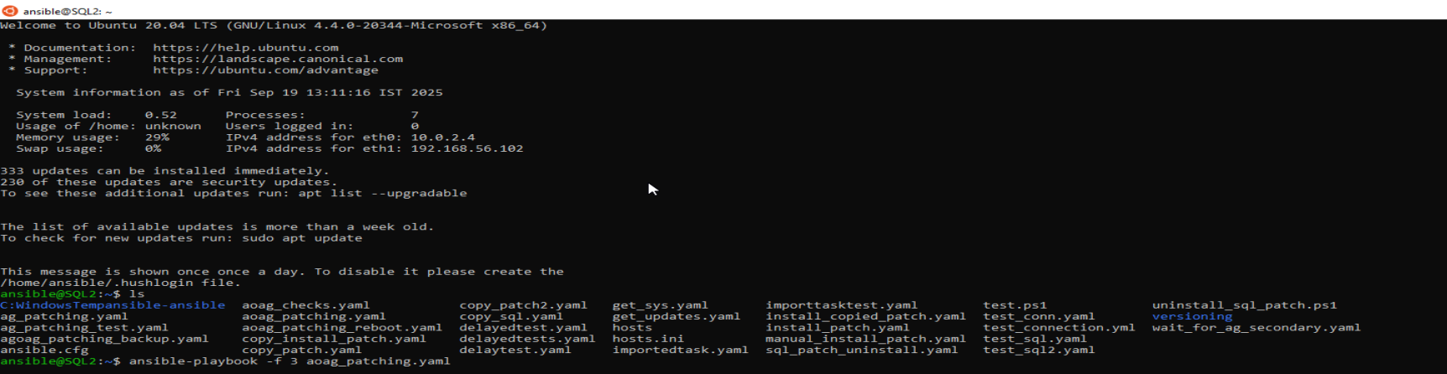

Installation:

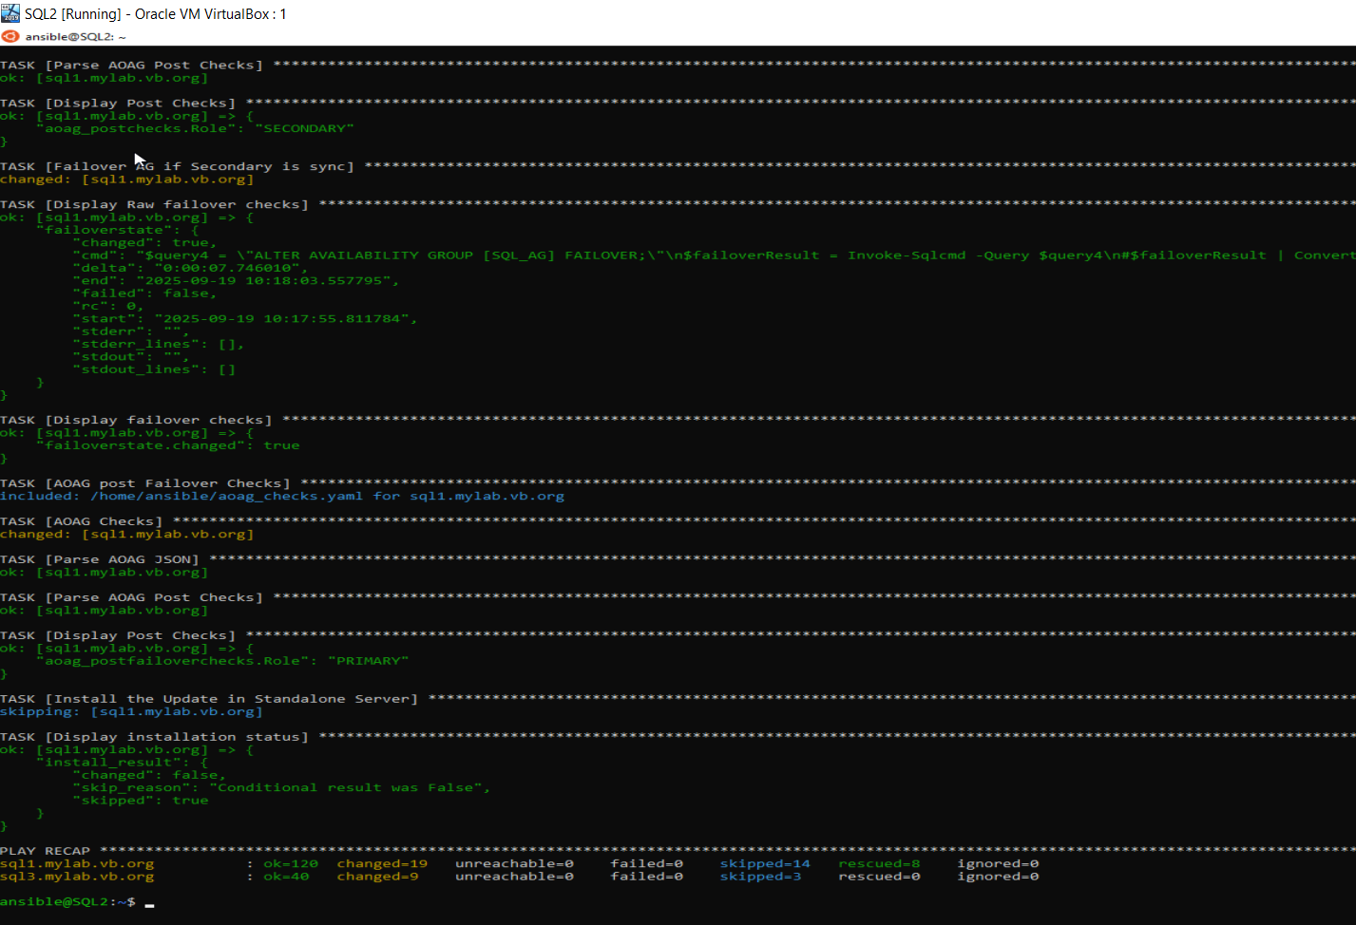

Version Update:

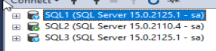

Uninstall Command

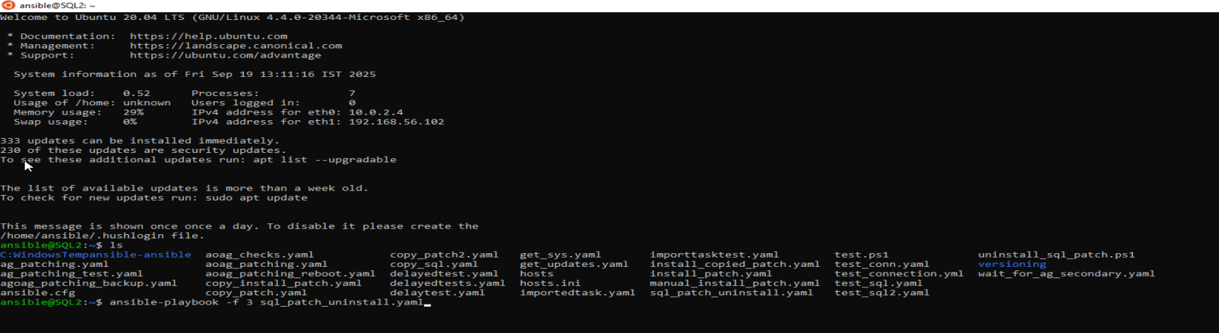

Failover issue due to server connection timeout:

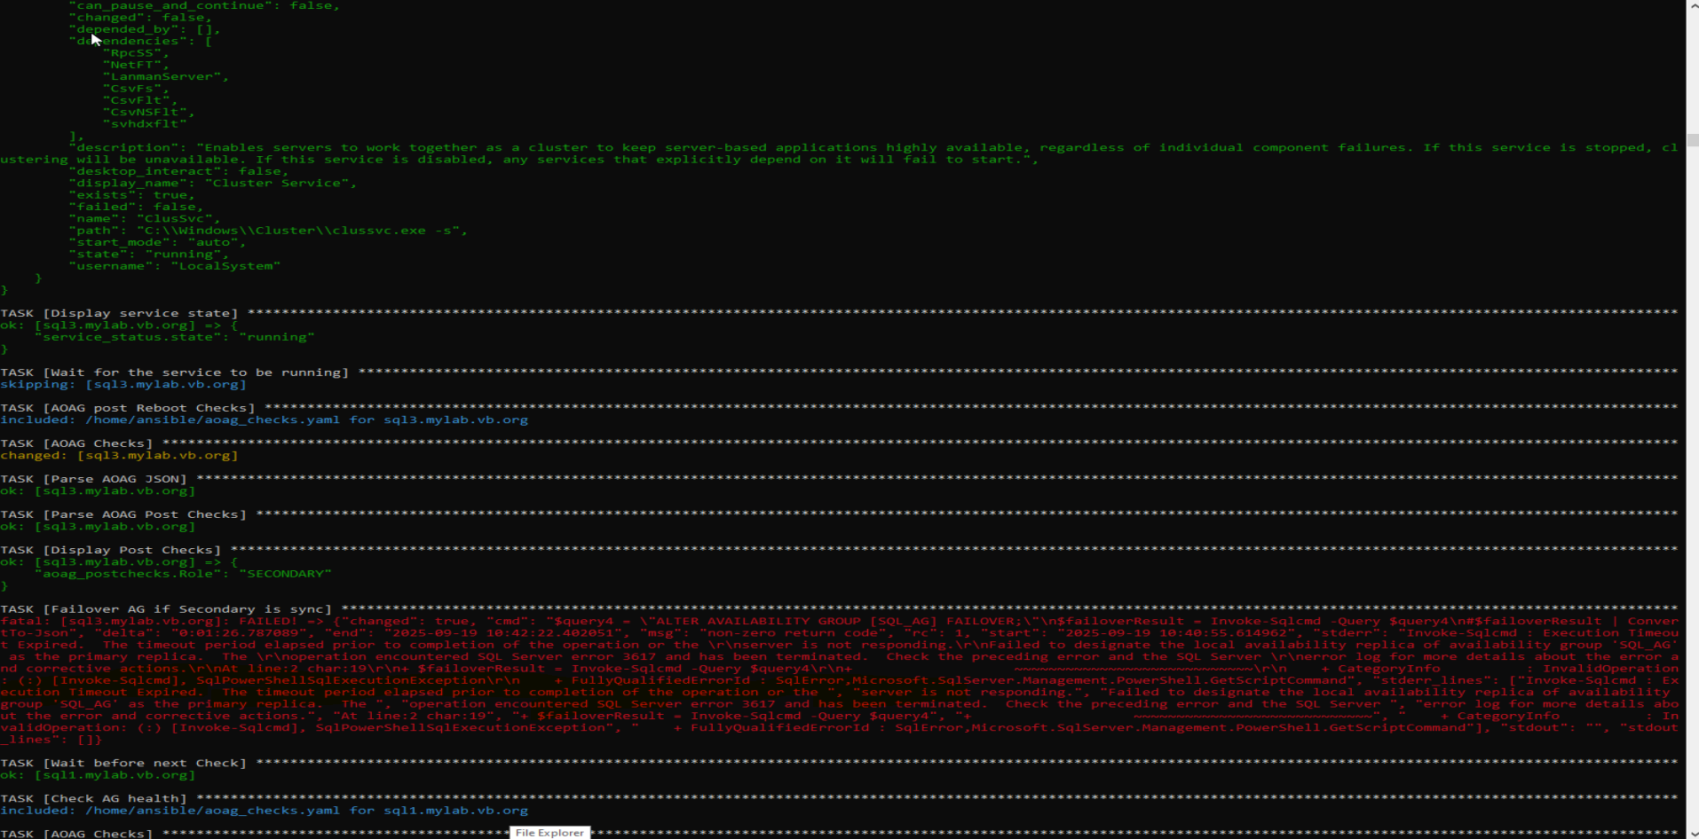

DB in new secondary was stuck in recovery pending state. Restarted SQL and is in sync and the tasks resumed.

**Uninstall status:**

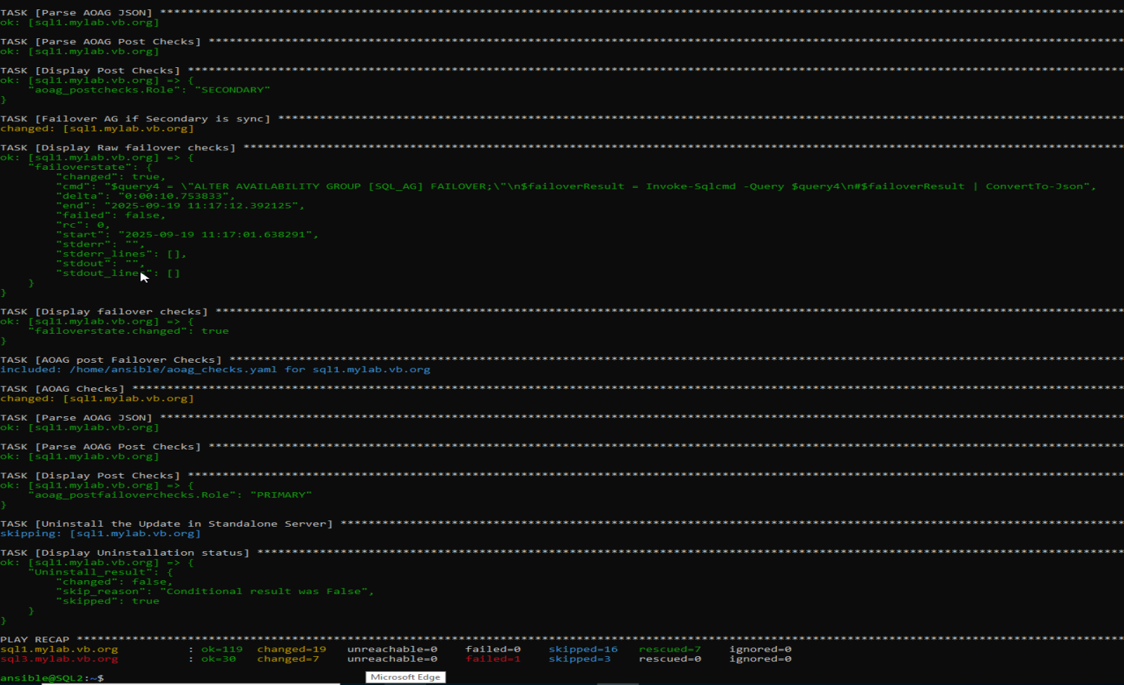

**Version check:**

