1. Open Powershell with run as admin and run below command

*Winrrm quickconfig*

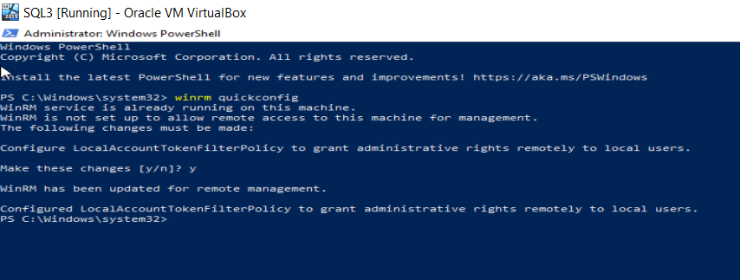

To enable WinRM HTTPS listener, create a self-signed certificate with this command:  
 *New-SelfSignedCertificate -DnsName “hostname.domain.com”,”192.178.34.2” -CertStoreLocation Cert:\LocalMachine\My*

--Remove FQDN if it not in domain

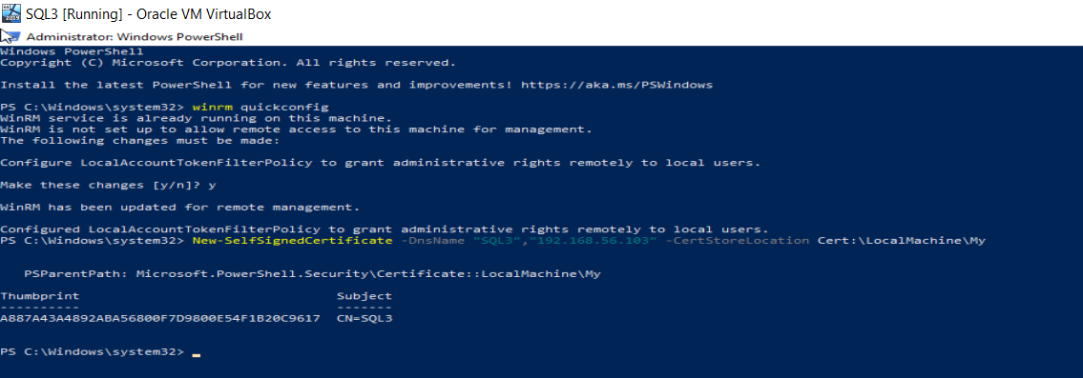

1. Create HTTPS listener: Get the thumbprint of the self-signed certificate created in previous step

*$thumbprint = (Get-ChildItem -Path Cert”\LocalMachine\My | Where-Object {$_.Subject -match “CN=SQL3”}).Thumbprint*

1. Print it to validate

*Write-Host “Thumbprint: $ thumbprint”*

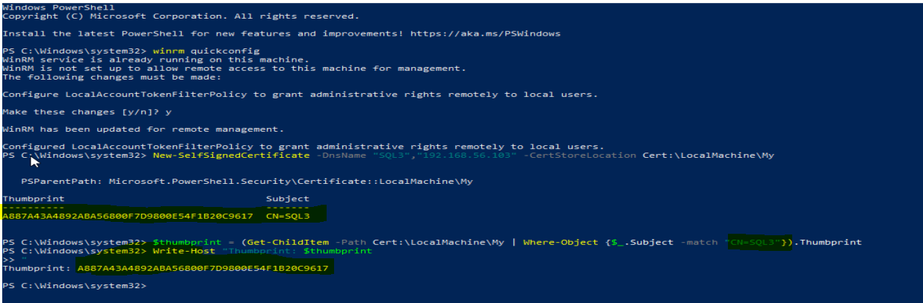

1. Create the listener using the thumbprint

*$params = @{*

*ResourceURI = “winrm/config/Listener”*

*SelectorSet = @{Transport = “HTTPS”, Address = “*”}*

*ValueSet = @{Hostname = “SQL3”; CertificateThumbprint = $thumbprint}*

*}*

*New-WSManInstance @params*

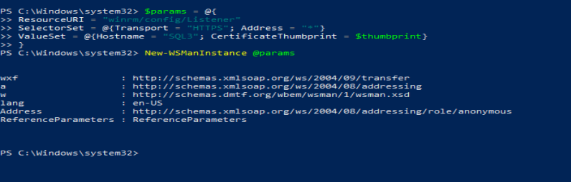

1. Validate the listeners:

*Winrm enumerate winrm/config/Listener*

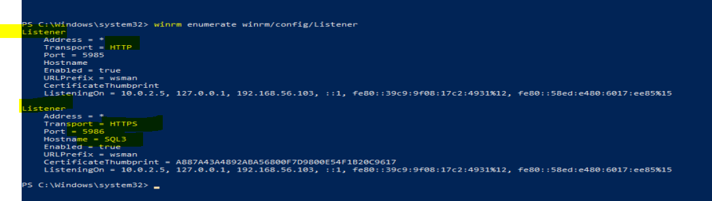

1. For Ansible connectivity, you need to do following configurations
2. Enable Basic Authentication for WinRM if not enabled already

*Set-Item -Path WSMan:\localhost\Service\Auth\Basic -Value $true*

1. Configure WinRM to allow unencrypted traffic (optional, use with caution in prod environments)

*Set-Item -Path WSMan:\localhost\Service\AllowUnencrypted -Value $true*

1. Increase the Maximum envelope size (optional, but use with caution in prod environments)

*Set-Item -Path WSMan:\localhost\MaxEnvelopeSizekb -Value 8192*



1. Restart the WinRM Service to apply the changes:

*Restart-Service WinRM*

1. Open the HTTPS port by creating Network Firewall Rule

*New-NetFirewallRule -DisplayName “Windows Remote Management (WS-Management)” -Name “Windows Remote Management (WS-Management)” -Profile Any -LocalPort 5986 -Protocol TCP*

**Note**: Check the service in Services.msc for service name and display name

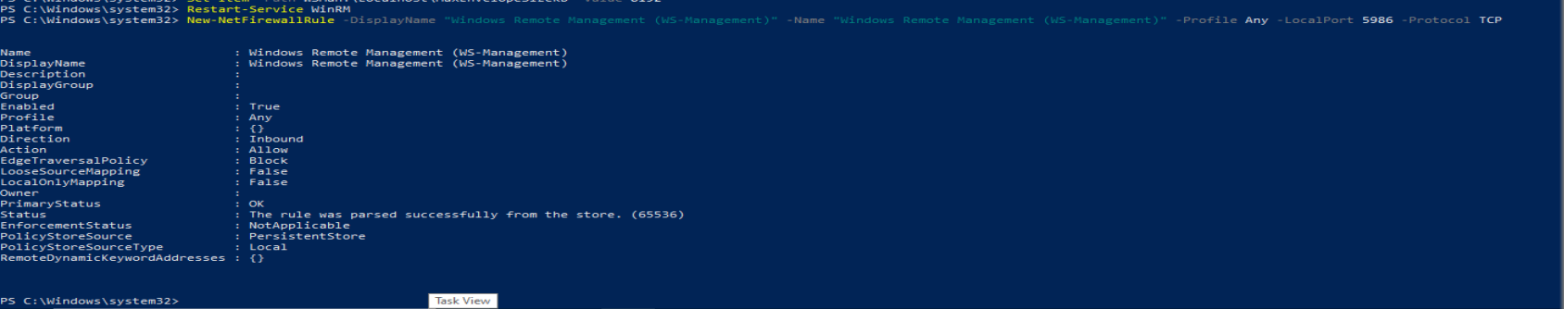

**Ansible configuration in Ubuntu server for WinRM:**

1. Pip for python3 to be installed

*Sudo apt update*

*Sudo apt install python3-pip*

1. After installation, verify the versions

*Pip3 –version*

1. Now install pywinrm using pip3

*Pip3 install pywinrm*

1. For Kerberos Support:

*Pip3 install pywinrm[kerberos]*

1. For NTLM authentication Support:

*Pip3 install pywinrm[credssp]*

If you are seeing **“Requirement already Satisfied”** messages while running above command, you can ignore it as the packages already installed.

1. Configure WinRM Parameters in inventory/config file

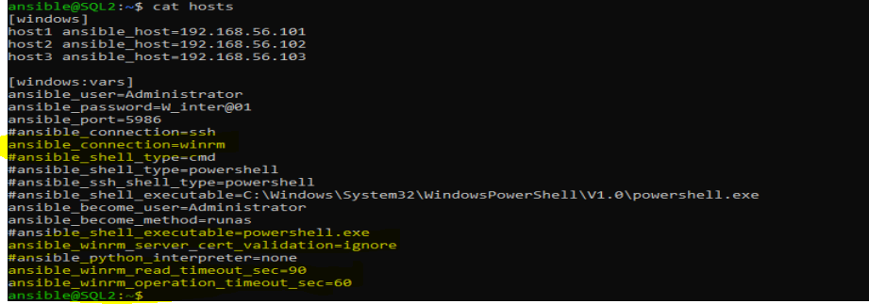

1. Run ansible commands and playbooks against the windows hosts configured with winRM

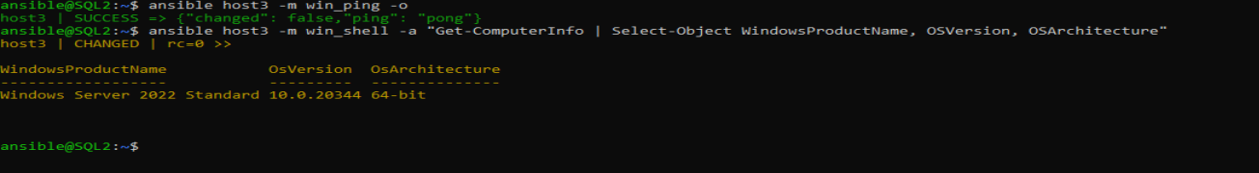

Host2 has not yet configured with WinRM

