Week 8
Task 1
import java.util.*;

class Sports {
String getName() {
return "Generic Sports";
}

void getNumberOfTeamMembers() {
System.out.println("Each team has n players in " + getName());
}
}

class Soccer extends Sports {
@Override
String getName() {
return "Soccer Class";
}

@Override
void getNumberOfTeamMembers() {
System.out.println("Each team has 11 players in " + getName());
}
}

public class Solution {
public static void main(String[] args) {
Sports c1 = new Sports();
Soccer c2 = new Soccer();

System.out.println(c1.getName());
c1.getNumberOfTeamMembers();

System.out.println(c2.getName());
c2.getNumberOfTeamMembers();
}
}
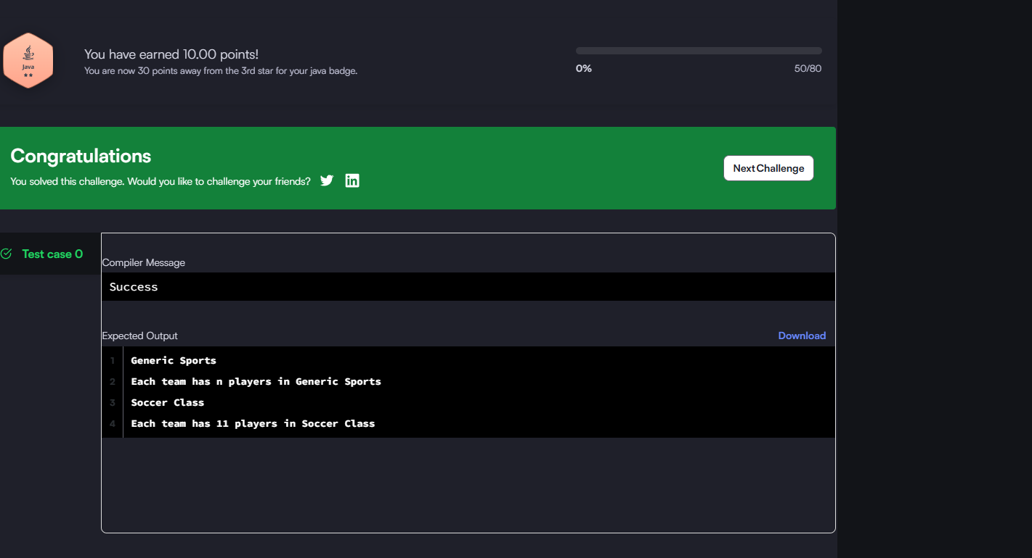
Week8
Task2
import java.util.*;
import java.io.*;

class BiCycle {
String define_me() {
return "a vehicle with pedals.";
}
}

class MotorCycle extends BiCycle {
String define_me() {
return "a cycle with an engine.";
}

MotorCycle() {
System.out.println("Hello I am a motorcycle, I am " + define_me());

// Use super.define_me() to access the superclass method
String temp = super.define_me();

System.out.println("My ancestor is a cycle who is " + temp);
}
}

public class Solution {
public static void main(String[] args) {
MotorCycle M = new MotorCycle();
}
}
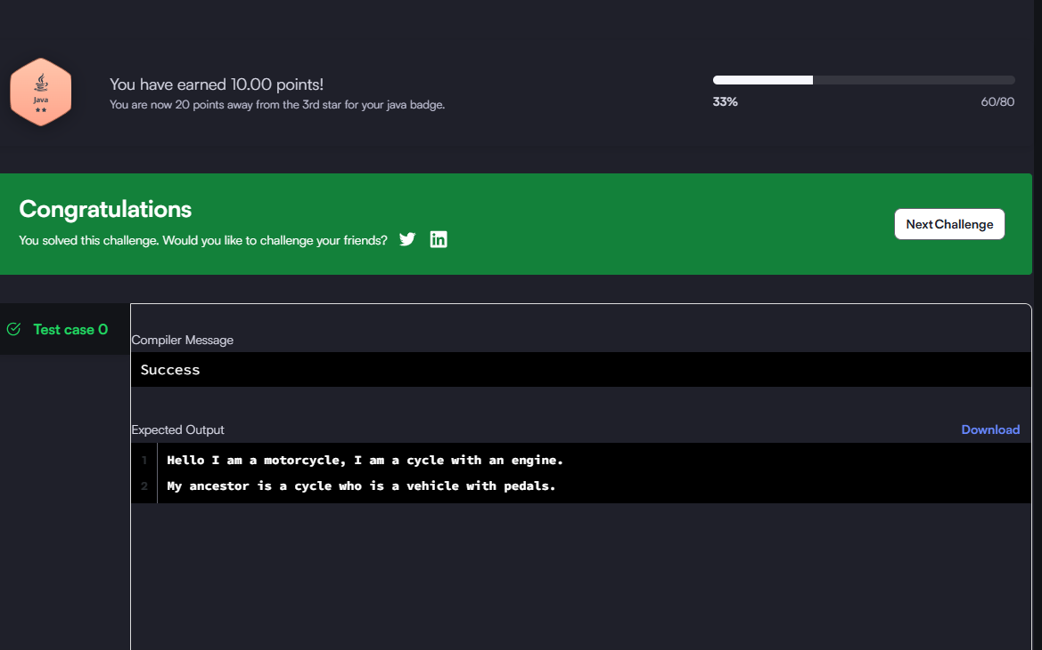

Week8
Task3
import java.io.*;
import java.util.*;

class Singleton {
private static Singleton instance;
public String str;

private Singleton() {}

public static Singleton getSingleInstance() {
if (instance == null) {
instance = new Singleton();
}
return instance;
}
}

public class Solution {
public static void main(String[] args) {
Scanner scan = new Scanner(System.in);
if (scan.hasNextLine()) {
String input = scan.nextLine();
Singleton singleton = Singleton.getSingleInstance();
singleton.str = "Hello I am a singleton! Let me say " + input + " to you";
System.out.println(singleton.str);
}
}
}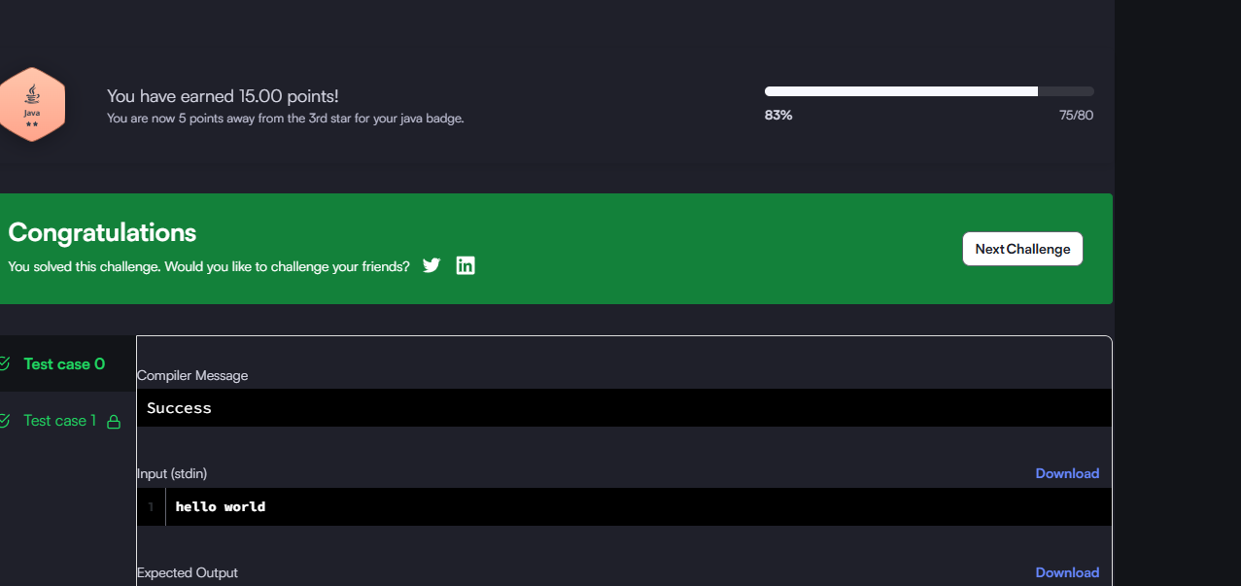
Task3
import java.io.*;
import java.util.*;

class Singleton {
private static Singleton instance;
public String str;

private Singleton() {}

public static Singleton getSingleInstance() {
if (instance == null) {
instance = new Singleton();
}
return instance;
}
}

public class Solution {
public static void main(String[] args) {
Scanner scan = new Scanner(System.in);
if (scan.hasNextLine()) {
String input = scan.nextLine();
Singleton singleton = Singleton.getSingleInstance();
singleton.str = "Hello I am a singleton! Let me say " + input + " to you";
System.out.println(singleton.str);
}
}
}

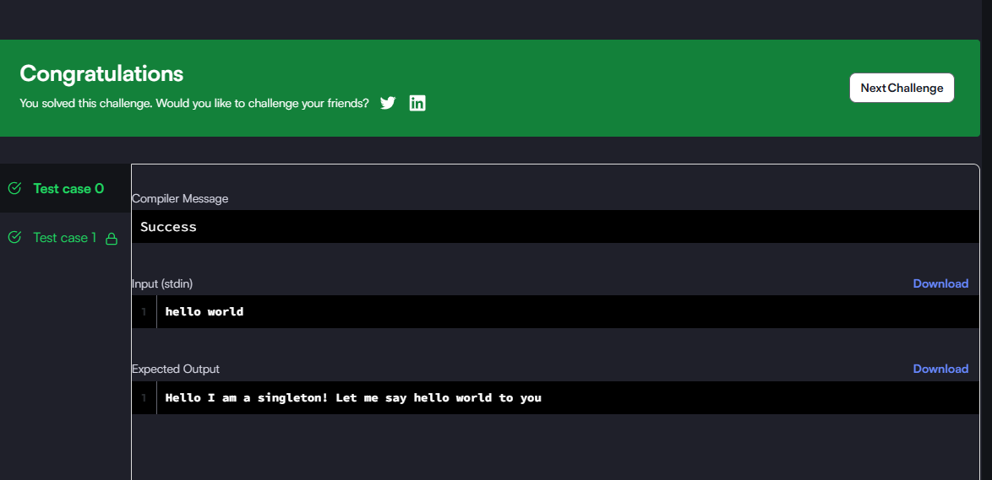
Task4
import java.io.*;
import java.util.*;

enum Color {
RED, GREEN
}

abstract class Tree {
private int value;
private Color color;
private int depth;

public Tree(int value, Color color, int depth) {
this.value = value;
this.color = color;
this.depth = depth;
}

public int getValue() {
return value;
}

public Color getColor() {
return color;
}

public int getDepth() {
return depth;
}

public abstract void accept(TreeVis visitor);
}

class TreeNode extends Tree {
private ArrayList<Tree> children = new ArrayList<>();

public TreeNode(int value, Color color, int depth) {
super(value, color, depth);
}

public void accept(TreeVis visitor) {
visitor.visitNode(this);
for (Tree child : children) {
child.accept(visitor);
}
}

public void addChild(Tree child) {
children.add(child);
}
}

class TreeLeaf extends Tree {
public TreeLeaf(int value, Color color, int depth) {
super(value, color, depth);
}

public void accept(TreeVis visitor) {
visitor.visitLeaf(this);
}
}

abstract class TreeVis {
public abstract int getResult();
public abstract void visitNode(TreeNode node);
public abstract void visitLeaf(TreeLeaf leaf);
}

class SumInLeavesVisitor extends TreeVis {
private int result = 0;

public int getResult() {
return result;
}

public void visitNode(TreeNode node) {
// Internal nodes ignored
}

public void visitLeaf(TreeLeaf leaf) {
result += leaf.getValue();
}
}

class ProductRedNodesVisitor extends TreeVis {
private long result = 1;
private final int MOD = 1000000007;

public int getResult() {
return (int) result;
}

public void visitNode(TreeNode node) {
if (node.getColor() == Color.RED) {
result = (result * node.getValue()) % MOD;
}
}

public void visitLeaf(TreeLeaf leaf) {
if (leaf.getColor() == Color.RED) {
result = (result * leaf.getValue()) % MOD;
}
}
}

class FancyVisitor extends TreeVis {
private int nonLeafEvenDepthSum = 0;
private int greenLeafSum = 0;

public int getResult() {
return Math.abs(nonLeafEvenDepthSum - greenLeafSum);
}

public void visitNode(TreeNode node) {
if (node.getDepth() % 2 == 0) {
nonLeafEvenDepthSum += node.getValue();
}
}

public void visitLeaf(TreeLeaf leaf) {
if (leaf.getColor() == Color.GREEN) {
greenLeafSum += leaf.getValue();
}
}
}

public class Solution {
private static int[] values;
private static Color[] colors;
private static Map<Integer, Set<Integer>> map = new HashMap<>();

public static Tree solve() {
FastScanner scanner = new FastScanner();
int n = scanner.nextInt();

values = new int[n];
for (int i = 0; i < n; i++) {
values[i] = scanner.nextInt();
}

colors = new Color[n];
for (int i = 0; i < n; i++) {
colors[i] = (scanner.nextInt() == 0) ? Color.RED : Color.GREEN;
}

for (int i = 0; i < n - 1; i++) {
int u = scanner.nextInt();
int v = scanner.nextInt();

map.computeIfAbsent(u, k -> new HashSet<>()).add(v);
map.computeIfAbsent(v, k -> new HashSet<>()).add(u);
}

if (n == 1) {
return new TreeLeaf(values[0], colors[0], 0);
}

TreeNode root = new TreeNode(values[0], colors[0], 0);
buildTree(root, 1);

return root;
}

private static void buildTree(TreeNode parent, int parentNum) {
for (int childNum : map.get(parentNum)) {
map.get(childNum).remove(parentNum);

if (!map.get(childNum).isEmpty()) {
TreeNode childNode = new TreeNode(
values[childNum - 1],
colors[childNum - 1],
parent.getDepth() + 1
);
parent.addChild(childNode);
buildTree(childNode, childNum);
} else {
TreeLeaf childLeaf = new TreeLeaf(
values[childNum - 1],
colors[childNum - 1],
parent.getDepth() + 1
);
parent.addChild(childLeaf);
}
}
}

public static void main(String[] args) {
Tree root = solve();
SumInLeavesVisitor vis1 = new SumInLeavesVisitor();
ProductRedNodesVisitor vis2 = new ProductRedNodesVisitor();
FancyVisitor vis3 = new FancyVisitor();

root.accept(vis1);
root.accept(vis2);
root.accept(vis3);

int res1 = vis1.getResult();
int res2 = vis2.getResult();
int res3 = vis3.getResult();

System.out.println(res1);
System.out.println(res2);
System.out.println(res3);
}

static class FastScanner {
private final InputStream in = System.in;
private final byte[] buffer = new byte[1024 * 64];
private int ptr = 0;
private int buflen = 0;

private boolean hasNextByte() {
if (ptr < buflen) return true;
ptr = 0;
try {
buflen = in.read(buffer);
} catch (IOException e) {
e.printStackTrace();
}
return buflen > 0;
}

private int readByte() {
return hasNextByte() ? buffer[ptr++] : -1;
}

public int nextInt() {
int c = readByte();
while (c <= ' ') {
if (c == -1) return -1;
c = readByte();
}
int res = 0;
while (c >= '0' && c <= '9') {
res = res * 10 + c - '0';
c = readByte();
}
return res;
}
}
}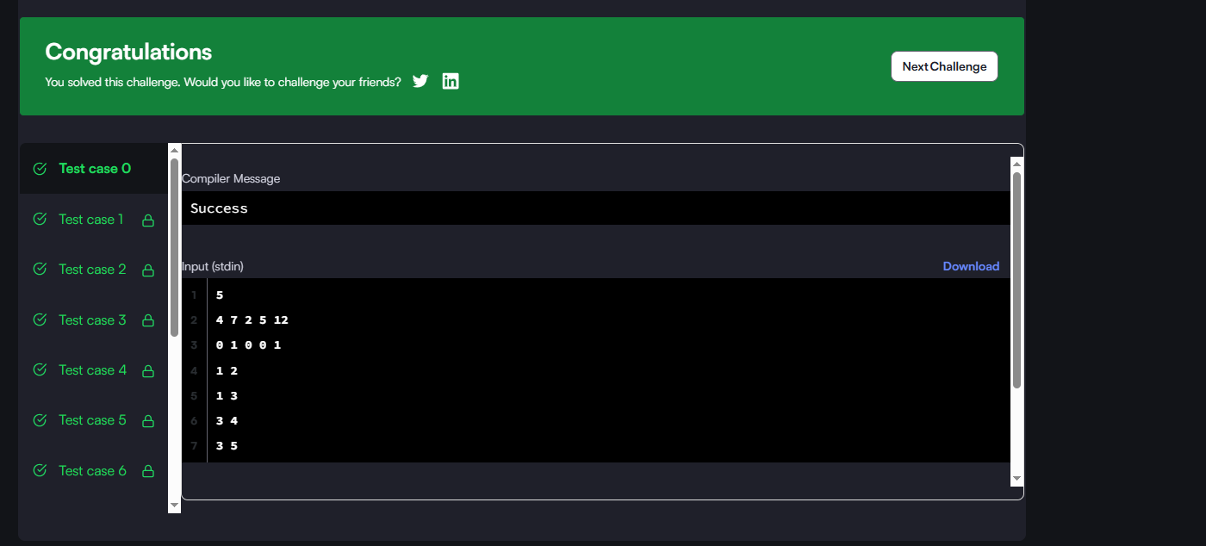

Task 5
import java.util.*;

public class Main {

static Iterator func(ArrayList mylist) {
Iterator it = mylist.iterator();
while (it.hasNext()) {
Object element = it.next();
if (element.equals("###")) // Line 1
break; // Line 2
}
return it;
}

@SuppressWarnings({ "unchecked" })
public static void main(String[] args) {
ArrayList mylist = new ArrayList();
Scanner sc = new Scanner(System.in);
int n = sc.nextInt();
int m = sc.nextInt();
for (int i = 0; i < n; i++) {
mylist.add(sc.nextInt());
}

mylist.add("###");
for (int i = 0; i < m; i++) {
mylist.add(sc.next());
}

Iterator it = func(mylist);
while (it.hasNext()) {
Object element = it.next();
System.out.println((String) element);
}
sc.close();
}
}

