TERRAFORM TASK – 02
1. Task Objective
I completed the Terraform practical in two parts:
- I executed the Terraform templates: local_file, random_pet, lifecycle rules and variables.
- I integrated Terraform with Jenkins through GitHub, the Terraform plugin, Terraform configuration and a Jenkins pipeline.
The uploaded task document begins with the Terraform_basic project and the two assigned tasks.

2. TASK 1 – Execute Terraform Templates

2.1 I created the Terraform project
I created the working directory and moved into it.
mkdir Terraform_basic
cd Terraform_basic
pwd
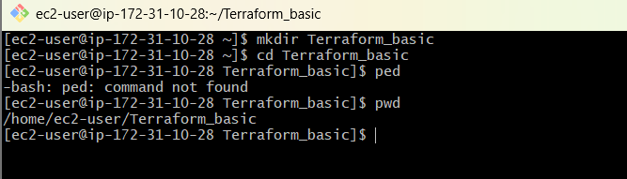
My project structure was:
Terraform_basic/
├── main.tf
├── variables.tf
├── terraform.tfvars
├── pets.txt
└── .terraform/

2.2 I created the first template – local_file
I created main.tf with the local_file resource.
resource "local_file" "my_pet" {
filename = "pets.txt"
content = "My cat name is HEN"
}
Step 1: I created main.tf
notepad main.tf
I pasted the above configuration and saved the file.
Step 2: I initialized Terraform
terraform init
Terraform initialized the working directory and downloaded the required provider.
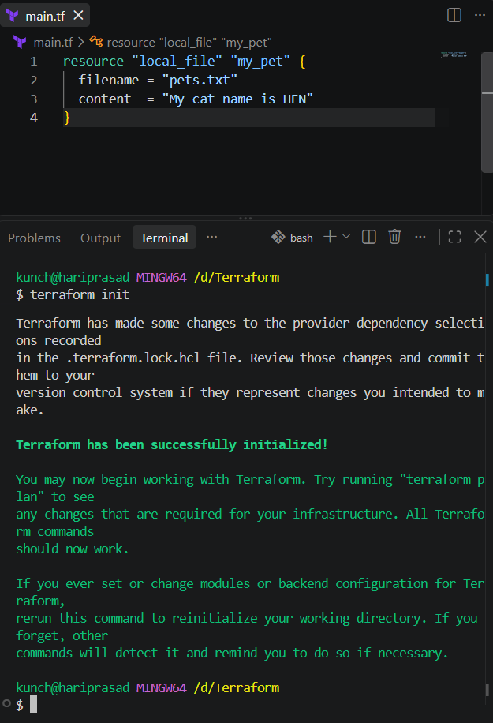
Step 3: I validated the configuration
terraform validate
Expected result: Success! The configuration is valid.
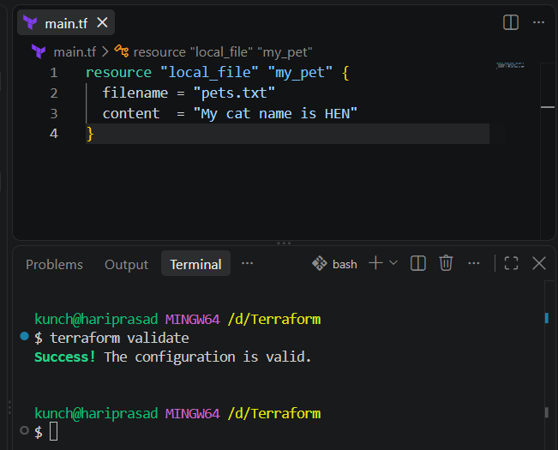
Step 4: I formatted the configuration
terraform fmt
Step 5: I generated the execution plan
terraform plan
Expected result: Plan: 1 to add, 0 to change, 0 to destroy.
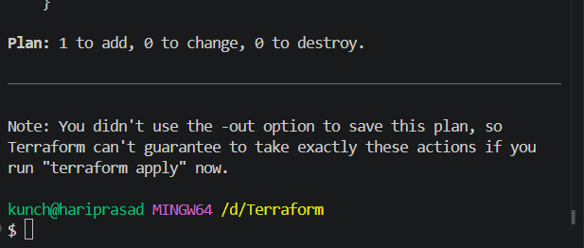
Step 6: I applied the configuration
terraform apply
yes
Expected result: Apply complete! Resources: 1 added, 0 changed, 0 destroyed.
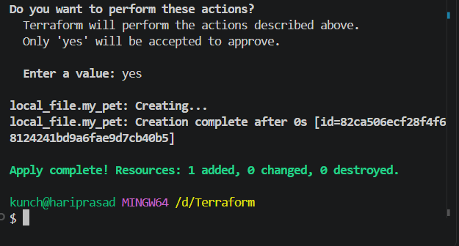
Step 7: I verified the generated file
dir
type pets.txt
The expected file content is:
My cat name is HEN
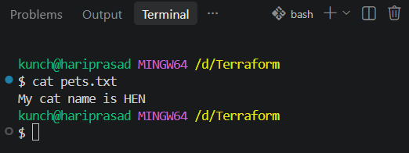

2.3 I created the second template – random_pet
I added the random_pet resource.
resource "random_pet" "petname" {
prefix = "MR"
separator = "."
length = 1
}
This generates a random pet name such as MR.spaniel or MR.gazelle. The exact result is random.

2.4 I used both resources together
resource "local_file" "my_pet" {
filename = "pets.txt"
content = "My cat name is HEN"
}
resource "random_pet" "petname" {
prefix = "MR"
separator = "."
length = 1
}
Step 1: I initialized and formatted the configuration
terraform init
terraform fmt
Step 2: I validated and planned
terraform validate
terraform plan
Step 3: I applied the configuration
terraform apply
yes
Step 4: I checked the Terraform state
terraform state list
I expected to see:
local_file.my_pet
random_pet.petname
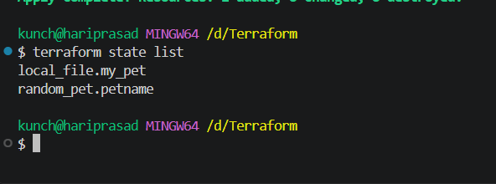
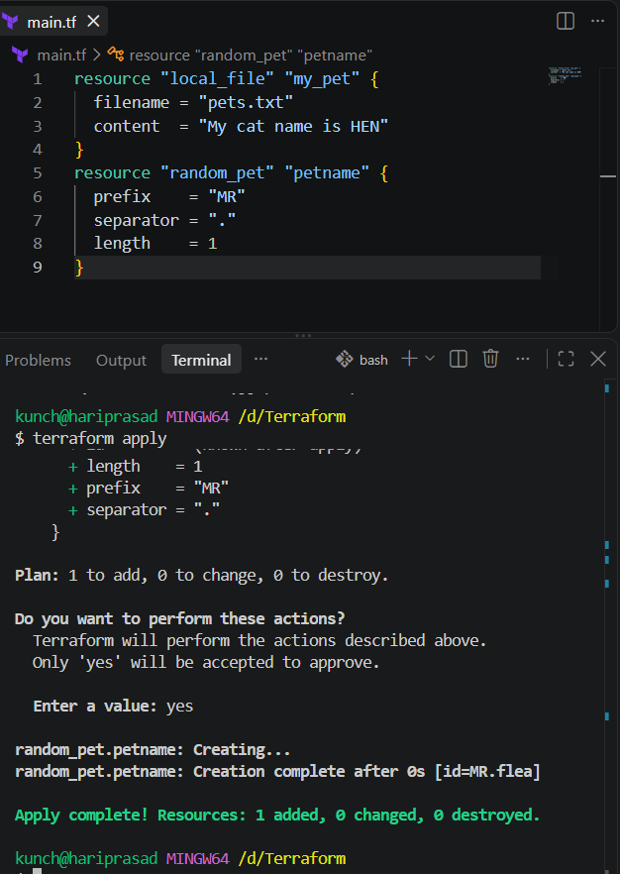

2.5 I inspected Terraform state
After applying the configuration, I inspected the state.
terraform show
terraform state list
Terraform created terraform.tfstate. I used Terraform commands to inspect the state rather than manually editing it.

2.6 I changed the local_file resource
I changed the file content from HEN to DOG.
resource "local_file" "my_pet" {
filename = "pets.txt"
content = "My cat name is DOG"
}
resource "random_pet" "petname" {
prefix = "MR"
separator = "."
length = 1
}
Step 1: I ran terraform plan
terraform plan
Terraform detected that local_file.my_pet needed replacement.
Step 2: I applied the change
terraform apply
yes
The replacement flow showed the old resource being destroyed and the new resource being created.
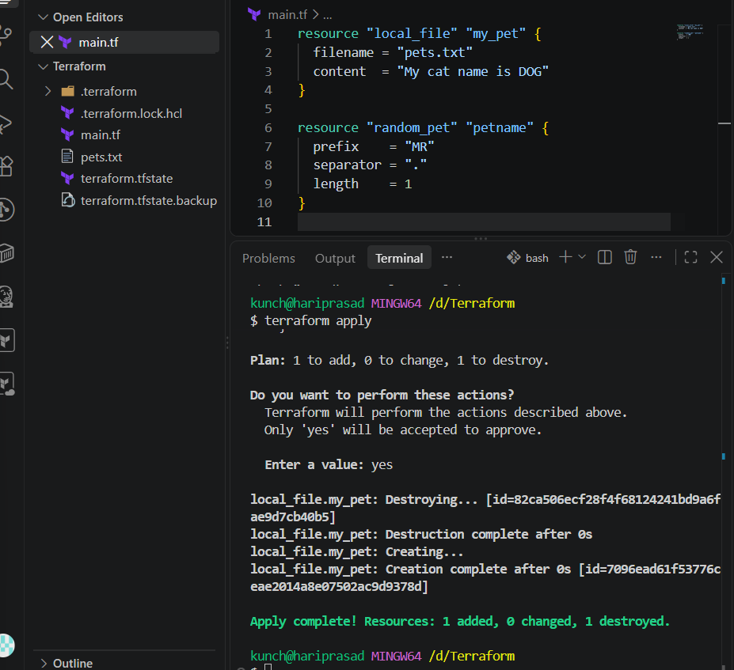

3. Terraform Lifecycle Rules
I then tested the three lifecycle rules covered by the task:
- create_before_destroy
- prevent_destroy
- ignore_changes

3.1 I tested create_before_destroy
resource "local_file" "my_pet" {
filename = "pets.txt"
content = "My cat name is DOG"
lifecycle {
create_before_destroy = true
}
}
resource "random_pet" "petname" {
prefix = "MR"
separator = "."
length = 1
}
Normally replacement can happen as:
Destroy old
↓
Create new
With create_before_destroy = true, Terraform tries:
Create new
↓
Destroy old
Step 1: I formatted, validated and planned
terraform fmt
terraform validate
terraform plan
Step 2: I applied the lifecycle configuration
terraform apply
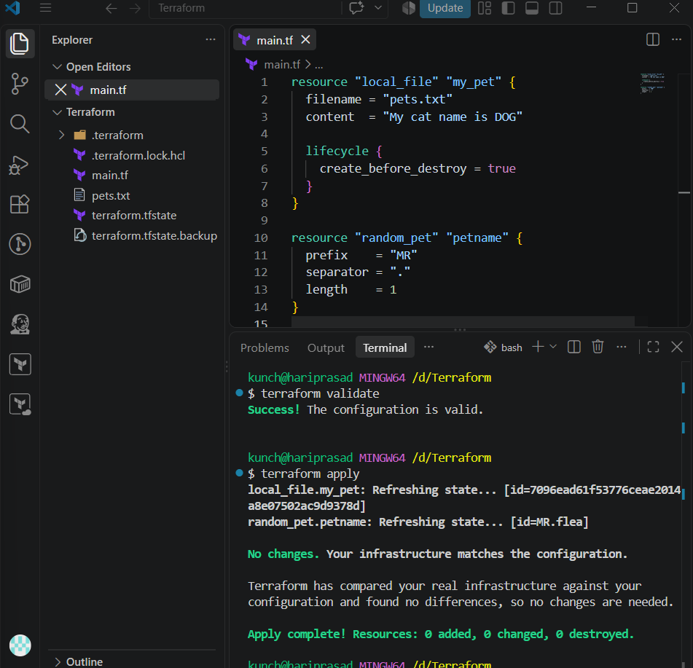

3.2 I tested prevent_destroy
resource "local_file" "my_pet" {
filename = "pets.txt"
content = "My cat name is MR.CAT"
lifecycle {
prevent_destroy = true
}
}
Step 1: I applied the configuration
terraform fmt
terraform validate
terraform plan
terraform apply
Step 2: I tested destroy protection
terraform destroy
Terraform should block the destruction because prevent_destroy = true is configured.
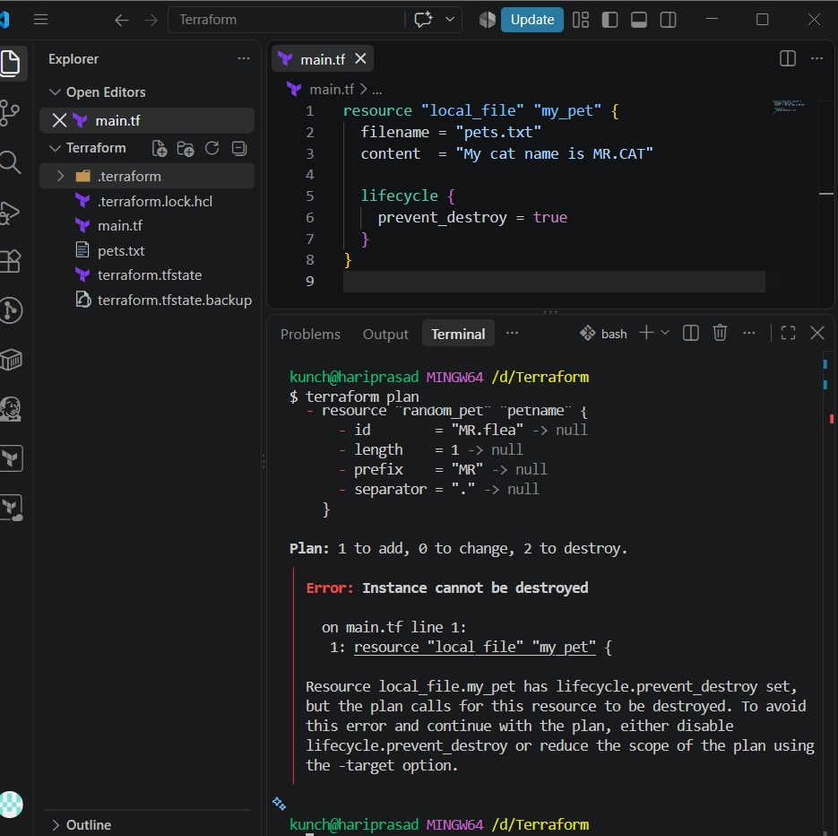

I understood that prevent_destroy is a Terraform configuration safeguard. It is useful for critical resources such as production databases, production storage and critical infrastructure.

3.3 I tested ignore_changes
resource "local_file" "my_pet" {
filename = "pets.txt"
content = "My cat name is BANANA"
lifecycle {
ignore_changes = [
content
]
}
}
Step 1: I ran the Terraform commands
terraform fmt
terraform validate
terraform plan
terraform apply
Terraform ignored the configured content difference when calculating changes.

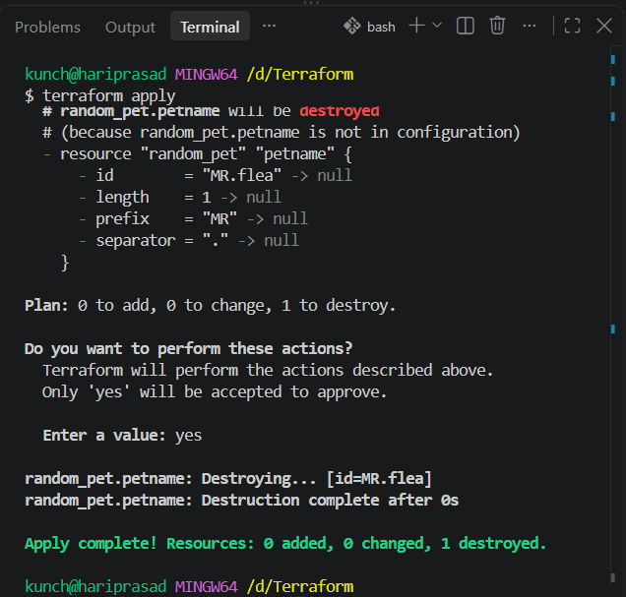
4. Terraform Variables
I replaced hard-coded values with variables so the configuration can be reused.
filename = var.filename
content = var.content

4.1 I created variables.tf
variable "filename" {
default = "pets.txt"
type = string
}
variable "content" {
default = "I love cats"
type = string
}
variable "prefix" {
default = "MR"
type = string
}
variable "length" {
default = 1
type = number
}

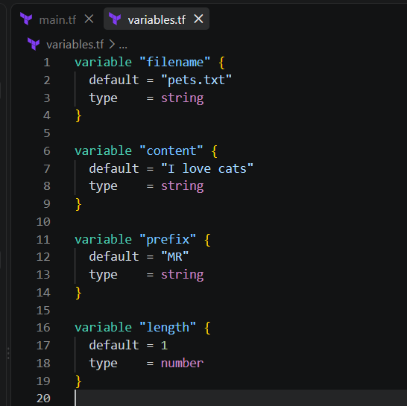

4.2 I modified main.tf
resource "local_file" "my_pet" {
filename = var.filename
content = var.content
}
resource "random_pet" "petname" {
prefix = var.prefix
separator = "."
length = var.length
}
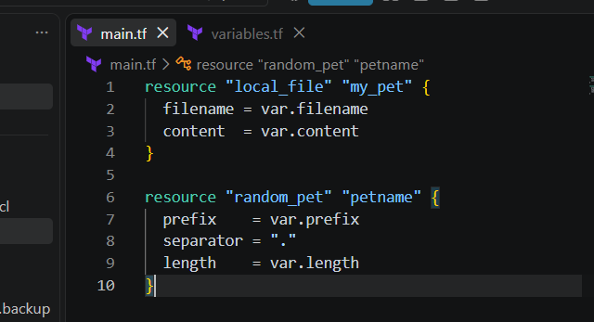

4.3 I executed the variable-based configuration
terraform init
terraform fmt
terraform validate
terraform plan
terraform apply
The default values I used were:
filename = pets.txt
content = I love cats
prefix = MR
length = 1

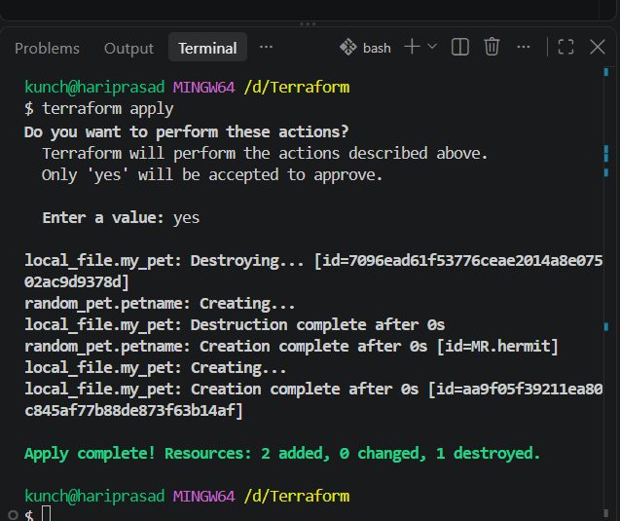

4.4 I tested variable types
Type | Example
string | "I love pets"
number | 1
bool | true / false
any | Any compatible value
list | ["cat", "dog"]
map | {pet1 = "cat", pet2 = "dog"}
object | Complex structured data
tuple | Ordered values of potentially different types

4.5 I tested variables without default values

Step 1: Open variables.tf

In VS Code, open:

variables.tf

Put only these two variable blocks in the file:

variable "filename" {

}

variable "content" {

}

So your variables.tf should look exactly like:

variable "filename" {

}

variable "content" {

}

These variables have no default values, so Terraform will ask you for the values when you run terraform apply.

Step 2: Open main.tf

Now open:

main.tf

Replace the existing content with:

resource "local_file" "my_pet" {

filename = var.filename

content = var.content

}

resource "random_pet" "petname" {

prefix = "MR"

separator = "."

length = 1

}

What changed?

Previously, you had something like:

resource "local_file" "my_pet" {

filename = "pets.txt"

content = "My cat name is HEN"

}

Now we are replacing the hardcoded values:

filename = "pets.txt"

content = "My cat name is HEN"

with variables:

filename = var.filename

content = var.content

So Terraform will get these values from the filename and content variables.

Step 3: Save both files

In VS Code:

Ctrl + S

Your project should now look like:

Terraform/

│

├── main.tf

└── variables.tf

That's all you need for this step.

Step 4: Format the files

Open the VS Code terminal and run:

terraform fmt

You should see something similar to:

main.tf

or no output if everything is already formatted.

Step 5: Validate

Run:

terraform validate

Expected:

Success! The configuration is valid.
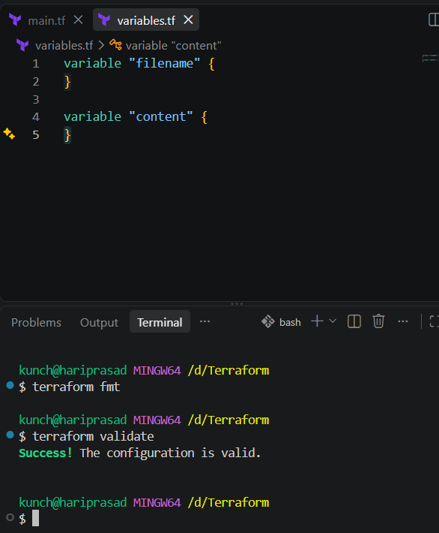

Step 6: Apply and provide values interactively

Now run:

terraform apply

Because we didn't provide default values, Terraform should ask:

var.content

Enter a value:

Enter:

i love tiger

Then Terraform may ask:

var.filename

Enter a value:

Enter:

wild.txt

Then Terraform will show the plan and ask:

Do you want to perform these actions?

Enter a value:

Enter:

Yes
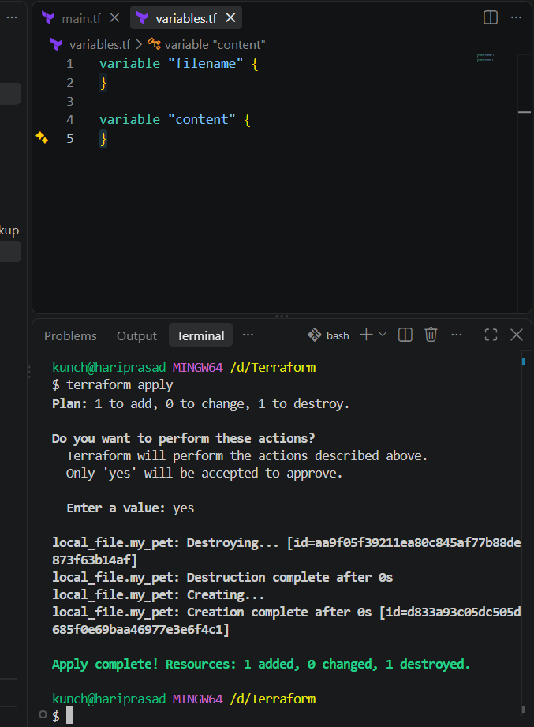The final structure is very simple
variables.tf
variable "filename" {
}

variable "content" {
}
main.tf
resource "local_file" "my_pet" {
filename = var.filename
content = var.content
}

resource "random_pet" "petname" {
prefix = "MR"
separator = "."
length = 1
}

4.6 I tested the -var option
terraform apply -var="filename=wild.txt" -var="content=i love tiger"
This allowed me to provide variable values directly from the terminal.
You already tested variables without default values using:
terraform apply
Now we'll provide the values directly from the terminal.
Step 6: Use -var
Run this as one complete command:
terraform apply -var="filename=wild.txt" -var="content=i love tiger"
Terraform will use:
filename = wild.txt
content = i love tiger
So it should not ask you to enter filename or content separately.
When Terraform asks:
Do you want to perform these actions?
Enter a value:
Enter:
Yes
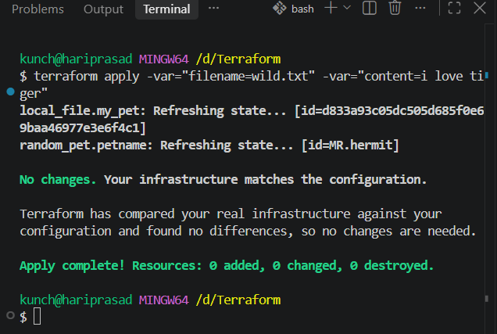
Step 7: Verify the file
Because the filename is wild.txt, run:
ls
You should see:
main.tf
variables.tf
wild.txt
Then check the content:
cat wild.txt
Expected:
i love tiger
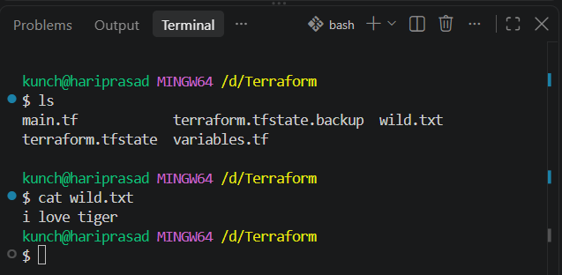
Step 8: Check Terraform state
Run:
terraform state list
You should have:
local_file.my_pet
random_pet.petname
This completes the -var option exercise.
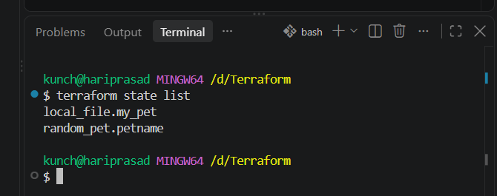
5. TASK 2 – Terraform + Jenkins Integration
Overall Flow
Your Terraform Code
↓
GitHub
↓
Jenkins
↓
Terraform Plugin / Tool
↓
terraform init
↓
terraform validate
↓
terraform plan
↓
AWS
Your source document uses this same flow.

Part 5 — Check Jenkins Prerequisites
⚠️ From here, we should work on your Jenkins EC2 server, not your Windows Git Bash, unless Jenkins is installed locally.
Connect to your Jenkins EC2 using SSH/terminal.
Step 1 — Check Terraform
terraform version
Expected something like:
Terraform v1.x.x
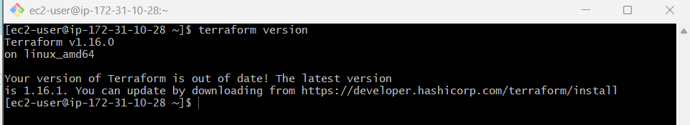

Step 2 — Check Git
git --version
Expected:
git version 2.x.x

Step 3 — Check AWS CLI
aws --version
Expected something like:
aws-cli/2.x.x
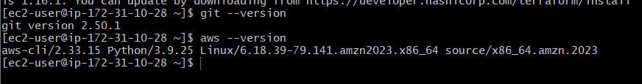

Step 4 — Check Jenkins
sudo systemctl status jenkins
Look for:
Active: active (running)
If it is running, press:
q
to exit the status screen.
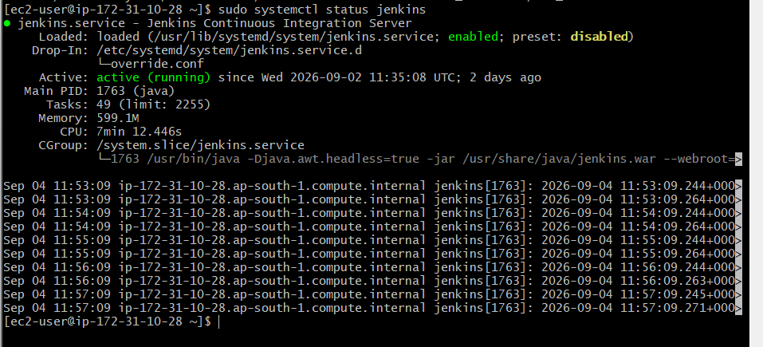

Part 5.2 — Check Terraform as Jenkins User
This is very important.
First:
terraform version
Then:
sudo -u jenkins terraform version
Why are we doing this?
Your normal Linux user may be able to execute:
terraform
but Jenkins runs as the jenkins user.
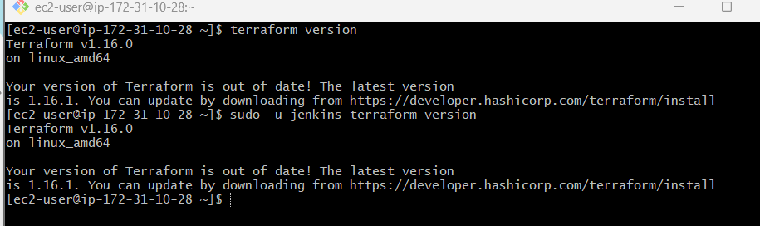
So we need to verify:
Normal User
↓
Terraform works

Jenkins User
↓
Terraform also works
If this works, Jenkins can find Terraform.

Part 5.3 — Check AWS Access
Because Terraform may eventually create AWS resources, Jenkins needs AWS permissions.
For an EC2-based Jenkins server, your source uses:
Jenkins EC2
↓
IAM Role
↓
AWS Permissions
↓
Terraform
↓
AWS Resources
Step 1 — Check AWS identity
Run:
aws sts get-caller-identity
You should receive JSON containing information such as:
{
"UserId": "...",
"Account": "...",
"Arn": "..."
}
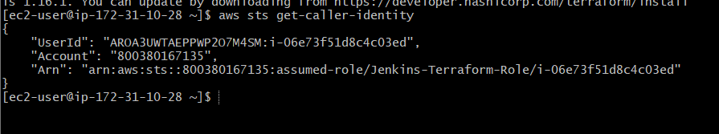

Step 2 — Check AWS identity as Jenkins
Run:
sudo -u jenkins aws sts get-caller-identity
This is the important test.
If both commands return an AWS identity, Jenkins has access to AWS through the EC2 IAM role.
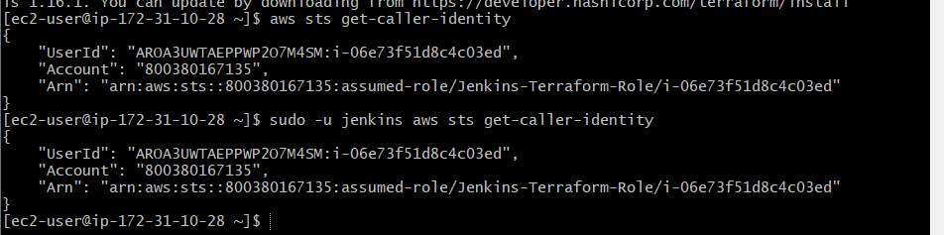

Part 6 — Create GitHub Terraform Project
Now we need a separate project for Jenkins.
You can create:
terraform-jenkins/
├── main.tf
├── variables.tf
└── Jenkinsfile
Important
You already have:
/d/Terraform
on your Windows machine.
For Jenkins, we will create/use a GitHub repository containing the Terraform configuration.
For example:
terraform-jenkins

Step 6.1 — Create GitHub Repository
Go to GitHub and create a new repository.
Example name:
terraform-jenkins
You can make it private or public according to your setup.
Then clone it to your local machine.
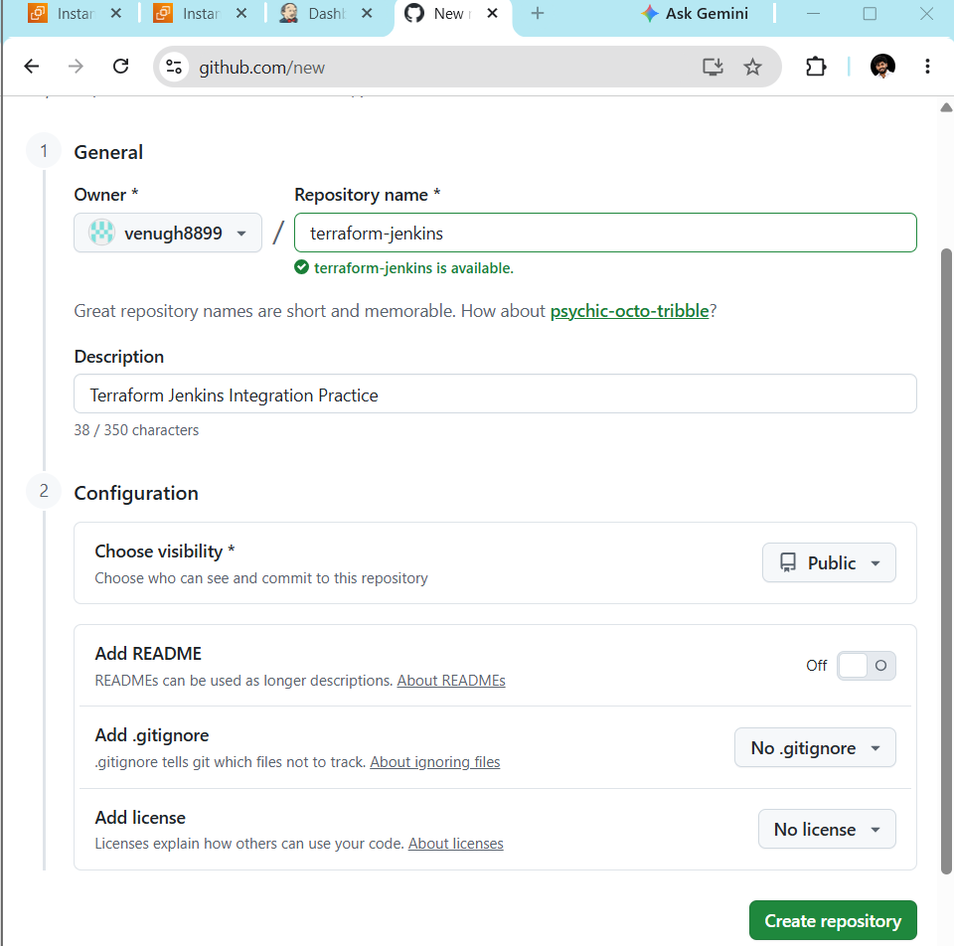
For example:
git clone https://github.com/YOUR_USERNAME/terraform-jenkins.git
Then:
cd terraform-jenkins
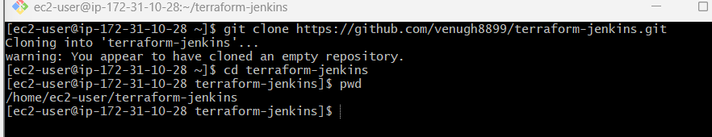

Step 6.2 — Add Terraform Files
Inside the repository:
terraform-jenkins/
├── main.tf
├── variables.tf
└── Jenkinsfile
For this Jenkins exercise, your Terraform configuration can be the same configuration you practiced.
main.tf
resource "local_file" "my_pet" {
filename = var.filename
content = var.content
}

resource "random_pet" "petname" {
prefix = "MR"
separator = "."
length = 1
}
variables.tf
variable "filename" {
}

variable "content" {
}
⚠️ However, there is one practical issue: Jenkins running terraform plan with variables that have no defaults will require variable values. So before running the Jenkins pipeline, we need to make sure your Jenkins project has a way to supply those variables. Your source document does not show a Jenkins variable-supply configuration, so don't add one yet—we'll follow the source and test the pipeline first.

Part 6.3 — Initialize Git
From inside your project:
git init
Then:
git add .
Then:
git commit -m "Add Terraform configuration"
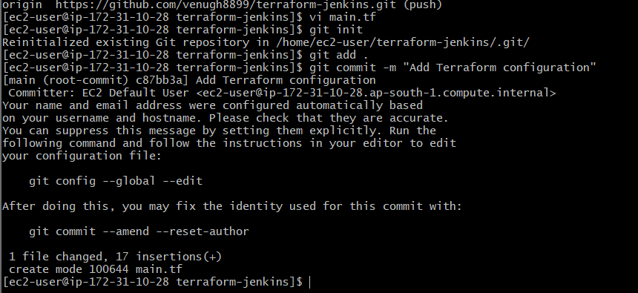

Step 6.4 — Connect GitHub
If the repository was not cloned and you're creating the local repository manually:
git remote add origin https://github.com/YOUR_USERNAME/terraform-jenkins.git
Then:
git branch -M main
Then:
git push -u origin main
Verify your files are visible in GitHub.
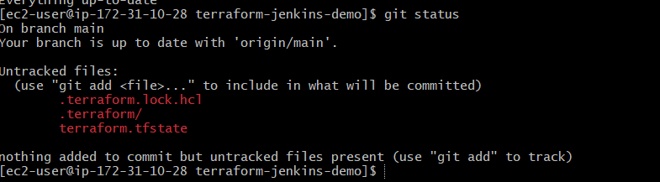

Part 7 — Install Terraform Plugin in Jenkins
Now go to Jenkins Web UI.
Navigate:
Jenkins
↓
Manage Jenkins
↓
Plugins
↓
Available plugins
Search:
Terraform
Install the Terraform plugin.
Also verify these commonly required plugins:
Git
Pipeline
Credentials Binding
Terraform
Your source specifically includes these plugin checks.
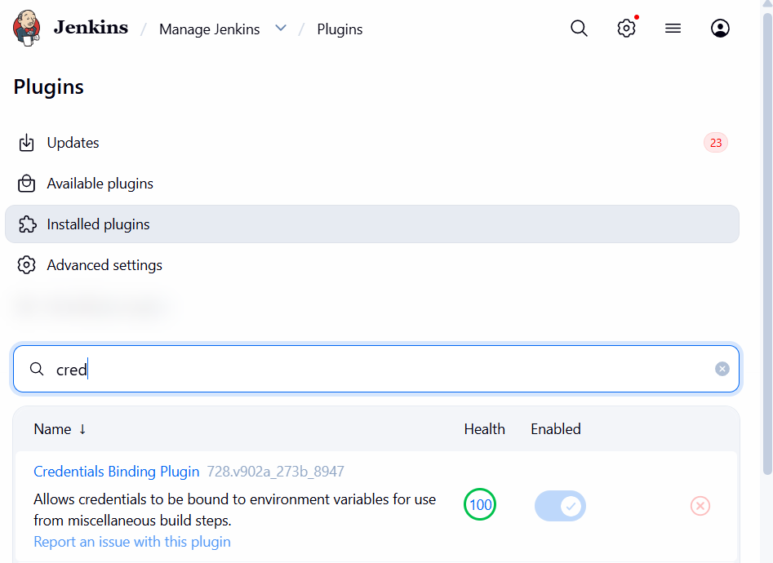

Part 8 — Configure Terraform in Jenkins
Go to:
Manage Jenkins
↓
Tools
Find:
Terraform installations
Click:
Add Terraform
Give the installation name:
terraform
Then configure the Terraform executable/installer.
Your source gives this example path:
/usr/local/bin/terraform
Then click:
Save
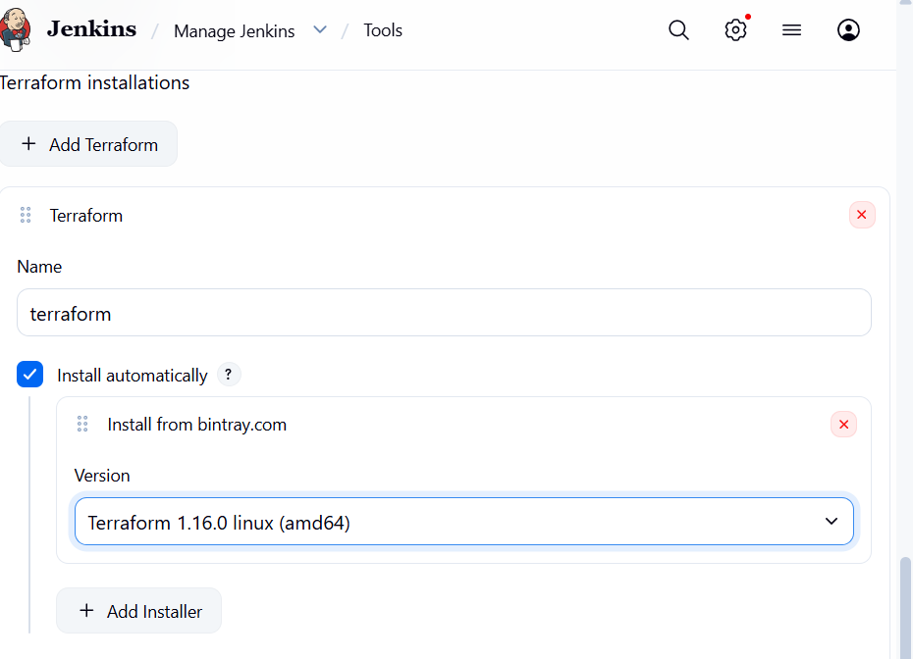

Part 9 — Create Jenkins Pipeline
Go to Jenkins dashboard.
Click:
New Item
Enter:
terraform-jenkins
Select:
Pipeline
Click:
OK

Step 9.1 — Configure Pipeline
Find:
Pipeline
For Definition, select:
Pipeline script from SCM
SCM:
Git
Repository URL:
https://github.com/YOUR_USERNAME/terraform-jenkins.git
Branch:
*/main
Script Path:
Jenkinsfile
Then:
Save
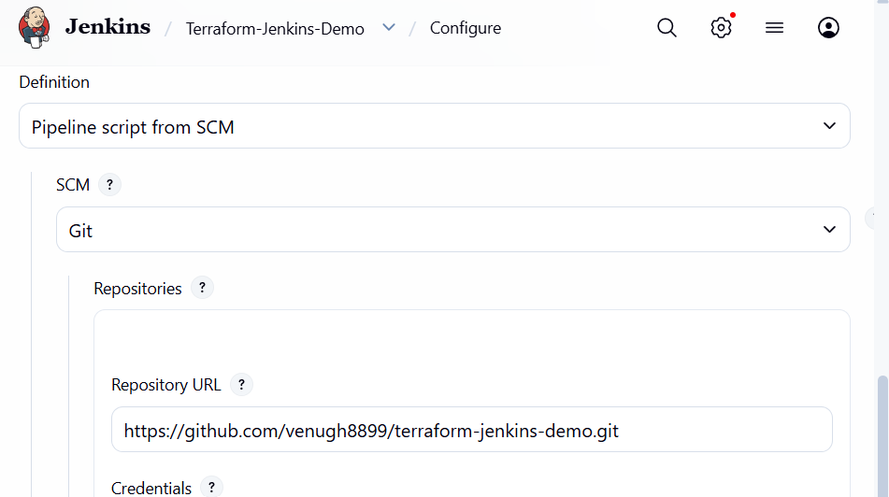

Part 10 — Create Jenkinsfile
Inside your GitHub repository, create a file called exactly:
Jenkinsfile
⚠️ No extension.
Not:
Jenkinsfile.txt
It should simply be:
Jenkinsfile
Put this inside:
pipeline {

agent any

stages {

stage('Checkout') {
steps {
git branch: 'main',
url: 'https://github.com/YOUR_USERNAME/terraform-jenkins.git'
}
}

stage('Terraform Version') {
steps {
sh 'terraform version'
}
}

stage('Terraform Init') {
steps {
sh 'terraform init'
}
}

stage('Terraform Validate') {
steps {
sh 'terraform validate'
}
}

stage('Terraform Plan') {
steps {
sh 'terraform plan'
}
}

}
}
Replace:
YOUR_USERNAME
with your actual GitHub username.
And:
terraform-jenkins
with your actual repository name if different.
This is the Jenkinsfile structure shown in your source document.

Part 10.1 — Push Jenkinsfile
From your local repository:
git add .
Then:
git commit -m "Add Jenkins pipeline"
Then:
git push
Now GitHub should contain:
terraform-jenkins/
│
├── main.tf
├── variables.tf
└── Jenkinsfile
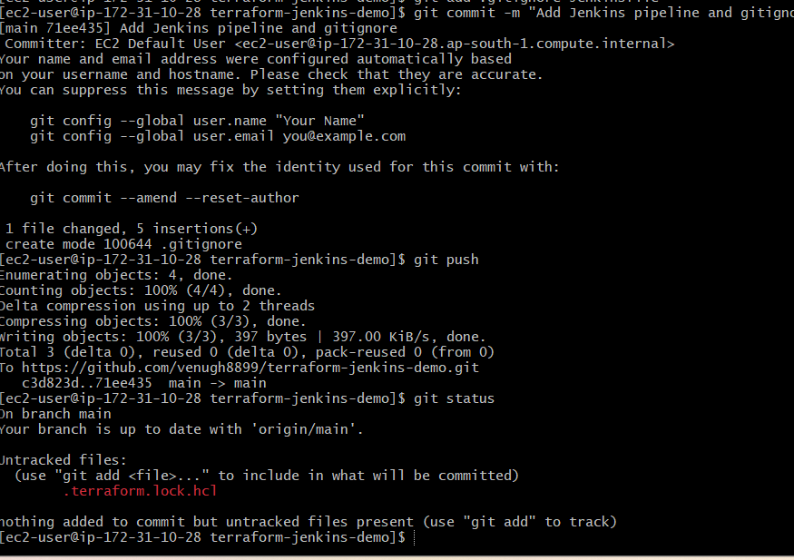

Part 11 — Run Jenkins Pipeline
Go back to Jenkins.
Open:
terraform-jenkins
Click:
Build Now
A build number should appear, such as:
#1
Click the build.
Then:
Console Output
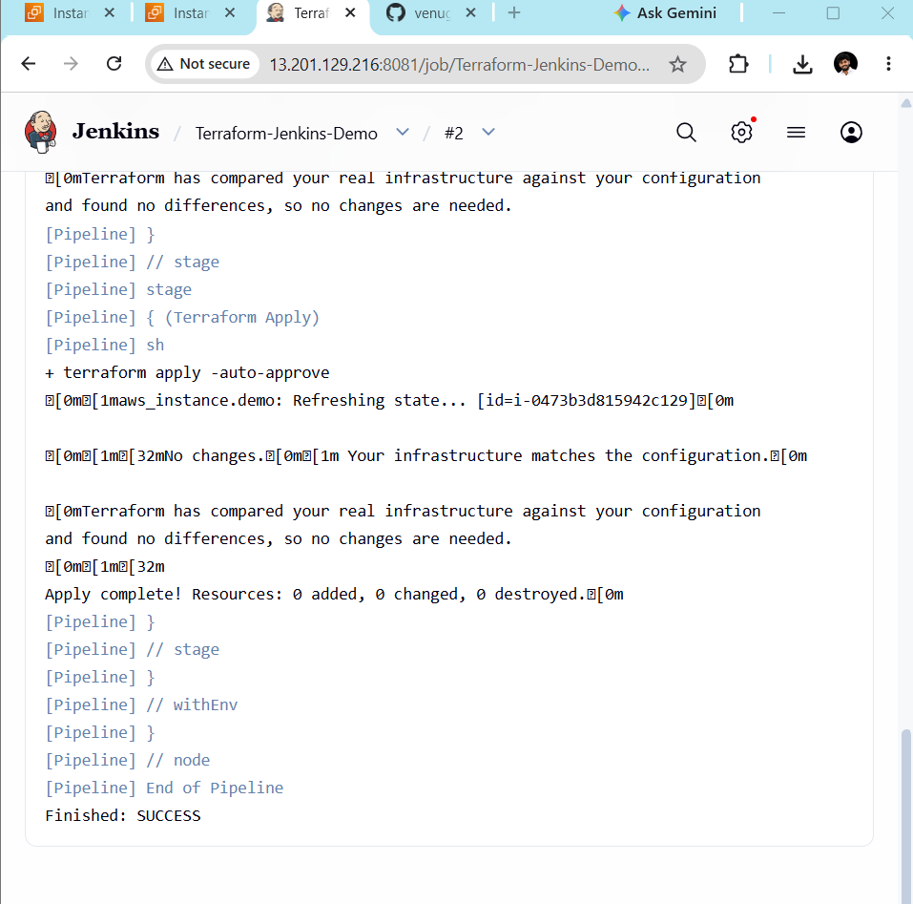

Expected Pipeline Flow
You should see:
Checkout
↓
Terraform Version
↓
Terraform Init
↓
Terraform Validate
↓
Terraform Plan
The source task specifically ends the Jenkins pipeline at Terraform Plan; it does not include terraform apply.

✅ Your Final Checklist
Jenkins Server
☐ terraform version
☐ git --version
☐ aws --version
☐ Jenkins running
☐ sudo -u jenkins terraform version
☐ aws sts get-caller-identity
☐ sudo -u jenkins aws sts get-caller-identity
GitHub
☐ GitHub repository created
☐ main.tf
☐ variables.tf
☐ Jenkinsfile
☐ git add .
☐ git commit
☐ git push
Jenkins
☐ Terraform plugin installed
☐ Git plugin available
☐ Pipeline plugin available
☐ Terraform configured under Tools
☐ Pipeline job created
☐ Pipeline script from SCM
☐ Git repository configured
☐ */main configured
☐ Jenkinsfile configured
☐ Build Now
☐ Console Output
☐ Terraform init successful
☐ Terraform validate successful
☐ Terraform plan successful

