1.Create VPC with 2 private and 2 public subnets.

Step 1: Login to AWS Console
Sign in to your AWS Management Console.
Step 2: Open the VPC Service
- In the AWS search bar, type VPC.
- Click VPC.
You should see the VPC Dashboard.
Step 3: Verify the AWS Region
At the top-right corner, ensure your region is US East (N. Virginia) - us-east-1.
Since your assignment specifies us-east-1a and us-east-1b, use the us-east-1 region.
Step 4: Create the VPC
- In the left navigation pane, click Your VPCs.
- Click Create VPC.
Configure the VPC
Choose VPC only.
Fill in the details:
Field | Value
Resources to create | VPC only
Name tag | DevOps-VPC
IPv4 CIDR | 10.0.0.0/16
IPv6 CIDR | No IPv6 CIDR Block
Tenancy | Default
Your screen should look similar to:
Name:
DevOps-VPC

IPv4 CIDR:
10.0.0.0/16

Tenancy:
Default
Click Create VPC.
You should see a success message:
Successfully created VPC
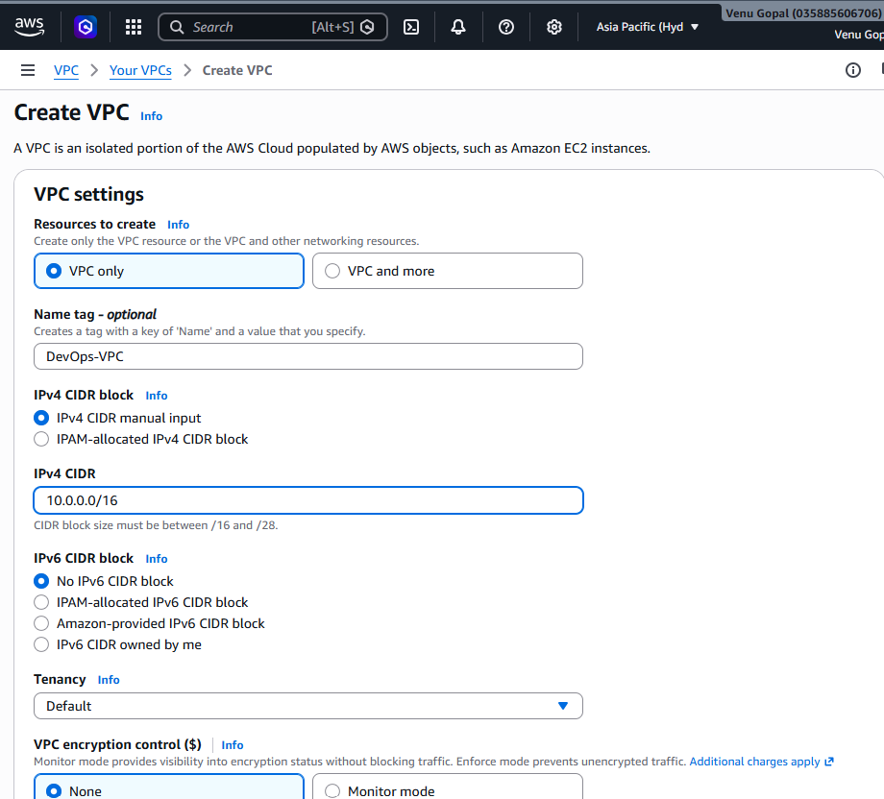
Step 5: Verify the VPC
You should now see something like:
Name | VPC ID | CIDR
DevOps-VPC | vpc-xxxxxxxx | 10.0.0.0/16

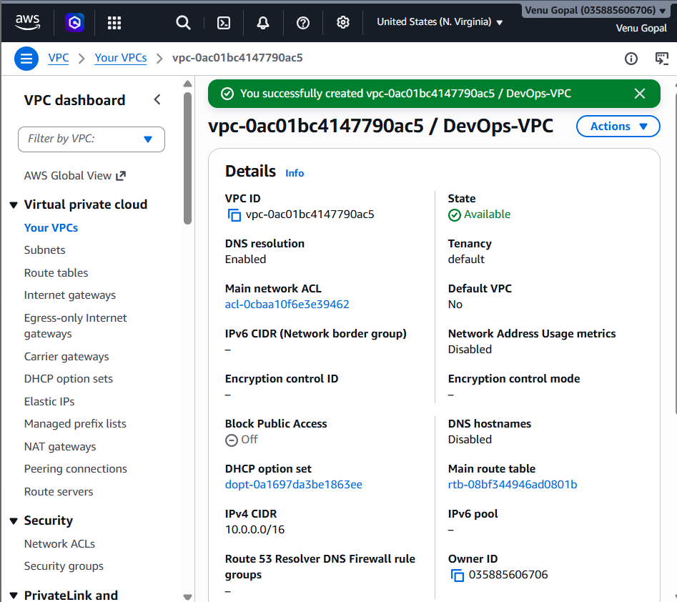
Step 6: Create Public Subnet 1
In the left menu:
Subnets → Create subnet
VPC
Select:
DevOps-VPC
Fill in:
Field | Value
Subnet name | Public-Subnet-1
Availability Zone | us-east-1a
IPv4 CIDR | 10.0.1.0/24
Click Create subnet.
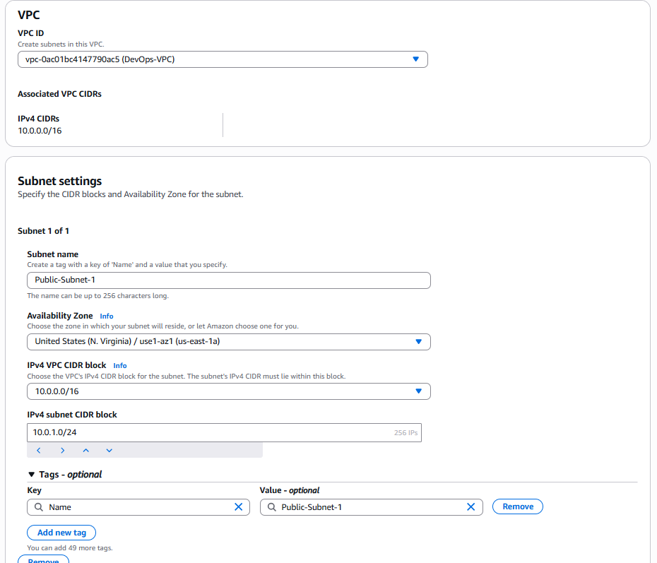
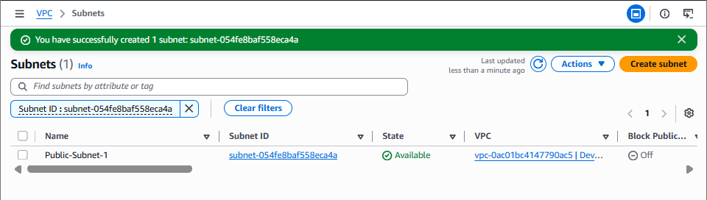

Step 7: Create Public Subnet 2
Again click Create subnet.
Field | Value
Subnet name | Public-Subnet-2
Availability Zone | us-east-1b
IPv4 CIDR | 10.0.2.0/24
Click Create subnet.
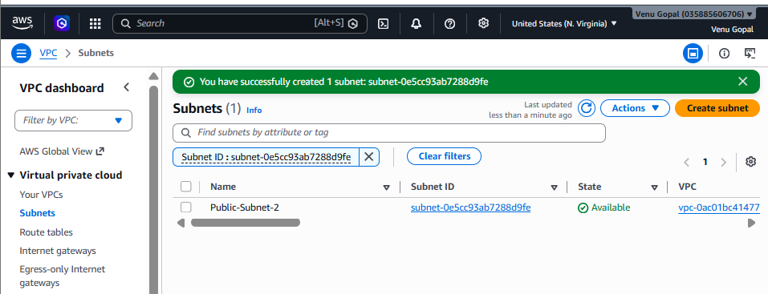

Step 8: Create Private Subnet 1
Click Create subnet.
Field | Value
Subnet name | Private-Subnet-1
Availability Zone | us-east-1a
IPv4 CIDR | 10.0.3.0/24
Click Create subnet.
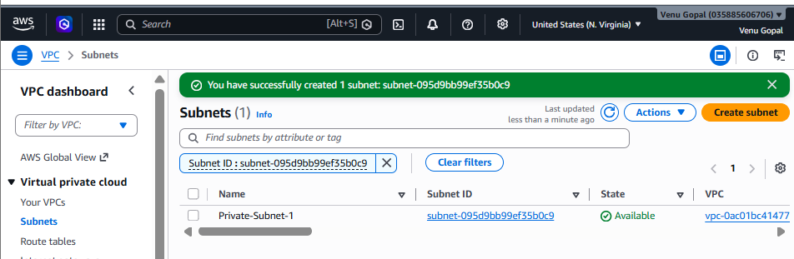

Step 9: Create Private Subnet 2
Click Create subnet.
Field | Value
Subnet name | Private-Subnet-2
Availability Zone | us-east-1b
IPv4 CIDR | 10.0.4.0/24
Click Create subnet.
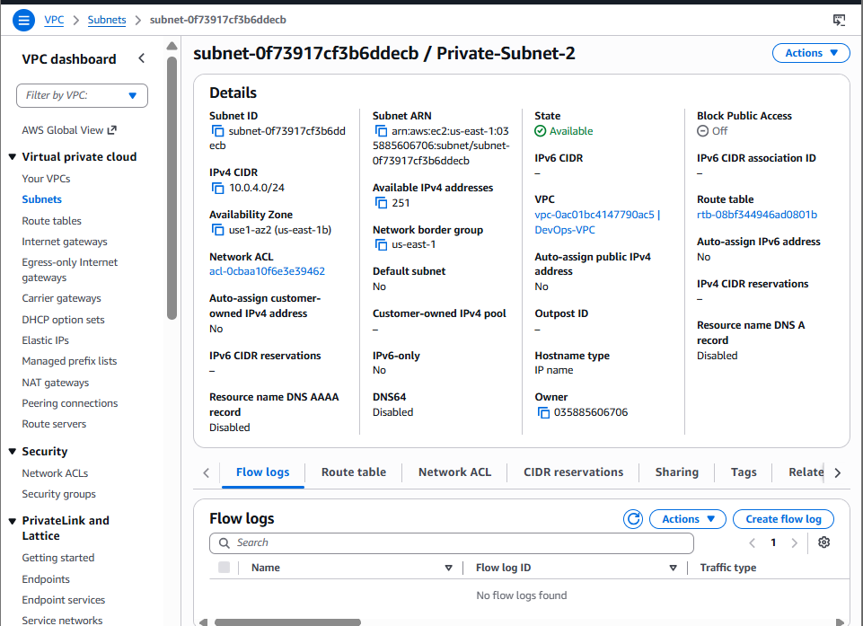

Step 10: Verify All Subnets
Go to Subnets.
You should see:
Subnet Name | CIDR | AZ
Public-Subnet-1 | 10.0.1.0/24 | us-east-1a
Public-Subnet-2 | 10.0.2.0/24 | us-east-1b
Private-Subnet-1 | 10.0.3.0/24 | us-east-1a
Private-Subnet-2 | 10.0.4.0/24 | us-east-1b
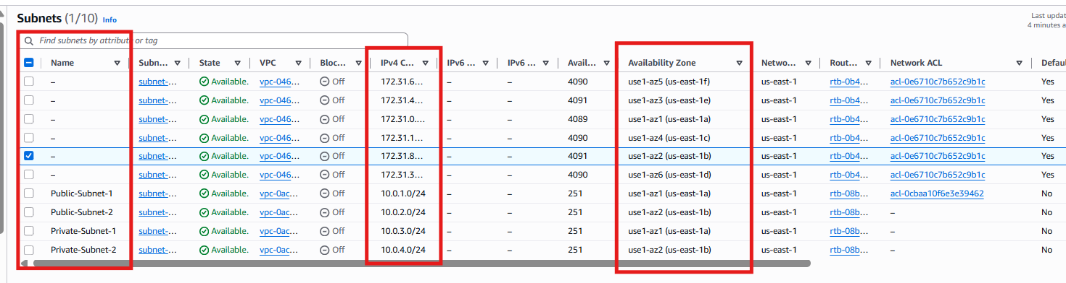

2. Enable DNS Hostname in VPC.
Objective
Enable DNS Resolution and DNS Hostnames for your VPC.
Why is this required?
When you launch EC2 instances:
- DNS Resolution allows the VPC to resolve domain names (for example, google.com).
- DNS Hostnames assigns a public DNS name to EC2 instances that have a public IP.
Without enabling DNS Hostnames, a public EC2 instance may not receive a public DNS name.

Step 1: Open the VPC Dashboard
- Log in to the AWS Management Console.
- Search for VPC.
- Open the VPC service.

Step 2: Navigate to Your VPCs
In the left navigation pane:
Virtual Private Cloud → Your VPCs
You should see your VPC, for example:
Name | CIDR
DevOps-VPC | 10.0.0.0/16

Step 3: Select Your VPC
Click on DevOps-VPC.
The details pane appears at the bottom of the page.
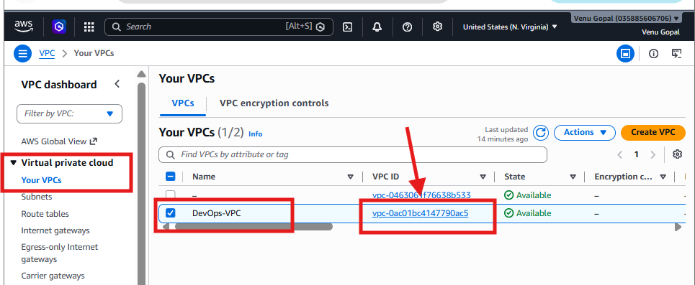

Step 4: Edit VPC Settings
With the VPC selected:
- Click Actions.
- Select Edit VPC settings.
A dialog box opens.

Step 5: Enable DNS Settings
Enable the following options:
- ✅ Enable DNS Resolution
- ✅ Enable DNS Hostnames
It should look like:
☑ Enable DNS Resolution
☑ Enable DNS Hostnames
Click Save.
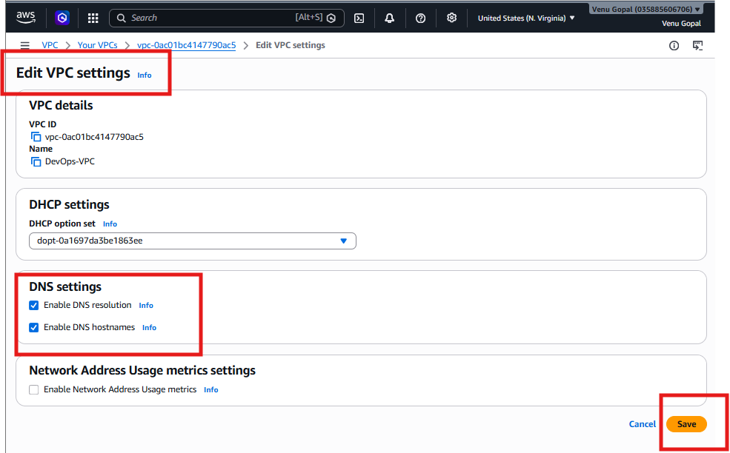

Step 6: Verify the Configuration
Select DevOps-VPC again.
In the Details tab, verify:
Setting | Expected Value
DNS Resolution | Enabled
DNS Hostnames | Enabled

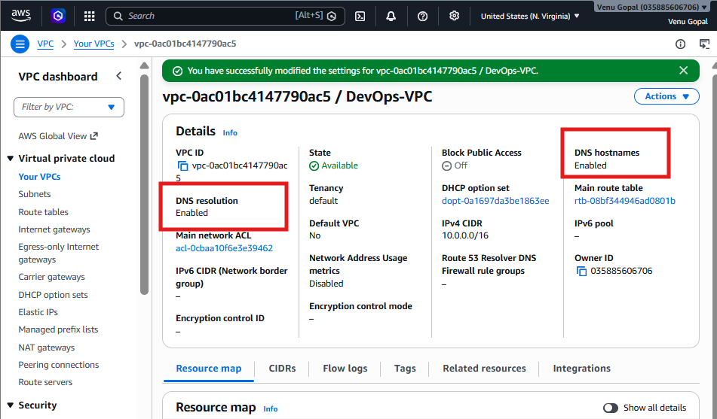

Why This Is Important
If you later launch a public EC2 instance with a public IP, it will automatically receive a public DNS name, such as:
ec2-54-210-100-123.compute-1.amazonaws.com
This makes it easier to access the instance and use services hosted on it.

3. Enable Auto Assign Public IP in 2 public subnets.
Objective
Enable Auto-Assign Public IPv4 Address for both public subnets so that any EC2 instance launched into these subnets automatically receives a public IP address.
Why is this important?
Without a public IP:
- You cannot SSH into the EC2 instance directly from the internet.
- You cannot access web applications (e.g., PHP website) hosted on the EC2 instance.
- Later tasks (installing PHP and testing the website) will not work as expected.

Step 1: Open the VPC Service
- Go to the AWS Management Console.
- Search for VPC.
- Open the VPC service.
Step 2: Open the Subnets Page
In the left navigation pane:
Virtual Private Cloud → Subnets
You should see:
Subnet Name | CIDR
Public-Subnet-1 | 10.0.1.0/24
Public-Subnet-2 | 10.0.2.0/24
Private-Subnet-1 | 10.0.3.0/24
Private-Subnet-2 | 10.0.4.0/24

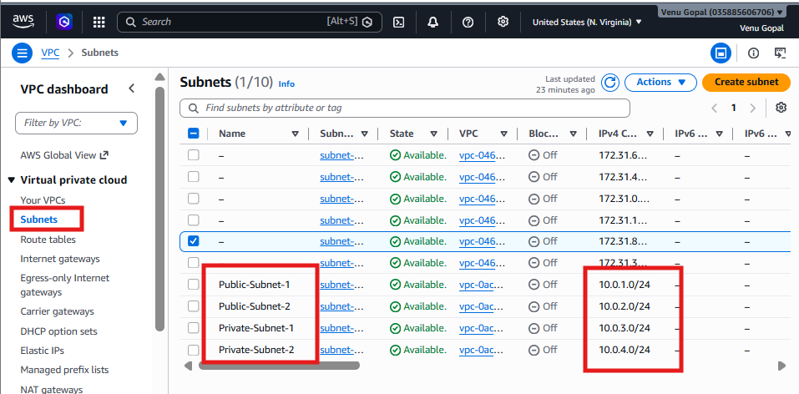

Step 3: Enable Auto-Assign Public IP for Public-Subnet-1
- Select Public-Subnet-1.
- Click Actions.
- Click Edit subnet settings.
Under Auto-assign IP settings:
✔ Enable:
Auto-assign public IPv4 address
Click Save.
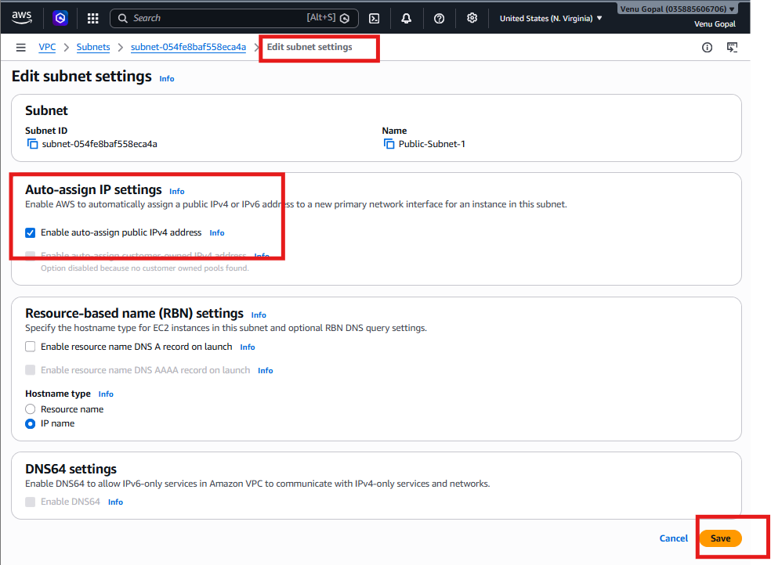

Step 4: Verify the Setting
Select Public-Subnet-1 again.
In the Details section, verify:
Property | Value
Auto-assign public IPv4 address | Enabled
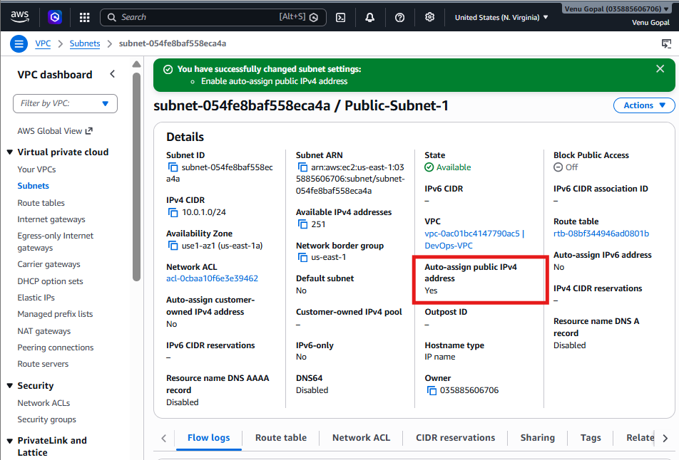

Step 5: Repeat for Public-Subnet-2
Repeat the same steps:
- Select Public-Subnet-2.
- Actions → Edit subnet settings
- Enable:
Auto-assign public IPv4 address
- Click Save.
Step 6: Verify Public-Subnet-2
Confirm:
Property | Value
Auto-assign public IPv4 address | Enabled

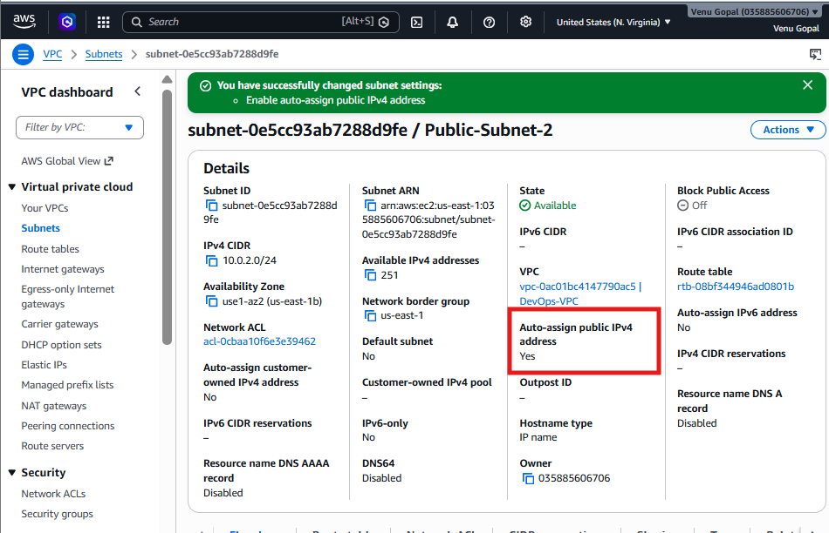
Important Note
Do NOT enable Auto-Assign Public IPv4 on:
- ❌ Private-Subnet-1
- ❌ Private-Subnet-2
These subnets are intended for private resources and should not automatically receive public IP addresses.
Expected Configuration
Subnet | Auto Public IP
Public-Subnet-1 | ✅ Enabled
Public-Subnet-2 | ✅ Enabled
Private-Subnet-1 | ❌ Disabled
Private-Subnet-2 | ❌ Disabled
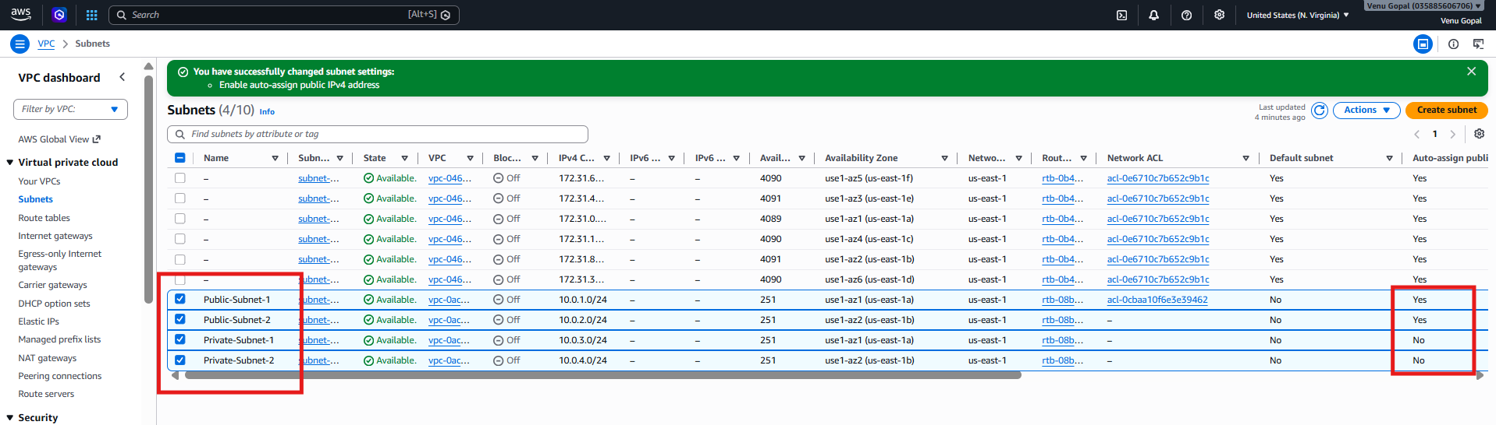
4. Add 2 private subnets in private route table.
Objective
Create a Private Route Table and associate it with:
- Private-Subnet-1
- Private-Subnet-2
At this stage, the route table will contain only the local route. We'll add the NAT Gateway route later in Task 8.

Network Diagram After This Task
DevOps-VPC (10.0.0.0/16)
-----------------------------------------
| |
Public Route Table Private Route Table
(Later) (Create now)
| |
Public-Subnet-1 Private-Subnet-1
Public-Subnet-2 Private-Subnet-2

Step 1: Open the VPC Service
- Log in to the AWS Management Console.
- Search for VPC.
- Open the VPC service.
Step 2: Open Route Tables
In the left navigation pane:
Virtual Private Cloud → Route Tables
You will see the main/default route table that AWS created with your VPC.

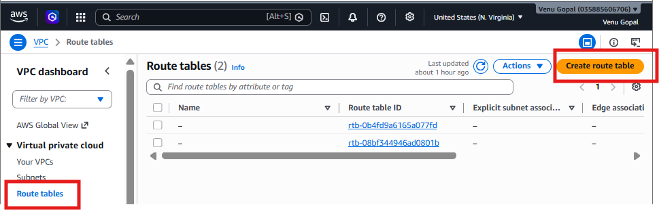

Step 3: Create a New Route Table
Click Create route table.
Enter the following:
Field | Value
Name | Private-RT
VPC | DevOps-VPC
Click Create route table.
You should see a success message.
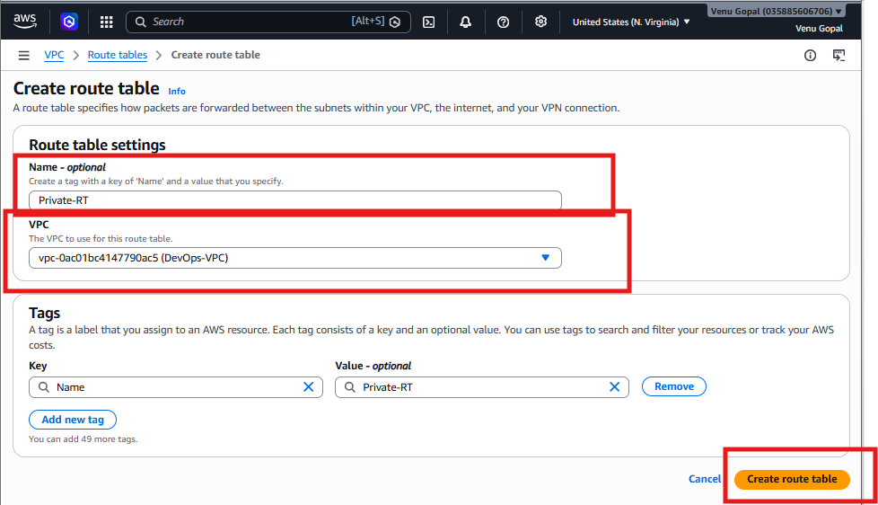

Step 4: Verify the Route Table
Select Private-RT.
In the Routes tab, you should see:
Destination | Target
10.0.0.0/16 | Local
Explanation:
- 10.0.0.0/16 → Local allows communication between all subnets inside the VPC.
- Do not add 0.0.0.0/0 yet. We'll do that after creating the NAT Gateway in Task 8.

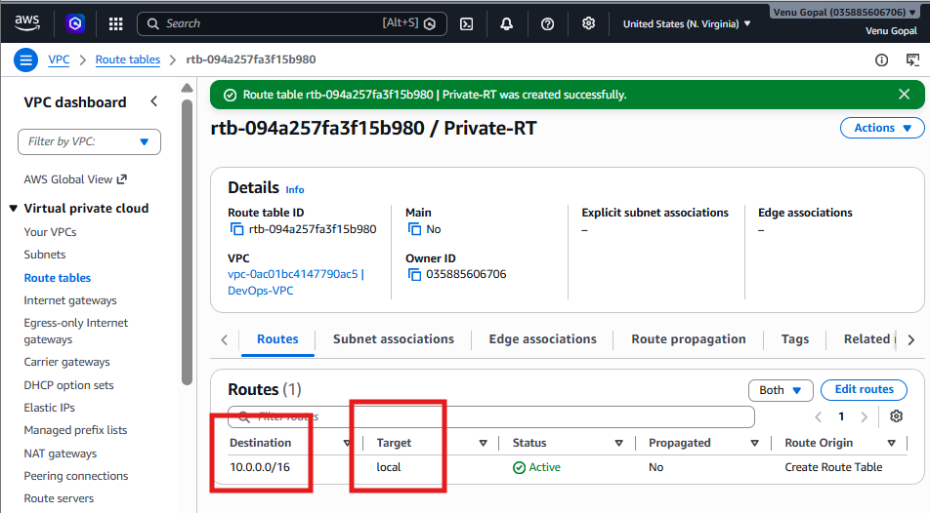
Step 5: Associate Private Subnet 1
With Private-RT selected:
- Open the Subnet associations tab.
- Click Edit subnet associations.
- Select:
  - ✅ Private-Subnet-1
- Click Save associations.
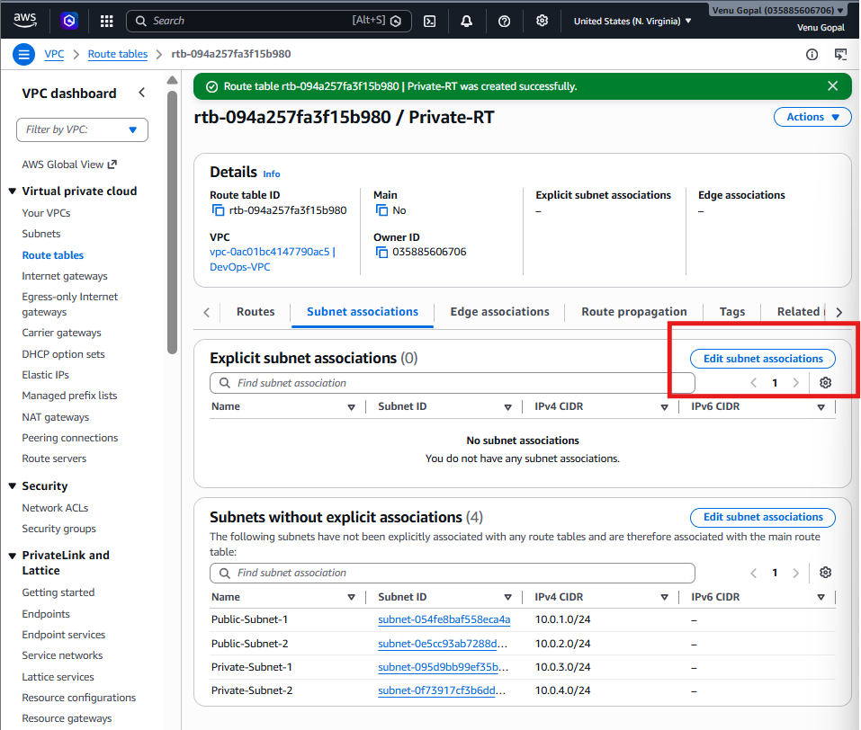
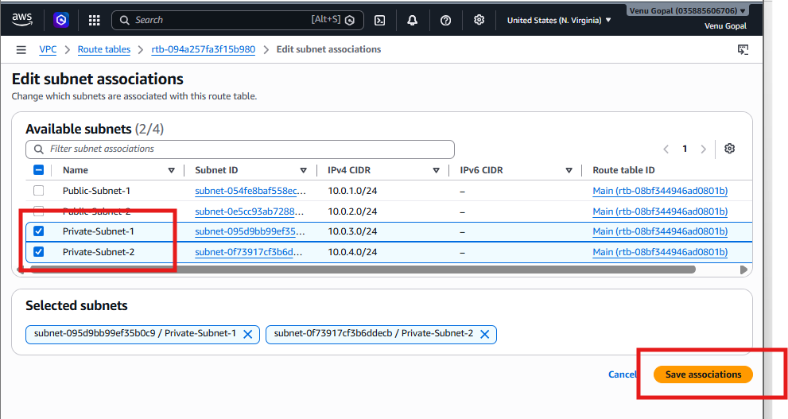
Step 6: Associate Private Subnet 2
Stay in the Subnet associations tab.
- Click Edit subnet associations again (if needed).
- Ensure both are selected:
  - ✅ Private-Subnet-1
  - ✅ Private-Subnet-2
- Click Save associations.

Step 7: Verify Associations
Under Subnet associations, you should see:
Subnet | Associated Route Table
Private-Subnet-1 | Private-RT
Private-Subnet-2 | Private-RT
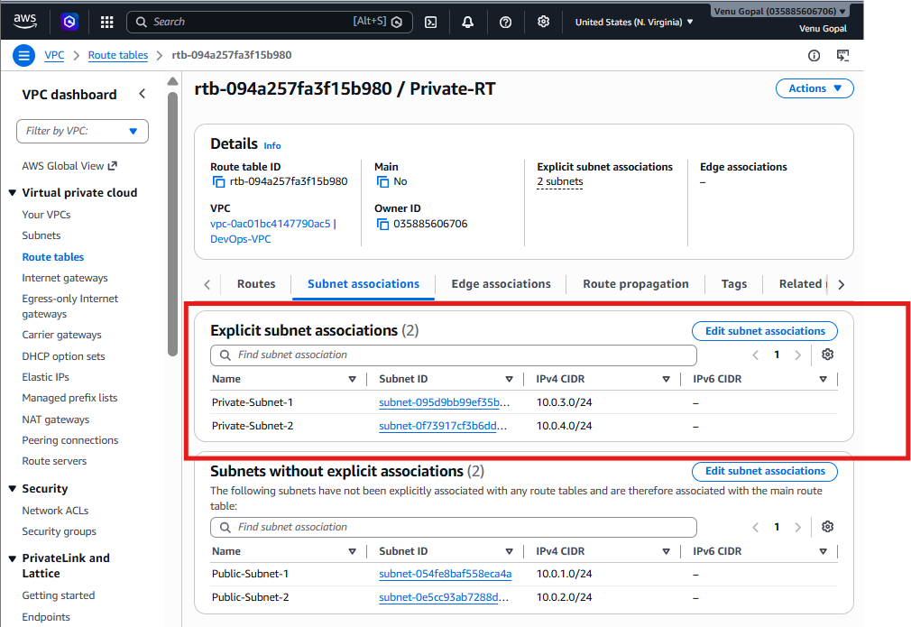

Expected Configuration
Private Route Table (Private-RT)

Routes
--------------------------
10.0.0.0/16 Local
Associated Subnets:
Private-Subnet-1
Private-Subnet-2
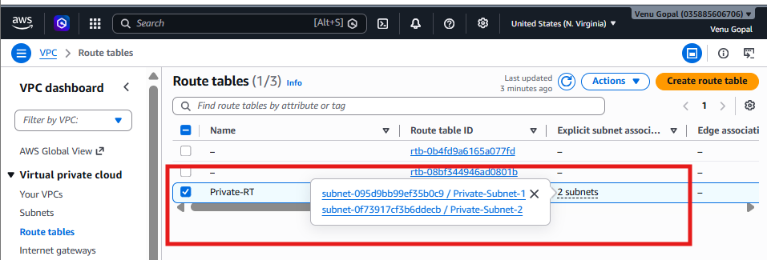
5. Add 2 public subnets in public route table.
Objective
Create a Public Route Table and associate it with:
- Public-Subnet-1
- Public-Subnet-2
We will add the Internet Gateway route (0.0.0.0/0) in Task 6.

Step 1: Open Route Tables
Go to:
VPC → Route Tables
Click Create route table.
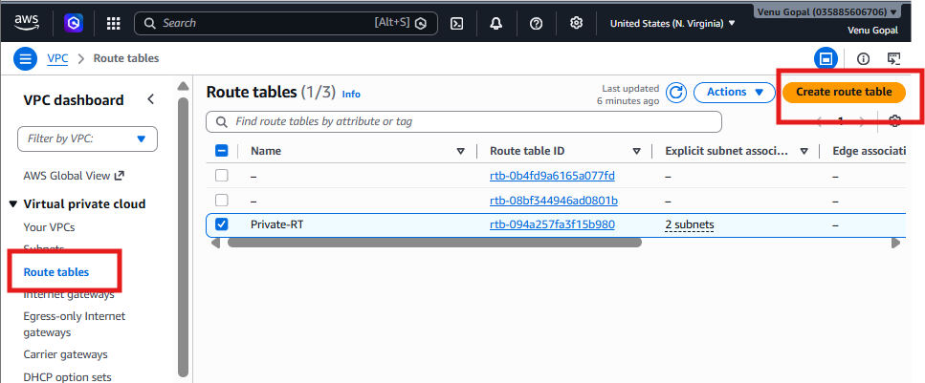

Step 2: Create the Public Route Table
Enter:
Field | Value
Name | Public-RT
VPC | DevOps-VPC
Click Create route table.
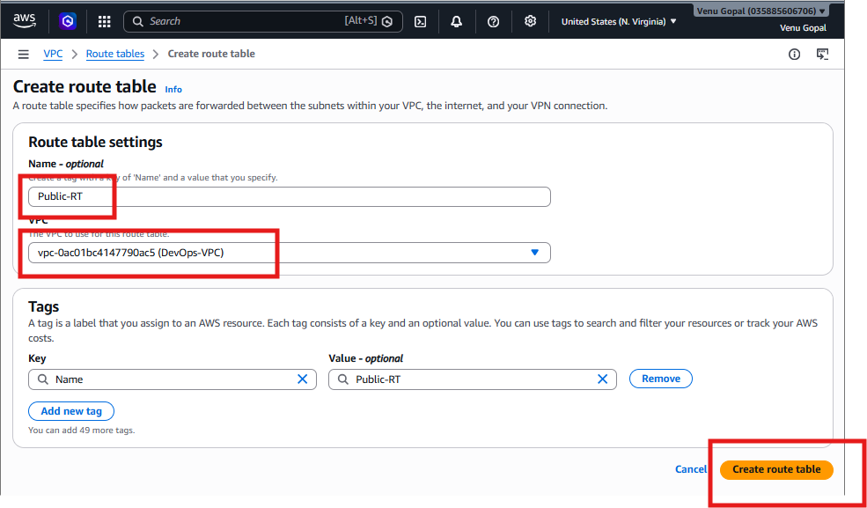

Step 3: Verify the Routes
Select Public-RT.
Go to the Routes tab.
Initially, you should see only:
Destination | Target
10.0.0.0/16 | Local
This is expected. We'll add the Internet Gateway route in the next task.
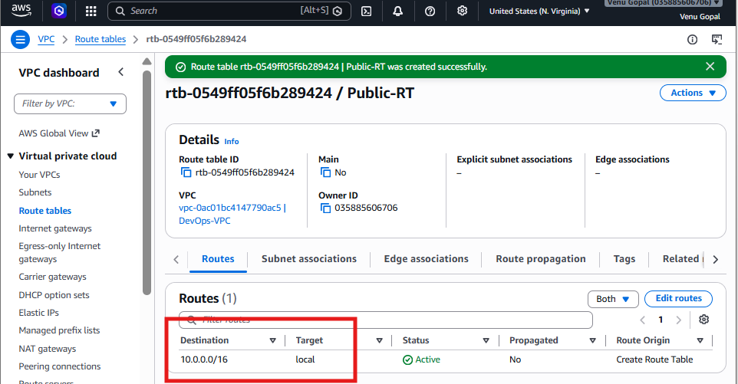

Step 4: Associate the Public Subnets
- Select Public-RT.
- Go to the Subnet associations tab.
- Under Explicit subnet associations, click Edit subnet associations.
- Select:
  - ✅ Public-Subnet-1
  - ✅ Public-Subnet-2
- Click Save associations.
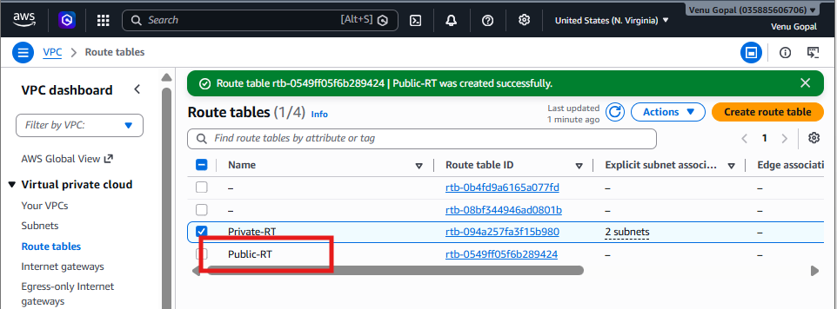
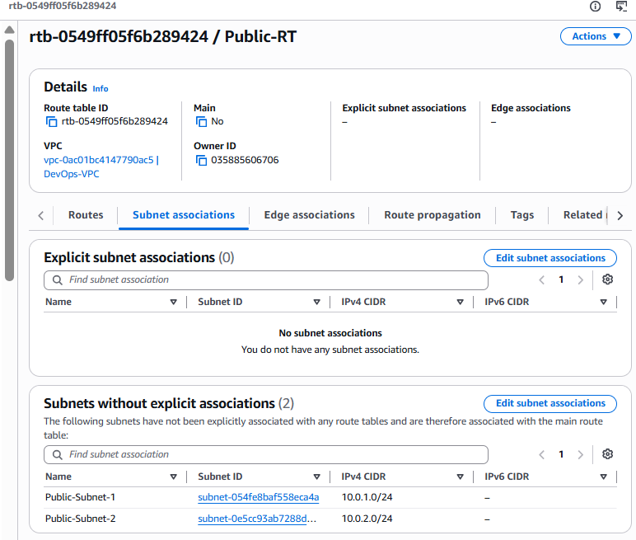
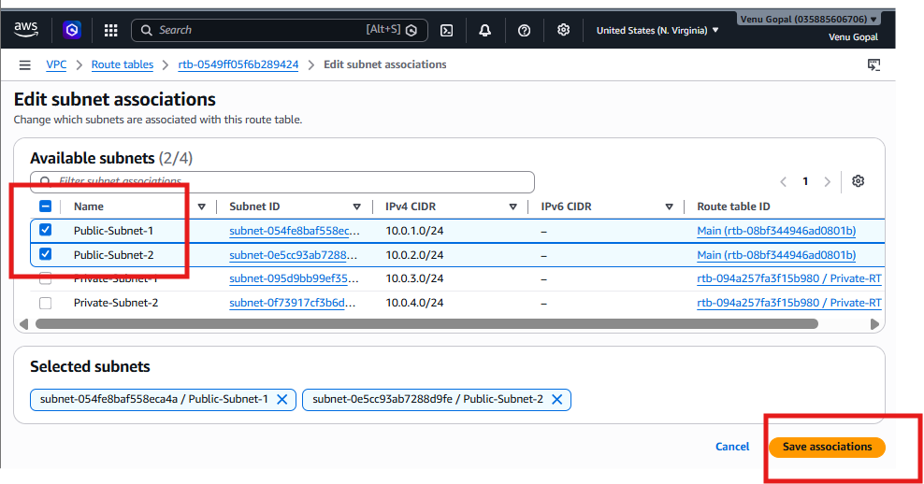
Step 5: Verify
Under Explicit subnet associations, you should now see:
Subnet
✅ Public-Subnet-1
✅ Public-Subnet-2
The Subnets without explicit associations section should now be empty (or only show subnets that are still using the main route table, if any).
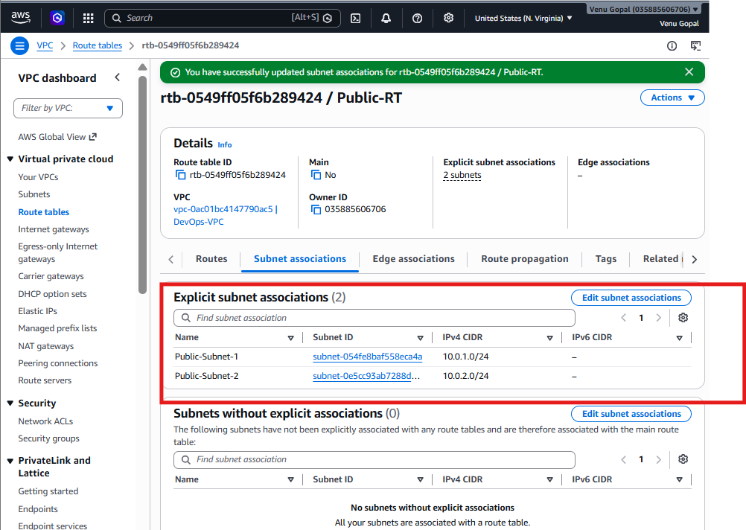

Expected State After Task 5
Route Table | Associated Subnets
Private-RT | Private-Subnet-1, Private-Subnet-2
Public-RT | Public-Subnet-1, Public-Subnet-2
Main Route Table | No subnet associations (or none relevant to this assignment)
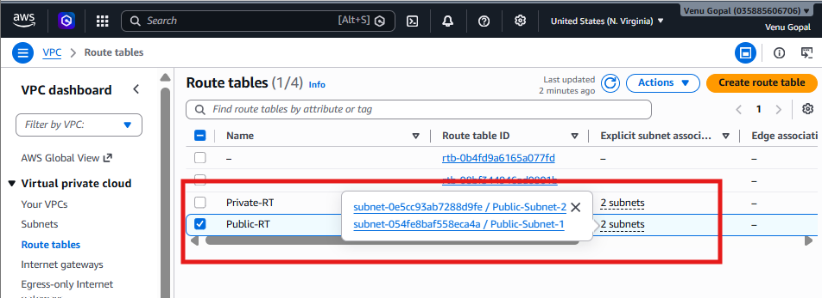

6. Public route table will have the routes to internet and local.
Objective
- Create an Internet Gateway (IGW).
- Attach it to your VPC.
- Add a default route (0.0.0.0/0) in the Public Route Table.
After this task:
- EC2 instances in public subnets can access the internet.
- They can receive inbound traffic (provided Security Groups allow it).

Current Network
Internet
❌ (Not Connected Yet)

DevOps-VPC
│
├── Public-RT
│ ├── Public-Subnet-1
│ └── Public-Subnet-2
│
└── Private-RT
├── Private-Subnet-1
└── Private-Subnet-2

Step 1: Create an Internet Gateway
- Go to VPC Dashboard.
- In the left menu, click Internet Gateways.
- Click Create internet gateway.
Enter:
Field | Value
Name | DevOps-IGW
Click Create internet gateway.
You should see:
Internet Gateway created successfully.
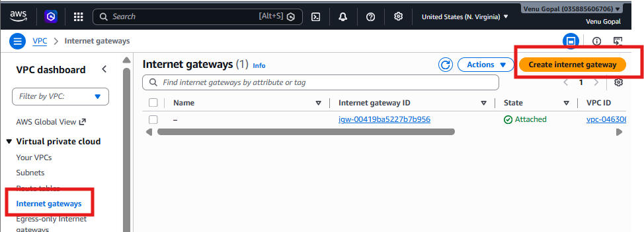
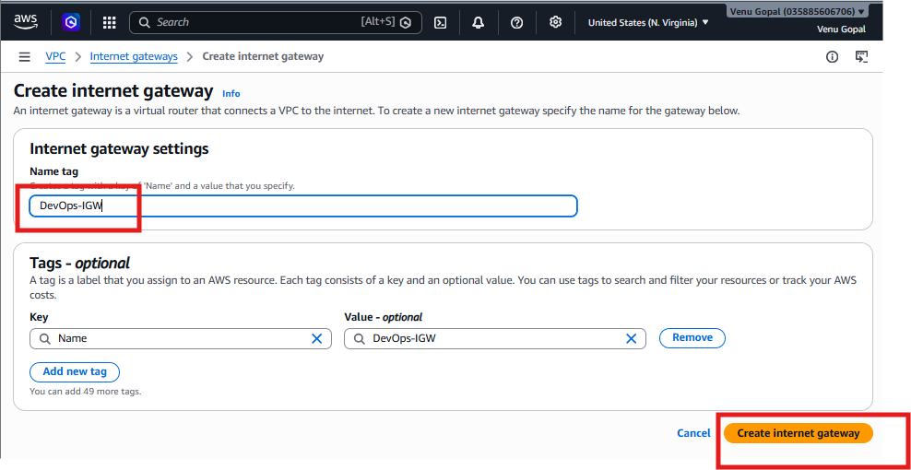

Step 2: Attach the Internet Gateway to the VPC
Select DevOps-IGW.
Click:
Actions → Attach to VPC
Choose:
DevOps-VPC
Click Attach internet gateway.
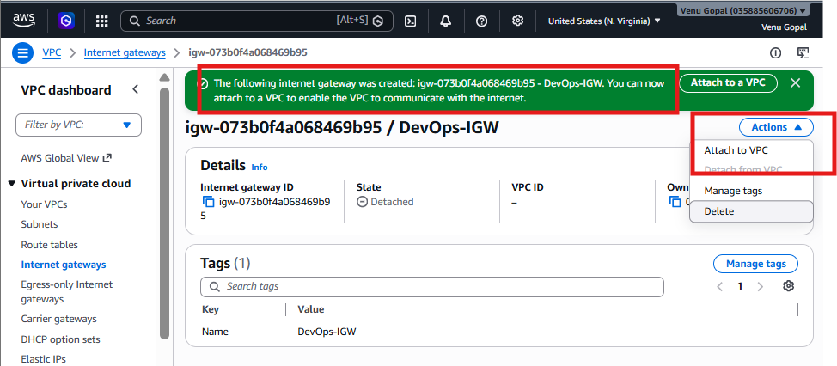
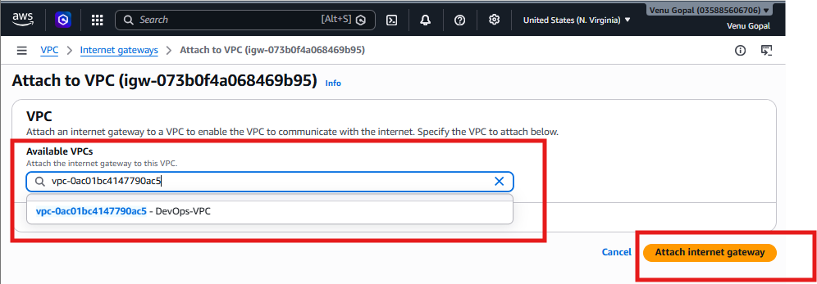

Verify
The Internet Gateway should now show:
Property | Value
State | Attached
VPC | DevOps-VPC
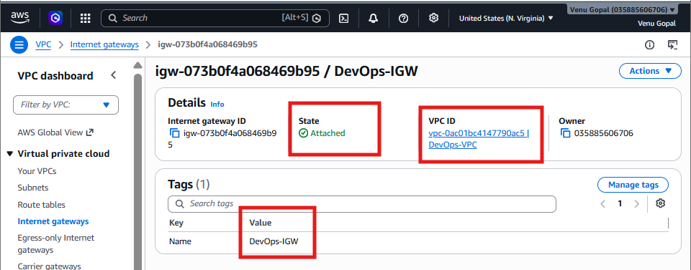

Step 3: Open the Public Route Table
Go to:
Route Tables
Select:
Public-RT
Open the Routes tab.
Click:
Edit routes

Step 4: Add the Internet Route
Click Add route.
Enter:
Destination | Target
0.0.0.0/0 | Internet Gateway
Choose:
DevOps-IGW
Click:
Save changes

Step 5: Verify the Routes
Your Public-RT should now contain:
Destination | Target
10.0.0.0/16 | Local
0.0.0.0/0 | Internet Gateway (DevOps-IGW)
This means any internet-bound traffic from instances in the public subnets will be sent to the Internet Gateway.
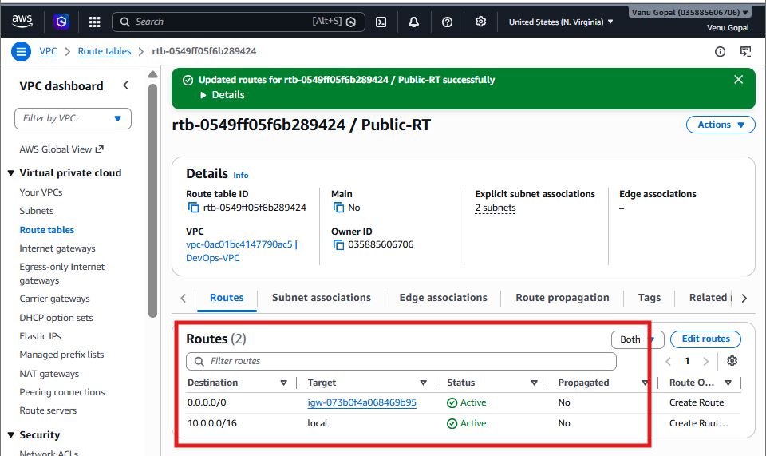
Architecture After Task 6
Internet
│
Internet Gateway
│
Public Route Table
┌───────────────────┐
│10.0.0.0/16 → Local│
│0.0.0.0/0 → IGW │
└───────────────────┘
│
┌──────────────┴──────────────┐
│ │
Public-Subnet-1 Public-Subnet-2
The Private Route Table should still contain only:
Destination | Target
10.0.0.0/16 | Local
Do not add an internet route to the private route table.
Verification
Check the following:
Internet Gateway
- Name: DevOps-IGW
- State: Attached
- VPC: DevOps-VPC
Public Route Table
Routes:
Destination | Target
10.0.0.0/16 | Local
0.0.0.0/0 | Internet Gateway

7. Create EC2 in public subnet with t2.micro and install PHP.
Objective
- Launch an Amazon Linux 2023 EC2 instance
- Instance type: t2.micro
- Place it in Public-Subnet-1
- Install Apache HTTP Server and PHP
- Verify the PHP page in your browser

Step 1: Open EC2 Dashboard
- Go to the AWS Management Console.
- Search for EC2.
- Open the EC2 service.
- Click Launch instances.
Step 2: Basic Configuration
Field | Value
Name | PHP-Server
AMI | Amazon Linux 2023
Instance Type | t2.micro
If t2.micro is not available in your account, you can use t3.micro.
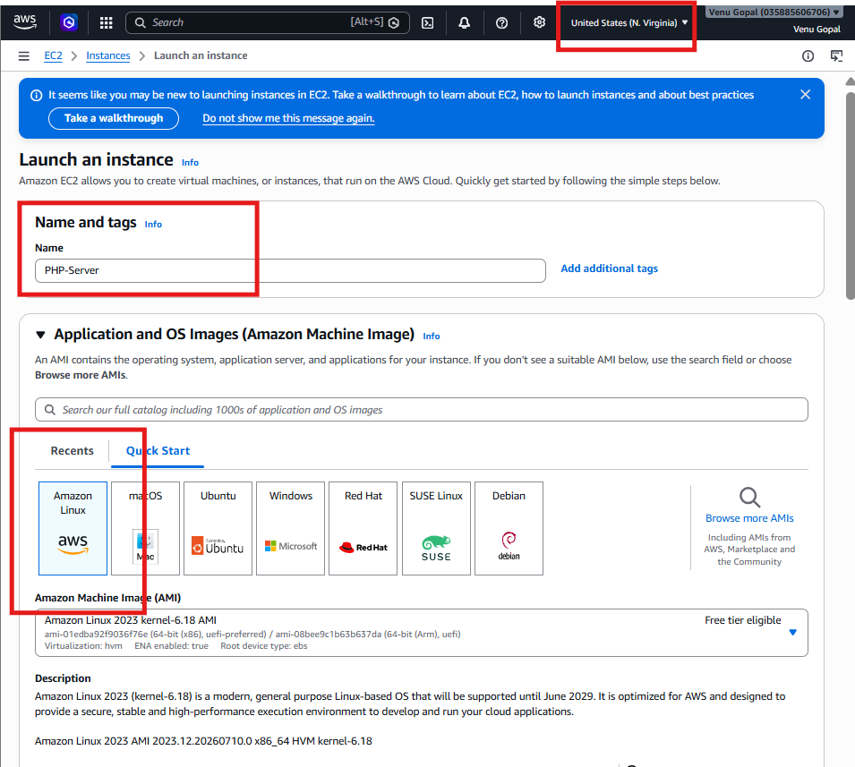

Step 3: Create or Select a Key Pair
If you already have a key pair:
- Select your existing key pair.
Otherwise:
- Click Create new key pair.
- Name it devops-key.
- Type: RSA
- Format: .pem
- Download and save it securely.

Step 4: Network Settings
Click Edit under Network settings.
Configure:
Setting | Value
VPC | DevOps-VPC
Subnet | Public-Subnet-1
Auto-assign Public IP | Enable
Firewall (Security Group) | Create new

Step 5: Configure Security Group
Create a new Security Group.
Rule | Protocol | Port | Source
SSH | TCP | 22 | My IP (recommended)
HTTP | TCP | 80 | Anywhere (0.0.0.0/0)
My IP for SSH is safer than Anywhere.
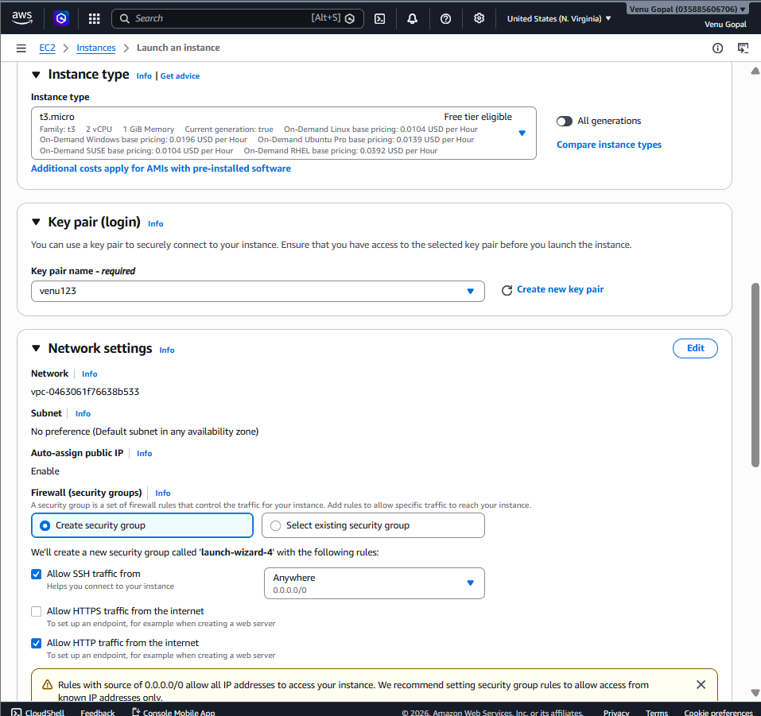
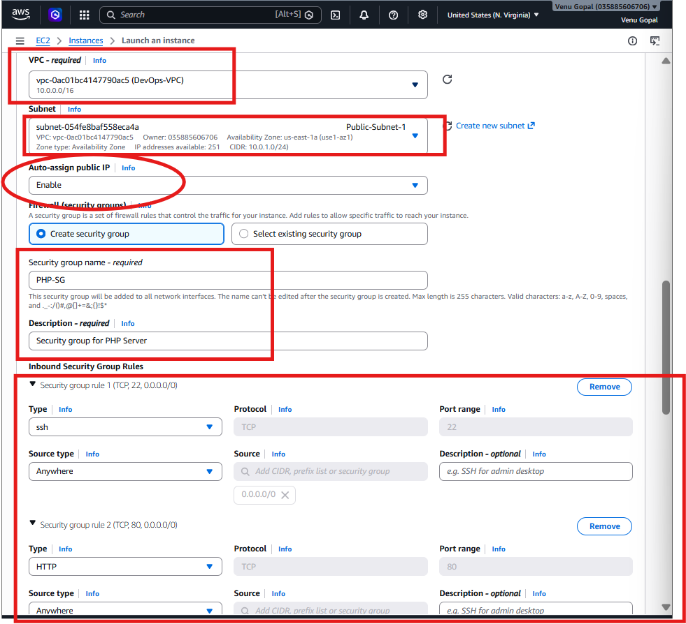

Step 6: Launch the Instance
Click Launch instance.
Wait until:
- Instance State: Running
- Status Checks: 2/2 checks passed
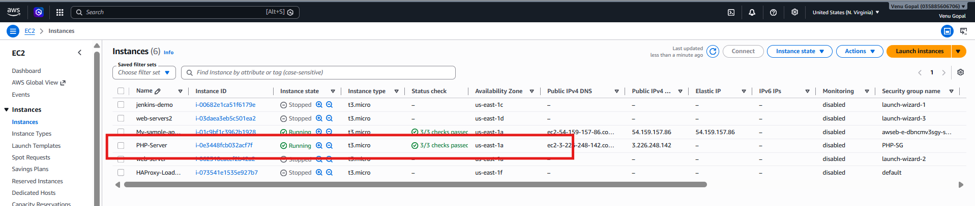

Step 7: Copy the Public IP
In the EC2 Instances page, note the Public IPv4 address, for example:
54.xx.xx.xx
You'll use this to connect via SSH.

Step 8: Connect to the EC2 Instance
From Git Bash (or your terminal):
chmod 400 devops-key.pem
Then connect:
ssh -i devops-key.pem ec2-user@<Public-IP>
Example:
ssh -i devops-key.pem ec2-user@54.210.123.45
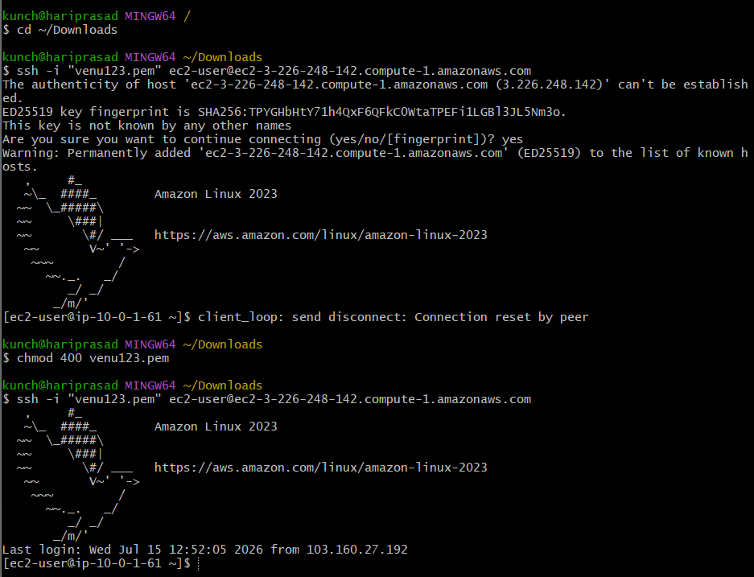
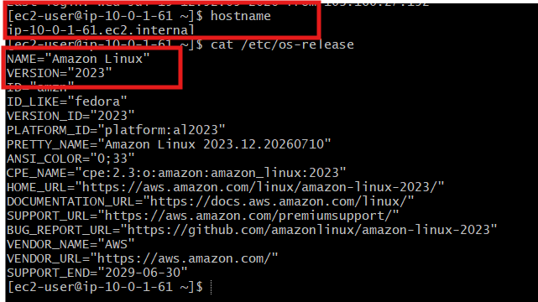
Step 9: Update the Server
Run:
sudo dnf update -y
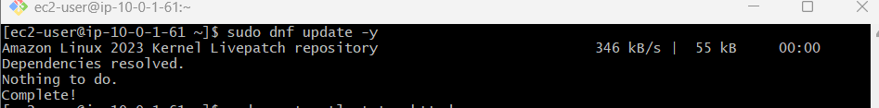
Step 10: Install Apache HTTP Server
sudo dnf install -y httpd
Start and enable Apache:
sudo systemctl enable httpd
sudo systemctl start httpd
Check its status:
sudo systemctl status httpd
It should show:
Active: active (running)
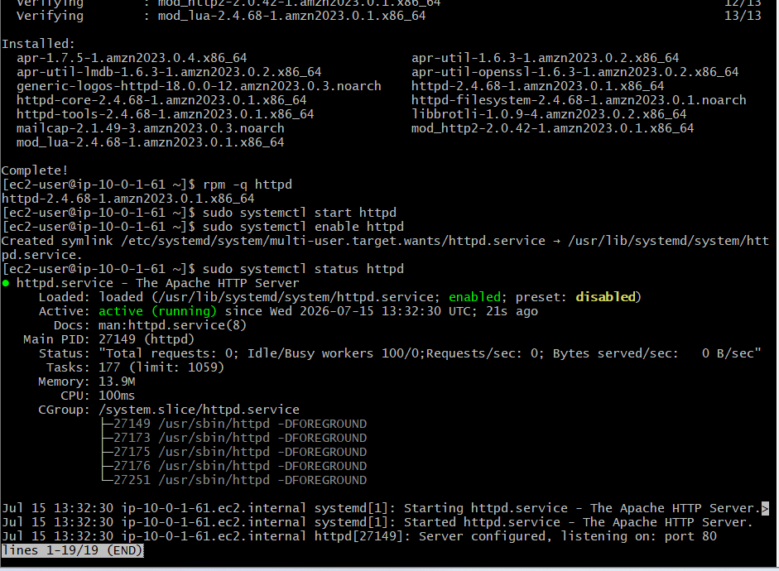

Step 11: Install PHP
sudo dnf install -y php
Verify:
php -v
You should see the installed PHP version.
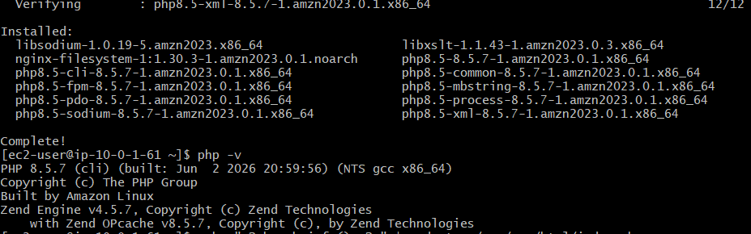
Step 12: Create a PHP Test Page
Create the file:
echo "<?php phpinfo(); ?>" | sudo tee /var/www/html/index.php
Restart Apache:
sudo systemctl restart httpd

Step 13: Test in the Browser
Open:
http://<Public-IP>/index.php
Example:
http://54.210.123.45/index.php
You should see the PHP Information page.
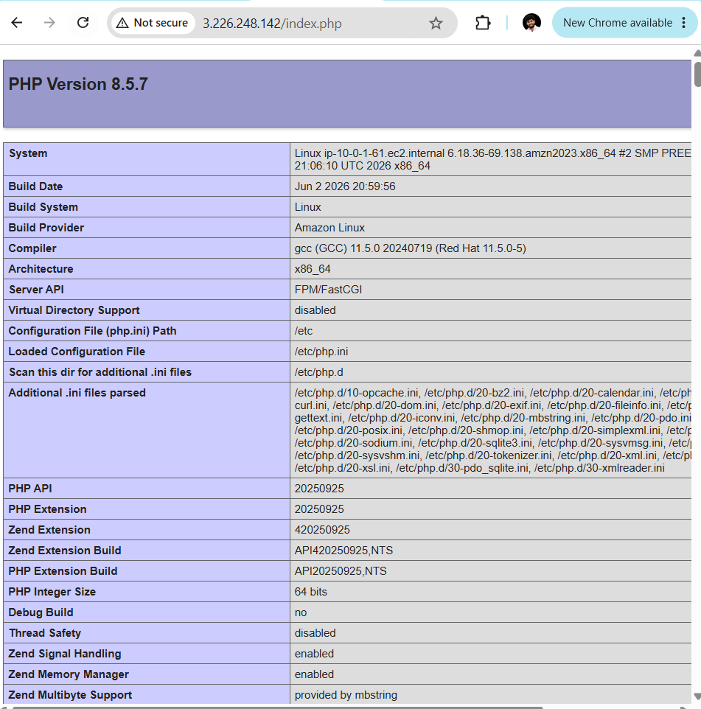

Step 14: Verify
Run:
sudo systemctl status httpd
php -v
Expected:
- Apache: active (running)
- PHP: Installed successfully
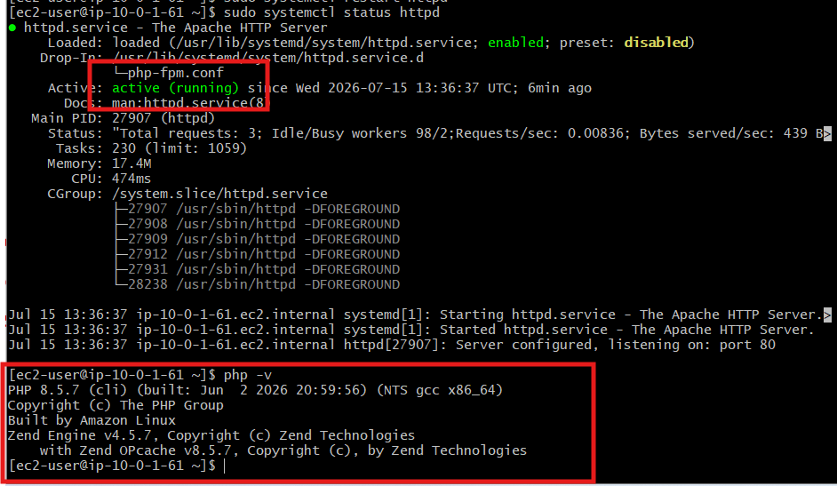

8. Configure NAT gateway in public subnet and connect to private instance.
Objective
We'll perform the following:
- Allocate an Elastic IP
- Create a NAT Gateway in the Public Subnet
- Update the Private Route Table
- Launch a Private EC2 instance
- Connect from the Public EC2 to the Private EC2
- Verify internet access from the Private EC2

Architecture
Internet
│
Internet Gateway
│
Public Route Table
│
┌──────────────┴──────────────┐
│ │
Public EC2 (PHP) NAT Gateway
│ │
└──────────────┬──────────────┘
│
Private Route Table
│
Private EC2 (Tomcat)

Step 1: Allocate an Elastic IP
Navigate to
EC2 → Network & Security → Elastic IPs
Click:
Allocate Elastic IP address
Leave all settings as default.
Click:
Allocate
You will see something like:
Allocation ID | Public IP
eipalloc-xxxxxxxx | 44.xx.xx.xx
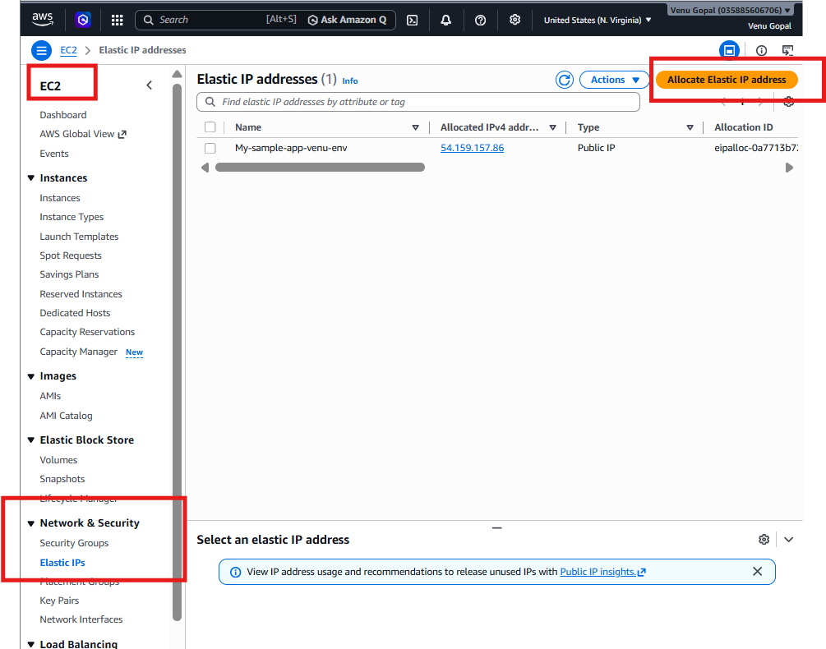
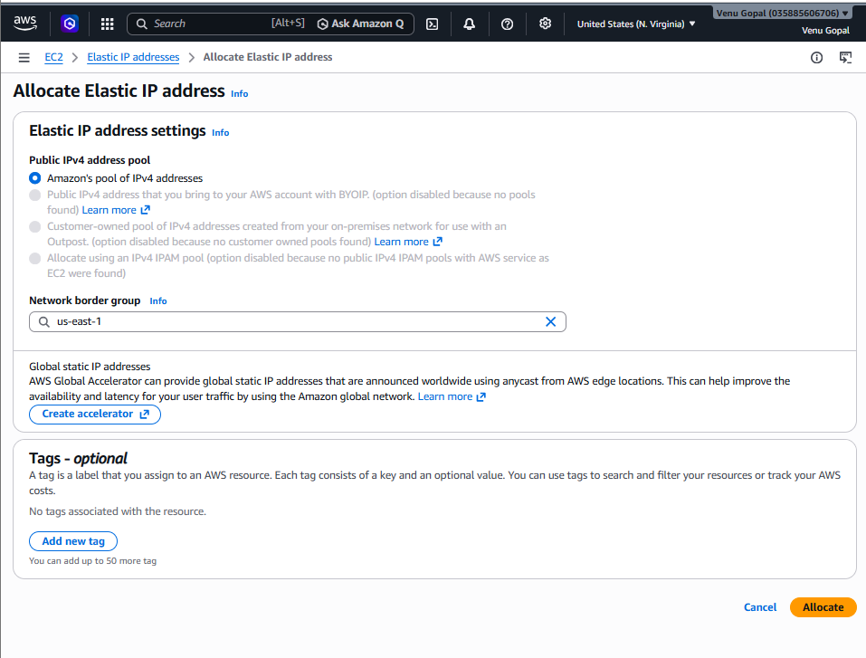

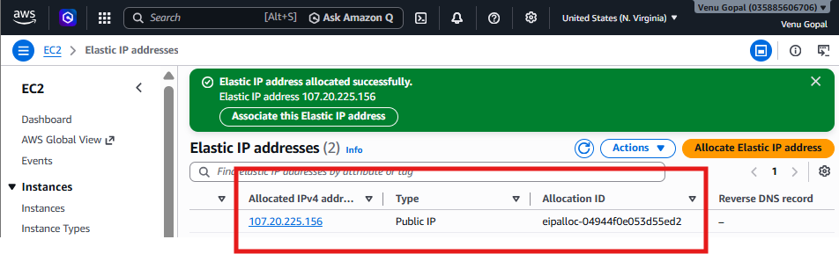
Step 2: Create the NAT Gateway
Navigate to:
VPC → NAT Gateways
Click:
Create NAT Gateway
Fill in the details:
Field | Value
Name | DevOps-NAT
Subnet | Public-Subnet-1
Connectivity Type | Public
Elastic IP | Select the Elastic IP you allocated
Click:
Create NAT Gateway

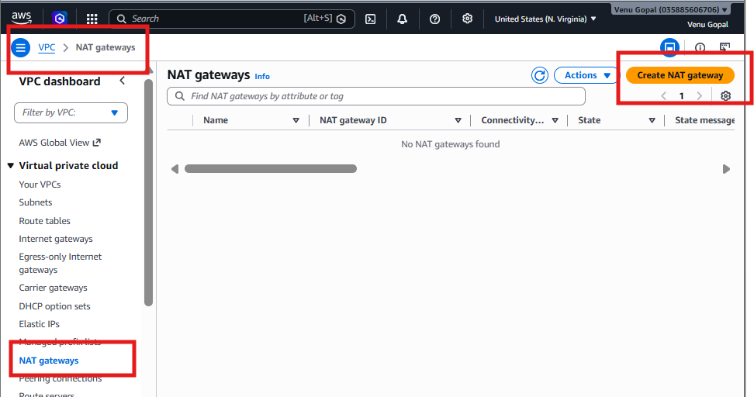

Step 3: Wait for the NAT Gateway
Initially, the status will be:
Pending
Wait 2–5 minutes until it changes to:
Available
Do not proceed until it is Available.
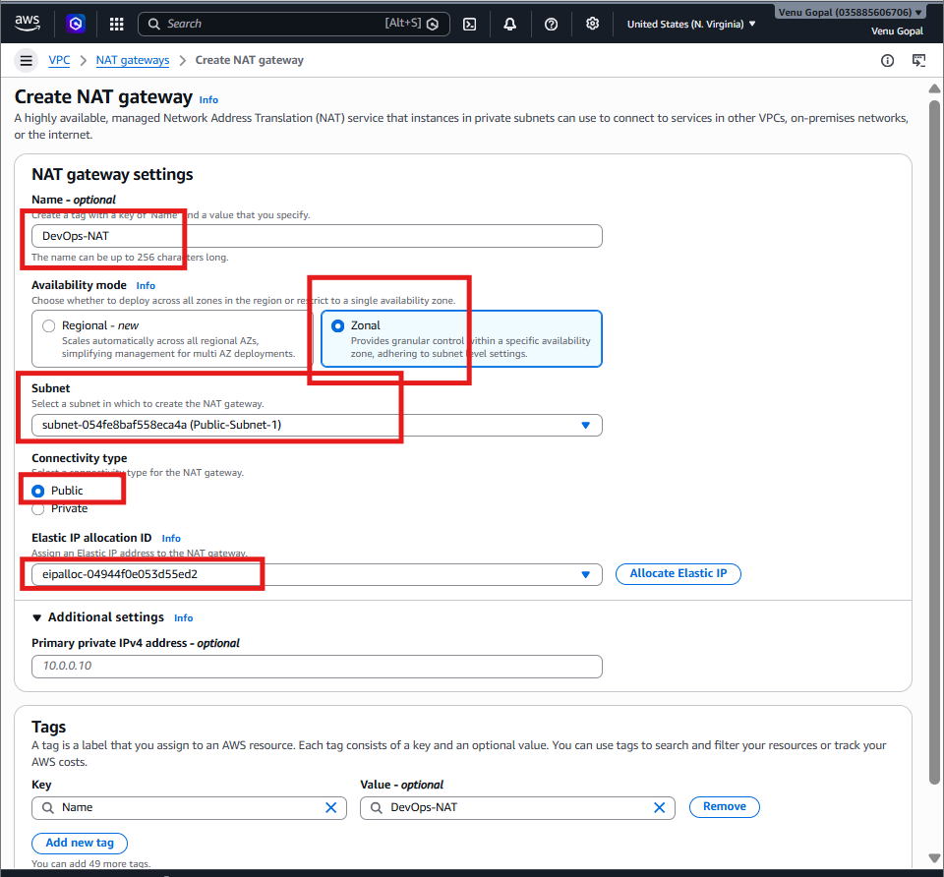
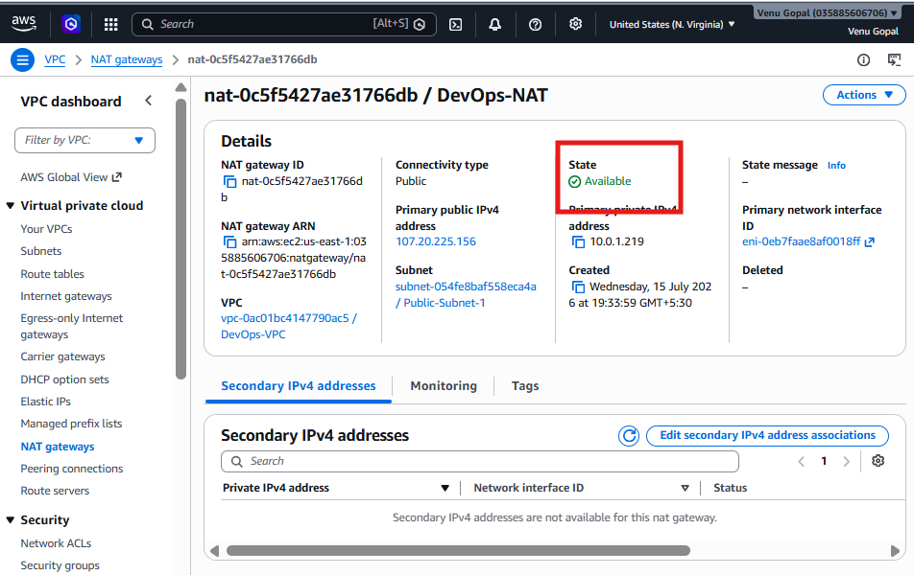

Step 4: Update the Private Route Table
Go to:
VPC → Route Tables
Select:
Private-RT
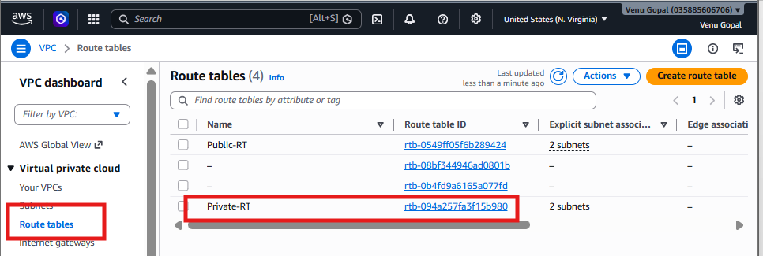
Open the Routes tab.
Click:
Edit routes
Click:
Add route
Enter:
Destination | Target
0.0.0.0/0 | NAT Gateway
Select:
DevOps-NAT
Click:
Save changes
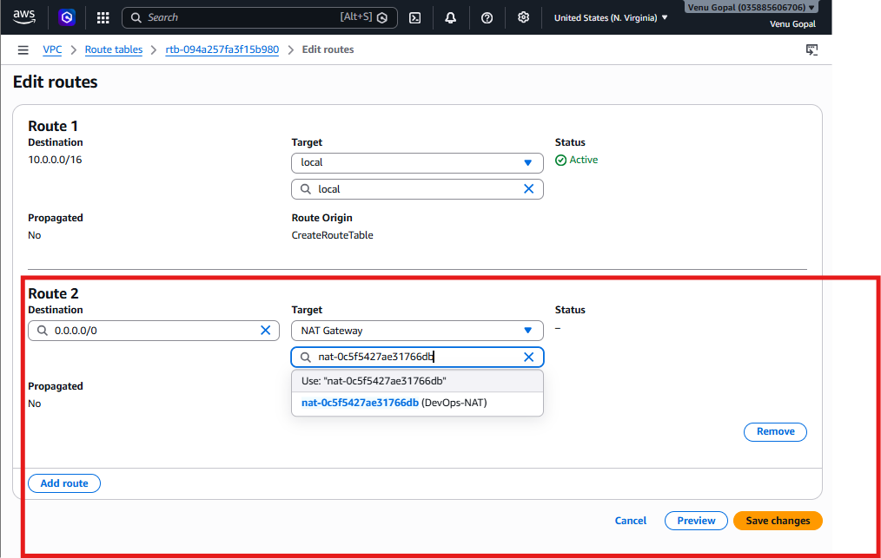

Step 5: Verify Routes
Your Private-RT should now contain:
Destination | Target
10.0.0.0/16 | Local
0.0.0.0/0 | NAT Gateway
This allows instances in the private subnets to initiate outbound internet connections while remaining inaccessible directly from the internet.
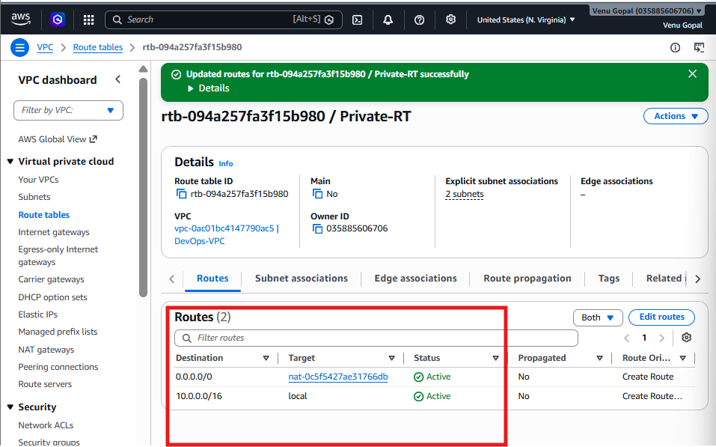

Step 6: Launch a Private EC2 Instance
Go to:
EC2 → Launch Instance
Configure:
Field | Value
Name | Tomcat-Private
AMI | Amazon Linux 2023
Instance Type | t2.micro (or t3.micro)
Key Pair | Use the same key pair as the public EC2
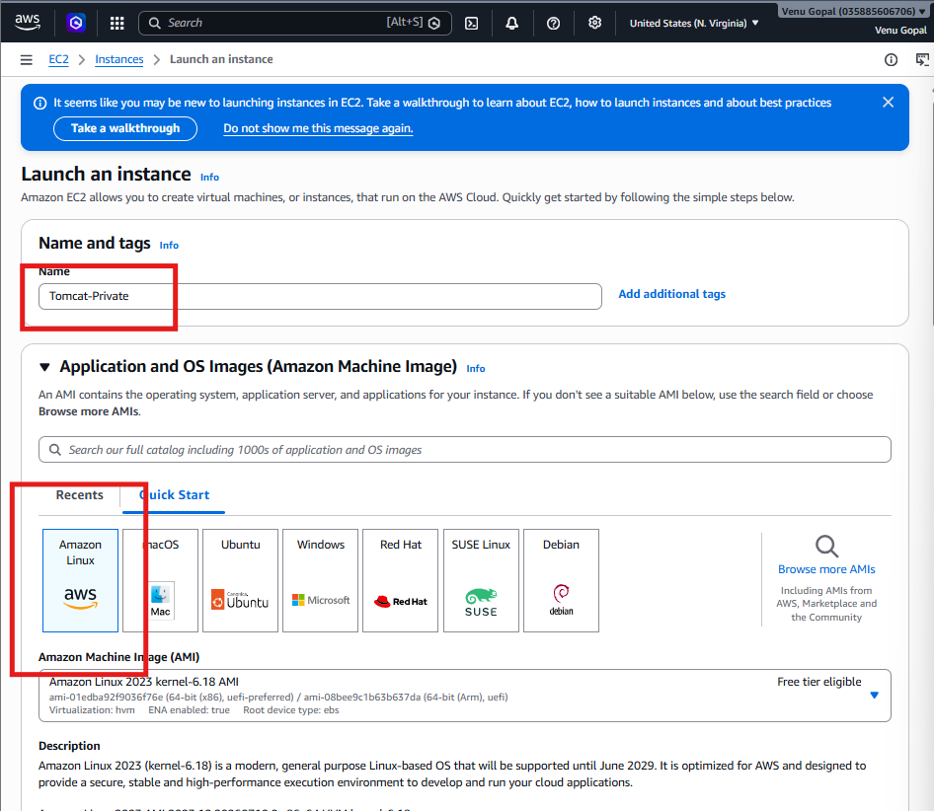

Network Settings
Click Edit.
Set:
Field | Value
VPC | DevOps-VPC
Subnet | Private-Subnet-1
Auto-assign Public IP | Disable
Security Group | Create a new one or use an existing one
Security Group Rules
For now, add:
Type | Port | Source
SSH | 22 | 10.0.0.0/16
This allows SSH from within your VPC only.
Launch the instance.
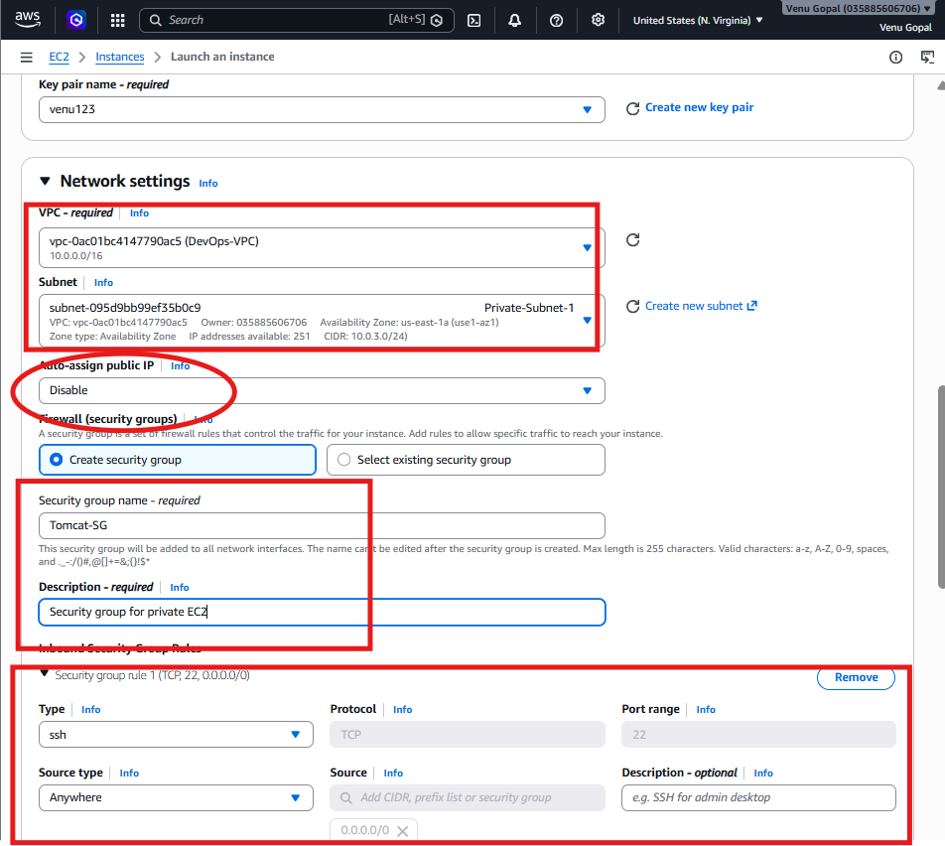

Step 7: Verify the Private EC2
After the instance is running:
- Verify that the Public IPv4 address field is empty.
- Note its Private IPv4 address, for example:
10.0.3.25
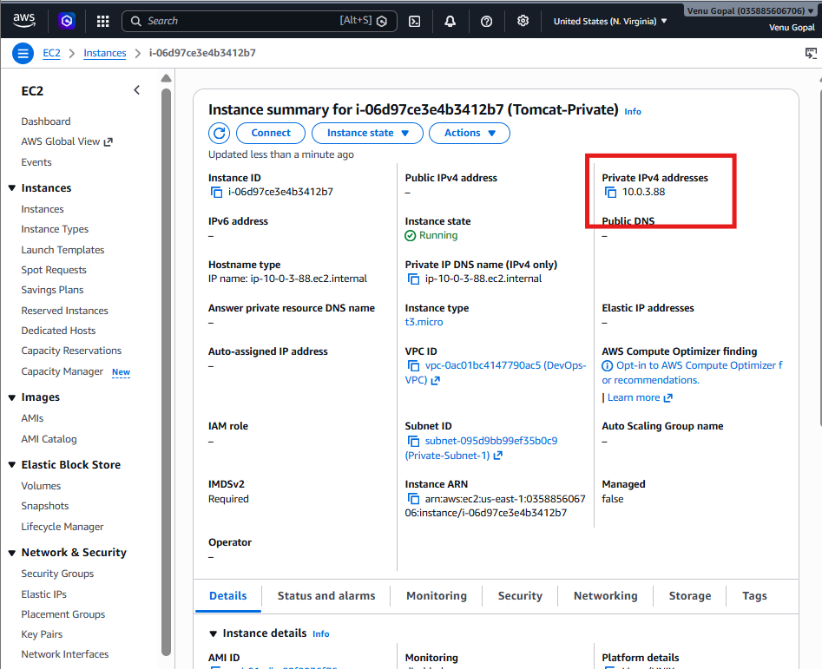

9. Install Apache Tomcat in private EC2 and deploy a sample app.
Since the private EC2 has no public IP, we cannot SSH directly from your laptop. We will use the Public EC2 as a Bastion Host (Jump Server).

Step 1: Get the Private IP
Go to:
EC2 → Instances → Tomcat-Private
Copy the Private IPv4 address.
Example:
10.0.3.52
We'll use it in the next step.

Step 2: Connect to Public EC2
From your laptop:
ssh -i venu123.pem ec2-user@<Public-EC2-Public-IP>
Example:
ssh -i venu123.pem ec2-user@54.xxx.xxx.xxx
Verify:
hostname

Step 3: Copy the Key to Public EC2
Since the private EC2 uses the same key pair (venu123.pem), copy it to the public EC2.
From your laptop:
scp -i venu123.pem venu123.pem ec2-user@<Public-EC2-Public-IP>:/home/ec2-user/
Example:
scp -i venu123.pem venu123.pem ec2-user@54.xxx.xxx.xxx:/home/ec2-user/

Step 4: SSH to the Private EC2
On the Public EC2, run:
chmod 400 venu123.pem
Then:
ssh -i venu123.pem ec2-user@<Private-EC2-Private-IP>
Example:
ssh -i venu123.pem ec2-user@10.0.3.52
If asked:
Are you sure you want to continue connecting?
Type:
yes
You should now be logged into the Private EC2.
Verify:
hostname
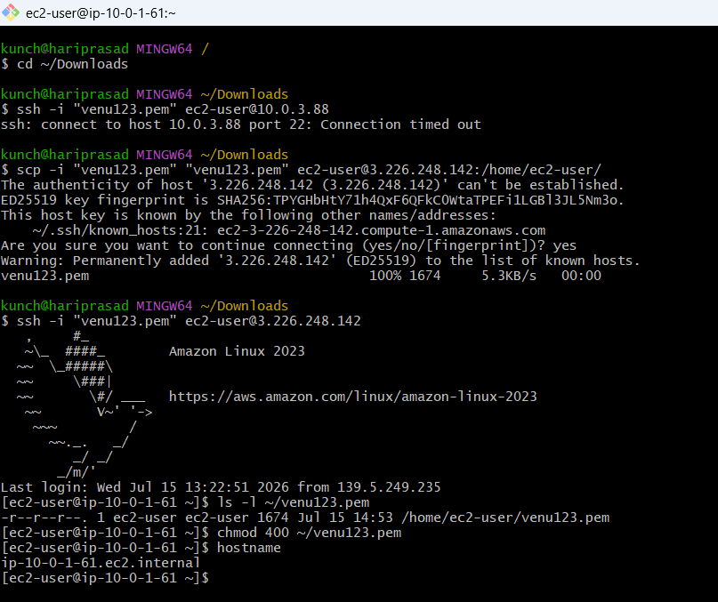

Step 5: Verify NAT Gateway
Run:
ping -c 4 amazon.com
or
sudo dnf update -y
If this works, your NAT Gateway is configured correctly.
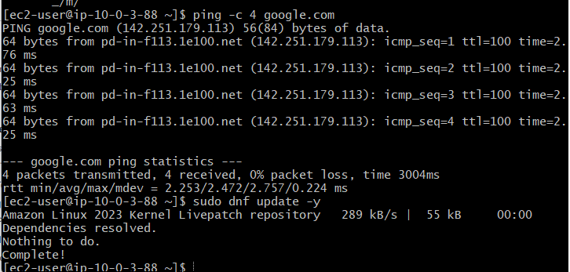

Step 6: Install Java
Install Amazon Corretto 17:
sudo dnf install java-17-amazon-corretto -y
Verify:
java -version
Expected output:
openjdk version "17..."
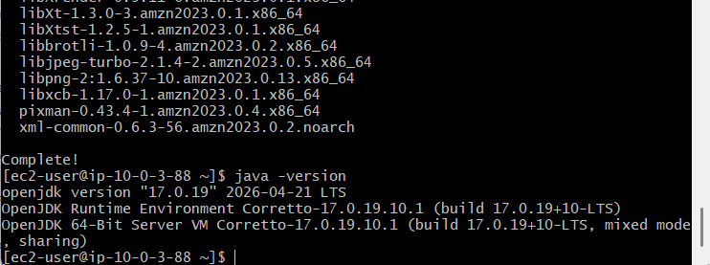

Step 7: Download Apache Tomcat
cd /opt

sudo wget https://downloads.apache.org/tomcat/tomcat-10/v10.1.44/bin/apache-tomcat-10.1.44.tar.gz
Extract it:
sudo tar -xzf apache-tomcat-10.1.44.tar.gz
Rename:
sudo mv apache-tomcat-10.1.44 tomcat

Step 8: Start Tomcat
sudo chmod +x /opt/tomcat/bin/*.sh
Start:
sudo /opt/tomcat/bin/startup.sh
Check:
ps -ef | grep tomcat
or
ss -tulnp | grep 8080
You should see Tomcat listening on 8080.
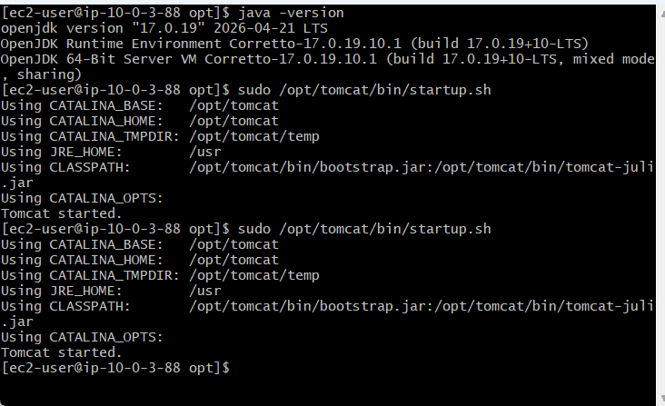
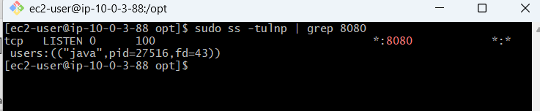

Step 9: Deploy a Sample Application
Create a simple web page:
echo "<h1>Tomcat Running from Private EC2</h1>" | sudo tee /opt/tomcat/webapps/ROOT/index.jsp
Restart Tomcat:
sudo /opt/tomcat/bin/shutdown.sh
sudo /opt/tomcat/bin/startup.sh
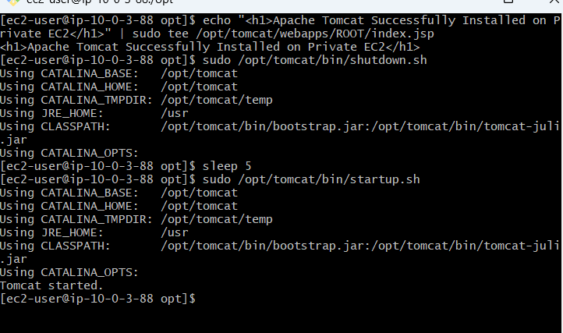

Step 10: Verify
Since Tomcat is in a private subnet, you won't be able to open it directly from your browser.
Instead, verify from the private EC2:
curl http://localhost:8080
You should receive the Tomcat page or your sample page.
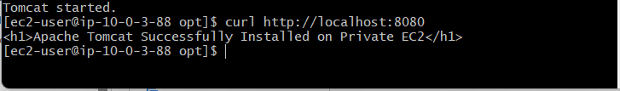

10. Configure VPC flow logs and store the logs in S3 and CloudWatch.
Step 1: Create an S3 Bucket
- Open AWS Console
- Go to S3
- Click Create bucket
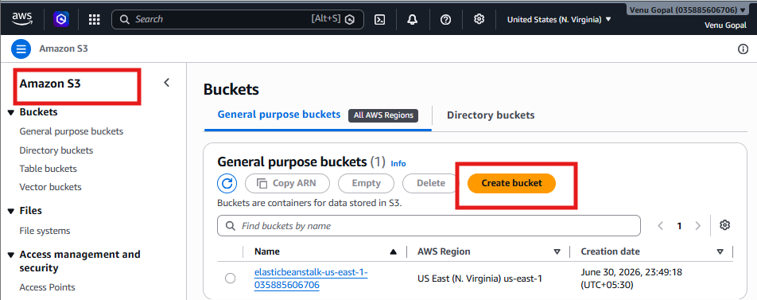
Enter:
Bucket name:
devops-vpc-flowlogs-<yourname>
Example:
devops-vpc-flowlogs-venu
Region:
US East (N. Virginia)
Keep everything else as default.
Click:
Create bucket
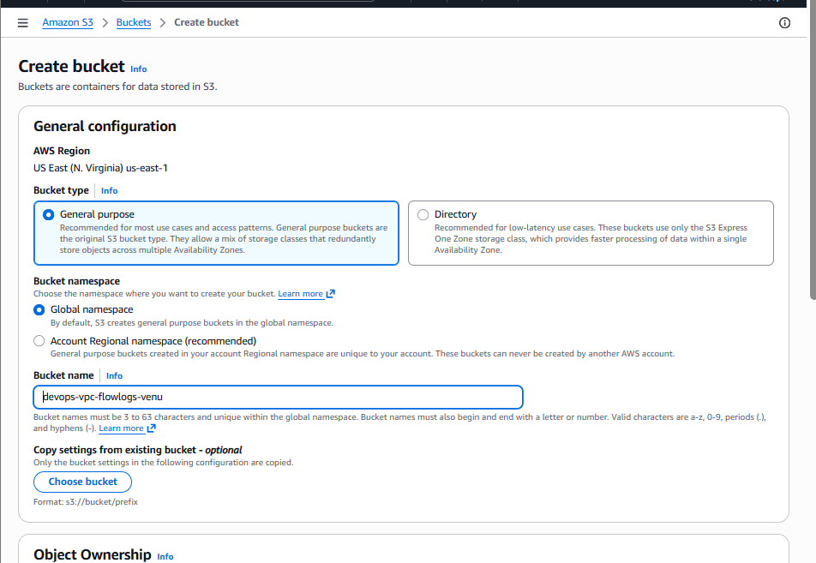
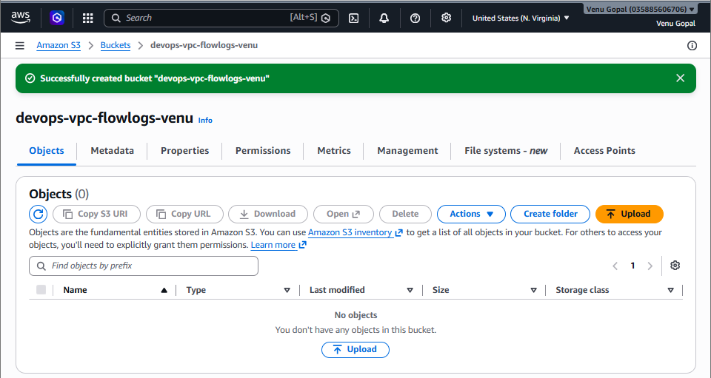

Step 2: Open VPC
Go to:
VPC
→ Your VPC (DevOps-VPC)
Select the VPC.
Click
Actions
→ Create Flow Log
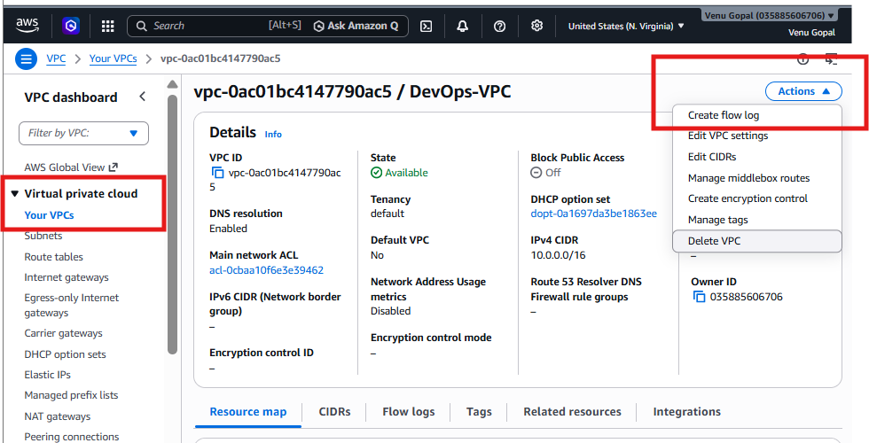

Step 3: Configure Flow Log
Fill in:
Name
DevOps-VPC-FlowLog
Filter
All
Maximum aggregation interval
1 minute
Destination
Select:
Send to Amazon S3
S3 bucket ARN:
arn:aws:s3:::devops-vpc-flowlogs-venu
Click
Create Flow Log
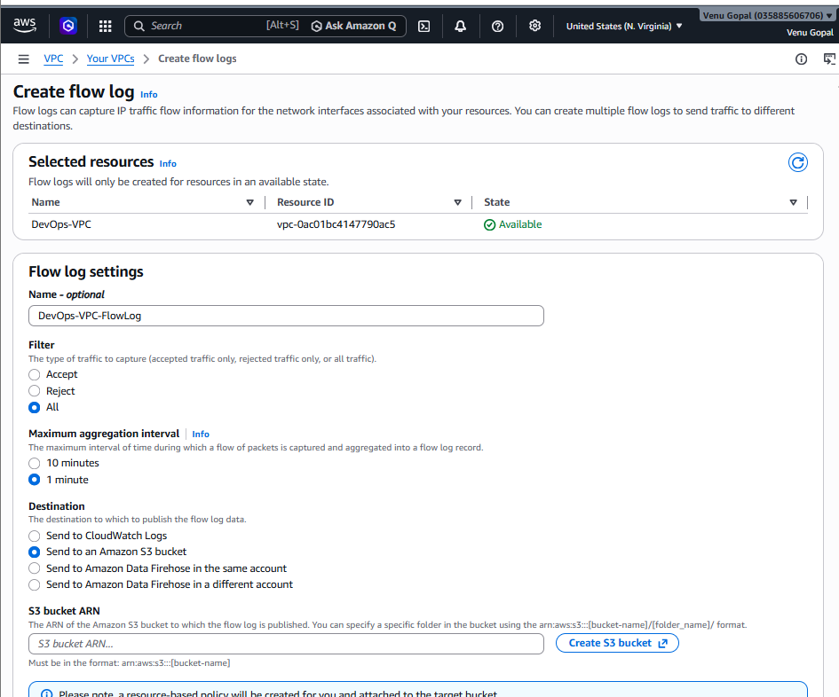
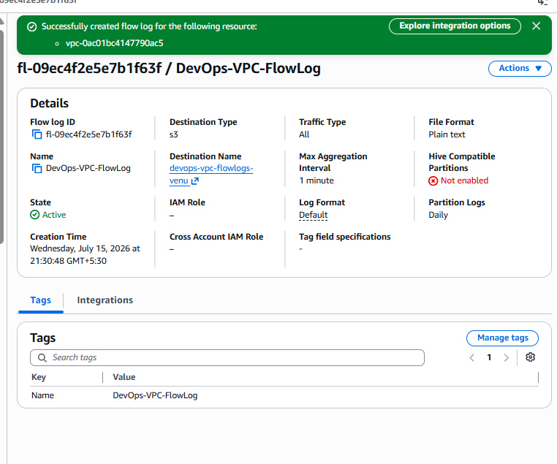

Step 4: Verify
Go to
VPC
→ Flow Logs
You should see
Status
Active


Step 5: Generate Traffic
SSH to either EC2 instance or run:
curl google.com
or
ping google.com
This generates network traffic that the flow log records.
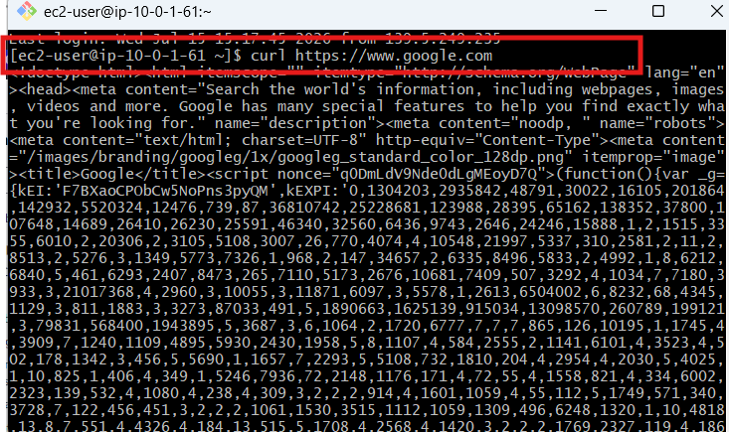

Step 6: Verify Logs
Open:
S3
→ Your Bucket
After a few minutes, you should see folders similar to:
AWSLogs/
Inside them will be the VPC Flow Log files.

