AWS LAMBDA

How to Use This Handbook
Chapters 1-5 build the foundation. Chapters 6-13 cover production engineering. Chapters 14-17 contain labs, deployment examples, troubleshooting and interview preparation. Green callouts contain short demo explanations you can speak directly.

Learning Path
Stage | Focus | Result
1. Foundation | Purpose, serverless model, terminology | Explain what Lambda does and when to use it.
2. Runtime | Invocation, lifecycle, cold starts, configuration | Understand how code runs and reuses environments.
3. Integration | Triggers, event source mappings, API Gateway | Choose the correct event pattern.
4. Production | IAM, VPC, scaling, reliability, observability | Operate secure and reliable functions.
5. Practice | Console, CLI, S3, API and automation labs | Give an end-to-end demonstration.

Contents
- 1. What AWS Lambda Is
- 2. Why and When to Use Lambda
- 3. Core Components and Terminology
- 4. Invocation Models and Event Sources
- 5. Execution Environment Lifecycle
- 6. Configuration, Runtimes and Packaging
- 7. IAM Permissions and Security
- 8. Networking and VPC Connectivity
- 9. Concurrency, Scaling and Cold Starts
- 10. Reliability, Retries and Error Handling
- 11. Versions, Aliases and Deployments
- 12. Monitoring and Observability
- 13. Performance and Cost Optimization
- 14. Hands-On Labs
- 15. Infrastructure as Code and CI/CD
- 16. Troubleshooting
- 17. Interview and Demo Preparation
- Appendices: Code, Policies, Commands, Glossary and Sources

1. What AWS Lambda Is
AWS Lambda is a serverless compute service that runs code in response to events or direct invocations without requiring you to provision or manage servers. You supply code or a container image, configure memory, timeout, permissions and event sources, and Lambda manages execution environments, scaling, routing and fault tolerance.
One-line interview answer: AWS Lambda is an event-driven serverless compute service that automatically runs and scales code while AWS manages the underlying infrastructure.

Shared responsibility
AWS manages | You manage
Physical infrastructure, host operating system and execution-environment capacity | Function code, dependencies and business logic
Environment placement, scaling and infrastructure availability | IAM permissions, resource policies and secrets
Runtime patches for managed runtimes according to runtime mode | Runtime selection, configuration, testing and upgrades
Invocation infrastructure and service integrations | Retries, idempotency, observability, downstream capacity and cost

What serverless means
- Servers still exist, but AWS provisions and operates them.
- Billing is primarily based on requests and compute duration rather than always-running instances.
- Scaling is automatic within quotas and configured concurrency controls.
- Functions should be stateless; durable state belongs in services such as DynamoDB, S3, RDS or ElastiCache.
- Serverless does not remove architecture, security, monitoring or cost responsibilities.

2. Why and When to Use Lambda
Good fit | Example
Event-driven processing | Resize an image when it is uploaded to S3.
API backends | API Gateway invokes a Lambda function for an order request.
Automation | Stop nonproduction EC2 instances on a schedule.
Stream/queue processing | Process SQS messages or DynamoDB/Kinesis records.
Integration and glue | Transform data between AWS services.
Short parallel jobs | Process independent records with bursty demand.

When Lambda may not be the best choice
- Long-running work beyond the function timeout; use ECS, EKS, Batch, Step Functions patterns, or another compute service.
- Workloads needing full OS control, privileged access, specialized hosts or persistent local processes.
- Predictable, continuously high utilization where provisioned compute may be more cost-effective.
- Applications that depend on local durable state or long-lived inbound connections.
- Workloads whose downstream database cannot handle automatic concurrency.
Lambda | EC2 | ECS/Fargate
Event-driven functions; minimal infrastructure management | Full virtual-machine control; you manage OS and scaling | Containerized services/jobs; more runtime control than Lambda
Maximum standard function duration applies | Runs continuously | Long-running tasks supported
Automatic per-request scaling within limits | ASG/manual scaling | Service/task scaling
Best for short, bursty, event-oriented work | Best for OS-specific or steady servers | Best for containerized APIs, workers and batch

3. Core Components and Terminology
Term | Meaning
Function | Code plus configuration that Lambda invokes.
Handler | Entry point called by the runtime, for example lambda_handler(event, context).
Event | JSON-like input describing the invocation or source record.
Context object | Runtime information such as request ID and remaining time.
Runtime | Language-specific environment such as Python, Node.js, Java or .NET.
Execution role | IAM role assumed by the function to access AWS resources.
Resource-based policy | Controls who or which service may invoke the function.
Trigger | Service/resource configured to initiate invocation.
Event source mapping | Lambda poller that reads streams/queues and invokes a function in batches.
Layer | Reusable archive of libraries, custom runtime or extensions mounted under /opt.
Version | Immutable snapshot of function code and most configuration.
Alias | Named pointer to a version, optionally with weighted routing.
/tmp | Ephemeral storage available within an execution environment; not durable shared storage.
Concurrency | Number of invocations being processed simultaneously.

4. Invocation Models and Event Sources
Model | Caller behavior | Failure handling | Examples
Synchronous | Waits for response | Caller receives error and decides retry behavior | API Gateway, ALB, CLI invoke RequestResponse
Asynchronous | Event is queued by Lambda; caller does not wait for function result | Lambda retries and can route failures to destinations/DLQ as configured | S3, SNS, EventBridge
Poll-based | Lambda event source mapping polls and sends batches | Source-specific retry, checkpoint and batch failure rules | SQS, Kinesis, DynamoDB Streams, Kafka

Critical distinction: An SQS trigger is not the same as S3 asynchronous invocation. Lambda polls SQS through an event source mapping, scales pollers, and deletes messages only after successful batch processing.

Push sources versus polling sources
- Push source: the service invokes Lambda. The function resource policy normally grants that service lambda:InvokeFunction.
- Polling source: Lambda reads records using an event source mapping. The execution role needs permissions to read from the source.
- For API Gateway, authorization to call the API and permission for API Gateway to invoke Lambda are separate controls.

Common triggers
Trigger | Typical use | Design concern
API Gateway / Function URL | HTTP API | Authentication, latency, payload and timeout limits
S3 | Object-created processing | Recursive invocation and duplicate events
SQS | Buffered worker | Visibility timeout, batch failures, DLQ and idempotency
EventBridge | Events and schedules | Pattern accuracy, retries and targets
DynamoDB Streams / Kinesis | Ordered change/stream processing | Shard concurrency, checkpointing and poison records
SNS | Fan-out notifications | Async retries, destinations and duplicate delivery
ALB | HTTP target | Response format, timeout and permissions

5. Execution Environment Lifecycle
Lambda runs a function inside an isolated execution environment. An environment can process multiple sequential invocations and may be reused, but reuse is never guaranteed. Do not store required durable state only in memory or /tmp.

Lifecycle phases
Step 1 - Init: Lambda prepares the environment, starts extensions/runtime and runs initialization code outside the handler.
Step 2 - Invoke: the runtime calls the handler with event and context.
Step 3 - Shutdown: Lambda terminates the runtime and extensions when the environment is recycled.
Step 4 - Restore: for supported SnapStart configurations, Lambda resumes from a persisted initialized snapshot rather than initializing from scratch.

Cold start versus warm invocation
Cold start | Warm invocation
New environment; includes initialization work | Existing environment reused
Downloads code/layers and starts runtime/extensions | Skips most initialization
Static initialization adds latency | Cached clients/connections may be reused
More visible in latency-sensitive or bursty workloads | Usually lower latency

Safe reuse practices
- Create SDK clients and connection pools outside the handler when safe so warm invocations can reuse them.
- Never assume memory or /tmp exists on the next invocation.
- Do not retain user-specific secrets or mutable state that could leak across invocations.
- Validate reused connections and use timeouts because environments can remain idle.
- Make handlers idempotent because events can be delivered more than once.
import json
import boto3

s3 = boto3.client("s3") # initialized once per environment when reused

def lambda_handler(event, context):
return {
"statusCode": 200,
"body": json.dumps({"request_id": context.aws_request_id})
}

6. Configuration, Runtimes and Packaging
Setting | Purpose | Production guidance
Memory | Controls memory and proportional compute resources | Power-tune; more memory can reduce duration enough to lower cost.
Timeout | Maximum invocation time | Set above expected p99 with downstream timeouts below it; avoid using maximum blindly.
Ephemeral storage | /tmp workspace | Use for temporary files/caches; encrypt sensitive data and do not treat as durable.
Architecture | x86_64 or arm64 where supported | Test native dependencies and compare price/performance.
Environment variables | Non-secret configuration | Store secrets in Secrets Manager/Parameter Store; encrypt configuration appropriately.
Dead-letter/destination | Failure routing for supported async patterns | Choose destination with runbook, alarm and retention.
Tracing/logging | Observability controls | Use structured logs, correlation IDs and X-Ray where useful.

Deployment packages
Package | Use | Key considerations
ZIP archive | Common source-based function | Include dependencies compiled for Lambda OS/architecture; size limits apply.
Container image | Large/native dependencies or standard image workflow | Must satisfy Lambda runtime interface and image/config rules; it is not a general long-running container.
Layer | Share libraries/extensions across functions | Version and test carefully; too many/large layers increase complexity and initialization work.

Runtime lifecycle: A supported runtime eventually becomes deprecated. Track runtime deprecation notices and update dependencies before production deployment is blocked or security support ends.

7. IAM Permissions and Security

Two directions of permission
Question | Control
What may the function call? | Execution role identity policy, plus target resource policies/KMS policies/SCPs and other guardrails.
Who may invoke the function? | Lambda resource-based policy and caller identity policy where applicable.

Execution role
Lambda assumes the execution role and supplies temporary credentials to the runtime. The role usually needs CloudWatch Logs permissions and only the exact application actions, such as s3:GetObject on a defined bucket prefix or dynamodb:PutItem on one table.
{
"Version": "2012-10-17",
"Statement": [{
"Effect": "Allow",
"Action": ["s3:GetObject"],
"Resource": "arn:aws:s3:::example-input/orders/*"
}]
}

Security best practices
- Use separate roles per workload and environment; avoid one broad shared Lambda role.
- Never put secrets in code, layers, images, logs or plain environment variables. Retrieve and cache secrets safely.
- Restrict invocation using source ARN/account conditions to prevent a confused deputy.
- Validate untrusted event fields; treat S3 keys, HTTP input and message bodies as hostile input.
- Patch runtimes and dependencies, scan packages/images, sign code where required and control deployment permissions.
- Use KMS customer managed keys when policy/lifecycle/audit requirements justify them.
- Limit outbound network paths and add alarms for unusual errors, duration, concurrency and invocations.
Common mistake: The execution role does not give API Gateway permission to invoke Lambda. Lambda needs a resource-policy statement allowing the API Gateway service from the intended API/stage/method source ARN.

8. Networking and VPC Connectivity
A Lambda function has outbound network access in the service-managed networking environment by default. Attach it to your VPC when it must reach private resources such as an RDS database, ElastiCache cluster, internal service or private endpoint.

Important VPC facts
- Select private subnets in at least two Availability Zones for resilience when appropriate.
- Lambda uses Hyperplane networking to reach the selected subnets/security groups.
- A function attached to a public subnet does not receive a public IP address and does not automatically gain internet access.
- For IPv4 internet access from private subnets, route through a NAT gateway/instance according to architecture; for AWS services, consider VPC endpoints.
- Security groups are stateful. Allow function egress and destination ingress on the application port, such as 3306 for MySQL or 5432 for PostgreSQL.
- The execution role needs EC2 network-interface permissions during configuration; apply least privilege guidance without blocking the Lambda service.
Destination | Network path | Example
Private RDS | Lambda VPC attachment -> private subnet -> RDS SG | Orders function queries private PostgreSQL.
S3 without NAT | Gateway endpoint and routes/policies | Private function reads S3 privately.
Secrets Manager | Interface endpoint or NAT/internet egress | Function retrieves database credentials.
Public API | NAT path for IPv4 from private subnet | Function calls approved external service.

Interview trap: Connecting Lambda to a public subnet does not give it internet access. The function does not receive a public IP; use the correct routing and egress design.

9. Concurrency, Scaling and Cold Starts
Concurrency is the number of in-flight invocations. If average requests per second is R and average duration is D seconds, estimated concurrency is approximately R x D. Example: 200 requests/second x 0.5 seconds = 100 concurrent executions.
Control | What it does | Does it pre-initialize?
Account concurrency quota | Regional pool shared by functions, subject to service rules | No
Reserved concurrency | Reserves capacity for one function and also sets its maximum concurrency | No
Provisioned concurrency | Maintains pre-initialized environments for a published version/alias | Yes
Event-source maximum concurrency | Limits scaling for a specific poll-based source where supported | No

Reserved versus provisioned concurrency
- Reserved concurrency protects critical capacity and prevents a function from overwhelming downstream systems, but unused reservation cannot be used freely by other functions.
- Provisioned concurrency reduces initialization latency but adds cost. Configure it on a version or alias, not $LATEST.
- Provisioned concurrency can still spill over or throttle depending on alias/function settings, available pool and configuration. Monitor metrics.

Cold-start reduction
- Minimize dependency size and initialization work.
- Initialize reusable clients outside the handler, but keep state safe.
- Choose memory based on measured performance, not habit.
- Use provisioned concurrency for strict, predictable latency when cost is justified.
- Use SnapStart only for supported runtimes/configurations and test snapshot safety, uniqueness and connections.
- Avoid unnecessary VPC, layers and extensions; use each only when required.

10. Reliability, Retries and Error Handling
Distributed events can be delayed, retried, duplicated or delivered out of order. A successful Lambda design assumes at-least-once behavior where applicable and protects side effects.

Idempotency
An idempotent handler produces the same business result when the same event is processed multiple times. Store a unique event/order ID with a conditional write, or use a proven idempotency utility and retention policy.
Invocation | Retry owner | Failure strategy
Synchronous | Caller/service | Return clear errors; client backoff; avoid retry storms.
Asynchronous | Lambda | Configure maximum event age/retries and on-failure destination or DLQ.
SQS | Event source mapping / queue visibility | Set visibility timeout correctly; partial batch response; DLQ/redrive policy.
Streams | Event source mapping | Batch retry controls, bisect, partial failures, maximum record age, destination.

SQS design checklist
- Make the queue visibility timeout longer than realistic processing plus retry headroom, following current AWS guidance.
- Use partial batch responses so successful records are not retried with failed records.
- Configure a redrive policy and alarm on DLQ messages.
- Set reserved/maximum concurrency to protect the database or third-party API.
- Design idempotency because a message may be received again.
- Monitor IteratorAge for streams or ApproximateAgeOfOldestMessage for queues in addition to Lambda metrics.

Destinations versus dead-letter queues
For asynchronous invocation, destinations can route rich success or failure records to supported targets. A DLQ captures failed event payloads after retry exhaustion. Select based on the invocation model and operational runbook; neither replaces monitoring.

11. Versions, Aliases and Deployments
Resource | Behavior
$LATEST | Mutable development version; code/config can change.
Published version | Immutable snapshot with a numeric version.
Alias | Stable name such as dev, test, blue or prod pointing to a version.
Weighted alias | Routes a percentage between two versions for canary deployment.

Safe deployment pattern
Step 1 - Deploy code and configuration to $LATEST through CI/CD.
Step 2 - Run automated tests and publish an immutable version.
Step 3 - Point a nonproduction alias to the version and validate integrations.
Step 4 - Shift a small percentage of production alias traffic to the new version.
Step 5 - Watch errors, duration, throttles, business metrics and logs.
Step 6 - Increase traffic gradually or move the alias back to the previous version for rollback.
Strategy | Lambda implementation | Trade-off
All-at-once | Move alias directly to new version | Fast; highest blast radius.
Canary | Weighted alias sends small percentage first | Early risk detection; requires meaningful alarms/traffic.
Linear | CodeDeploy shifts traffic in increments | Controlled rollout; longer deployment.
Blue/green | Two versions/aliases; switch stable entry point | Fast rollback; duplicate validation/configuration.

Production rule: Invoke production through an alias, not an unqualified mutable function reference. This supports immutable versions, controlled traffic shifting and rollback.

12. Monitoring and Observability
Signal | What to watch
Invocations | Traffic volume and unexpected spikes/drops.
Errors | Handler/runtime failures; use rate, not only count.
Duration | Average and percentiles versus timeout/SLA.
Throttles | Concurrency exhaustion or scaling/downstream controls.
ConcurrentExecutions | Capacity consumption; view Max statistic.
IteratorAge | Stream backlog and processing delay.
AsyncEventAge / delivery failures | Asynchronous processing delay/destination failure where applicable.
Provisioned metrics | Utilization, spillover and provisioned concurrency usage.

Logs and tracing
- Use JSON structured logs with request ID, correlation ID, function version, event type and business identifiers that are not sensitive.
- Never log credentials, authorization headers, secrets, full personal records or plaintext payment data.
- Set CloudWatch log retention explicitly; the default indefinite retention can create cost/compliance problems.
- Use CloudWatch Logs Insights for queries and alarms, X-Ray/service traces for distributed latency, and EMF/OpenTelemetry patterns where appropriate.
- Create alarms on error rate, throttles, duration p95/p99, concurrency, DLQ depth and source backlog.
fields @timestamp, @requestId, @message
| filter @message like /ERROR/
| sort @timestamp desc
| limit 50

13. Performance and Cost Optimization

Cost components
- Request charges for invocations, subject to pricing rules and free tier.
- Compute duration based on configured memory and execution time, with architecture/tier pricing differences.
- Additional ephemeral storage above the included amount, based on size and duration.
- Provisioned concurrency charges while configured, plus applicable request/duration charges.
- Other services: API Gateway, NAT Gateway, CloudWatch Logs, X-Ray, data transfer, SQS, S3 and databases may dominate total cost.

Optimization order
Step 1 - Measure duration, memory use, initialization, errors and downstream latency.
Step 2 - Test several memory sizes; higher memory adds CPU and can reduce total duration.
Step 3 - Reduce package size, imports, network calls and chatty SDK operations.
Step 4 - Batch work where the event source supports it without increasing failure blast radius.
Step 5 - Reuse safe connections/clients and cache configuration/secrets with bounded lifetime.
Step 6 - Right-size logs, retention, tracing and provisioned concurrency.
Step 7 - Review NAT and downstream service costs, not only the Lambda line item.
Cost insight: The cheapest memory setting is not always the lowest memory. A faster function at higher memory can cost the same or less. Measure with representative traffic.

14. Hands-On Labs

Lab 1 - Hello Lambda in the console
Step 1 - Open Lambda -> Functions -> Create function -> Author from scratch.
Step 2 - Name it lambda-hello-demo, select a supported Python runtime and create a new basic execution role.
Step 3 - Replace the code with the sample below and deploy.
Step 4 - Create a test event containing {"name":"Venu"} and invoke it.
Step 5 - Review the response, execution duration, memory usage and request ID.
Step 6 - Open the CloudWatch log stream and locate START, application log, END and REPORT.
import json

def lambda_handler(event, context):
name = event.get("name", "AWS learner")
print(json.dumps({"level":"INFO", "request_id":context.aws_request_id}))
return {"statusCode": 200, "body": json.dumps({"message": f"Hello {name}"})}
Demo words: I provide only code and configuration. Lambda creates an execution environment, invokes my handler, scales when events increase, and writes logs through the execution role.

Lab 2 - S3 upload trigger
Step 1 - Create a uniquely named S3 input bucket in the same Region as the function.
Step 2 - Create a Lambda function with an execution role that can read only objects under the required bucket/prefix.
Step 3 - Add an S3 ObjectCreated trigger and let the console add a restricted invocation permission.
Step 4 - Upload a small text file and verify the S3 event in CloudWatch Logs.
Step 5 - Upload another file and observe a warm invocation if Lambda reuses the environment.
Step 6 - Prevent recursion: never write output back to the same triggering prefix without a filter or separate bucket.
import json
import urllib.parse

def lambda_handler(event, context):
for record in event.get("Records", []):
bucket = record["s3"]["bucket"]["name"]
key = urllib.parse.unquote_plus(record["s3"]["object"]["key"])
print(json.dumps({"bucket":bucket, "key":key}))
return {"processed": len(event.get("Records", []))}

Lab 3 - Scheduled EC2 stop automation
Step 1 - Create a Lambda execution role allowing ec2:DescribeInstances and ec2:StopInstances only for the approved lab design.
Step 2 - Set environment variable INSTANCE_ID to a nonproduction instance.
Step 3 - Deploy the function and test manually.
Step 4 - Create an EventBridge Scheduler schedule for the required time zone and add Lambda as target.
Step 5 - Verify history/logs and disable the schedule after the demo.
import os
import boto3

ec2 = boto3.client("ec2")

def lambda_handler(event, context):
instance_id = os.environ["INSTANCE_ID"]
ec2.stop_instances(InstanceIds=[instance_id])
return {"stopping": instance_id}
Safety: Use only a disposable nonproduction EC2 instance. Do not grant ec2:* and do not schedule actions against production without approval, tagging controls and a recovery runbook.

Lab 4 - API Gateway HTTP API
Step 1 - Create or reuse the hello function.
Step 2 - Create an API Gateway HTTP API integration with the Lambda function.
Step 3 - Create route GET /hello and a stage.
Step 4 - Confirm Lambda resource policy permits only the intended API source ARN.
Step 5 - Call the invoke URL and inspect the Lambda proxy response.
Step 6 - Add authentication before exposing real functionality; do not treat an unprotected public URL as production-ready.

Lab 5 - SQS worker and failure test
Step 1 - Create a standard SQS queue and a DLQ; configure the source queue redrive policy.
Step 2 - Grant the execution role minimum receive/delete/get-attributes permissions.
Step 3 - Add the SQS trigger with a small batch and appropriate batch failure reporting.
Step 4 - Send normal messages and verify processing.
Step 5 - Send a poison message that deliberately fails; observe retries and DLQ redrive.
Step 6 - Delete test messages/resources after capturing evidence.
def lambda_handler(event, context):
failures = []
for record in event["Records"]:
try:
if record["body"] == "fail":
raise ValueError("intentional lab failure")
print(record["body"])
except Exception:
failures.append({"itemIdentifier": record["messageId"]})
return {"batchItemFailures": failures}

Lab cleanup checklist
- Delete or disable EventBridge schedules and API stages no longer required.
- Remove S3 notifications before deleting buckets; empty lab objects, then delete buckets.
- Delete SQS source/DLQ after verifying no required messages remain.
- Delete unused functions, layers, versions, log groups and execution roles after dependency checks.
- Remove provisioned concurrency and NAT gateways created only for labs; these can continue charging.

15. Infrastructure as Code and CI/CD
Use AWS SAM, CloudFormation, CDK, Terraform or another controlled IaC workflow to version function configuration, IAM, event sources, alarms and deployment behavior. Avoid creating production functions manually because configuration drift is difficult to review and reproduce.

Minimal AWS SAM example
Transform: AWS::Serverless-2016-10-31
Resources:
HelloFunction:
Type: AWS::Serverless::Function
Properties:
CodeUri: src/
Handler: app.lambda_handler
Runtime: python3.13 # verify currently supported runtime
Architectures: [arm64]
MemorySize: 512
Timeout: 10
Tracing: Active
Events:
HelloApi:
Type: HttpApi
Properties:
Path: /hello
Method: GET

Pipeline stages
Stage | Checks
Source | Peer review, branch protection, secret scanning.
Build | Pin dependencies, compile for target architecture, create artifact/image.
Test | Unit, event-contract, integration, IAM and security tests.
Package | Generate immutable, checksummed artifact; optional code signing.
Deploy nonprod | IaC change set/plan, smoke test and observability validation.
Release | Publish version; canary/linear alias deployment with alarms.
Rollback | Move alias to previous known-good version and investigate.

16. Troubleshooting
Symptom | Likely cause | Checks / fix
AccessDeniedException | Execution role or target resource/KMS policy denies action | Confirm caller role in logs/CloudTrail; scope and align policies.
API 500/502 | Handler exception or invalid proxy response | Inspect logs; return correct statusCode, headers and serialized body.
Task timed out | Slow dependency, network route, DNS, deadlock or timeout too low | Use remaining-time logging, client timeouts, traces; fix dependency before increasing timeout.
Throttles | Reserved/account/source concurrency or scaling limit | Check ConcurrentExecutions/Throttles; protect downstream; request quota if justified.
No S3 invocation | Wrong Region, notification filter/policy or overwritten notification config | Inspect bucket notification and function resource policy; upload matching new object.
SQS messages repeat | Handler failure, visibility timeout, batch handling or timeout | Use idempotency, partial batch response and correct visibility/redrive settings.
VPC function has no internet | No public IP/NAT route, SG/NACL/DNS issue | Use private subnet routing through NAT or endpoints; verify SG/NACL/DNS.
Import/module error | Dependency absent or built for wrong OS/architecture | Build in compatible environment; inspect ZIP root, layer path or image.
Cold-start latency | Large package/init, new environments, VPC/extensions | Profile init; reduce dependencies; tune memory; consider provisioned concurrency/SnapStart.
Logs missing | Execution role lacks log permissions or wrong Region/log group | Check role, Region, log group retention and function logging config.

Systematic diagnosis
Step 1 - Confirm Region, account, function name, alias/version and actual event source.
Step 2 - Open CloudWatch metrics: Invocations, Errors, Throttles, Duration and concurrency/source backlog.
Step 3 - Find the request ID in structured logs and read the first exception, not only the final symptom.
Step 4 - Use CloudTrail for configuration/permission changes and X-Ray/traces for downstream latency.
Step 5 - Verify execution-role permission, function resource policy, KMS/resource policies, SCPs and VPC endpoint policies.
Step 6 - Test the exact event contract with a captured sanitized event.
Step 7 - Check timeout relationships, retries, idempotency, concurrency and downstream capacity.
Step 8 - Deploy a known-good version through an alias if customer impact requires rollback.

17. Interview and Demo Preparation

Short demo flow (12-15 minutes)
Time | Topic | What to explain
1 min | Definition | Event-driven serverless compute; no server management.
2 min | Architecture | Trigger -> Lambda -> downstream service -> logs.
2 min | Lifecycle | Handler, Init/Invoke, cold/warm execution.
2 min | Security | Execution role versus resource policy.
2 min | Scaling | Concurrency, reserved and provisioned concurrency.
4 min | Lab | Invoke function, view response/logs/request ID.
2 min | Production | Retries, idempotency, alarms, versions/aliases and cleanup.

Top interview questions and model answers
Q: What is AWS Lambda?
A: An event-driven serverless compute service that runs and automatically scales code while AWS manages underlying infrastructure.
Q: What is a Lambda handler?
A: The configured entry point the runtime calls with the event and context objects.
Q: What is a cold start?
A: Latency when Lambda creates and initializes a new execution environment before invoking the handler.
Q: How do you reduce cold starts?
A: Reduce package/init work, tune memory, reuse clients, use supported SnapStart or provisioned concurrency when justified, and measure.
Q: Execution role versus resource policy?
A: The execution role controls what the function can call; the resource policy controls who or what may invoke the function.
Q: Reserved versus provisioned concurrency?
A: Reserved concurrency reserves and caps capacity but does not pre-initialize. Provisioned concurrency maintains initialized environments and costs extra.
Q: How does Lambda scale?
A: It creates additional execution environments for concurrent invocations within account, function, source and scaling limits.
Q: Why must Lambda functions be idempotent?
A: Events can be retried or delivered more than once; idempotency prevents duplicate business side effects.
Q: What is an event source mapping?
A: A Lambda-managed poller that reads supported queues or streams, batches records and invokes the function.
Q: Can a VPC Lambda access the internet from a public subnet?
A: Not automatically. It has no public IP; use correct private-subnet egress through NAT or appropriate endpoints.
Q: Versions and aliases?
A: A version is immutable; an alias is a named pointer to a version and can support weighted traffic shifting.
Q: Lambda layer?
A: A versioned archive mounted under /opt for shared dependencies, custom runtimes or extensions.
Q: How do you monitor Lambda?
A: CloudWatch metrics/logs/alarms, source backlog metrics, X-Ray or OpenTelemetry tracing, structured logs and CloudTrail for configuration changes.
Q: How is Lambda priced?
A: Primarily requests and compute duration, plus items such as provisioned concurrency and extra ephemeral storage; connected services also add cost.
Q: How do you troubleshoot timeout?
A: Trace downstream calls, use client timeouts and remaining-time logs, check VPC/DNS/routes, profile code and only then adjust function timeout.
Q: What is SnapStart?
A: For supported configurations, Lambda snapshots an initialized environment at publish time and restores from it to reduce startup latency; snapshot-safe design is required.
Q: Lambda versus EC2?
A: Lambda suits event-driven short workloads with automatic scaling; EC2 suits full OS control, persistent processes and workloads needing server-level control.
Q: What happens after a handler error?
A: It depends on invocation type: synchronous caller handles it, async Lambda retries/routes failure, and poll-based sources use source-specific retry/checkpoint rules.

Appendix A - Reference Architectures
Pattern | Flow | Key controls
REST API | Client -> API Gateway -> Lambda -> DynamoDB | Auth, validation, throttling, idempotency, alarms.
File processing | S3 input -> Lambda -> processed S3 / metadata DB | Prefix filter, recursion prevention, duplicate handling.
Queue worker | Producer -> SQS -> Lambda -> RDS/API | Visibility, batch failure, DLQ, concurrency cap.
Scheduled automation | EventBridge Scheduler -> Lambda -> AWS API | Least privilege, time zone, audit, safe tags.
Stream processing | DynamoDB/Kinesis stream -> Lambda -> target | Ordering, batch/checkpoint, poison records, IteratorAge.
Orchestration | Step Functions -> multiple Lambda tasks/services | Task timeouts/retries, compensation, execution history.

Appendix B - CLI Quick Reference
aws lambda list-functions
aws lambda get-function --function-name lambda-hello-demo
aws lambda get-function-configuration --function-name lambda-hello-demo
aws lambda invoke --function-name lambda-hello-demo --payload '{"name":"Venu"}' response.json
aws lambda update-function-code --function-name lambda-hello-demo --zip-file fileb://function.zip
aws lambda publish-version --function-name lambda-hello-demo
aws lambda create-alias --function-name lambda-hello-demo --name prod --function-version 1
aws lambda update-alias --function-name lambda-hello-demo --name prod --function-version 2
aws lambda get-policy --function-name lambda-hello-demo
aws lambda list-event-source-mappings --function-name lambda-hello-demo
aws lambda put-function-concurrency --function-name lambda-hello-demo --reserved-concurrent-executions 10
aws logs tail /aws/lambda/lambda-hello-demo --follow

Appendix C - Glossary
Term | Simple meaning
Serverless | Cloud execution model where infrastructure provisioning/operation is abstracted from the developer.
Trigger | Configuration that causes or connects an event to a function.
Invocation | One request for Lambda to run a handler.
Concurrency | Number of invocations executing at the same time.
Cold start | Initialization latency for a new execution environment.
Idempotency | Repeated processing produces one intended business effect.
DLQ | Queue/topic receiving failed events or messages after configured retries/redrive.
Backpressure | Controlling intake so downstream systems are not overloaded.
p95 duration | Duration at or below which 95 percent of measured invocations complete.
Poison message | Record that repeatedly fails processing until isolated or corrected.

Appendix D - New Lambda Options
AWS documentation now also describes Lambda MicroVMs and Lambda Managed Instances as additional Lambda compute models. They solve different isolation, duration or multi-concurrency use cases and should not be mixed into the basic definition of a standard Lambda function. Evaluate their current Regional availability, pricing, limits and operational model separately before adoption.
Interview guidance: Unless the interviewer specifically asks about newer Lambda compute models, answer using the standard event-driven Lambda function model covered throughout this handbook.

Appendix E - Official Sources and Further Reading
- What is AWS Lambda?: https://docs.aws.amazon.com/lambda/latest/dg/welcome.html
- Execution environment lifecycle: https://docs.aws.amazon.com/lambda/latest/dg/lambda-runtime-environment.html
- Lambda best practices: https://docs.aws.amazon.com/lambda/latest/dg/best-practices.html
- Execution roles: https://docs.aws.amazon.com/lambda/latest/dg/lambda-intro-execution-role.html
- Resource-based policies: https://docs.aws.amazon.com/lambda/latest/dg/access-control-resource-based.html
- Lambda VPC networking: https://docs.aws.amazon.com/lambda/latest/dg/configuration-vpc.html
- Concurrency and scaling: https://docs.aws.amazon.com/lambda/latest/dg/lambda-concurrency.html
- Provisioned concurrency: https://docs.aws.amazon.com/lambda/latest/dg/provisioned-concurrency.html
- Asynchronous invocation: https://docs.aws.amazon.com/lambda/latest/dg/invocation-async.html
- Event source mappings: https://docs.aws.amazon.com/lambda/latest/dg/invocation-eventsourcemapping.html
- Monitoring: https://docs.aws.amazon.com/lambda/latest/dg/lambda-monitoring.html
- Troubleshooting: https://docs.aws.amazon.com/lambda/latest/dg/lambda-troubleshooting.html
- Lambda quotas: https://docs.aws.amazon.com/lambda/latest/dg/gettingstarted-limits.html
- Lambda pricing: https://aws.amazon.com/lambda/pricing/

Lambda Task 1: Create, Test and Monitor a Function
- Task architecture
- Test event
- ↓
- AWS Lambda function
- ├── Reads name from event
- ├── Reads ENVIRONMENT variable
- ├── Returns JSON response
- └── Writes logs → CloudWatch Logs
- We will create:
- Configuration | - Value
- Region | - Mumbai — ap-south-1
- Function name | - lambda-greeting-training
- Runtime | - Python 3.14
- Architecture | - x86_64
- Environment variable | - ENVIRONMENT=Dev
- Published version | - Version 1
- Alias | - dev
- Part A: Create the Lambda function
- Step 1: Open Lambda
- Search for Lambda in the AWS Console.
- Open AWS Lambda.
- Confirm the Region is:
- Asia Pacific (Mumbai) — ap-south-1
- Select Functions.
- Choose Create function.
- Step 2: Select the creation method
- Select:
- Author from scratch
- Enter:
- Function name: lambda-greeting-training
- Runtime: Python 3.14
- Architecture: x86_64
- If Python 3.14 is unavailable, select the newest supported Python version displayed in your console.
- Step 3: Configure the execution role
- Expand:
- Change default execution role
- Select:
- Create a new role with basic Lambda permissions
- Lambda will create a role similar to:
- lambda-greeting-training-role-xxxxxxxx
- The basic role allows the function to create log groups/streams and write events to CloudWatch Logs. It does not provide broad access to S3, KMS or other services. AWS Lambda getting started
- Choose Create function.
- 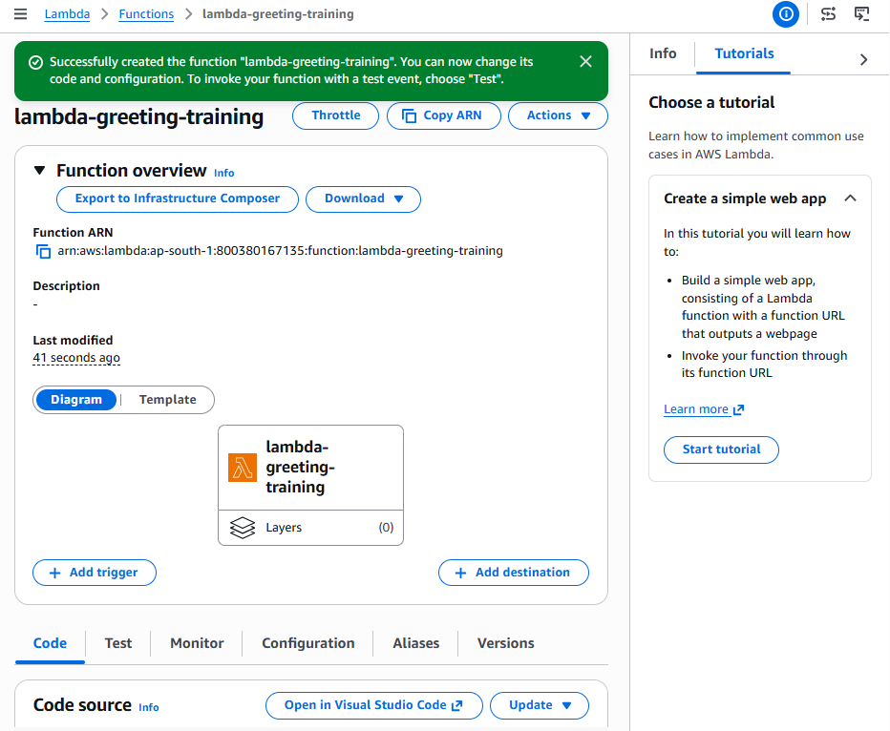
- Part B: Add the environment variable
- After the function is created:
- Open the Configuration tab.
- Select Environment variables.
- Choose Edit.
- Choose Add environment variable.
- Enter:
- Key: ENVIRONMENT
- Value: Dev
- Choose Save.
- Environment variables allow the same code to use different configuration for dev, test and production.
- Do not store plaintext passwords or API secrets in ordinary environment variables. Use Secrets Manager or another suitable secret-management system.
- 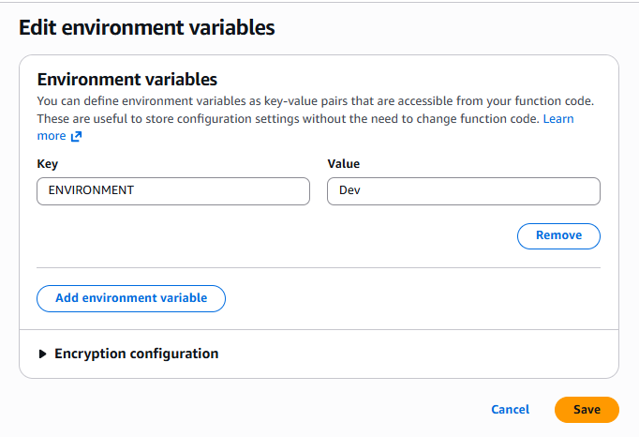
- Part C: Add the Python code
- Step 4: Open the code editor
- Select the Code tab.
- Open:
- lambda_function.py
- Delete the existing code.
- Paste:
- import json
- import logging
- import os

- logger = logging.getLogger()
- logger.setLevel(logging.INFO)

- ENVIRONMENT = os.environ.get("ENVIRONMENT", "Unknown")

- def lambda_handler(event, context):
- logger.info(
- "Invocation started",
- extra={
- "request_id": context.aws_request_id,
- "environment": ENVIRONMENT
- }
- )

- name = event.get("name")

- if not name:
- logger.warning("Validation failed: name was not provided")

- return {
- "statusCode": 400,
- "body": json.dumps({
- "message": "The 'name' field is required.",
- "environment": ENVIRONMENT
- })
- }

- message = f"Hello {name} from {ENVIRONMENT} environment"

- logger.info("Greeting created for name=%s", name)

- return {
- "statusCode": 200,
- "body": json.dumps({
- "message": message,
- "requestId": context.aws_request_id
- })
- }
- Choose Deploy.
- Deploying saves the code into $LATEST.
- 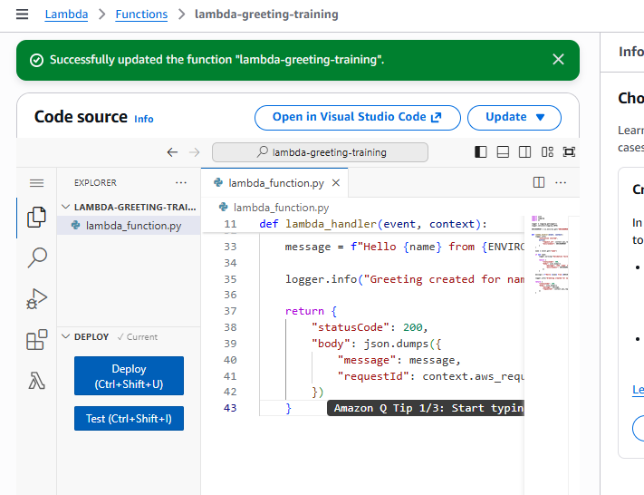
- Part D: Create a successful test event
- Step 5: Configure the event
- Choose Test or open the Test tab.
- Select:
- Create new event
- Event name:
- GreetingSuccessTest
- Event sharing:
- Private
- Event JSON:
- {
- "name": "Venu"
- }
- Choose Save, then Test.
- Expected result
- Status:
- Succeeded
- 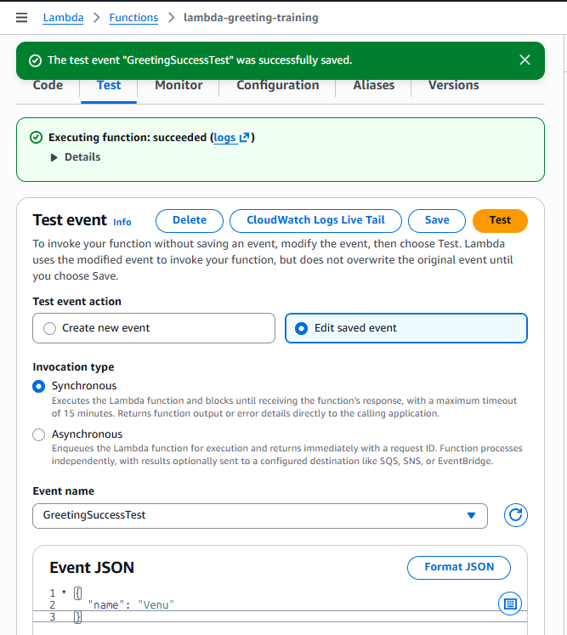
- Response:
- {
- "statusCode": 200,
- "body": "{\"message\": \"Hello Venu from Dev environment\", \"requestId\": \"...\"}"
- }
- The response body is a JSON-formatted string because this response structure is suitable for later API Gateway proxy integration.
- Expand Function Logs and confirm entries similar to:
- START RequestId: ...
- Invocation started
- Greeting created for name=Venu
- END RequestId: ...
- REPORT RequestId: ...
- The report shows:
- Duration
- Billed duration
- Configured memory
- Maximum memory used
- Request ID
- Part E: Test validation
- Step 6: Create a missing-name test
- Create another test event:
- Event name: GreetingMissingNameTest
- JSON:
- {}
- Choose Test.
- Lambda invocation status may still show:
- Succeeded
- But your function response should contain:
- {
- "statusCode": 400,
- "body": "{\"message\": \"The 'name' field is required.\", \"environment\": \"Dev\"}"
- }
- This distinction is important:
- Lambda invocation succeeded: the Python handler executed normally.
- Application response is 400: the function deliberately rejected invalid input.
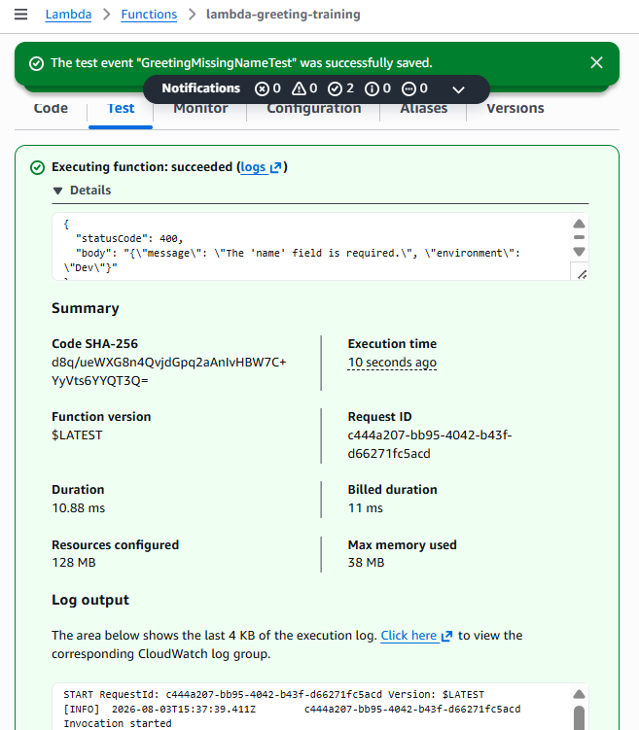
- Part F: Check CloudWatch Logs
- Step 7: Open the log group
- From the Lambda function:
- Open Monitor.
- Choose View CloudWatch logs.
- Alternatively:
- CloudWatch → Log groups → /aws/lambda/lambda-greeting-training
- Open the most recent log stream.
- Confirm the successful invocation contains:
- Greeting created for name=Venu
- Confirm the validation test contains:
- Validation failed: name was not provided
- Also identify:
- START RequestId
- END RequestId
- REPORT RequestId
- Capture this as monitoring evidence.
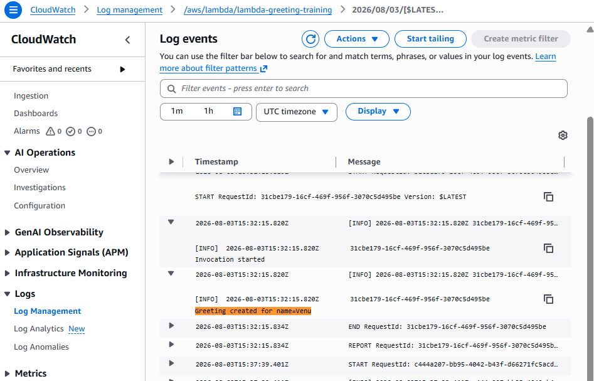
- Part G: Check Lambda metrics
- Return to:
- Lambda → lambda-greeting-training → Monitor
- Review:
- Metric | - Meaning
- Invocations | - Number of function executions
- Duration | - Execution time
- Errors | - Unhandled Lambda execution failures
- Throttles | - Invocations rejected by concurrency limits
- Concurrent executions | - Simultaneous executions
- The missing-name test should not increase the Lambda Errors metric because the function returned a controlled response instead of throwing an exception.
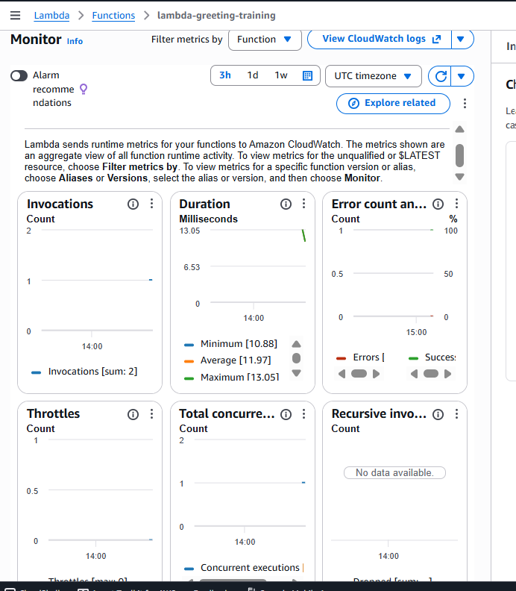
- Part H: Publish a version
- Step 8: Publish Version 1
- Open the function.
- Choose Actions.
- Select Publish new version.
- Description:
- Initial working version with greeting and validation
- Choose Publish.
- Lambda creates:
- Version 1
- A published version is an immutable snapshot of qualifying code and configuration. $LATEST remains editable. Lambda versions
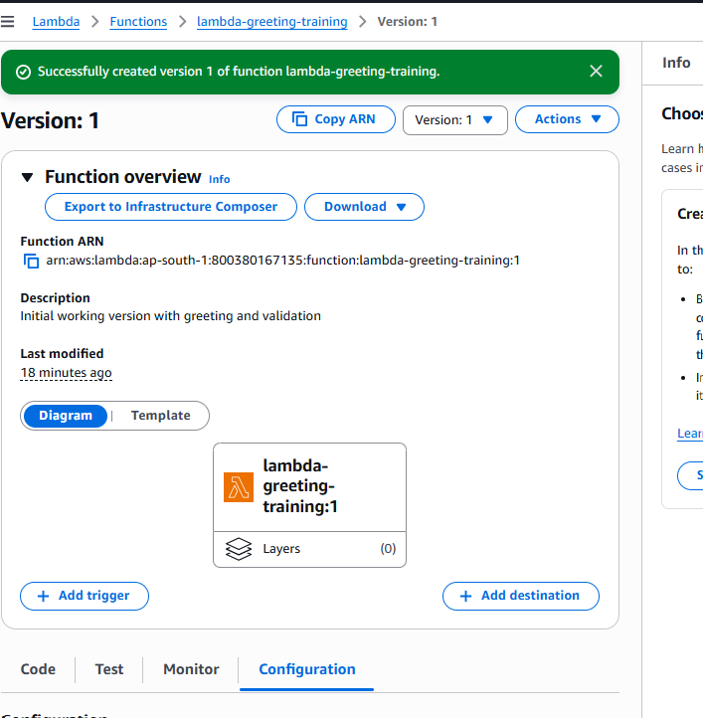
- Part I: Create the dev alias
- Step 9: Create alias
- Open the Aliases tab.
- Choose Create alias.
- Enter:
- Name: dev
- Description: Development alias
- Version: 1
- Choose Save.
- The qualified ARN will resemble:
- arn:aws:lambda:ap-south-1:800380167135:function:lambda-greeting-training:dev
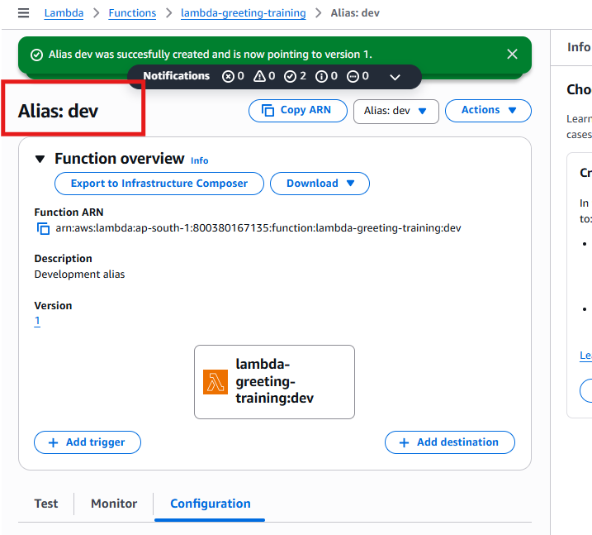
- Final verification
- Test | - Expected
- Function created | - Active
- Successful event | - statusCode: 200
- Missing name | - Controlled statusCode: 400
- Environment variable | - Output contains Dev
- CloudWatch | - Both invocations logged
- Lambda error metric | - No unhandled error
- Published version | - Version 1
- Alias | - dev → Version 1

- The Actions button is greyed out because you are on the Functions list page and no function checkbox is selected.
- However, this list-page Actions menu is not the best place to publish a version.
- Open the function
- Click the blue function name:
- lambda-greeting-training
- This opens the function details page.
- Publish Version 1
- On the function details page, use either of these locations, depending on the console layout:
- Option 1: Versions tab
- Open the Versions tab.
- Choose Publish new version.
- Description:
- Initial working version with greeting and validation
- Choose Publish.
- Option 2: Function Actions menu
- Open the function details page.
- Find Actions near the upper-right side.
- Choose Publish new version.
- Enter the description.
- Choose Publish.
- Expected result
- You should be redirected to:
- lambda-greeting-training:1
- The function ARN should end with:
- :1
- For example:
- arn:aws:lambda:ap-south-1:800380167135:function:lambda-greeting-training:1
- Do not select the checkbox on the Functions list unless you want list-level actions such as deletion. Open the function name to manage versions and aliases.
- completed
- Now create the dev alias pointing to Version 1.
- Create the dev alias
- Step 1: Return to the function
- Open:
- Lambda → Functions → lambda-greeting-training
- Do not remain inside the read-only Version 1 page if the alias controls are not visible.
- Step 2: Open Aliases
- Select the Aliases tab.
- Choose:
- Create alias
- Enter:
- Name: dev
- Description: Development alias for the greeting function
- Version: 1
- Leave weighted alias/routing configuration disabled.
- Choose Save or Create.
- Expected result
- The alias list should display:
- Alias | - Version
- dev | - 1
- The alias ARN should resemble:
- arn:aws:lambda:ap-south-1:800380167135:function:lambda-greeting-training:dev
- Optional: Test the alias using AWS CLI
- Your existing kms-app profile does not have Lambda invocation permission, so do not add Lambda permissions to that KMS-specific user.
- You can test the alias directly from the console by opening:
- Aliases → dev
- and using a test event if the interface provides that option.
- Lambda Task 1 completion checklist
- Requirement | - Status
- Function created | - Completed
- Python handler deployed | - Completed
- ENVIRONMENT=Dev | - Completed
- Successful name test | - Completed
- Missing-name validation | - Completed
- CloudWatch Logs | - Completed
- Cold/warm start observation | - Completed
- Version 1 published | - Completed
- dev alias | - Complete after saving
- After the dev alias appears and points to Version 1, Lambda Task 1 is fully complete.
- next
- Worked for 22s
- Lambda Task 2: Process S3 Uploads Automatically
- Goal
- When a .txt file is uploaded under input/, S3 invokes Lambda. Lambda counts words and characters and writes a JSON result under processed/.
- input/sample.txt
- ↓
- S3 ObjectCreated event
- ↓
- Lambda function
- ↓
- processed/sample-result.json
- ↓
- CloudWatch Logs
- Using separate prefixes prevents the generated result from invoking the function again.
- Part A: Create the S3 bucket
- Step 1: Create the bucket
- Open:
- Amazon S3 → Buckets → Create bucket
- Configure:
- Setting | - Value
- Bucket type | - General purpose
- Region | - Mumbai — ap-south-1
- Bucket name | - lambda-file-processing-800380167135-2026-venu
- Object Ownership | - ACLs disabled
- Block Public Access | - Enabled
- Versioning | - Enable
- Default encryption | - SSE-S3
- Bucket Key | - Not applicable to SSE-S3
- If the name is unavailable, add a unique suffix.
- Use standard S3 encryption for this Lambda-focused task:
- Server-side encryption with Amazon S3 managed keys (SSE-S3)
- We do not need the customer-managed KMS key here because it would add unrelated key-policy permissions to the Lambda execution role.
- Choose Create bucket.
- 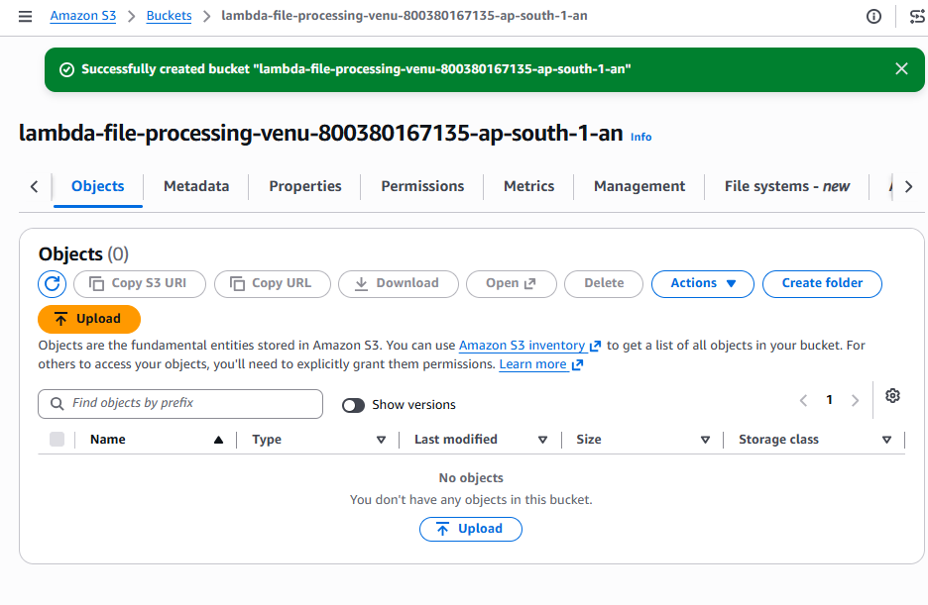
- Part B: Create the Lambda function
- Step 2: Open Lambda
- Go to:
- Lambda → Functions → Create function
- Confirm the Region is:
- ap-south-1
- The bucket and Lambda function must be in the same Region. AWS S3-trigger tutorial
- Step 3: Configure the function
- Select:
- Author from scratch
- Enter:
- Function name: lambda-s3-file-processor
- Runtime: Python 3.14
- Leave these settings unchanged:
- Setting | - Selection
- ARM64 | - Unchecked — use x86_64
- Durable execution | - Disabled
- EC2 capacity provider | - Disabled
- Custom execution role | - Unchecked
- Function URL | - Disabled
- VPC | - Disabled
- Code signing | - Disabled
- Custom KMS encryption | - Disabled
- Lambda will create a new execution role with basic CloudWatch Logs permissions.
- Choose Create function.
- Part C: Configure basic settings
- Open:
- Configuration → General configuration → Edit
- Configure:
- Description:
- Processes text files uploaded to the S3 input prefix

- Memory:
- 128 MB

- Ephemeral storage:
- 512 MB

- Timeout:
- 30 seconds

- SnapStart:
- None
- Choose Save.
- Thirty seconds provides enough time to retrieve and process small training files. This task is not designed for large objects.
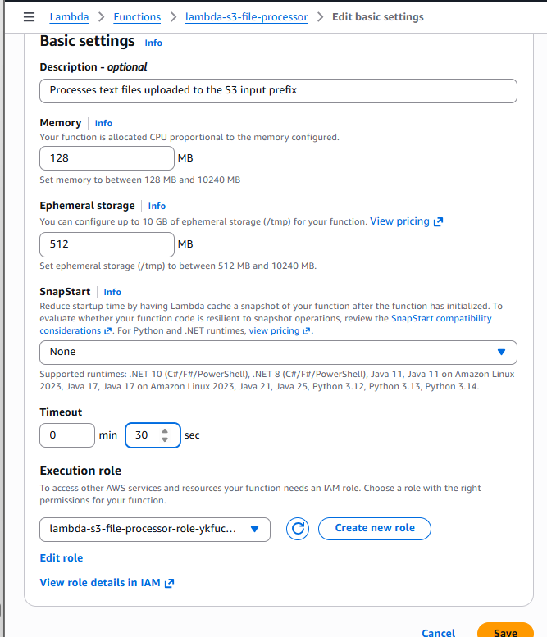

- Part D: Give Lambda S3 permissions
- Step 4: Open the execution role
- Go to:
- Configuration → Permissions
- Under Execution role, click the role name. It should resemble:
- lambda-s3-file-processor-role-xxxxxxxx
- IAM opens in a new tab.
- Choose:
- Add permissions → Create inline policy → JSON
- Paste:
- {
- "Version": "2012-10-17",
- "Statement": [
- {
- "Sid": "ReadInputTextFiles",
- "Effect": "Allow",
- "Action": [
- "s3:GetObject"
- ],
- "Resource": "arn:aws:s3:::lambda-file-processing-800380167135-2026-venu/input/*"
- },
- {
- "Sid": "WriteProcessedResults",
- "Effect": "Allow",
- "Action": [
- "s3:PutObject"
- ],
- "Resource": "arn:aws:s3:::lambda-file-processing-800380167135-2026-venu/processed/*"
- }
- ]
- }
- If your actual bucket name differs, replace it in both ARNs.
- Choose Next.
- Policy name:
- LambdaS3FileProcessorPolicy
- Choose Create policy.
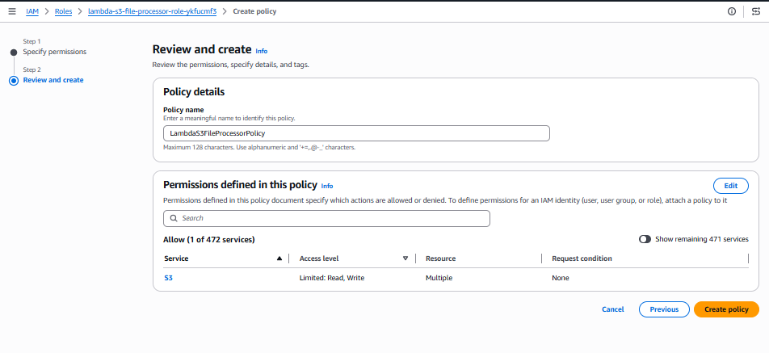
- Permission explanation
- The function can:
- Read objects only from input/.
- Write objects only to processed/.
- Write logs through its basic execution-role policy.
- The function cannot:
- Read unrelated bucket prefixes.
- Delete S3 objects.
- Make objects public.
- Manage the bucket.
- Access other buckets.
- Return to the Lambda function after creating the policy. The next step is deploying the Python file-processing code.
- Part E: Deploy the file-processing code
- Step 1: Return to Lambda
- Return to:
- Lambda → Functions → lambda-s3-file-processor
- Open the Code tab and select:
- lambda_function.py
- Delete the existing code and paste:
- import json
- import logging
- import os
- import urllib.parse

- import boto3

- logger = logging.getLogger()
- logger.setLevel(logging.INFO)

- s3 = boto3.client("s3")

- def lambda_handler(event, context):
- logger.info("Received S3 event: %s", json.dumps(event))

- processed_files = []

- for record in event.get("Records", []):
- bucket = record["s3"]["bucket"]["name"]

- encoded_key = record["s3"]["object"]["key"]
- key = urllib.parse.unquote_plus(encoded_key)

- logger.info("Processing s3://%s/%s", bucket, key)

- # Extra protection in addition to the trigger filters
- if not key.startswith("input/"):
- logger.warning("Skipped object outside input prefix: %s", key)
- continue

- if not key.lower().endswith(".txt"):
- logger.warning("Skipped unsupported file type: %s", key)
- continue

- response = s3.get_object(
- Bucket=bucket,
- Key=key
- )

- file_bytes = response["Body"].read()
- text = file_bytes.decode("utf-8")

- character_count = len(text)
- word_count = len(text.split())
- line_count = len(text.splitlines())

- source_filename = os.path.basename(key)
- filename_without_extension = os.path.splitext(source_filename)[0]

- output_key = (
- f"processed/{filename_without_extension}-result.json"
- )

- result = {
- "sourceBucket": bucket,
- "sourceKey": key,
- "characterCount": character_count,
- "wordCount": word_count,
- "lineCount": line_count,
- "requestId": context.aws_request_id
- }

- s3.put_object(
- Bucket=bucket,
- Key=output_key,
- Body=json.dumps(result, indent=2),
- ContentType="application/json"
- )

- logger.info(
- "Processed %s: words=%s, characters=%s, lines=%s",
- key,
- word_count,
- character_count,
- line_count
- )

- logger.info(
- "Result written to s3://%s/%s",
- bucket,
- output_key
- )

- processed_files.append(result)

- return {
- "statusCode": 200,
- "processedFiles": processed_files
- }
- Choose Deploy.
- 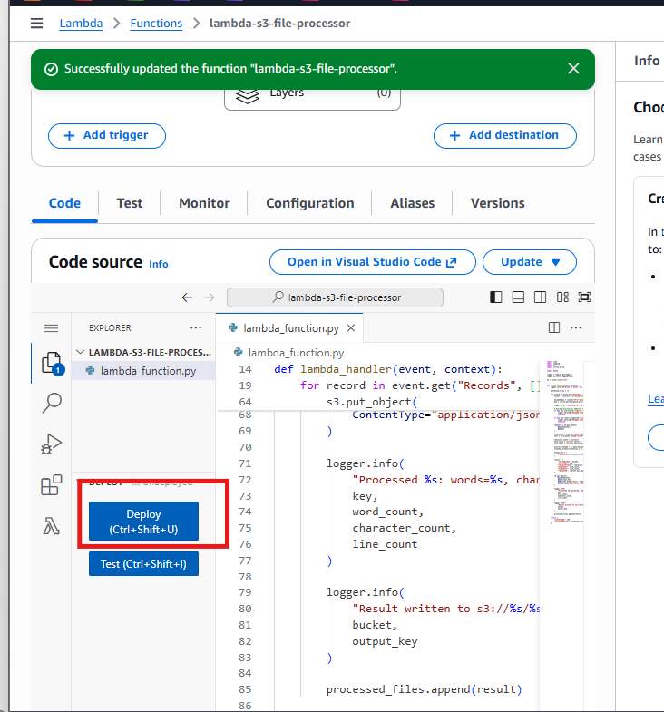
- What this code does
- Receives the S3 event.
- Reads the bucket and object key.
- Decodes spaces and special characters in the key.
- Accepts only input/*.txt.
- Downloads the file using s3:GetObject.
- Counts characters, words and lines.
- Writes a JSON result under processed/.
- Logs the operation in CloudWatch.
- Using a deterministic output name such as:
- processed/sample-result.json
- also makes repeated S3 event delivery safer because a duplicate event overwrites the same result instead of creating many different outputs.
- Part F: Add the S3 trigger
- Step 2: Add trigger
- At the top of the Lambda function page, under Function overview, choose:
- Add trigger
- Select:
- S3
- Configure:
- Bucket:
- lambda-file-processing-venu-800380167135-ap-south-1-an

- Event type:
- All object create events

- Prefix:
- input/

- Suffix:
- .txt
- Enable the recursive-invocation acknowledgment if the console requires it.
- We are safely preventing recursion because:
- Trigger reads: input/*.txt
- Lambda writes: processed/*.json
- The generated output does not match the trigger prefix or suffix.
- Choose Add.
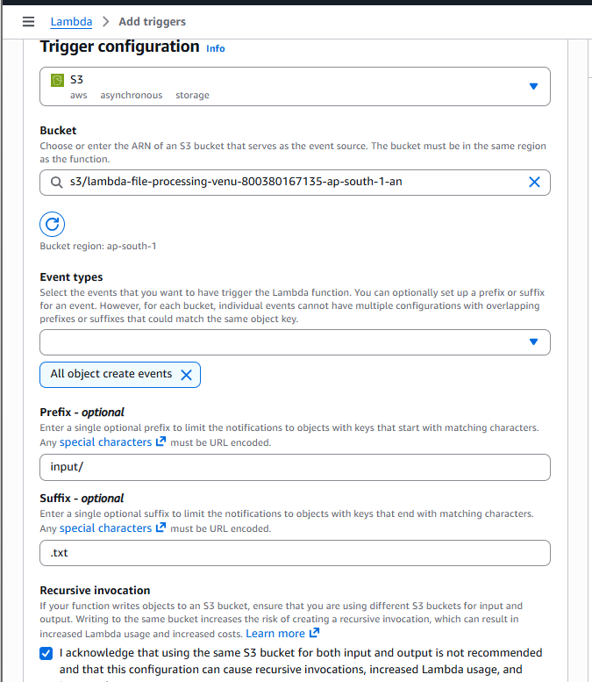
- The Lambda console automatically adds a resource-based permission allowing this specific S3 bucket to invoke the function.
- Verify the trigger
- Under Function overview, you should see:
- S3 → lambda-s3-file-processor
- Open:
- Configuration → Triggers
- Confirm:
- Setting | - Expected
- Trigger | - S3
- Event | - ObjectCreated
- Prefix | - input/
- Suffix | - .txt
- Status | - Enabled
- Do not upload the file until the trigger is visible and enabled.

- Test the S3 trigger
- Step 1: Create a sample file
- In Git Bash, run:
- printf "AWS Lambda processes files automatically.\nThis is an event-driven S3 demonstration.\nHello Venu.\n" > sample.txt
- Verify:
- cat sample.txt
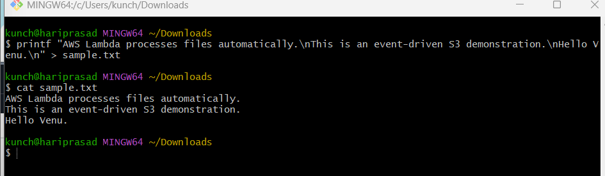
- Step 2: Create the input folder
- Open:
- S3 → lambda-file-processing-venu-800380167135-ap-south-1-an
- Choose:
- Create folder
- Folder name:
- input
- Choose Create folder.
- The object-key prefix becomes:
- input/
- Step 3: Upload the file
- Open the input folder.
- Choose Upload.
- Choose Add files.
- Select sample.txt from Downloads.
- Choose Upload.
- The complete S3 object key must be:
- input/sample.txt
- Uploading sample.txt to the bucket root will not invoke the function because it does not match the input/ prefix.
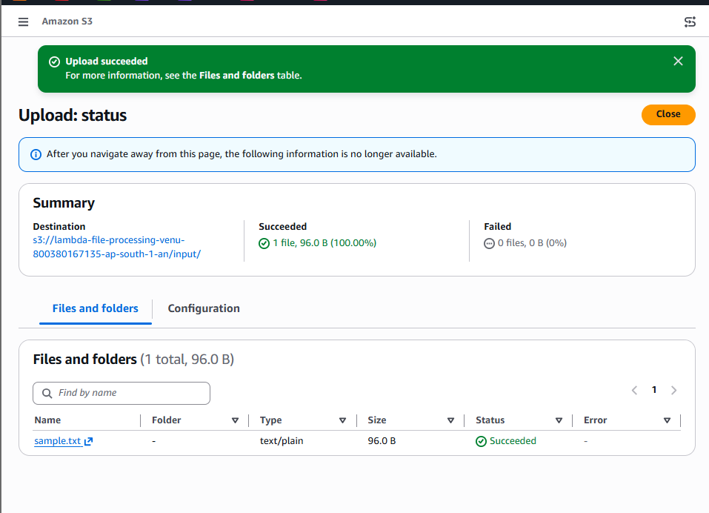
- Verify the output
- Wait approximately 5–15 seconds, then return to the bucket root and refresh.
- You should see:
- input/
- processed/
- Open:
- processed/
- Expected object:
- sample-result.json
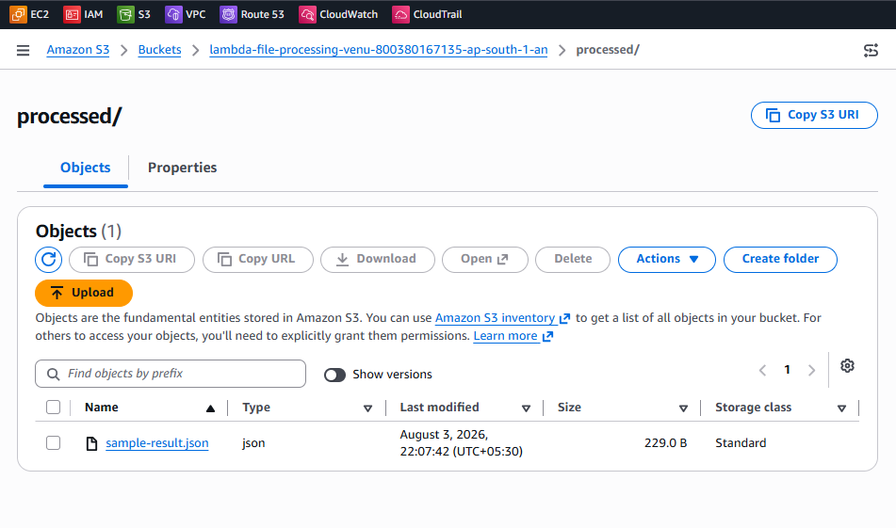
- Open or download the result. It should resemble:
- {
- "sourceBucket": "lambda-file-processing-venu-800380167135-ap-south-1-an",
- "sourceKey": "input/sample.txt",
- "characterCount": 98,
- "wordCount": 13,
- "lineCount": 3,
- "requestId": "..."
- }
- Exact character count may vary slightly depending on newline formatting.
- 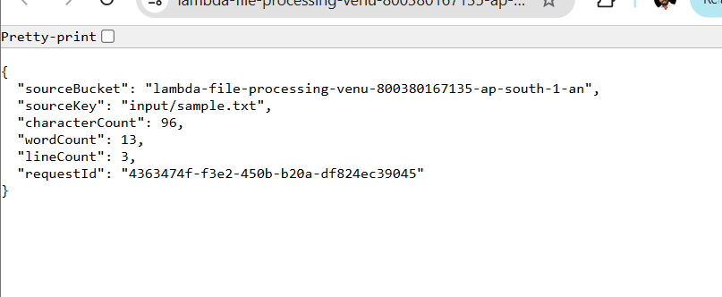
- Verify CloudWatch Logs
- Open:
- CloudWatch → Log groups → /aws/lambda/lambda-s3-file-processor
- Open the newest log stream.
- Confirm:
- Processing s3://lambda-file-processing-venu-800380167135-ap-south-1-an/input/sample.txt
- Processed input/sample.txt
- Result written to s3://lambda-file-processing-venu-800380167135-ap-south-1-an/processed/sample-result.json
- If processed/sample-result.json appears, the S3 trigger, IAM permissions, Lambda code and output processing are all working correctly.
