Task 1: Create an IAM user and assign EC2 & S3 full access
Console Steps
- Go to IAM → Users → Create user
- User name: cloudadmin
- Enable AWS Management Console access
- Set a password
- Click Next
- Choose Attach policies directly
- Select:
  - AmazonEC2FullAccess
  - AmazonS3FullAccess
- Create user
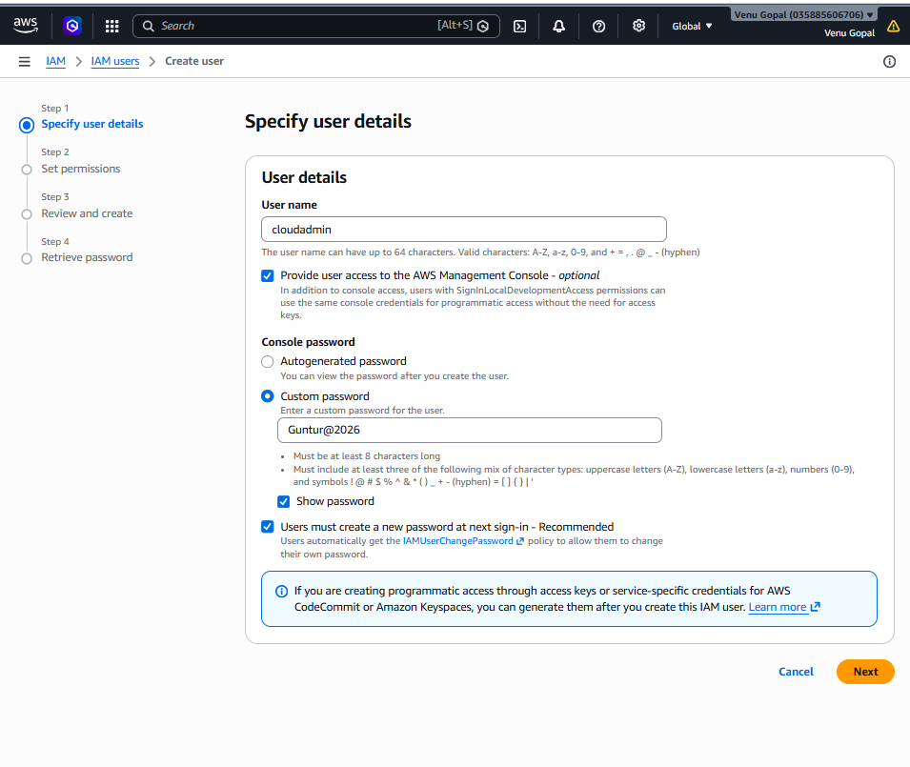
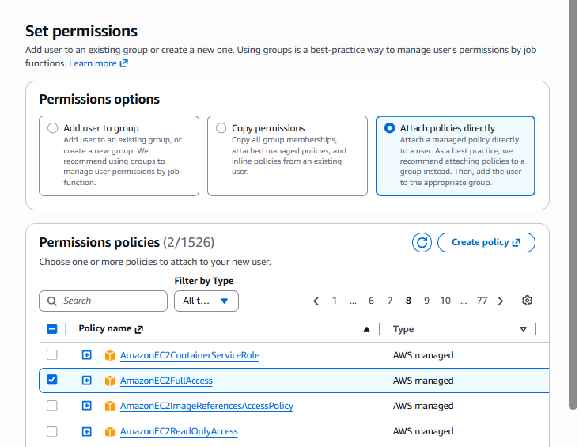
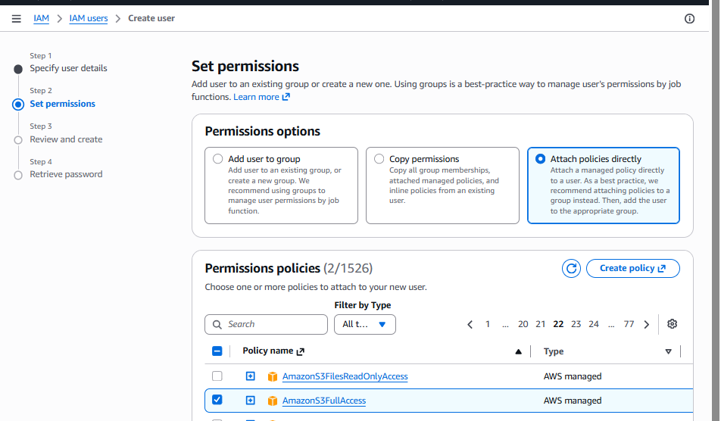
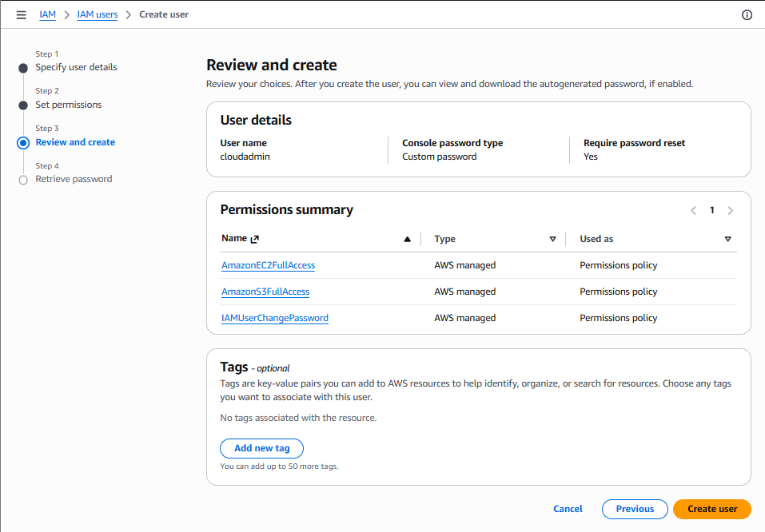

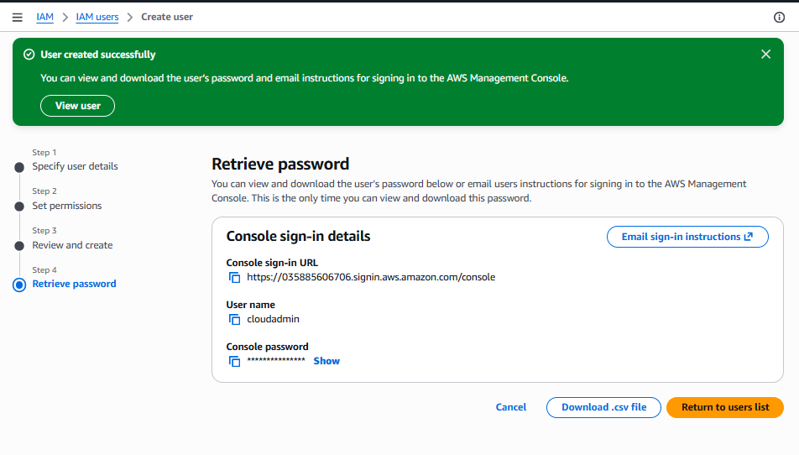
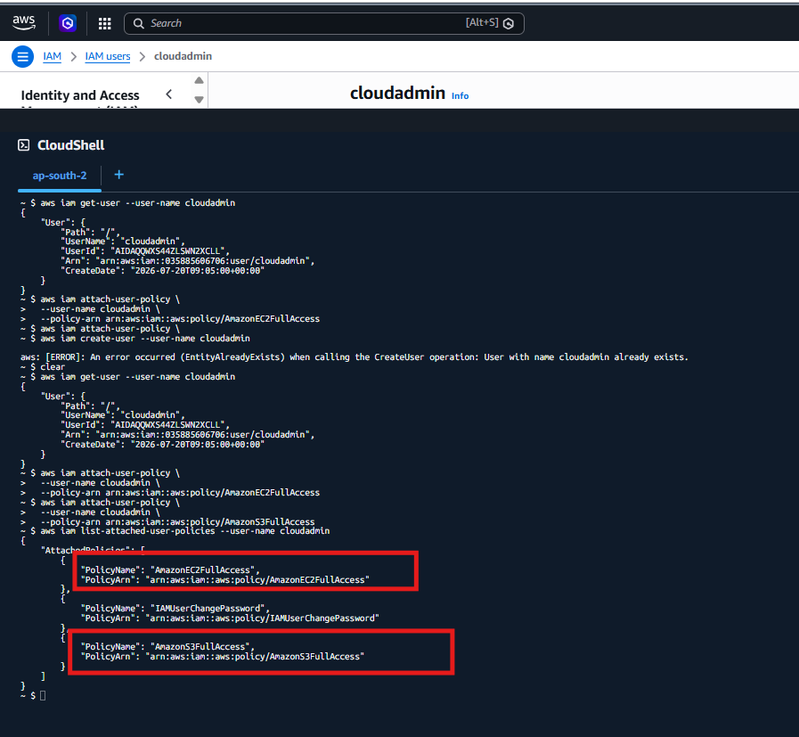

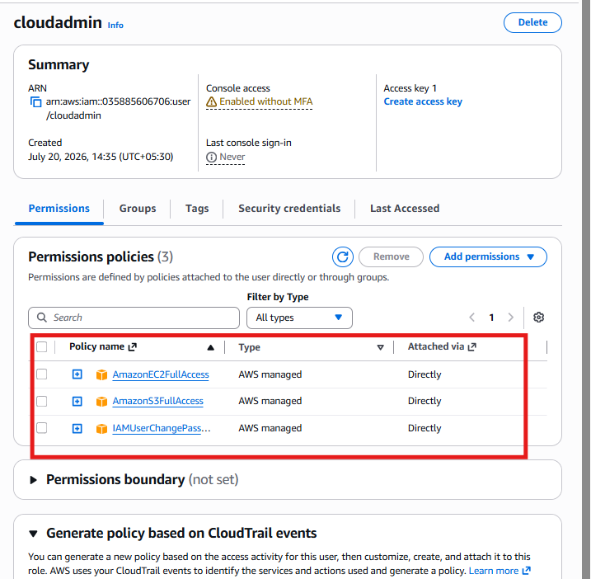

✅ Console password self-service (IAMUserChangePassword)

Why is it there?
When an IAM user is created with AWS Management Console access (a password), AWS often attaches the managed policy:
IAMUserChangePassword
This policy allows the user to:
- Sign in to the AWS Console
- Change their own password
- View their own account password policy
It does not give administrative access.
Task 2: Create an IAM Group and assign EC2 Read-Only access
Step 1: Create the group
Run this command in CloudShell:
aws iam create-group --group-name EC2-ReadOnly-Group
Expected output
{
"Group": {
"Path": "/",
"GroupName": "EC2-ReadOnly-Group",
"GroupId": "AGPAxxxxxxxxxxxx",
"Arn": "arn:aws:iam::123456789012:group/EC2-ReadOnly-Group",
"CreateDate": "2026-07-20T08:30:00+00:00"
}
}
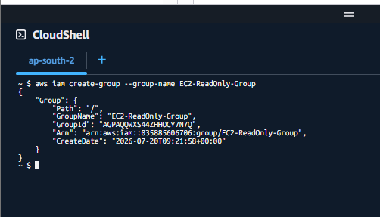
Step 2: Attach EC2 Read-Only policy
Run:
aws iam attach-group-policy \
--group-name EC2-ReadOnly-Group \
--policy-arn arn:aws:iam::aws:policy/AmazonEC2ReadOnlyAccess
No output means success.
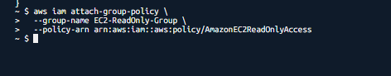
Step 3: Verify the policy is attached
Run:
aws iam list-attached-group-policies \
--group-name EC2-ReadOnly-Group
Expected output
{
"AttachedPolicies": [
{
"PolicyName": "AmazonEC2ReadOnlyAccess",
"PolicyArn": "arn:aws:iam::aws:policy/AmazonEC2ReadOnlyAccess"
}
]
}
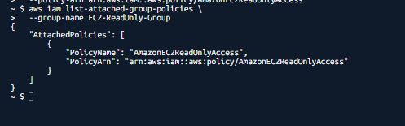
What does this policy allow?
Users in this group can:
- View EC2 instances
- View security groups
- View EBS volumes
- View snapshots
- View route tables and networking details
They cannot:
- Launch instances
- Stop/start instances
- Terminate instances
- Modify security groups
This follows the least privilege principle.
Console verification (take screenshot)
Go to:
IAM → User groups → EC2-ReadOnly-Group → Permissions
You should see:
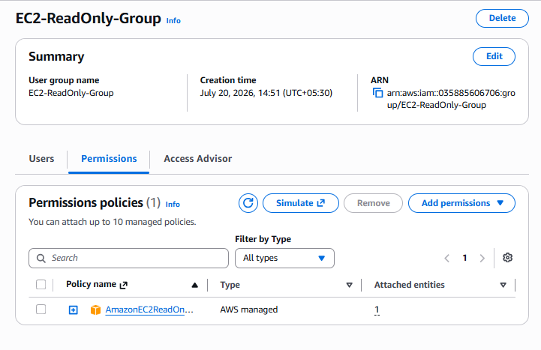
Interview explanation (30 seconds)
I created an IAM group named EC2-ReadOnly-Group and attached the AWS managed policy AmazonEC2ReadOnlyAccess. This allows users in the group to view EC2 resources without making any changes, which is useful for auditors, support teams, or monitoring users.

Task 3: Create user Devops
Run:
aws iam create-user --user-name Devops
If you get EntityAlreadyExists, that’s fine — we’ll use the existing user.
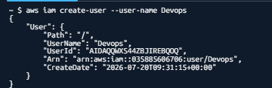
Add the user to the group
aws iam add-user-to-group \
--user-name Devops \
--group-name EC2-ReadOnly-Group
No output means success.
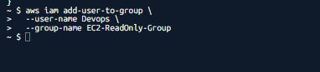
Verify the user is in the group
aws iam get-group --group-name EC2-ReadOnly-Group
You should see:
{
"Users": [
{
"UserName": "Devops"
}
]
}
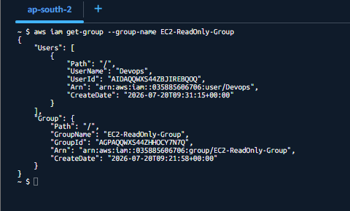
Console check
Go to:
IAM → User groups → EC2-ReadOnly-Group → Users
You should see Devops listed there.
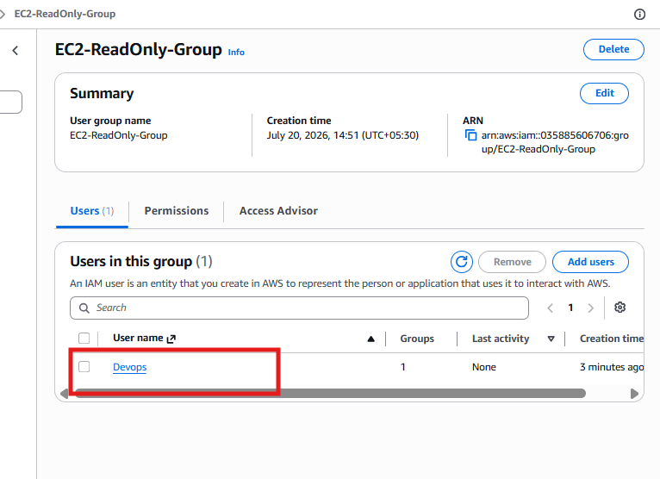
Interview explanation
I created an IAM user named Devops and added it to the EC2-ReadOnly-Group. The user inherits permissions from the group, which is the recommended approach because permissions are managed centrally and can be reused for multiple users.

Task 4 – Write a bash script to create an IAM user with VPC full access.
Step 1: Create the script file
Run:
nano create_vpc_user.sh
Step 2: Paste this script
#!/bin/bash

# Script to create an IAM user with VPC Full Access

USERNAME=$1

# Check if username is provided
if [ -z "$USERNAME" ]; then
echo "Usage: $0 <username>"
exit 1
fi

echo "Creating IAM user: $USERNAME"

# Create IAM user
aws iam create-user --user-name $USERNAME

# Attach VPC Full Access policy
echo "Attaching AmazonVPCFullAccess policy..."

aws iam attach-user-policy \
--user-name $USERNAME \
--policy-arn arn:aws:iam::aws:policy/AmazonVPCFullAccess

echo "User $USERNAME created successfully with VPC Full Access"
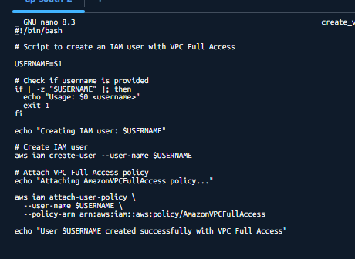
Step 3: Save and exit
- Press Ctrl + O → Enter
- Press Ctrl + X
Step 4: Make the script executable
Run:
chmod +x create_vpc_user.sh
Step 5: Execute the script
Example:
./create_vpc_user.sh networkadmin
Expected output
Creating IAM user: networkadmin
Attaching AmazonVPCFullAccess policy...
User networkadmin created successfully with VPC Full Access
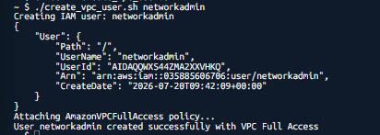

Step 6: Verify the policy
Run:
aws iam list-attached-user-policies --user-name networkadmin
You should see:
{
"AttachedPolicies": [
{
"PolicyName": "AmazonVPCFullAccess",
"PolicyArn": "arn:aws:iam::aws:policy/AmazonVPCFullAccess"
}
]
}
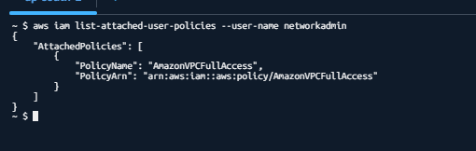
What each line means
Line | Purpose
#!/bin/bash | Run script using Bash shell
USERNAME=$1 | Read username from command argument
if [ -z "$USERNAME" ] | Check if username is empty
aws iam create-user | Create IAM user
aws iam attach-user-policy | Attach VPC full access policy

Interview explanation (1 minute)
I wrote a reusable Bash script that accepts a username as a command-line argument, validates the input, creates the IAM user, and attaches the AmazonVPCFullAccess managed policy. This demonstrates Bash scripting, input validation, and AWS CLI automation, which are common DevOps tasks.

Task 5: Create an IAM policy to allow EC2 access only in specific AWS Regions.
This is a very important interview question because companies often restrict users to approved regions (for compliance and cost control).
Goal
Allow EC2 access only in:
- Mumbai → ap-south-1
- Hyderabad → ap-south-2
Deny EC2 access in all other regions.
Step 1: Create the policy JSON file
Open a file:
nano ec2-region-policy.json
Paste this JSON:
{
"Version": "2012-10-17",
"Statement": [
{
"Sid": "AllowEC2InApprovedRegions",
"Effect": "Allow",
"Action": "ec2:*",
"Resource": "*",
"Condition": {
"StringEquals": {
"aws:RequestedRegion": [
"ap-south-1",
"ap-south-2"
]
}
}
},
{
"Sid": "DenyEC2InOtherRegions",
"Effect": "Deny",
"Action": "ec2:*",
"Resource": "*",
"Condition": {
"StringNotEquals": {
"aws:RequestedRegion": [
"ap-south-1",
"ap-south-2"
]
}
}
}
]
}
Save and exit:
- Ctrl + O → Enter
- Ctrl + X
Step 2: Create the IAM policy
Run:
aws iam create-policy \
--policy-name EC2-Region-Restricted \
--policy-document file://ec2-region-policy.json
Expected output
{
"Policy": {
"PolicyName": "EC2-Region-Restricted",
"Arn": "arn:aws:iam::035885606706:policy/EC2-Region-Restricted"
}
}
⚠️ Copy the ARN from the output.

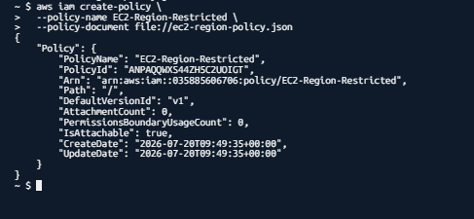
“Arn": "arn:aws:iam::035885606706:policy/EC2-Region-Restricted"
Step 3: Attach the policy to the Devops user
Use your account ID (035885606706):
aws iam attach-user-policy \
--user-name Devops \
--policy-arn arn:aws:iam::035885606706:policy/EC2-Region-Restricted
No output means success.
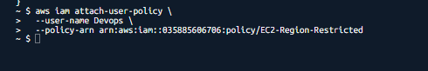
Step 4: Verify the policy is attached
Run:
aws iam list-attached-user-policies --user-name Devops
You should see:
AmazonEC2ReadOnlyAccess
EC2-Region-Restricted
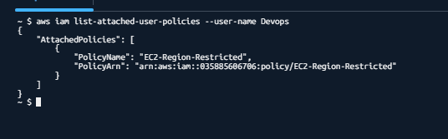
How this policy works
Allow statement
"StringEquals": {
"aws:RequestedRegion": [
"ap-south-1",
"ap-south-2"
]
}
Allows EC2 actions only in Mumbai and Hyderabad.
Deny statement
"StringNotEquals": {
"aws:RequestedRegion": [
"ap-south-1",
"ap-south-2"
]
}
Explicitly denies EC2 actions in every other region.
Explicit Deny always overrides Allow.
Real-world example
Imagine a company operates only in India:
- Mumbai → Production
- Hyderabad → Disaster Recovery
They block regions like:
- us-east-1 (Virginia)
- eu-west-1 (Ireland)
- ap-southeast-1 (Singapore)
This prevents accidental resource creation and helps with compliance.
Console verification
Go to:
IAM → Users → Devops → Permissions
You should see:
- AmazonEC2ReadOnlyAccess
- EC2-Region-Restricted
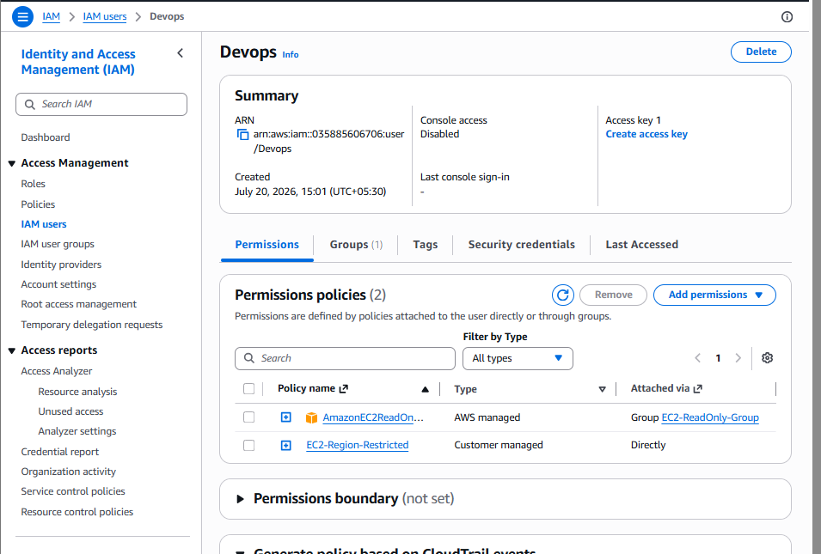
Interview explanation (1 minute)
I created a custom IAM policy using the aws:RequestedRegion condition key. The policy allows EC2 actions only in ap-south-1 and ap-south-2 and explicitly denies EC2 actions in all other regions. This is commonly used for compliance, governance, and cost-control requirements.

Policy | Attached via
AmazonEC2ReadOnlyAccess | Group (EC2-ReadOnly-Group)
EC2-Region-Restricted | Directly to user
This is exactly the expected setup.
What this means
Inherited from Group
- Devops can view EC2 resources.
- Cannot create, stop, start, or terminate instances.
Directly attached policy
- EC2 actions are allowed only in:
  - ap-south-1 (Mumbai)
  - ap-south-2 (Hyderabad)
- Access to all other regions is explicitly denied.
Console access disabled
You also noticed:
Console access: Disabled
That means:
- ❌ The user cannot log in to the AWS Console.
- ✅ The user can use the Access Key for AWS CLI or SDK access.
If you want to enable console login later:
Console method
IAM → Users → Devops → Security credentials → Assign console access
CLI method
aws iam create-login-profile \
--user-name Devops \
--password 'Welcome@123' \
--password-reset-required
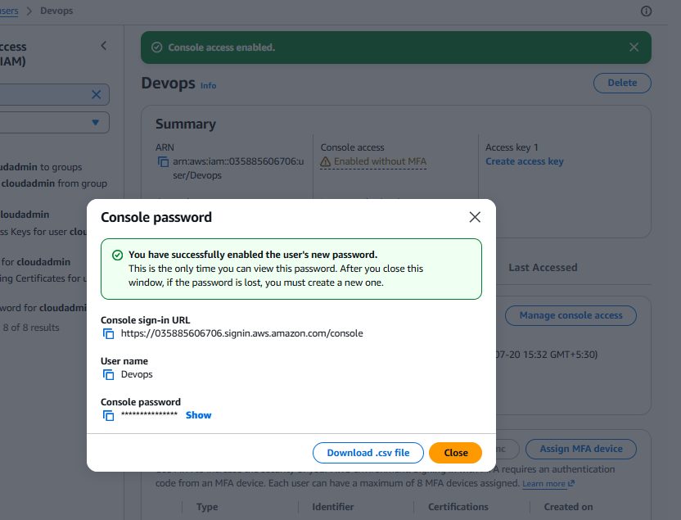
Interview explanation (very important)
Q: Why attach one policy through a group and another directly to the user?
Answer
I attached AmazonEC2ReadOnlyAccess through the group because it is a common permission that can be reused for multiple users. I attached the EC2-Region-Restricted policy directly to the Devops user because it is a user-specific restriction. This follows the principle of centralized permission management with additional fine-grained controls where needed.

Task 6- We have two accounts: Account A and Account B. Account A user should access an S3 bucket in Account B.
Scenario
Account | Purpose
Account A | Contains IAM user dev-user
Account B | Owns S3 bucket team-shared-bucket-demo
Goal:
User dev-user in Account A should be able to list, upload, and download objects from the S3 bucket in Account B.
Architecture
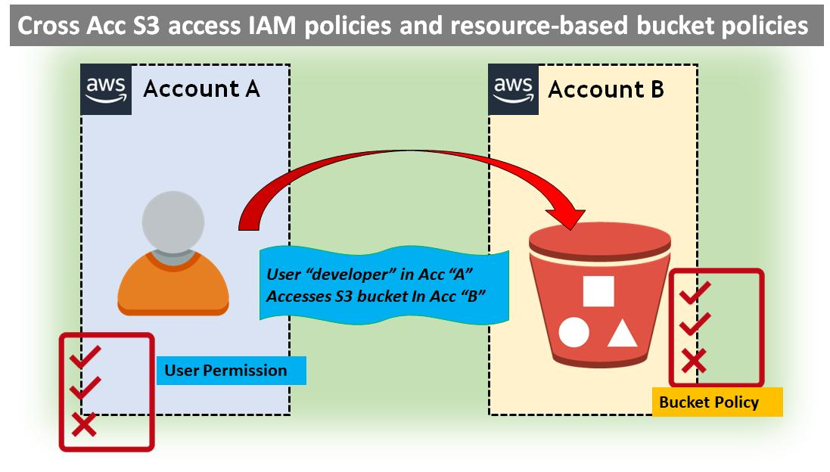
Step 1: Create IAM User in Account A
Login to Account A
Go to IAM → Users → Create user
User details
- User name: dev-user
- Check Provide user access to the AWS Management Console (optional)
- Set a password
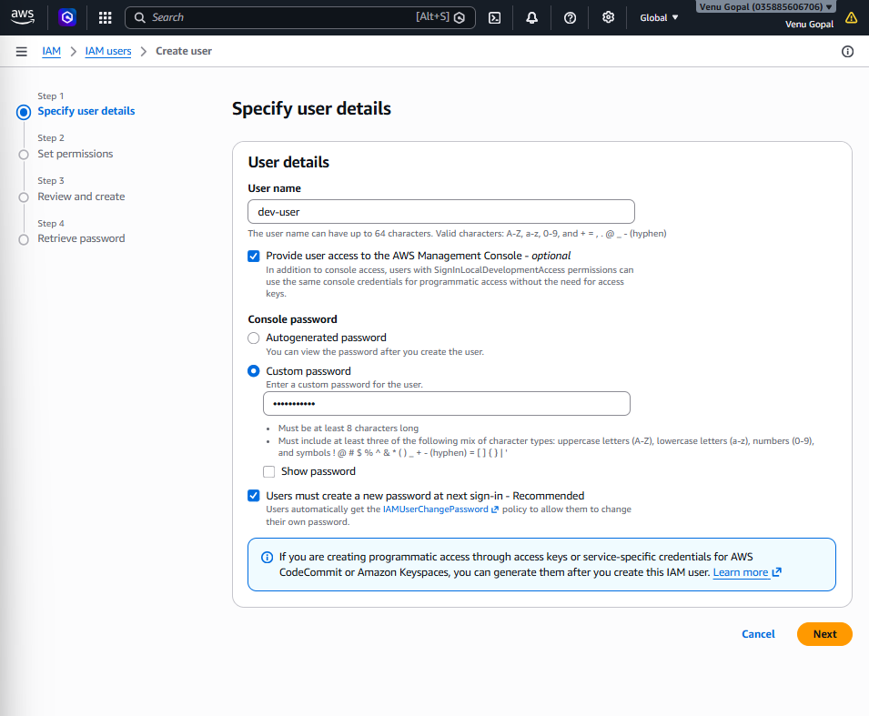
Click Next.
Attach S3 policy
Choose Attach policies directly and select:
- AmazonS3FullAccess (for lab purposes)
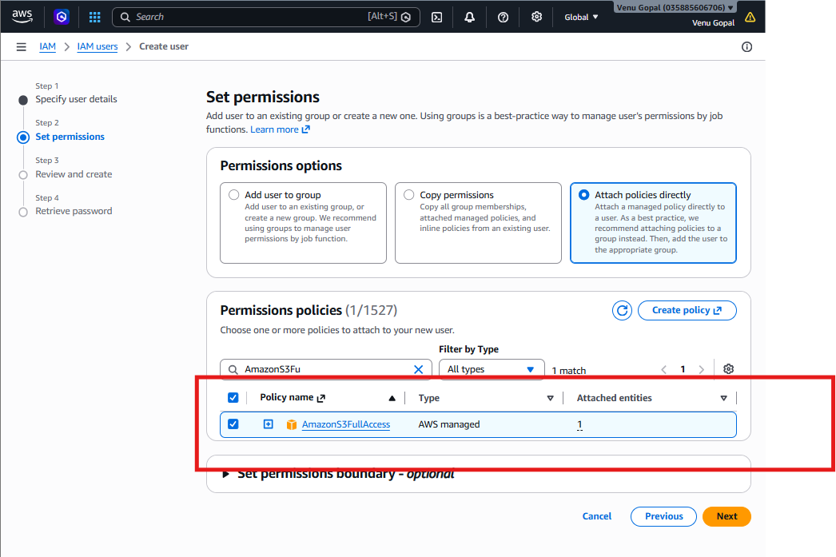

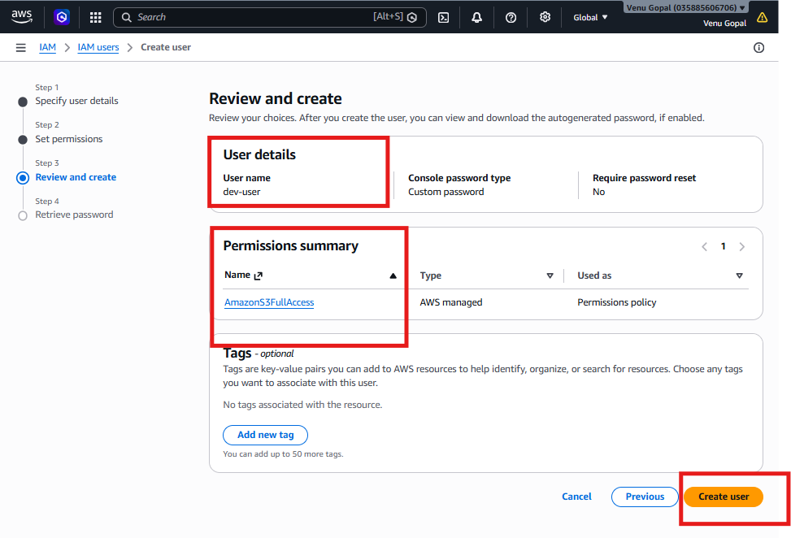
Click Create user.
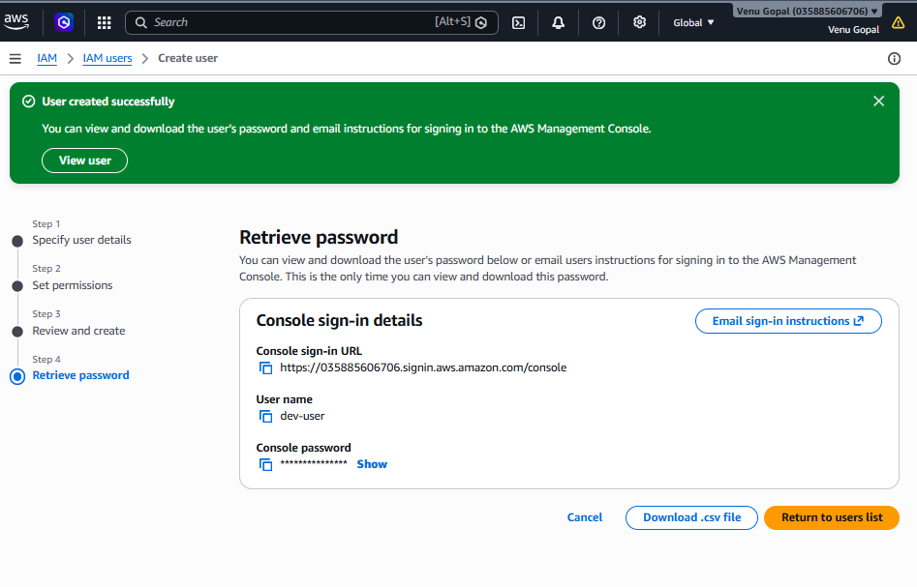
Step 2: Create Access Key for dev-user
Open the user dev-user.
Go to Security credentials → Create access key.
Choose:
- Command Line Interface (CLI)
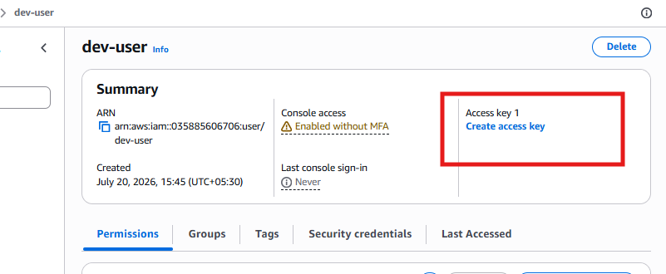
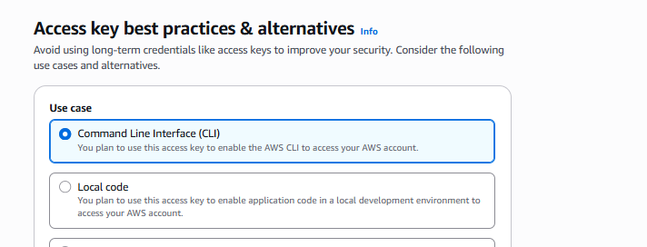

Download or copy:
- Access Key ID
- Secret Access Key
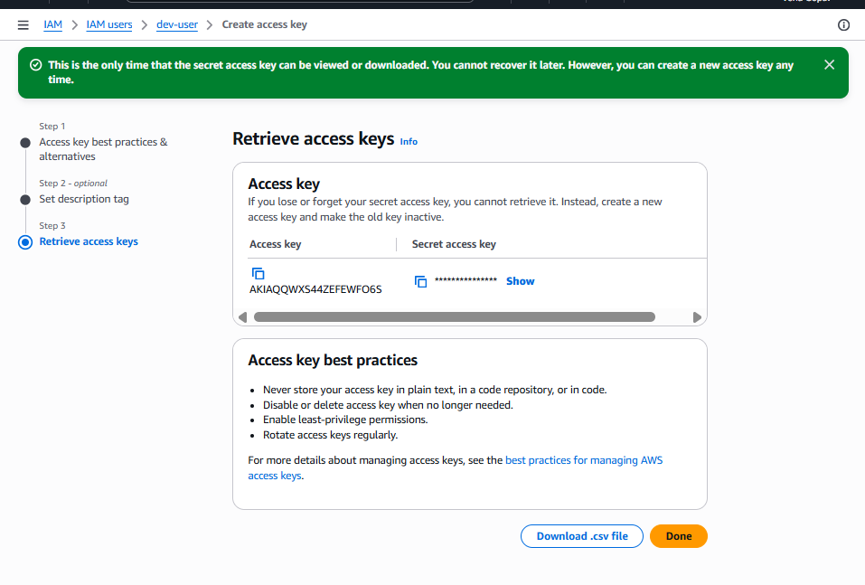
⚠️ Save them safely.
Step 3: Configure AWS CLI with Account A credentials
Open CloudShell or your terminal and run:
aws configure
Enter:
AWS Access Key ID: AKIA...
AWS Secret Access Key: xxxxxxxxx
Default region name: ap-south-1
Default output format: json
Verify:
aws sts get-caller-identity
You should see Account A ID.
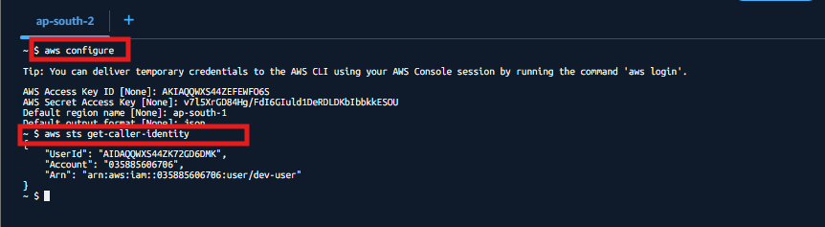

Step 4: Login to Account B
Now sign in to Account B (bucket owner account).
Step 5: Create S3 Bucket in Account B
Go to S3 → Create bucket.
Bucket settings
- Bucket name: team-shared-bucket-demo-12345 (must be globally unique)
- Region: ap-south-1
- Keep default settings
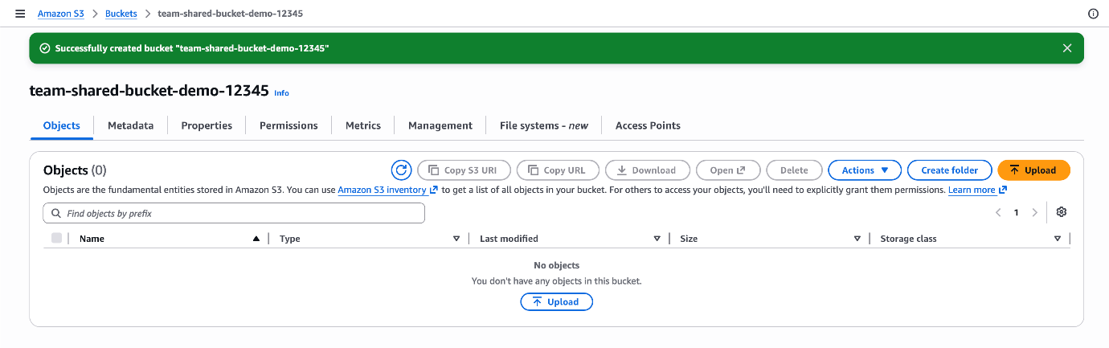
Click Create bucket.
Step 6: Add Bucket Policy in Account B
Open the bucket:
Permissions → Bucket policy → Edit
Paste this policy.
Replace ACCOUNT-A-ID
Example: 111111111111
{
"Version": "2012-10-17",
"Statement": [
{
"Sid": "AllowAccountADevUser",
"Effect": "Allow",
"Principal": {
"AWS": "arn:aws:iam::ACCOUNT-A-ID:user/dev-user"
},
"Action": [
"s3:ListBucket",
"s3:GetObject",
"s3:PutObject"
],
"Resource": [
"arn:aws:s3:::team-shared-bucket-demo-12345",
"arn:aws:s3:::team-shared-bucket-demo-12345/*"
]
}
]
}
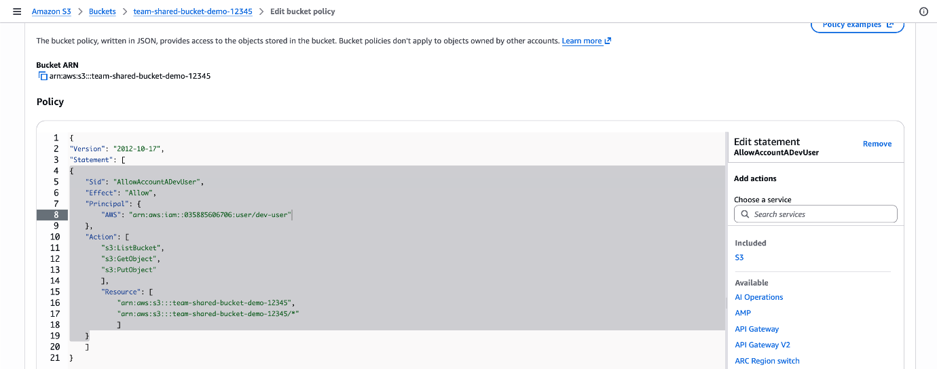
Click Save changes.

Step 7: Test Access from Account A
Switch back to the terminal configured with dev-user credentials.
List the bucket
aws s3 ls s3://team-shared-bucket-demo-12345
Expected:
(empty output or object list)
If you can list the bucket, the policy is working.

Step 8: Upload a File
Create a test file:
echo "Hello from Account A" > test.txt
Upload it:
aws s3 cp test.txt s3://team-shared-bucket-demo-12345
Expected output:
upload: ./test.txt to s3://team-shared-bucket-demo-12345/test.txt
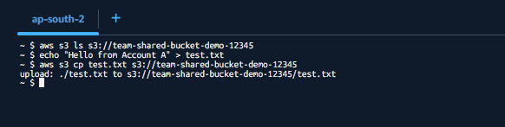

Step 9: Verify in Account B
Go to S3 → team-shared-bucket-demo-12345 → Objects
You should see:
- test.txt
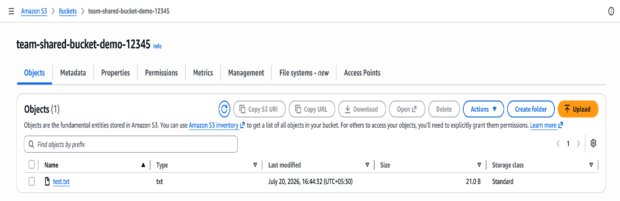
Step 10: Download the File from Account A

To download file from Account A:
Step-by-step
Step 1: Verify you are using Account A credentials
Run:
aws sts get-caller-identity
You should see Account A ID in the output.
Example:
{
"UserId": "AIDA....",
"Account": "111111111111",
"Arn": "arn:aws:iam::111111111111:user/dev-user"
}
If you see Account B’s ID, reconfigure the CLI with Account A access keys.
Step 2: List the bucket contents
Replace the bucket name with your actual bucket name:
aws s3 ls s3://team-shared-bucket-demo-12345
Example output:
2026-07-20 15:20:10 21 test.txt
This confirms the user can see the object.
Step 3: Download the file
Run:
aws s3 cp s3://team-shared-bucket-demo-12345/test.txt .
What does the . mean?
- . = current directory
- The file will be downloaded to the folder where you are currently working.
Expected output
download: s3://team-shared-bucket-demo-12345/test.txt to ./test.txt
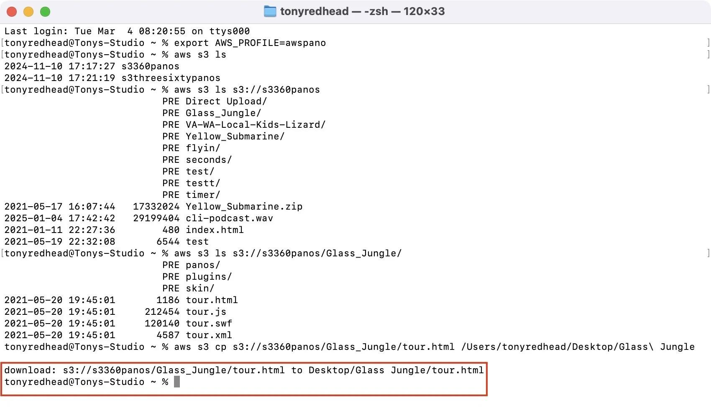
Step 4: Verify the file exists
Run:
ls -l test.txt
You should see the file listed.
Step 5: Read the file content
Run:
cat test.txt
Expected output:
Hello from Account A
Download to a specific folder (optional)
Create a folder:
mkdir downloads
Download into it:
aws s3 cp s3://team-shared-bucket-demo-12345/test.txt ./downloads/
Verify:
ls downloads

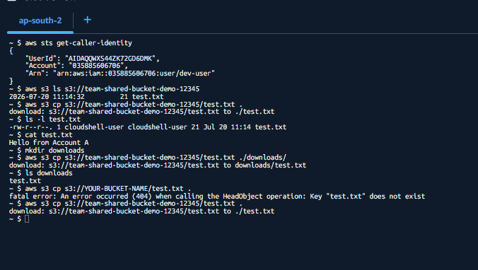
Delete the local file:
rm test.txt
Download it again:
aws s3 cp s3://team-shared-bucket-demo-12345/test.txt .
Check contents:
cat test.txt
Expected:
Hello from Account A

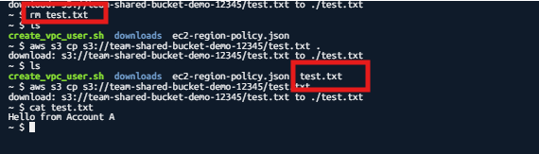
How the Permission Flow Works
Account A
IAM user policy
Account B
Bucket policy
Both policies allow the request
Access granted
Both policies must allow the action. If either side denies or does not allow it, access fails.

Interview Answer (45 seconds)
To provide cross-account S3 access, I create an IAM user in Account A and an S3 bucket in Account B. In Account B, I add a bucket policy that trusts the IAM user ARN from Account A. In Account A, I attach an IAM policy allowing ListBucket, GetObject, and PutObject on the bucket. After configuring AWS CLI with the user’s access keys, I verify access by listing the bucket and uploading/downloading objects. Cross-account S3 access requires both a resource-based policy and an identity-based policy.

