AMAZON API GATEWAY

How to Use This Handbook
Chapters 1-5 establish core API Gateway concepts. Chapters 6-14 cover integrations, security and production operations. Chapters 15-18 contain labs, infrastructure as code, troubleshooting, and interview preparation. Green callouts are short explanations for your demo.

Learning Path
Stage | Focus | Result
1. Foundation | Purpose, API types and terminology | Explain API Gateway and choose REST, HTTP or WebSocket.
2. Request flow | Routes, methods, integration, deployment and stages | Trace a request end to end.
3. Security | IAM, Cognito/JWT, Lambda authorizers, policies | Protect APIs using the correct control.
4. Production | Throttling, caching, domains, logs and WAF | Operate reliable, observable APIs.
5. Practice | Lambda, mock, private and WebSocket labs | Give an end-to-end demonstration.

Contents
- 1. What Amazon API Gateway Is
- 2. Why and When to Use It
- 3. API Types: REST, HTTP and WebSocket
- 4. Core Terminology and Request Flow
- 5. Endpoint Types and Integrations
- 6. Lambda Proxy and Non-Proxy Integrations
- 7. Deployments, Stages and Versions
- 8. Authentication and Authorization
- 9. Request Validation and Transformation
- 10. CORS, Binary Data and Responses
- 11. Throttling, Quotas, Usage Plans and Caching
- 12. Custom Domains, TLS and Route 53
- 13. Private APIs and VPC Links
- 14. Monitoring, Security and Cost
- 15. Hands-On Labs
- 16. Infrastructure as Code and CI/CD
- 17. Troubleshooting
- 18. Interview and Demo Preparation
- Appendices: Architecture, Policies, Commands, Glossary and Sources

1. What Amazon API Gateway Is
Amazon API Gateway is a managed service for creating, publishing, securing, monitoring and operating APIs. It acts as the controlled front door between clients and backends such as Lambda functions, HTTP services, AWS services, workloads behind load balancers, or WebSocket applications.
One-line interview answer: API Gateway is a managed API front door that receives client requests, applies routing, authentication, throttling and transformation, invokes a backend, and returns a controlled response.

What API Gateway manages
Capability | Purpose
Managed endpoints | TLS endpoints and request routing without managing proxy servers.
Security | IAM, JWT/Cognito, Lambda authorizers, resource policies and optional WAF controls.
Traffic control | Throttling, quotas and usage plans where supported.
Integration | Lambda, HTTP, AWS service, mock and private backend connectivity.
Transformation | Parameter mapping and VTL mapping templates for selected API types/integrations.
Operations | Deployments, stages, access logs, metrics, tracing and alarms.
Domains | Custom domain names, API mappings/base paths and ACM certificates.

What it does not replace
- Business logic belongs in Lambda or another backend.
- A database is still required for durable application data.
- API Gateway does not automatically authenticate every API; you must configure authorization.
- Throttling protects capacity but is not a complete DDoS, abuse or business-rate-control strategy.
- An API key identifies a client for usage metering; it is not strong authentication.

2. Why and When to Use It
Use case | Example
Serverless backend | Mobile app -> HTTP API -> Lambda -> DynamoDB.
Enterprise REST API | Client -> REST API -> authorizer -> VPC Link -> private ALB.
AWS service facade | REST API directly invokes Step Functions, SQS or DynamoDB using an IAM role.
WebSocket application | Chat client maintains a connection and exchanges routed messages.
Public partner API | Custom domain, authentication, throttling, usage plans, logs and WAF.
Private internal API | VPC clients reach a private REST API through interface endpoints.

When another service may fit better
- Application Load Balancer for simple HTTP routing to targets when full API-management features are unnecessary.
- CloudFront for global content delivery and caching of static/dynamic content; it can be used in front of a Regional API.
- AWS AppSync for managed GraphQL and real-time application patterns.
- Direct service SDK access when trusted clients can safely use IAM and an API facade adds no value.
- Self-managed gateways when specialized protocols, plugins or portability requirements justify the operational burden.

3. API Types: REST, HTTP and WebSocket
Type | Best for | Strengths | Important limits/choices
HTTP API | Low-cost RESTful APIs and Lambda/HTTP backends | Simpler configuration, lower price, JWT authorizers, automatic deployments/CORS options | Fewer API-management features than REST API.
REST API | Feature-rich public or private APIs | API keys, usage plans, request validation, caching, WAF support, private endpoints, transformations | More configuration and generally higher request cost.
WebSocket API | Two-way persistent communication | Routes messages over maintained connections; callback management API | Connection lifecycle/state must be stored and handled.

Decision rule: Start with HTTP API for a simple Lambda or HTTP backend. Choose REST API only when you need its additional management, validation, transformation, caching, WAF, private API or usage-plan features. Choose WebSocket for bidirectional persistent communication.

REST API endpoint types
Endpoint | Traffic path | Use
Regional | Regional endpoint; optionally place CloudFront in front | Most modern public APIs and controlled custom edge design.
Edge-optimized | API Gateway-managed CloudFront distribution | Clients distributed globally with the legacy managed edge option.
Private | Accessible through interface VPC endpoint and policies | Internal APIs with no public endpoint access.

4. Core Terminology and Request Flow
Term | Meaning
API | Top-level API Gateway resource.
Resource/path | REST API URL path, such as /orders/{id}.
Route | HTTP/WebSocket route combining path/method or route key.
Method | HTTP verb such as GET, POST, PUT or DELETE.
Integration | Backend connection and request/response behavior.
Deployment | Snapshot of API configuration made available for invocation.
Stage | Named reference/environment such as dev, test or prod.
Authorizer | Component that evaluates identity/token and returns authorization context/policy.
Model/validator | Schema and request-validation configuration for REST APIs.
Usage plan | REST API association of API keys, quotas and per-client throttling.
Resource policy | Policy controlling who may invoke the API, including account/VPC restrictions.
API mapping | Maps a custom-domain base path to an API/stage.

End-to-end request flow
Step 1 - Client resolves the execute-api or custom domain and establishes TLS.
Step 2 - API Gateway matches the host, stage, route/resource and method.
Step 3 - Resource policy and configured authentication/authorizer are evaluated.
Step 4 - Request validation, parameter mapping or transformation runs where configured.
Step 5 - Traffic controls are applied and API Gateway calls the integration backend.
Step 6 - Integration output is mapped or passed through as the method response.
Step 7 - Access logs and metrics record the transaction; the client receives the response.
Demo words: API Gateway does not execute my business logic. It controls and routes the request, while Lambda or another backend performs the business work.

5. Endpoint Types and Integrations
Integration | Backend | Use
Lambda proxy / AWS_PROXY | Lambda function | Pass standardized event to Lambda; function controls HTTP response.
Lambda custom | Lambda function | API Gateway maps request/response using configured templates.
HTTP proxy | Public/private HTTP endpoint | Pass request to HTTP backend with minimal transformation.
HTTP custom | HTTP endpoint | Map and transform requests/responses.
AWS service | AWS service API | Directly call SQS, Step Functions, DynamoDB and others using credentials/mapping.
Mock | No backend | Return a configured response; useful for CORS OPTIONS, tests or stubs.
VPC Link | Private ALB/NLB or supported private integration | Connect API Gateway to private services without public exposure.

Integration credentials
- For Lambda, a Lambda resource-policy statement permits API Gateway to invoke the function.
- For AWS service integration, API Gateway can assume an IAM role with least-privilege permissions.
- For HTTP backends, use TLS validation and an appropriate backend authentication strategy.
- Restrict permissions using source ARN and source account conditions to prevent confused-deputy access.

6. Lambda Proxy and Non-Proxy Integrations

Lambda proxy integration
Proxy integration passes the request context, headers, path/query parameters and body to Lambda. Lambda must validate input and return the required proxy response format. It is simpler and most common for serverless APIs.
import json

def lambda_handler(event, context):
name = (event.get("queryStringParameters") or {}).get("name", "Venu")
return {
"statusCode": 200,
"headers": {"Content-Type": "application/json"},
"body": json.dumps({"message": f"Hello {name}"}),
"isBase64Encoded": False
}
Common 502 cause: For REST API Lambda proxy integration, an incorrectly shaped Lambda response can produce 502 Bad Gateway. Ensure statusCode is numeric, body is a string, and headers/binary flags are valid.

Non-proxy/custom integration
API Gateway separates method request, integration request, integration response and method response. You can transform bodies with Velocity Template Language, map parameters and select status responses. This provides control but increases configuration complexity.
Proxy | Non-proxy
Backend receives broad request event | Gateway constructs a custom backend payload
Backend returns HTTP-shaped response | Gateway maps backend output to method responses
Simpler, less gateway configuration | More transformation and legacy-contract control
Validation/business response logic mostly in backend | Gateway can validate/map before/after backend

7. Deployments, Stages and Versions
A REST API deployment is an immutable snapshot of API configuration. A stage points to a deployment and adds environment-specific settings such as logging, throttling, caching, variables and canary configuration. Changing methods/integrations does not affect clients until you deploy again.
Concept | REST API | HTTP API
Deployment | Explicit snapshot | Deployment resource; automatic deployment can be enabled
Stage | Named reference to deployment | Stage, including optional $default stage
Auto deploy | Not the standard REST deployment model | Can automatically release route/integration changes
Canary | Stage canary settings available | Use deployment/route/backend strategies appropriate to HTTP API

Environment strategy
- Prefer separate AWS accounts for production and nonproduction isolation; stages are not a substitute for account boundaries.
- Use IaC to deploy repeatable APIs and prevent console drift.
- Keep backend aliases/versions stable: prod API should invoke a production Lambda alias, not mutable $LATEST.
- Use stage variables only for non-secret configuration; never store passwords or tokens in them.
- Record deployment IDs, source commits and change approvals for rollback.

8. Authentication and Authorization
Option | How it works | Best use
IAM / SigV4 | Caller signs request with AWS credentials | Service-to-service or trusted AWS identities.
Cognito user pool | REST API authorizer validates user-pool tokens | User-facing REST APIs using Cognito.
JWT authorizer | HTTP API validates JWT issuer/audience/scopes | OIDC/OAuth 2.0 identity providers and Cognito.
Lambda authorizer | Custom function evaluates token/request and returns policy/result | Custom or legacy authorization logic.
Resource policy | Restricts principals, accounts, IPs, VPCs or endpoints | Cross-account, network and perimeter control.
mTLS | Client certificate authentication on supported custom domains/configurations | Partner or device identity requiring mutual TLS.

API keys are not authentication
REST API keys and usage plans identify clients for metering, quota and throttling. Keys can be copied or exposed and should not be treated as user identity or authorization. Combine them with real authentication when required.

Lambda authorizer design
- Validate issuer, audience, signature, expiration and required claims/scopes.
- Return least-privilege routes/resources and use cache keys carefully.
- Never log bearer tokens or credentials.
- Set short, justified caching for rapidly changing permissions.
- Fail closed on errors and monitor authorizer latency/denials.
Security model: Authorization can involve caller IAM, API resource policy, authorizer, WAF, VPC endpoint policy and backend permissions. An explicit deny or failure in any required layer can reject the request.

9. Request Validation and Transformation

Request validation
REST APIs can validate required request parameters and request bodies against models before invoking the backend. This rejects malformed requests early, but the backend must still validate all untrusted input and business rules.
Layer | Responsibility
API Gateway | Presence/schema checks, route matching, size/content-type rules and configured transformations.
Backend | Authorization context use, semantic/business validation, injection protection and durable invariants.

Parameter mapping and VTL
- Use simple parameter mapping when it satisfies the transformation.
- Use mapping templates only when body transformation or conditional logic is required.
- Treat templates as production code: version, test and review them.
- Set passthrough behavior intentionally so unknown content types are accepted or rejected predictably.
- Never construct unsafe backend commands from unvalidated request data.
#set($inputRoot = $input.path('$'))
{
"orderId": "$util.escapeJavaScript($input.params('id'))",
"amount": $inputRoot.amount,
"requestId": "$context.requestId"
}

10. CORS, Binary Data and Responses

CORS
Cross-Origin Resource Sharing is a browser security mechanism for cross-origin script requests. It is not authentication and does not protect an API from curl, mobile apps or servers. Configure only trusted origins, required methods and required headers.
Step 1 - Browser sends a simple request or an OPTIONS preflight for a non-simple cross-origin request.
Step 2 - API returns allowed origin, methods and headers according to policy.
Step 3 - Browser decides whether frontend JavaScript may read/use the response.
- For proxy integrations, the backend must normally include CORS response headers, including on errors.
- Do not use Access-Control-Allow-Origin: * together with credentialed requests.
- Test preflight, success and error responses from the actual frontend origin.
- HTTP APIs offer centralized CORS configuration; understand how it interacts with backend headers.

Binary and streaming responses
For binary payloads in Lambda proxy responses, base64-encode the body and set isBase64Encoded correctly, with API media-type configuration as required. REST APIs also support response-streaming scenarios under current service rules; confirm payload, timeout and billing behavior before using an API as a large-file delivery path.

11. Throttling, Quotas, Usage Plans and Caching

Token-bucket throttling
API Gateway uses rate and burst controls. When capacity is exceeded, clients can receive 429 Too Many Requests. Throttling targets are best-effort controls and clients should use exponential backoff with jitter.
Control | Scope | Purpose
Account/Regional service quota | Account and Region | Overall API Gateway request capacity.
Stage/method throttling | API stage or route/method | Protect API/backend paths.
Usage plan throttling | REST API key/client association | Per-client rate/burst controls.
Usage plan quota | Requests over a period | Metering/soft entitlement, not a billing guarantee.
Backend concurrency | Lambda/ECS/database | Final downstream protection and backpressure.

Caching for REST APIs
Stage caching can reduce backend calls and latency. API Gateway caches responses by configured cache keys for a TTL. The default documented TTL is 300 seconds and the maximum is 3600 seconds; verify current rules. Cache clusters incur hourly charges while enabled.
- Cache only safe responses and include every identity/tenant/variant field in the cache key.
- Avoid caching sensitive user-specific data under a shared key.
- Plan invalidation and stale-data behavior.
- Encrypt cache data where required and restrict cache-flush permissions.
- Measure hit rate and backend savings; disable an ineffective cache.
Protection rule: API throttling does not automatically protect a fragile database if Lambda concurrency can still exceed connection capacity. Add queueing, reserved concurrency, RDS Proxy or application controls as appropriate.

12. Custom Domains, TLS and Route 53
Step 1 - Request or import a certificate in AWS Certificate Manager in the Region required by the API endpoint/domain configuration.
Step 2 - Create an API Gateway custom domain name with the intended endpoint type and TLS policy.
Step 3 - Create an API mapping/base-path mapping to the correct API and stage.
Step 4 - Create a Route 53 alias record for the domain to the API Gateway target.
Step 5 - Test hostname, certificate chain, route mapping, authorization and logs.
Item | Purpose
Custom domain | Friendly hostname such as api.example.com.
ACM certificate | Proves server identity and enables TLS.
API mapping | Routes base path such as /v1 to an API/stage.
Route 53 alias | DNS record directs clients to API Gateway.
TLS security policy | Controls supported TLS protocol policy according to service options.

Common domain mistakes
- Certificate requested in the wrong Region for the selected endpoint type.
- DNS points to the execute-api hostname using the wrong record configuration.
- Base-path/API mapping sends traffic to the wrong stage.
- Certificate validation records are removed, blocking renewal.
- A disabled default execute-api endpoint is tested instead of the custom domain.

13. Private APIs and VPC Links

Private REST API
A private REST API is invoked from VPC connectivity through an interface VPC endpoint for execute-api. Access is governed by API resource policies and may also be restricted by VPC endpoint policy. PrivateLink charges apply.

VPC Link
A VPC Link connects API Gateway to private backend resources such as supported load balancers. It is for API Gateway-to-backend connectivity, whereas a private API controls client-to-API connectivity. These are different concepts.
Pattern | Client -> API | API -> backend
Public API + private backend | Internet/CloudFront -> Regional API | VPC Link -> private ALB/NLB/service
Private API + AWS service/Lambda | VPC -> interface endpoint -> private API | Lambda/AWS integration
Private API + private backend | VPC -> interface endpoint | VPC Link -> private backend

Interview distinction: Private API answers “who can reach the API endpoint?” VPC Link answers “how does API Gateway reach a private backend?”

14. Monitoring, Security and Cost

Access logs versus execution logs
Log | Contents | Guidance
Access logs | One record per request using selected $context variables | Enable structured JSON; include request ID, route, status, integration status/latency and caller fields.
Execution logs | Detailed API execution information where supported/configured | Use carefully; data tracing can expose sensitive payloads and increase cost.
CloudTrail | API configuration/control-plane activity | Audit deployments, authorizers, policies, domains and configuration changes.

{
"requestId":"$context.requestId",
"ip":"$context.identity.sourceIp",
"route":"$context.routeKey",
"status":"$context.status",
"latency":"$context.responseLatency",
"integrationStatus":"$context.integration.status"
}

Important metrics and alarms
- Count/requests and unexpected traffic changes.
- 4XXError rate: authentication, validation, routing, throttling or client problems.
- 5XXError rate: API Gateway or integration failures.
- Latency and IntegrationLatency percentiles to separate gateway versus backend delay.
- CacheHitCount/CacheMissCount for REST API caching.
- WebSocket connection/message metrics and integration errors.

Security checklist
- Require authentication unless the API is intentionally public.
- Apply least-privilege Lambda resource policies and integration roles with source restrictions.
- Use WAF for supported public API types when threat/rate rules are required.
- Validate inputs and limit payload sizes; never trust authorizer context blindly.
- Disable the default execute-api endpoint when only a controlled custom domain should be used, where supported.
- Use TLS and mTLS when required; protect certificates and trust stores.
- Do not log tokens, authorization headers, secrets or sensitive bodies.
- Create alarms, Config/security checks and incident runbooks.

Cost model
- API request charges vary by REST, HTTP and WebSocket API and pricing tier/Region.
- Data transfer out and, for WebSocket, connection/message dimensions can apply.
- REST API caching is charged hourly by cache size while enabled.
- Private APIs add interface endpoint/PrivateLink hourly and data-processing charges.
- Lambda, CloudWatch Logs, X-Ray, WAF, NAT, CloudFront, backend and data transfer costs are separate.
Cost guidance: Use HTTP API when its feature set is sufficient, set log retention, remove idle caches/VPC endpoints from labs, and estimate the complete request path rather than only API Gateway request pricing.

15. Hands-On Labs

Lab 1 - HTTP API with Lambda
Step 1 - Create a Lambda function returning the proxy response shown earlier.
Step 2 - Open API Gateway -> Create API -> HTTP API -> Build.
Step 3 - Add the Lambda integration and route GET /hello.
Step 4 - Create a stage or use $default and configure automatic deployment intentionally.
Step 5 - Invoke the endpoint with curl and verify the JSON response.
Step 6 - Enable access logging, invoke again and locate the request ID/status/latency.
curl -i "https://API_ID.execute-api.REGION.amazonaws.com/hello?name=Venu"
Demo words: The client calls API Gateway, the route matches GET /hello, API Gateway invokes Lambda, Lambda returns an HTTP-shaped response, and API Gateway sends it to the client.

Lab 2 - REST API with mock integration
Step 1 - Create a REST API and resource /health.
Step 2 - Add GET method with Mock integration.
Step 3 - Configure a 200 method/integration response with a small JSON body.
Step 4 - Deploy to dev stage.
Step 5 - Invoke /dev/health and inspect access logs.
Step 6 - Change the response, redeploy, and demonstrate that REST changes require a deployment.

Lab 3 - REST API request validation
Step 1 - Create POST /orders with a Lambda proxy or mock/custom backend.
Step 2 - Create a JSON model requiring productId and quantity with correct types.
Step 3 - Create a request validator for the body and attach it to POST.
Step 4 - Deploy and send an invalid request; confirm API Gateway returns 400 before backend invocation.
Step 5 - Send a valid request and verify backend processing.
Step 6 - Confirm the backend also performs semantic validation.
curl -i -X POST "https://API_ID.execute-api.REGION.amazonaws.com/dev/orders" \
-H "Content-Type: application/json" \
-d '{"productId":"P100","quantity":2}'

Lab 4 - JWT-authorized HTTP API
Step 1 - Use a Cognito user pool or approved OIDC provider and obtain issuer/audience values.
Step 2 - Create an HTTP API JWT authorizer.
Step 3 - Attach the authorizer and required scopes to a protected route.
Step 4 - Call without a token and confirm denial.
Step 5 - Call with a valid token and confirm the backend receives claims/context.
Step 6 - Do not paste real tokens into shared screenshots, logs or shell history.

Lab 5 - Custom domain
Step 1 - Use a domain you control and request an ACM certificate with DNS validation.
Step 2 - Create the API Gateway custom domain.
Step 3 - Map /demo or the root path to the correct API and stage.
Step 4 - Create the Route 53 alias record.
Step 5 - Test TLS, hostname, route, CORS and authorization.
Step 6 - Keep validation DNS records for managed renewal; remove the lab mapping/domain when finished.

Lab cleanup checklist
- Delete custom-domain mappings and DNS test records no longer required.
- Delete unused API stages/deployments/APIs and Lambda functions after dependency checks.
- Delete log groups only after retaining required evidence; otherwise set short lab retention.
- Remove REST cache clusters, provisioned VPC Links and interface endpoints created only for the lab.
- Delete IAM roles/authorizers only after confirming they are not shared.

16. Infrastructure as Code and CI/CD
Define APIs, routes, integrations, permissions, domains, logs, alarms and authorizers through OpenAPI plus SAM/CloudFormation, CDK, Terraform or another governed IaC workflow. This makes deployments reviewable and repeatable.

Minimal AWS SAM HTTP API example
Transform: AWS::Serverless-2016-10-31
Resources:
Api:
Type: AWS::Serverless::HttpApi
Properties:
StageName: prod
AccessLogSettings:
DestinationArn: !GetAtt ApiLogGroup.Arn
Format: '{"requestId":"$context.requestId","status":"$context.status"}'
HelloFunction:
Type: AWS::Serverless::Function
Properties:
CodeUri: src/
Handler: app.lambda_handler
Runtime: python3.13 # verify current supported runtime
Events:
Hello:
Type: HttpApi
Properties:
ApiId: !Ref Api
Path: /hello
Method: GET

Pipeline stages
Stage | Checks
Lint | Validate OpenAPI/IaC, schemas, mappings and policy syntax.
Test | Unit, contract, authorization, CORS and negative tests.
Security | Least privilege, secret scan, public exposure and WAF review.
Deploy dev | Create change set/plan, deploy, smoke test and log verification.
Release | Promote immutable backend/API configuration with approval.
Canary | Shift backend/API stage canary where supported; monitor alarms.
Rollback | Restore prior deployment/backend alias/mapping and investigate.

17. Troubleshooting
Symptom | Likely cause | Checks / fix
403 Forbidden | Authorization/resource policy/API key/WAF/default endpoint issue | Use request ID and logs; inspect authorizer, IAM, policy, key/plan and domain endpoint.
401 Unauthorized | Missing/invalid JWT or authorizer rejection | Verify token signature, issuer, audience, expiry, scopes and authorizer logs.
404 / Missing Authentication Token | Wrong path, method, stage, deployment or custom mapping | Check invoke URL, route/resource, stage deployment and base-path mapping.
429 Too Many Requests | Account/stage/method/usage-plan throttle | Check throttles/quotas; backoff; protect backend; request quota only if justified.
500 Internal Server Error | Gateway configuration or backend/integration error | Inspect execution/access logs, integration status and request ID.
502 Bad Gateway | Invalid Lambda proxy response or unreachable/invalid backend response | Validate response shape, Lambda logs, VPC Link target health and TLS.
504 Gateway Timeout | Backend exceeds integration timeout or network problem | Trace IntegrationLatency, backend logs, DNS/routes and client/backend timeouts.
CORS browser error | Preflight or response headers missing/mismatched | Test OPTIONS and actual response; verify origin/method/header on errors too.
Changes not visible | REST API not redeployed or wrong stage | Create deployment and associate the intended stage.
Custom domain fails | DNS/certificate/Region/API mapping issue | Check ACM status, endpoint target, Route 53 alias and mapping.
Private API denied | Resource policy/VPC endpoint policy/DNS/endpoint problem | Confirm private DNS, execute-api endpoint, source VPC/VPCE and both policies.
No access logs | Stage logging destination/permissions/config incorrect | Check stage settings, log group Region, format and role where required.

Systematic diagnosis
Step 1 - Capture status code, response body, timestamp, method, URL and API Gateway request ID.
Step 2 - Confirm API ID, Region, domain, stage, route/resource and deployment.
Step 3 - Check access log status, integration status, response latency and integration latency.
Step 4 - Evaluate authentication/authorization, resource policy, API key/usage plan, WAF and endpoint policy.
Step 5 - Inspect backend logs using the integration request ID/correlation ID.
Step 6 - Verify mapping templates, content type, proxy response shape and binary/CORS settings.
Step 7 - Check throttling, quotas, cache behavior, VPC Link/target health and DNS/TLS.
Step 8 - Rollback to the previous deployment/backend alias if impact requires it.

18. Interview and Demo Preparation

Short demo flow (12-15 minutes)
Time | Topic | What to explain
1 min | Definition | Managed front door for APIs.
2 min | API types | REST versus HTTP versus WebSocket decision.
2 min | Flow | Client -> route/auth -> integration -> response/logs.
2 min | Security | IAM/JWT/authorizer/resource policy; API key caveat.
2 min | Traffic | Throttling, quota, caching and backend protection.
4 min | Lab | Invoke endpoint; view Lambda and access logs.
2 min | Production | Stages, domains, alarms, IaC and cleanup.

Top interview questions and model answers
Q: What is API Gateway?
A: A managed service that publishes, secures, routes, throttles, transforms and monitors APIs in front of Lambda, HTTP and AWS service backends.
Q: REST versus HTTP API?
A: HTTP API is simpler and lower-cost; REST API adds features such as API keys/usage plans, validation, caching, private endpoints, WAF and richer transformations.
Q: What is a stage?
A: A named API environment/reference to a deployment with settings such as logging, throttling, caching and variables.
Q: What is Lambda proxy integration?
A: API Gateway passes the request event to Lambda and Lambda returns a required HTTP-shaped response.
Q: Why 502 from Lambda proxy?
A: Most commonly the function returned an invalid proxy response or the integration/backend response failed.
Q: API key versus authentication?
A: API keys support identification, metering, quota and throttling; they are not strong user authentication.
Q: How do you secure an API?
A: Use suitable authentication, resource policies, least-privilege integration permissions, TLS, optional WAF/mTLS, validation, throttling and monitoring.
Q: What is a Lambda authorizer?
A: A custom Lambda function that evaluates token/request data and returns an authorization result/policy and context.
Q: What is CORS?
A: A browser-enforced cross-origin policy; it is not authentication and does not block non-browser callers.
Q: What is a VPC Link?
A: A managed connection from API Gateway to supported private backends in a VPC.
Q: Private API versus VPC Link?
A: Private API restricts client access to the API endpoint; VPC Link connects API Gateway to a private backend.
Q: What causes 504?
A: The integration did not respond within the allowed time or a network/backend issue delayed it.
Q: How does throttling work?
A: Rate and burst token-bucket controls can return 429; clients should back off, and downstream capacity also needs protection.
Q: What is API caching?
A: REST API stage cache stores backend responses by cache key/TTL to reduce latency and backend calls.
Q: How do custom domains work?
A: ACM certificate + API Gateway domain + API mapping + Route 53 alias record.
Q: How do you monitor API Gateway?
A: Structured access logs, metrics/alarms, execution logs where appropriate, tracing and CloudTrail for configuration changes.
Q: What are mapping templates?
A: VTL templates that transform request or response payloads for supported custom integrations.
Q: Why are changes not visible?
A: For REST APIs, configuration changes must be deployed to the stage being invoked.

Appendix A - Reference Architectures
Pattern | Flow | Controls
Serverless API | Client -> HTTP API -> Lambda -> DynamoDB | JWT/IAM, validation, Lambda concurrency, logs.
Managed partner API | Client -> REST API -> authorizer -> backend | API key/usage plan plus authentication, WAF, custom domain.
Private service facade | VPC -> interface endpoint -> private REST API -> Lambda | Resource and endpoint policies, private DNS.
Private container API | Client -> Regional API -> VPC Link -> private ALB/ECS | JWT/IAM, WAF, SGs, target health.
Direct AWS integration | REST API -> SQS/Step Functions/DynamoDB | Integration role, mapping, validation, error mapping.
Real-time app | WebSocket API -> routes/Lambda -> connection store | Connect auth, connection lifecycle, callback permissions.

Appendix B - CLI Quick Reference
aws apigateway get-rest-apis
aws apigatewayv2 get-apis
aws apigateway get-resources --rest-api-id REST_API_ID
aws apigateway create-deployment --rest-api-id REST_API_ID --stage-name dev
aws apigateway get-stages --rest-api-id REST_API_ID
aws apigatewayv2 get-routes --api-id HTTP_API_ID
aws apigatewayv2 get-integrations --api-id HTTP_API_ID
aws apigatewayv2 get-stages --api-id HTTP_API_ID
aws apigatewayv2 get-domain-names
aws lambda get-policy --function-name api-backend
aws logs tail API_GATEWAY_LOG_GROUP --follow

Appendix C - Lambda Permission
aws lambda add-permission \
--function-name api-backend:prod \
--statement-id AllowApiGatewayInvoke \
--action lambda:InvokeFunction \
--principal apigateway.amazonaws.com \
--source-arn "arn:aws:execute-api:REGION:ACCOUNT:API_ID/*/GET/hello"
Policy caution: Restrict the source ARN to the intended API, stage, method and path where practical. Do not grant every API Gateway API permission to invoke every function.

Appendix D - Glossary
Term | Simple meaning
API | Contract and managed endpoint exposed to clients.
Route | Rule matching a request to an integration.
Integration | Backend invoked by API Gateway.
Deployment | Snapshot of API configuration.
Stage | Named deployed environment/configuration.
Authorizer | Component that makes an authorization decision.
CORS | Browser rules controlling cross-origin script access.
Throttle | Rate/burst control that can reject excess traffic.
Usage plan | REST API association of API keys with throttles/quotas.
VPC Link | Managed path from API Gateway to a private VPC backend.
Private API | REST API reachable through VPC endpoint controls.
mTLS | Mutual TLS where server and client certificates participate in authentication.

Appendix E - Official Sources
- API Gateway Developer Guide: https://docs.aws.amazon.com/apigateway/latest/developerguide/welcome.html
- Choose REST versus HTTP API: https://docs.aws.amazon.com/apigateway/latest/developerguide/http-api-vs-rest.html
- Lambda proxy integration: https://docs.aws.amazon.com/apigateway/latest/developerguide/set-up-lambda-proxy-integrations.html
- REST API stages: https://docs.aws.amazon.com/apigateway/latest/developerguide/set-up-stages.html
- API access control: https://docs.aws.amazon.com/apigateway/latest/developerguide/apigateway-control-access-to-api.html
- REST API transformations: https://docs.aws.amazon.com/apigateway/latest/developerguide/rest-api-data-transformations.html
- CORS for REST APIs: https://docs.aws.amazon.com/apigateway/latest/developerguide/how-to-cors.html
- REST API caching: https://docs.aws.amazon.com/apigateway/latest/developerguide/api-gateway-caching.html
- WebSocket APIs: https://docs.aws.amazon.com/apigateway/latest/developerguide/apigateway-websocket-api.html
- Access logging variables: https://docs.aws.amazon.com/apigateway/latest/developerguide/api-gateway-variables-for-access-logging.html
- API Gateway quotas: https://docs.aws.amazon.com/apigateway/latest/developerguide/limits.html
- API Gateway pricing: https://aws.amazon.com/api-gateway/pricing/
Features, quotas, payload/timeout rules, availability and pricing can change. Verify current official AWS documentation for your API type and Region before production implementation.

API Gateway Task: Build a Serverless Employee CRUD API
Architecture
Client / cURL
↓
Amazon API Gateway REST API
↓
AWS Lambda proxy integration
↓
Amazon DynamoDB
↓
CloudWatch Logs and metrics
Resources
Resource | Name
DynamoDB table | Employees
Partition key | employeeId
Lambda function | employee-api-function
REST API | Employee-REST-API
Stage | dev
Resource | /employees
Child resource | /employees/{employeeId}
API methods
Method | Endpoint | Purpose
POST | /employees | Create an employee
GET | /employees | List employees
GET | /employees/{employeeId} | Retrieve one employee
PATCH | /employees/{employeeId} | Update an employee
DELETE | /employees/{employeeId} | Delete an employee
Example requests
Create
POST /employees
{
"employeeId": "EMP101",
"name": "Venu Gopal",
"department": "DevOps"
}
Expected:
201 Created
Get one employee
GET /employees/EMP101
Expected:
{
"employeeId": "EMP101",
"name": "Venu Gopal",
"department": "DevOps"
}
Update
PATCH /employees/EMP101
{
"department": "Cloud DevOps"
}
Expected:
200 OK
Delete
DELETE /employees/EMP101
Expected:
204 No Content
Features included
This single task covers:
- API Gateway fundamentals
- REST resources and methods
- GET, POST, PATCH and DELETE
- Path parameters
- JSON request bodies
- Lambda proxy integration
- Lambda execution-role permissions
- DynamoDB CRUD operations
- HTTP status codes
- CORS
- dev stage deployment
- Testing using Git Bash/cURL
- CloudWatch access and Lambda logs
- Error handling
- Resource cleanup
Learning outcome
You will understand this complete request flow:
cURL request
→ API Gateway method
→ Lambda event
→ DynamoDB operation
→ Lambda proxy response
→ HTTP response
→ CloudWatch logs
For a basic demo, one task is sufficient because it covers API creation, integration, deployment, testing and monitoring in a real end-to-end architecture.

API Gateway CRUD Task — Phase 1: Create DynamoDB Table
We’ll use Amazon DynamoDB to store employee records.
Architecture
API Gateway REST API
↓
Lambda function
↓
DynamoDB Employees table
Step 1: Open DynamoDB
- Search for DynamoDB in the AWS Console.
- Open Amazon DynamoDB.
- Confirm the Region is:
Asia Pacific (Mumbai) — ap-south-1
- In the left menu, select Tables.
- Choose Create table.
Step 2: Configure table details
Enter:
Table name: Employees
Partition key: employeeId
For the partition-key data type, select:
String
Do not configure a sort key.
Why employeeId?
Every DynamoDB item must have a unique partition-key value:
{
"employeeId": "EMP101",
"name": "Venu Gopal",
"department": "DevOps"
}
employeeId uniquely identifies each employee.
Partition-key names are case-sensitive. Use exactly:
employeeId
not:
EmployeeId
employeeID
employeeid
Step 3: Table settings
Select:
Customize settings
Configure:
Setting | Value
Table class | DynamoDB Standard
Capacity mode | On-demand
Maximum read/write throughput | Leave default/no maximum
Local secondary indexes | None
Global secondary indexes | None
Encryption | Owned by Amazon DynamoDB/default
Deletion protection | Disabled for this lab
Point-in-time recovery | Leave disabled for this temporary lab
Resource-based policy | None
On-demand mode is convenient for an unpredictable training workload because no read/write capacity planning is needed.
Step 4: Tags
Optional tag:
Key: Environment
Value: Training
Optional:
Key: Project
Value: Employee-CRUD-API
Step 5: Create the table
Choose:
Create table
Wait until the table status becomes:
Active
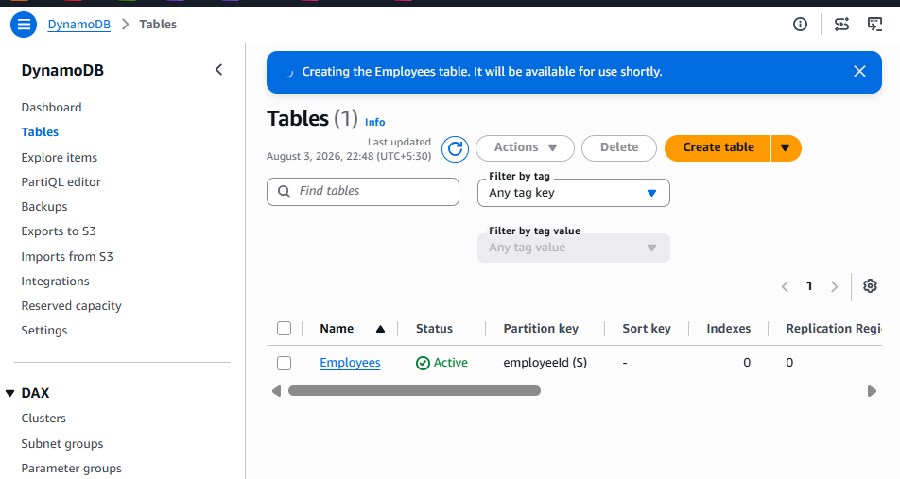
Step 6: Verify the table
Open the Employees table and confirm:
Property | Expected
Table status | Active
Partition key | employeeId
Partition-key type | String
Sort key | None
Capacity mode | On-demand
Region | ap-south-1
Do not manually add employee records yet. The API’s POST method will create them.
After the table status becomes Active, the next phase is creating employee-api-function with least-privilege DynamoDB permissions.
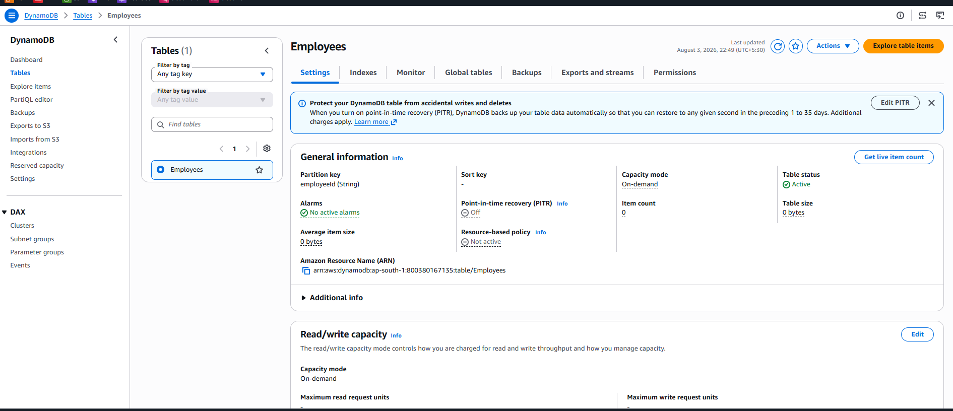

Phase 2: Create the CRUD Lambda function
Step 1: Create the function
Open:
Lambda → Functions → Create function
Select:
Author from scratch
Configure:
Function name: employee-api-function
Runtime: Python 3.14
Keep:
Architecture: x86_64
Execution role: Create new role with basic Lambda permissions
Leave these unchecked:
- Durable execution
- EC2 capacity provider
- ARM64
- Custom execution role
- Function URL
- VPC
- Code signing
- Custom KMS encryption
Choose Create function.
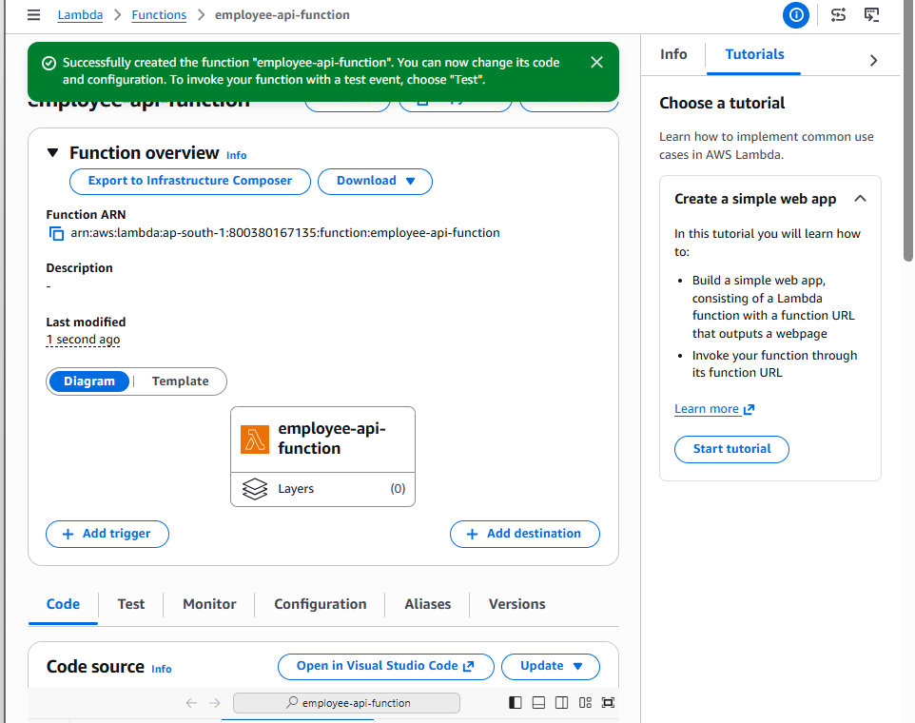
Step 2: General configuration
Open:
Configuration → General configuration → Edit
Configure:
Description:
CRUD backend for the Employee REST API

Memory:
128 MB

Ephemeral storage:
512 MB

Timeout:
10 seconds

SnapStart:
None
Keep the automatically created role and choose Save.
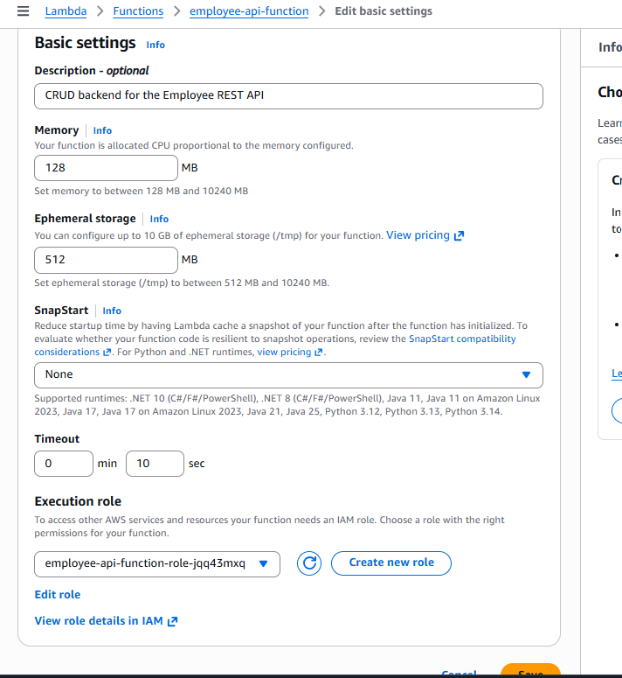
Step 3: Add table environment variable
Open:
Configuration → Environment variables → Edit
Add:
Key: TABLE_NAME
Value: Employees
Choose Save.
This avoids hard-coding the table name in the function.
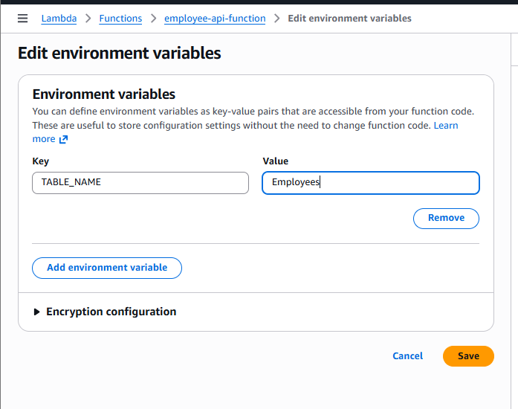
Phase 3: Grant DynamoDB permissions
Step 4: Open the execution role
Open:
Configuration → Permissions
Under Execution role, click the role name. It should resemble:
employee-api-function-role-xxxxxxxx
IAM opens in a new tab.
Choose:
Add permissions → Create inline policy → JSON
Paste:
{
"Version": "2012-10-17",
"Statement": [
{
"Sid": "EmployeeTableCrudAccess",
"Effect": "Allow",
"Action": [
"dynamodb:PutItem",
"dynamodb:GetItem",
"dynamodb:Scan",
"dynamodb:UpdateItem",
"dynamodb:DeleteItem"
],
"Resource": "arn:aws:dynamodb:ap-south-1:800380167135:table/Employees"
}
]
}
Choose Next.
Policy name:
EmployeeTableCrudPolicy
Choose Create policy.
The Lambda role should now contain:
Policy | Purpose
AWSLambdaBasicExecutionRole-... | Write CloudWatch logs
EmployeeTableCrudPolicy | CRUD operations on only the Employees table
Do not attach AmazonDynamoDBFullAccess. The custom policy follows least privilege.

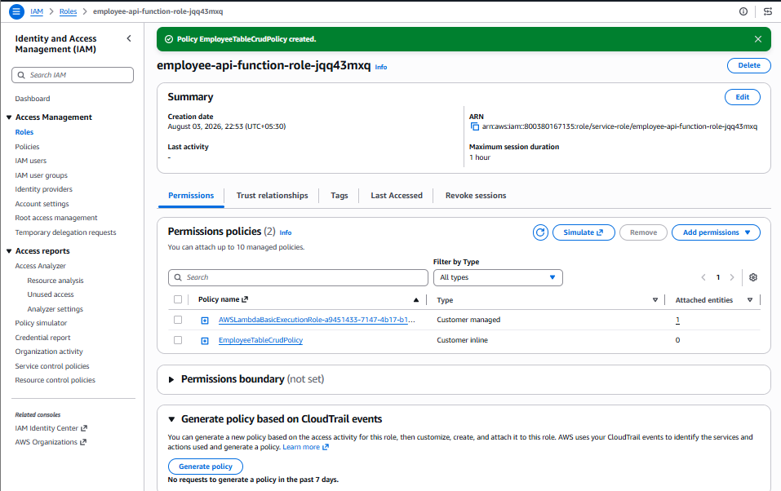
Phase 4: Deploy the Lambda CRUD code
Return to:
Lambda → Functions → employee-api-function → Code
Open lambda_function.py, replace the existing code with the following:
import json
import logging
import os
from decimal import Decimal

import boto3
from botocore.exceptions import ClientError

logger = logging.getLogger()
logger.setLevel(logging.INFO)

TABLE_NAME = os.environ.get("TABLE_NAME", "Employees")

dynamodb = boto3.resource("dynamodb")
table = dynamodb.Table(TABLE_NAME)

class DecimalEncoder(json.JSONEncoder):
def default(self, value):
if isinstance(value, Decimal):
return int(value) if value % 1 == 0 else float(value)

return super().default(value)

def response(status_code, body=None):
return {
"statusCode": status_code,
"headers": {
"Content-Type": "application/json",
"Access-Control-Allow-Origin": "*",
"Access-Control-Allow-Headers": "Content-Type,Authorization",
"Access-Control-Allow-Methods": "GET,POST,PATCH,DELETE,OPTIONS"
},
"body": "" if body is None else json.dumps(
body,
cls=DecimalEncoder
)
}

def parse_body(event):
body = event.get("body")

if not body:
return {}

if isinstance(body, dict):
return body

return json.loads(body)

def lambda_handler(event, context):
logger.info("Received event: %s", json.dumps(event))

method = event.get("httpMethod")
resource = event.get("resource")
path_parameters = event.get("pathParameters") or {}
employee_id = path_parameters.get("employeeId")

try:
# CORS preflight
if method == "OPTIONS":
return response(200, {"message": "CORS preflight successful"})

# POST /employees
if method == "POST" and resource == "/employees":
body = parse_body(event)

required_fields = [
"employeeId",
"name",
"department"
]

missing_fields = [
field for field in required_fields
if not body.get(field)
]

if missing_fields:
return response(
400,
{
"message": "Required fields are missing",
"missingFields": missing_fields
}
)

employee = {
"employeeId": body["employeeId"],
"name": body["name"],
"department": body["department"]
}

table.put_item(
Item=employee,
ConditionExpression=(
"attribute_not_exists(employeeId)"
)
)

logger.info(
"Created employee %s",
employee["employeeId"]
)

return response(201, employee)

# GET /employees
if method == "GET" and resource == "/employees":
result = table.scan()

return response(
200,
{
"employees": result.get("Items", []),
"count": result.get("Count", 0)
}
)

# GET /employees/{employeeId}
if (
method == "GET"
and resource == "/employees/{employeeId}"
):
result = table.get_item(
Key={"employeeId": employee_id}
)

employee = result.get("Item")

if not employee:
return response(
404,
{"message": "Employee not found"}
)

return response(200, employee)

# PATCH /employees/{employeeId}
if (
method == "PATCH"
and resource == "/employees/{employeeId}"
):
body = parse_body(event)

allowed_fields = ["name", "department"]
fields_to_update = {
key: value
for key, value in body.items()
if key in allowed_fields and value
}

if not fields_to_update:
return response(
400,
{
"message": (
"Provide name or department to update"
)
}
)

update_parts = []
names = {}
values = {}

for field, value in fields_to_update.items():
name_key = f"#{field}"
value_key = f":{field}"

update_parts.append(
f"{name_key} = {value_key}"
)
names[name_key] = field
values[value_key] = value

result = table.update_item(
Key={"employeeId": employee_id},
UpdateExpression=(
"SET " + ", ".join(update_parts)
),
ExpressionAttributeNames=names,
ExpressionAttributeValues=values,
ConditionExpression=(
"attribute_exists(employeeId)"
),
ReturnValues="ALL_NEW"
)

logger.info("Updated employee %s", employee_id)

return response(200, result["Attributes"])

# DELETE /employees/{employeeId}
if (
method == "DELETE"
and resource == "/employees/{employeeId}"
):
table.delete_item(
Key={"employeeId": employee_id},
ConditionExpression=(
"attribute_exists(employeeId)"
)
)

logger.info("Deleted employee %s", employee_id)

return response(204)

return response(
404,
{
"message": (
f"Route not found: {method} {resource}"
)
}
)

except json.JSONDecodeError:
logger.warning("Invalid JSON request body")

return response(
400,
{"message": "Request body contains invalid JSON"}
)

except ClientError as error:
error_code = error.response["Error"]["Code"]

logger.exception(
"DynamoDB operation failed: %s",
error_code
)

if error_code == "ConditionalCheckFailedException":
if method == "POST":
return response(
409,
{"message": "Employee already exists"}
)

return response(
404,
{"message": "Employee not found"}
)

return response(
500,
{"message": "Database operation failed"}
)

except Exception:
logger.exception("Unexpected application error")

return response(
500,
{"message": "Internal server error"}
)
Choose Deploy.
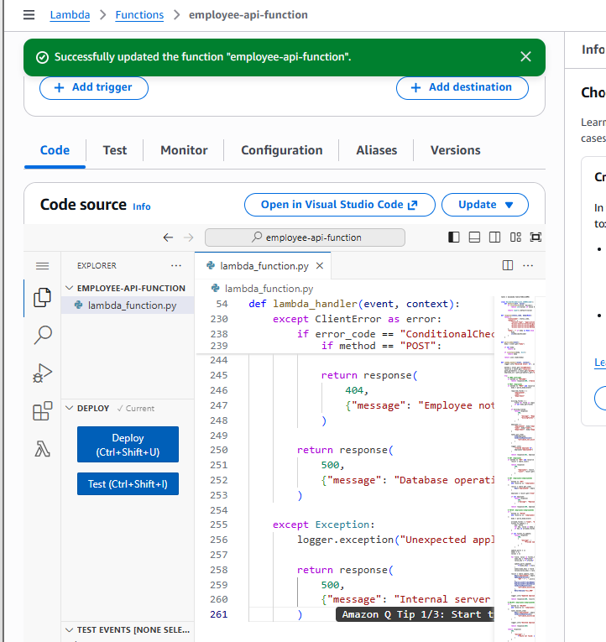
Test Lambda before creating API Gateway
Test 1: Create an employee
Create a test event named:
CreateEmployeeTest
Use:
{
"resource": "/employees",
"path": "/employees",
"httpMethod": "POST",
"headers": {
"Content-Type": "application/json"
},
"pathParameters": null,
"body": "{\"employeeId\":\"EMP101\",\"name\":\"Venu Gopal\",\"department\":\"DevOps\"}"
}
Choose Test.
Expected response:
{
"statusCode": 201,
"body": "{\"employeeId\": \"EMP101\", \"name\": \"Venu Gopal\", \"department\": \"DevOps\"}"
}
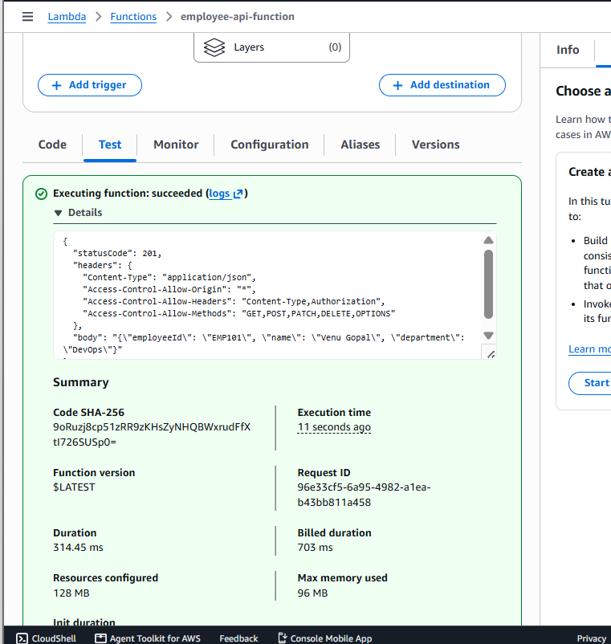
Verify DynamoDB
Open:
DynamoDB → Tables → Employees → Explore table items
You should see:
employeeId: EMP101
name: Venu Gopal
department: DevOps
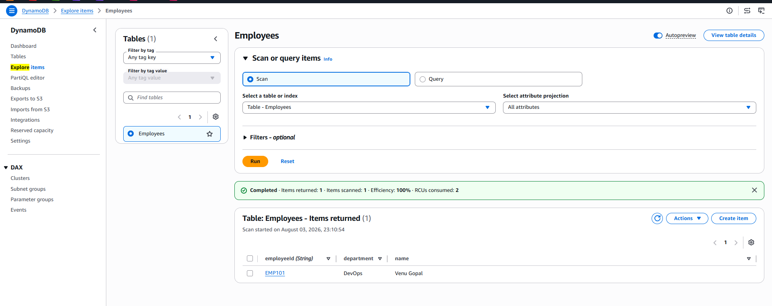
Test 2: List employees
Create another event:
ListEmployeesTest
{
"resource": "/employees",
"path": "/employees",
"httpMethod": "GET",
"headers": {},
"pathParameters": null,
"body": null
}
Expected:
{
"statusCode": 200,
"body": "{\"employees\": [{...}], \"count\": 1}"
}
Once both tests succeed, the Lambda and DynamoDB backend are ready for API Gateway.
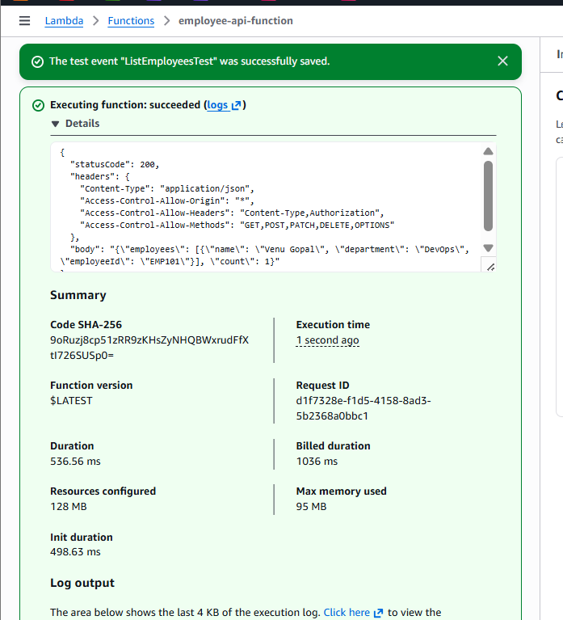
Phase 5: Create the REST API
Step 1: Open API Gateway
- Search for API Gateway.
- Open Amazon API Gateway.
- Confirm Region:
Asia Pacific (Mumbai) — ap-south-1
- Choose Create API.
Step 2: Choose REST API
You will see API types such as:
- HTTP API
- WebSocket API
- REST API
- REST API Private
Under:
REST API
choose:
Build
Do not select:
REST API Private
Step 3: Configure API details
Choose:
New API
Enter:
API name: Employee-REST-API
Description: Serverless CRUD API for employee management
Endpoint type: Regional
If an IP address type is displayed, keep:
IPv4
or the default supported setting.
Choose:
Create API
Final configuration
API name: Employee-REST-API
Description: Serverless CRUD API for employee management
API endpoint type: Regional
Security policy: SecurityPolicy_TLS13_1_3_2025_09
Endpoint access mode: Strict
IP address type: IPv4

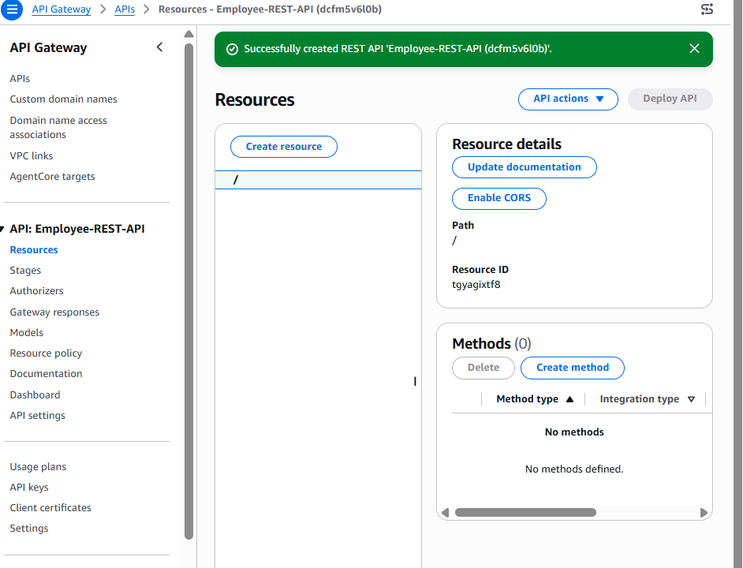
Phase 6: Create /employees
After the API opens:
- Select the root resource:
/
- Choose Create resource.
- Configure:
Resource name: employees
Resource path: /employees
- Keep CORS unchecked for now—we already return CORS headers from Lambda and can configure OPTIONS later.
- Choose Create resource.
The resource tree should show:
/
└── employees
Create the employee ID resource
- Select /employees.
- Choose Create resource.
- Enter:
Resource name: employeeId
Resource path: /{employeeId}
If the console asks only for the path part, enter:
{employeeId}
- Choose Create resource.
Expected resource tree:
/
└── employees
└── {employeeId}
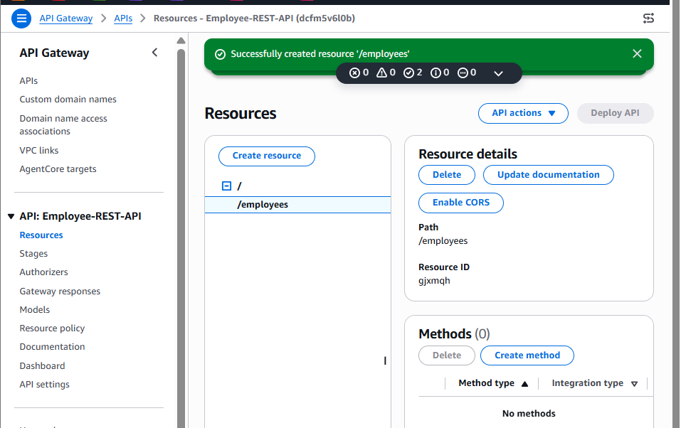
The braces identify employeeId as a dynamic path parameter. For example:
/employees/EMP101
API Gateway will pass:
"pathParameters": {
"employeeId": "EMP101"
}
to Lambda.
All five CRUD methods are configured correctly:
/
└── /employees
├── GET
├── POST
└── /{employeeId}
├── GET
├── PATCH
└── DELETE
Phase 7: Deploy the API
Step 1: Deploy
Choose:
Deploy API
Configure:
Stage: New stage
Stage name: dev
Deployment description: Initial Employee CRUD API deployment
Optional stage description:
Development stage for Employee REST API
Choose Deploy.
Step 2: Copy the invoke URL
After deployment, API Gateway opens the dev stage.
Find Invoke URL. It should resemble:
https://dcfm5v6l0b.execute-api.ap-south-1.amazonaws.com/dev
Your base endpoint is:
https://dcfm5v6l0b.execute-api.ap-south-1.amazonaws.com/dev/employees
Copy your displayed URL rather than typing it manually.
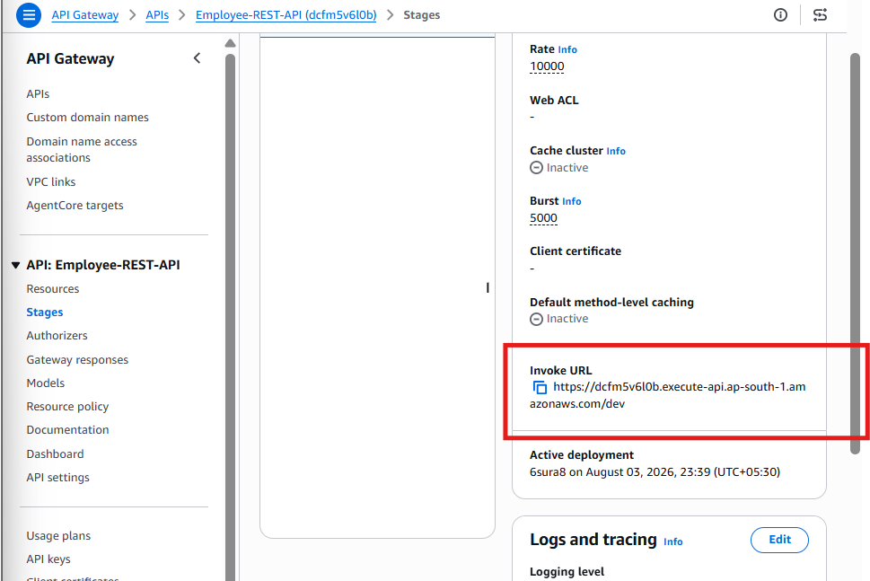
Phase 8: Test from Git Bash
The API currently has no authorizer, so your existing AWS CLI profiles are not required. Use curl.
Test 1: List employees
curl -i "https://dcfm5v6l0b.execute-api.ap-south-1.amazonaws.com/dev/employees"
Expected:
HTTP/1.1 200
The body should include EMP101 if the Lambda test created it.
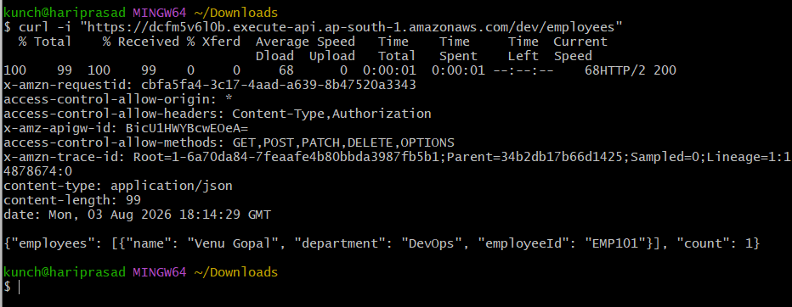
Test 2: Create a second employee
curl -i -X POST "https://dcfm5v6l0b.execute-api.ap-south-1.amazonaws.com/dev/employees" -H "Content-Type: application/json" -d '{"employeeId":"EMP102","name":"Priya Sharma","department":"Cloud"}'
Expected:
HTTP 201
Response body:
{
"employeeId": "EMP102",
"name": "Priya Sharma",
"department": "Cloud"
}
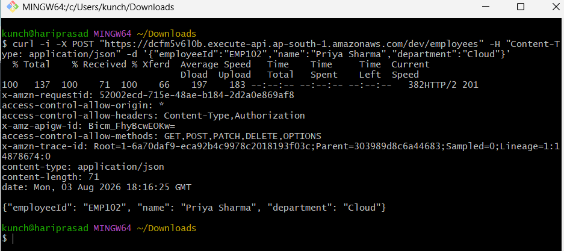
Test 3: Retrieve one employee
curl -i "https://dcfm5v6l0b.execute-api.ap-south-1.amazonaws.com/dev/employees/EMP102"
Expected:
HTTP 200
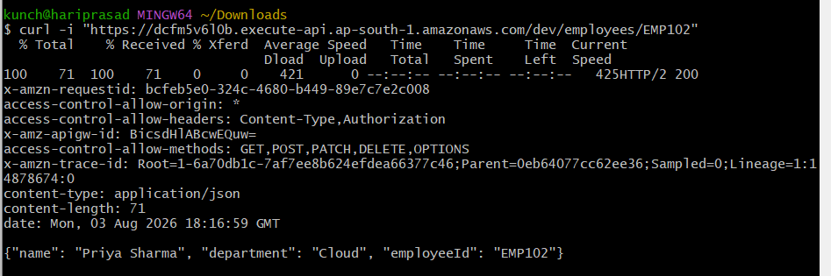
Test 4: Update the employee
curl -i -X PATCH "https://dcfm5v6l0b.execute-api.ap-south-1.amazonaws.com/dev/employees/EMP102" -H "Content-Type: application/json" -d '{"department":"AWS DevOps"}'
Expected:
HTTP 200
The response should contain:
"department": "AWS DevOps"
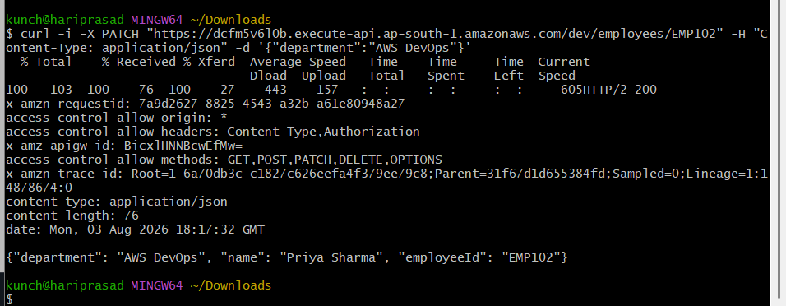
Test 5: Delete the employee
curl -i -X DELETE "https://dcfm5v6l0b.execute-api.ap-south-1.amazonaws.com/dev/employees/EMP102"
Expected:
HTTP 204
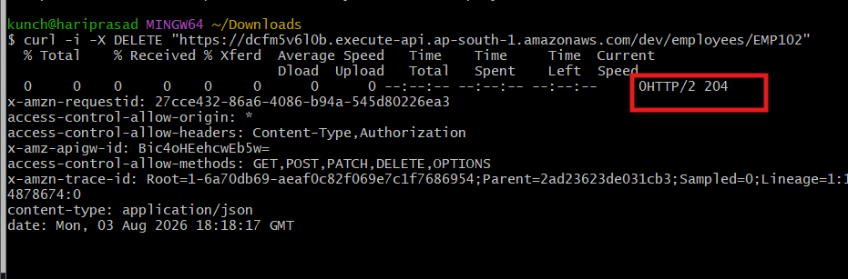
Test 6: Confirm deletion
curl -i "https://dcfm5v6l0b.execute-api.ap-south-1.amazonaws.com/dev/employees/EMP102"
Expected:
HTTP 404
Use the exact invoke URL shown in your dev stage. If your URL differs from the example, replace it in every command.
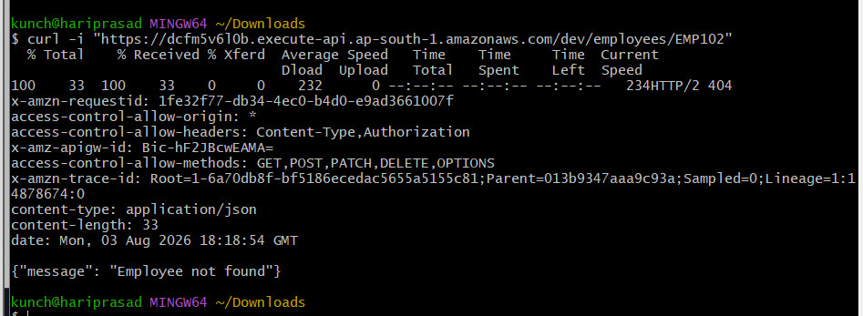

A final capstone can combine KMS, Lambda and API Gateway into one secure serverless application.
Final Clubbing Task: Secure Employee Records API
Architecture
Client / cURL
↓ HTTPS
API Gateway REST API
↓
Lambda function
├── KMS Encrypt/Decrypt
│ └── alias/training-key
↓
DynamoDB SecureEmployees
↓
CloudWatch Logs + CloudTrail
Objective
Build an API that encrypts sensitive employee information before storing it in DynamoDB.
Example sensitive field:
salary
DynamoDB should store ciphertext instead of readable salary data.
API operations
Method | Endpoint | Purpose
POST | /secure-employees | Encrypt and create record
GET | /secure-employees/{employeeId} | Read and decrypt record
DELETE | /secure-employees/{employeeId} | Delete record
POST request
{
"employeeId": "EMP201",
"name": "Rahul Kumar",
"department": "DevOps",
"salary": "85000"
}
Stored DynamoDB item
{
"employeeId": "EMP201",
"name": "Rahul Kumar",
"department": "DevOps",
"encryptedSalary": "AQICAH..."
}
The plaintext salary must not be stored.
Encryption context
Lambda encrypts the salary using:
{
"Application": "EmployeeAPI",
"Environment": "Dev",
"EmployeeId": "EMP201"
}
The same context must be provided during decryption.
This cryptographically binds the ciphertext to the application, environment and employee.
GET response
{
"employeeId": "EMP201",
"name": "Rahul Kumar",
"department": "DevOps",
"salary": "85000"
}
Lambda:
- Retrieves the ciphertext from DynamoDB.
- Base64-decodes it.
- Calls KMS Decrypt with the correct context.
- Returns the plaintext only to the authorized API caller.
Least-privilege Lambda role
Allow only:
dynamodb:PutItem
dynamodb:GetItem
dynamodb:DeleteItem
kms:Encrypt
kms:Decrypt
kms:DescribeKey
logs:CreateLogStream
logs:PutLogEvents
Restrict DynamoDB access to the SecureEmployees table and KMS access to:
arn:aws:kms:ap-south-1:800380167135:key/864f6af2-eec5-4381-9bfc-09d4111aa5ab
Do not allow Lambda to:
kms:DisableKey
kms:PutKeyPolicy
kms:ScheduleKeyDeletion
dynamodb:DeleteTable
Security tests
Test | Expected result
Correct encryption context | Salary decrypts
Incorrect employee ID context | InvalidCiphertextException
Lambda lacks kms:Decrypt | GET fails with controlled 500/403
Application role attempts DisableKey | Access denied
DynamoDB inspection | Only encrypted salary visible
CloudTrail inspection | Encrypt and Decrypt operations recorded
CloudWatch inspection | Request IDs and safe operational logs visible
Important logging rule
Do not log:
- Plaintext salary
- Ciphertext unnecessarily
- Access tokens
- Request authorization headers
Log only safe information:
Request ID
Employee ID
Operation
Result
Error category
What this task combines
AWS topic | Implementation
KMS | Encryption, decryption, context and audit
Lambda | Application logic and least-privilege execution role
API Gateway | REST resources, methods, deployment and HTTPS
DynamoDB | Secure ciphertext storage
IAM | Separation of administration and application usage
CloudWatch | Runtime logs and metrics
CloudTrail | KMS security audit
This is an excellent final project because it demonstrates not just that the three services work independently, but how they form a secure production-style serverless workflow.
Final Capstone — Step 1: Create SecureEmployees Table
We will create a separate table so the existing Employees CRUD API remains unchanged.
1. Open DynamoDB
Go to:
AWS Console → DynamoDB → Tables → Create table
Confirm the Region:
Asia Pacific (Mumbai) — ap-south-1
2. Table details
Enter:
Table name: SecureEmployees
Partition key: employeeId
Partition key type: String
Do not configure a sort key.
The partition-key spelling is case-sensitive. Use exactly:
employeeId
3. Customize settings
Select:
Customize settings
Configure:
Setting | Selection
Table class | DynamoDB Standard
Capacity mode | On-demand
Maximum throughput | Not configured
Warm throughput | Keep default values
Secondary indexes | None
Encryption | AWS owned key
Deletion protection | Off for this lab
Resource-based policy | Empty
Point-in-time recovery | Off for this temporary lab
Why use an AWS owned key here?
The salary will already be encrypted explicitly by Lambda using:
alias/training-key
DynamoDB’s default encryption still protects the entire table at rest. Our application-level ciphertext provides the visible KMS learning objective.
4. Add tags
Add:
Key: Project
Value: Secure-Employee-Capstone
Optional:
Key: Environment
Value: Training
5. Create the table
Choose:
Create table
Wait until:
Table status: Active
6. Verify
Confirm:
Property | Expected
Table | SecureEmployees
Partition key | employeeId (String)
Sort key | None
Capacity | On-demand
Status | Active
Items | 0
The table ARN should be:
arn:aws:dynamodb:ap-south-1:800380167135:table/SecureEmployees
Do not manually create an item. The secure API’s POST operation will create it after encrypting the salary.

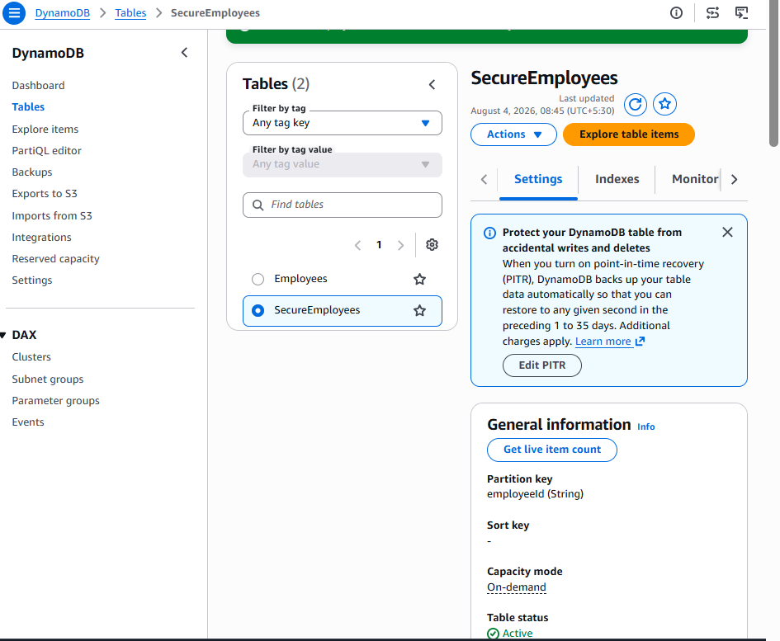

Yes, SecureEmployees was created successfully.
Verified
Property | Result
Table status | Active
Partition key | employeeId (String)
Sort key | None
Capacity mode | On-demand
Item count | 0
Encryption | AWS owned key
PITR | Off
Deletion protection | Off
Resource policy | Not active
Table ARN:
arn:aws:dynamodb:ap-south-1:800380167135:table/SecureEmployees
Step 2: Create the secure Lambda function
Go to:
Lambda → Functions → Create function
Select:
Author from scratch
Configure:
Function name: secure-employee-api-function
Runtime: Python 3.14
Keep:
Architecture: x86_64
Execution role: Create a new role with basic Lambda permissions
Leave these unchecked:
- Durable execution
- EC2 capacity provider
- ARM64
- Custom execution role
- Function URL
- Tenant isolation
- VPC
- Code signing
- Encryption with AWS KMS
We will use KMS from the function code. The “Encryption with AWS KMS” creation option is for encrypting the Lambda deployment package, which is a different requirement.
Optional tag:
Project = Secure-Employee-Capstone
Click Create function.
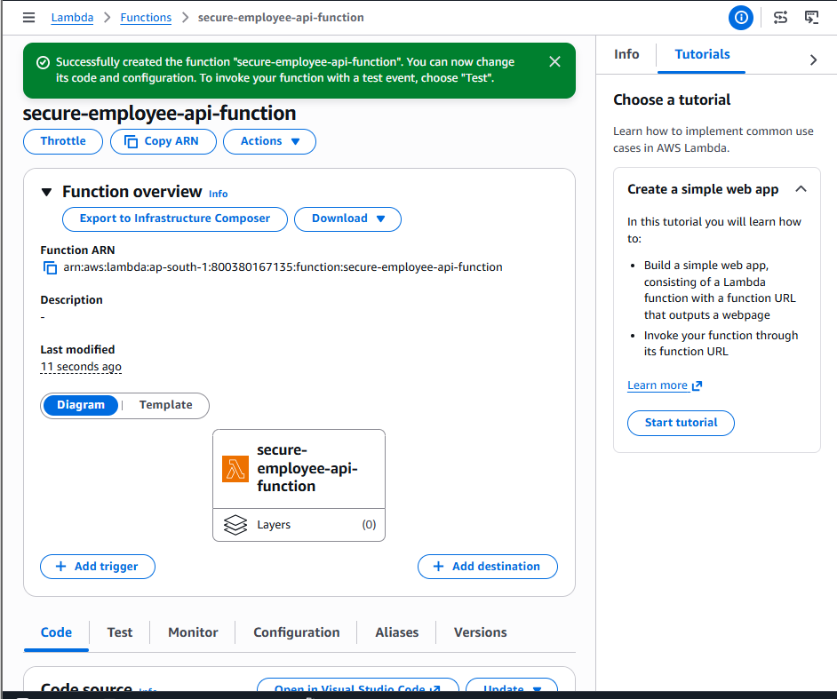
Configure basic settings
After it becomes Active, open:
Configuration → General configuration → Edit
Enter:
Description:
Encrypts sensitive employee salary data using AWS KMS

Memory:
128 MB

Ephemeral storage:
512 MB

Timeout:
10 seconds

SnapStart:
None
Keep the automatically created execution role and click Save.
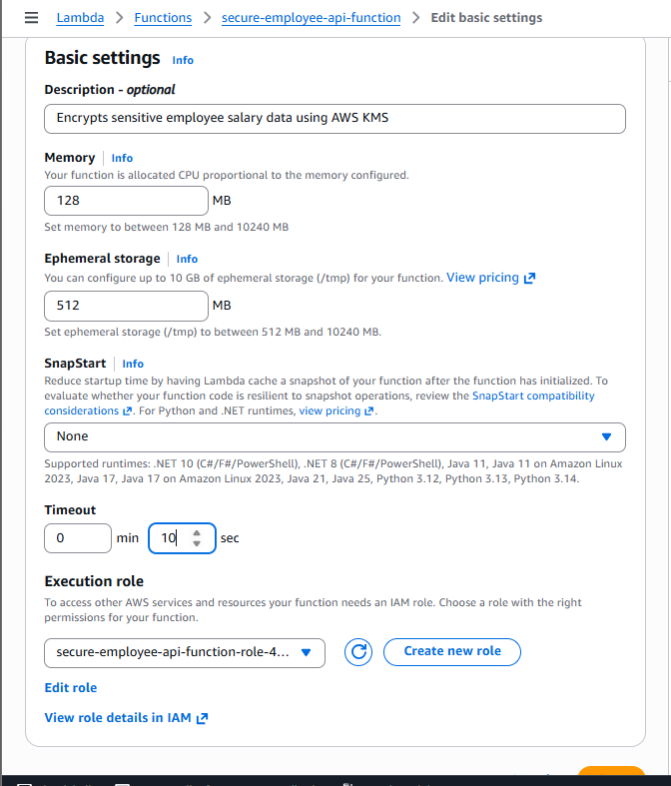
Add environment variables
Open:
Configuration → Environment variables → Edit
Add these three variables:
Key | Value
TABLE_NAME | SecureEmployees
KMS_KEY_ID | arn:aws:kms:ap-south-1:800380167135:key/864f6af2-eec5-4381-9bfc-09d4111aa5ab
ENVIRONMENT | Dev
Click Save.
Do not store the salary or any credentials in environment variables.
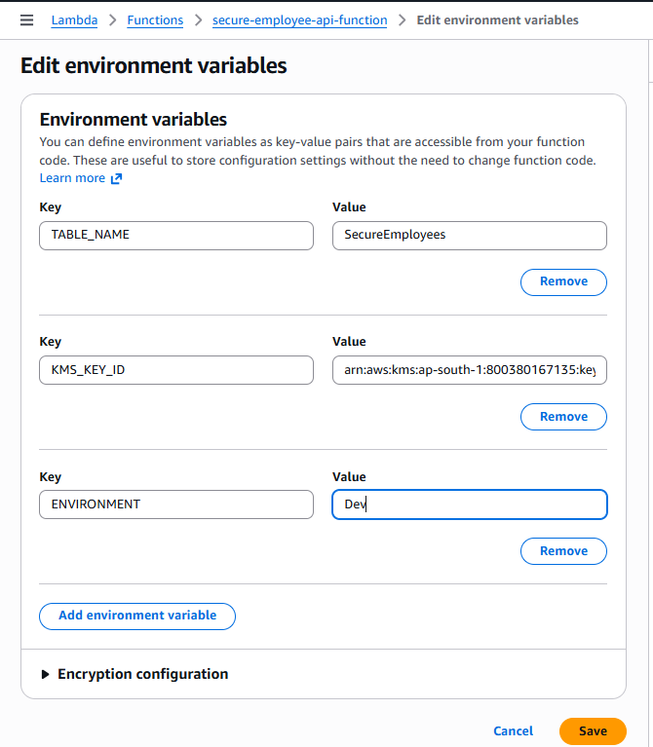

Step 3: Add least-privilege permissions
The Lambda execution role currently has only CloudWatch Logs permission. Add DynamoDB and KMS permissions.
Open the execution role
Go to:
Lambda → secure-employee-api-function
→ Configuration → Permissions
Under Execution role, click the role name. It should resemble:
secure-employee-api-function-role-xxxxxxxx
IAM opens in a new tab.
Do not edit the existing AWSLambdaBasicExecutionRole policy.
Create the inline policy
Choose:
Add permissions → Create inline policy → JSON
Paste:
{
"Version": "2012-10-17",
"Statement": [
{
"Sid": "SecureEmployeeTableAccess",
"Effect": "Allow",
"Action": [
"dynamodb:PutItem",
"dynamodb:GetItem",
"dynamodb:DeleteItem"
],
"Resource": "arn:aws:dynamodb:ap-south-1:800380167135:table/SecureEmployees"
},
{
"Sid": "EncryptAndDecryptSalaryWithRequiredContext",
"Effect": "Allow",
"Action": [
"kms:Encrypt",
"kms:Decrypt"
],
"Resource": "arn:aws:kms:ap-south-1:800380167135:key/864f6af2-eec5-4381-9bfc-09d4111aa5ab",
"Condition": {
"StringEquals": {
"kms:EncryptionContext:Application": "EmployeeAPI",
"kms:EncryptionContext:Environment": "Dev"
}
}
},
{
"Sid": "DescribeTrainingKey",
"Effect": "Allow",
"Action": "kms:DescribeKey",
"Resource": "arn:aws:kms:ap-south-1:800380167135:key/864f6af2-eec5-4381-9bfc-09d4111aa5ab"
}
]
}
Why the condition is important
KMS operations are allowed only when the request includes:
{
"Application": "EmployeeAPI",
"Environment": "Dev"
}
The function will also add:
EmployeeId=<current employee ID>
That value becomes cryptographically bound to the ciphertext.
Create the policy
Choose Next.
Policy name:
SecureEmployeeApplicationPolicy
Choose Create policy.
Verify the role
The role should show two policies:
Policy | Purpose
AWSLambdaBasicExecutionRole-... | CloudWatch Logs
SecureEmployeeApplicationPolicy | DynamoDB and KMS application access
The role does not have:
kms:DisableKey
kms:PutKeyPolicy
kms:ScheduleKeyDeletion
dynamodb:DeleteTable
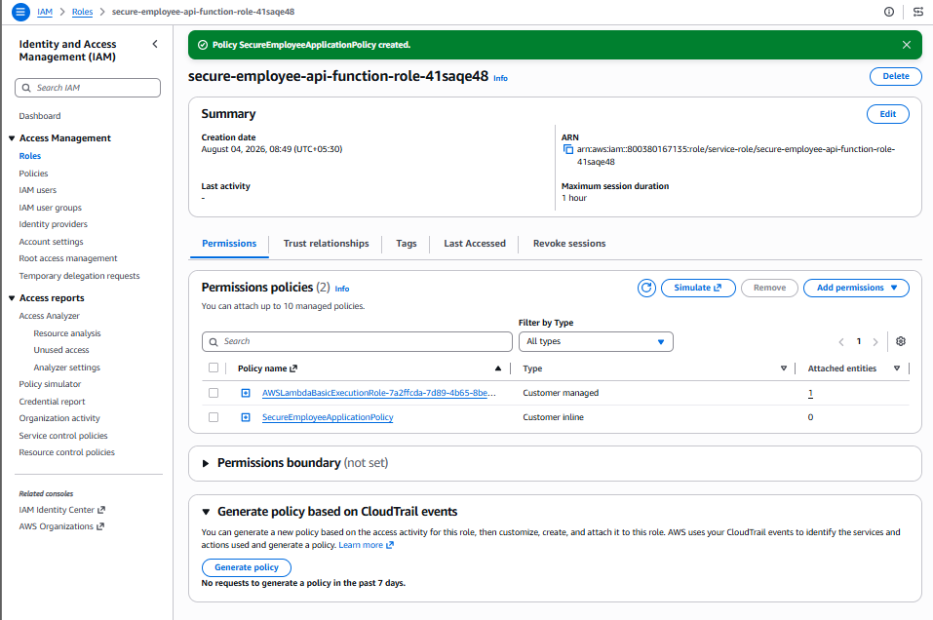
After the policy is created, return to the Lambda function’s Code tab.

Step 4: Deploy the secure Lambda code
Return to:
Lambda → Functions → secure-employee-api-function → Code
Open lambda_function.py, delete the existing code, and paste:
import base64
import json
import logging
import os
import re

import boto3
from botocore.exceptions import ClientError

logger = logging.getLogger()
logger.setLevel(logging.INFO)

TABLE_NAME = os.environ["TABLE_NAME"]
KMS_KEY_ID = os.environ["KMS_KEY_ID"]
ENVIRONMENT = os.environ.get("ENVIRONMENT", "Dev")

dynamodb = boto3.resource("dynamodb")
table = dynamodb.Table(TABLE_NAME)
kms = boto3.client("kms")

def api_response(status_code, body=None):
return {
"statusCode": status_code,
"headers": {
"Content-Type": "application/json",
"Access-Control-Allow-Origin": "*",
"Access-Control-Allow-Headers": (
"Content-Type,Authorization"
),
"Access-Control-Allow-Methods": (
"POST,GET,DELETE,OPTIONS"
)
},
"body": (
""
if body is None
else json.dumps(body)
)
}

def parse_body(event):
body = event.get("body")

if not body:
return {}

if isinstance(body, dict):
return body

return json.loads(body)

def valid_employee_id(employee_id):
if not isinstance(employee_id, str):
return False

return bool(
re.fullmatch(
r"[A-Za-z0-9_-]{1,64}",
employee_id
)
)

def encryption_context(employee_id):
return {
"Application": "EmployeeAPI",
"Environment": ENVIRONMENT,
"EmployeeId": employee_id
}

def lambda_handler(event, context):
method = event.get("httpMethod")
resource = event.get("resource")
path_parameters = event.get("pathParameters") or {}
employee_id = path_parameters.get("employeeId")

request_id = context.aws_request_id

logger.info(
"operation=%s resource=%s employeeId=%s "
"requestId=%s result=started",
method,
resource,
employee_id,
request_id
)

try:
if method == "OPTIONS":
return api_response(
200,
{"message": "CORS preflight successful"}
)

# POST /secure-employees
if (
method == "POST"
and resource == "/secure-employees"
):
body = parse_body(event)

required_fields = [
"employeeId",
"name",
"department",
"salary"
]

missing_fields = [
field
for field in required_fields
if not body.get(field)
]

if missing_fields:
return api_response(
400,
{
"message": "Required fields are missing",
"missingFields": missing_fields
}
)

employee_id = body["employeeId"]

if not valid_employee_id(employee_id):
return api_response(
400,
{
"message": (
"employeeId must contain only "
"letters, numbers, hyphens or "
"underscores"
)
}
)

salary = str(body["salary"])

if len(salary.encode("utf-8")) > 4096:
return api_response(
400,
{"message": "Salary value is too large"}
)

kms_result = kms.encrypt(
KeyId=KMS_KEY_ID,
Plaintext=salary.encode("utf-8"),
EncryptionContext=encryption_context(
employee_id
)
)

encrypted_salary = base64.b64encode(
kms_result["CiphertextBlob"]
).decode("utf-8")

item = {
"employeeId": employee_id,
"name": str(body["name"]),
"department": str(body["department"]),
"encryptedSalary": encrypted_salary
}

table.put_item(
Item=item,
ConditionExpression=(
"attribute_not_exists(employeeId)"
)
)

logger.info(
"operation=POST employeeId=%s "
"requestId=%s result=created",
employee_id,
request_id
)

return api_response(
201,
{
"employeeId": employee_id,
"name": item["name"],
"department": item["department"],
"message": (
"Employee created with encrypted salary"
)
}
)

# GET /secure-employees/{employeeId}
if (
method == "GET"
and resource
== "/secure-employees/{employeeId}"
):
if not valid_employee_id(employee_id):
return api_response(
400,
{"message": "Invalid employeeId"}
)

result = table.get_item(
Key={"employeeId": employee_id}
)

item = result.get("Item")

if not item:
return api_response(
404,
{"message": "Employee not found"}
)

ciphertext = base64.b64decode(
item["encryptedSalary"]
)

kms_result = kms.decrypt(
KeyId=KMS_KEY_ID,
CiphertextBlob=ciphertext,
EncryptionContext=encryption_context(
employee_id
)
)

salary = kms_result["Plaintext"].decode(
"utf-8"
)

logger.info(
"operation=GET employeeId=%s "
"requestId=%s result=decrypted",
employee_id,
request_id
)

return api_response(
200,
{
"employeeId": item["employeeId"],
"name": item["name"],
"department": item["department"],
"salary": salary
}
)

# DELETE /secure-employees/{employeeId}
if (
method == "DELETE"
and resource
== "/secure-employees/{employeeId}"
):
if not valid_employee_id(employee_id):
return api_response(
400,
{"message": "Invalid employeeId"}
)

table.delete_item(
Key={"employeeId": employee_id},
ConditionExpression=(
"attribute_exists(employeeId)"
)
)

logger.info(
"operation=DELETE employeeId=%s "
"requestId=%s result=deleted",
employee_id,
request_id
)

return api_response(204)

return api_response(
404,
{
"message": (
f"Route not found: {method} {resource}"
)
}
)

except json.JSONDecodeError:
logger.warning(
"requestId=%s result=invalid_json",
request_id
)

return api_response(
400,
{"message": "Request body contains invalid JSON"}
)

except ClientError as error:
error_code = error.response["Error"]["Code"]

logger.error(
"operation=%s employeeId=%s requestId=%s "
"result=aws_error errorCategory=%s",
method,
employee_id,
request_id,
error_code
)

if error_code == "ConditionalCheckFailedException":
if method == "POST":
return api_response(
409,
{"message": "Employee already exists"}
)

return api_response(
404,
{"message": "Employee not found"}
)

if error_code == "InvalidCiphertextException":
return api_response(
500,
{
"message": (
"Unable to authenticate encrypted data"
)
}
)

if error_code == "AccessDeniedException":
return api_response(
500,
{
"message": (
"Secure service permission error"
)
}
)

return api_response(
500,
{"message": "Secure operation failed"}
)

except Exception:
logger.exception(
"operation=%s employeeId=%s requestId=%s "
"result=unexpected_error",
method,
employee_id,
request_id
)

return api_response(
500,
{"message": "Internal server error"}
)
Choose Deploy.
Security features in the code
- Plaintext salary is never written to DynamoDB.
- Plaintext salary and ciphertext are not logged.
- KMS encryption context includes application, environment and employee ID.
- Duplicate employee IDs return 409.
- Missing employees return 404.
- KMS failures return controlled responses without internal details.
- Output does not expose the KMS key ARN or ciphertext.
After deployment, we will test POST and GET directly in Lambda before creating API Gateway.
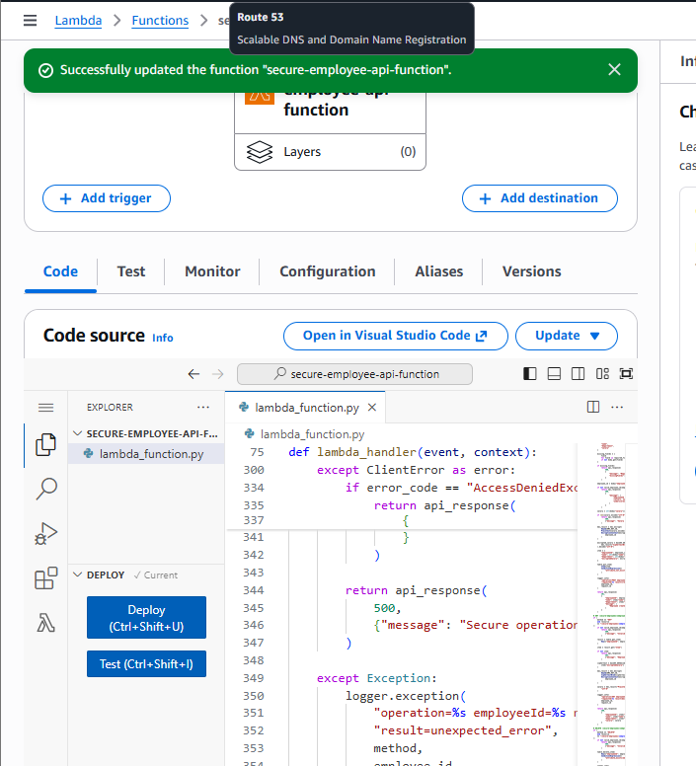
Step 5: Test encryption directly in Lambda
Test 1: Create a secure employee
Open:
Lambda → secure-employee-api-function → Test
Choose:
Create new event
Event name:
CreateSecureEmployeeTest
Event sharing:
Private
Paste:
{
"resource": "/secure-employees",
"path": "/secure-employees",
"httpMethod": "POST",
"headers": {
"Content-Type": "application/json"
},
"pathParameters": null,
"body": "{\"employeeId\":\"EMP201\",\"name\":\"Rahul Kumar\",\"department\":\"DevOps\",\"salary\":\"85000\"}"
}
Choose Save changes, then Test.
Expected response
Status: Succeeded
{
"statusCode": 201,
"body": "{\"employeeId\": \"EMP201\", \"name\": \"Rahul Kumar\", \"department\": \"DevOps\", \"message\": \"Employee created with encrypted salary\"}"
}
The response should not return the salary or ciphertext.
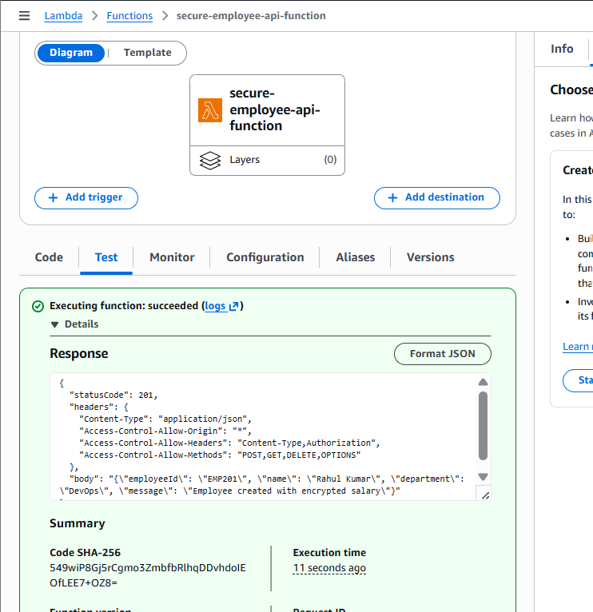
Step 6: Inspect DynamoDB
Open:
DynamoDB → Tables → SecureEmployees
→ Explore table items
Choose Scan or Run.
Expected item:
employeeId: EMP201
name: Rahul Kumar
department: DevOps
encryptedSalary: AQICAH...
Verify that there is no attribute named:
salary
This proves the table stores only encrypted salary data.
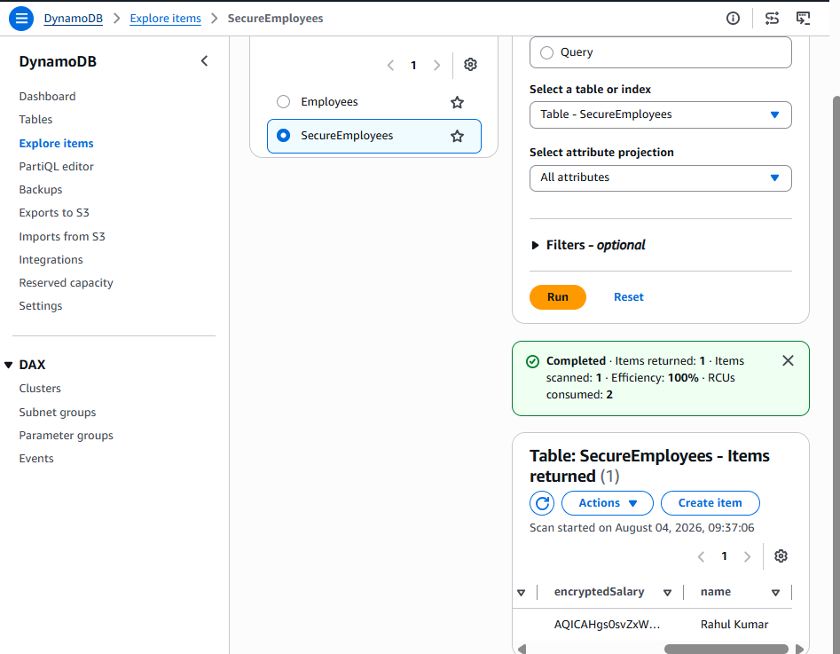
Step 7: Test correct-context decryption
Return to:
Lambda → secure-employee-api-function → Test
Create a new event:
Event name: GetSecureEmployeeTest
Paste:
{
"resource": "/secure-employees/{employeeId}",
"path": "/secure-employees/EMP201",
"httpMethod": "GET",
"headers": {},
"pathParameters": {
"employeeId": "EMP201"
},
"body": null
}
Choose Save changes, then Test.
Expected response
{
"statusCode": 200,
"body": "{\"employeeId\": \"EMP201\", \"name\": \"Rahul Kumar\", \"department\": \"DevOps\", \"salary\": \"85000\"}"
}
This confirms:
DynamoDB ciphertext
→ Base64 decode
→ KMS Decrypt
→ Correct encryption context
→ Plaintext salary returned
If the POST or GET returns 500, open Function Logs and copy only the error category—do not copy the ciphertext.

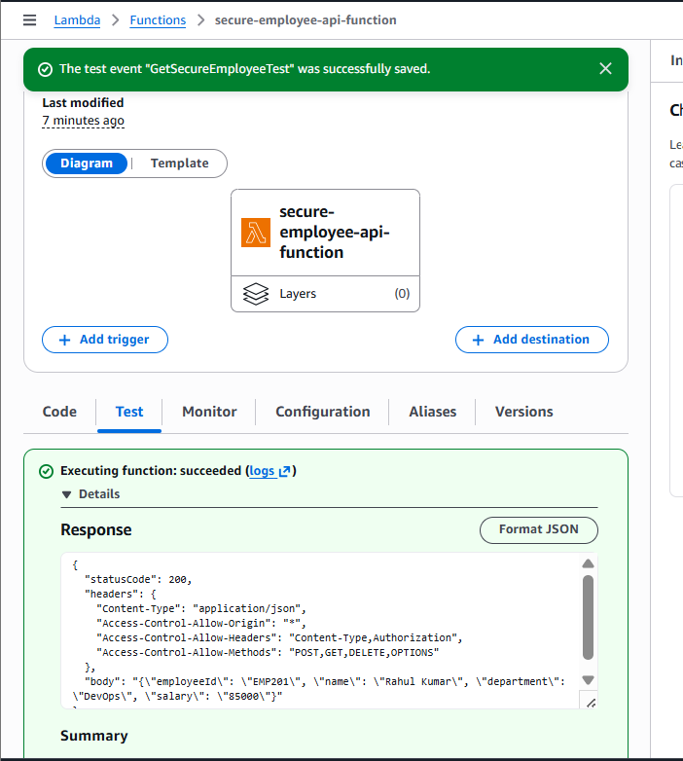
Step 8: Create the secure REST API
Open:
API Gateway → APIs → Create API
Under REST API, choose:
Build
Select:
New API
Configure:
API name: Secure-Employee-REST-API
Description: KMS-encrypted employee records API
API endpoint type: Regional
Security policy: SecurityPolicy_TLS13_1_3_2025_09
Endpoint access mode: Strict
IP address type: IPv4
Choose Create API.
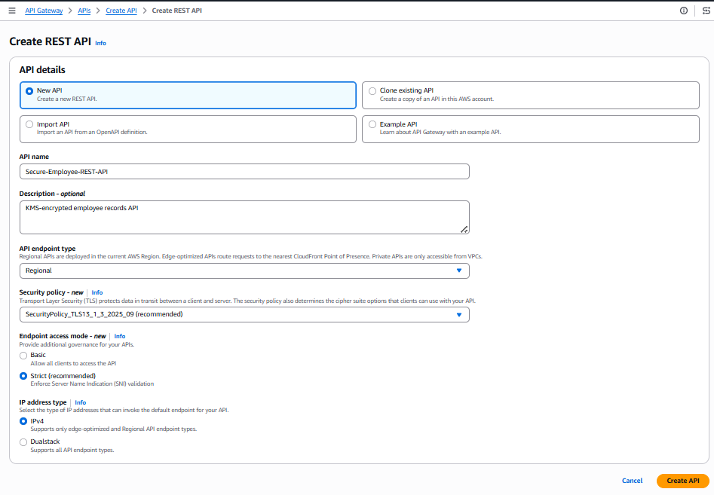
Step 9: Create /secure-employees
In the Resources page:
- Select the root resource /.
- Choose Create resource.
- Configure:
Proxy resource: Off
Resource name: secure-employees
The path should become:
/secure-employees
Leave CORS unchecked for now.
Choose Create resource.
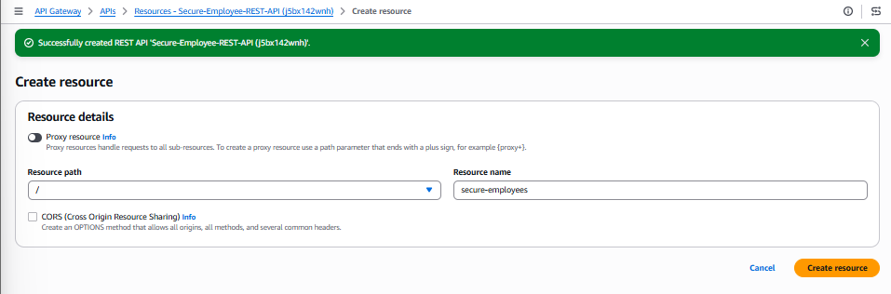
Step 10: Create /{employeeId}
- Select /secure-employees.
- Choose Create resource.
- Confirm the parent path shows:
/secure-employees/
- In Resource name, enter exactly:
{employeeId}
Include the curly braces.
- Leave Proxy resource and CORS unchecked.
- Choose Create resource.
Expected tree:
/
└── /secure-employees
└── /{employeeId}
Do not create /employeeId as a separate sibling resource. {employeeId} must be nested under /secure-employees.
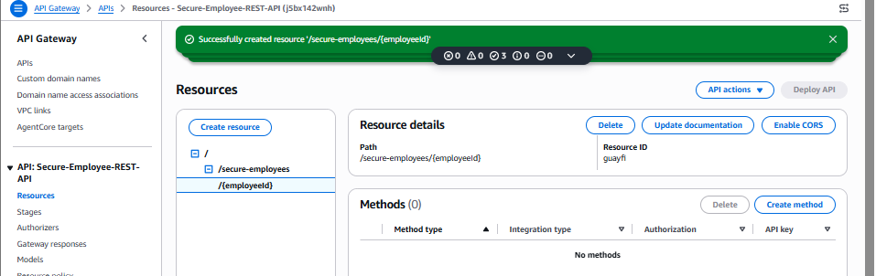
Step 11: Create the API methods
POST /secure-employees
Select:
/secure-employees
Choose Create method and configure:
Method type: POST
Integration type: Lambda function
Lambda proxy integration: Enabled
Response transfer mode: Buffered
Lambda Region: ap-south-1
Lambda function: secure-employee-api-function
Grant API Gateway permission: Enabled
Integration timeout: 29000
Leave the following empty/default:
Authorization: NONE
API key required: False
Request validator: None
Query parameters: None
Headers: None
Request models: None
Choose Create method.
GET /secure-employees/{employeeId}
Select:
/{employeeId}
Create another method:
Method type: GET
Integration type: Lambda function
Lambda proxy integration: Enabled
Response mode: Buffered
Lambda: secure-employee-api-function
Grant invoke permission: Enabled
Timeout: 29000
Authorization: NONE
API key required: False
Choose Create method.
DELETE /secure-employees/{employeeId}
Keep /{employeeId} selected and create:
Method type: DELETE
Integration type: Lambda function
Lambda proxy integration: Enabled
Response mode: Buffered
Lambda: secure-employee-api-function
Grant invoke permission: Enabled
Timeout: 29000
Authorization: NONE
API key required: False
Choose Create method.
Verify the final resource tree
/
└── /secure-employees
├── POST
└── /{employeeId}
├── GET
└── DELETE
Do not deploy until all three methods appear in the resource tree.
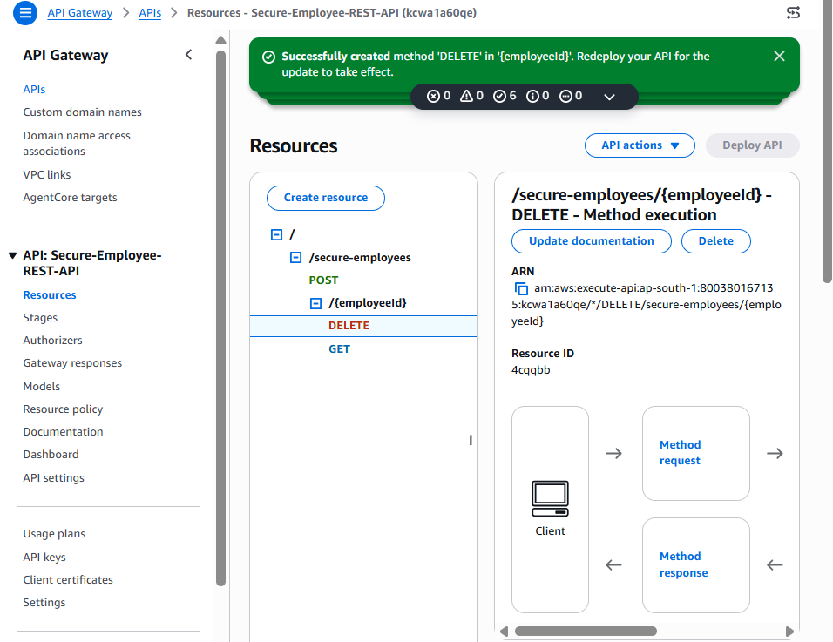
Step 12: Deploy the Secure Employee API
Your resource structure in Mumbai (ap-south-1) is correct:
- /secure-employees → POST
- /secure-employees/{employeeId} → GET, DELETE
Now deploy it:
- In API Gateway → Employee-REST-API → Resources, choose Deploy API.
- For Stage, select the existing stage: dev
- Deployment description: Added secure employee KMS API
- Choose Deploy.
Your base URL should remain:
https://dcfm5v6l0b.execute-api.ap-south-1.amazonaws.com/dev
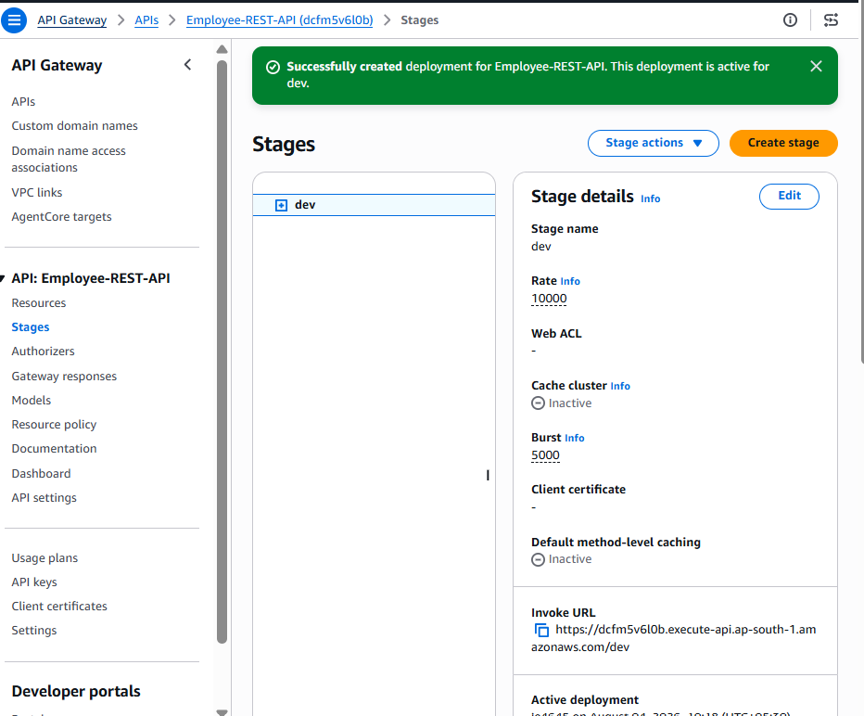
Create the dev stage
- In Secure-Employee-REST-API, choose Deploy API.
- Open the Stage dropdown.
- Select New stage.
- A Stage name field should appear. Enter:
dev
- Enter the deployment description:
Initial deployment of secure employee KMS API
- Choose Deploy.
After deployment, open:
Stages → dev
Copy the displayed Invoke URL. It should be similar to:
https://kcwa1a60qe.execute-api.ap-south-1.amazonaws.com/dev
Then test:
curl -i -X POST "https://kcwa1a60qe.execute-api.ap-south-1.amazonaws.com/dev/secure-employees"

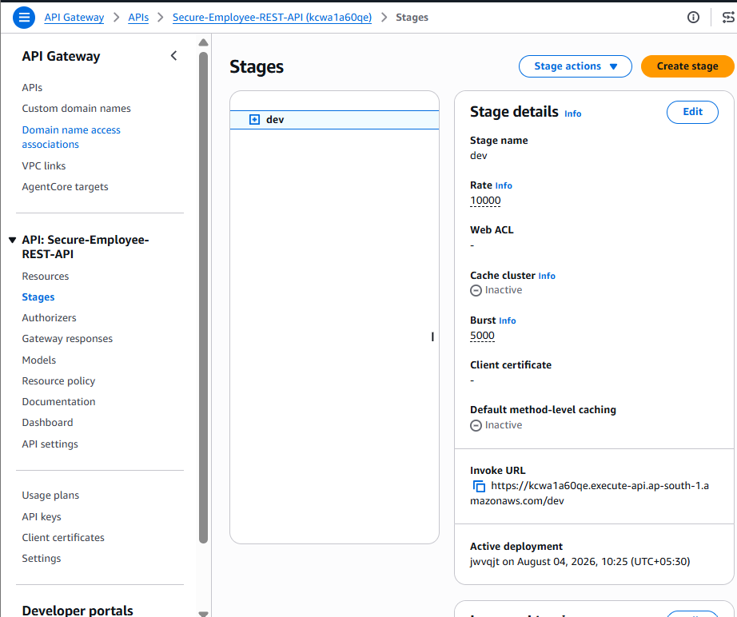

Test POST from Git Bash
Run this as one line:
curl -i -X POST "https://dcfm5v6l0b.execute-api.ap-south-1.amazonaws.com/dev/secure-employees" -H "Content-Type: application/json" -d '{"employeeId":"EMP202","name":"Priya Sharma","department":"Cloud Security","salary":"95000"}'
Expected result:
- HTTP status: 201
- Employee EMP202 created
- Response must not contain the plaintext salary or ciphertext.
Then go to:
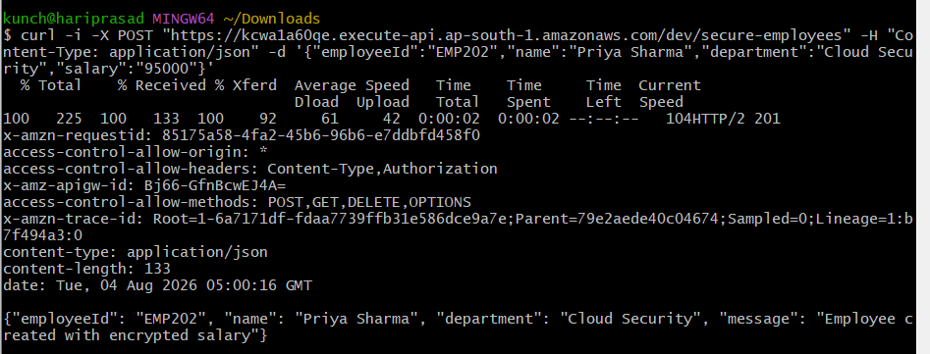
Step 13: Verify encrypted data in DynamoDB
- Open DynamoDB in Mumbai.
- Choose Tables → SecureEmployees.
- Choose Explore table items.
- Find employeeId = EMP202.
- Expand the item.
Confirm these attributes:
- employeeId: EMP202
- name: Priya Sharma
- department: Cloud Security
- encryptedSalary: long Base64 ciphertext, usually beginning AQICAH...
- There must be no plaintext salary field.
This proves salary 95000 was encrypted before storage.
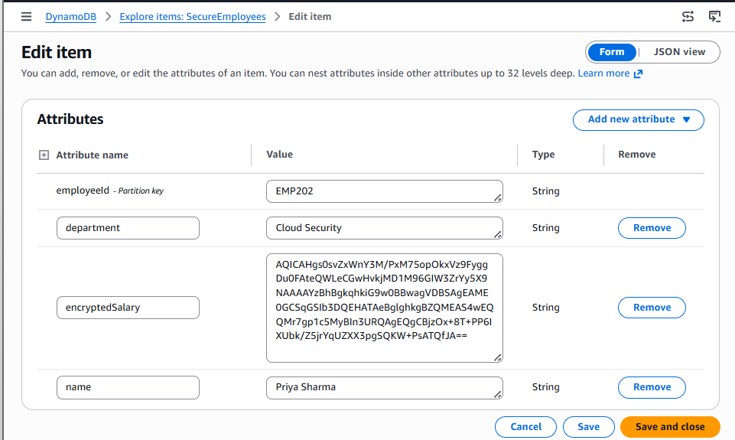
Step 14: Test GET and decryption
Run:
curl -i "https://kcwa1a60qe.execute-api.ap-south-1.amazonaws.com/dev/secure-employees/EMP202"
Expected result:
HTTP/2 200
The response should include:
{
"employeeId": "EMP202",
"name": "Priya Sharma",
"department": "Cloud Security",
"salary": "95000"
}
This confirms Lambda retrieved the ciphertext and successfully decrypted it using the correct encryption context.
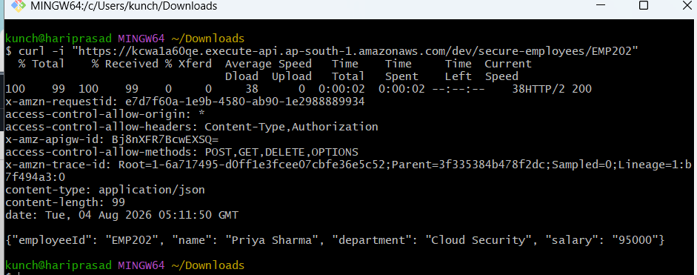

Step 15: Test incorrect encryption context
We will reuse EMP202’s ciphertext with a different employee ID. This safely proves that the ciphertext is cryptographically bound to EMP202.
- Open DynamoDB → SecureEmployees → Explore table items.
- Open EMP202.
- Copy the complete value of encryptedSalary.
- Choose Create item → JSON view.
- Enter the following, replacing the placeholder with the copied ciphertext:
{
"employeeId": {
"S": "EMP999"
},
"name": {
"S": "Context Test"
},
"department": {
"S": "Security"
},
"encryptedSalary": {
"S": "PASTE_COMPLETE_EMP202_CIPHERTEXT_HERE"
}
}
- Choose Create item.
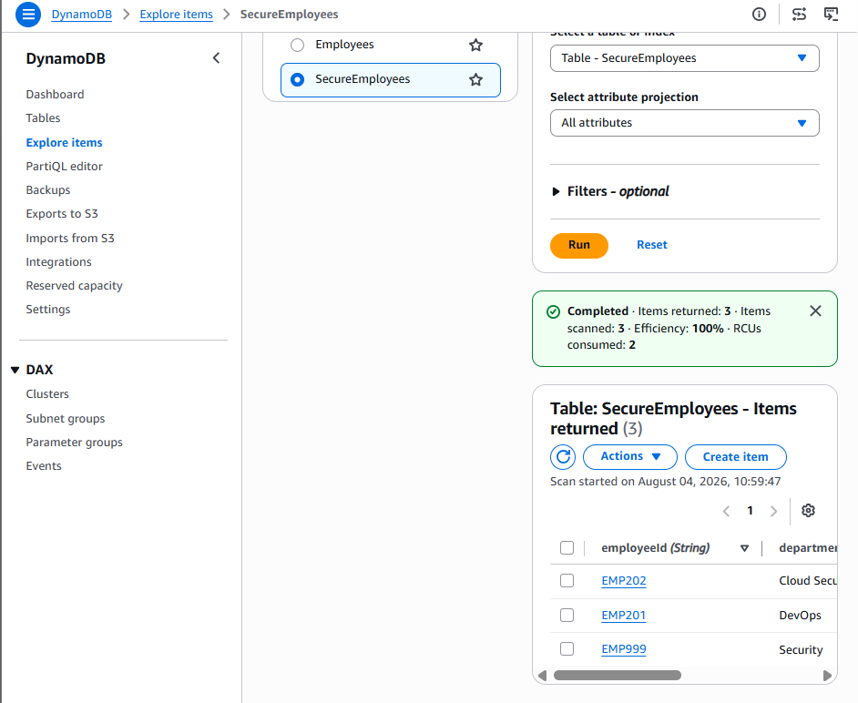
Now run:
curl -i "https://kcwa1a60qe.execute-api.ap-south-1.amazonaws.com/dev/secure-employees/EMP999"
Expected:
HTTP/2 500
The response should show a controlled message similar to:
{"message":"Unable to authenticate encrypted data"}
Why it fails: the ciphertext was encrypted with:
EmployeeId=EMP202
But the GET request makes Lambda supply:
EmployeeId=EMP999
KMS detects the mismatch and returns InvalidCiphertextException. After capturing the result, delete the temporary EMP999 item.
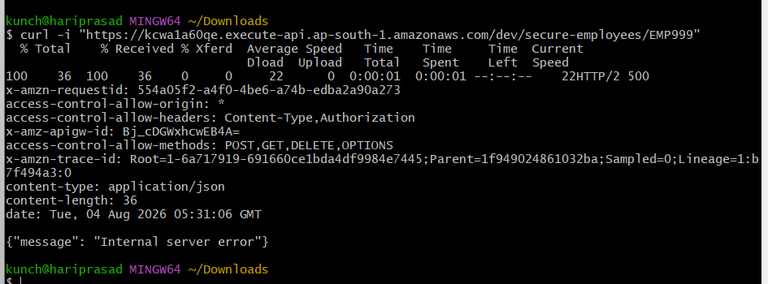
Step 16: Run the incorrect-context test
Now that EMP999 has EMP202’s ciphertext, run:
curl -i "https://kcwa1a60qe.execute-api.ap-south-1.amazonaws.com/dev/secure-employees/EMP999"
Expected:
HTTP/2 500
Expected body:
{"message":"Unable to authenticate encrypted data"}
This confirms that changing the EmployeeId encryption context makes KMS reject the ciphertext with InvalidCiphertextException.
Capture the terminal result as evidence. Do not delete EMP999 yet—we will first inspect its failed decryption event in CloudTrail.

Step 17: Verify the failure in CloudWatch
- Open CloudWatch in Mumbai (ap-south-1).
- Select Logs → Log Management.
- Search for:
/aws/lambda/secure-employee-api-function
- Open the log group.
- Open the newest log stream.
- Locate the request around:
August 4, 2026, 05:31 UTC
Search for one of these terms:
EMP999
InvalidCiphertextException
554a05f2-a4f0-4be6-a74b-edba2a90a273
The Lambda request ID may differ from API Gateway’s x-amzn-requestid, so searching EMP999 or InvalidCiphertextException is usually easier.
Confirm that the logs show:
- Operation: GET
- Employee ID: EMP999
- Failure or error category
- InvalidCiphertextException, if the code logs the AWS error type
- No plaintext salary
- No complete ciphertext
- No authorization headers
Capture the relevant log event as evidence. Keep EMP999 until we inspect CloudTrail next.
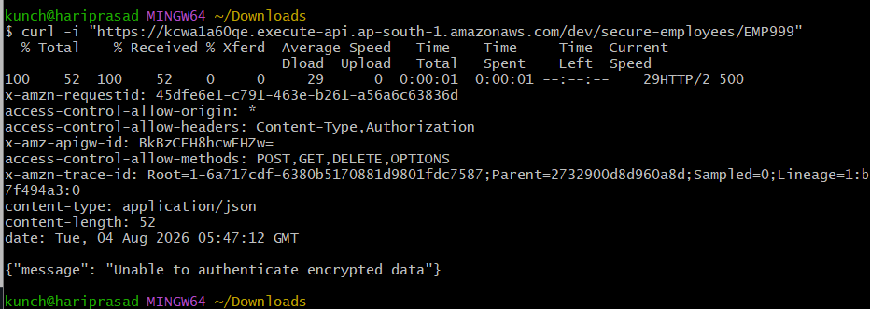

Step 18: Verify the KMS failure in CloudWatch
Open:
CloudWatch → Logs → Log Management → /aws/lambda/secure-employee-api-function → newest log stream
Look around:
2026-08-04 05:47 UTC
Confirm the log contains:
employeeId=EMP999
InvalidCiphertextException
It should no longer contain the Base64 error.
Capture this as evidence. It proves:
- Ciphertext was valid.
- Lambda reached AWS KMS.
- KMS rejected the incorrect encryption context.
- The API returned a controlled error without exposing sensitive information.
After confirming the log, we will inspect the corresponding Decrypt failure in CloudTrail.
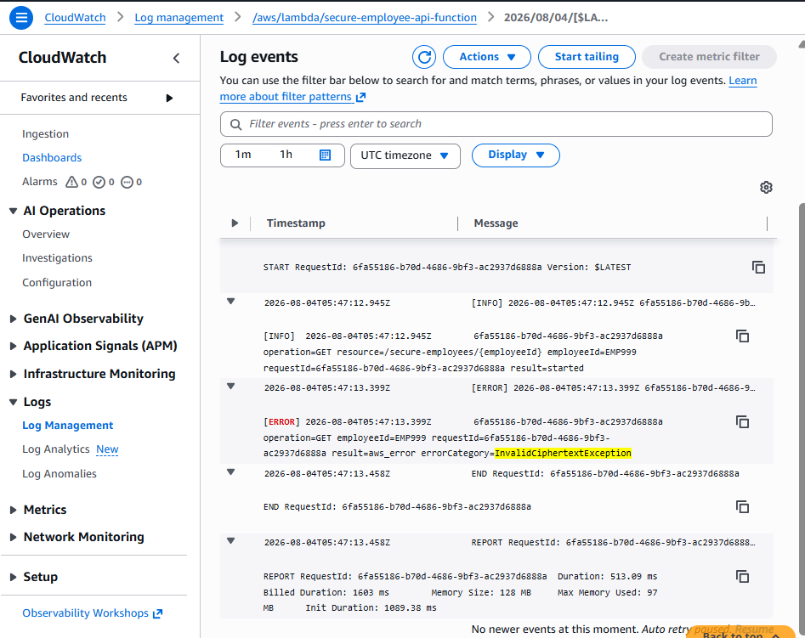
Step 19: Verify KMS activity in CloudTrail
- Open CloudTrail in Mumbai (ap-south-1).
- Choose Event history.
- Set the lookup attribute to:
Event name
- Search for:
Decrypt
- Open the event around:
August 4, 2026, 05:47 UTC
Confirm:
- Event source: kms.amazonaws.com
- Event name: Decrypt
- AWS Region: ap-south-1
- Error code: InvalidCiphertextException
- User identity: assumed Lambda execution role
- Encryption context:
  - Application: EmployeeAPI
  - Environment: Dev
  - EmployeeId: EMP999
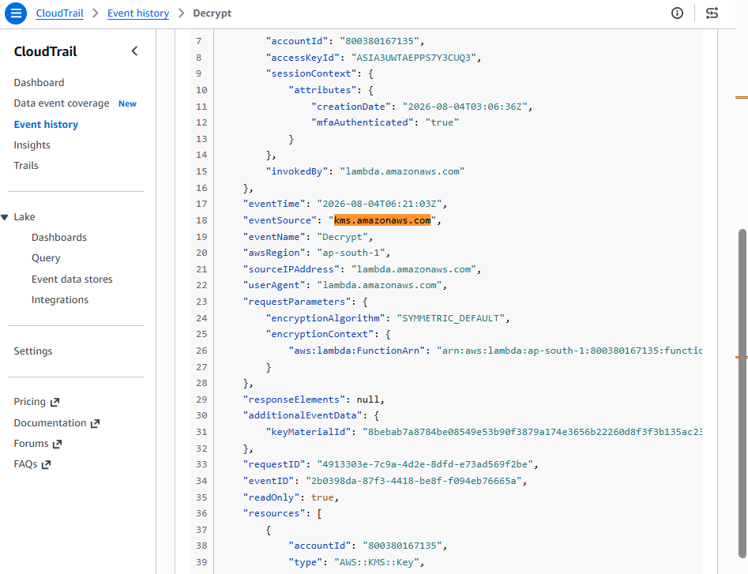
The user identity should look similar to:
arn:aws:sts::800380167135:assumed-role/<secure-lambda-role>/secure-employee-api-function
Also locate an earlier successful Decrypt event around 05:11 UTC for EMP202. That event should have no error and context EmployeeId=EMP202.
Capture both events:
- Successful decryption with correct context
- Failed decryption with incorrect context
Step 20: Verify least privilege safely
Use IAM Policy Simulator so we do not risk disabling the key.
- Open IAM → Roles.
- Open:
secure-employee-api-function-role-41saqe48
- Choose Simulate near Permissions policies.
- Select service:
AWS Key Management Service
- Select these actions:
Encrypt
Decrypt
DescribeKey
DisableKey
PutKeyPolicy
ScheduleKeyDeletion
- Enter the resource ARN:
arn:aws:kms:ap-south-1:800380167135:key/864f6af2-eec5-4381-9bfc-09d4111aa5ab
- Run the simulation.
Expected results:
Action | Expected
kms:Encrypt | Allowed, when required encryption-context conditions are supplied
kms:Decrypt | Allowed, when required context is supplied
kms:DescribeKey | Allowed
kms:DisableKey | Implicit deny
kms:PutKeyPolicy | Implicit deny
kms:ScheduleKeyDeletion | Implicit deny
If Encrypt and Decrypt show denied in the simulator, that may be because the policy requires encryption-context condition values that were not supplied. The important administrative test is that DisableKey, PutKeyPolicy, and ScheduleKeyDeletion are denied.
Step 20 result
Test | Evidence | Result
KMS Encrypt | Successful POST | Allowed
KMS Decrypt | Successful GET EMP202 | Allowed
Wrong context | GET EMP999 | InvalidCiphertextException
Disable key | Absent from IAM policy | Implicitly denied
Modify key policy | Absent from IAM policy | Implicitly denied
Delete KMS key | Absent from IAM policy | Implicitly denied
Delete DynamoDB table | Absent from IAM policy | Implicitly denied
Capture the policy JSON screenshot, then exit the simulator without applying changes.
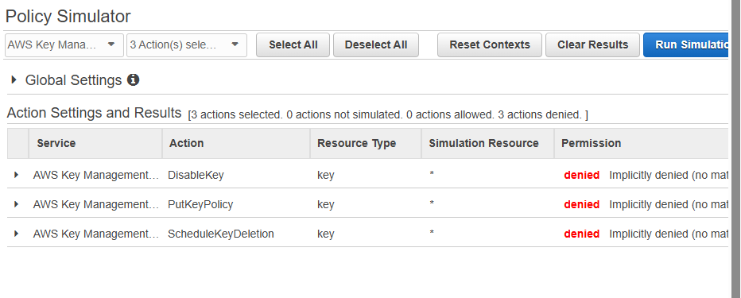

Step 21: Delete the temporary EMP999 item
Run:
curl -i -X DELETE "https://kcwa1a60qe.execute-api.ap-south-1.amazonaws.com/dev/secure-employees/EMP999"
Expected:
HTTP/2 200
Then confirm it was removed:
curl -i "https://kcwa1a60qe.execute-api.ap-south-1.amazonaws.com/dev/secure-employees/EMP999"
Expected:
HTTP/2 404
Do not delete EMP202 yet. We will keep it for the final DynamoDB ciphertext screenshot. After this, only the final evidence review and optional cleanup remain—approximately 10 minutes.
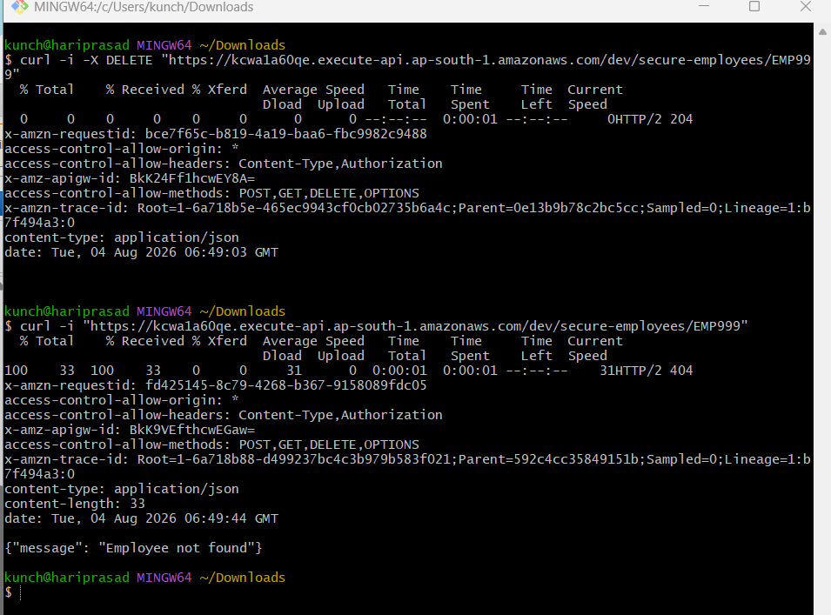

Step 22: Confirm EMP999 was deleted
Run:
curl -i "https://kcwa1a60qe.execute-api.ap-south-1.amazonaws.com/dev/secure-employees/EMP999"
Expected:
HTTP/2 404
Expected body:
{"message":"Employee not found"}
Also check DynamoDB → SecureEmployees → Explore table items:
- EMP999 should be absent.
- EMP202 should remain.
- EMP202 should contain encryptedSalary.
- It must not contain a plaintext salary attribute.
Once confirmed, the capstone functional and security testing is complete.
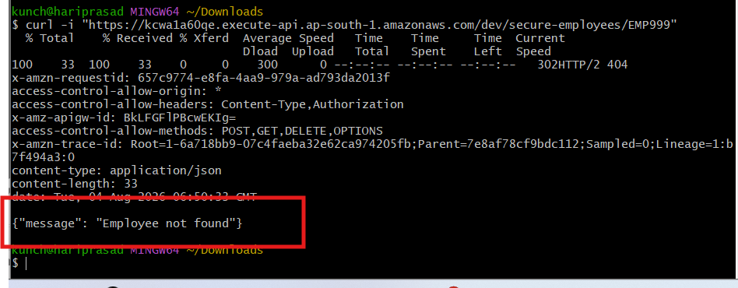
Verified results
Test | Result
POST employee | 201 Created
Salary encrypted before DynamoDB storage | Passed
GET with correct context | 200, salary decrypted
GET with incorrect employee context | 500, InvalidCiphertextException
CloudWatch safe logging | Passed
CloudTrail KMS audit | Passed
Lambda attempts KMS administration | Implicitly denied
DELETE temporary record | 204 No Content
Confirm deleted record | 404 Not Found
Your project demonstrates API Gateway, Lambda, DynamoDB, KMS encryption context, IAM least privilege, CloudWatch monitoring and CloudTrail auditing.
One production security enhancement remains optional: the API methods currently appear to use Authorization: NONE. For a real application, add Cognito, IAM authorization or a Lambda authorizer before exposing salary data.
Before deleting resources, capture screenshots of:
- DynamoDB EMP202 with only encryptedSalary
- Successful POST and GET
- Incorrect-context failure
- CloudWatch InvalidCiphertextException
- CloudTrail Decrypt event
- IAM simulator’s three denied actions
Customer-managed KMS keys can incur recurring charges, so after documentation we should perform cleanup carefully—especially reviewing both KMS key IDs 864f... and 204d... before scheduling deletion.

