Hibernate
Hibernate Framework
Hibernate is a Java framework that simplifies the development of Java applications to interact with the database. It is an open source, lightweight, ORM (Object Relational Mapping) tool. Hibernate implements the specifications of JPA (Java Persistence API) for data persistence.
Data Persistence: - Representing data permanently in backend systems is called “Data Persistence”.
ORM Tool
An ORM tool simplifies the data creation, data manipulation and data access. It is a programming technique that maps the object to the data stored in the database.
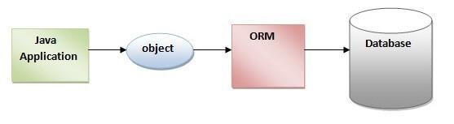
The ORM tool internally uses the JDBC API to interact with the database.
What is JPA?
Java Persistence API (JPA) is a Java specification that provides certain functionality and standard to ORM tools. The javax.persistence package contains the JPA classes and interfaces.
Advantages of Hibernate Framework
Following are the advantages of hibernate framework:
1) Open Source and Lightweight
Hibernate framework is open source and lightweight.
2) Fast Performance
The performance of hibernate framework is fast because cache is internally used in hibernate framework.

3) Database Independent Query
HQL (Hibernate Query Language) is the object-oriented version of SQL. It generates the database independent queries. So you don't need to write database specific queries. Before Hibernate, if the database is changed for the project, we need to change the SQL query as well, which leads to the maintenance problem.
4) Automatic Table Creation
Hibernate framework provides the facility to create the tables of the database automatically. So there is no need to create tables in the database manually.
5) Simplifies Complex Join
Fetching data from multiple tables is easy in hibernate framework.
Hibernate Architecture
The Hibernate architecture includes many objects such as persistent objects, session factory, transaction factory, connection factory, session, transaction etc.
The Hibernate architecture is categorized in four layers.
- Java application layer
- Hibernate framework layer
- Backend API layer
- Database layer

Let's see the diagram of hibernate architecture:
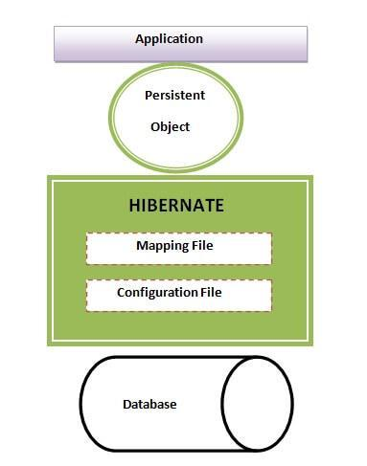
This is the high level architecture of Hibernate with mapping file and configuration file.
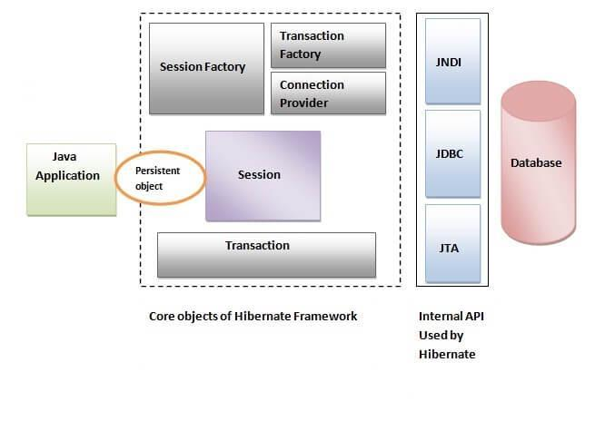
Hibernate framework uses many objects such as session factory, session, transaction etc. along with existing Java API such as JDBC (Java Database Connectivity), JTA (Java Transaction API) and JNDI (Java Naming Directory Interface).

Elements of Hibernate Architecture
For creating the first hibernate application, we must know the elements of Hibernate architecture. They are as follows:

SessionFactory
The SessionFactory is a factory of session and client of ConnectionProvider. It holds a second level cache (optional) of data. The org.hibernate.SessionFactory interface provides a factory method to get the object of Session.

Session
The session object provides an interface between the application and data stored in the database. It is a short-lived object and wraps the JDBC connection. It is a factory of Transaction, Query and Criteria. It holds a first-level cache (mandatory) of data. The org.hibernate.Session interface provides methods to insert, update and delete the object. It also provides factory methods for Transaction, Query and Criteria.

Transaction
The transaction object specifies the atomic unit of work. It is optional. The org.hibernate.Transaction interface provides methods for transaction management.

ConnectionProvider
It is a factory of JDBC connections. It abstracts the application from DriverManager or DataSource. It is optional.

TransactionFactory
It is a factory of Transactions. It is optional.

Hibernate First Example
Here, we are going to create a simple example of a hibernate application using eclipse IDE. For creating the first hibernate application in Eclipse IDE, we need to follow the following steps:
Note :- Download Hibernate related jar files then add those files to the application as well as add a mysql connector jar file if db is mysql.
Create Maven Project of Java then add the following dependencies
- Hibernate - Core(6.0.0 version)
- Mysql Connector

- Create the java project
  - Create the java project by File Menu - New - project - java project . Now specify the project name e.g. firsthb then next - finish .
- Add jar files for hibernate
  - To add the jar files Right click on your project - Build path - Add external archives. Now select all the jar files as shown in the image given below then click open.
- Create the Persistent class
  - Here, we are creating the same persistent class. To create the persistent class, Right click on src - New - Class - specify the class with package name (e.g. com.testpack.mypackage) – finish
public class Employee {
private int id;
private String firstName,lastName;

public int getId() {
return id;
}
public void setId(int id) {
this.id = id;
}
public String getFirstName() {
return firstName;
}
public void setFirstName(String firstName) {
this.firstName = firstName;
}
public String getLastName() {
return lastName;
}
public void setLastName(String lastName) {
this.lastName = lastName;
}
}

- Create the mapping file for Persistent class
  - Here, we are creating the same mapping file. To create the mapping file, Right click on src - new - file - specify the file name (e.g. employee.hbm.xml) - ok. It must be outside the package.

employee.hbm.xml
<?xml version='1.0' encoding='UTF-8'?>
<!DOCTYPE hibernate-mapping PUBLIC
"-//Hibernate/Hibernate Mapping DTD//EN"
"http://www.hibernate.org/dtd/hibernate-mapping-3.0.dtd">

<hibernate-mapping>
<class name="com.mypackage.Employee" table="emp1000">
<id name="id">
<generator class="assigned"></generator>
</id>
<property name="firstName"></property>
<property name="lastName"></property>
</class>
</hibernate-mapping>
- Create the Configuration file
  - The configuration file contains all the information for the database such as connection_url, driver_class, username, password etc. The hbm2ddl.auto property is used to create the table in the database automatically. We will have in-depth learning about Dialect class in the next topics.
  - To create the configuration file, right click on src - new - file. Now specify the configuration file name e.g. hibernate.cfg.xml
<?xml version='1.0' encoding='UTF-8'?>
<!DOCTYPE hibernate-configuration PUBLIC
"-//Hibernate/Hibernate Configuration DTD 5.3//EN"
"http://hibernate.sourceforge.net/hibernate-configuration-5.3.dtd">
<hibernate-configuration>
<session-factory>
<property name="hbm2ddl.auto">update</property>
<property name="dialect">org.hibernate.dialect.Oracle9Dialect</property>
<property name="connection.url">jdbc:oracle:thin:@localhost:1521:xe</property>
<property name="connection.username">system</property>
<property name="connection.password">oracle</property>
<property name="connection.driver_class">oracle.jdbc.driver.OracleDriver</property>
<mapping resource="employee.hbm.xml"/>
</session-factory>
</hibernate-configuration>

For MySQL
<?xml version="1.0" encoding="UTF-8"?>
<!DOCTYPE hibernate-configuration PUBLIC
"-//Hibernate/Hibernate Configuration DTD 5.3//EN"
"http://hibernate.sourceforge.net/hibernate-configuration-5.3.dtd">

<hibernate-configuration>
<session-factory>
<property name="connection.driver_class">com.mysql.cj.jdbc.Driver</property>
<property name="connection.url">jdbc:mysql://localhost:3306/hyberdb</property>
<property name="dialect">org.hibernate.dialect.MySQL5Dialect</property>
<property name="connection.user">root</property>
<property name="connection.password">root</property>
<property name="show_sql">true</property>
<property name="hbm2ddl.auto">update</property>
<mapping resource="emp.hbm.xml"/>
</session-factory>
</hibernate-configuration>

hbm2ddl.auto
create :- It creates a new table every time, before creating a table, it will delete the table if the table already exists.
create-drop :- it create new table every time and after completion action it delete that table automatically
update :- it creates a new table if table does not exist, if it exists just it will continue other operations.
- Create the class that retrieves or stores the persistent object (testMain.java)
Configuration cfg = new Configuration();
cfg.configure("emp.cfg.xml");

SessionFactory sf = cfg.buildSessionFactory();

Session s = sf.openSession();
Transaction t = s.beginTransaction();
Employee emp = new Employee(1001, "Prateek");
Serializable sz = s.save(emp);
t.commit();
s.close();
sf.close();
System.out.println((Integer)sz + " Inserted.....");
- Run the application
Sample Main Class Code
Customer c1 = new Customer();
c1.setCid(1002);
c1.setCname("Pavan Kumar");
c1.setEmail("Pavan@gmail.com");
c1.setPhno("9988123256");
c1.setLoc("Hyderabad");
c1.setPincode("500090");
Date d1 =new Date();
c1.setcDate(d1);

Student s1 = new Student();
s1.setSno(122);
s1.setSname("Sahasra");
s1.setFees(12000.00f);

// persistant object

Configuration cfg = new Configuration();
cfg.configure("hibernate.cfg.xml");// reading content from config file
SessionFactory sf = cfg.buildSessionFactory(); // making connection to database
Session s = sf.openSession();
Transaction t = s.beginTransaction();
s.save(c1); // it will create table and stores data in table from c1 object.
s.save(s1);
t.commit();
sf.close();
s.close();

System.out.println("Rows are Inserted....");

