Spring Data JPA offers several ways to write queries, simplifying data access compared to plain JPA or Hibernate.
1. Derived Query Methods:
Spring Data JPA can automatically generate queries based on the method names defined in your repository interfaces. [1]
public interface UserRepository extends JpaRepository<User, Long> {
List<User> findByEmail(String email);
List<User> findByNameAndAgeGreaterThan(String name, int age);
}
2. JPQL (Java Persistence Query Language) with @Query:
For more complex queries that cannot be expressed through derived methods, you can write JPQL queries using the @Query annotation. JPQL operates on entity objects and their fields.
import org.springframework.data.jpa.repository.Query;
import org.springframework.data.repository.query.Param;
public interface UserRepository extends JpaRepository<User, Long> {
@Query("SELECT u FROM User u WHERE u.name = :name AND u.status = :status")
List<User> findUsersByNameAndStatus(@Param("name") String name, @Param("status") String status);
}

3. Native SQL Queries with @Query:
When you need to leverage database-specific SQL features or optimize performance, you can use native SQL queries by setting nativeQuery = true in the @Query annotation.
import org.springframework.data.jpa.repository.Query;
public interface UserRepository extends JpaRepository<User, Long> {
@Query(value = "SELECT * FROM users WHERE age > ?1", nativeQuery = true)
List<User> findUsersOlderThan(int age);
}

4. Query by Example (QBE):
Spring Data JPA also supports Query by Example, allowing you to build queries dynamically based on an example entity.
import org.springframework.data.domain.Example;
import org.springframework.data.domain.ExampleMatcher;
// ... in your service or component
User user = new User();
user.setName("John");
ExampleMatcher matcher = ExampleMatcher.matching().withIgnoreCase("name");
Example<User> example = Example.of(user, matcher);
List<User> users = userRepository.findAll(example);
5. JPA Criteria API:
For highly dynamic and programmatic query construction, you can use the JPA Criteria API, often combined with custom repository implementations. This provides a type-safe way to build queries.

Lombok
Lombok is a Java library that integrates seamlessly with Spring Boot to significantly reduce boilerplate code. It achieves this by providing annotations that automatically generate common methods like getters, setters, constructors, equals(), hashCode(), and toString() at compile time.

Key benefits of using Lombok in Spring Boot:
- Code Conciseness: Annotations like @Data, @Getter, @Setter, @NoArgsConstructor, and @AllArgsConstructor eliminate the need to manually write these repetitive methods, resulting in much cleaner and more compact code.
- Improved Readability: By removing verbose boilerplate, the core logic of your Spring Boot application becomes more prominent and easier to understand.
- Increased Development Speed: Developers can focus on implementing business logic rather than spending time on generating standard methods, leading to faster development cycles.
- Reduced Errors: Automated code generation minimizes the potential for human errors that can occur when manually writing repetitive code.
Common Lombok annotations used in Spring Boot:
- @Data: A powerful annotation that bundles @Getter, @Setter, @RequiredArgsConstructor, @ToString, and @EqualsAndHashCode.
- @Getter / @Setter: Generates getter and setter methods for fields.
- @NoArgsConstructor / @AllArgsConstructor / @RequiredArgsConstructor: Generates constructors with no arguments, all arguments, or only required arguments, respectively.
- @Builder: Simplifies the creation of builder patterns for complex object instantiation.
- @Slf4j: Provides a convenient way to add a logger instance to your class, simplifying logging setup.
Integration with Spring Boot:
To use Lombok in a Spring Boot project, you typically add the Lombok dependency to your pom.xml (for Maven) or build.gradle (for Gradle). You also need to ensure your IDE has Lombok plugin support enabled for proper compilation and code assistance.

How to configure project Lombok to eclipse?
1. Download the Lombok jar file from this official link.
2. Double click on the downloaded jar file to execute it. A GUI will appear to specify the IDE in which you want to plugin it.
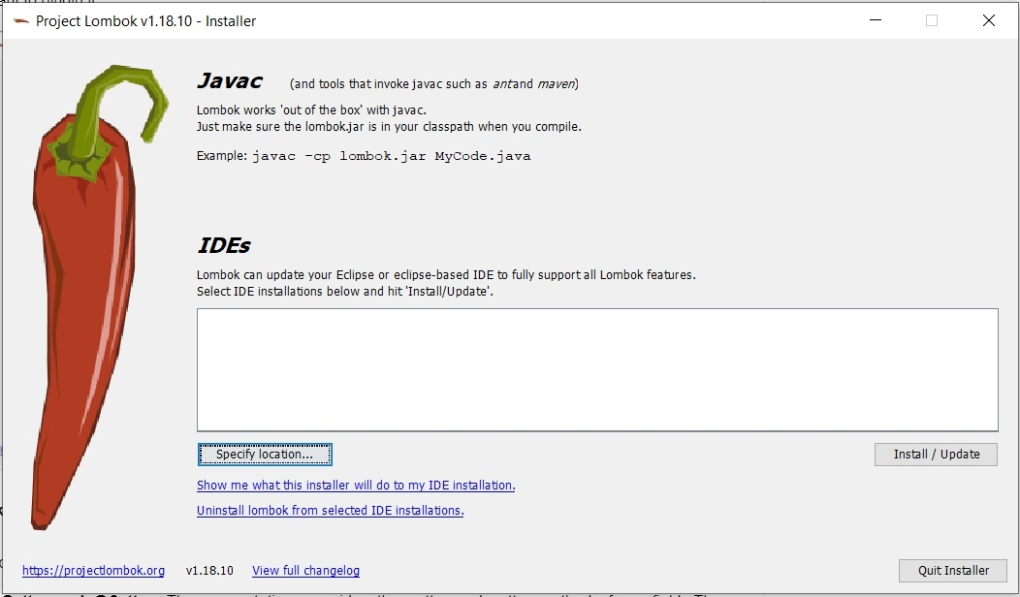
3. Click on specify a location and select the IDE.
4. Click on install to complete the installation and then quit the installer.
5. To verify the correct installation, go to the Eclipse IDE, select help, and then about the eclipse. You will see project Lombok installed there.
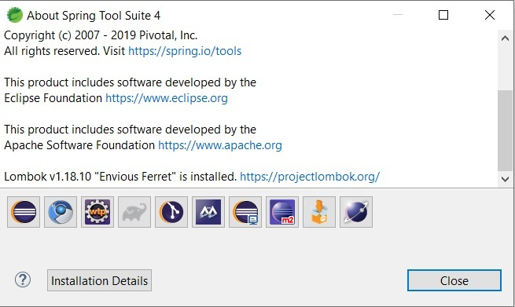
Lombok annotations: Lombok provides a set of annotations to make our coding life easier. Let us look at the few most frequently used annotations of Lombok.
1. @Getter and @Setter: These annotations provide the getter and setter methods for a field. These annotations can be used at both the levels, field as well as class. @Getter annotation generates a getter method with access type as public which simply returns the field and with name getName() if the field name is "Name". @Setter annotation generates a setter method with access type as public which returns void and takes a single parameter to assign the value to the field. The default setter will have the name setName() if the field name is "Name".
import lombok.Getter;
import lombok.Setter;

public class Employee {
private @Getter @Setter Integer employeeId;
private @Getter @Setter String name;
private @Getter @Setter String company;
private @Getter @Setter String emailId;
}
2. @NoArgsConstructor: This annotation is used to generate a constructor with no arguments. It has an empty body and does nothing. It is generally used in combination with some other parameterized constructor in use. It is required when you want to generate an object of the class by passing no arguments in the constructor.
import lombok.NoArgsConstructor;

@NoArgsConstructor
public class Employee {
private Integer employeeId;
private String name;
private String company;
private String emailId;
}
3. @AllArgsConstructor: This annotation is used to generate a parameterized constructor which accepts a single parameter for each field and initializes them using it. It is required when you want to generate an object of the class by passing the initial values of the fields in the constructor.
Before Lombok:
// Before Lombok
public class User {
private String name;
private int age;
​
public User(String name, int age) {
this.name = name;
this.age = age;
}
}

With @AllArgsConstructor:
// Constructor automatically generated by Lombok
​
@AllArgsConstructor
public class User {
private String name;
private int age;
​

}
4. @ToString: This annotation is used to override the toString() method and generate a default implementation for it. The default implementation prints the class name and the fields in order, separated by commas. You can also skip some fields that you don't want to print by annotating them with @ToString.Exclude.
import lombok.ToString;

@ToString
public class Employee {
private Integer employeeId;
private String name;
private String company;
private String emailId;
}
5. @EqualsAndHashCode: This annotation is used to override the equals() and hashCode() methods and provides a default implementation for this. The default implementation uses all the non-static fields, and we can modify it and can exclude some fields using the annotation @EqualsAndHashCode.Exclude.
import lombok.EqualsAndHashCode;

@EqualsAndHashCode
public class Employee {
private Integer employeeId;
private String name;
private String company;
private String emailId;
}
6. @Data: This annotation is a shortcut annotation and bundles @ToString, @Getter, @Setter, @EqualsAndHashCode and @RequiredArgsConstructor annotations into a single annotation. This annotation provides all the normally used boilerplate code in the model classes of java like getters for all the fields, setter for all the non-final fields, a default implementation for toString(), equals() and hashCode() using all the fields of the class and a constructor that initializes all the fields of the class.
import lombok.Data;

@Data
public class Employee {
private Integer employeeId;
private String name;
private String company;
private String emailId;
}
7. @Builder: This annotation can be used remove boilerplate code involved in setting properties for an object. This is useful for POJO's which have many fields.With this annotation setting properties for an object can be done in a single statement of code thereby making it readable and clean.
import lombok.Builder;

@Builder
public class Employee {
private Integer employeeId;
private String name;
private String company;
private String emailId;
}
Example: Using @Builder
import java.io.*;
​
class LombokTest {
public static void main (String[] args) {
Employee employee = Employee.builder().employeeId(21).name("GFG").company("GeeksForGeeks")
.emailId("gfg@geeks.com").build();
}
}

