**Technologies & Frameworks :**

1. JDK Version 1.6 or above
2. Spring Version 2.1.4 or above
3. Spring boot
4. Lombok
5. JMS
6. Jndi
7. Spring Framework
8. Hibernate
9. JPA,JDBC template
10. Spring Rest Webservices
11. Log4j
12. WebLogic

**Data Base:**

1. My SQL

**IDE:**

1. Eclipse

**Tool for testing webservices:**

1. Postman

**Note:** Lombok needs to be installed to generate the getters and setter methods.

**Question 1**: The code currently takes 5000 seconds to run. Improve the code so that it runs faster.

**Class Name**: MessageProcessServiceImpl

**Implementation code snippet**:

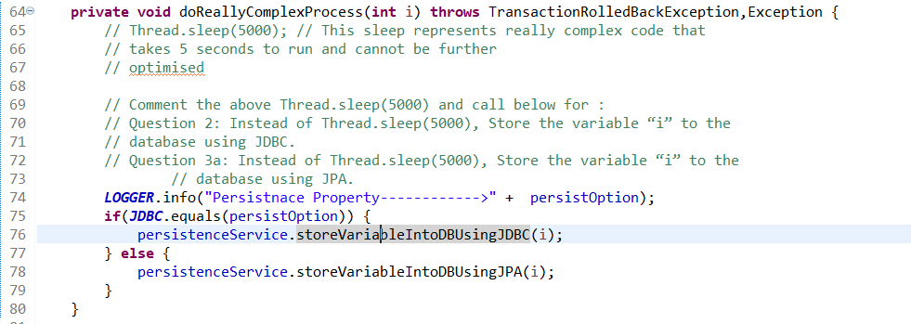

**Implemented Multithread for process**:

**Class Name** : MessageProcessServiceImpl, MessageProcessTaskServiceImpl

**Interface:** MessageProcessService, MessageProcessTaskService

**Implementation code snippet**:

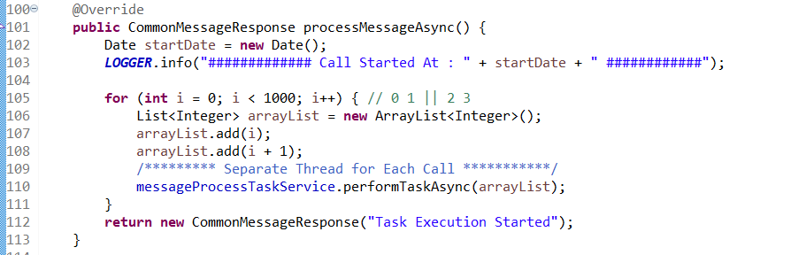

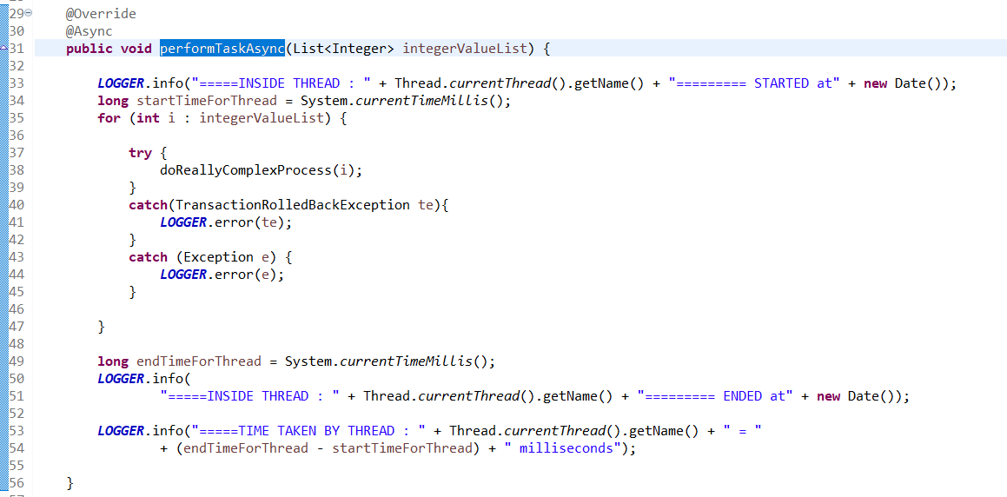

**Question 2:**Instead of Thread.sleep(5000), Store the variable “i” to the database using JDBC.

**Class Names:** MessageProcessServiceImpl, PersistenceServiceImpl, PersistDaoImpl, MessageProcessTaskServiceImpl

**Interfaces**: PersistenceService, PersistDao, MessageProcessTaskService

**Implementation code snippet:**

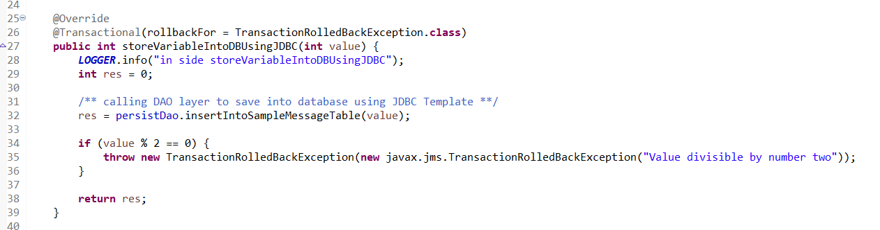

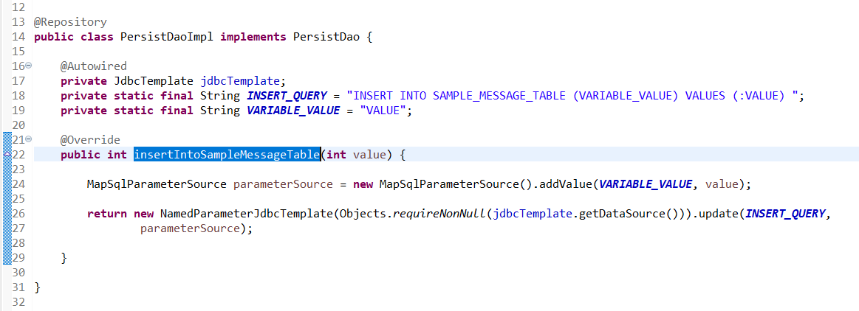

**Question 3a:**Instead of Thread.sleep(5000), Store the variable “i” to the database using JPA.

**Class Name:** PersistenceServiceImpl

**Interface**: SampleMessageEntityRepository, PersistenceService

**Implementation code snippet:**

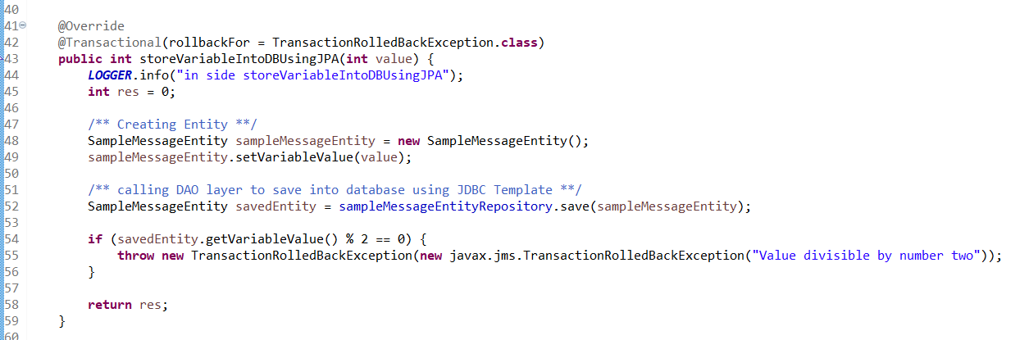

**Question 3b:**After the variable is stored to the database, If the variable is divisible by 2, rollback the transaction so it is not stored into the database, and continue processing.

**Class Names**: PersistenceServiceImpl, PersistDaoImpl, MessageProcessTaskServiceImpl

**Interfaces:** PersistenceService, PersistDao, MessageProcessTaskService

**Implementation code snippet:**





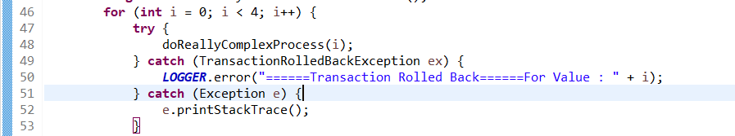

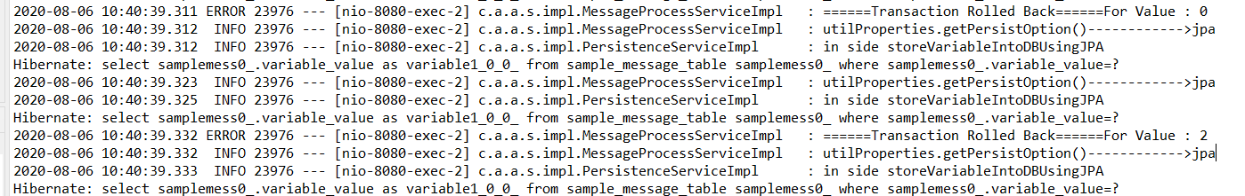

**Question4:**If the message is of Type “TextMessage” then delay the processing by 10 seconds. Provide a solution between and *//Question4 Area Start*and *//Question4 Area Stop.*

**Class Name**: TestQuestion

**Implementation code snippet:**

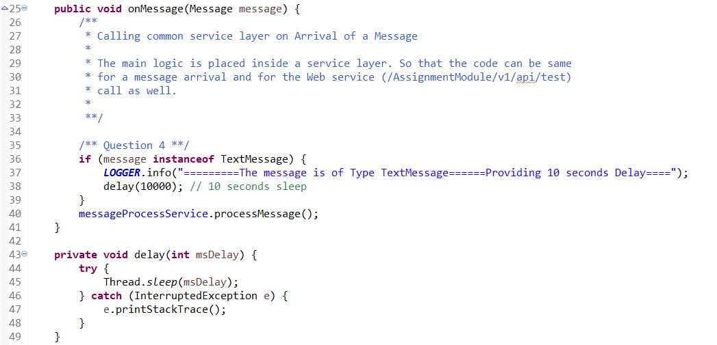

**Question5:**Currentlythis code can only be invoked via JMS.  Modify it so that it is a web service as well.

**Class Names**: MessageProcessorRestControlled

**Implementation code snippet:**

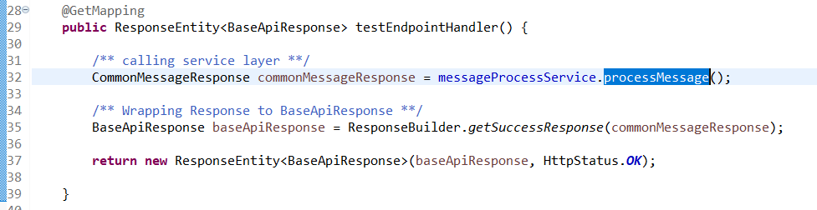

**Status Codes for the request response:**

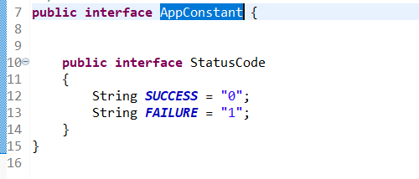

**Rest Webservices testing Result :**

**URL :** <http://localhost:8080/altron/v1/api/message>

**Screenshot from postman:**

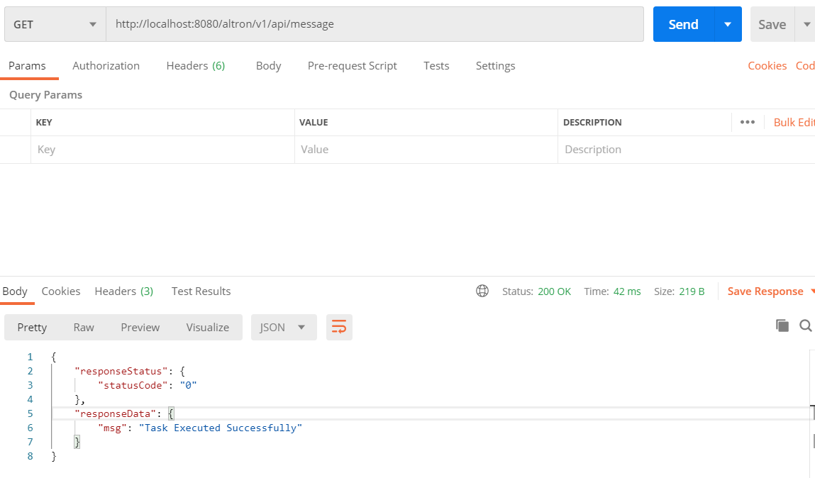

**Output from postman Console:**

