IOCO Robot Service

**Purpose :**

The purpose of this service is to encapsulate the robot apocalypse

**Project Structure :**

**/database/repository** contains database integration code

**/database/model** contains database entities

**/database/dao** contains data access objects

**/service** contains logic for the service

**/src** contains the application Main class and application wide config

**/controller** contains controllers logic

**/config** contains Application configuration

**/constants** contains application constants

**/dto** contains data transfer objects

**Languages,Frameworks & Tools :**

**Application** : Maven, Java, SpringBoot, Swagger, H2 database

**API's :**

**/survivor/register - [POST]** -- To register survivor

**/survivor/reportSurvivorInfected - [PUT]** -- To report infected survivor

**/survivor/update - [PUT]** -- To update the survivor

**/reports - [GET]** -- To get the reports

**/robots - [GET]** -- to get the sorted robots list

**Swagger UI:**

URL: http://localhost:8080/swagger-ui/index.html#

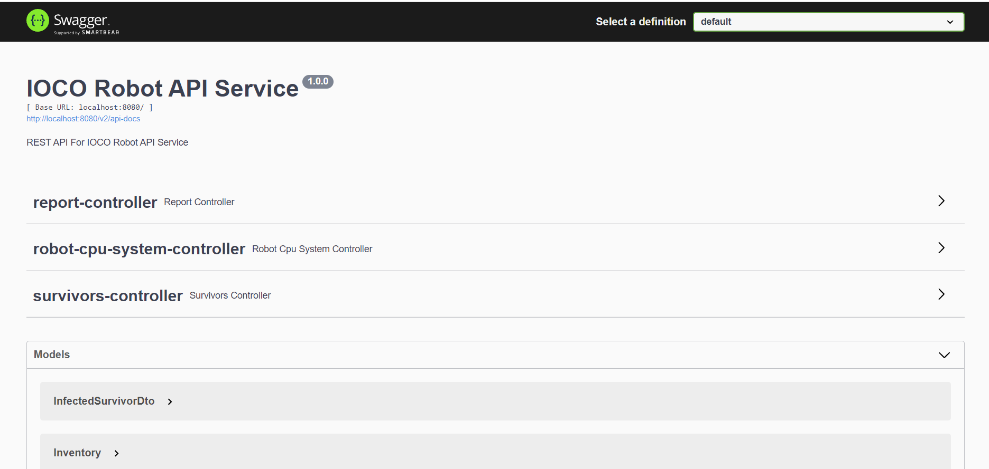

**Survivor Registration API :**

**URL:**

**http://localhost:8080/survivor/register**

**Method** : POST

Request Payload:

{

    "id":"98765",

    "name":"venu",

    "age":"25",

    "gender":"FEMALE",

    "latitude":"987656364",

    "longitude":"87364895",

    "isInfected":"false",

    "inventory":{

         "water":"N",

         "food":"N",

         "medication":"N",

         "ammunition":"N"

    }

}

**Response for validation errors :**

[

    {

        "responseCode": "422",

        "responseMessage": "Field must not be null  ||  Latitude",

        "message": "FAILURE"

    },

    {

        "responseCode": "422",

        "responseMessage": "Field must not be null  ||  Longitude",

        "message": "FAILURE"

    },

    {

        "responseCode": "422",

        "responseMessage": "Field must not be null  ||  Name",

        "message": "FAILURE"

    },

    {

        "responseCode": "422",

        "responseMessage": "Please provide the valid number  ||  Age",

        "message": "FAILURE"

    },

    {

        "responseCode": "422",

        "responseMessage": "Please provide the valid number  ||  Id",

        "message": "FAILURE"

    },

    {

        "responseCode": "422",

        "responseMessage": "Gender should be MALE,FEMALE || Gender",

        "message": "FAILURE"

    },

    {

        "responseCode": "422",

        "responseMessage": "field should be Y,N  ||  Water",

        "message": "FAILURE"

    }

]

**Successful Response :**

{

    "responseCode": "200",

    "responseMessage": "SUCCESSFUL",

    "message": "Survivor registration successful"

}

**Failed Response :**

{

    "responseCode": "500",

    "responseMessage": "FAILURE",

    "message": "Survivor already exist"

}

**Survivor Update API :**

**Url**

**http://localhost:8080/survivor/update**

**Method:** PUT

**Request payload :**

{

    "id":"98765",

    "name":"venu",

    "age":"25",

    "gender":"FEMALE",

    "latitude":"987656364",

    "longitude":"87364895",

    "isInfected":"false",

    "inventory":{

         "water":"N",

         "food":"N",

         "medication":"N",

         "ammunition":"N"

    }

}

**Response :**

**Failed response:**

**{**

**"responseCode": "500",**

**"responseMessage": "FAILURE",**

**"message": "Survivor does not exist"**

**}**

**Success Response :**

{

    "responseCode": "200",

    "responseMessage": "SUCCESSFUL",

    "message": "Survivor updated successfully"

}

**Report Infected Survivor API :**

**http://localhost:8080/survivor/reportSurvivorInfected**

**Method PUT,**

This API will allow Survivor to update he infected Survivor three times after that it will mark as infected

Request payload :

{

"infectedSurvivorId": 0

}

Successful response :

**"responseCode": "200",**

**"responseMessage": "SUCCESSFUL",**

**"message": "Infected Survivor Updated successfully"**

**}**

After three times reported response :

**{**

**"responseCode": "200",**

**"responseMessage": "SUCCESSFUL",**

**"message": " Survivor already Infected"**

**}**

Failed response:

**{**

**"responseCode": "200",**

**"responseMessage": "FAILURE",**

**"message": "Survivor does not exist"**

**}**

**Robot CPU system API :**

**http://localhost:8080/robots**

method GET,

Sorted Robot Response :

**[**

**{**

**"model": "0DKO8",**

**"serialNumber": "247CZL6DXQPKUI9",**

**"manufacturedDate": "2021-11-11T23:20:52.200+00:00",**

**"category": "Flying"**

**},**

**{**

**"model": "1W7S9",**

**"serialNumber": "V1CZSEZXLGL0ZXF",**

**"manufacturedDate": "2021-10-24T23:20:52.200+00:00",**

**"category": "Flying"**

**},**

**{**

**"model": "5ZZKH",**

**"serialNumber": "Y9HDK9G233O1UNP",**

**"manufacturedDate": "2021-10-21T23:20:52.200+00:00",**

**"category": "Flying"**

**},**

**{**

**"model": "9JGTE",**

**"serialNumber": "4X3TFA32ON4YM0F",**

**"manufacturedDate": "2021-11-02T23:20:52.200+00:00",**

**"category": "Flying"**

**},**

**{**

**"model": "A9UVK",**

**"serialNumber": "MLSTULTAG7UGFIG",**

**"manufacturedDate": "2021-10-30T23:20:52.200+00:00",**

**"category": "Flying"**

**},**

**{**

**"model": "CYNE4",**

**"serialNumber": "98W8ZIMU0XZE2V2",**

**"manufacturedDate": "2021-10-12T23:20:52.200+00:00",**

**"category": "Flying"**

**},**

**{**

**"model": "EZNQO",**

**"serialNumber": "OQG2F6XTP873TDG",**

**"manufacturedDate": "2021-11-17T23:20:52.200+00:00",**

**"category": "Flying"**

**},**

**{**

**"model": "G40QO",**

**"serialNumber": "OGCSWRKG11BOT23",**

**"manufacturedDate": "2021-10-18T23:20:52.200+00:00",**

**"category": "Flying"**

**},**

**{**

**"model": "GD8WX",**

**"serialNumber": "GVKGGGFMJF4JSU3",**

**"manufacturedDate": "2021-10-06T23:20:52.200+00:00",**

**"category": "Flying"**

**},**

**{**

**"model": "GWP5H",**

**"serialNumber": "T7Z0OE1MPJK7Y2E",**

**"manufacturedDate": "2021-11-14T23:20:52.200+00:00",**

**"category": "Flying"**

**},**

**{**

**"model": "JIYH5",**

**"serialNumber": "KQM7593VFRDNH6Q",**

**"manufacturedDate": "2021-10-03T23:20:52.200+00:00",**

**"category": "Flying"**

**},**

**{**

**"model": "P1QLD",**

**"serialNumber": "BHGVMKDDQHZX0KV",**

**"manufacturedDate": "2021-11-08T23:20:52.200+00:00",**

**"category": "Flying"**

**},**

**{**

**"model": "PXGVT",**

**"serialNumber": "HCGU39VAQ7979JR",**

**"manufacturedDate": "2021-11-05T23:20:52.200+00:00",**

**"category": "Flying"**

**},**

**{**

**"model": "R1YN8",**

**"serialNumber": "T44AU46Q49DSX2Y",**

**"manufacturedDate": "2021-10-27T23:20:52.200+00:00",**

**"category": "Flying"**

**},**

**{**

**"model": "VU61P",**

**"serialNumber": "FJBXSF83J6AMHVD",**

**"manufacturedDate": "2021-10-15T23:20:52.200+00:00",**

**"category": "Flying"**

**},**

**{**

**"model": "YJVBC",**

**"serialNumber": "ASH27QZWPWB405R",**

**"manufacturedDate": "2021-10-09T23:20:52.200+00:00",**

**"category": "Flying"**

**},**

**{**

**"model": "YVBV3",**

**"serialNumber": "5Z7PLKZGC2BN1MC",**

**"manufacturedDate": "2021-09-30T23:20:52.198+00:00",**

**"category": "Flying"**

**},**

**{**

**"model": "0373I",**

**"serialNumber": "8VQIHP9J4F6BTGH",**

**"manufacturedDate": "2021-10-01T23:20:52.200+00:00",**

**"category": "Land"**

**},**

**{**

**"model": "0D8AD",**

**"serialNumber": "D7NJUKOOZDKJC6B",**

**"manufacturedDate": "2021-10-22T23:20:52.200+00:00",**

**"category": "Land"**

**},**

**{**

**"model": "1E8XF",**

**"serialNumber": "EUGBPOZFTWM8KCQ",**

**"manufacturedDate": "2021-10-29T23:20:52.200+00:00",**

**"category": "Land"**

**},**

**{**

**"model": "37K3L",**

**"serialNumber": "3B2GI8PCMJKXZPW",**

**"manufacturedDate": "2021-10-11T23:20:52.200+00:00",**

**"category": "Land"**

**},**

**{**

**"model": "3CXQD",**

**"serialNumber": "5Y9VBF3C6TXF0V0",**

**"manufacturedDate": "2021-11-01T23:20:52.200+00:00",**

**"category": "Land"**

**},**

**{**

**"model": "3CZHA",**

**"serialNumber": "O8OLGE0110KSBA4",**

**"manufacturedDate": "2021-10-16T23:20:52.200+00:00",**

**"category": "Land"**

**},**

**{**

**"model": "5NPK3",**

**"serialNumber": "WP9X8W31V4T5DMJ",**

**"manufacturedDate": "2021-11-03T23:20:52.200+00:00",**

**"category": "Land"**

**},**

**{**

**"model": "5O3Q9",**

**"serialNumber": "W4MYTF5EXH5A2OH",**

**"manufacturedDate": "2021-10-14T23:20:52.200+00:00",**

**"category": "Land"**

**},**

**{**

**"model": "7M34A",**

**"serialNumber": "UMBL9PR6GW1TMM3",**

**"manufacturedDate": "2021-10-31T23:20:52.200+00:00",**

**"category": "Land"**

**},**

**{**

**"model": "8QYTT",**

**"serialNumber": "W6HY2GGZ9IQJC1Z",**

**"manufacturedDate": "2021-11-18T23:20:52.200+00:00",**

**"category": "Land"**

**},**

**{**

**"model": "A8ME0",**

**"serialNumber": "IWQSMEL67ZCGX3B",**

**"manufacturedDate": "2021-10-20T23:20:52.200+00:00",**

**"category": "Land"**

**},**

**{**

**"model": "BI14U",**

**"serialNumber": "5KD6GNSIGNSO1WX",**

**"manufacturedDate": "2021-11-09T23:20:52.200+00:00",**

**"category": "Land"**

**},**

**{**

**"model": "ECBYH",**

**"serialNumber": "7VIRHR29O6BLTH3",**

**"manufacturedDate": "2021-11-12T23:20:52.200+00:00",**

**"category": "Land"**

**},**

**{**

**"model": "FV8GV",**

**"serialNumber": "U0HCH9Q69YGAW1H",**

**"manufacturedDate": "2021-11-10T23:20:52.200+00:00",**

**"category": "Land"**

**},**

**{**

**"model": "GOTHF",**

**"serialNumber": "LFC01TYH2K2F735",**

**"manufacturedDate": "2021-10-08T23:20:52.200+00:00",**

**"category": "Land"**

**},**

**{**

**"model": "GQMVG",**

**"serialNumber": "V99HABBBAT6M8IL",**

**"manufacturedDate": "2021-10-26T23:20:52.200+00:00",**

**"category": "Land"**

**},**

**{**

**"model": "GXTFE",**

**"serialNumber": "EC8S2ZN3DR47HUF",**

**"manufacturedDate": "2021-11-16T23:20:52.200+00:00",**

**"category": "Land"**

**},**

**{**

**"model": "H5PQA",**

**"serialNumber": "MBXTY82AQ5V360S",**

**"manufacturedDate": "2021-11-04T23:20:52.200+00:00",**

**"category": "Land"**

**},**

**{**

**"model": "IOMIN",**

**"serialNumber": "8TCEKKWKOL11YGD",**

**"manufacturedDate": "2021-10-23T23:20:52.200+00:00",**

**"category": "Land"**

**},**

**{**

**"model": "IQB6V",**

**"serialNumber": "FEMNKI3HL8L7I4W",**

**"manufacturedDate": "2021-10-04T23:20:52.200+00:00",**

**"category": "Land"**

**},**

**{**

**"model": "J4DZY",**

**"serialNumber": "N2TT6Y4XJ7XGGV0",**

**"manufacturedDate": "2021-11-07T23:20:52.200+00:00",**

**"category": "Land"**

**},**

**{**

**"model": "LNHSM",**

**"serialNumber": "2Y0OMRRM5W2H1V0",**

**"manufacturedDate": "2021-10-05T23:20:52.200+00:00",**

**"category": "Land"**

**},**

**{**

**"model": "M2YFO",**

**"serialNumber": "HB40HT2HKNS5Z0B",**

**"manufacturedDate": "2021-10-17T23:20:52.200+00:00",**

**"category": "Land"**

**},**

**{**

**"model": "MEYDX",**

**"serialNumber": "MTRNIP3K8XRBH19",**

**"manufacturedDate": "2021-10-19T23:20:52.200+00:00",**

**"category": "Land"**

**},**

**{**

**"model": "OGYVZ",**

**"serialNumber": "XON0GJDCTCFTF8L",**

**"manufacturedDate": "2021-10-13T23:20:52.200+00:00",**

**"category": "Land"**

**},**

**{**

**"model": "QN8B3",**

**"serialNumber": "1RMYFEFWEQHOU5F",**

**"manufacturedDate": "2021-10-07T23:20:52.200+00:00",**

**"category": "Land"**

**},**

**{**

**"model": "U1Q99",**

**"serialNumber": "32K0IZ8N34UZ463",**

**"manufacturedDate": "2021-11-06T23:20:52.200+00:00",**

**"category": "Land"**

**},**

**{**

**"model": "U4J9K",**

**"serialNumber": "YEAOMTU52KWQ4J2",**

**"manufacturedDate": "2021-10-25T23:20:52.200+00:00",**

**"category": "Land"**

**},**

**{**

**"model": "UMYIK",**

**"serialNumber": "BOHLJ9ZLGWDOJFN",**

**"manufacturedDate": "2021-11-15T23:20:52.200+00:00",**

**"category": "Land"**

**},**

**{**

**"model": "UWP07",**

**"serialNumber": "2ZEOLWK56Q4YIM5",**

**"manufacturedDate": "2021-10-02T23:20:52.200+00:00",**

**"category": "Land"**

**},**

**{**

**"model": "WOV6W",**

**"serialNumber": "P843YCQ0AQ72RFF",**

**"manufacturedDate": "2021-10-10T23:20:52.200+00:00",**

**"category": "Land"**

**},**

**{**

**"model": "Z3FM6",**

**"serialNumber": "DMJTJ6PN2CXCVHB",**

**"manufacturedDate": "2021-11-13T23:20:52.200+00:00",**

**"category": "Land"**

**},**

**{**

**"model": "ZE2NK",**

**"serialNumber": "ST4JOJSV7LO28XW",**

**"manufacturedDate": "2021-10-28T23:20:52.200+00:00",**

**"category": "Land"**

**}**

**]**

**Reports API :**

**http://localhost:8080/reports**

Method GET,

Response:

**{**

**"message": "SUCCESSFUL",**

**"percentageOfInfectedSurvivors": 100,**

**"percentageOfNonInfectedSurvivors": 0,**

**"infectedSurvivors": [**

**{**

**"id": 9876598,**

**"name": "Venu",**

**"age": 30,**

**"gender": "MALE",**

**"latitude": "9876563641",**

**"longitude": "87364895",**

**"inventory": {**

**"id": 2,**

**"water": "N",**

**"food": "N",**

**"medication": "N",**

**"ammunition": "N"**

**},**

**"isInfected": true,**

**"infectionReportCount": 3**

**}**

**],**

**"nonInfectedSurvivors": [],**

**"robots": [**

**{**

**"model": "01NVX",**

**"serialNumber": "API4J2EDTJU7T4T",**

**"manufacturedDate": "2021-10-17T23:23:55.325+00:00",**

**"category": "Land"**

**},**

**{**

**"model": "01PQK",**

**"serialNumber": "V64WPJKNFC67IO4",**

**"manufacturedDate": "2021-09-30T23:23:55.324+00:00",**

**"category": "Flying"**

**},**

**{**

**"model": "1815J",**

**"serialNumber": "6VT538T51RXDW5W",**

**"manufacturedDate": "2021-11-18T23:23:55.325+00:00",**

**"category": "Land"**

**},**

**{**

**"model": "2XY2V",**

**"serialNumber": "Z1C0LT7YFZI9PBW",**

**"manufacturedDate": "2021-10-31T23:23:55.325+00:00",**

**"category": "Land"**

**},**

**{**

**H2 Database screenshot :**

**Database credentials :** Please refer the application.properties

**Console URL :** http://localhost:8080/h2-console/login.jsp

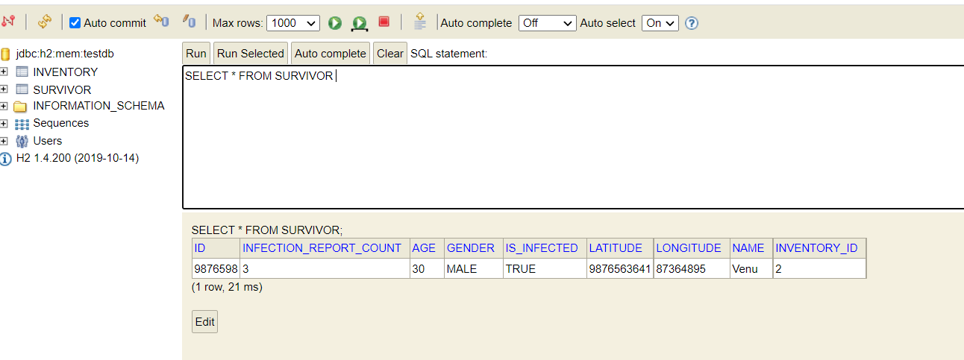

Thanks you!