1. **Configure Classic Load balancer.**

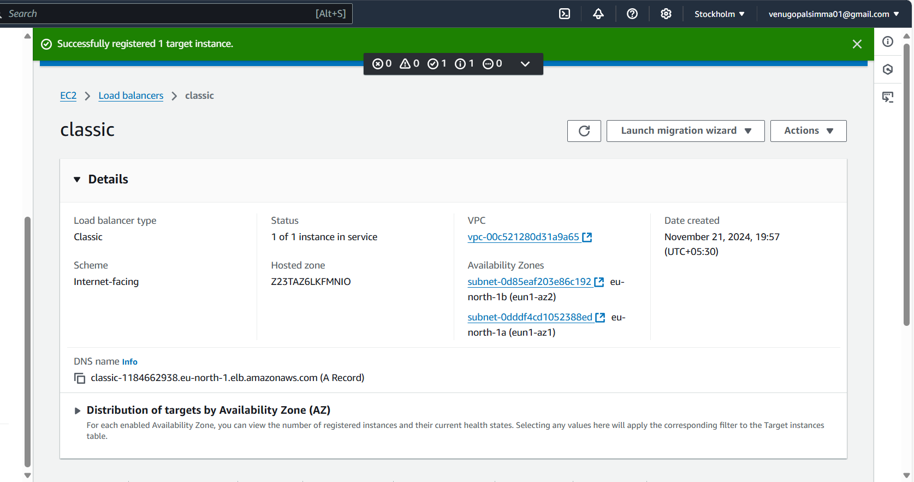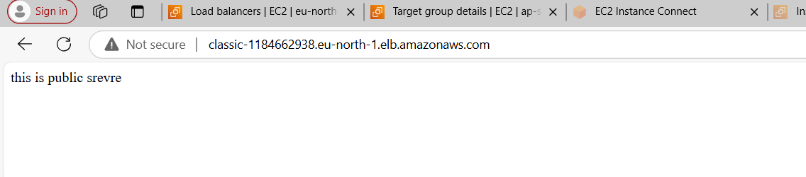

1. **Configure Application Load balancer.**

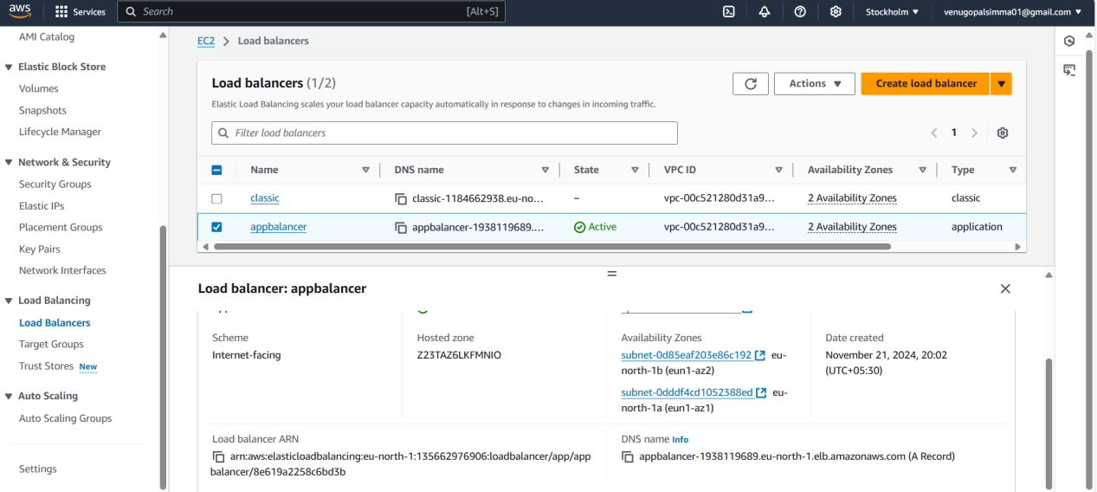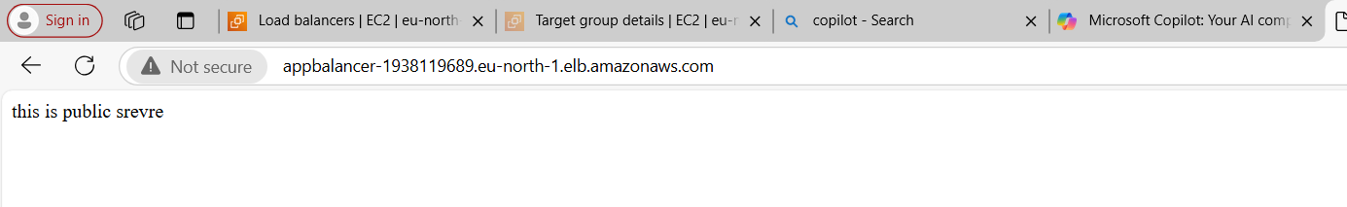

1. **Configure Network Load balancer.**

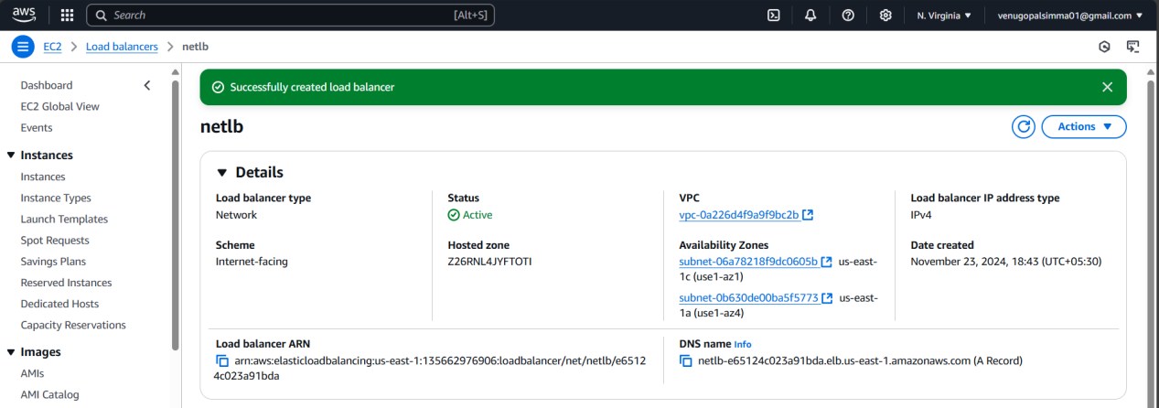

1. **Attach SSL for application load balancer.**

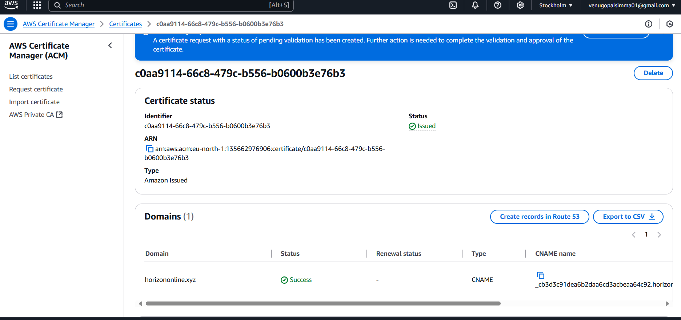

1. **Map Applciation load balancer to R53.**

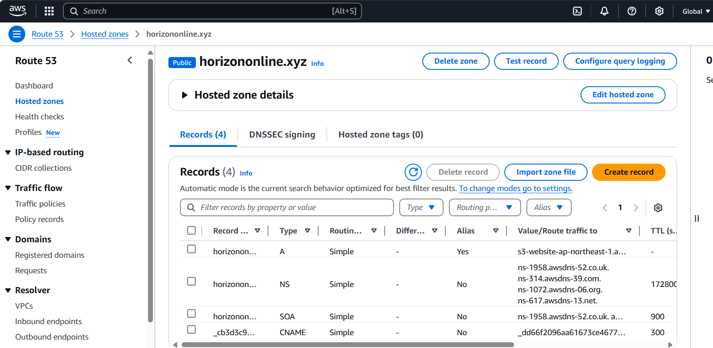

1. **Push the application load balancer logs to s3.**

