A3 – Deployment demo section and reproduction appendix (draft)
Nov 6, 2026 · @venu

Deployment demo
We deployed nested CLaRa with the learned budget head as a local web app (demo_app.py, Gradio) that runs the full pipeline for one question in 0.1–0.8 s on an L40S GPU. The user picks one of 50 held-out questions (or types their own question about the same passages) and a total memory budget of 16, 32, 64 or 128 vectors. The page then shows every stage of the system:
- Retrieval. All 10 candidate passages, ranked by the trained query reasoner's cosine score, with the gold passages marked and the 4 that the generator reads highlighted.
- Budget splits. How the total budget is divided over the 4 retrieved passages in three ways: the learned budget head (its most likely split and that split's probability), CLaRa's uniform split, and our top-heavy rule.
- Answers. The answer generated with each split, with exact match and F1 against the gold answer.
Every passage is compressed once into 32 nested memory vectors and cached, so a split only decides how many of each passage's vectors the generator reads; changing the budget does not re-compress anything. The app loads any trained run with --run (default: the A2 budget-head model on 2WikiMultihopQA, seed 42).

Architecture and why a local app
The demo is one Python process on the GPU server; the laptop only displays the page through an SSH tunnel, and the budget split (highlighted) is the stage our method adds to CLaRa.
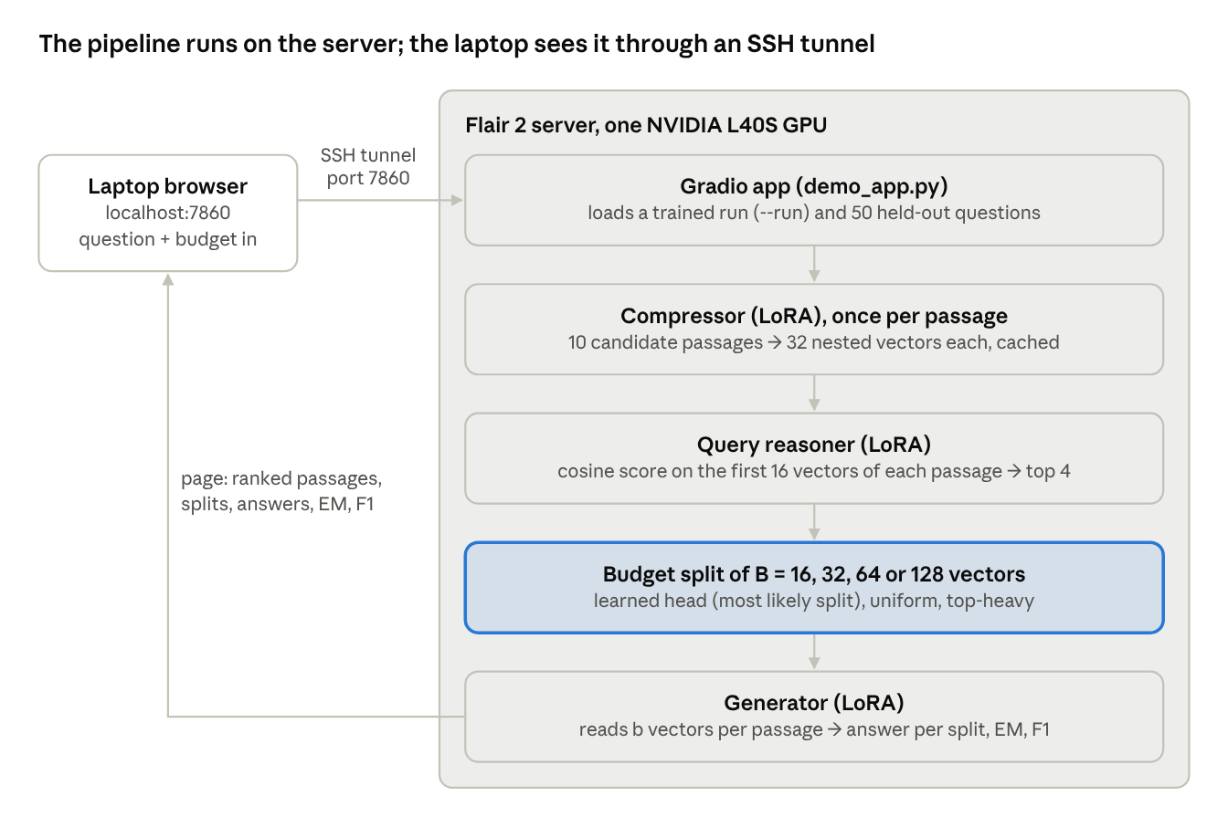
demo architecture · laptop, SSH tunnel, five stages on the server
A local app is the right deployment for this project for three reasons:
- Shared GPU server. Other users' jobs run on the same GPUs. The app runs only while we use it, and the SSH tunnel needs no open port on the server.
- Research prototype. A 0.5B model with checkpoints that live on the server, answering one question at a time. Public hosting would add scaling and authentication work without showing anything more about the method.
- Same code path as the evaluation. The app loads the same checkpoints and chooses splits exactly as evaluate.py does (checked on a test model), so what the demo shows is what our tables measure.

How to run the demo
The demo needs one GPU on the server (or several seconds per question on a CPU) and is opened from a laptop browser.
- Install Gradio in its own environment on the server, so the training environment stays untouched. The versions are pinned because Gradio 6 needs huggingface_hub 1.x, which Transformers 4.46.3 does not support:
python3 -m venv ~/demo_env --system-site-packages
~/demo_env/bin/pip install "gradio==4.44.1" "fastapi==0.112.2" "huggingface_hub<1.0"
- Start the app on the server:
CUDA_VISIBLE_DEVICES=1 ~/demo_env/bin/python demo_app.py
- On the laptop, open an SSH tunnel and browse to http://localhost:7860:
ssh -L 7860:localhost:7860 <user>@<server>
Options: --run runs/qwen/<dataset>/<run> loads another trained model (for example the seed-43 budget head), --dataset hotpotqa switches the question set, --port changes the port if 7860 is taken on the shared server, and --share prints a public gradio.live link instead of using a tunnel.

Four examples from the demo
The four cases below show both what the system does well and where it breaks; in every case the budget split does not change the answer, which matches our main A2 finding.
Case | Question (type) | Retrieval | Answer vs gold | What it shows
A | Do The Christian Licorice Store and The Crime of Korea come from the same country? (comparison) | 1 of 2 gold read; the other at rank 6 | “yes” = gold, all splits, at 64 and 128 vectors | Yes/no comparison questions can be answered without full evidence
B | Who is the paternal grandfather of Felicity Tree? (inference, two hops) | 2 of 2 gold read, ranks 1 and 2 | “Sir Henry Tree” vs Julius Beerbohm, wrong for all splits, still wrong at 128 vectors | The answer stops at the first hop; more memory does not fix it
C | Own question on the same passages: Who is the father of Felicity Tree? (one hop) | Both relevant passages at ranks 1 and 2 | “Sir Henry Tree” vs Sir Herbert Beerbohm Tree | Right person, garbled first name: compression keeps the gist, loses exact names
D | Place of birth of the director of Prostitution (1963 film)? (compositional), seed-43 head | 2 of 2 gold read | “Maghreb Institute” vs Algeria, all splits | The learned split [32, 16, 8, 8] differs from uniform, yet the answer is the same
Case A (Figure X). The query reasoner ranked one gold passage second and the other sixth, so the generator read only one of them. It still answered “yes” correctly, as yes/no answers can often be guessed from the question; our extra metrics show the same: F1 on yes/no answers barely depends on memory. The seed-42 budget head chose the uniform split with probability 0.08, close to 1/13 for the 13 possible splits of 64 vectors, so this head has almost no preference.
Cases B and C (Figures Y, Z). Retrieval was perfect, yet the two-hop question got the father's name instead of the grandfather's, and with all 128 vectors (every passage complete) the answer did not change. Asking the one-hop question directly returns the same “Sir Henry Tree”: the model finds the bridge person but garbles his first name and never takes the second hop. The bottleneck is what the compressed memory and the 0.5B generator can recover, not how the budget is split.
Case D (Figure W). The seed-43 budget head, which in A2 learned to favour gold documents, gives the top-ranked passage the most memory ([32, 16, 8, 8], probability 0.12 against 0.08 for no preference). All three splits still give the same wrong answer, close in topic to the gold one (the Maghreb is the region that includes Algeria).

Comparison with a standard text RAG
To place the deployed system against a conventional pipeline, we compare it with a standard text RAG on the same 300 held-out questions per dataset: the same Qwen2.5-0.5B base model with no training, reading BM25's top-4 passages as raw text (about 500 tokens). Besides EM and F1 we report ROUGE-2, ROUGE-L (computed exactly as the rouge-score package) and containment, the share of answers that contain the gold answer. demo_app_compare.py shows the text-RAG answer and these scores next to ours for every question.
Dataset | System | Input | EM | F1 | ROUGE-2 | ROUGE-L | Containment | Answer words
2Wiki | Standard text RAG | 490 tokens | 15.7 | 23.5 | 17.6 | 23.5 | 33.7 | 8.1
2Wiki | Official CLaRa code | 64 vectors | 32.3 | 34.2 | 22.4 | 34.3 | 32.3 | 2.4
2Wiki | Ours: nested + budget head | 64 vectors | 34.9 | 39.5 | 23.8 | 39.6 | 36.3 | 2.5
HotpotQA | Standard text RAG | 528 tokens | 8.7 | 21.7 | 11.6 | 21.6 | 27.3 | 8.1
HotpotQA | Official CLaRa code | 64 vectors | 11.7 | 18.3 | 7.2 | 18.5 | 12.7 | 2.6
HotpotQA | Ours: nested + budget head | 64 vectors | 12.1 | 19.8 | 7.2 | 20.0 | 13.8 | 2.3
On 2Wiki, our system beats the text RAG by 16.0 F1 [+10.4, +21.5] and 16.1 ROUGE-L [+10.8, +21.6] (paired over the same questions, 95% intervals) while reading about 8× less input. On HotpotQA, F1 and ROUGE-L are within noise (−1.9 [−6.6, +2.6] and −1.6 [−6.4, +3.3]) and our EM is 3.4 points higher. The metrics disagree in a consistent way: the untrained text RAG writes long answers (8 words against our 2.4), which helps the lenient metrics (containment, ROUGE-2) and hurts exact match. Our generator was trained on 1,000 training questions while the text RAG is zero-shot, so part of the gap reflects task training and answer format rather than compression alone.

Limitations of the demo
- Not open-domain. Each question comes with its own 10 candidate passages from the dataset; a typed question reuses the selected example's passages instead of searching a corpus.
- One user, one question at a time. It is a research prototype on a shared server, with no queueing, authentication or persistent storage.
- Server-side model. The checkpoints and the base model live on the server, so the demo needs the SSH tunnel (or --share); on a CPU it still works but takes several seconds per question.
- Demo model choice. The screenshots use the A2 budget-head models (seeds 42 and 43); the best A3 variant (instruction tuning with the generator only) can be loaded with --run, but the split behaviour is the same.

Appendix: reproducing Assignment 3
All A3 experiments ran on the Flair 2 server (2× NVIDIA L40S, 46 GB each, shared with other users) with Python 3.10, PyTorch 2.4, PEFT 0.20 and Transformers 4.46.3 (A2 used 4.43.4). They start from the trained A2 checkpoints r2_nested_M32_all_e6_s42 and r2_fixed_M16_e6_s42. Each script runs in the background, writes a log to logs/, skips finished steps and survives logout. Each screenshot below is the output of python3 show_step_a3.py <step>, which prints the saved evidence of that step from the logs and tables.
Step | What runs | Command | Screenshot | Time (shared L40S)
1 | Environment, GPUs, A3 files | ./scripts/00_check_gpus.sh | show_step_a3.py 1 | seconds
2 | Instruction tuning (compressor + generator) → E2E (rule splits, budget head) → evaluation → memory diagnostic, 3 seeds, both datasets | GPUS=1 SEEDS=42,43,44 bash scripts/13_it_nested.sh | show_step_a3.py 2 | ~18 min tuning + 30–40 min per run
3 | The same with the compressor frozen (generator only) | SEEDS=42,43,44 bash scripts/17_it_gen_only.sh | show_step_a3.py 3 | ~10 min tuning + 30–40 min per run
4 | 7 E2E ablations on 2Wiki (official learning rate and temperature on fixed-16; budget-head entropy bonus and temperature) | bash scripts/14_e2e_ablations.sh | show_step_a3.py 4 | ~15–20 min per run, two in parallel
5 | Fixed-16 retrained with the official SCP target, then E2E and evaluation | bash scripts/15_scp_allqa.sh | show_step_a3.py 5 | ~45 min SCP + ~20 min
6 | Ablation table, 300 questions | python3 summarize_ablations.py --dataset 2wiki | show_step_a3.py 6 | seconds
7 | Ablations re-evaluated on 3,000 questions | bash scripts/16_big_eval_a3.sh | show_step_a3.py 7 | 25–90 min per run
8 | Instruction tuning vs A2: answers and retrieval, 3 seeds | python3 compare_it.py --seeds 42,43,44 | show_step_a3.py 8 | seconds
9 | Instruction tuning vs A2: memory diagnostic and compressor-only QA | (same table) | show_step_a3.py 9 | seconds
10 | All A3 runs and their outputs | — | show_step_a3.py 10 | seconds
11 | Deployment demo | ~/demo_env/bin/python demo_app.py | Figures X–W (Cases A–D) | 0.1–0.8 s per question
Two things happened during the runs that a reader of the logs will see. The last two 3,000-question evaluations stopped with a CUDA out-of-memory error when other users' jobs and ours filled GPU 0; we restarted the same script on GPU 1 and it skipped the finished runs. With the compressor frozen, the before-E2E retrieval matches A2 exactly on HotpotQA (39.0) and differs by 4 of 300 questions on 2Wiki (25.7 vs 27.0), which we attribute to the newer Transformers version flipping a few near-tied rankings.
All A3 code, tables, per-run results and logs (without model weights) are in a3_share.zip, made with python3 pack_a3.py; the README lists every file.

