**Problem Statement:**

To Prepare a model on fraud data to check on the probability of Risky Vs Good. Risky patients -Taxable Income <= 30000.

Histogram:

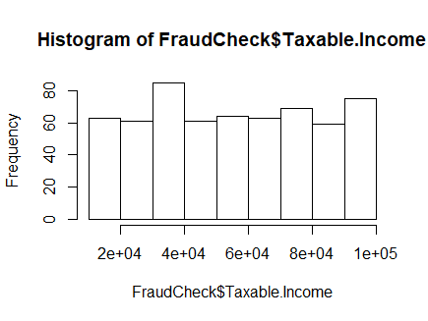

=>Split the data into train and test data

opall_tree = ctree(Risky_Good ~ Undergrad + Marital.Status + City.Population + Work.Experience + Urban, data = FC)

=>summary(opall_tree)

Length Class Mode

1 Binary Tree S4

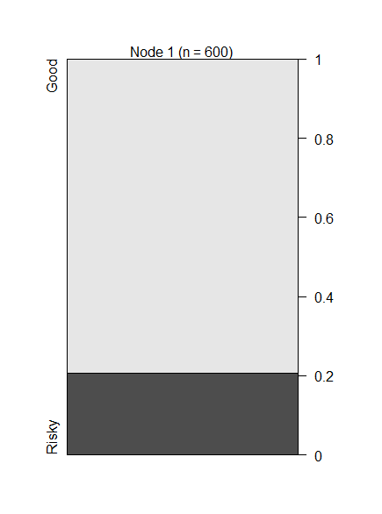

From the above tree, It looks like the data has 20 % of Risky patients and 80 % good patients.

Plot using training data:

op_tree = ctree(Risky_Good ~ Undergrad + Marital.Status + City.Population + Work.Experience + Urban, data = FC_train)

summary(op_tree)

# Length Class Mode

# 1 BinaryTree S4

plot(op_tree)

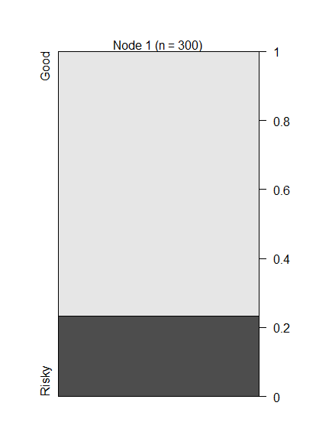

mean(pred_test_df==FC_test$Risky_Good)

# 0.82=>accuracy=82%

Confusion Matrix and Statistics

#Reference

#Prediction Good Risky

# Good 246 0

# Risky 54 0

#Accuracy : 0.82