Problem Statement:

Divide the data (Diabetes) into training and test datasets and create a Random Forest Model to classify 'Class Variable'.

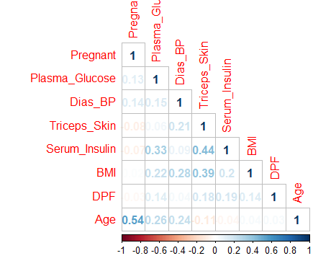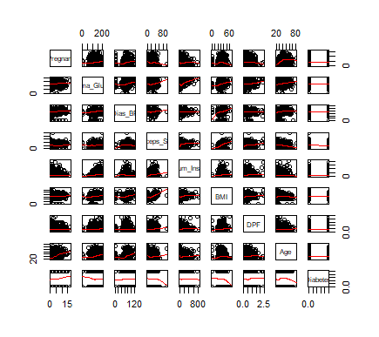

=>Split the data into train and test datasets.

=>create a model using random forest method.

=== Confusion Matrix ===

[[145 31]

[ 42 36]]

=== Classification Report ===

precision recall f1-score support

NO 0.78 0.82 0.80 176

YES 0.54 0.46 0.50 78

micro avg 0.71 0.71 0.71 254

macro avg 0.66 0.64 0.65 254

weighted avg 0.70 0.71 0.71 254

=== All AUC Scores ===

[0.7162963 0.78259259 0.75666667 0.68962963 0.81333333 0.82

0.82444444 0.86814815 0.78 0.825 ]

=== Mean AUC Score ===

Mean AUC Score - Random Forest: 0.7876111111111112

